Supplementary Information

Computational Screening of Transition Metal-Doped CdS for Photocatalytic Hydrogen Production
Yuting Li^{1,2}, Daniel Bahamon^{1,2}, Mutasem Sinnokrot^{1,3}, Lourdes F. Vega^{1,2,*}
¹Research and Innovation Center on CO₂ and Hydrogen (RICH), Khalifa University, PO Box 127788. Abu Dhabi, United Arab Emirates.
²Chemical Engineering Department. Khalifa University, PO Box 127788, Abu Dhabi, UAE.
³Chemistry Department, Khalifa University, PO Box 127788, Abu Dhabi, United Arab Emirates.

*Correspondence to: lourdes.vega@ku.ac.ae

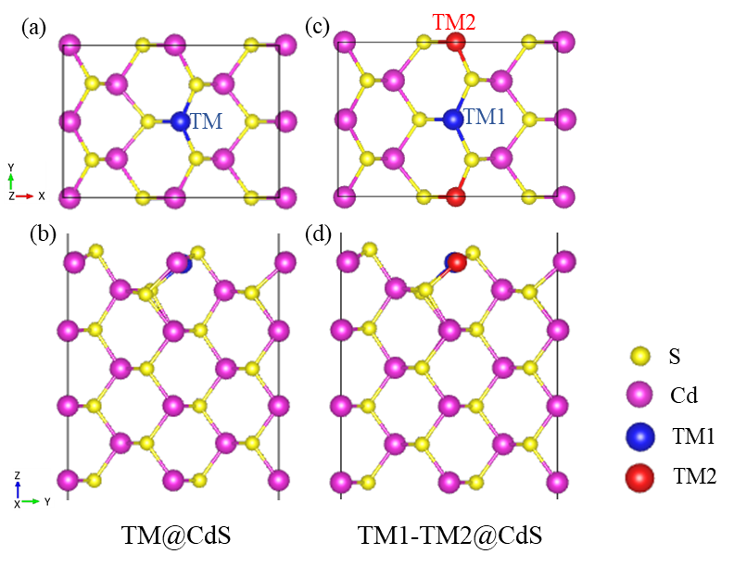
Fig. S1 (a) Top view of an optimized TM@CdS configuration, (b) side view of an optimized TM@CdS configuration, (c) top view of optimized TM1-TM2@CdS configuration and (d) side view of optimized TM1-TM2@CdS configuration.

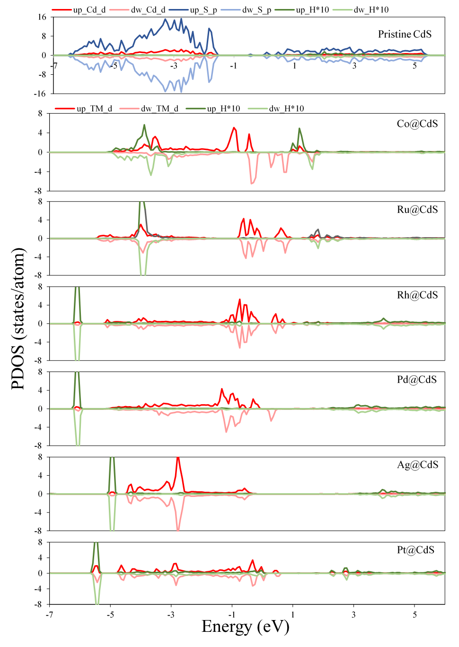
Fig. S2 Partial density of state (PDOS) of H adsorbed on pristine CdS (110) surface and TM@CdS surface from the conventional DFT calculations. The upward electron spin is denoted as up, downward spin is denoted as dw, p represents the sum of p orbital, d represents the sum of d orbital. The PDOS of H atom in pristine CdS surface was multiplied by 10 to enable a more easily visual comparison. The Fermi level is set to 0.
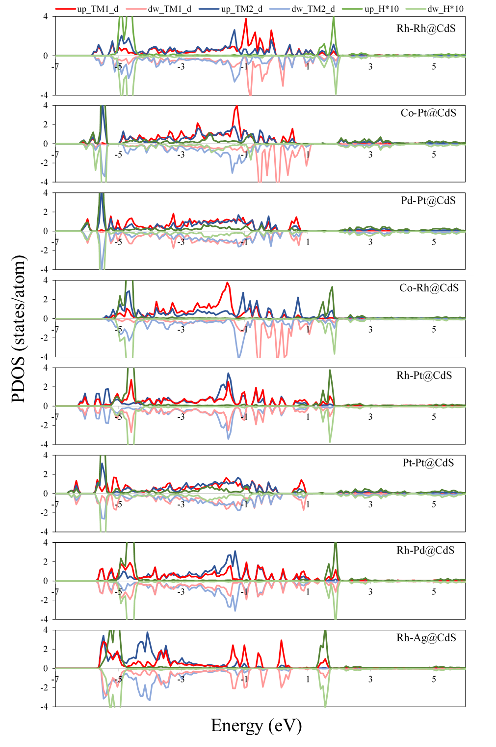
Fig. S3 Partial density of state (PDOS) of H adsorbed on the TM1-TM2@CdS surface from the conventional DFT calculations. The upward electron spin is denoted as up, downward spin is denoted as dw, d represents the sum of d orbital. The PDOS of H atom in pristine CdS surface was multiplied by 10 to enable a more easily visual comparison. The Fermi level is set to 0.

Fig. S4 Relationship between band structure of TM1-TM2@CdS semiconductor and redox potentials of H₂S and H₂O decomposition computed with the HSE06 hybrid functional.

Table S1. The top view of the most stable configurations for species adsorption on TM@CdS after geometry optimization. The order of the TM dopant from left to right is 3d series to 5d series. Color scheme: Cd = purple, S = yellow, H = white, O = red, TM = grey.
 | H₂S | HS | H₂O | OH | H
Pristine | 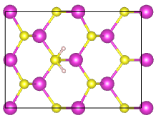 | 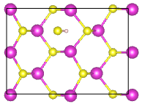 | 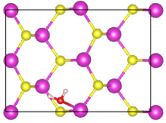 | 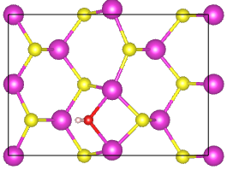 | 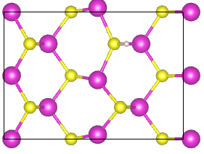
Co | 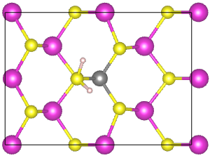 | 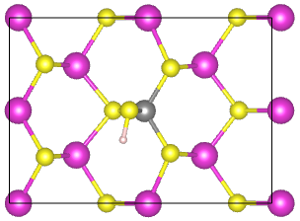 | 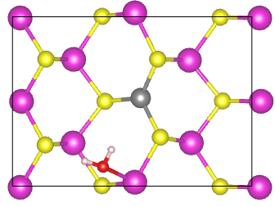 | 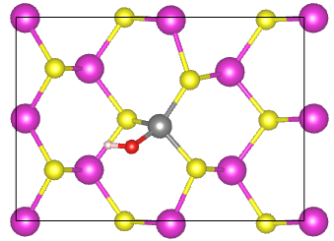 | 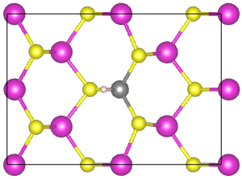
Ni | 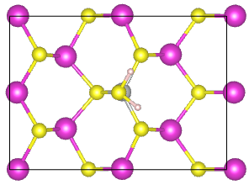 | 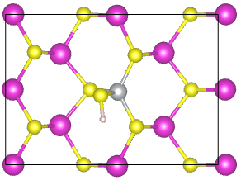 | 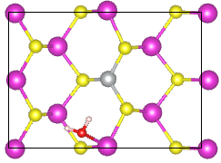 | 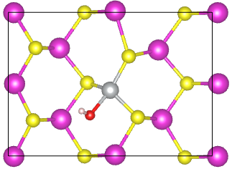 | 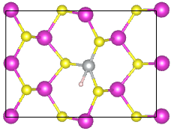
Cu | 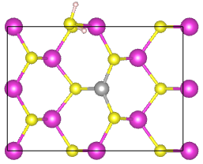 | 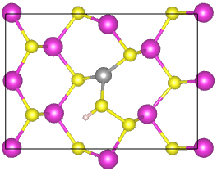 | 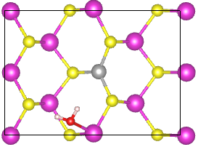 | 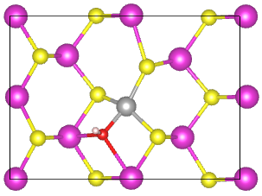 | 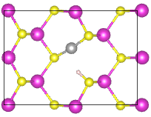
Zn | 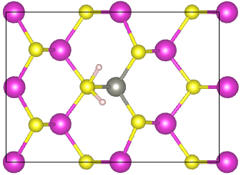 | 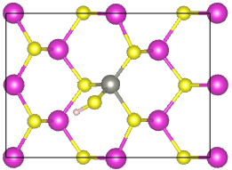 | 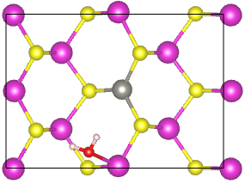 | 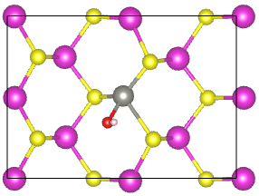 | 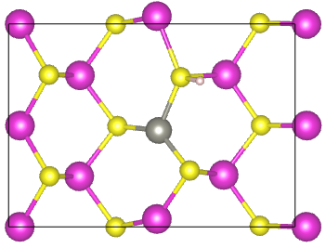
Ru | 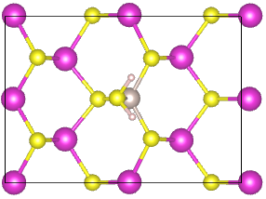 | 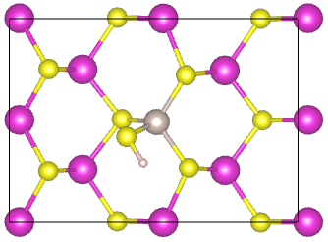 | 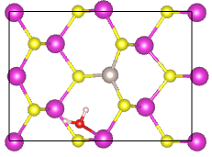 | 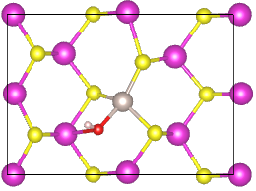 | 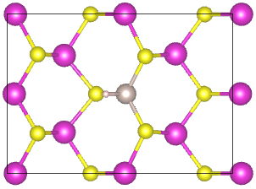
Rh | 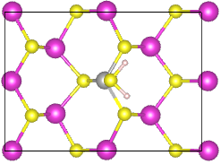 | 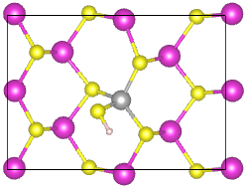 | 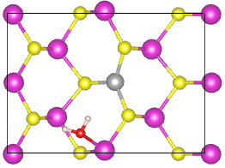 | 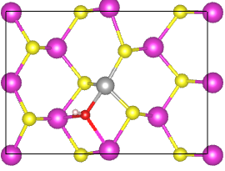 | 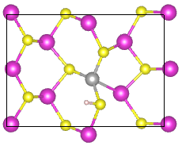
Pd | 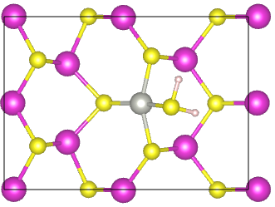 | 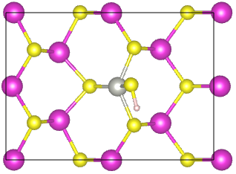 | 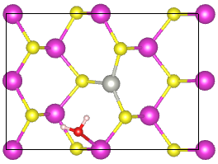 | 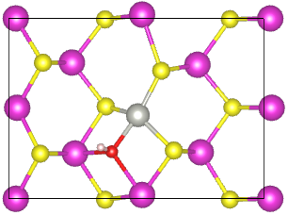 | 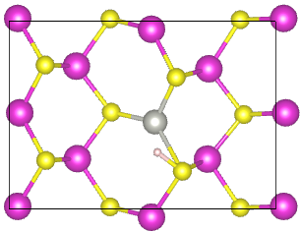
Ag | 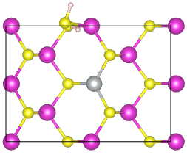 | 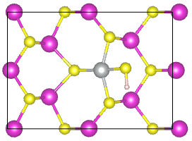 | 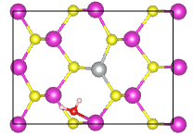 | 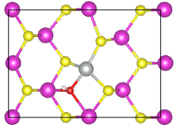 | 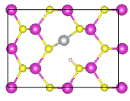
Pt | 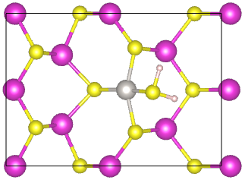 | 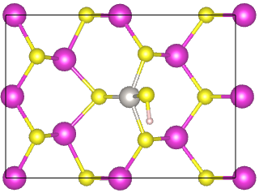 | 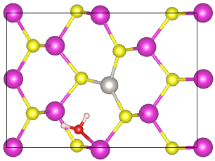 | 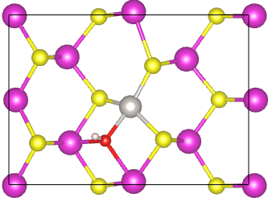 | 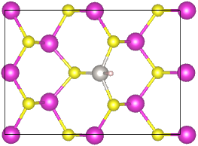
Au | 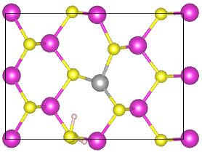 | 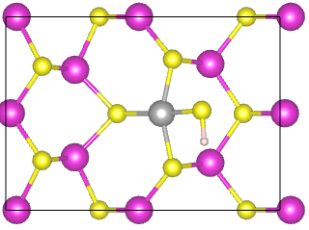 | 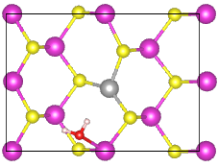 | 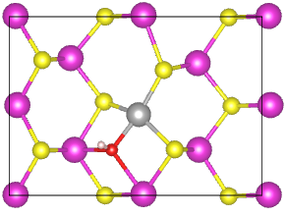 | 