7,8-Dihydroxyflavone induces mitochondrial apoptosis and down-regulates the expression of ganglioside GD3 in malignant melanoma cells

Won Seok Ju^{1,2,†}, Sang Young Seo^{1,†}, Seong-eun Mun¹, Kyongtae Kim¹, Jin Ok Yu¹, Jae-Sung Ryu³, Ji-Su Kim⁴, and Young-Kug Choo^{1,5,*}

¹Department of Biological Science, College of Natural Sciences, Wonkwang University, 460, Iksan-daero, Iksan-si, Jeollabuk-do 54538, Republic of Korea
²Animal Biotechnology Division, National Institute of Animal Science, Rural Development Administration, 1500 Kongjwipatjwi-ro, Iseo-myeon, Wanju-gun, Jeonbuk 55365, Republic of Korea
³Stem Cell Convergence Research Center, Korea Research Institute of Bioscience and Biotechnology (KRIBB), 125, Gwahak-ro, Yuseong-gu, Daejeon, 34141, Republic of Korea
⁴Primate Resources Center (PRC), Korea Research Institute of Bioscience and Biotechnology (KRIBB), 181, Ipsin-gil, Jeongeup-si, Jeollabuk-do 56216, Republic of Korea
⁵Institute for Glycoscience, Wonkwang University, 460, Iksan-daero, Iksan-si, Jeollabuk-do 54538, Republic of Korea

†These authors contributed equally to this work.

*Correspondence to: Young-Kug Choo, Department of Biological Science, College of Natural Sciences, Wonkwang University, 460, Iksan-daero, Iksan-si, Jeollabuk-do 54538, Republic of Korea, Tel.: +82-63-850-6087, Fax: +82-63-857-8837, E-mail: ykchoo@wku.ac.kr

Fig. S1
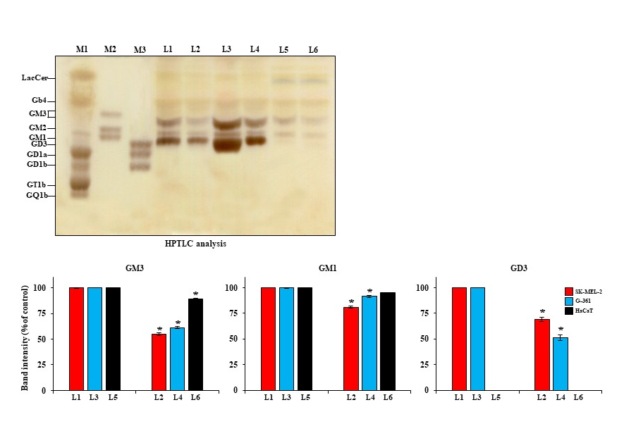

Fig. S2
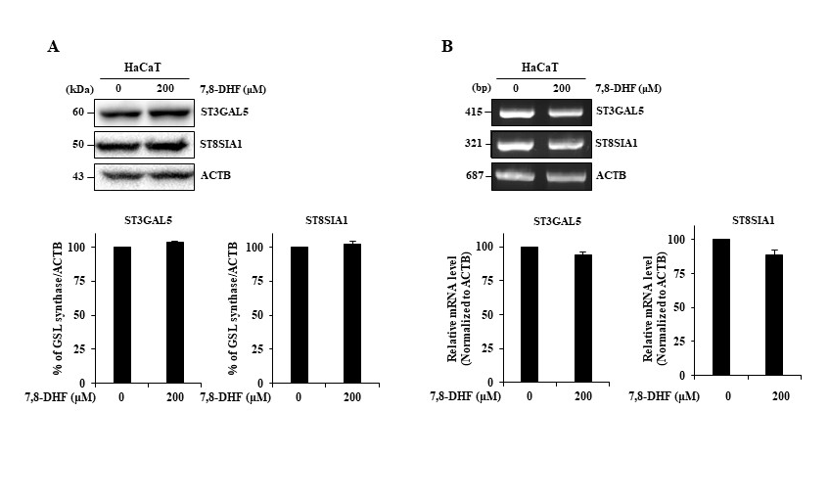

Supplementary Figure legends

Fig. S1 Changes in ganglioside expression in 7,8-DHF-treated SK-MEL-2, G-361, and non-tumoral HaCaT cells. HPTLC analysis of gangliosides in untreated SK-MEL-2 cells (L1), SK-MEL-2 cells treated with 7,8-DHF [200 µM for 24 hours (hr)] (L2), untreated G-361 cells (L3), G-361 cells treated with 7,8-DHF (200 µM for 24 hr) (L4), untreated HaCaT cells (L5), and HaCaT cells treated with 7,8-DHF (200 µM for 24 hr) (L6). M, marker; L, line; M1 adult rat brain standard gangliosides; M2 and M3, ganglioside standard mixture marker (upper panel); the quantification of band intensity for GM3, GM1, and GD3 in SK-MEL-2, G-361, and HaCaT cells (lower panel). Red square, blue square, and black square indicate SK-MEL-2, G-361, and HaCaT cells, respectively. All data presented the mean ± standard deviation (SD) (n = 3, *p < 0.05).

Fig. S2 7,8-DHF shows no significant difference on the expression of ganglioside synthases in non-tumoral HaCaT cells A Western blot analysis and B reverse transcription-polymerase chain reaction analysis of GM3 and GD3 synthase expression in non-tumoral HaCaT cells. ACTB was used as a loading control. ACTB; β-actin. Data were the results of three independent experiments performed in triplicates (n = 3, *p < 0.05)
Table S1

Primer sequences used to generate templates for RT-PCR.
Gene | Description | Species | Primer (5′→3′) | Reaction condition | Size (bp)
ST3GAL5 | ST3 beta-galactoside alpha-2,3-sialyltransferase 5 | Homo sapiens | F: CCC TGA ACC AGT TCG ATG TT  R: GTG GCT AAG ACA ACG GCA AT | Denaturation: 30 s at 95 °C  Annealing: 30 s at 62 °C  Extension: 30 s at 72 °C  Reaction cycles: 35 | 415
ST8SIA1 | ST8 alpha-N-acetylneuraminide alpha-2,8-sialyltransferase 1 | Homo sapiens | F: GCA ATC TCC CTC CTC CTT TGT CA  R: GCT TGG CAT GGA TTC CTC TA |  | 321
ACTB | β-Actin | Homo sapiens | F: CGC AAG TAC TCC GTG TGG AT  R: GTC AGT GTA CAG GTA AGC CCT G |  | 687

