Supplementary Information

Beyond a ‘perfect fit’: the interplay between morphology and spatiotemporal overlap as determinants of microstructure in a bat-flower network

Ugo Mendes Diniz^{1,2 *}, Ludmilla Moura de Souza Aguiar^{2,3}

¹Research Department Life Science Systems, Technische Universität München, Freising, Germany.
²Graduate Program in Ecology, University of Brasília, Brasília, Brazil.
³Zoology department, University of Brasília, Brazil

*Corresponding author
E-mail address: ugo.diniz@tum.de
Tel.: +49 0152 02746484

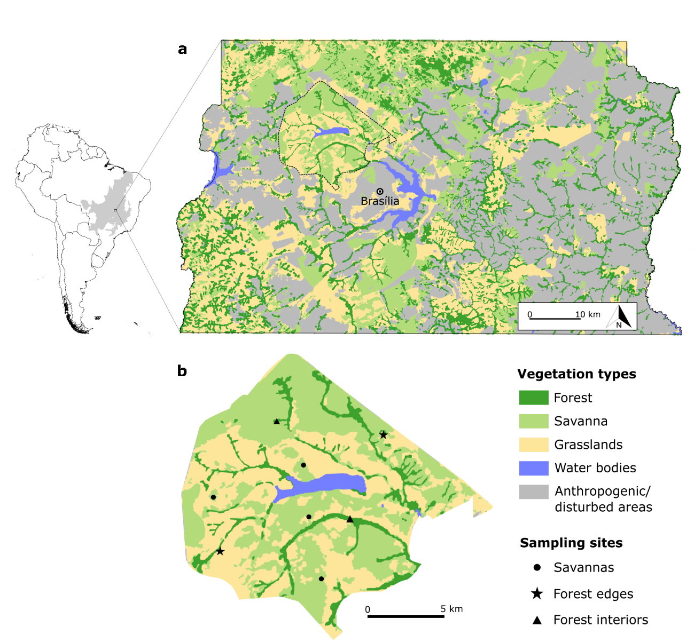
Figure S1. Map illustrating the location and distribution of sampling sites in the Brasília National Park. a - location of the Federal District within the Cerrado biome in South America (shaded area), where the Park (limited by a dashed line) is located. Different colors on the map corrcorrespondvegetation types. b – A close-up of the park, with sampling points marked according to the targeted vegetation type.

Table S1. Pollen morphotypes found on the body of bats throughout the twelve sampling months, identified to the lowest possible taxonomic level. N - Frequency (and percentage in relation to the total number of interactions); n - the of sum of flowering individuals recorded in the transections; Habitat type - in which vegetation type they were reported (CSS – Cerrado sensu stricto, GFI – gallery forest interior, GFE – gallery forest edge), Chirop. - whether they are chiropterophilous or not; and floral shape. Dashes indicate that the species was found in pollen samples but not in site (n, habitat type), or that chiropterophily or floral shape may not be inferred by the taxonomical level achieved.

Pollen type | N (%) | n | Habitat type | Chirop. | Floral shape | Label
Acanthaceae
Justicia sp. | 1 (0.3) | - | - | No | - | Jusp
Amaryllidaceae
Hippeastrum glaucescens | 1 (0.3) | 1 | S | No | Infundibuliform | Hglau
Arecaecae
Syagrus type | 1 (0.3) | - | - | No | - | Asya
Asteraceae
Baccharis type | 1 (0.3) | - | - | No | - | Abacc
Vernoniae type | 1 (0.3) | - | - | - | - | Asver
Caryocaraceae
Caryocar brasiliense | 46 (15.2) | 95 | S | Yes | Brush | Cbra
Combretaceae
Combretum fruticosum | 5 (1.7) | 10 | I | No | Pseudanthium | Cfru
Convolvulaceae
Ipomoeae procumbens | 1 (0.3) | 1 | S | No | Infundibuliform | Ipro
Merremia tomentosa | 1 (0.3) | 4 | S | No | Infundibuliform | Mtom
Cunoniaceae
Lamanonia ternata | 23 (7.6) | 30 | E | No | Pseudanthium | Lter
Fabaceae
Bauhinia goyazensis group¹ | 25 (8.3) | 46 | S/E | Yes | Tubular | Bgoy
Bauhinia holophylla | 11 (3.7) | 4 | S/E | Yes | Tubular | Bholo
Bauhinia rufa group² | 30 (9.9) | 13 | E | Yes | Tubular | Brufa
Caesalpinoidae sp. 1 | 3 (1.0) | - | - | - | - | Fcae1
Caesalpinoidae sp. 2 | 1 (0.3) | - | - | - | - | Fcae2
Caesalpinoidae sp. 3 | 1 (0.3) | - | - | - | - | Fcae3
Hymenaea courbaril | 10 (3.3) | 2 | I | Yes | Cupuliform | Hcou
Hymenaea stigonocarpa | 22 (7.3) | 6 | S | Yes | Cupuliform | Hsti
Inga aff. laurina | 4 (1.3) | - | - | Yes | Pseudanthium | Ilau
Inga edulis | 5 (1.7) | - | - | Yes | Tubular | Iedu
Inga vera | 8 (2.6) | - | - | Yes | Tubular | Iver
Mimosa aff. setosa | 1 (0.3) | 26 | S | No | Pseudanthium | Mset
Loranthaceae
Psittacanthus robustus | 35 (11.6) | 61 | S | No | Tubular | Prob
Lyrthraceae
Lafoensia pacari | 28 (9.3) | 2 | E | Yes | Campanulate | Lpac
Malvaceae
Ceiba pentandra | 13 (4.3) | - | I | Yes | Brush | Cpen
Pseudobombax longiflorum | 6 (2.0) | 21 | E | Yes | Brush/urceolate³ | Plon
Pseudobombax tomentosum | 4 (1.3) | 4 | S | Yes | Brush/urceolate³ | Ptom
Moraceae
Moraceae type | 2 (0.7) | - | - | - | - | Mora
Myrtaceae
Eucalyptus sp. | 3 (1.0) | - | - | Yes⁴ | Brush | Eusp
Myrcia sp. | 1 (0.3) | 31⁵ | S | No | Brush | Myrsp
Myrtaceae type | 1 (0.3) | - | - | - | - | Myrt
Sapotaceae
Pouteria type | 1 (0.3) | - | - | - | - | Spou
Smilacaceae
Smilax sp. | 1 (0.3) | - | - | No | Pseudanthium | Smil
Undetermined
Undetermined 1 | 1 (0.3) | - | - | - | - | Indet1
Undetermined 2 | 1 (0.3) | - | - | - | - | Indet2
¹ Includes the following species with similar flower and pollen morphology: B. goyazensis and B. dumosa;
² Includes the following species with similar flower and pollen morphology: B. rufa and B. longifoli;
³ Flowers have an overall brush-like appearance, but the nectar chamber is formed by the large urceolate calyx;
⁴ Paleotropical chiropterophilous species introduced in the region for economic purposes and found around the PNB;
⁵ Abundance is the sum of M. eryocalyx and M. multifloral, the two species found in the site with similar floral morphologies.

Table S2. Bat species captured during 12 sampling months in the Brasília National Park. N - absolute number of captured individuals; rN - relative frequency; Habitat type – the vegetation type in which they were reported (S – savanna, I – gallery forest interior, E – gallery forest edge); pollen carriers - number (and percentage) of bats from each species that carried pollen; and the richness of plant species and/or pollen morphotypes found in their samples.

Species | N | rN | Habitat type |  | Pollen carriers (%) |  | Pollen type richness |  | Network label
Molossidae
Molossops temminckii | 3 | 0.008 | E |  | 0 (0.0) |  | 0 |  | -
Mormoopidae
Pteronotus rubiginosus | 1 | 0.003 | I |  | 0 (0.0) |  | 0 |  | -
Phyllostomidae
Carollinae
Carollia perspicillata | 62 | 0.161 | S/E/I |  | 23 (37.1) |  | 12 |  | Cper
Desmodontinae
Diphylla ecaudata | 1 | 0.003 | S |  | 0 (0.0) |  | 0 |  | -
Glossophaginae
Anoura caudifer | 24 | 0.062 | S/E/I |  | 23 (95.8) |  | 14 |  | Acau
Anoura geoffroyi | 5 | 0.013 | S/E/I |  | 5 (100.0) |  | 8 |  | Ageo
Glossophaga soricina | 43 | 0.111 | S/E/I |  | 41 (95.3) |  | 14 |  | Gsor
Lonchophyllinae
Lonchophylla dekeyseri | 22 | 0.057 | S/E |  | 19 (86.4) |  | 8 |  | Ldek
Micronycterinae
Micronycteris schmidtorum | 4 | 0.010 | S |  | 3 (75.0) |  | 3 |  | Msch
Stenodermatinae
Artibeus concolor | 1 | 0.003 | I |  | 1 (100.0) |  | 1 |  | Acon
Artibeus lituratus | 79 | 0.205 | S/E/I |  | 14 (17.7) |  | 7 |  | Alit
Artibeus planirostris | 24 | 0.062 | S/E/I |  | 11 (45.8) |  | 5 |  | Apla
Dermanura cf. anderseni | 17 | 0.044 | S/E/I |  | 1 (5.9) |  | 2 |  | Dand
Dermanura cinerea | 36 | 0.093 | S/E/I |  | 5 (13.9) |  | 4 |  | Dcin
Platyrrhinus lineatus | 37 | 0.096 | S/E/I |  | 14 (37.8) |  | 9 |  | Plin
Sturnira lilium | 13 | 0.034 | S/E/I |  | 2 (15.4) |  | 2 |  | Slil
Sturnira tildae | 1 | 0.003 | E |  | 0 (0.0) |  | 0 |  | -
Vespertilionidae
Eptesicus diminutus | 1 | 0.003 | S |  | 0 (0.0) |  | 0 |  | -
Eptesicus furinalis | 2 | 0.005 | S |  | 0 (0.0) |  | 0 |  | -
Lasiurus blossevillii | 1 | 0.003 | E |  | 0 (0.0) |  | 0 |  | -
Myotis diminutus | 1 | 0.003 | E |  | 0 (0.0) |  | 0 |  | -
Myotis riparius | 2 | 0.005 | E/I |  | 0 (0.0) |  | 0 |  | -
Myotis nigricans | 6 | 0.016 | E/I |  | 0 (0.0) |  | 0 |  | -
Total | 386

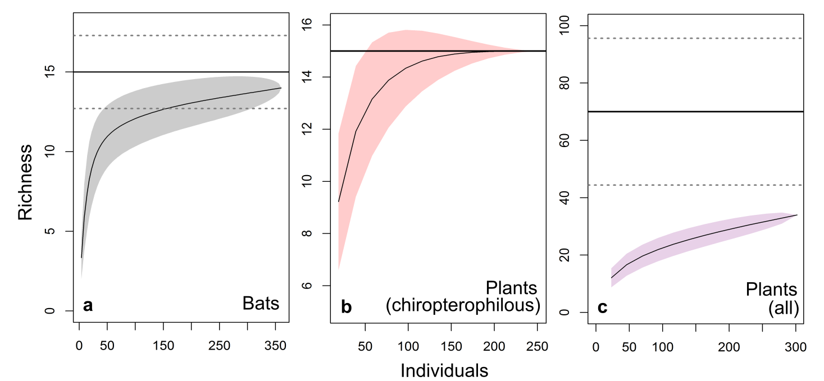
Figure S2. Rarefaction curves. a - bats species; b - pollen types from chiropterophilous plants; c - pollen types from all plants pooled. Shaded areas represent 95% confidence intervals, and solid and dashed horizontal lines indicate the estimated asymptotic richness and its standard error, respectively.

Table S3. All plants registered in the transections that were classified as potential resources for bats, according to the criteria specified in the methods. Habitat type: CSS – Cerrado sensu stricto, GFI – gallery forest interior, GFE – gallery forest edge), their pollination syndrome and floral shape.
Espécie | Habitat type | Syndrome | Bat visitation | Floral shape
Acanthaceae
Justicia clivalis | GFI | Ornithophily | No | Tubular
Justicia irwinii | GFI | Entomophily | No | Campanulate
Ruellia incompta | CSS | Entomophily | No | Infundibuliform
Alstroemeriaceae
Alstroemeria gardneri | CSS | Ornithophily | No | Infundibuliform
Alstroemeria stenopetala | GFE | Sphingophily | No | Campanulate
Amaryllidaceae
Hippeastrum glaucescens | CSS | Ornithophily | Yes | Infundibuliform
Apocynaceae
Mandevilla illustris | CSS | Entomophily | No | Infundibuliform
Mandevilla pohliana | CSS | Entomophily | No | Infundibuliform
Odontadenia lutea | CSS | Entomophily | No | Infundibuliform
Arecaceae
Syagrus comosa | CSS | Entomophily | No | Cupuliform
Bignoniaceae
Adenocalymma  pedunculatum | CSS | Entomophily | No | Infundibuliform
Amphilophium elongatum | GFE, GFI | Entomophily | No | Infundibuliform
Anemopaegma acutifolium | CSS | Entomophily | No | Infundibuliform
Anemopaegma arvense | CSS | Entomophily | No | Infundibuliform
Arrabidaea sceptrum | CSS | Entomophily | No | Infundibuliform
Bignonia cf. corymbosa | GFI | Entomophily | No | Infundibuliform
Fridericia cf. florida | GFI | Entomophily | No | Infundibuliform
Fridericia platyphylla | GFE | Entomophily | No | Infundibuliform
Handroanthus chrysothrichus | CSS | Entomophily | No | Infundibuliform
Jacaranda caroba | GFE | Entomophily | No | Infundibuliform
Jacaranda ulei | CSS | Entomophily | No | Infundibuliform
Jacaranda sp. | GFI | Entomophily | No | Infundibuliform
Calophyllaceae
Kielmeyera abdita | CSS | Entomophily | No | Rotate
Kielmeyera coriaceae | CSS, FGE | Entomophily | No | Rotate
Kielmeyera pumila | CSS | Entomophily | No | Rotate
Kielmeyera variabilis | CSS | Entomophily | No | Rotate
Caryocaraceae
Caryocar brasiliense | CSS | Chiropterophily | Yes | Brush
Celastraceae
Plenckia populnea | GFE | Entomophily | No | Pseudanthium
Chrysobalanaceae
Couepia grandiflora | CSS | Entomophily | No | Brush
Combretaceae
Combretum fruticosum | GFI | Ornithophily | Yes | Brush
Convolvulaceae
Ipomoea sp. | CSS | Entomophily | No | Infundibuliform
Ipomoea procumbens | CSS | Entomophily | Yes | Infundibuliform
Jacquemontia velutina | CSS | Entomophily | No | Infundibuliform
Merremia digitata var. elongata | CSS | Entomophily | No | Infundibuliform
Merremia tomentosa | CSS | Entomophily | Yes | Infundibuliform
Cunoniaceae
Lamanonia ternata | GFE | Entomophily | Yes | Pseudanthium
Erythroxylaceae
Erythroxylum tortuosum | CSS | Entomophily | No | Pseudanthium
Fabaceae
Bauhinia dumosa | GFE | Chiropterophily | Yes | Tubular
Bauhinia goyazensis | CSS, GFE | Chiropterophily | Yes | Tubular
Bauhinia holophylla | CSS | Chiropterophily | Yes | Tubular
Bauhinia longifolia | GFE | Chiropterophily | Yes | Tubular
Bauhinia rufa | GFE | Chiropterophily | Yes | Tubular
Calliandra dysantha | CSS, GFE | Ornithophily | No | Pseudanthium
Hymenaea courbaril | GFI | Chiropterophily | Yes | Cupuliform
Hymenaea stigonocarpa | CSS, GFE | Chiropterophily | Yes | Cupuliform
Leptolobium dasycarpum | GFE | Entomophily | No | Pseudanthium
Mimosa clausseni | CSS, GFE | Entomophily | No | Pseudanthium
Mimosa regnelli | CSS, GFE | Entomophily | No | Pseudanthium
Mimosa setosa | CSS, GFE | Entomophily | Yes | Pseudanthium
Mimosa somnians | CSS, GFE | Entomophily | No | Pseudanthium
Stryphnodendron adstringens | CSS | Entomophily | No | Pseudanthium
Tachigali vulgaris | CSS | Entomophily | No | Pseudanthium
Gentianaceae
Calolisianthus speciosus | CSS | Entomophily | No | Campanulate
Sinningia elatior | GFE | Ornithophily | No | Tubular
Iridaceae
Gladiolus verdickii | CSS | Entomophily | No | Cupuliform
Lamiaceae
Hypenia macrantha | CSS | Ornithophily | No | Tubular
Amasonia hirta | CSS | Entomophily | No | Tubular
Rhabdocaulon denudatum | GFE | Entomophily | No | Tubular
Loranthaceae
Psittacanthus robustus | CSS | Ornithophily | Yes | Tubular
Lythraceae
Diplusodon spp. | CSS, GFE | Entomophily | No | Rotate
Diplusodon virgatus | CSS, GFE | Entomophily | No | Rotate
Lafoensia pacari | GFE | Chiropterophily | Yes | Campanulate
Malvaceae
Eriotheca pubescens | CSS, GFE | Entomophily | No | Brush
Luehea divaricata | GFI | Entomophily | No | Brush
Luehea grandiflora | CSS, GFE | Chiropterophily | No | Cupuliform
Pavonia rosa-campestris | CSS, GFE | Entomophily | No | Rotate
Peltaea polymorpha | CSS, GFE | Entomophily | No | Rotate
Pseudobombax longiflorum | GFE | Chiropterophily | Yes | Brush/urceolate
Pseudobombax tomentosum | CSS | Chiropterophily | Yes | Brush/urceolate
Myrtaceae
Campomanesia adamantium | CSS | Entomophily | No(?) | Brush
Campomanesia cf. aurea | CSS | Entomophily | No(?) | Brush
Campomanesia pubescens | CSS | Entomophily | No(?) | Brush
Campomanesia sessiliflora | CSS | Entomophily | No(?) | Brush
Myrcia eriocalyx | CSS | Entomophily | Yes | Brush
Myrcia cf. multiflora | CSS, GFE | Entomophily | Yes | Brush
Psidium sp. | CSS | Entomophily |  | Brush
Orobanchaceae
Esterhazya splendida | CSS | Ornithophily | No | Tubular
Protecaeae
Roupala montana | CSS, GFE | Entomophily | No | Pseudanthium
Rubiaceae
Ferdinandusa speciosa | GFE | Ornithophily | No | Tubular
Rutaceae
Spiranthera odoratissima | CSS | Entomophily | No | Tubular
Styracaceae
Styrax ferruginea | CSS | Entomophily | No | Rotate
Velloziaceae
Vellozia squamata | CSS | Entomophily | No | Infundibuliform
Vochysiaceae
Qualea grandiflora | CSS | Entomophily | No | Calcarate
Qualea multiflora | CSS | Entomophily | No | Calcarate

