Boosting the optical limiting properties of helicene-containing arene to the linear analogue
Xiaohui Yu,¹ Yunfei Li,² Wei Wang,¹ Ziwei Yuan,¹ Zheng Xie,²* Shuyun Zhou,² and Jinchong Xiao²*

¹ College of Chemistry and Environmental Science, Key Laboratory of Chemical Biology of Hebei Province, Hebei University, Baoding 071002, P. R. China
E-mail: jcxiaoicas@163.com
² Key Laboratory of Photochemical Conversion and Optoelectronic Materials, Technical Institute of Physics and Chemistry, Chinese Academy of Sciences, Beijing 100190, China
E-mail: zhengxie@mail.ipc.ac.cn

Content
Experimental part························································································S2
Figure S1··································································································S2
Figure S2··································································································S3
Figure S3 and S4·························································································S4
Figure S5 and S6·························································································S5
Figure S7 and S8·························································································S6
Figure S9 and S10························································································S7
Figure S11 and S12······················································································S8
Figure S13 and S14······················································································S9
Figure S15 and S16·····················································································S10
Figure S17 and Table S1 ··············································································S11
Figure S18-S20 ·························································································S12
Figure S21 and S22 ····················································································S13
Figure S23 and Table S2 ··············································································S14

Experimental part
All the chemical reagents were purchased from the commercial companies and directly used without further purification. The oxygen-sensitive and moisture-sensitive reactions were performed under argon and monitored via thin layer chromatography on silica gel with GF 254 indicator. Anhydrous tetrahydrofuran (THF) and toluene were distilled from Na. Column chromatography was finished with silica gel (200-300 mesh).
Nuclear magnetic resonance (NMR) spectra were measured on a Bruker Advance 600 MHz spectrometer and a WNMR 400 spectrometer in CDCl₃, and the chemical shifts were reported in parts per million (ppm) and referenced to CDCl₃ (7.26 ppm) for ¹H NMR and to CDCl₃ (77.16 ppm) for ¹³C NMR. The high-resolution mass spectrometry (HRMS) was recorded on Bruker Biflex III MALDI-TOF. UV-vis and fluorescence spectra were achieved on an Analytikjena Specord 210 Plus UV-vis spectrophotometer and HITACHI F-7000 fluorescence spectrophotometer. The electrochemical tests were measured in anhydrous dichloromethane and 1,2-dichlorobenzene (ODCB) including n-Bu₄NPF₆ (0.1 M) as a supporting electrolyte on a CHI 630A under argon atmosphere. A three-electrode system was employed by using glassy carbon as working electrode, Ag/AgNO₃ as reference electrolyte and platinum wire as counter electrolyte. The scan rate is 0.1 V s⁻¹ and the potentials were estimated against ferrocene/ferrocenium couple.
Preparation of hybrid Ormosil Gel Glasses:
The materials were prepared by the hydrolysis and polycondensation of MTES in acidic medium (H₂O, acetic acid or HCl, pH = 2.5) using a modified method reported before. The molar ratio of MTES: ethanol: distilled water in the precursor was 3:1:3. The mixture was stirred overnight and evaporated to the initial volume of the MTES precursor. The mixture was stirring for 5-7 days. The ethanol or THF solution of compound 5 was added to the solution. After aging was finished, the gels were divided into several volume parts, cast into polypropylene cells individually, and dried 1-2 days at room temperature to give the final monoliths.
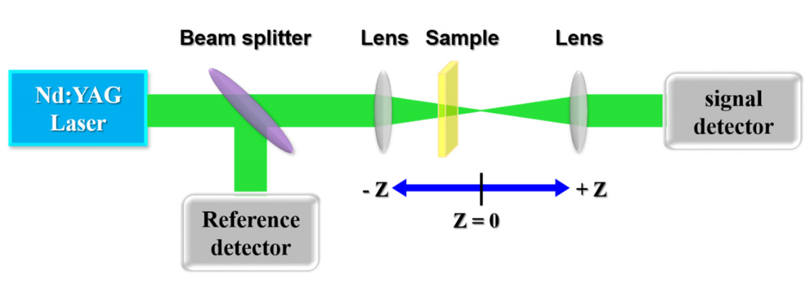
Figure S1 The typical double-beams experimental arrangement of Z-scan measurement.
The detail description of Z-scan measurement: The Z-scan method was introduced by Sheik-Bahae et al. in 1989 to determine the magnitude of the excited-state absorption cross-section (σ_{ex}), nonlinear absorption coefficient (β_{eff}) and the sign and magnitude of the nonlinear refractive index (n₂). In this work, the optical performances are collected using Z-scan technology with FWHM of 8 ns laser pulses with a repetition frequency of 10 Hz from a Nd:YAG laser under wavelength of 532 nm. The spatial and temporal profiles of the laser pulses presented an approximately Gaussian distribution. As shown in Figure S1, the laser beam has been divided into two beams: one laser beam is collected directly by reference detector to monitor energy fluctuations. Meanwhile, another beam is focused with lens on samples to detect the transmittance as the sample is scanned through the Z-direction to tune the intensities on it.
Herein, the Z-scan curves, which are the normalized transmittance as a function of the sample position (Z), were measured with an open-aperture. The samples were placed in quartz cell with thickness of 1 mm with identical linear transmittance 70% at 532 nm and fixed on a stepper motor which was controlled by a computer to move along the Z axis reference to the focal point. In this measurement, normalized transmittance of 1.0 indicates that the material exhibits no NLO behavior. When the sample exhibits saturable absorption, normalized transmittance above 1.0 will be observed. In contrast, the normalized transmittance below 1.0 indicates that the sample exhibits reverse saturable absorption.
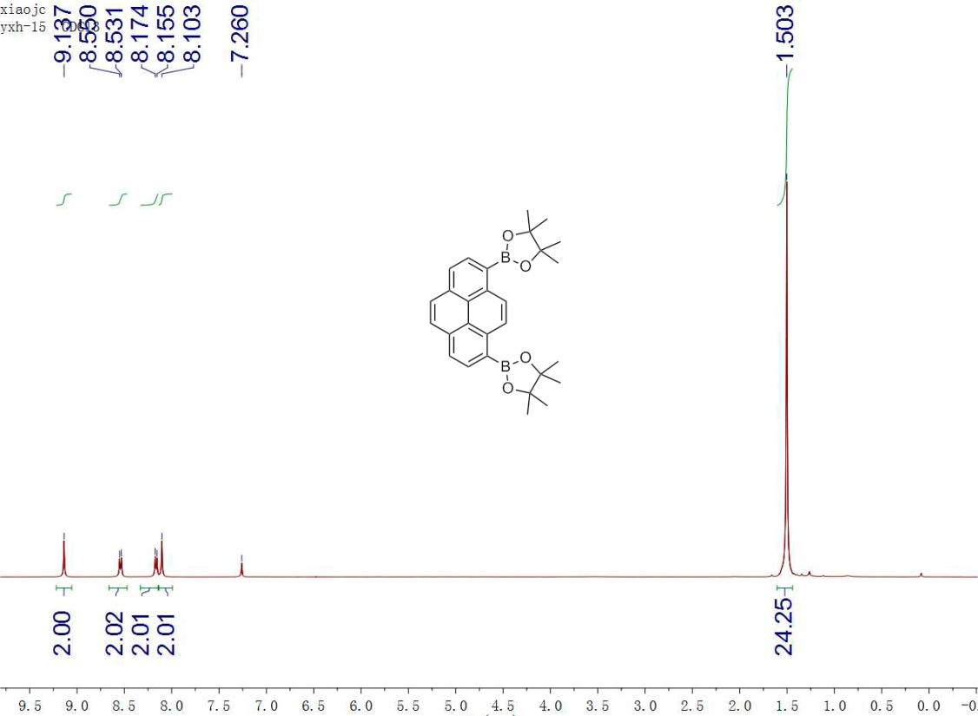
Figure S2 ¹H NMR spectrum of 2.

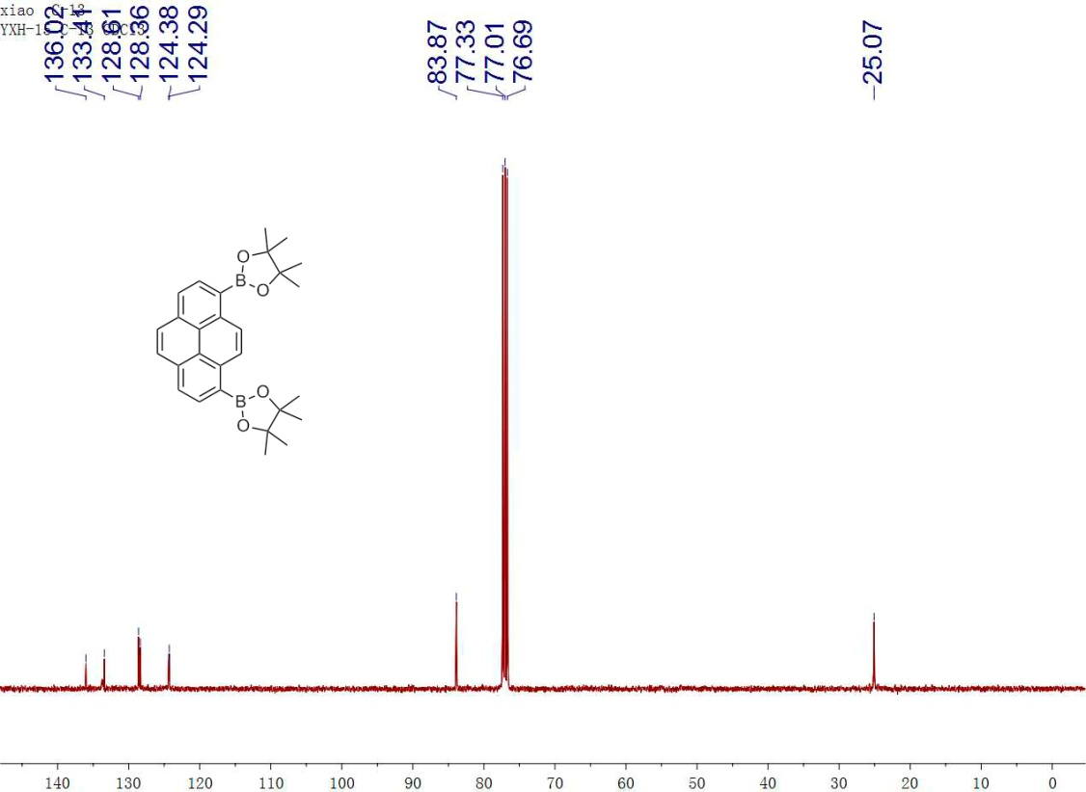
Figure S3 ¹³C NMR spectrum of 2.

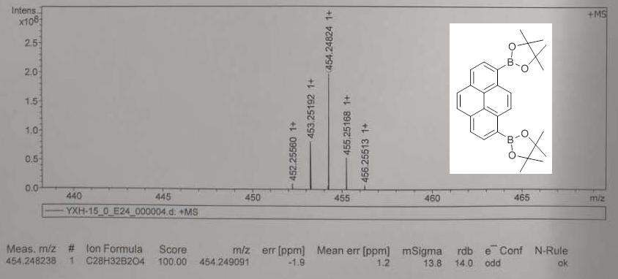
Figure S4 HR-MS spectrum of 2.

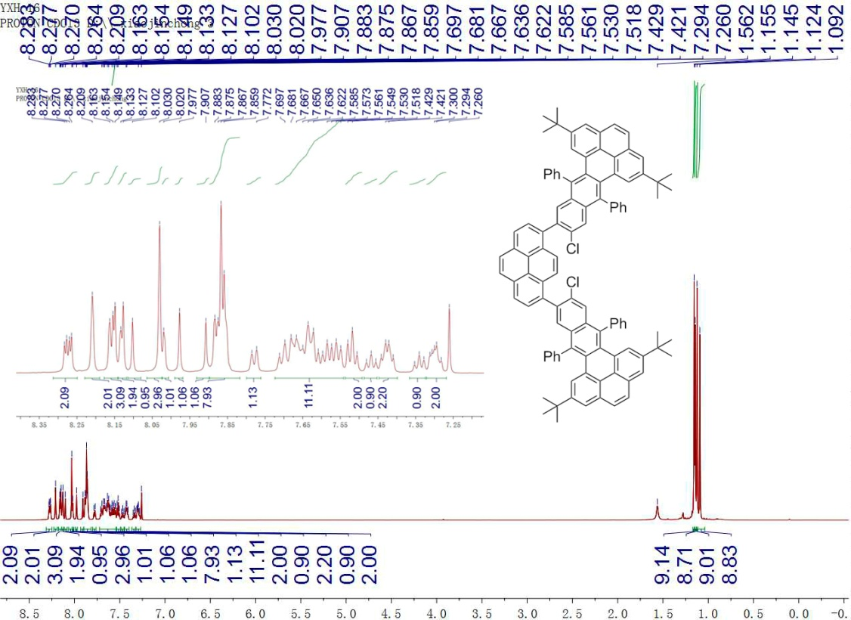
Figure S5 ¹H NMR spectrum of 4.

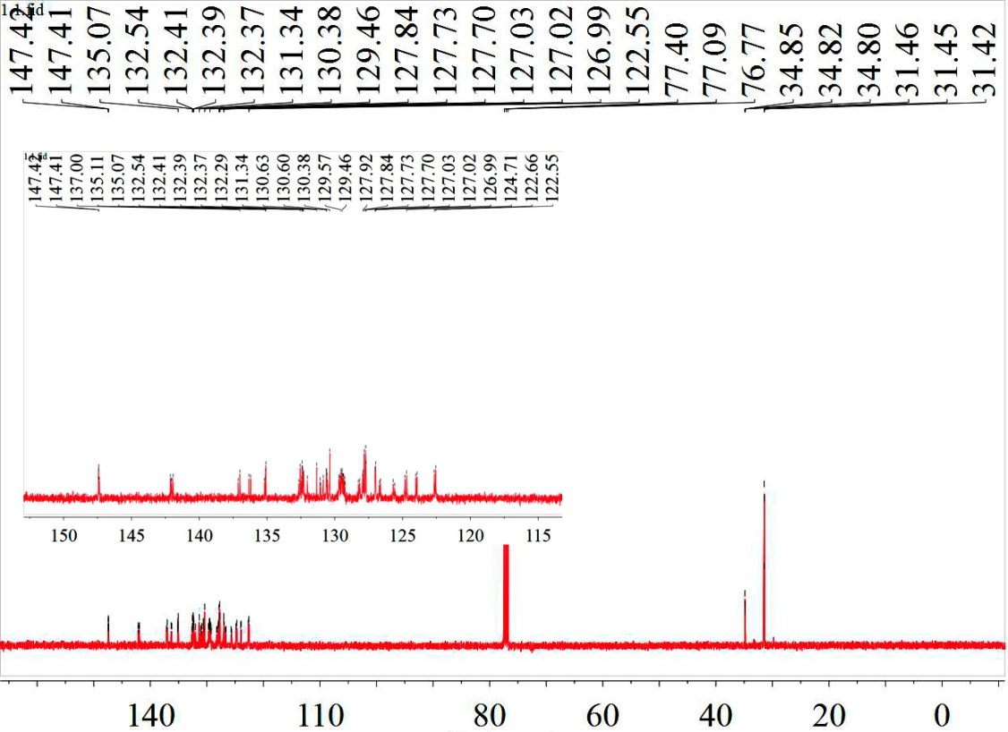
Figure S6 ¹³C NMR spectrum of 4.

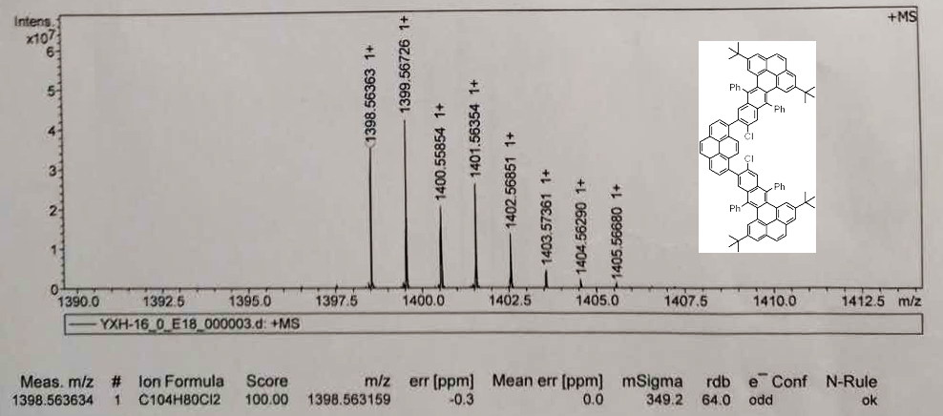
Figure S7 HR-MS spectrum of 4.

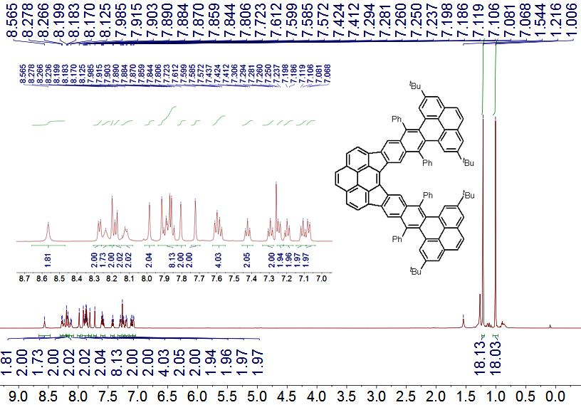
Figure S8 ¹H NMR spectrum of 5.

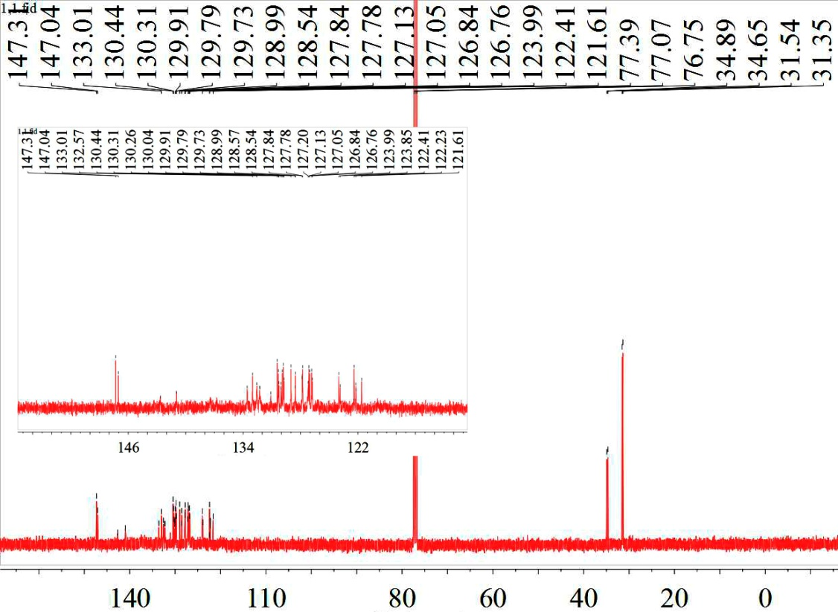
Figure S9 ¹³C NMR spectrum of 5.

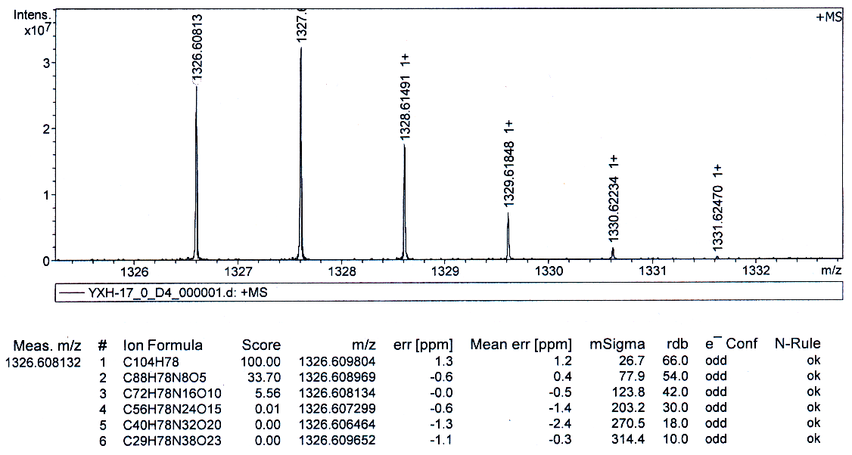
Figure S10 HR-MS spectrum of 5.

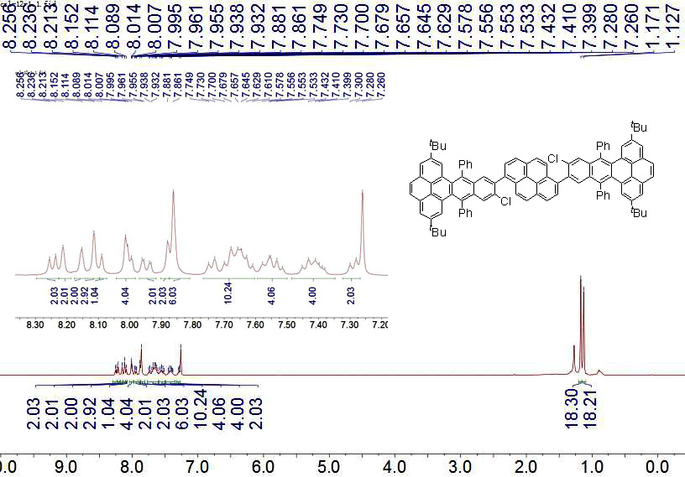
Figure S11 ¹H NMR spectrum of 7 (400 MHz, CDCl₃).

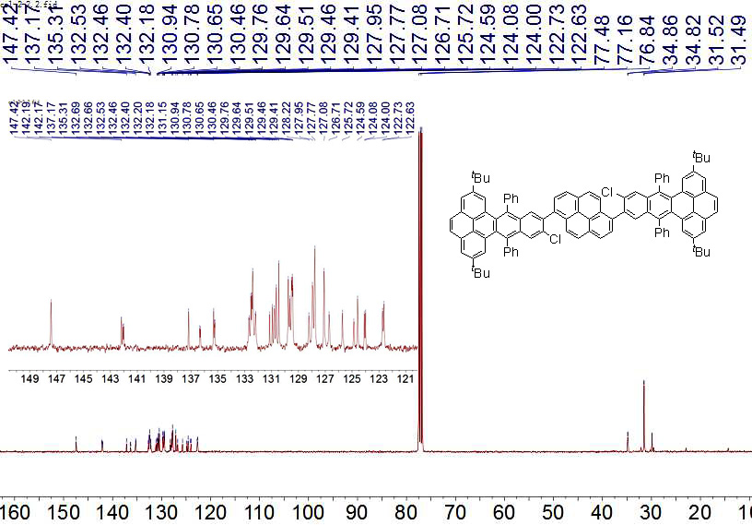
Figure S12 ¹³C NMR spectrum of 7 (100 MHz, CDCl₃+CS₂).

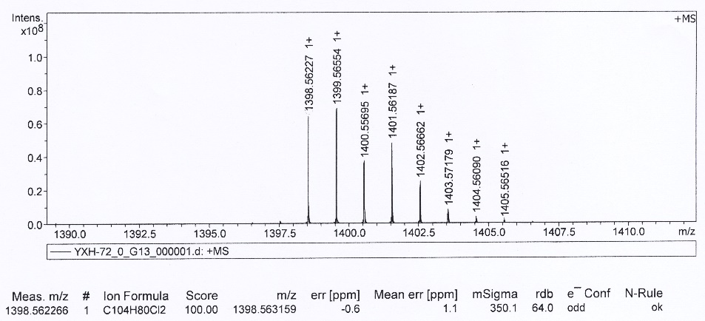
Figure S13 HR-MS spectrum of 7.

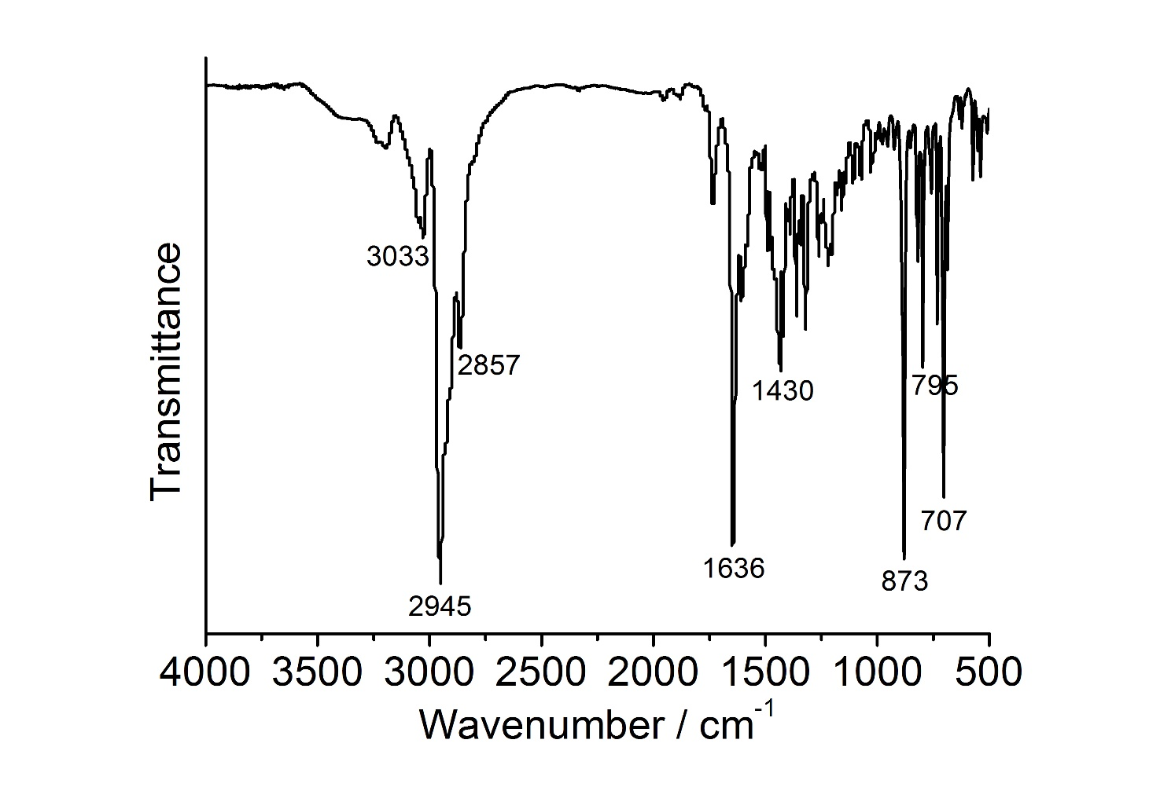
Figure S14 FT-IR spectrum of 9.

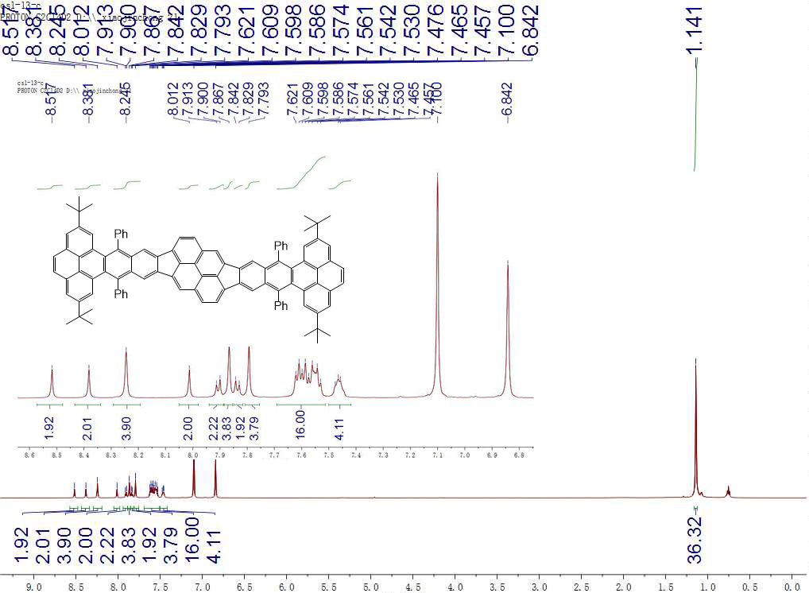
Figure S15 ¹H NMR spectrum of 9.

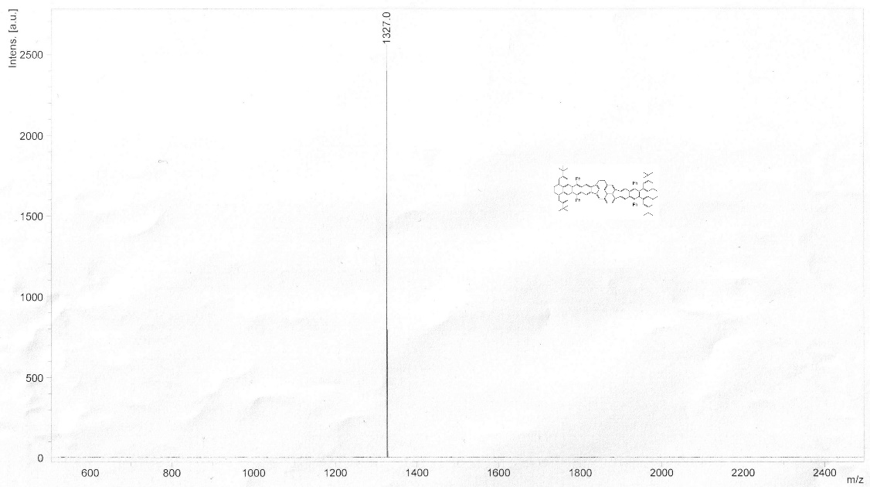
Figure S16 MALDI-TOF spectrum of 9.

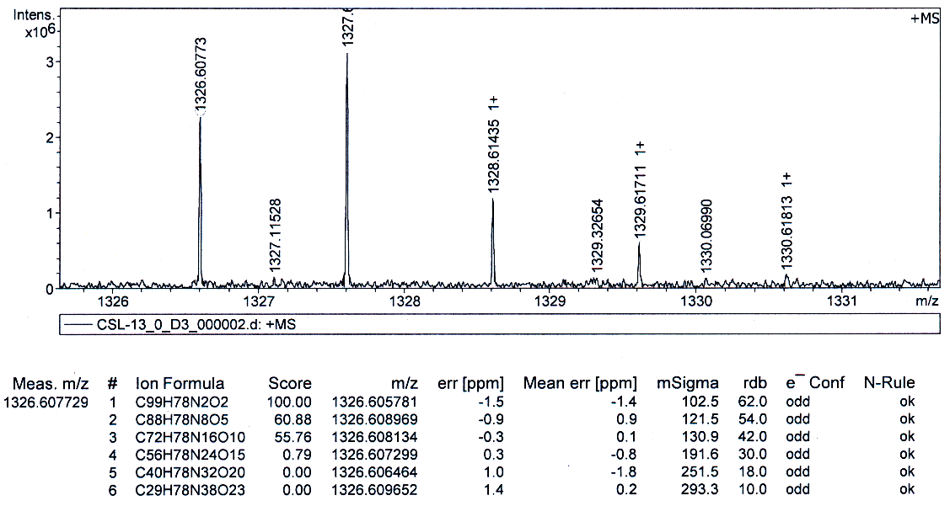
Figure S17 HR-MS spectrum of 9.

Table S1 Crystal data and structure refinement of 5
 | 5
Empirical formula | C₁₀₄H₇₈
Formula weight | 1327.6
Temperature / K | 100.00(10)
Crystal system | triclinic
Space group | P-1
Unit cell dimensions | a = 14.6457(2)  b = 16.7294(4)  c = 22.7944(5)  α = 88.152(2)  β = 76.205(2)  γ = 67.284(2)
Volume / Å³ | 4991.95(19)
Z | 4
Density/g/cm³ | 1.015
Absorption coefficient / mm⁻¹ | 1.391
F(000) | 1604
Crystal size / mm³ | 0.10×0.06×0.03
Radiation type | Cu k/a λ = 1.54184
CCDC number | 2167040

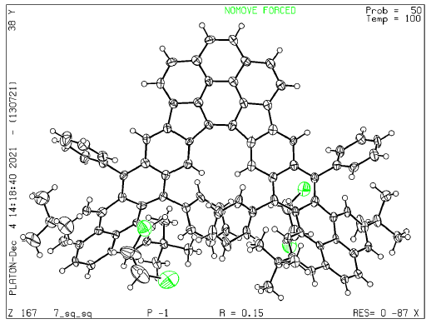
Figure S18 Crystal structure of 5 with an ellipsoid contour at the 50% probability level.

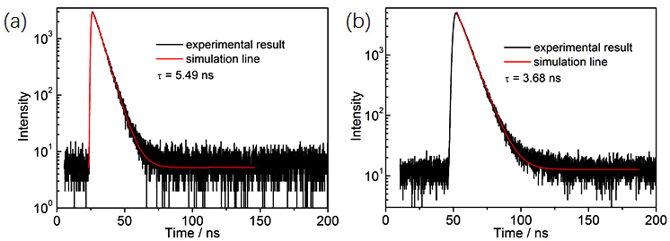
Figure S19 Fluorescence decay of (a) 5 and (b) 8 in degassed dichloromethane.

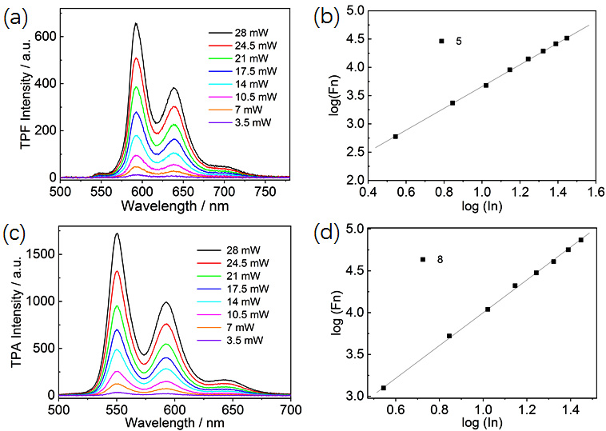
Figure S20 TPF intensity-wavelength spectra (a) 5, (c) 8 and log(Fn)&log(In) (b) 5, (d) 8.

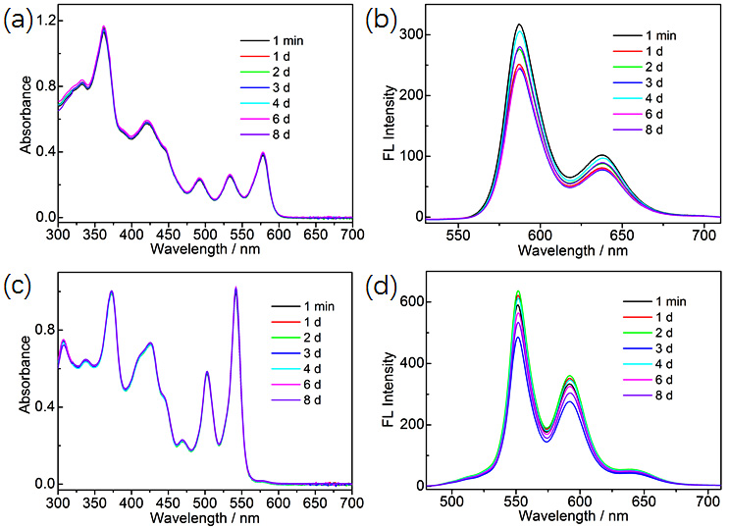
Figure S21 The changes of UV-vis absorption and emission spectra 5 (a)/(b) and 8 (c)/(d) in toluene under ambient light and air conditions.

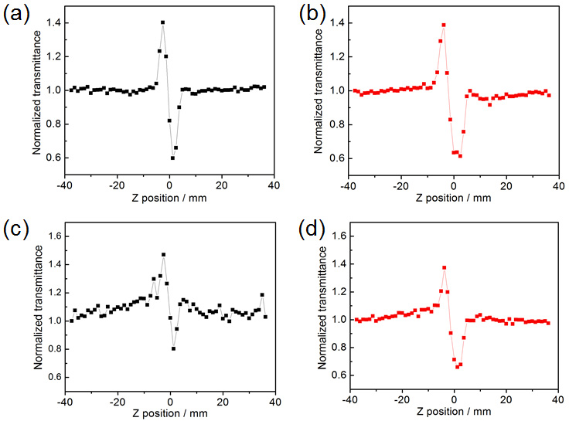
Figure S22 Normalized closed-aperture of 5 at 4.5 µJ (a), 20 µJ (b) and 8 at 4.5 µJ (c), 20 µJ (d).

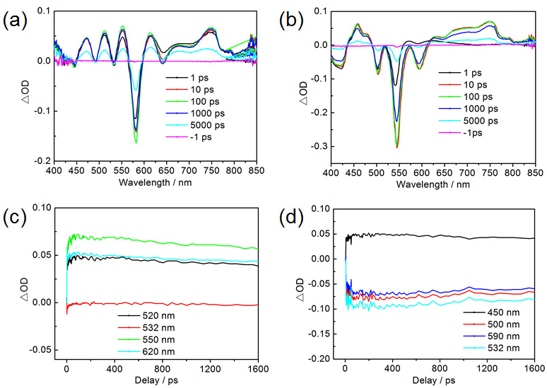
Figure S23 The transient absorption spectra of 5 (a) and 8 (b). Time profiles at different wavelengths of 5 (c) and 8 (d).

Table S2 Cartesition coordinates for the optimized species at B3LYP/6-311G* level

5
Energy (with Zero-point Energy correction) = -4009.551098(-4008.059161) Hartree
Free energy (298 K) = -4009.672677 Hartree
Zero number of imaginary frequency
Charge = 0 Multiplicity = 1
C 13.2793 1.5276 4.4484
C 9.3162 0.7584 3.1497
C 9.8324 6.222 10.9753
C 10.8743 2.1374 4.4285
C 7.153 8.9161 6.5953
H 7.8926 8.4139 6.2743
C 9.3613 6.4148 8.6296
C 11.6882 0.3166 3.0238
C 6.0965 12.6651 0.201
C 14.3362 0.8053 3.8697
C 8.0202 7.5475 11.872
C 7.9039 11.9231 2.1822
H 8.5261 11.6754 2.8571
C 6.0724 10.8063 3.5296
C 5.6626 11.9479 1.3473
C 10.2613 4.2457 5.7162
C 11.9451 1.3411 3.9846
C 13.5392 2.4451 5.502
C 6.4093 9.7396 5.703
C 6.6638 8.6788 10.2375
C 10.3724 0.0254 2.6174
C 8.7232 7.0922 10.7654
C 6.8 8.8444 7.9184
C 10.2672 5.8269 9.6169
C 9.1121 4.6118 4.8062
C 9.5847 1.7819 4.0398
H 8.8535 2.2681 4.4029
C 12.4008 3.1477 6.1359
C 8.3588 12.6549 1.1
C 7.4171 8.2074 9.0912
C 9.4505 5.9942 7.3441
H 8.8773 6.3815 6.6931
C 6.9051 8.398 11.576
C 9.4029 5.0514 3.5163
H 10.3059 5.1222 3.2328
C 6.5659 11.5291 2.328
C 8.4503 7.3192 9.3872
C 10.379 4.9891 6.9377
C 12.462 3.7621 7.3971
C 11.1541 3.215 5.4114
C 7.4553 12.9988 0.0994
C 8.3707 5.3878 2.6417
H 8.5711 5.6914 1.7643
C 9.8239 13.1031 0.9895
C 13.5917 3.5262 8.3601
C 7.8544 0.434 2.7896
C 15.6615 1.1001 4.2629
C 7.8021 4.5 5.2104
H 7.597 4.1965 6.0866
C 8.2521 9.5964 4.0155
C 14.073 -0.1629 2.8979
C 11.3855 4.593 7.8587
C 6.884 10.0784 4.3998
C 7.1547 1.6524 2.2176
H 7.1225 2.3596 2.8955
H 6.2435 1.4112 1.9521
H 7.6485 1.9742 1.4341
C 6.7617 4.839 4.3115
H 5.8574 4.7609 4.5917
C 7.4967 7.7137 14.2155
H 7.6854 7.4893 15.1194
C 7.0381 5.2751 3.0591
H 6.3312 5.5031 2.4669
C 7.1238 -0.0685 4.0486
H 6.2032 -0.3129 3.8154
H 7.1129 0.6388 4.7253
C 8.3494 7.2159 13.1818
C 15.9376 2.0673 5.2215
C 9.8597 14.661 0.9321
H 9.3118 14.9731 0.1816
H 9.507 15.0279 1.7691
C 10.2045 5.8961 12.2696
H 10.9547 5.3319 12.4117
C 13.825 2.2244 8.8416
H 13.295 1.4981 8.5325
C 8.4116 8.8903 2.8581
H 7.6536 8.7015 2.3149
C 10.6559 12.6657 2.2043
H 10.3072 13.0977 3.0119
H 10.5993 11.6917 2.3049
H 10.4771 11.542 -0.2144
C 14.8703 2.7581 5.8068
H 15.0524 3.455 6.4275
C 14.3939 4.5704 8.7886
H 14.234 5.4497 8.4697
C 11.2837 4.9906 9.2215
H 11.917 4.6778 9.8576
C 9.3713 9.8955 4.7819
H 9.2792 10.4192 5.5703
C 10.7587 8.7237 3.2778
H 11.6212 8.4045 3.0377
C 9.4982 6.3774 13.3541
H 9.7823 6.15 14.2322
C 10.6262 9.4349 4.402
C 14.8198 2.0104 9.7582
H 14.9496 1.1413 10.1209
C 9.6929 8.4341 2.4539
H 9.811 7.9484 1.647
C 15.4227 4.3433 9.6765
H 15.9763 5.0623 9.9524
C 15.6531 3.068 10.1691
H 16.3657 2.9096 10.7766
C 17.5694 3.9679 5.2944
H 17.5946 4.1044 4.3234
H 16.8194 4.4727 5.6745
C 17.583 2.2845 7.0702
H 16.935 2.835 7.5572
C 12.7892 -0.4412 2.487
H 12.6307 -1.1284 1.8502
H 14.7969 -0.6413 2.5115
C 5.1511 12.9838 -0.8239
C 3.8353 12.659 -0.7201
C 3.3437 12.0233 0.4771
C 4.2294 11.7191 1.5174
C 1.9639 11.7178 0.6383
C 3.7471 11.2769 2.7521
H 1.3577 11.9192 -0.0637
C 1.4923 11.1392 1.7891
C 2.397 10.9405 2.8449
C 4.6842 11.0078 3.8675
C 0.0662 10.5971 1.9349
H 2.0766 10.5609 3.6547
C 4.2935 10.9154 5.2016
C -0.8447 11.0568 0.7841
C -0.569 11.0423 3.2601
C 0.1454 9.0853 1.9039
C 5.1763 10.3396 6.1492
C 3.0352 11.5877 5.6699
H -0.8 12.0328 0.7028
H -0.5463 10.6453 -0.0532
H -0.0715 10.652 4.008
H -1.5006 10.7385 3.2928
H -0.5418 12.0194 3.3225
H 0.6341 8.8009 1.1033
H 0.6153 8.767 2.7032
C 4.8461 10.296 7.5385
C 2.0568 10.903 6.3789
C 2.8885 12.9583 5.4136
H 4.0738 10.7468 7.8607
C 5.641 9.6044 8.3954
H 2.1454 9.9719 6.5466
C 0.9287 11.6079 6.8449
H 3.5538 13.4283 4.9255
C 1.7662 13.6198 5.8819
C 5.591 9.4939 9.8621
C 0.8189 12.9604 6.5799
H 0.2517 11.1587 7.3387
H 1.6631 14.5489 5.7088
C 4.7456 9.9877 10.8538
H 0.0576 13.4349 6.8938
H 3.9924 10.5146 10.6113
C 4.9922 9.7144 12.1923
C 6.091 8.8894 12.5987
H 4.4185 10.083 12.8542
C 6.4139 8.5065 13.9394
H 5.8662 8.8096 14.6541
H 10.2067 -0.6644 1.9849
C 10.4334 12.5175 -0.2893
H 11.3371 12.8761 -0.4152
C 7.7626 -0.6798 1.7184
H 8.162 -0.3623 0.882
H 6.8226 -0.9094 1.566
H 8.2463 -1.4737 2.0304
H 16.3802 0.6242 3.8642
H 7.5889 -0.8547 4.4044
C 17.3824 2.4632 5.597
C 18.4007 1.7529 4.7974
H 18.2987 0.7857 4.9242
H 19.2955 2.0269 5.0884
H 18.2838 1.9715 3.8496
H 18.4917 2.5571 7.3128
H 17.451 1.3414 7.305
H 7.7639 13.4688 -0.666
H 5.4517 13.4363 -1.6022
H 3.2409 12.8499 -1.4356
H 11.3877 9.6265 4.9376
H -0.7592 8.7112 1.8854
H -1.7681 10.7869 0.9707
H 11.5908 12.9267 2.072
H 10.7844 14.9626 0.8073
H 9.8762 12.7617 -1.0585
H 18.4085 4.2803 5.6902

NICS(0)
Charge = 0 Multiplicity = 1
C 6.65033 -2.62804 0.64087
C 4.43348 -3.32099 4.20892
C 2.74464 5.19189 -0.19067
C 4.74538 -2.05018 2.11582
C -1.82897 1.71159 -0.43221
H -0.9129 1.17782 -0.64456
C 1.80344 3.0391 0.07129
C 6.14455 -4.00717 2.61739
C -6.09849 -4.05479 -2.54797
C 7.63697 -3.56727 0.2401
C 0.7092 6.53637 -0.09147
C -4.08753 -2.2874 -3.30787
H -3.32554 -1.59253 -3.61828
C -4.42252 -0.91644 -1.20708
C -5.82259 -2.911 -1.74826
C 3.1872 -0.24474 1.20911
C 5.84536 -2.89088 1.79235
C 6.4887 -1.42218 -0.09265
C -3.07613 1.02571 -0.57539
C -1.33955 5.30157 0.05103
C 5.4311 -4.19909 3.81317
C 1.35208 5.29815 -0.1048
C -1.79487 3.04083 -0.0943
C 3.05126 3.75925 -0.09896
C 1.95308 -0.82231 1.82497
C 4.09528 -2.27196 3.33177
H 3.30924 -1.596 3.62884
C 5.47671 -0.44043 0.35388
C -4.39806 -3.36337 -4.15315
C -0.68721 4.01165 -0.01576
C 1.83571 1.71495 0.42863
H 0.91931 1.18762 0.65505
C -0.69445 6.53839 0.01988
C 1.44215 -2.04519 1.37447
H 1.96368 -2.57867 0.58771
C -4.7398 -2.06179 -2.08858
C 0.69748 4.01059 -0.01825
C 3.08167 1.02734 0.57269
C 5.46259 0.90421 -0.04966
C 4.42149 -0.91547 1.21943
C -5.37435 -4.26005 -3.72953
C 0.27445 -2.5738 1.91795
H -0.10585 -3.52263 1.55359
C -3.69031 -3.58646 -5.50361
C 6.67311 1.5962 -0.59104
C 3.69197 -3.45977 5.55138
C 8.36628 -3.34824 -0.94185
C 1.25694 -0.14276 2.83629
H 1.63929 0.80528 3.20017
C -1.95384 -0.85838 -1.79404
C 7.87162 -4.71967 1.06013
C 4.28162 1.67844 0.12968
C -3.18309 -0.25365 -1.19565
C 2.19931 -3.75815 5.2902
H 1.71878 -2.96968 4.70937
H 1.6573 -3.85293 6.23688
H 2.07877 -4.69488 4.73866
C 0.08957 -0.67123 3.38118
H -0.4328 -0.12862 4.16264
C 0.69264 8.95965 -0.11331
H 1.22283 9.90641 -0.16565
C -0.40745 -1.88973 2.92207
H -1.31915 -2.30155 3.34243
C 3.8189 -2.14378 6.352
H 3.30809 -2.23447 7.31568
H 3.37481 -1.29664 5.82531
C 1.45411 7.73694 -0.16499
C 8.15049 -2.2269 -1.72901
C -4.74265 -3.68161 -6.63158
H -5.43604 -4.51207 -6.4814
H -5.33397 -2.76402 -6.69519
C 3.49638 6.37198 -0.28489
H 4.57906 6.33577 -0.3579
C 7.82667 1.70141 0.19692
H 7.84167 1.23661 1.17693
C -1.49477 -2.10666 -1.35549
H -2.04569 -2.63018 -0.58222
C -2.72064 -2.44612 -5.85871
H -3.23271 -1.48208 -5.92673
H -1.91051 -2.3494 -5.13307
H -2.12431 -4.86228 -4.65972
C 7.22131 -1.27286 -1.27169
H 7.05598 -0.39402 -1.87481
C 6.67126 2.21166 -1.85143
H 5.78608 2.14231 -2.47544
C 4.24067 3.08472 -0.11641
H 5.16664 3.61637 -0.29361
C -1.22059 -0.19382 -2.78862
H -1.56333 0.771 -3.14739
C 0.3695 -2.00823 -2.88973
H 1.26605 -2.45196 -3.31038
C 2.85788 7.61812 -0.27048
H 3.46257 8.51828 -0.3336
C -0.07086 -0.76196 -3.33116
C 8.94215 2.39946 -0.2584
H 9.82311 2.47357 0.37132
C -0.34782 -2.6773 -1.89951
H -0.01022 -3.6464 -1.54593
C 7.78883 2.90453 -2.31098
H 7.76775 3.36898 -3.29192
C 8.92821 3.00373 -1.51409
H 9.79793 3.54703 -1.86927
C 7.86277 -1.79542 -4.19661
H 7.22111 -2.6747 -4.30178
H 7.21722 -0.93146 -4.02545
C 9.76916 -0.72468 -2.94072
H 9.18075 0.16391 -2.7064
C 7.17785 -4.91441 2.211
H 7.38552 -5.77559 2.83963
H 8.63602 -5.42708 0.75162
C -7.1186 -4.96976 -2.12132
C -7.82349 -4.75352 -0.98217
C -7.61391 -3.57468 -0.19085
C -6.63683 -2.63219 -0.60612
C -8.35958 -3.33539 0.97588
C -6.49492 -1.40738 0.10014
H -9.08412 -4.08421 1.27301
C -8.16861 -2.19012 1.73566
C -7.24515 -1.23757 1.2663
C -5.48101 -0.43025 -0.35279
C -8.92915 -1.92755 3.0485
H -7.09687 -0.34317 1.85038
C -5.4626 0.91936 0.0352
C -9.82988 -3.10986 3.44765
C -9.82101 -0.67658 2.88608
C -7.92004 -1.6918 4.19522
C -4.2773 1.68613 -0.14769
C -6.672 1.62335 0.56307
H -10.60876 -3.30272 2.70491
H -9.25848 -4.03146 3.58939
H -9.2396 0.2126 2.63691
H -10.36381 -0.471 3.81453
H -10.55773 -0.82273 2.09116
H -7.26916 -2.55998 4.33131
H -7.28294 -0.82427 4.01102
C -4.23303 3.09525 0.0813
C -6.67377 2.24994 1.81798
C -7.82061 1.72738 -0.23223
H -5.15822 3.63191 0.24714
C -3.04181 3.76622 0.06082
H -5.7923 2.18159 2.4473
C -7.79043 2.95219 2.26535
H -7.83254 1.25397 -1.20817
C -8.93504 2.43501 0.21078
C -2.73253 5.19925 0.13429
C -8.92493 3.05 1.46132
H -7.77241 3.42517 3.24225
H -9.81216 2.50806 -0.42438
C -3.48236 6.38195 0.20924
H -9.79389 3.60062 1.80698
H -4.5653 6.34877 0.27971
C -2.84156 7.62655 0.17802
C -1.43735 7.74124 0.07348
H -3.44473 8.52865 0.22616
C -0.67377 8.9617 0.00319
H -1.20238 9.91005 0.04051
H 5.70141 -5.04777 4.43007
C -2.88481 -4.90426 -5.44388
H -2.37797 -5.08773 -6.39668
C 4.26303 -4.59614 6.41822
H 4.15387 -5.57345 5.94017
H 3.72474 -4.64036 7.36884
H 5.32158 -4.44517 6.64759
H 9.09761 -4.09489 -1.22764
H 4.86715 -1.90165 6.5479
C 8.89015 -1.98966 -3.05838
C 9.79935 -3.17149 -3.43931
H 10.59075 -3.33568 -2.70295
H 10.28641 -2.96851 -4.39691
H 9.23707 -4.10305 -3.54869
H 10.29682 -0.53702 -3.88163
H 10.51827 -0.84158 -2.1526
H -5.6131 -5.13493 -4.32615
H -7.30784 -5.85147 -2.72688
H -8.57963 -5.46369 -0.65992
H 0.47933 -0.23037 -4.10097
H -8.44884 -1.51609 5.13723
H -10.33281 -2.88779 4.39271
H -2.26446 -2.64226 -6.83315
H -4.25228 -3.8338 -7.59812
H -3.52616 -5.76502 -5.23915
H 8.37654 -1.63708 -5.14994
Bq -2.08797 6.46482 0.11099
Bq 0.00626 5.28279 -0.02656
Bq 2.10238 6.45891 -0.18455
Bq 0.0084 7.74571 -0.04554
Bq 1.92978 4.2598 -0.06828
Bq 3.04906 2.38397 0.16449
Bq 4.31855 0.33489 0.57252
Bq 7.80504 2.30283 -1.05484
Bq 0.76812 -1.3575 2.37615
Bq 5.11586 -3.12338 2.9799
Bq 5.60466 -1.72453 1.00495
Bq -4.31711 0.33848 -0.5739
Bq -7.8028 2.33965 1.01438
Bq -5.59961 -1.72651 -0.98378
Bq 7.41901 -2.41091 -0.5257
Bq 6.88778 -3.78791 1.42697
Bq -1.91919 4.2639 0.02722
Bq -3.04202 2.38762 -0.18458
Bq -0.7864 -1.43439 -2.34309
Bq -7.41983 -2.39622 0.54684
Bq -5.0868 -3.1564 -2.92923
Bq -6.85232 -3.81599 -1.36611

8
Energy (with Zero-point Energy correction) = -4009.555290(-4008.063254) Hartree
Free energy (298 K) = -4009.677876 Hartree
Zero number of imaginary frequency

Charge = 0 Multiplicity = 1
C 0 0.0755 1.3009 -1.8693
C 0 0.2118 0.0168 -2.2285
C 0 7.1096 -1.0195 -0.061
C 0 7.0201 0.3044 0.1455
C 0 -1.1246 1.8774 -1.9502
C 0 -2.2178 1.2059 -2.3876
C 0 -2.099 -0.1161 -2.6535
C 0 -0.8563 -0.657 -2.6637
C 0 -3.4233 1.8133 -2.5244
C 0 -4.5469 1.1063 -2.8259
C 0 -4.4534 -0.2489 -2.8527
C 0 -3.222 -0.8316 -2.9119
C 0 -5.7477 1.6783 -3.1324
C 0 -6.8705 0.9318 -3.1804
C 0 -6.8049 -0.3912 -2.9509
C 0 -5.6047 -0.9756 -2.7691
C 0 -5.9199 2.9743 -3.483
C 0 -7.0899 3.5867 -3.7447
C 0 -8.1786 2.81 -3.6685
C 0 -8.072 1.4971 -3.4188
C 0 -7.9386 -1.1221 -2.9298
C 0 -7.9087 -2.4372 -2.6677
C 0 -6.7601 -3.0498 -2.3509
C 0 -5.6592 -2.2782 -2.4055
C 0 -9.1957 0.7619 -3.4113
C 0 -9.1298 -0.5492 -3.1648
C 0 8.1698 -1.6954 0.3913
C 0 9.189 -1.07 1.028
C 0 9.1461 0.2792 1.1152
C 0 8.0362 0.9452 0.7278
C 0 10.1868 -1.7495 1.6515
C 0 10.9531 -1.0945 2.5652
C 0 10.7568 0.2373 2.7098
C 0 10.1666 0.9343 1.7068
C 0 11.9264 -1.6582 3.3324
C 0 12.4018 -1.012 4.4176
C 0 11.9616 0.2228 4.7148
C 0 11.1361 0.8459 3.8585
C 0 12.3787 0.8588 5.8261
C 0 11.9335 2.0938 6.1102
C 0 11.036 2.7176 5.3292
C 0 10.6548 2.0542 4.2237
C 0 12.5212 -2.8388 3.0543
C 0 13.4301 -3.4596 3.8283
C 0 13.7748 -2.8195 4.9561
C 0 13.2951 -1.5985 5.2387
C 0 13.7129 -0.9669 6.3492
C 0 13.2555 0.2557 6.6452
C 0 3.0464 2.9966 -0.6167
C 0 1.7503 2.9362 -0.9968
C 0 1.2595 1.7747 -1.453
C 0 2.076 0.7273 -1.5357
C 0 3.3411 0.7774 -1.1385
C 0 3.8646 1.9215 -0.6589
C 0 1.4785 -0.3711 -2.0046
C 0 2.1668 -1.5232 -2.0893
C 0 3.4486 -1.5427 -1.6568
C 0 3.9835 -0.391 -1.2098
C 0 4.2333 -2.6419 -1.5997
C 0 5.4863 -2.6134 -1.0923
C 0 5.9834 -1.449 -0.6507
C 0 5.2229 -0.3603 -0.737
C 0 5.8128 0.7356 -0.2533
C 0 5.1463 1.9027 -0.2274
C 0 -3.4621 3.1265 -2.1955
C 0 -4.2738 3.5633 -1.2112
C 0 -4.279 4.854 -0.8418
C 0 -3.5008 5.7436 -1.4756
C 0 -2.7119 5.3336 -2.4788
C 0 -2.6929 4.0382 -2.8277
C 0 -7.1961 5.0856 -4.0758
C 0 -8.4666 5.4431 -4.8847
C 0 -7.2602 5.8576 -2.7421
C 0 -5.9944 5.6046 -4.8993
C 0 10.639 2.1452 1.2732
C 0 11.7813 2.6959 1.7531
C 0 12.2885 3.8727 1.3524
C 0 11.6978 4.5598 0.3693
C 0 10.635 4.0046 -0.223
C 0 10.1551 2.8255 0.2064
C 0 -3.0904 -2.1105 -3.3479
C 0 -2.3893 -3.0627 -2.6965
C 0 -2.2706 -4.3102 -3.1774
C 0 -2.8625 -4.644 -4.3324
C 0 -3.5868 -3.7245 -4.9857
C 0 -3.7074 -2.4829 -4.4901
C 0 10.1189 -3.0996 1.5766
C 0 9.9333 -3.8522 2.6809
C 0 9.828 -5.188 2.6028
C 0 9.9225 -5.8034 1.4154
C 0 10.1142 -5.0731 0.3074
C 0 10.2043 -3.7365 0.3906
C 0 -6.7245 -4.5436 -1.9843
C 0 -6.5674 -5.3407 -3.2957
C 0 -5.5591 -4.917 -1.0381
C 0 -8.0202 -5.0166 -1.2817
C 0 10.5284 4.1244 5.6723
C 0 9.2753 4.5545 4.874
C 0 11.6599 5.1229 5.3473
C 0 10.1577 4.2361 7.1688
C 0 14.0206 -4.8379 3.4859
C 0 15.5149 -4.9412 3.8735
C 0 13.9383 -5.1962 1.9833
C 0 13.2243 -5.8933 4.282
H 0 -1.1299 2.9167 -1.5947
H 0 -0.6222 -1.6834 -2.968
H 0 -5.0566 3.6259 -3.621
H 0 -9.1749 3.2419 -3.8387
H 0 -8.8481 -3.0083 -2.6778
H 0 -4.7557 -2.7892 -2.0709
H 0 -10.1869 1.2091 -3.6
H 0 -10.0684 -1.1294 -3.1556
H 0 8.0782 -2.7854 0.289
H 0 7.8789 2.0107 0.9618
H 0 12.3107 2.6023 7.0103
H 0 9.8988 2.5368 3.5906
H 0 12.2951 -3.3438 2.112
H 0 14.4849 -3.2884 5.6528
H 0 14.441 -1.4325 7.0355
H 0 13.6212 0.751 7.5611
H 0 3.431 3.9545 -0.2259
H 0 1.1009 3.8224 -0.9169
H 0 1.6714 -2.441 -2.443
H 0 3.8331 -3.6107 -1.945
H 0 6.0859 -3.5354 -1.0282
H 0 5.6225 2.8036 0.1906
H 0 -4.9169 2.8581 -0.6569
H 0 -4.9276 5.1876 -0.0145
H 0 -3.5148 6.8059 -1.1808
H 0 -2.0809 6.0596 -3.0182
H 0 -2.0471 3.7388 -3.6725
H 0 -8.5364 4.8384 -5.8172
H 0 -9.405 5.3112 -4.3018
H 0 -8.4707 6.5152 -5.1853
H 0 -6.3429 5.6965 -2.1373
H 0 -8.1264 5.5325 -2.1223
H 0 -7.355 6.9543 -2.9083
H 0 -5.039 5.607 -4.3311
H 0 -5.8551 5.0008 -5.8247
H 0 -6.1407 6.6635 -5.2103
H 0 12.4156 2.1961 2.5001
H 0 13.215 4.265 1.8061
H 0 12.1146 5.516 0.0133
H 0 10.1799 4.5099 -1.0927
H 0 9.3464 2.4478 -0.4343
H 0 -1.9361 -2.8566 -1.7106
H 0 -1.7033 -5.0688 -2.6121
H 0 -2.7719 -5.6684 -4.7297
H 0 -4.0847 -3.9923 -5.9328
H 0 -4.2988 -1.7574 -5.076
H 0 9.8228 -3.3822 3.6737
H 0 9.6558 -5.7818 3.5163
H 0 9.8403 -6.9007 1.3506
H 0 10.1972 -5.5719 -0.6726
H 0 10.3758 -3.1659 -0.5394
H 0 -7.4056 -5.1395 -4.0005
H 0 -5.6236 -5.074 -3.8192
H 0 -6.5426 -6.4374 -3.1058
H 0 -5.5738 -4.2913 -0.1168
H 0 -4.5605 -4.8236 -1.5169
H 0 -5.6186 -5.9811 -0.7165
H 0 -8.2415 -4.394 -0.3853
H 0 -8.9099 -5.0056 -1.9486
H 0 -7.9375 -6.0731 -0.9402
H 0 8.4334 3.8405 5.0238
H 0 9.474 4.6552 3.7833
H 0 8.9111 5.5552 5.1993
H 0 12.5803 4.9169 5.9386
H 0 11.9383 5.0767 4.2695
H 0 11.3524 6.1695 5.5709
H 0 11.0306 4.1281 7.8484
H 0 9.4048 3.4648 7.4496
H 0 9.7225 5.2333 7.4057
H 0 15.689 -4.9145 4.9709
H 0 16.106 -4.1217 3.4053
H 0 15.9575 -5.906 3.5377
H 0 12.8946 -5.3391 1.627
H 0 14.4292 -4.4173 1.3565
H 0 14.4494 -6.1609 1.7653
H 0 12.1458 -5.8732 4.0093
H 0 13.2911 -5.719 5.3796
H 0 13.5991 -6.9227 4.0838

NICS (0)
Charge = 0 Multiplicity = 1
C 3.97578 -1.05238 -0.00989
C 3.87699 0.39363 0.01265
C -3.94577 1.05507 -0.00384
C -3.84697 -0.39148 0.00806
C 5.20306 -1.65485 -0.06601
C 6.40095 -0.87495 -0.08953
C 6.3039 0.54693 0.0913
C 5.01051 1.15627 0.0683
C 7.67829 -1.45622 -0.33883
C 8.83232 -0.65692 -0.29093
C 8.74204 0.66387 0.2894
C 7.48949 1.29746 0.33979
C 10.13796 -1.06449 -0.86056
C 11.31264 -0.36793 -0.46634
C 11.2386 0.72243 0.45465
C 9.9802 1.24709 0.85616
C 10.26287 -2.03205 -1.85971
C 11.4945 -2.39247 -2.43958
C 12.63935 -1.77425 -1.96116
C 12.57424 -0.76819 -0.98173
C 12.43439 1.29487 0.96438
C 12.36301 2.29744 1.94697
C 11.14533 2.74625 2.43454
C 9.97327 2.21884 1.85903
C 13.7609 -0.13368 -0.4876
C 13.69547 0.83363 0.46259
C -5.17286 1.65788 -0.05726
C -6.3708 0.87813 -0.08777
C -6.27382 -0.5454 0.08814
C -4.98029 -1.15449 0.05931
C -7.64703 1.45948 -0.33859
C -8.80059 0.65777 -0.29322
C -8.7109 -0.65974 0.29215
C -7.45838 -1.29607 0.33768
C -10.10408 1.06305 -0.8635
C -11.27659 0.37591 -0.46085
C -11.20222 -0.71436 0.46272
C -9.94722 -1.23849 0.86239
C -12.4001 -1.28783 0.9729
C -12.32459 -2.2929 1.94443
C -11.10315 -2.74008 2.43999
C -9.93517 -2.21007 1.87342
C -10.22349 2.02474 -1.87684
C -11.45273 2.39212 -2.4426
C -12.60259 1.7878 -1.94249
C -12.54135 0.78358 -0.969
C -13.72985 0.15182 -0.46784
C -13.66351 -0.81997 0.47511
C 0.61681 -2.99849 -0.01071
C 2.01467 -2.87297 -0.01201
C 2.61036 -1.60322 -0.00493
C 1.7563 -0.49705 0.0024
C 0.3772 -0.60214 0.00219
C -0.25189 -1.88124 -0.00391
C 2.44743 0.76065 0.0085
C 1.72775 1.93231 0.01301
C 0.28193 1.88355 0.01106
C -0.34719 0.60447 0.00673
C -0.58673 3.00086 0.01262
C -1.98458 2.8754 0.00955
C -2.58034 1.60564 0.00627
C -1.72631 0.4994 0.00537
C -2.41743 -0.75834 0.0013
C -1.69771 -1.93001 -0.00307
C 7.73299 -2.93619 -0.56049
C 8.38167 -3.75197 0.3748
C 8.38541 -5.13771 0.23437
C 7.7425 -5.73557 -0.84747
C 7.09697 -4.93598 -1.78961
C 7.08923 -3.55075 -1.64462
C 11.5278 -3.45075 -3.55738
C 12.94132 -3.64552 -4.1343
C 11.04593 -4.80734 -2.99722
C 10.59996 -3.01486 -4.71401
C -7.32174 -2.7705 0.55591
C -6.58088 -3.30131 1.62186
C -6.4276 -4.67755 1.77154
C -7.00809 -5.55148 0.85381
C -7.74408 -5.03716 -0.21218
C -7.89872 -3.66114 -0.35867
C 7.34157 2.77062 0.56399
C 6.6194 3.28897 1.64903
C 6.43758 4.66193 1.79707
C 6.96809 5.54436 0.85714
C 7.6872 5.04244 -0.22554
C 7.87317 3.66955 -0.36896
C -7.71379 2.9386 -0.55792
C -8.40983 3.74211 0.35452
C -8.44671 5.1261 0.20629
C -7.78702 5.73597 -0.85922
C -7.08938 4.94957 -1.77457
C -7.05124 3.56552 -1.6232
C 11.03607 3.79125 3.56
C 10.35772 5.06769 3.01534
C 10.19219 3.21748 4.72081
C 12.41203 4.18441 4.12644
C -11.0759 -3.79434 3.56323
C -9.65111 -4.09298 4.06013
C -11.68918 -5.11204 3.03715
C -11.90213 -3.29153 4.76877
C -11.56805 3.43784 -3.56825
C -12.33639 2.83318 -4.76514
C -10.19619 3.90994 -4.07971
C -12.3359 4.67013 -3.03789
H 5.2744 -2.73333 -0.10671
H 4.93504 2.2346 0.10873
H 9.37197 -2.51673 -2.2246
H 13.61688 -2.04059 -2.34515
H 13.29553 2.69746 2.32684
H 9.02501 2.57186 2.23072
H 14.72113 -0.45765 -0.87861
H 14.60299 1.28915 0.84833
H -5.24475 2.73666 -0.09051
H -4.90514 -2.23316 0.09231
H -13.25494 -2.70617 2.3212
H -8.98452 -2.54968 2.24721
H -9.32729 2.48756 -2.25291
H -13.58057 2.07262 -2.3176
H -14.69071 0.48166 -0.85234
H -14.57078 -1.27523 0.86174
H 0.1868 -3.99609 -0.01559
H 2.62018 -3.77416 -0.01766
H 2.22063 2.90067 0.01678
H -0.15668 3.99845 0.01589
H -2.59003 3.77665 0.01077
H -2.19057 -2.89837 -0.00724
H 8.87966 -3.29228 1.22185
H 8.88942 -5.75101 0.97461
H 7.74551 -6.81523 -0.95718
H 6.59651 -5.39047 -2.63894
H 6.58125 -2.93505 -2.38005
H 13.34349 -2.72023 -4.55627
H 13.64586 -4.01168 -3.3826
H 12.9127 -4.38663 -4.93763
H 10.03074 -4.75032 -2.60159
H 11.69719 -5.14922 -2.18787
H 11.05592 -5.57042 -3.78247
H 9.56055 -2.91688 -4.39403
H 10.91268 -2.05233 -5.12817
H 10.62593 -3.75355 -5.52116
H -6.13019 -2.62814 2.34393
H -5.8554 -5.06658 2.60797
H -6.88656 -6.6239 0.96786
H -8.19602 -5.70835 -0.93567
H -8.46979 -3.26645 -1.1922
H 6.20037 2.60801 2.383
H 5.87954 5.0418 2.64718
H 6.82351 6.61405 0.96924
H 8.10295 5.72054 -0.96408
H 8.42983 3.28418 -1.21654
H -8.92231 3.27337 1.18778
H -8.98835 5.72923 0.92813
H -7.81465 6.81475 -0.97458
H -6.57459 5.413 -2.61038
H -6.5102 2.9603 -2.34336
H 10.94381 5.50484 2.20206
H 9.35691 4.86778 2.62961
H 10.26655 5.81931 3.80637
H 10.64553 2.30817 5.12506
H 9.17539 2.97094 4.40822
H 10.11745 3.94688 5.53336
H 12.947 3.32433 4.53869
H 13.04962 4.65237 3.37142
H 12.28435 4.90908 4.93512
H -9.16193 -3.19885 4.45702
H -9.01622 -4.50617 3.27369
H -9.69069 -4.82868 4.86838
H -12.72264 -4.97784 2.70845
H -11.11806 -5.49745 2.18837
H -11.68715 -5.87619 3.82104
H -12.9481 -3.11465 4.50874
H -11.49546 -2.35502 5.16022
H -11.8851 -4.02969 5.57664
H -13.35007 2.52876 -4.49561
H -11.82022 1.95338 -5.15905
H -12.41825 3.56578 -5.57406
H -9.61095 4.4037 -3.30129
H -9.6027 3.08164 -4.47721
H -10.33467 4.63051 -4.89069
H -11.80913 5.12612 -2.19547
H -13.34113 4.40831 -2.69851
H -12.43721 5.42651 -3.82279
Bq -11.36681 1.40453 -1.42588
Bq -12.46894 -0.25181 0.00217
Bq -11.15208 -1.74729 1.42597
Bq -10.00693 -0.08598 -0.00005
Bq -7.74966 4.34298 -0.70902
Bq -7.54359 0.08236 -0.00027
Bq -7.16352 -4.16652 0.70538
Bq -5.09842 0.24995 0.00111
Bq -2.90336 0.40206 0.00343
Bq -1.1572 1.74489 0.0086
Bq -1.01056 -0.67798 0.00143
Bq 1.04057 0.6803 0.00732
Bq 1.18724 -1.74252 -0.00449
Bq 2.93337 -0.39967 0.00175
Bq 5.12853 -0.24756 0.00114
Bq 7.5745 -0.07997 0.0002
Bq 7.1545 4.16298 0.71212
Bq 7.73813 -4.34136 -0.7055
Bq 10.04063 0.09067 -0.00294
Bq 11.18913 1.75449 1.41929
Bq 12.50271 0.26352 -0.00901
Bq 11.40359 -1.3999 -1.42818

