Table 1 Optimization of reaction conditions ª

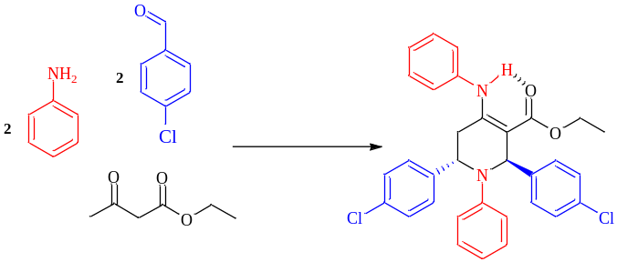
Yield (%)^{b} | Time (h) | Solvent(10ml) | Catalyst (g) | Entry
68 | 9 | AcOH | Nano-γ-Al₂O₃/Sb(V) (0.01) | 1
60 | 10 | MeCN | Nano-γ-Al₂O₃/Sb(V) (0.01) | 2
75 | 7 | H₂O | Nano-γ-Al₂O₃/Sb(V) (0.01) | 3
83 | 6 | EtOH | Nano-γ-Al₂O₃/Sb(V) (0.01) | 4
70 | 9 | EtOH | Nano-γ-Al₂O₃/Sb(V) (0.02) | 5
67 | 9 | EtOH | Nano-γ-Al₂O₃/Sb(V) (0.03) | 6
Trace | 24 | EtOH | - | 7
70 | 9 | EtOH | SbCl₅ (0.01) | 8
40 | 12 | EtOH | Nano-γ-Al₂O₃ (0.01) | 9
ªAniline (4 mmol), ethylacetoacetate (2 mmol), 4-chlorobenzaldehyde (4 mmol). ^{b}Isolated yield

Table 2 Synthesis of tetrahydropyridine derivatives under ultrasonic irradiation and thermal method ª
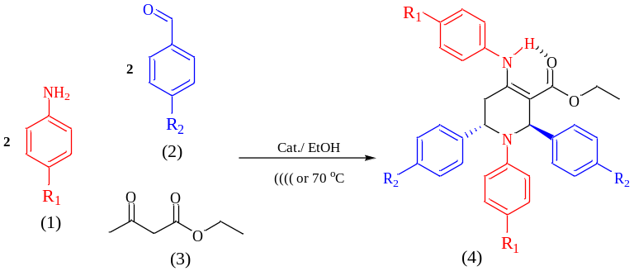

Ref. | Ultrasonic Irradiation  Time(min) Yield^{b} |  | Termal condition  Time(h) Yield^{b} |  | Product | Entry
44 | 86% | 2.5 | 85% | 6 | 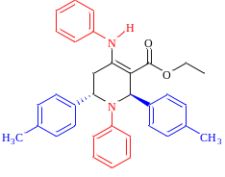4a | 1
45 | 85% | 2.5 | 83% | 6 | 4b 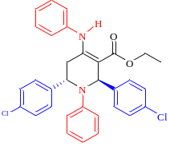 | 2
44 | 76% | 2 | 75% | 5 | 4c 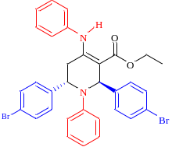 | 3
45 | 86% | 2 | 84% | 5 | 4d 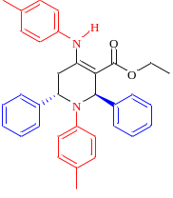 | 4
46 | 85% | 2.3 | 81% | 6 | 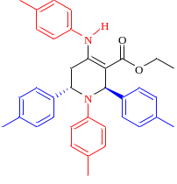  4e | 5
- | 86% | 2.5 | 85% | 6 | 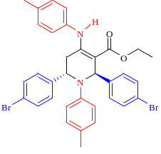4f | 6
- | 82% | 2.5 | 80% | 5 | 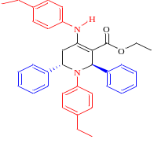4g | 7
- | 82% | 2.5 | 79% | 6 | 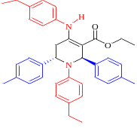4h | 8
- | 78% | 2.5 | 75% | 6 | 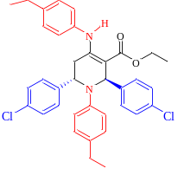4i | 9
47 | 90% | 1.9 | 86% | 6.5 | 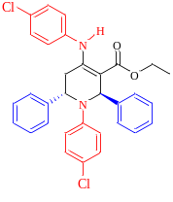4j | 10
48 | 84% | 2.6 | 82% | 7 | 4k 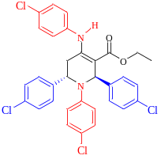 | 11
48 | 88% | 2.1 | 85% | 5 | 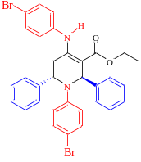4l | 12
ªAmine (2 mmol), Ethylacetoacetate (1 mmol), Aldehyde (2 mmol)

