Introduction of Sb (V)-metalloid ion supported on mesoporous Nano-γ-alumina as an effective catalytic system for the synthesis of highly substituted tetraydropyridines under ultrasonic and thermal conditions
Maryam Aghamohammadsadegh,ª Abdolhamid Bamoniri,^{*a} and Bi Bi Fatemeh Mirjalili^{b}

ª Department of Organic Chemistry, Faculty of Chemistry, University of Kashan, Kashan, I.R.Iran. E-mail:
bamoniri@kashanu.ac.ir
^{b} Department of Chemistry, College of Science, Yazd University, Yazd, I.R.Iran.

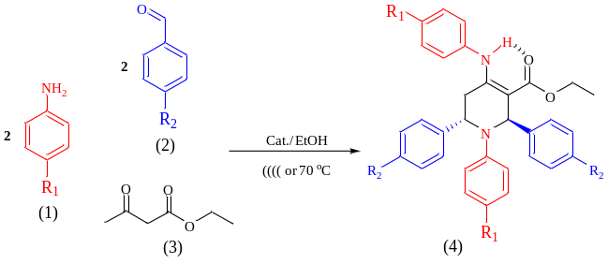

Ethyl-1-phenyl-4-(phenylamino)-2,6-di-p-tolyl-1,2,5,6-tetrahydropyridine-3-carboxylate (4a)
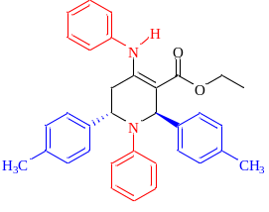
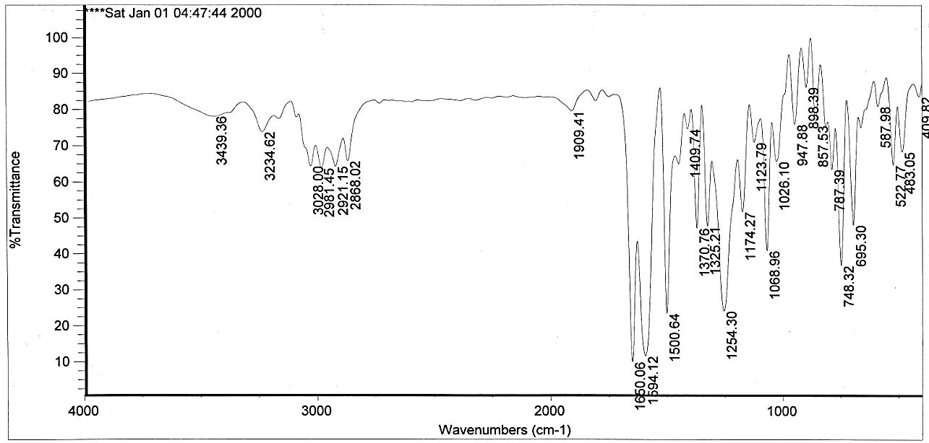
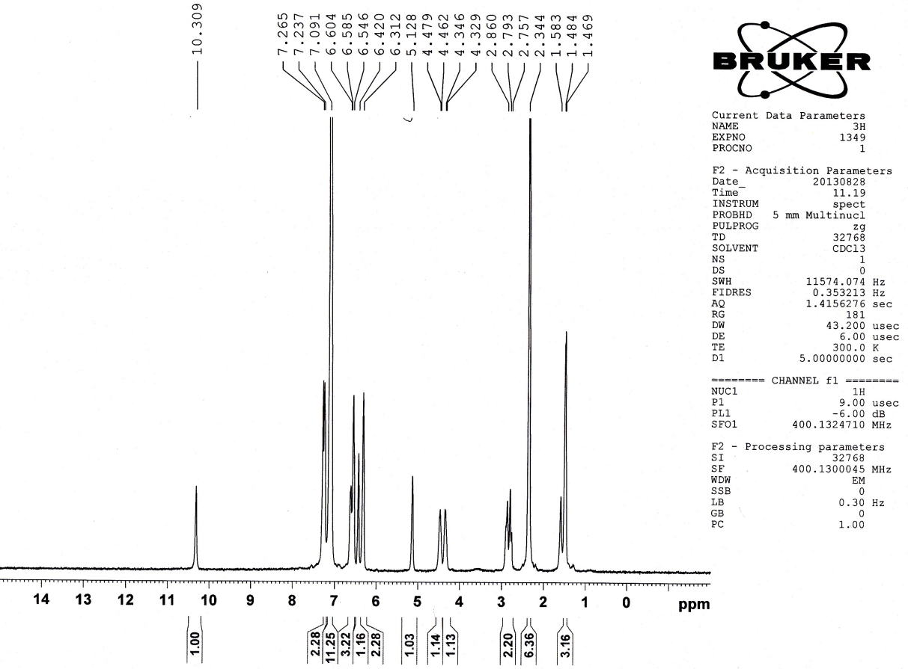

Ethyl-2,6-bis(4-chlorophenyl)-1-phenyl-4-(phenylamino)-1,2,5,6-tetrahydropyridine-3-carboxylate (4b)
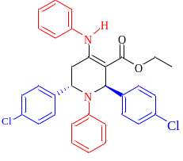
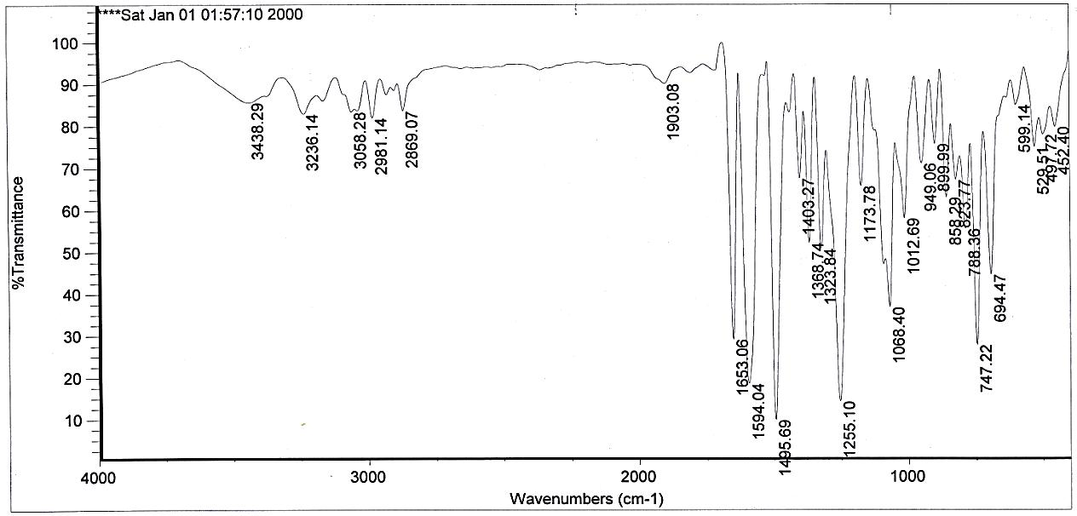
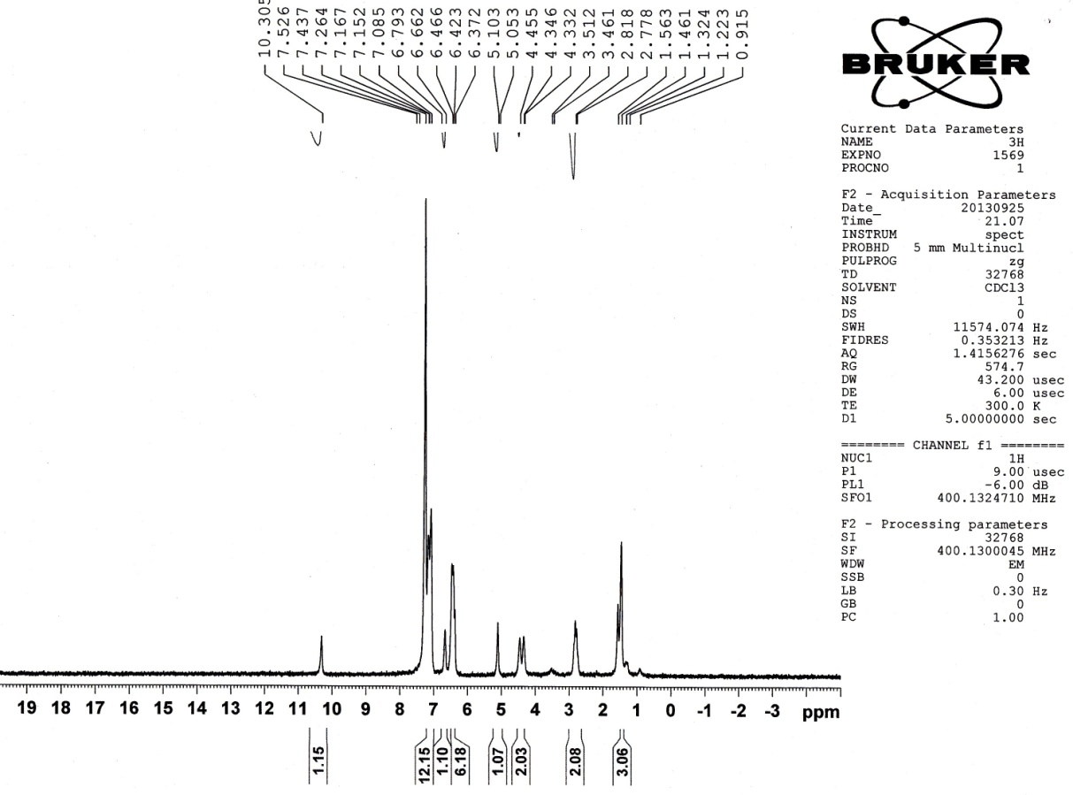

Ethyl-2,6-bis(4-bromophenyl)-1-phenyl-4-(phenylamino)-1,2,5,6-tetrahydropyridine-3-carboxylate (4c)
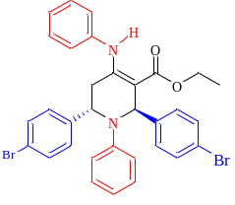
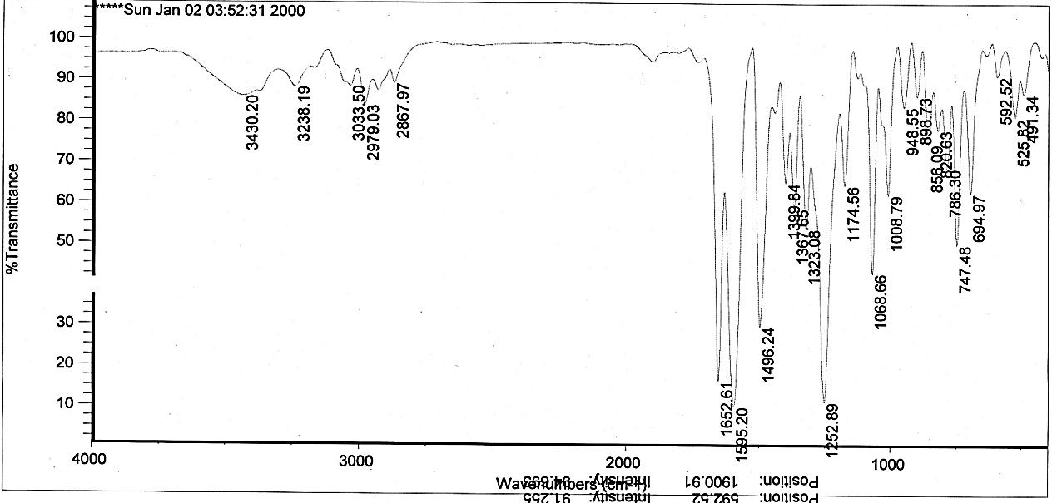
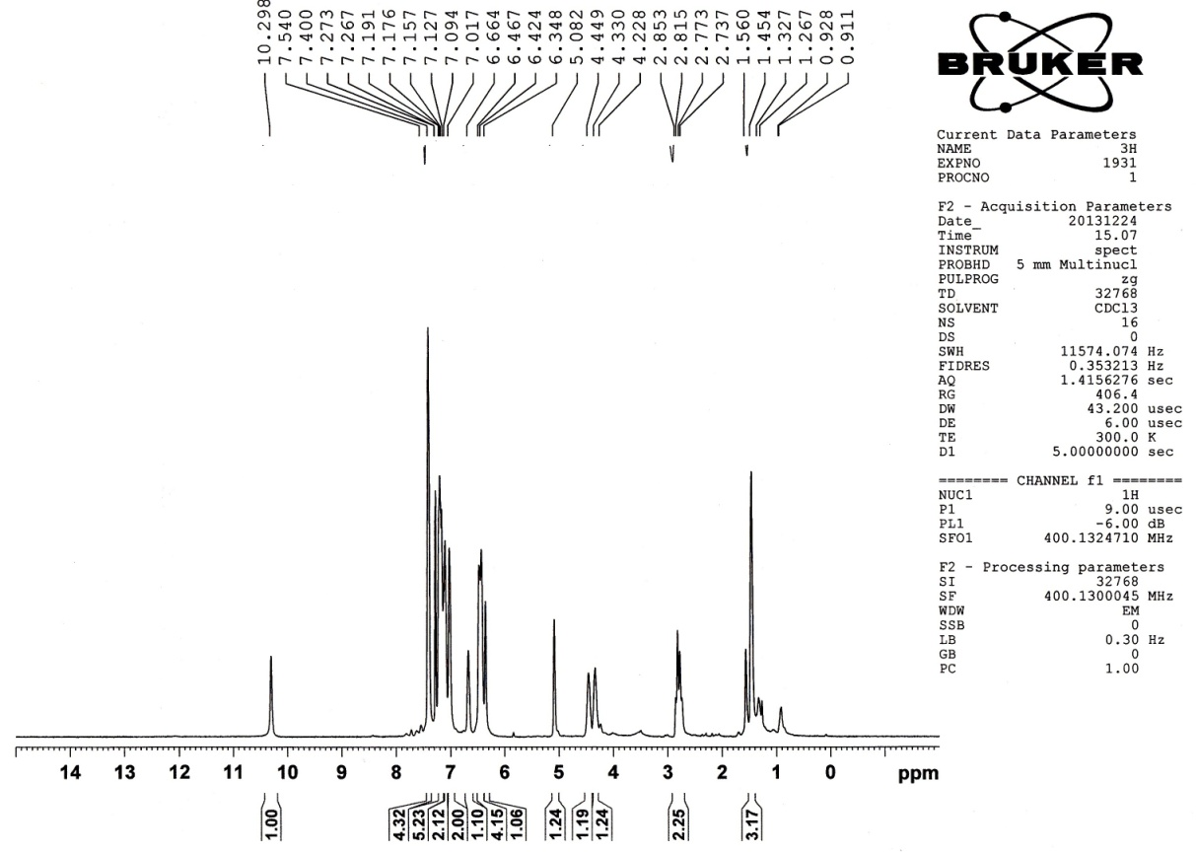

Ethyl -2,6-diphenyl-1-(p-tolyl)-4-(p-tolylamino)-1,2,5,6-tetrahydropyridine-3-carboxylate (4d)
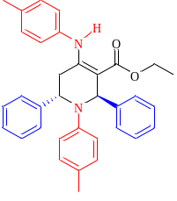
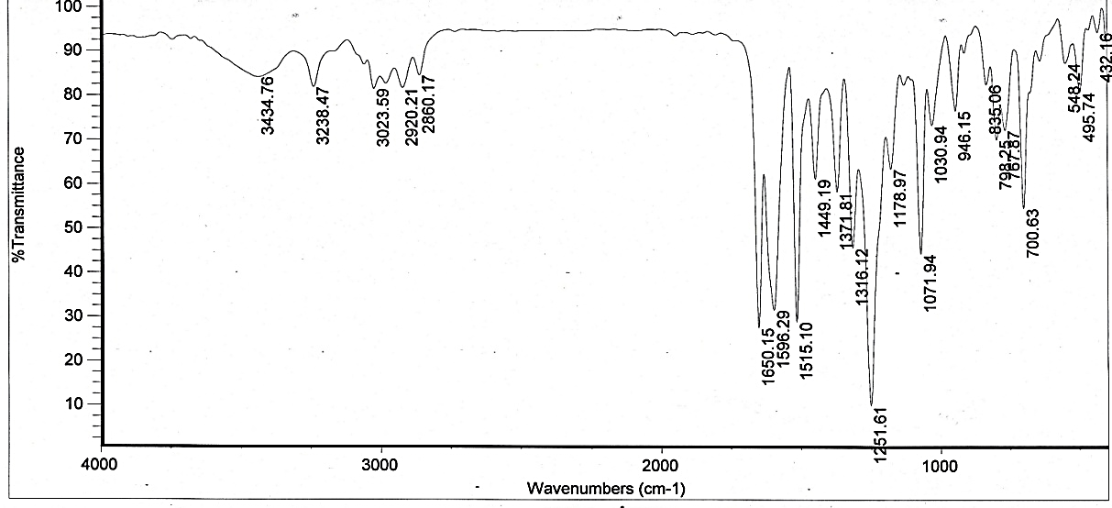
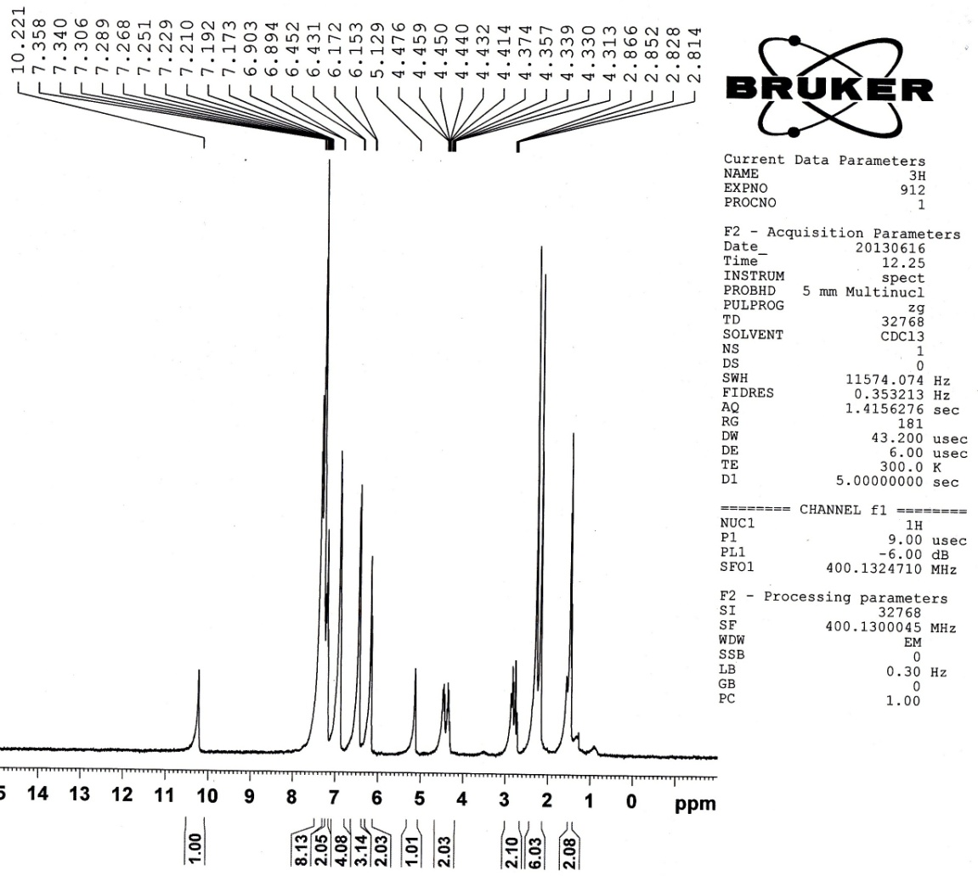
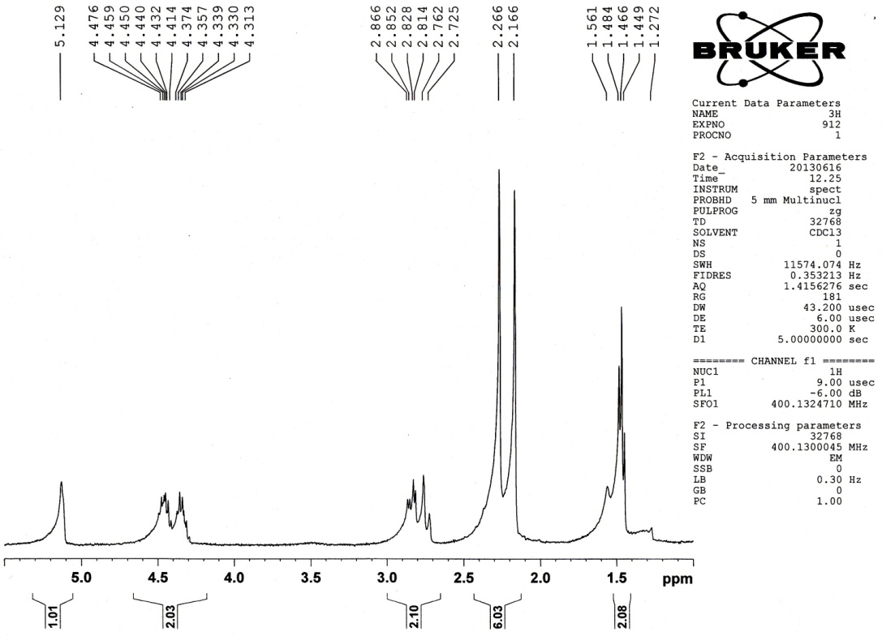

Ethyl-1,2,6-tri-p-tolyl-4-(p-tolylamino)-1,2,5,6-tetrahydropyridine-3-carboxylate (4e)
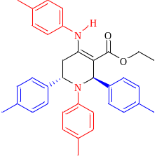
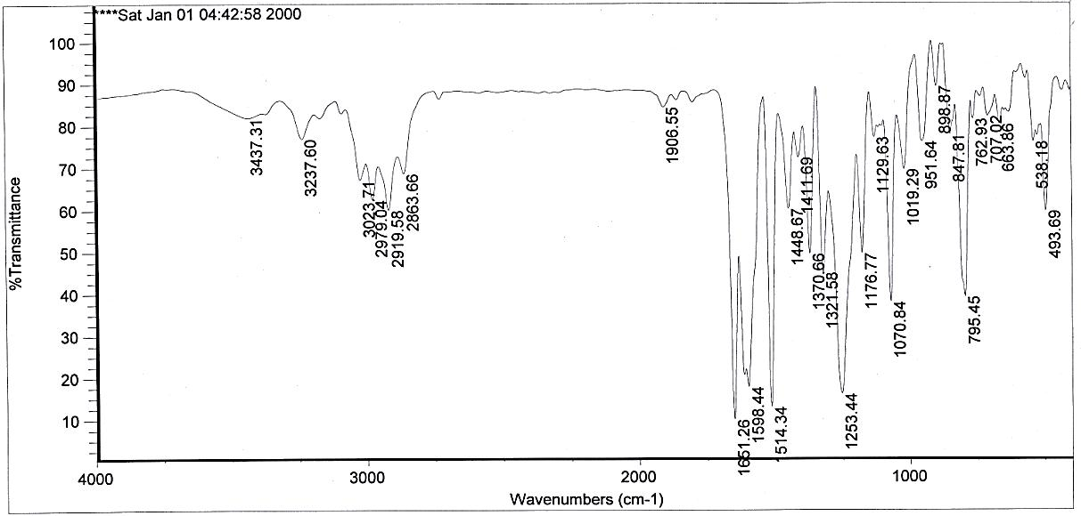
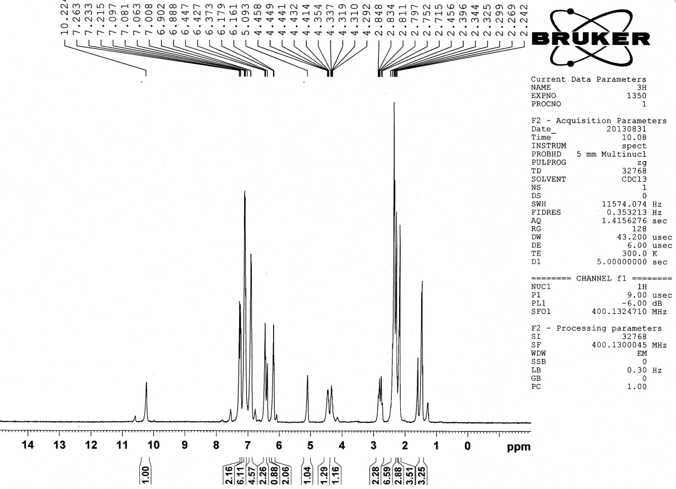
Ethyl-2,6-bis(4-bromophenyl)-1-(p-tolyl)-4-(p-tolylamino)-1,2,5,6-tetrahydropyridine-3-carboxylate (4f)
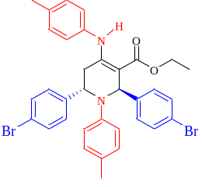
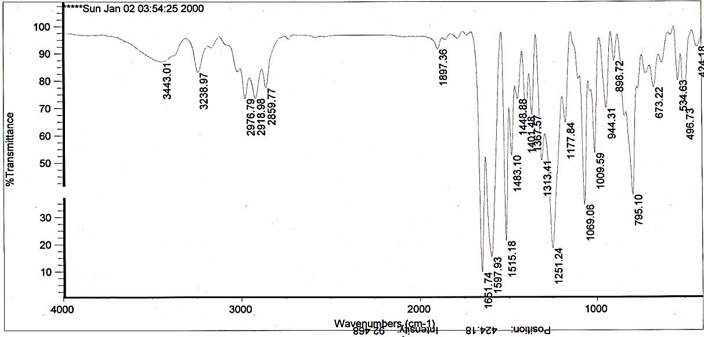
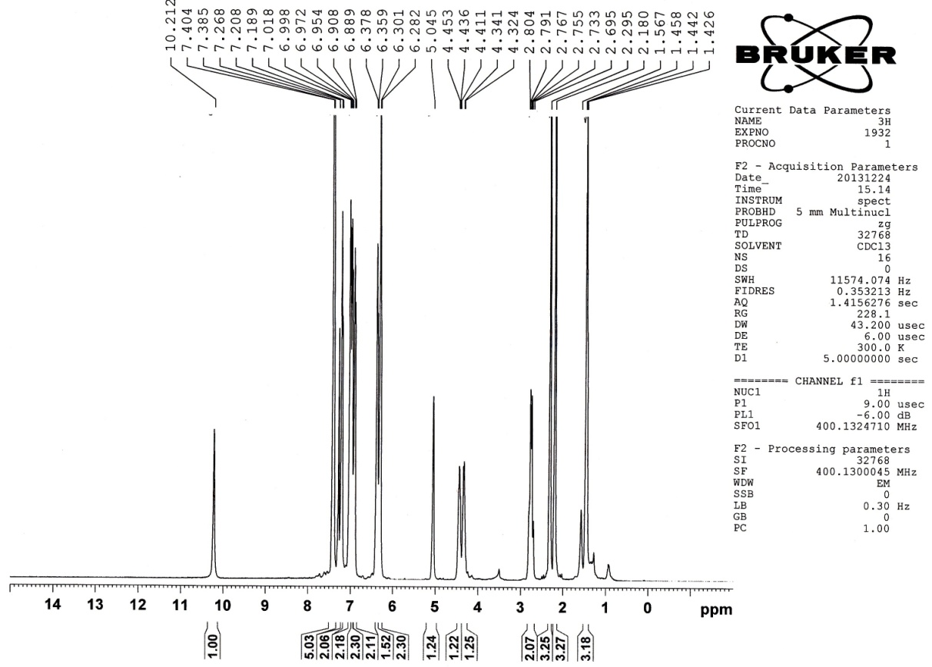
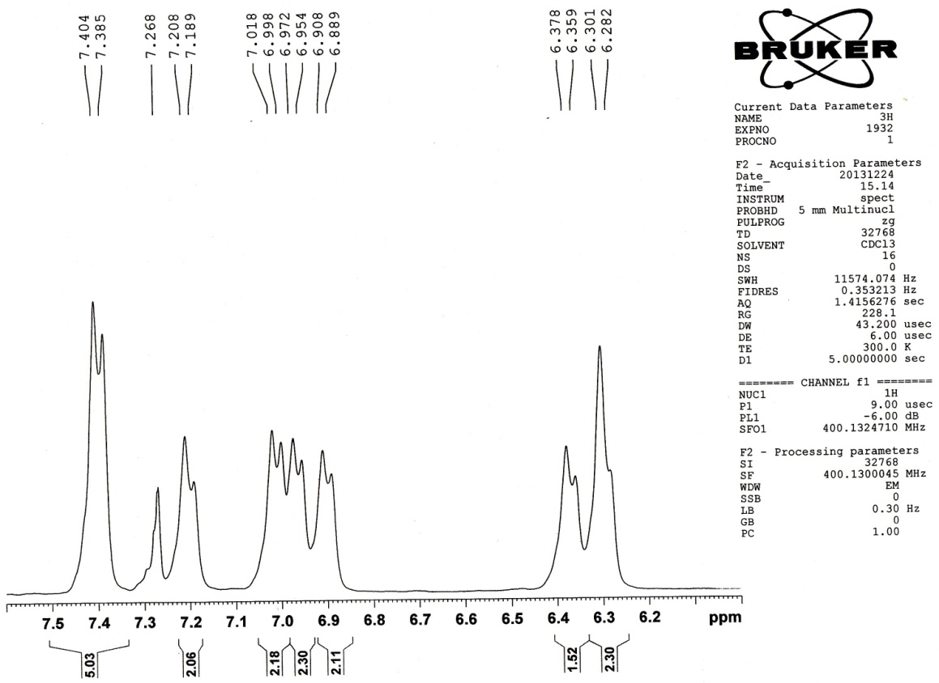
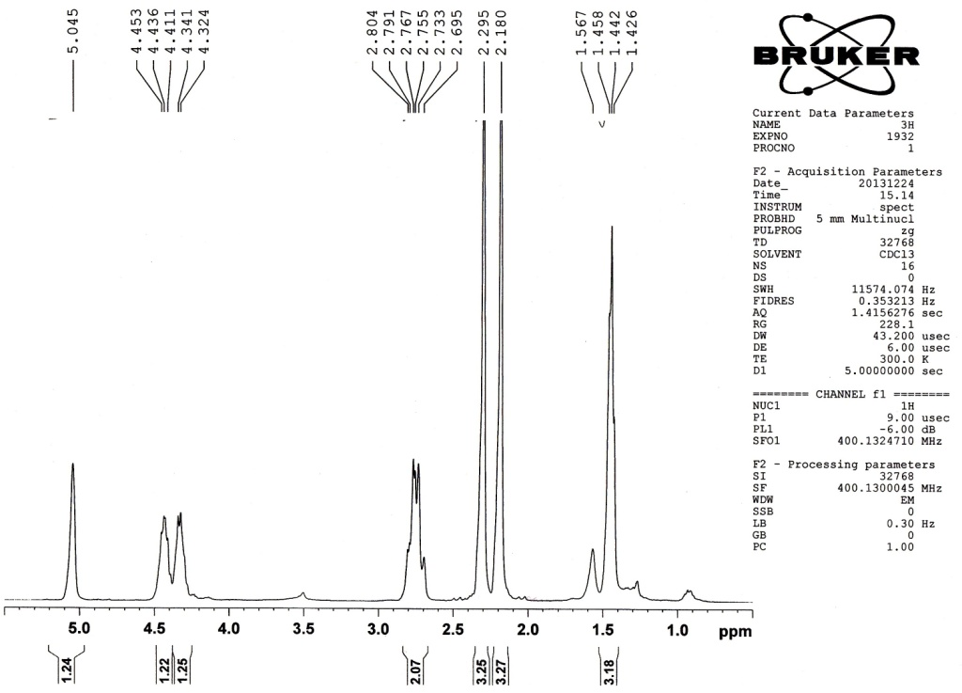
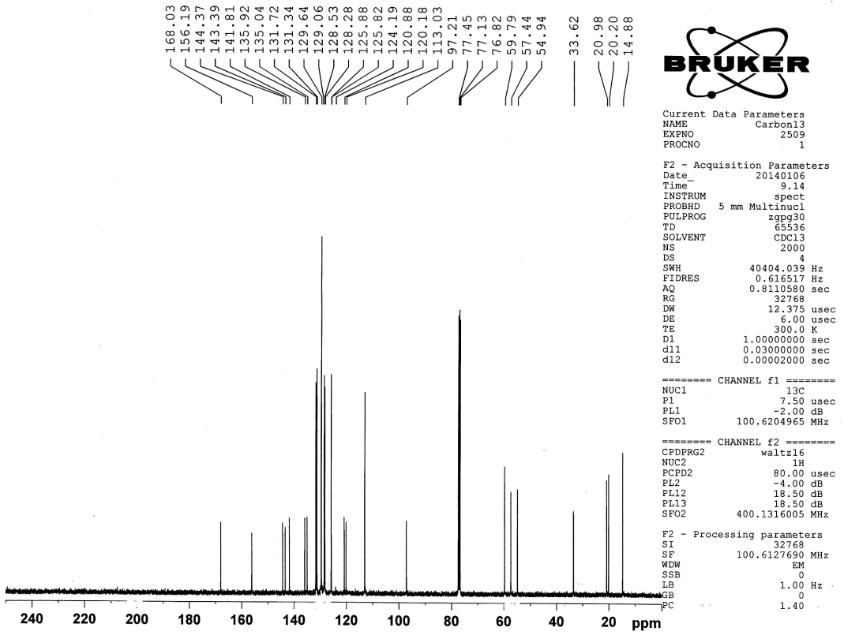
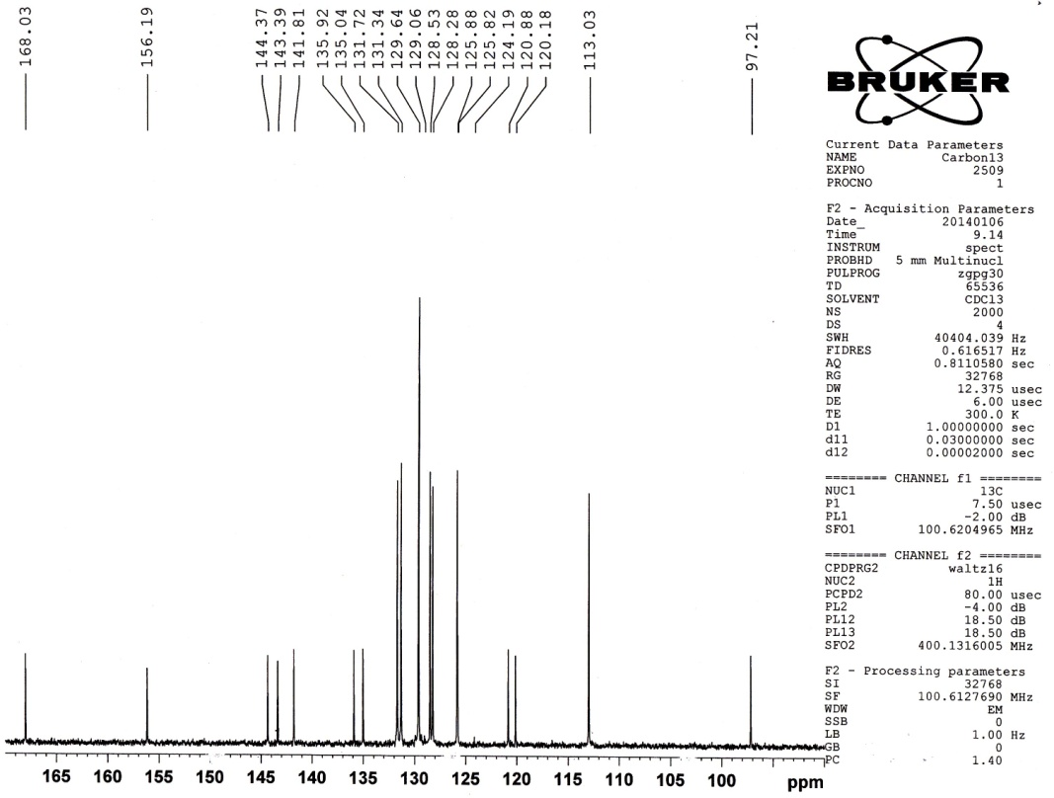

Ethyl-1-(4-ethylphenyl)-4-((4-ethylphenyl)amino)-2,6-diphenyl-1,2,5,6-tetrahydropyridine-3-carboxylate (4g)
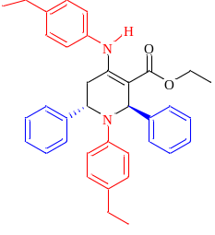
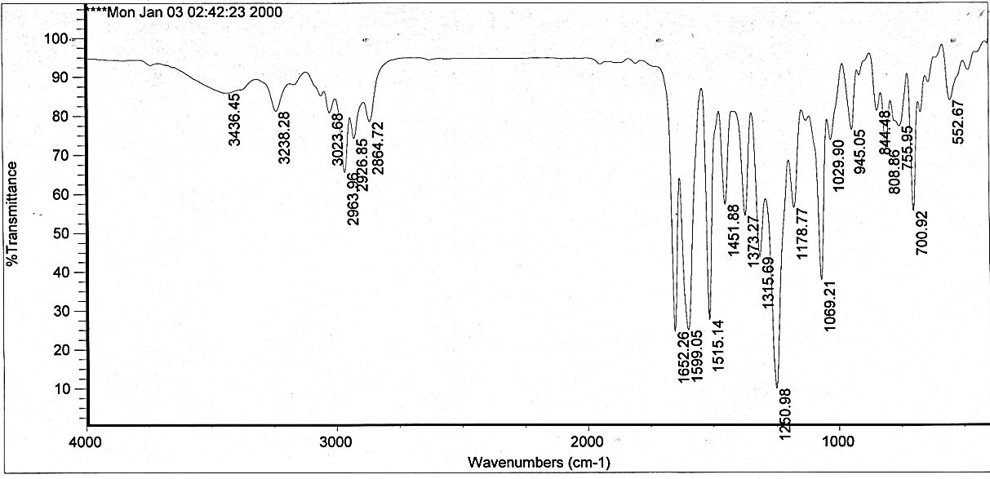
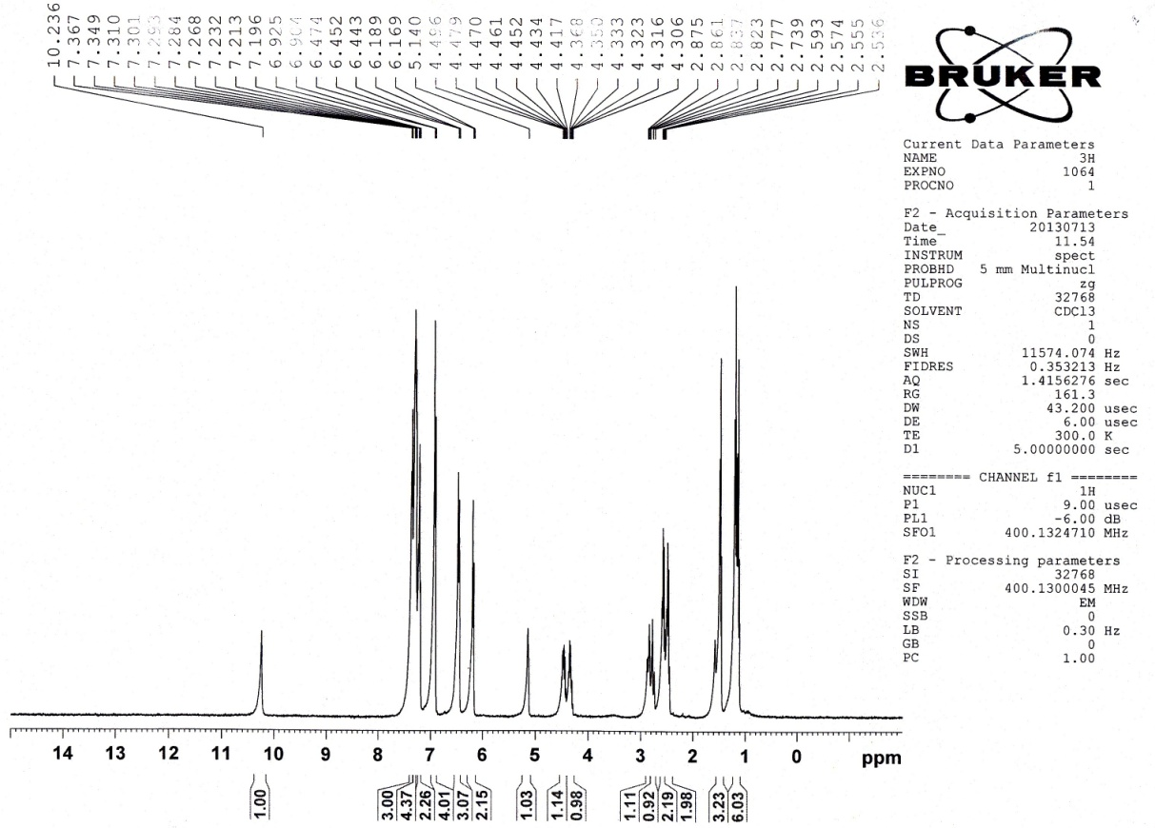
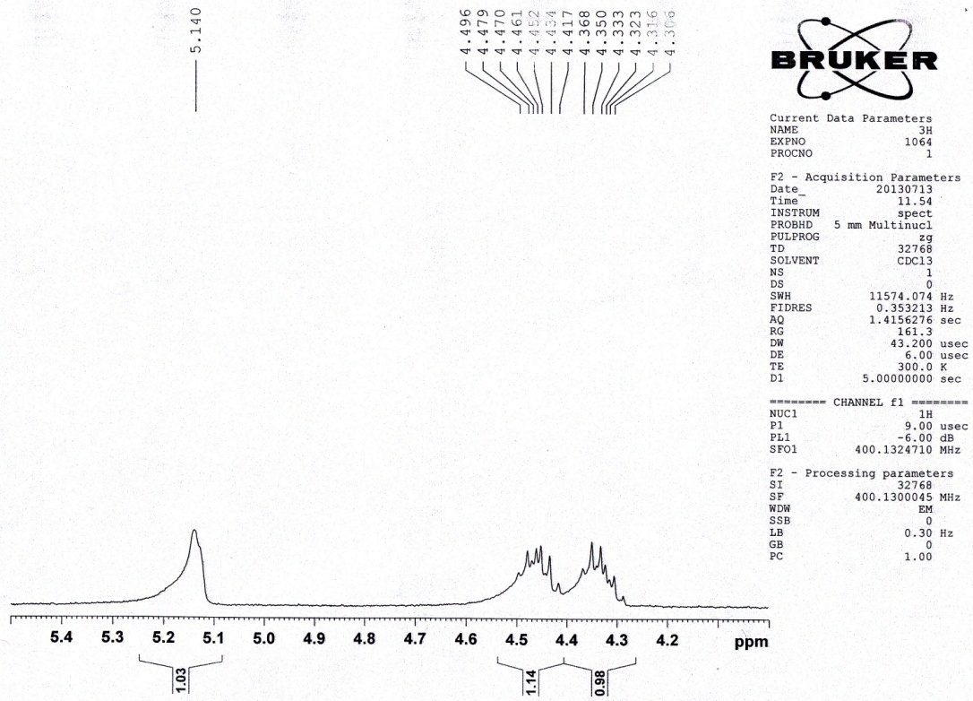
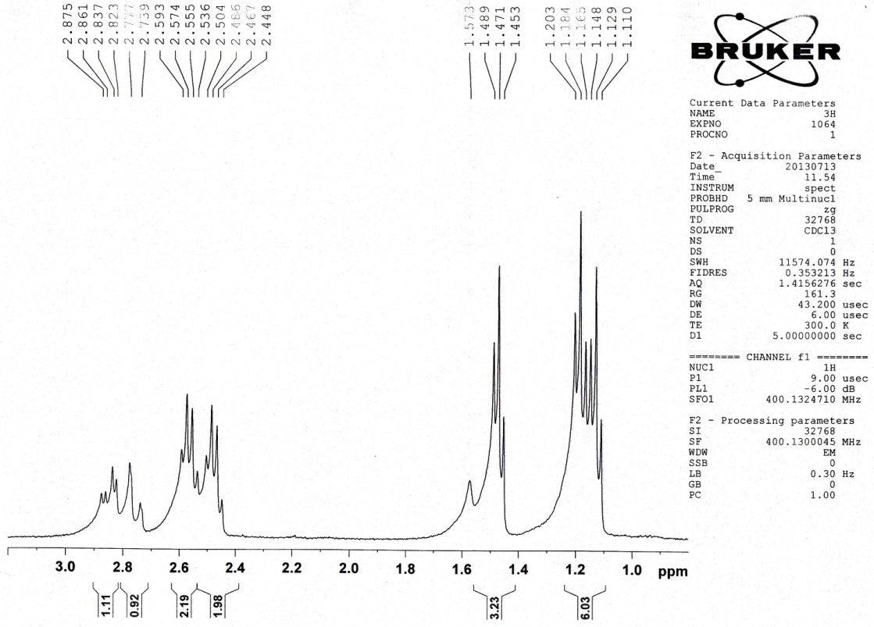
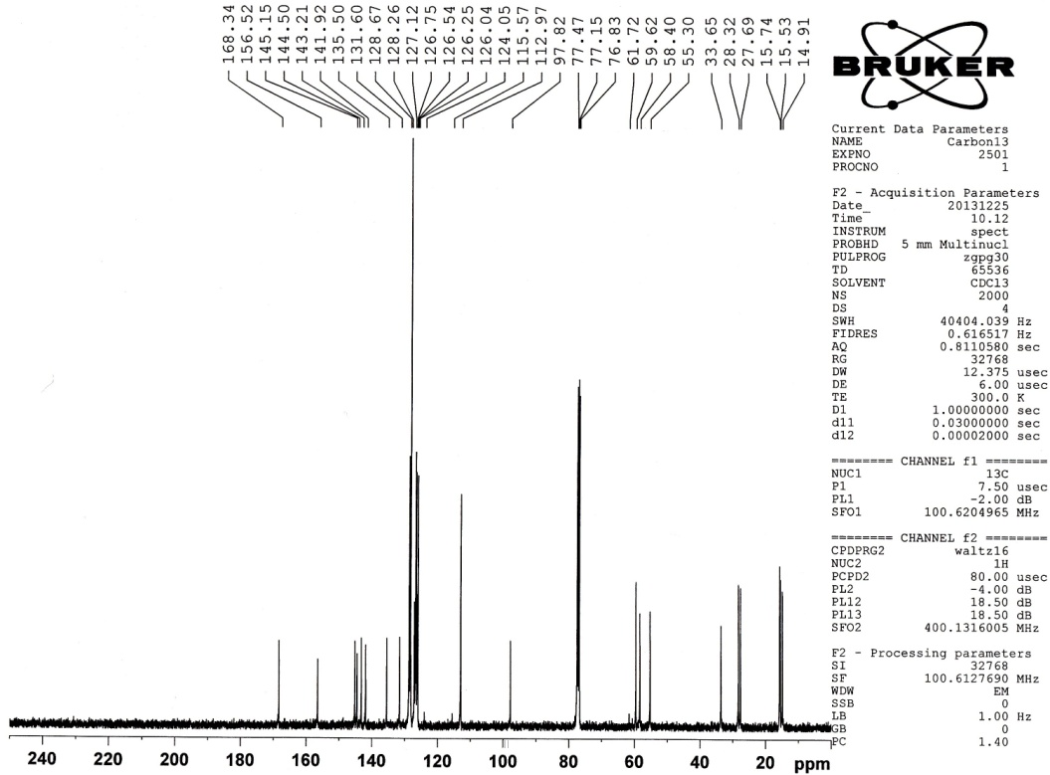
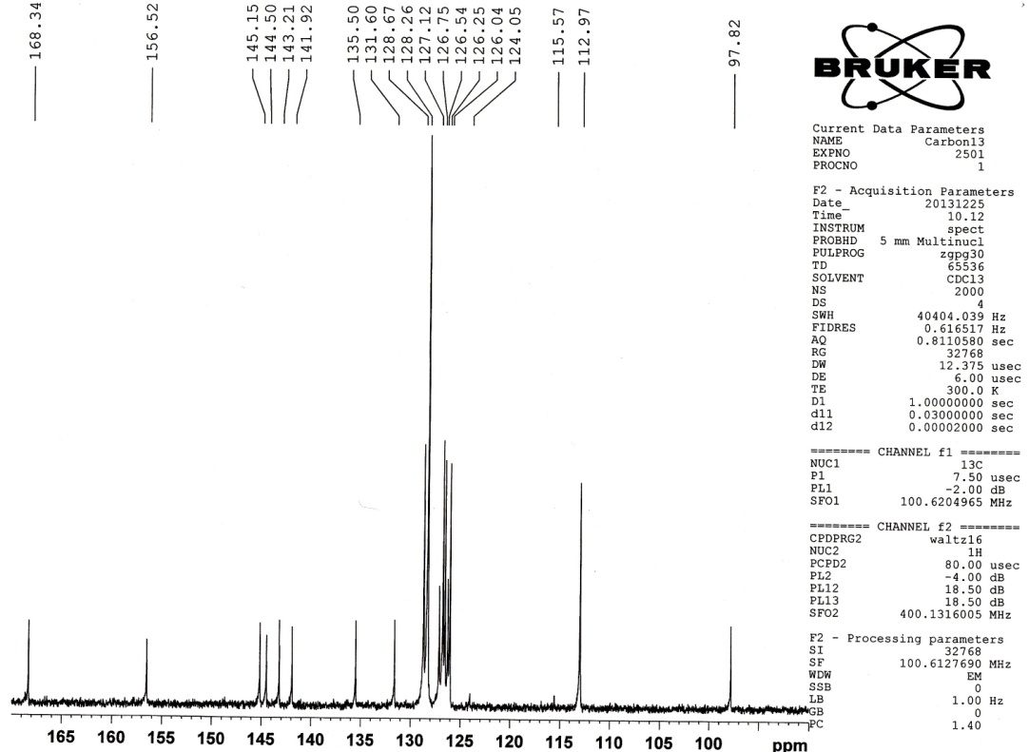

Ethyl-1-(4-methylphenyl)-4-((4-ethylphenyl)amino)-2,6-di-p-tolyl-1,2,5,6-tetrahydropyridine-3-carboxylate (4h)
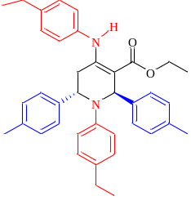
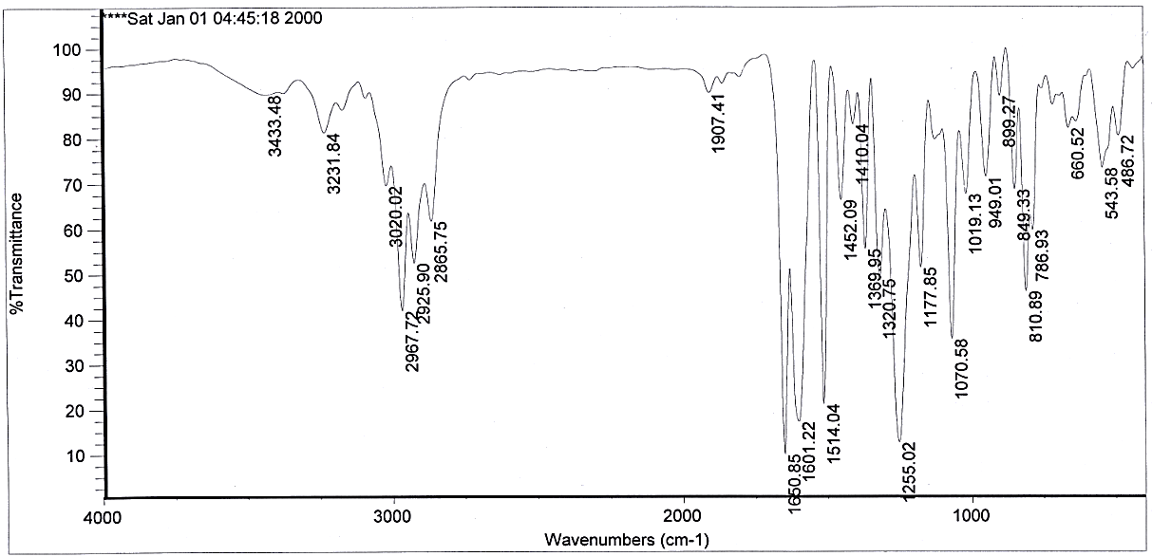
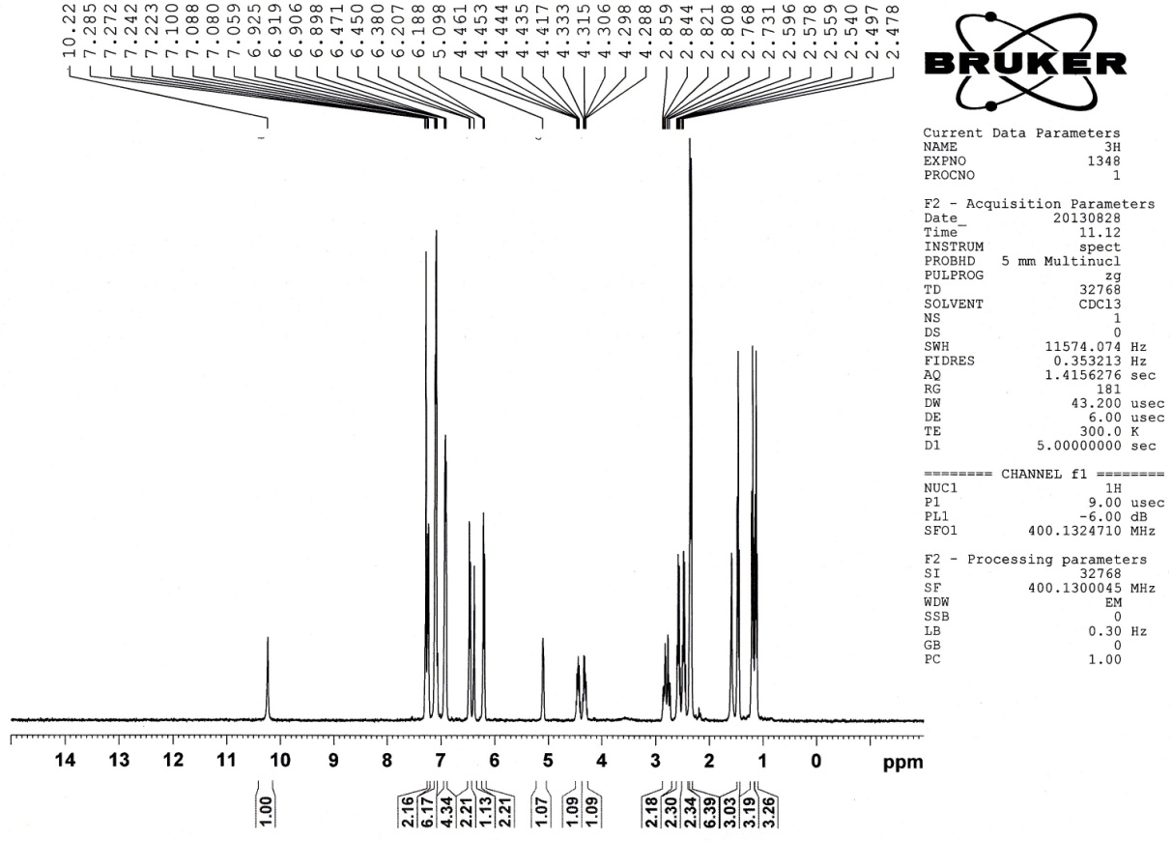
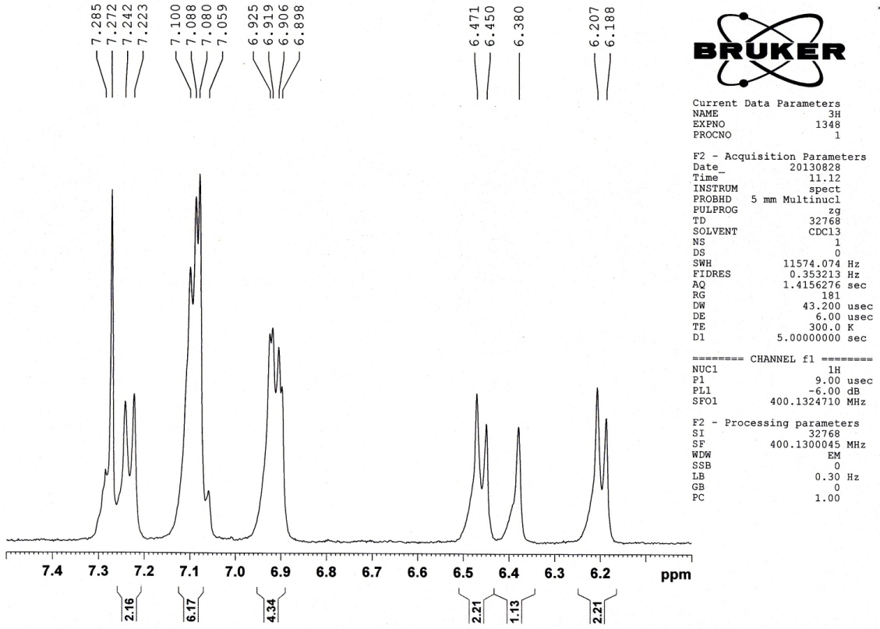
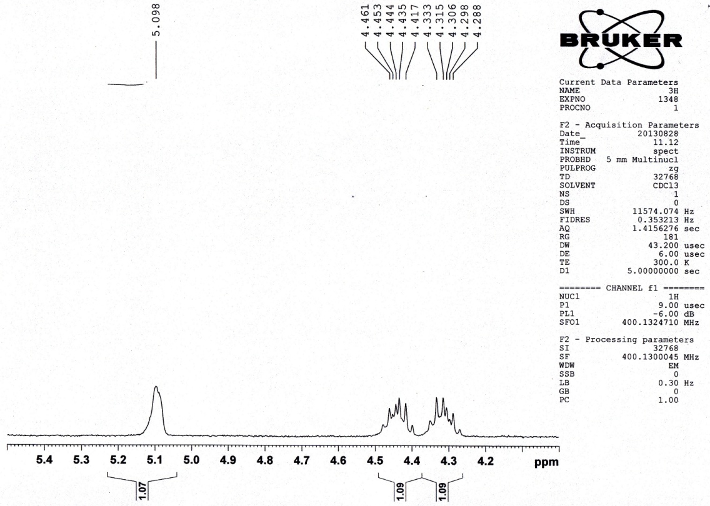
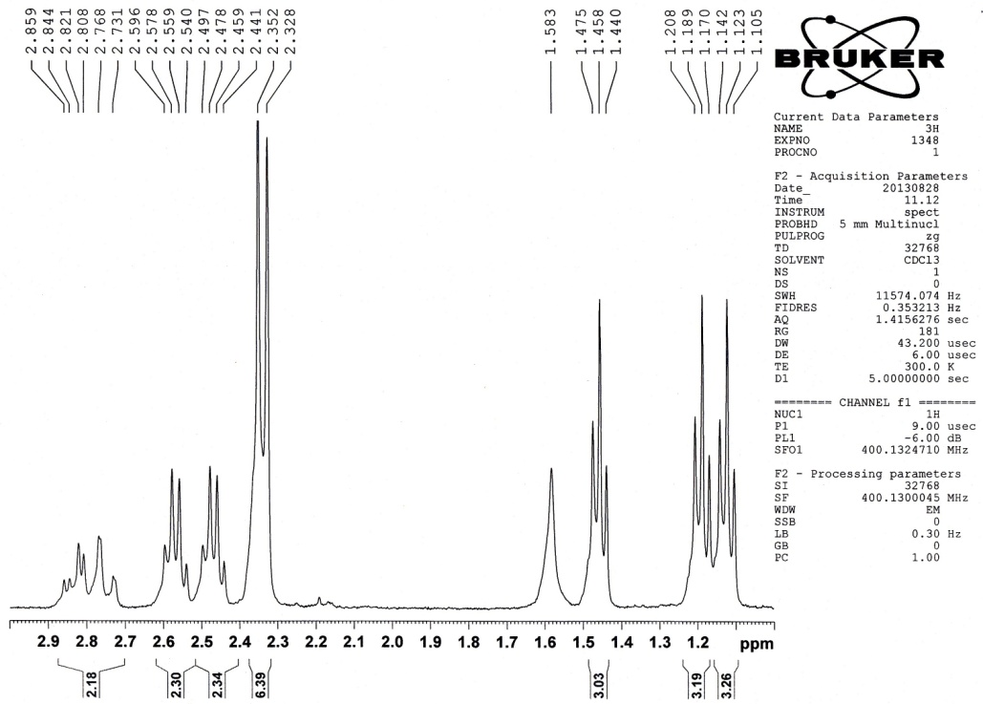
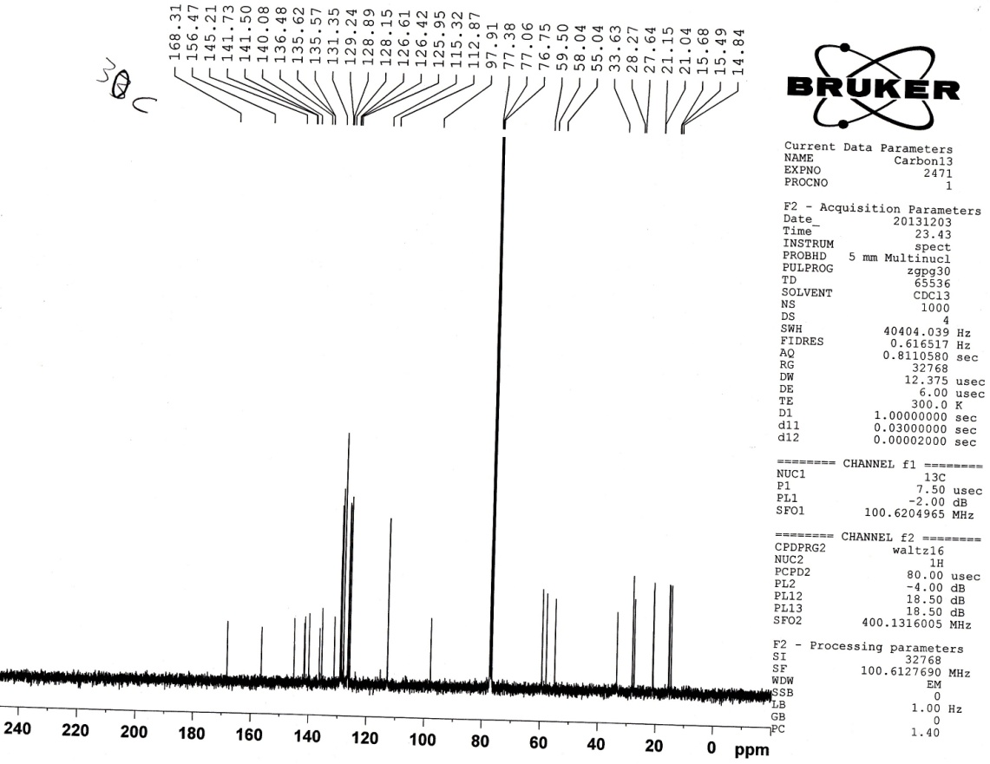
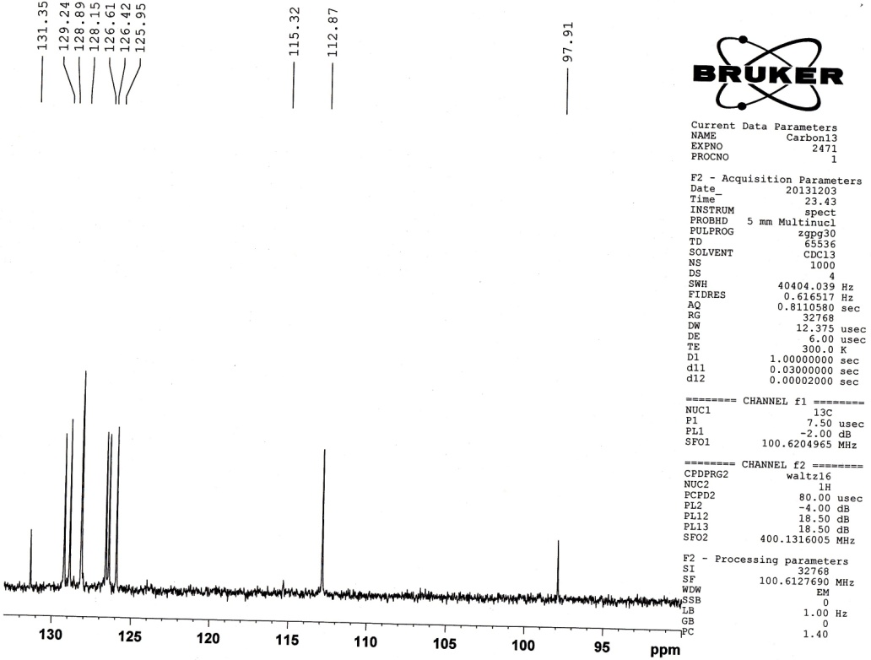

Ethyl-2,6-bis(4-chlorophenyl)-1-(4-ethylphenyl)-4-((4-ethylphenyl)amino)-1,2,5,6 tetrahydropyridine -3-carboxylate (4i)
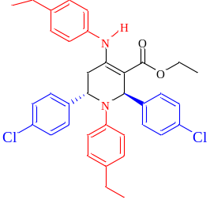
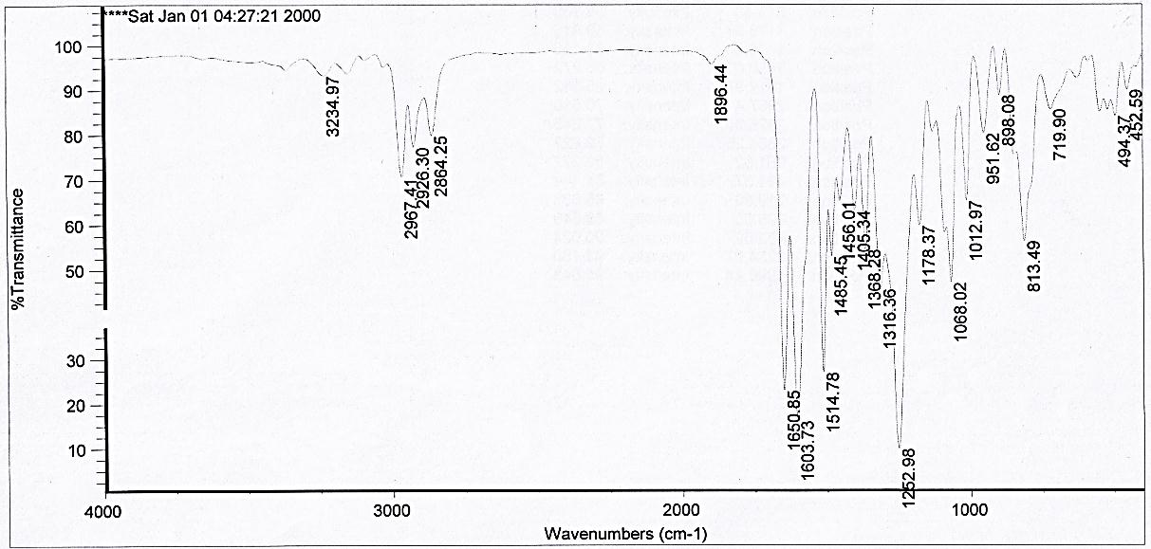
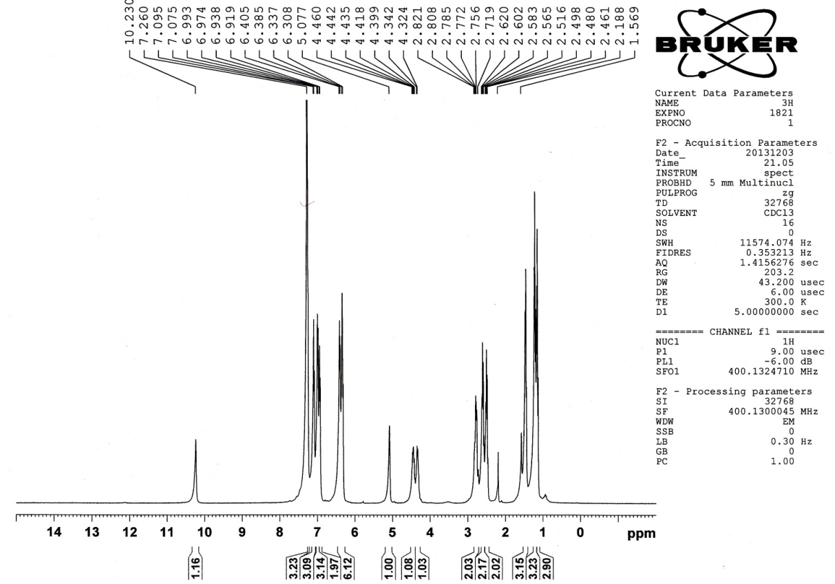
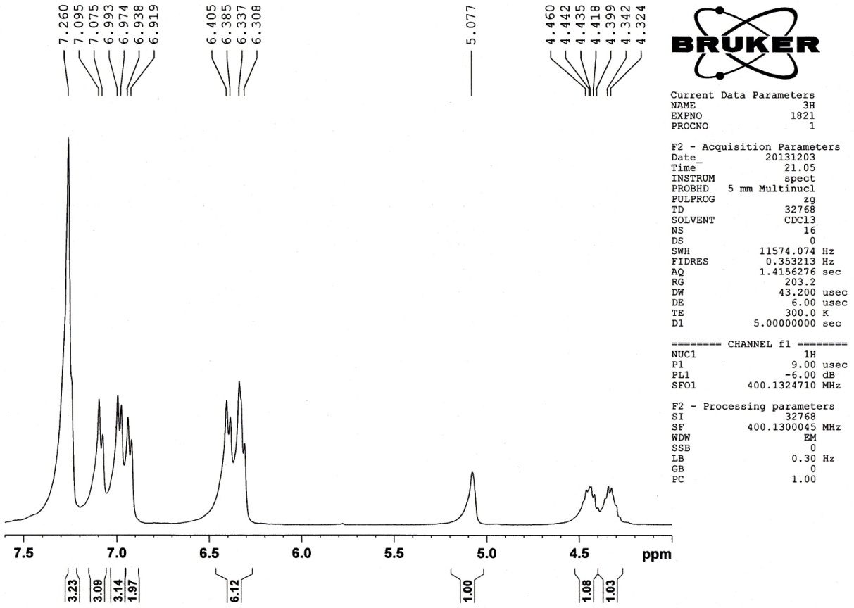
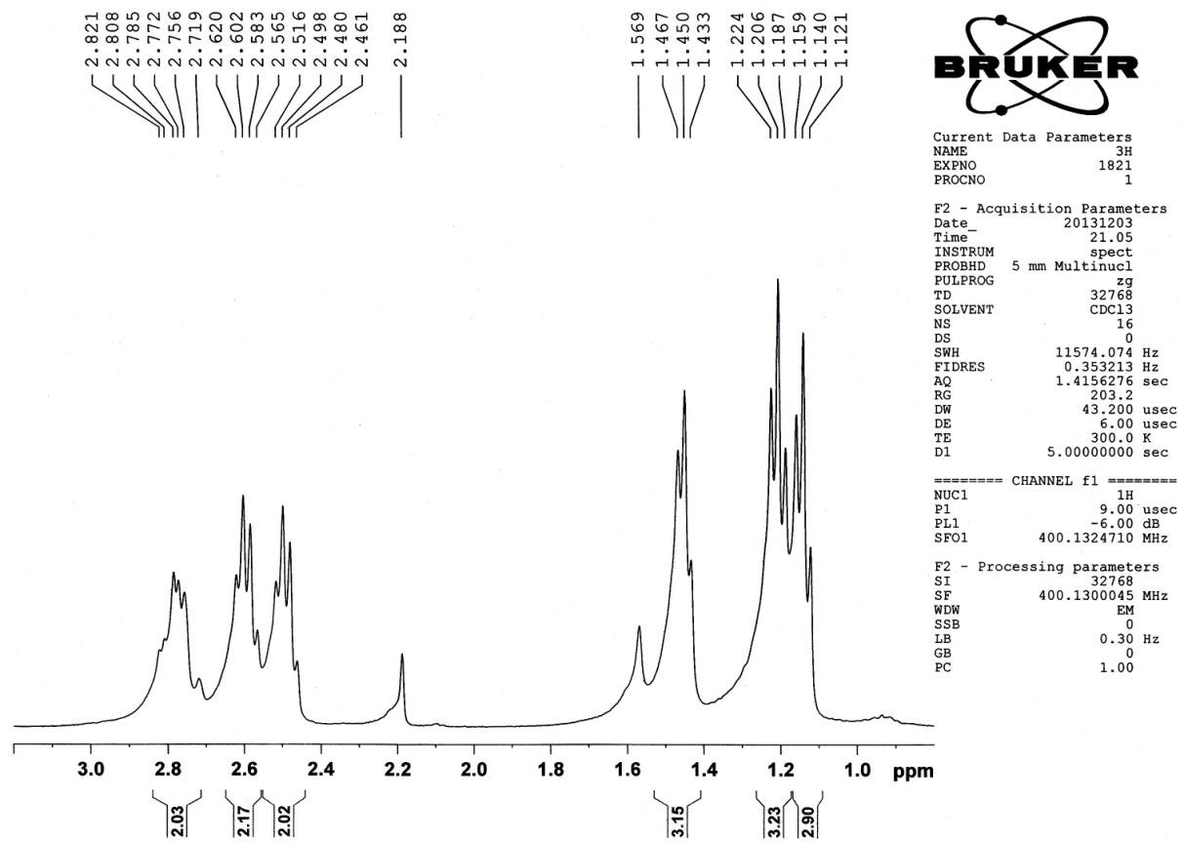
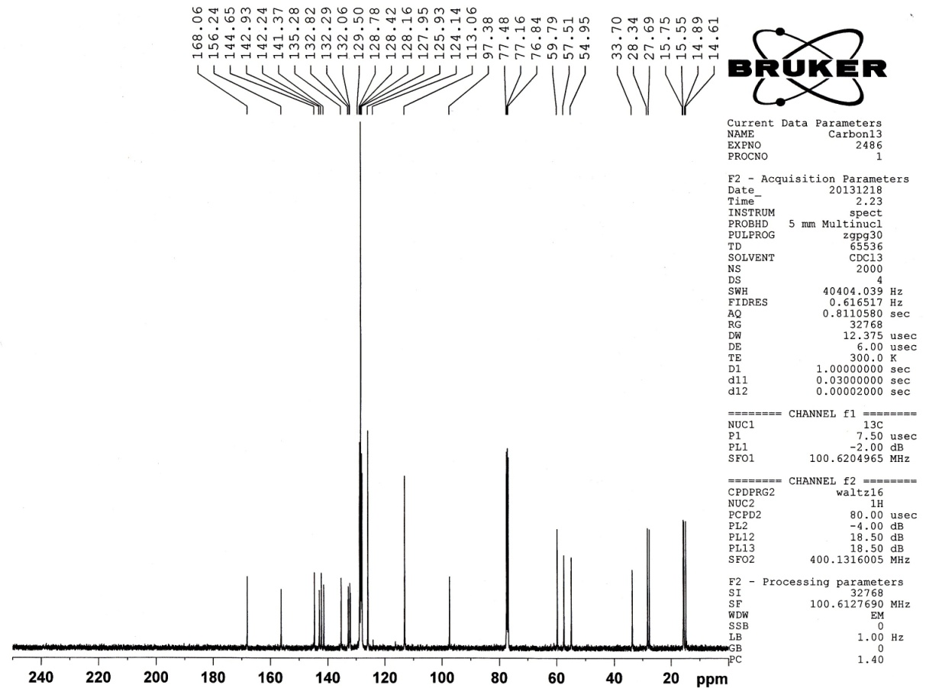
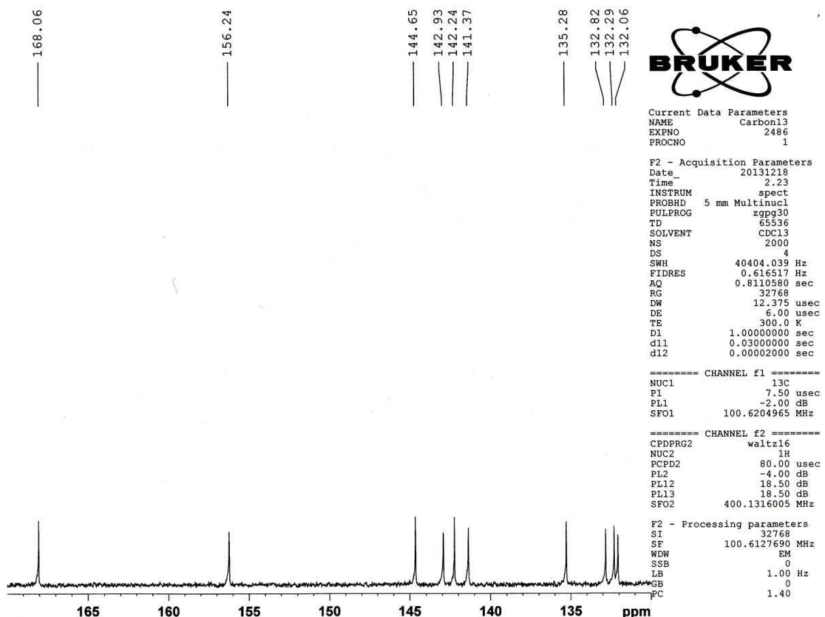
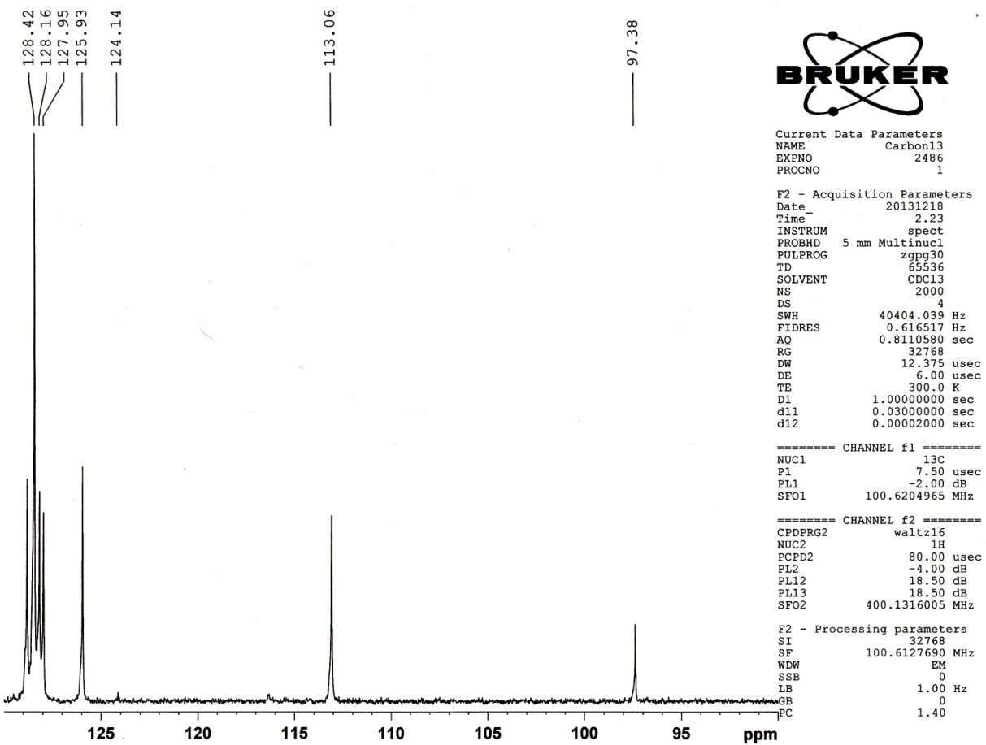

Ethyl-1-(4-chlorophenyl)-4-((4-chlorophenyl)amino)-2,6-diphenyl-1,2,5,6-tetrahydropyridine-3-carboxylate (4j)
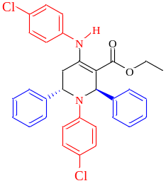
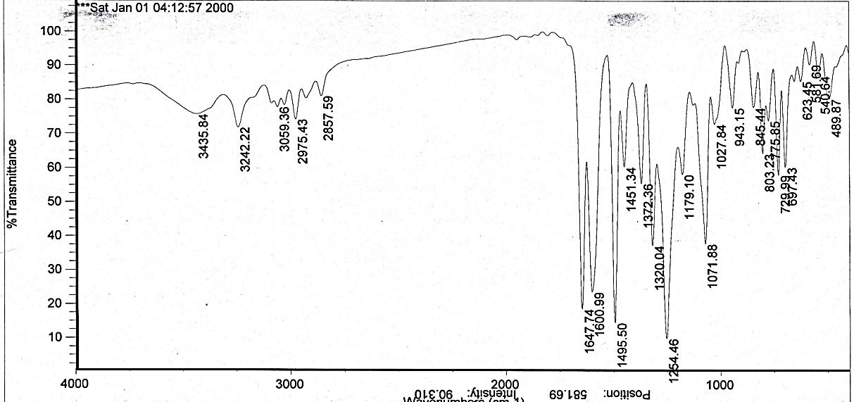
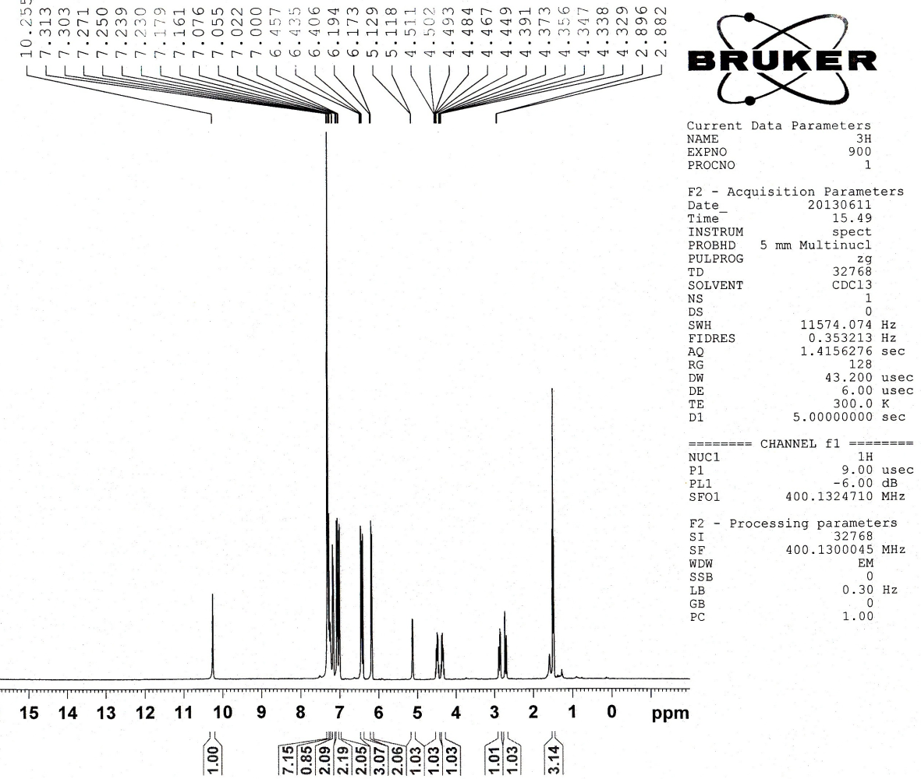
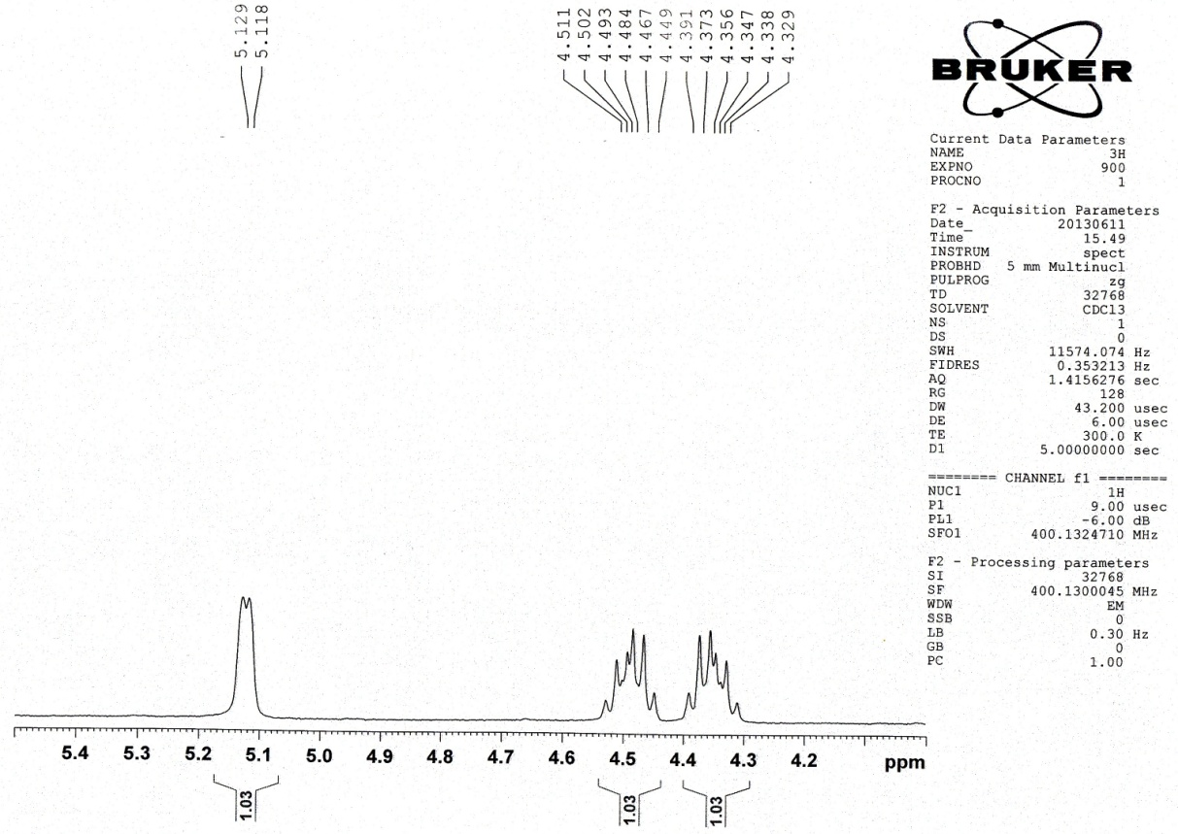
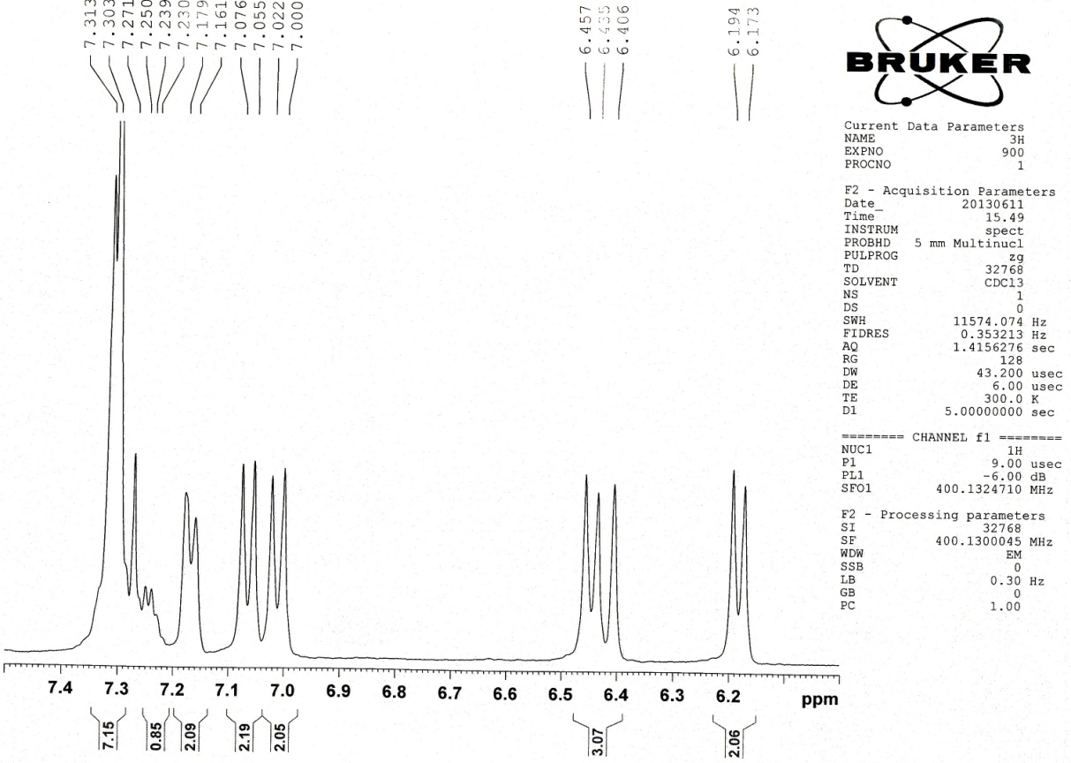
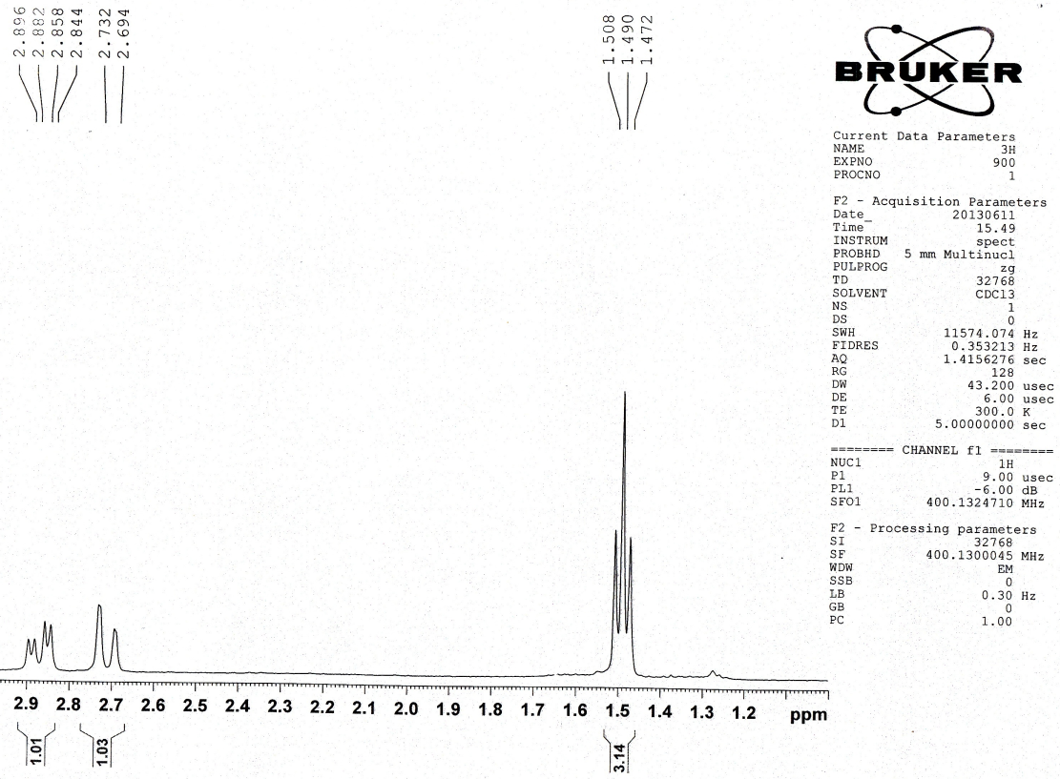

Ethyl-1,2,6-tris(4-chlorophenyl)-4-((4-chlorophenyl)amino)-1,2,5,6-tetrahydropyridine-3-carboxylate (4k)
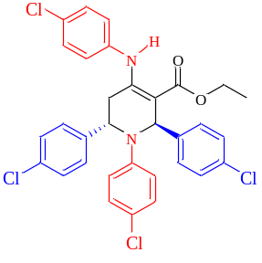
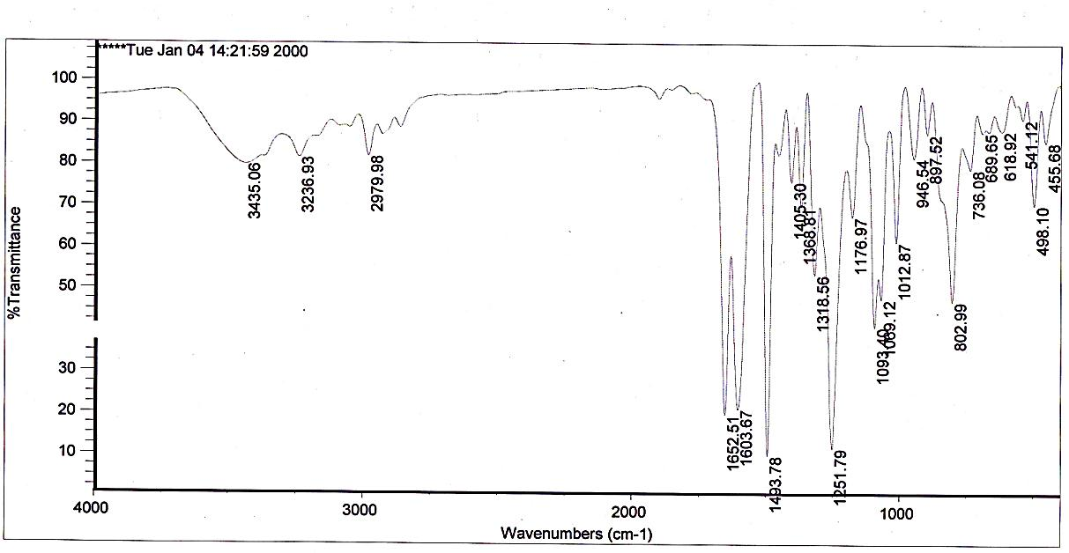
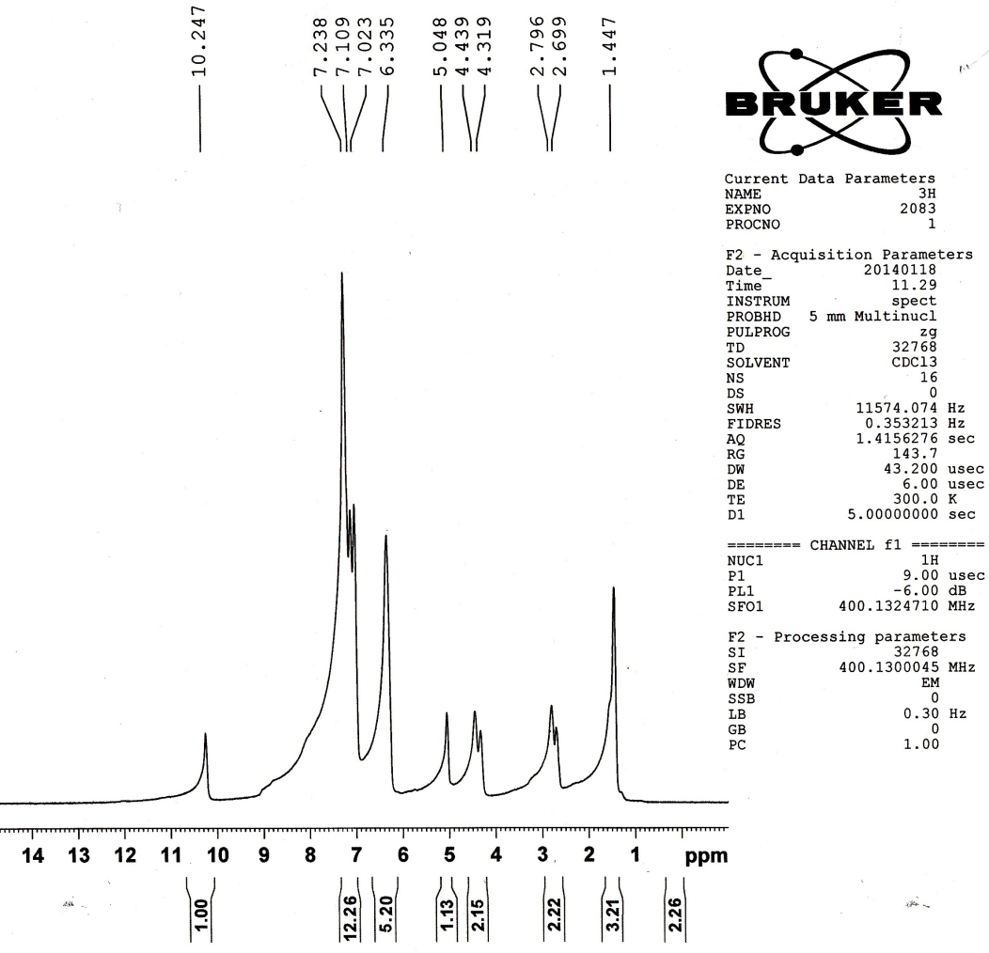
Ethyl-1-(4-bromophenyl)-4-((4-bromophenyl)amino)-2,6-diphenyl-1,2,5,6-tetrahydropyridine-3-carboxylate (4l)
