【Supplementary materials】
Search Name:
Date Run: 01/05/2022 12:06:31
Comment:
ID Search Hits
#1 MeSH descriptor: [Atrial Fibrillation] explode all trees 5138
#2 (Atrial Fibrillations):ti,ab,kw OR (Fibrillation, Atrial):ti,ab,kw OR (Fibrillations, Atrial):ti,ab,kw OR (Auricular Fibrillation):ti,ab,kw OR (Auricular Fibrillations):ti,ab,kw OR (Fibrillation, Auricular):ti,ab,kw OR (Fibrillations, Auricular):ti,ab,kw OR (Fibrillation, Persistent Atrial):ti,ab,kw OR (Fibrillations, Persistent Atrial):ti,ab,kw OR (Fibrillation, Familial Atrial):ti,ab,kw OR (Fibrillations, Familial Atrial):ti,ab,kw OR (Fibrillation, Paroxysmal Atrial):ti,ab,kw OR (Fibrillations, Paroxysmal Atrial):ti,ab,kw OR (Fibrillations, Paroxysmal Atrial):ti,ab,kw OR (AF):ti,ab,kw OR (nonvalvular atrial fibrillation):ti,ab,kw OR (non-valvular atrial fibrillation):ti,ab,kw OR (nonvalvular AF):ti,ab,kw OR (non-valvular atrial fibrillation):ti,ab,kw OR (valvular atrial fibrillation):ti,ab,kw OR (valvular AF):ti,ab,kw 15938
#3 #1 OR #2 15938
#4 MeSH descriptor: [Factor Xa Inhibitors] explode all trees 633
#5 (Factor Xa Inhibitor):ti,ab,kw OR (Inhibitor, Factor Xa):ti,ab,kw OR (Xa Inhibitor, Factor):ti,ab,kw OR (Direct Factor Xa Inhibitors):ti,ab,kw OR (Direct-Acting Oral Anticoagulants):ti,ab,kw OR (Anticoagulants, Direct-Acting Oral):ti,ab,kw OR (Direct Acting Oral Anticoagulants):ti,ab,kw OR (Oral Anticoagulants, Direct-Acting):ti,ab,kw OR (Direct Factor Xa Inhibitor):ti,ab,kw OR (Direct-Acting Oral Anticoagulant):ti,ab,kw OR (Anticoagulant, Direct-Acting Oral):ti,ab,kw OR (Direct Acting Oral Anticoagulant):ti,ab,kw OR (Oral Anticoagulant, Direct-Acting):ti,ab,kw OR (Non-vitamin K antagonist oral anticoagulants):ti,ab,kw OR (new oral anticoagulant):ti,ab,kw OR (novel oral anticoagulant):ti,ab,kw OR (novel oral anticoagulants):ti,ab,kw OR (new oral anticoagulant):ti,ab,kw OR (new oral anticoagulants):ti,ab,kw OR (NOAC):ti,ab,kw OR (NOACs):ti,ab,kw 1720
#6 MeSH descriptor: [Dabigatran] explode all trees 345
#7 (BIBR 1048):ti,ab,kw OR (Pradaxa):ti,ab,kw OR (Dabigatran Etexilate):ti,ab,kw OR (Etexilate, Dabigatran):ti,ab,kw OR (Dabigatran Etexilate Mesylate):ti,ab,kw OR (Etexilate Mesylate, Dabigatran):ti,ab,kw OR (Mesylate, Dabigatran Etexilate):ti,ab,kw 376
#8 MeSH descriptor: [Rivaroxaban] explode all trees 649
#9 (BAY 59 7939):ti,ab,kw OR (BAY 597939):ti,ab,kw 76
#10 (edoxaban):ti,ab,kw OR (DU-176):ti,ab,kw OR (Savaysa):ti,ab,kw OR (DU-176b):ti,ab,kw OR (edoxaban tosylate):ti,ab,kw 657
#11 (betrixaban) OR (BEVYXXA) OR (PRT054021) 132
#12 (apixaban):ti,ab,kw OR (Eliquis):ti,ab,kw OR (BMS 562247):ti,ab,kw OR (BMS562247):ti,ab,kw OR (BMS-562247):ti,ab,kw 1087
#13 #4 OR #5 OR #6 OR #7 OR #8 OR #9 OR #10 OR #11 OR #12 3824
#14 MeSH descriptor: [Warfarin] explode all trees 1782
#15 (Apo-Warfarin):ti,ab,kw OR (Aldocumar):ti,ab,kw OR (Gen-Warfarin):ti,ab,kw OR (Warfant):ti,ab,kw OR (Coumadin):ti,ab,kw OR (Marevan):ti,ab,kw OR (Warfarin Potassium):ti,ab,kw OR (Potassium, Warfarin):ti,ab,kw OR (Warfarin Sodium):ti,ab,kw OR (Sodium, Warfarin):ti,ab,kw OR (Coumadine):ti,ab,kw OR (Tedicumar):ti,ab,kw OR (vitamin K antagonist oral anticoagulant):ti,ab,kw OR (vitamin K antagonist oral anticoagulants):ti,ab,kw 760
#16 #14 OR #15 2363
#17 MeSH descriptor: [Transcatheter Aortic Valve Replacement] explode all trees 207
#18 (Transcatheter Aortic Valve Implantation):ti,ab,kw OR (TAVR):ti,ab,kw OR (TAVI):ti,ab,kw OR (Biological Aortic Valve):ti,ab,kw OR (Bioprosthetic Aortic Valve):ti,ab,kw 1205
#19 (Biological heart valve):ti,ab,kw OR (biological valve prostheses):ti,ab,kw OR (biological valves):ti,ab,kw OR (Transcatheter mitral valve replacement):ti,ab,kw OR (Bioprosthetic Mitral Valve):ti,ab,kw OR (Mitral Bioprosthetic Valve Implantation):ti,ab,kw 195
#20 #17 OR #18 OR #19 1303
#21 #3 AND #13 AND #16 AND #20 9
Supplementary material list 1: The strategy for searching articles in each database
Supplementary materials S1: Flow chart for literature screening
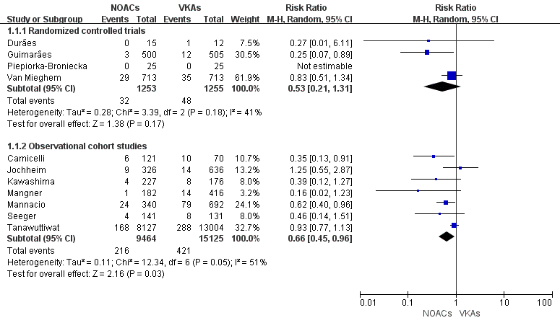
Supplementary materials S2: Forest plots for stroke
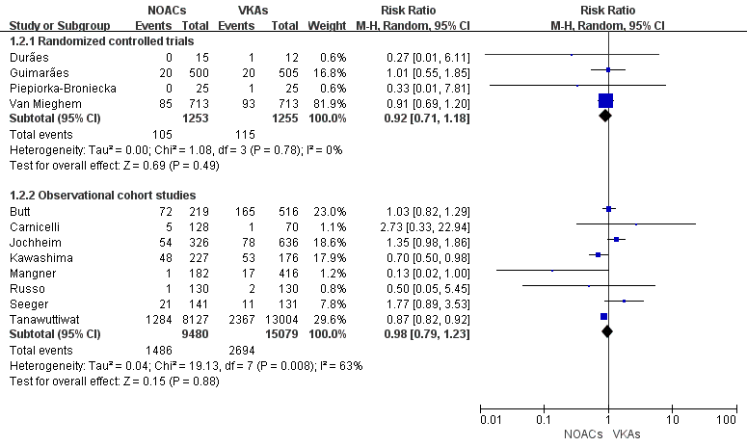
Supplementary materials S3: Forest plots for all-cause mortality
Supplementary material S4: Sensitivity restricted to RCTs in the group of stroke
Supplementary material S5: Sensitivity restricted to OCSs in the group of stroke
Supplementary material S6: Sensitivity restricted to RCTs in the group of all cause of death
Supplementary material S7: Sensitivity restricted to OCSs in the group of all cause of death
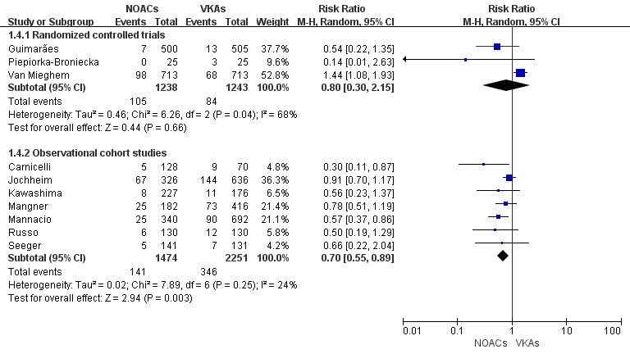
Supplementary material S8: Forest plots for major bleeding
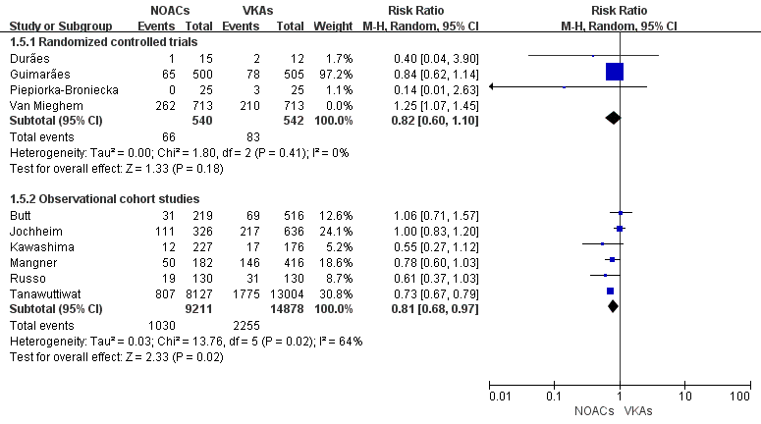
Supplementary material S9: Forest plots for any bleeding
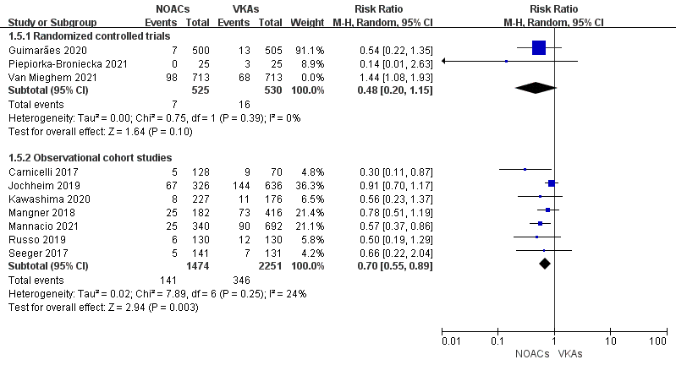
Supplementary material S10: Forest plots for major bleeding when omitting the study by Van Mieghem et.al
Supplementary material S11: Sensitivity analysis for major bleeding in RCTs
Supplementary material S12: Sensitivity analysis for major bleeding in OCSs
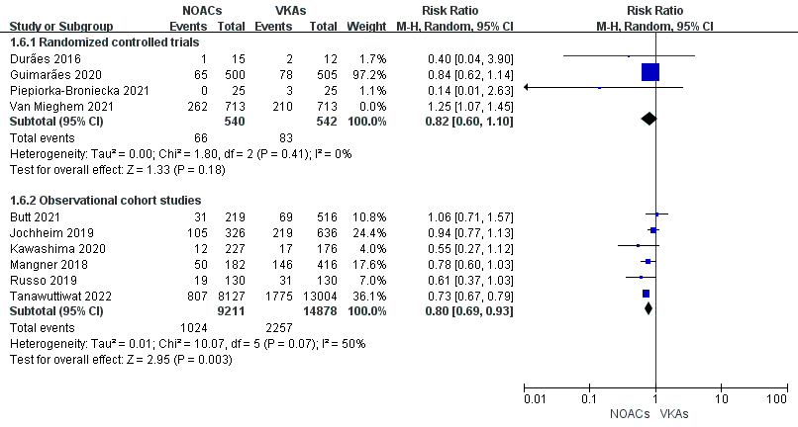
Supplementary material S13: Forest plots for any bleeding when omitting the study by Van Mieghem et.al
Supplementary material S14: Sensitivity analysis for any bleeding in OCSs
Supplementary material S15: Sensitivity analysis for any bleeding in RCTs
Supplementary material S16: Quality assessment of randomised controlled studies
Supplementary material S17: Quality assessment of observational cohort studies

