Table 1. Comparative analysis of liver damage indicator enzymes 6 hours after brain death induction. (ALT: Alanine aminotransferase; AST: aspartate aminotransferase; LDH: lactate dehydrogenase; ALP: alkaline phosphatase).
 | GROUPS
Parameters  (IU/L) | Control | BD
ALT | 66,6±9,2 | 232,7±40,9*
AST | 140,1±3,9 | 349,2±26,5*
LDH | 267,1±17,7 | 411,1±12,4*
ALP | 99,2±9,5 | 135,8±13,2*
*p<0.05 vs. Control; #p<0.05 vs. BD.

Table 2. Comparative analysis of inflammatory mediators in liver tissue 6 hours after brain death induction in different groups. (BD: Brain death; TNF: Tumor necrosis factor).

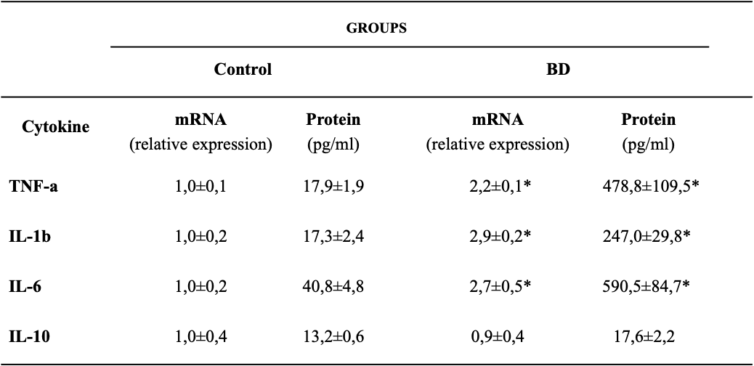
*p<0.05 vs. Control; #p<0.05 vs. BD.

Table 3. Expression of Class I MHC and Class II MHC in liver tissue 6 hours after brain death induction in the different groups. (BD: Brain death; MHC: major histocompatibility complex).

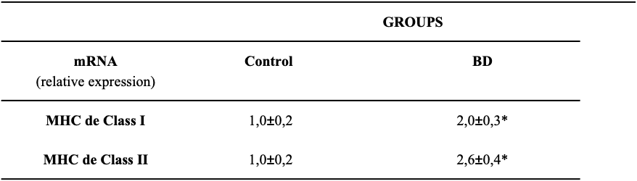

*p<0.05 vs. Control; #p<0.05 vs. BD.

Table 4. Comparative analysis of inflammatory mediators in plasma 6 hours after brain death induction in the different groups. (BD: Brain death).
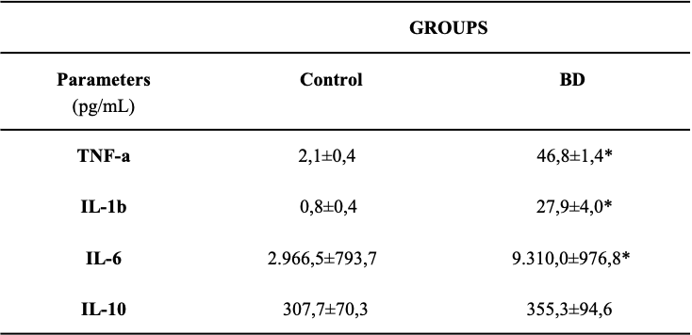

*p<0.05 vs. Control; #p<0.05 vs. BD.
Figure 1. Analysis of cerebral blood flow identified by transcranial color ultrasound. (A) Presence of blood flow in the reverse direction (yellow arrow) before brain death. (B) Presence of flow compatible with brain circulatory collapse (yellow arrow).

Figure 2. Comparative analyzes of the evolution of MBP between the groups during a period of 6 hours after the induction of brain death. (MBP: Mean blood pressure).

Figure 3. Immunohistochemistry for detection of M1 macrophages (arrows) in liver tissue 6 hours after induction of brain death. (A) Control; (B) Brain death; 400X magnification.

Figure 4. Quantification of M1 macrophage infiltrate 6 hours after brain death induction in different experimental groups. *p<0.05 vs. Control; (BD: Brain death).

Figure 5. Comparative analyzes of gene expression and concentration of inflammatory meters in liver tissue 6 hours after brain death in the different groups. *p<0.05 vs. Control; #p<0.05 vs. BD. (BD: Brain death).

Figure 6. Comparative analyzes of Class I MHC and Class II MHC expression in liver tissue 6 hours after brain death in the different experimental groups. *p<0.05 vs. Control; #p<0.05 vs. BD. (BD: Brain death; MHC: major histocompatibility complex).

Figure 7. Comparative analyze s of NFB gene expression in liver tissue 6 hours after brain death in different groups. *p<0.05 vs. Control; #p<0.05 vs. BD. (BD: Brain death).

Figure 8. Analysis of the densiometric quantification (arbitrary units) of the NF-αB band in the liver tissue in the different groups. *p<0.05 vs. Control; #p<0.05 vs. BD. (BD: Brain death).

Figure 9. Illustrative image of the Super-Shift assay 6 hours after brain death induction (BD group), indicating that the dimers present in liver tissue are composed of the p50, p65 and c-Rel subunits. (BD: Brain death)

