Supplementary Information
Table S-1. Operationalization of outcome variables.
Dependent Variable | Operationalization | Instrument
AIM 1: FEASIBILITY
Enrollment | Enrolled rate out of those screened and recruited | N/a
Attrition | Percentage of non-responders at months 1 and 3 | N/a
Intervention  Acceptability | Dichotomous; Maternal report of whether she found the intervention helpful, a nuisance, and easy to understand. | Surveyed at 2 weeks postpartum
Censoring | Proportions of participants who stopped lactating or receiving milk at an unknown time during the study (interval censored), were still receiving milk or lactating at the end of the study period were (right censored), or were lost to follow up
AIM 2: LACTATION & INFANT FEEDING OUTCOMES
Exclusive mother’s own milk s(MOM) Feeding | Dichotomous; “yes” for infants who received only expressed milk or breastfed. If inpatient: proportion of MOM feedings and formula in 24 hours. If discharged: Maternal report of number of times fed formula, expressed MOM, or breastfed in the previous 24-hour period | Month 1 follow up; Month 3 follow up; EHR
Any MOM Feeding | Dichotomous; “yes” for infants who received any expressed milk or breastfed. If inpatient: proportion of MOM feedings in 24 hours. If discharged: Maternal report of number of times fed formula, expressed MOM, or breastfed in the previous 24-hour period. | Month 1 follow up; Month 3 follow up; EHR
Expressing Milk or Breastfeeding | Continuous variable; number of days expressing milk or breastfeed. | Month 1 follow up; Month 3 follow up; EHR

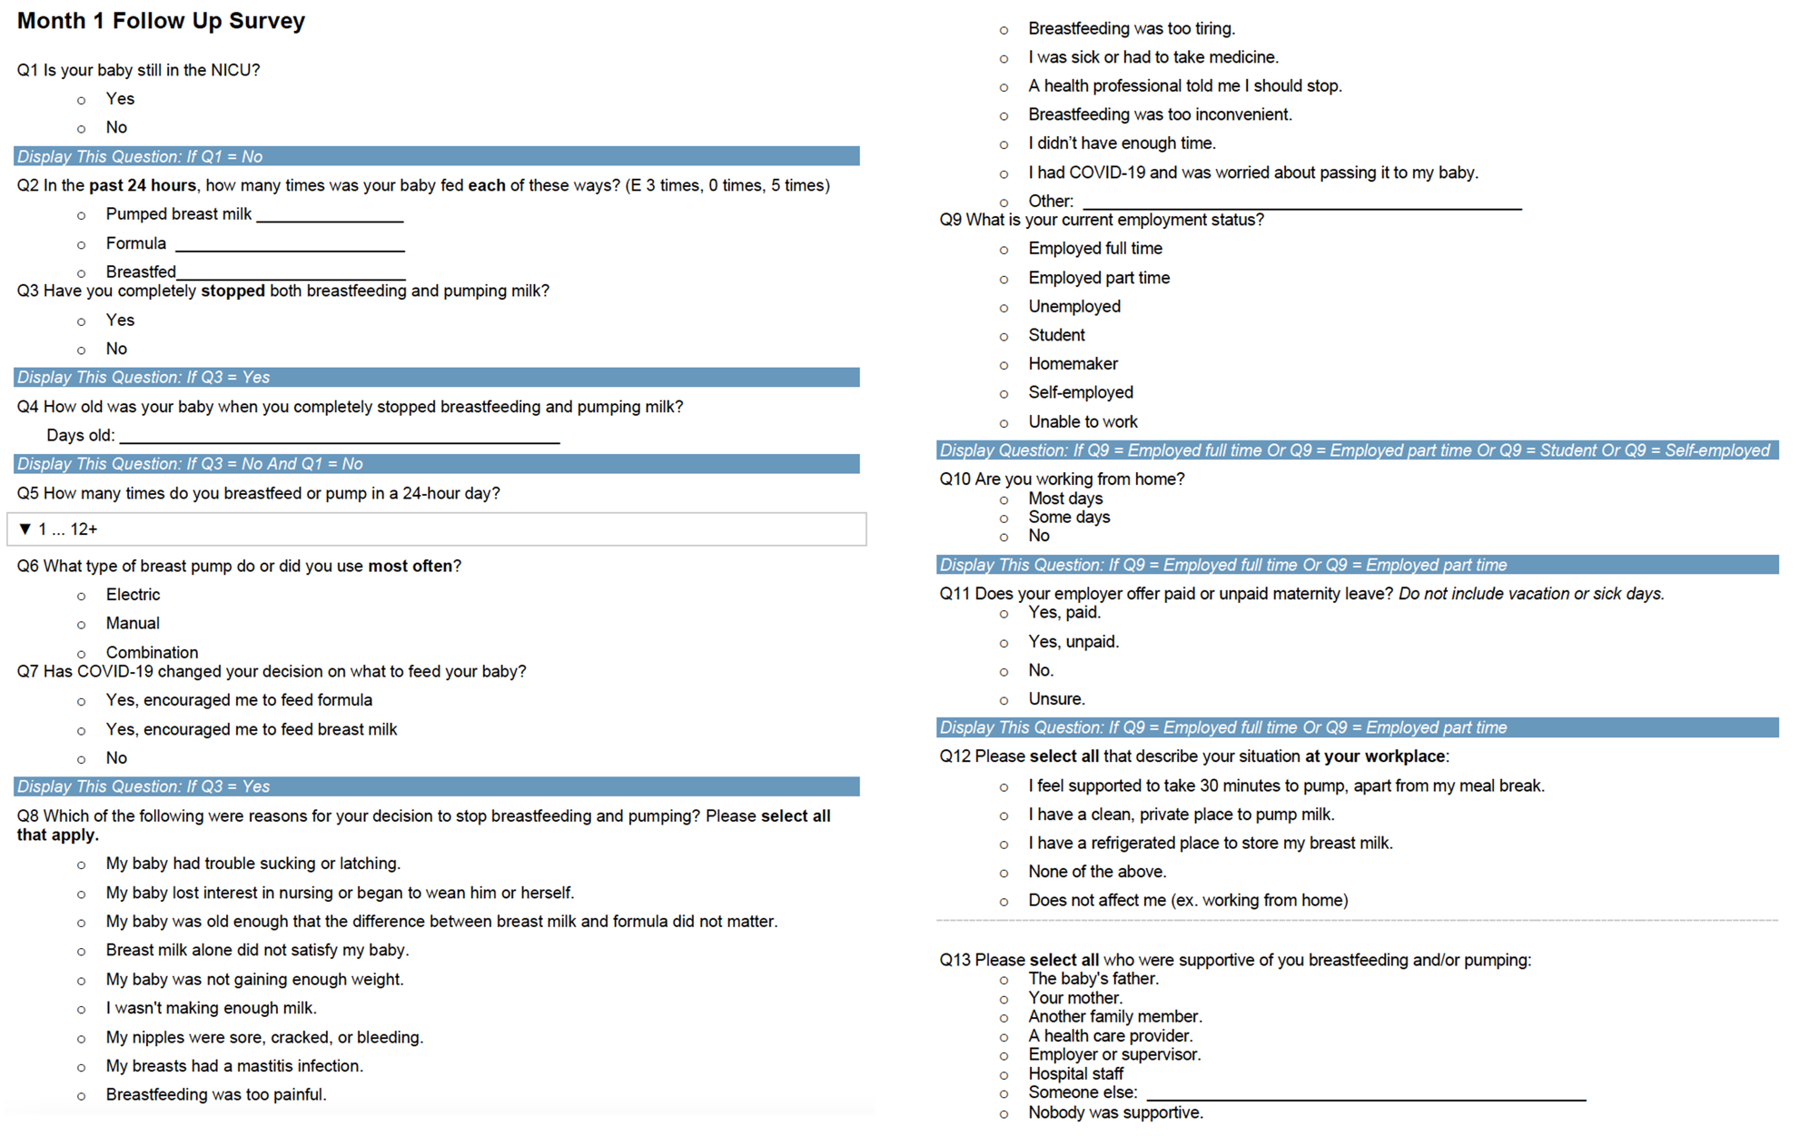
Figure S-1. Follow up survey administered at months 1 and 3 to determine lactation and infant feeding outcomes.

Table S-2. Time-to-event curve summary: any mother’s own milk (MOM) feeding
Group | Month | N.Risk | N.Events | N.Censor | Survival | Std.Err | 0.95LCL | 0.95UCL
Standard | 1 | 20 | 4 | 1 | 0.80 | 0.11 | 0.64 | 1.00
 | 3 | 15 | 8 | 8 | 0.41 | 0.30 | 0.21 | 0.67
Enhanced | 1 | 16 | 1 | 0 | 0.94 | 0.07 | 0.83 | 1.00
 | 3 | 15 | 5 | 10 | 0.63 | 0.19 | 0.43 | 0.91

Table S-3. Time-to-event curve summary: exclusive mother’s own milk (MOM) feeding
Group | Month | N.Risk | N.Events | N.Censor | Survival | Std.Err | 0.95LCL | 0.95UCL
Standard | 1 | 20 | 7 | 1 | 0.65 | 0.16 | 0.47 | 0.90
 | 3 | 12 | 6 | 6 | 0.33 | 0.33 | 0.17 | 0.62
Enhanced | 1 | 16 | 5 | 0 | 0.69 | 0.17 | 0.49 | 0.96
 | 3 | 11 | 6 | 5 | 0.31 | 0.37 | 0.15 | 0.65

Table S-4. Time-to-event curve summary: expressing milk or breastfeeding
Group | Day | N.Risk | N.Events | N.Censor | Survival | Std.Err | 0.95LCL | 0.95UCL
Standard | 17 | 20 | 0 | 1 | 1.00 | 0.00 | 1.00 | 1.00
 | 19 | 19 | 0 | 1 | 1.00 | 0.00 | 1.00 | 1.00
 | 21 | 18 | 0 | 1 | 1.00 | 0.00 | 1.00 | 1.00
 | 25 | 17 | 1 | 0 | 0.94 | 0.06 | 0.84 | 1.00
 | 30 | 16 | 1 | 0 | 0.88 | 0.09 | 0.74 | 1.00
 | 32 | 15 | 1 | 2 | 0.82 | 0.11 | 0.66 | 1.00
 | 34 | 12 | 2 | 0 | 0.69 | 0.17 | 0.49 | 0.96
 | 38 | 10 | 1 | 0 | 0.62 | 0.20 | 0.42 | 0.92
 | 62 | 9 | 0 | 1 | 0.62 | 0.20 | 0.42 | 0.92
 | 70 | 8 | 1 | 0 | 0.54 | 0.24 | 0.34 | 0.87
 | 78 | 7 | 1 | 0 | 0.46 | 0.29 | 0.26 | 0.81
 | 84 | 6 | 0 | 1 | 0.46 | 0.29 | 0.26 | 0.81
 | 91 | 5 | 1 | 0 | 0.37 | 0.36 | 0.18 | 0.76
 | 92 | 4 | 0 | 2 | 0.37 | 0.36 | 0.18 | 0.76
 | 115 | 2 | 0 | 1 | 0.37 | 0.36 | 0.18 | 0.76
 | 150 | 1 | 0 | 1 | 0.37 | 0.36 | 0.18 | 0.76
Enhanced | 11 | 16 | 1 | 0 | 0.94 | 0.07 | 0.83 | 1.00
 | 29 | 15 | 0 | 1 | 0.94 | 0.07 | 0.83 | 1.00
 | 31 | 14 | 1 | 0 | 0.87 | 0.10 | 0.72 | 1.00
 | 37 | 13 | 0 | 1 | 0.87 | 0.10 | 0.72 | 1.00
 | 46 | 12 | 0 | 1 | 0.87 | 0.10 | 0.72 | 1.00
 | 48 | 11 | 1 | 0 | 0.79 | 0.14 | 0.61 | 1.00
 | 56 | 10 | 1 | 0 | 0.71 | 0.17 | 0.51 | 1.00
 | 91 | 9 | 1 | 0 | 0.63 | 0.21 | 0.42 | 0.95
 | 92 | 8 | 0 | 6 | 0.63 | 0.21 | 0.42 | 0.95
 | 107 | 2 | 0 | 1 | 0.63 | 0.21 | 0.42 | 0.95
 | 113 | 1 | 0 | 1 | 0.63 | 0.21 | 0.42 | 0.95

Table S-5: Feasibility metrics
 | Enhanced (n=16) | Standard (n=20) | Total (n=36)
Enrollment
Screened (n=130)
Eligible | – | – | 57 (44%)
Enrolled | 19 | 22 | 41 (32%)
Withdrew (n=19) | 3 (16%) | 2 (9%) | 5 (12%)
Participated, of enrolled | 16 (84%) | 20 (91%) | 36 (88%)
Participated, of screened | – | – | 36 (28%)
Attrition & Censoring
Month 1 Attrition (n=36) | 2 (6%) | 3 (8%) | 5 (14%)
Month 3 Attrition (n=27) | 2 (7%) | 5 (19%) | 7 (26%)
Overall Attrition (n=36) | 4 (11%) | 8 (22%) | 12 (33%)
Acceptability
Texts were convenient | 16 (100%) | 20 (100%) | 36 (100%)
Texts were a nuisance | 1 (6%) | 1 (5%) | 2 (6%)
Texts were easy to understand | 16 (100%) | 20 (100%) | 36 (100%)
Texts were time consuming | 0 (0%) | 3 (15%) | 3 (8%)
Texts provided important information | 16 (100%) | 19 (95%) | 35 (97%)
Text frequency was
Too much | 0 (0%) | 2 (10%) | 2 (10%)
Not enough | 1 (6%) | 0 (0%) | 1 (3%)
Just right | 15 (94%) | 18 (90%) | 33 (92%)
Personalized messages were helpful [enhanced group]¹ | 1.4 mean  [range 1-3] | – | –
Sodium information was easy to understand [enhanced group]¹ | 1.4 mean  [range 1-4] | – | –
Accompanying information on pumping frequency was helpful [enhanced group]¹ | 15 (94%) | – | –
¹Measured on a Likert scale (1-4) from very helpful (1) to very unhelpful (4).

