Supplementary Notes

1 Different Models we have tried
1.1 MuSeAM model: MuSeAM model detects the presence of motifs in the sequence. But fails to capture how these motifs are spread in the sequence. Training with larger motifs in a single layer means that they have to capture combinations of motifs and their distributions. This makes the model larger and harder to interpret. Models we have trained in this architecture have not reached the expected results. (r: 0.64). We have also tried using filters of different lengths in our MuSeAM model in order to allow capturing larger regions. (r: 0.781).
1.2 Model with dinucleotide encoded input: To show that the distribution of only dinucleotides is not enough to accurately predict bendability we also trained a CNN model that takes dinucleotide one-hot encoding as input and learns dinucleotide occurrence patterns in the first 1D convolution layer and their distribution in the second convolution layer. This model achieves Pearson's r=0.802 on the test dataset whereas a previous model which takes dinucleotide counts and gapped dinucleotides counts achieved Pearson’s r=0.6.
1.3 Multinomial CNN-RNN Model: We have also tried increasing and decreasing model depth, width and changing hyperparameters. We had also experimented with RNNs in our second layer. Using a model with multinomial CNN layer and then a bidirectional GRU layer resulted in Pearson's correlation (r) of 0.8452 in the test set. Although the models are very close in their performance, we had decided to move forward with the DeepBend architecture as it provided the scope for a better understanding of what makes sequences more or less bendable. All the models have been trained on Tiling library, validated on ChrV test library (Methods 1) and tested on Random library. The results of these models are summarised in Supplementary Table 2.
1.4 Machine Learning Models using sequence features:
We used several machine learning models such as Linear Regression, Support Vector Machine and Random Forest to predict bendability of sequences from extracted features. As features, we used the number of times each of the 16 dinucleotides, 64 trinucleotides and 256 tetranucleotides occurred in a sequence and 136 helical separation extent values, which is a measure of tendency of a dinucleotide pair to be separated at helical distance ¹⁶. Thus, each sequence was converted into a 152 feature vector. The models were trained on Tiling library and tested on Random library, Cerevisae nucleosomal library and chromosome V library. The Pearson's correlation between predicted and actual values for these models are shown in Supplementary Table 1.

2 Motifs in Chromatin Conformation Found by Meme-suite
We used streme [15] to find enriched motifs of 8-bp width in domains and boundaries. -250 bp to +250 bp around all boundaries middle in 16 chromosomes were considered as boundary sequences. The rest of the chromosome was considered in domains. Average domain sequence length was about 3700bp. When finding enrichment of boundary sequences, we used domain sequences as control sequences and vice versa.
Motif Logo | P-value | Motif logo | P-value
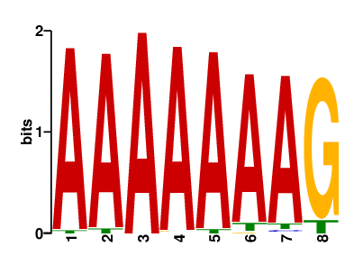 | 4.2e-016 | 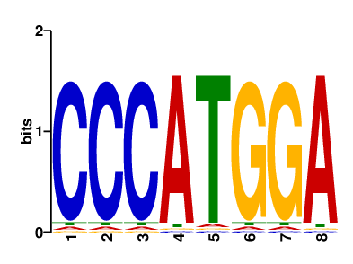 | 3.7e-003
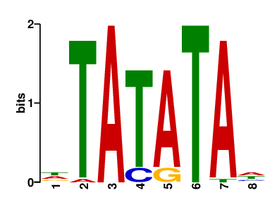 | 2.7e-009 | 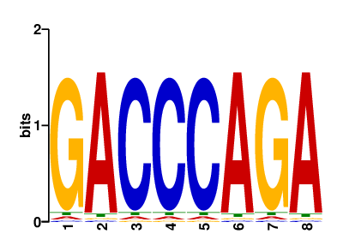 | 3.7e-002
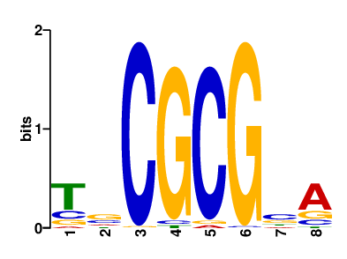 | 4.3e-008 | 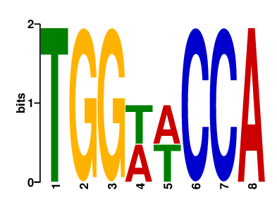 | 4.1e-002
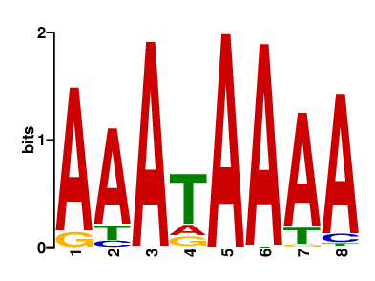 | 4.8e-007 | 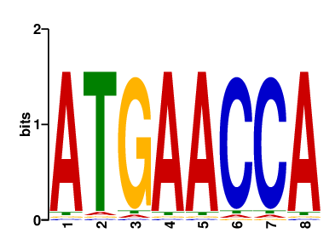 | 4.4e-002
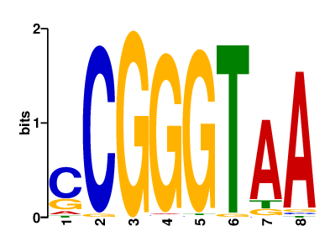 | 1.0e-005 | 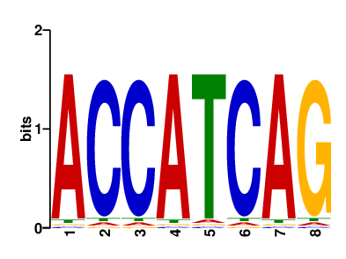 | 6.0e-002
Supplementary Fig. 1. Motifs found by meme-suite. (Left) Motifs that are relatively enriched in boundaries compared to domains. (Right) Motifs that are relatively enriched in domains compared to boundaries.

