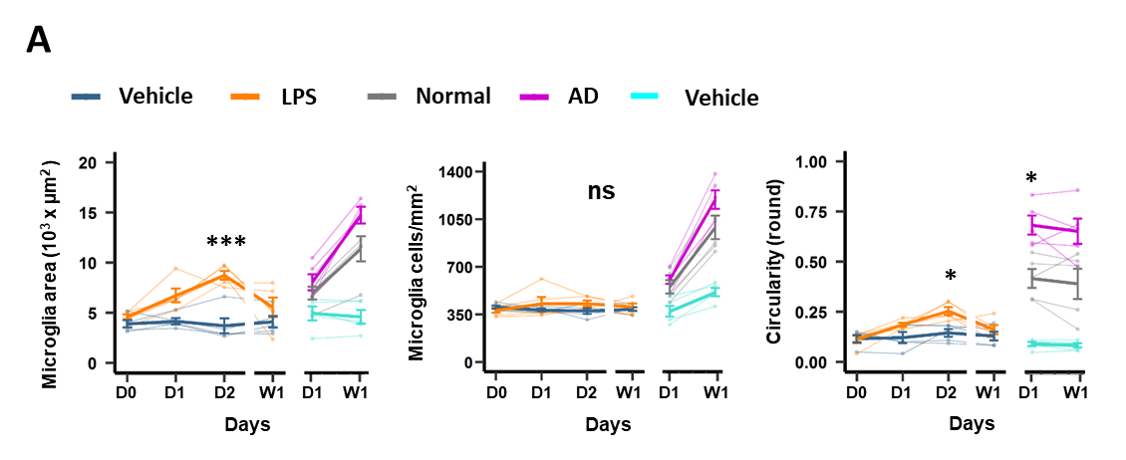

Supplementary Figure 1: Morphological changes of microglia during inflammation. A: Effects of LPS and Tau-AD on microglia recruitment (microglia total area and the number of microglia) and somatic circumference (circularity). Data are shown as mean ± SEM values, n=5 mice per group. Asterisks indicate comparisons between AD and normal groups and LPS and vehicle. * p < 0.05, ** p < 0.01, *** p < 0.001, GEE post-hoc pairwise comparison with Tukey method.

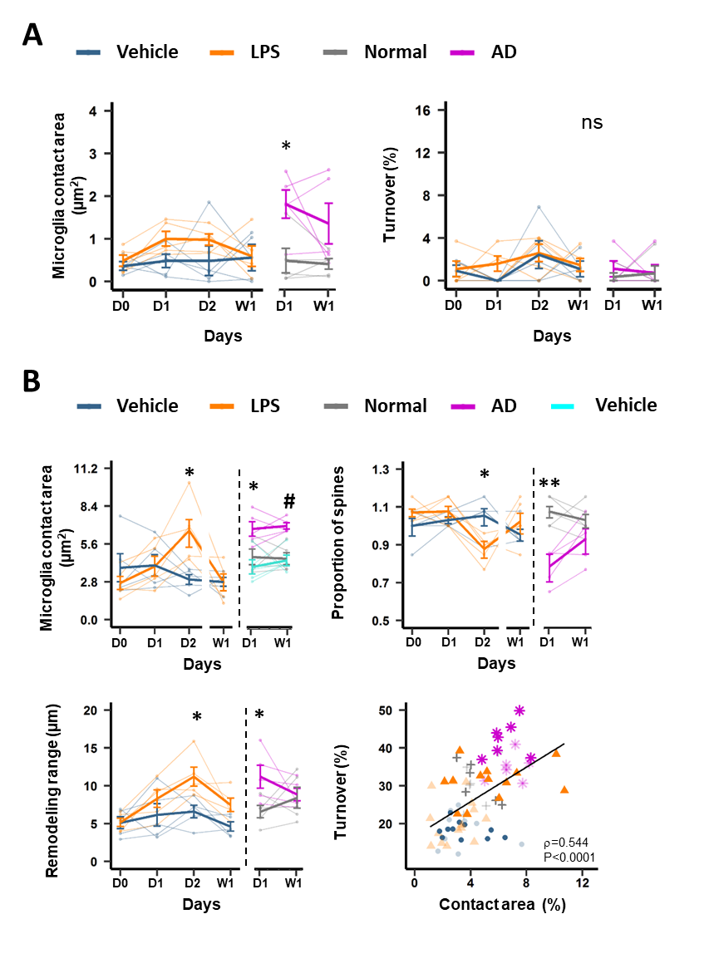
Supplementary Figure 2: Tau-AD and LPS modulate microglia interaction with synapses under basal conditions and in response to spine photodamage. A: Baseline recordings were performed every 10 minutes for 2 hours of selected dendritic and axonal branches per each mouse. Asterisks show multiple comparisons between LPS vs vehicle treatment and AD vs Normal extracts at each day of evaluation for microglia-spine contact duration. Bold lines show group mean ± SEM values, thin lines represent individual animals. * p < 0.05, ns=not significant, GEE post-hoc pairwise comparison with Tukey method. B: Microglia-neuron interactions after photodamage. (Left) An increase in microglia contact area after LPS (D2: Vehicle: 2.97±0.36 % vs LPS: 6.59±1.02 %, p=0.029) and Tau-AD treatments (Control: 4.64±0.58 μm² vs Tau-AD: 6.71±0.53 μm², p=0.029). Analysis of remodeling range. (Right) Proportion of survived spines was calculated as the ratio between the number of spines 2 hours before and after photodamage. Correlation between spine turnover and microglia-neuron contact area after photodamage (n=5 mice per group; Spearman`s test). Each symbol represents one photodamage experiment, the solid line shows linear regression. ρ, Spearman's coefficient correlation. Asterisks show multiple comparisons between treatments at each particular timepoint. * p < 0.05, ** p < 0.01, *** p < 0.001, GEE post-hoc pairwise comparison with Tukey method. Bold lines show group mean ± SEM values, thin lines represent individual animals (n=5 mice).
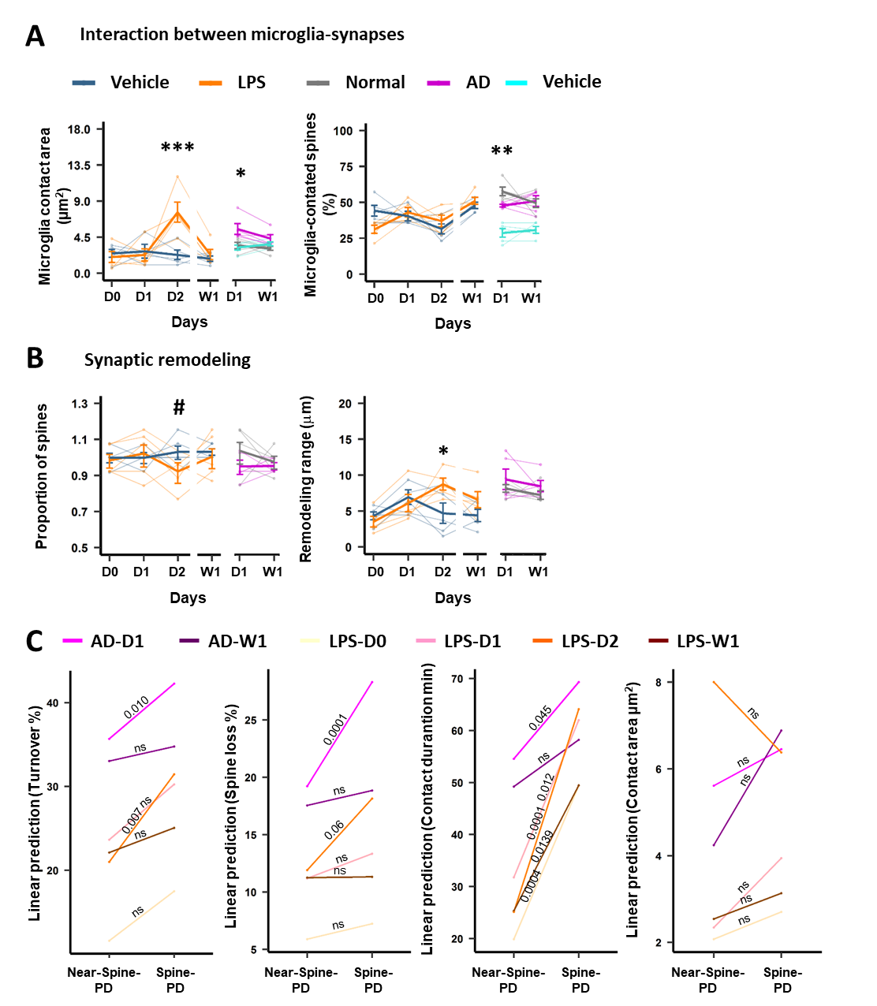
Supplementary Figure 3. Microglia-synapse interaction and synaptic remodeling following Near-Spine-PD. A-B: Microglia-synapse interaction and synaptic remodeling associated to Near-Spine-PD. Time-course of LPS and Tau-AD effects on microglia-neuron interaction (A) and synaptic remodeling (B) parameters after Near-Spine-PD. Bold lines show group mean ± SEM values, thin lines represent individual animals (n=5 mice per group). Asterisks indicate comparisons between AD and vehicle groups and LPS and vehicle.* p < 0.05, ** p < 0.01, *** p < 0.001 for GEE post-hoc pairwise comparison with the Tukey method. C: Comparison between Spine-PD and Near-Spine-PD in the remodeling and microglia-synapse interaction parameters for each treatment group (connected by line). Asterisks denote p-value adjusted using Tukey method for multiple comparisons (ns = not significant).
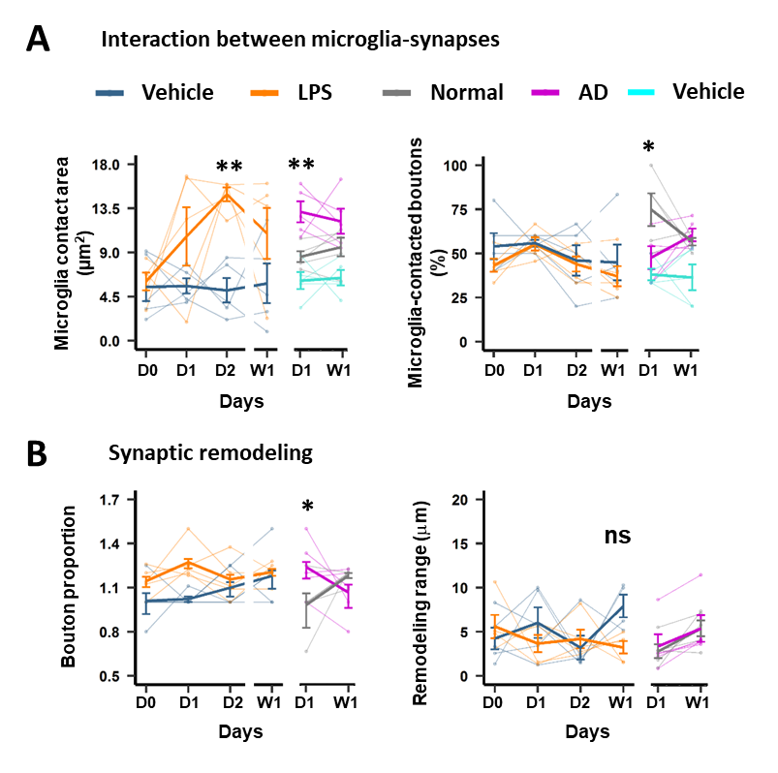
Supplementary Figure 4. Microglia-synapse interaction and synaptic remodeling following Near-Bouton-PD. Changes in microglia-neuron interaction (A) and synaptic remodeling (B) parameters for Near-Bouton-PDBold lines show group mean ± SEM values, thin lines represent individual animals (n=5 mice per group). Asterisks indicate comparisons between AD and normal groups and LPS and vehicle. * p < 0.05, ** p < 0.01, *** p < 0.001 for GEE post-hoc pairwise comparison with the Tukey method.
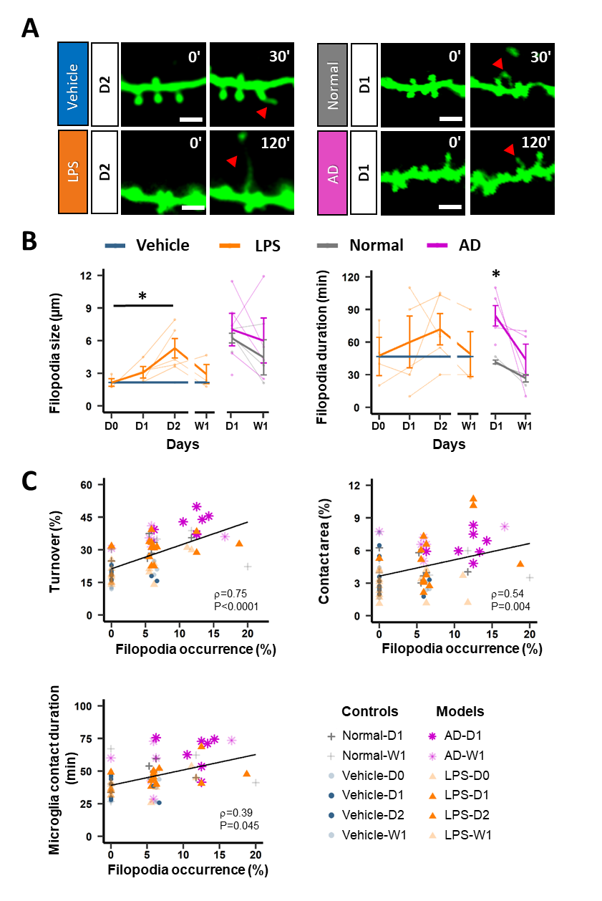

Supplementary Figure 5. spine head filopodia formation/elimination in two models of neuroinflammation. A: Formation of SHF (red arrows) from the head of spines after photodamage. Time is given in minutes for all groups. Scale bars, 3 μm. B: Quantification of filopodia formation after photodamage under neuroinflammatory and control conditions. Size and duration of filopodium were calculated during the 2 hours of evaluation for each experiment. As the frequency of filopodia formation was low in the vehicle group (D0, D1, D2 and W1), all filopodia events in this group were pooled with events in the D0-LPS group to perform statistical comparisons. A significant increase was found in the size of filopodium at D2 in comparison with D0 (D0: 2.27±0.35 μm vs D2: 5.85±1.24 μm, p=0.036). However, the lifetime of the filopodium did not differ between treatments or days. Unlike for LPS, SHF lived longer in the Tau-AD group when compared to the control group at D1 and no significant changes were found in size. Black asterisks and lines denote comparisons between treatments per day. Bold lines show group mean ± SEM values, thin lines represent individual animals. * p < 0.05, ** p < 0.01, *** p < 0.001, GEE and GLM post-hoc pairwise comparison with Tukey method for Tau-AD and LPS experiments, respectively. C Correlations between filopodia occurrence and the turnover of spines, microglia-neuron contact area and the duration of the contact. Each symbol represents the mean value per day per animal, the solid line shows linear regression. ρ, Spearman's coefficient of correlation.
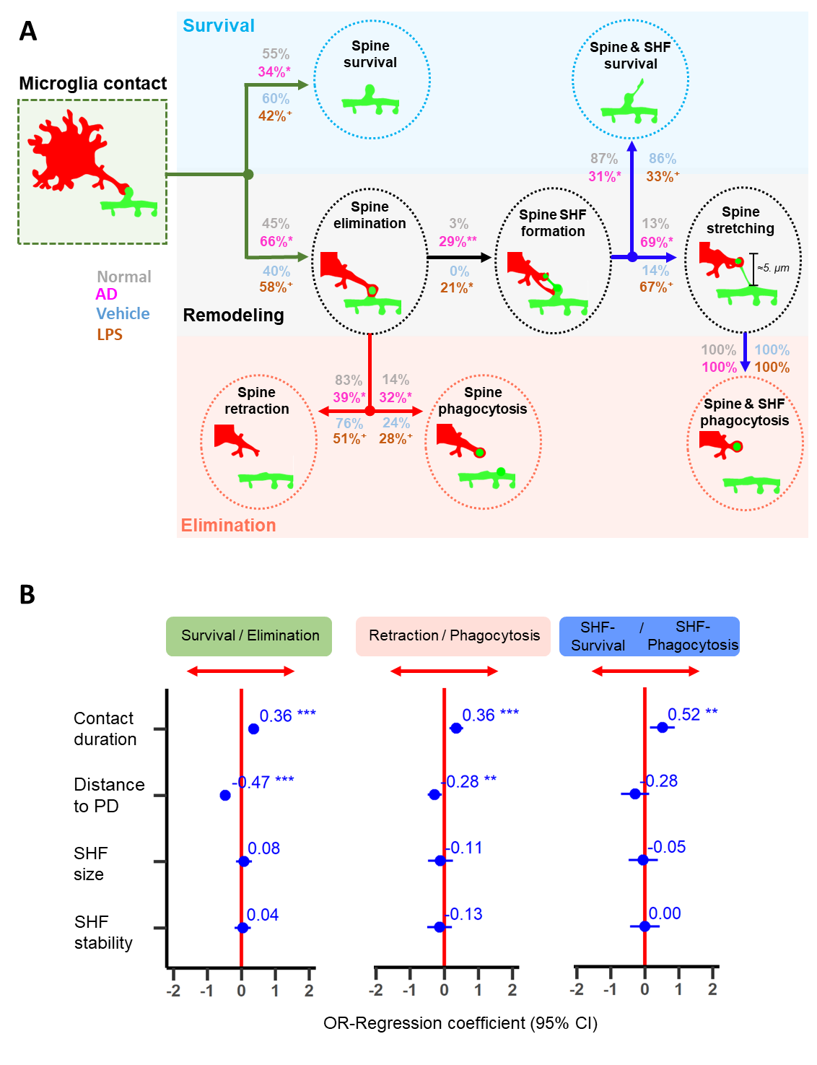
Supplementary Figure 6. Real-time mechanisms of microglia-synapse interaction and spine head filopodia formation/elimination in two models of neuroinflammation. A: Gray, pink, blue, and orange colors indicate the percentages of spines for each transition in Normal-D1, AD-D1, Vehicle-D2 and LPS-D2 groups, respectively. The significant differences between neuroinflammatory models and controls are shown as *p < 0.05, **p < 0.01 and tendencies as ⁺p < 0.1, the Fisher’s exact test. Note a similarity of changes in LPS and AD models relative to the corresponding controls: Neuroinflammation increased the chances that a spine contacted by activated microglia will be eliminated/remodeled compared to the chances that it will be maintained in its original configuration. Furthermore, the spines contacted by activated microglia are more likely to be eliminated by phagocytosis than be retracted like spines contacted by healthy-resting microglia. Following spine engulfment, activated microglia much more often induce SHF, its stretching and spine elimination than in control conditions. B: Forest plot of estimates (95% confidence interval) from univariate logistic regression models for the association between choices (Elimination/Survival, Phagocytosis/Retraction or SHF-phagocytosis/Survival) and contact duration, distance to the photodamage, SHF size and stability. Significant predictors were contact duration and distance to the photodamage. **p < 0.01, ***p < 0.001, logistic regression.

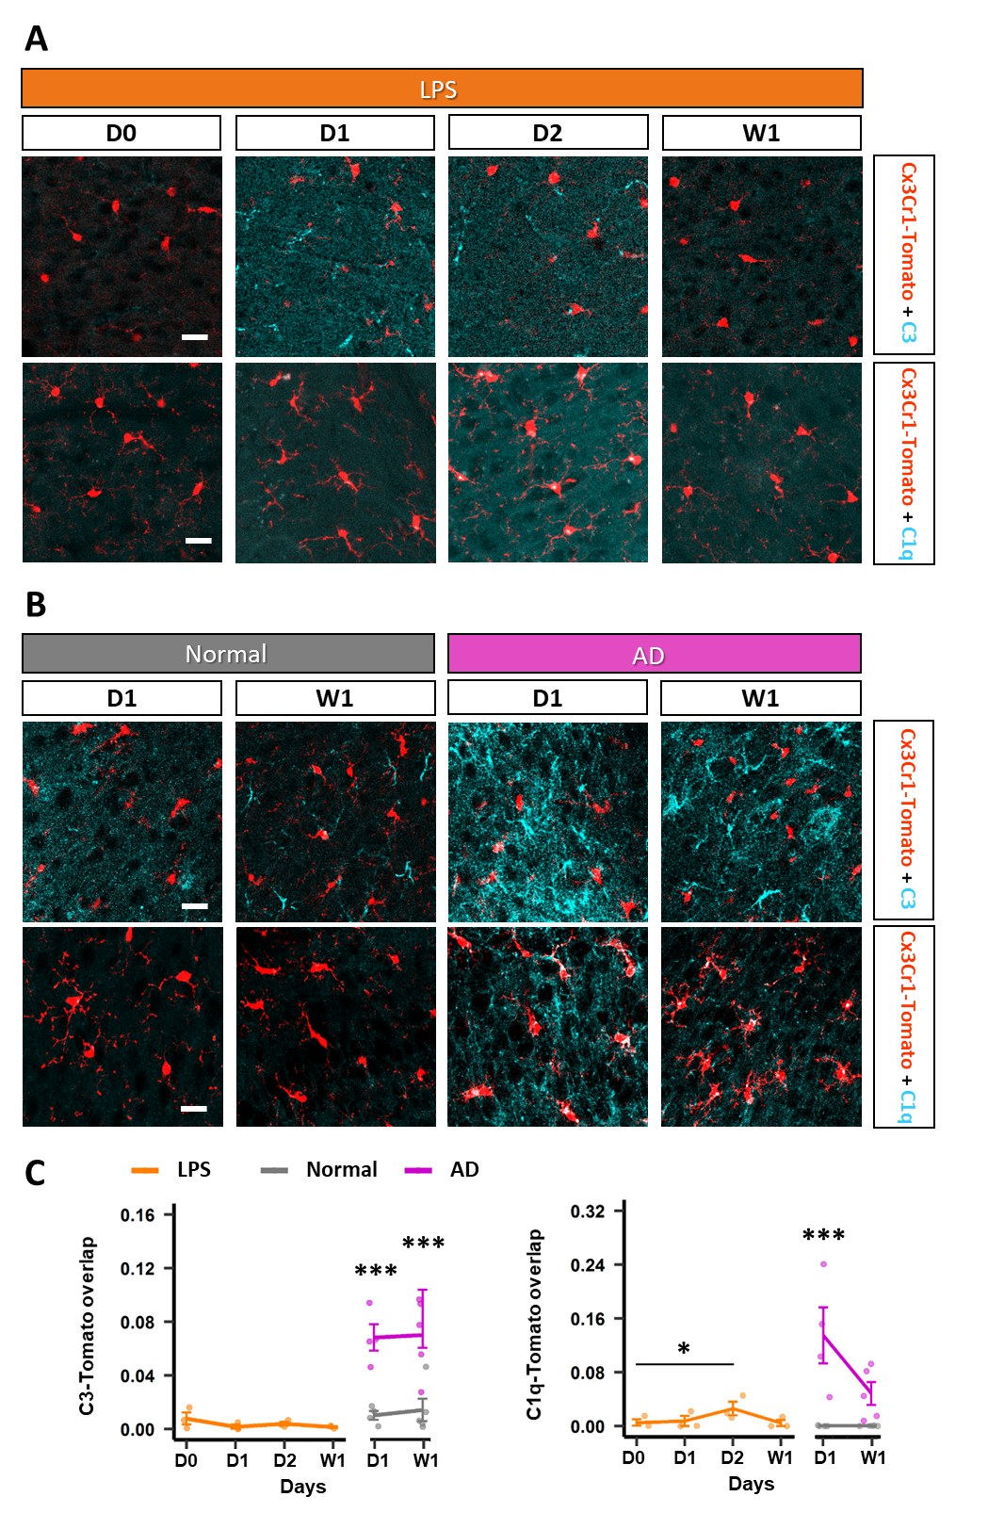

Supplementary Figure 7: Increased C1q and C3 colocalization with microglia in Tau-AD and LPS treated mice. A and B: Confocal RSC images of mice injected with Tau-AD or LPS, and controls to illustrate the expression of C1q (cyan) or C3 (cyan) and CX3CR1Cre/Tomato (red). Scale bar, 20 µm. C: Significantly increased co-localization of C1q and C3 with CX3CR1-Tomato was observed in the RSC of mice injected with Tau-AD (D1: n=4 mice in each group; W1: n=5 mice in each group), but not those injected with the control extract (D1: n=4 mice in each group; W1: n=5 mice in each group). A similar effect was observed after LPS stimulation (D0, D1, D2 and W1: n=3 mice). Bold lines show group mean ± SEM values, dots represent individual animals. * p < 0.05, ** p < 0.01. GLM followed by post hoc Tukey’s test.

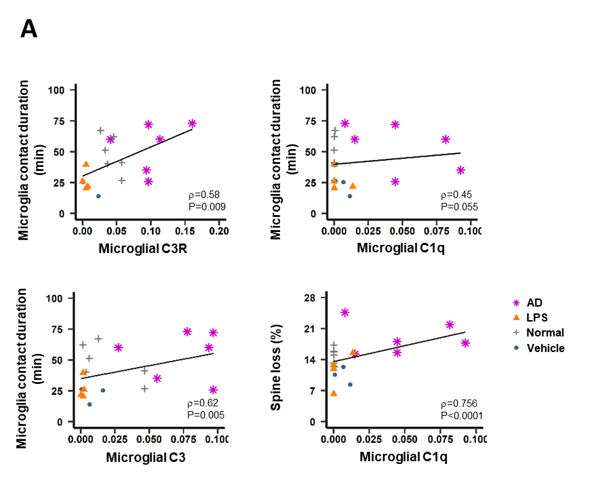

Supplementary Figure 8: Relationship between the complement proteins and microglia-synapse interaction parameters. A: Correlations between the immunoreactivity of complement system proteins C1q, C3 and C3R with microglia contact duration and synaptic loss are shown. Each symbol represents the mean value per animal, the solid line shows linear regression. ρ, Spearman's coefficient of correlation.

Supplementary Video 1. Microglia-spine interaction on D2 after systemic vehicle injection. Representative time-lapse recording (120 min with 10 min interval). Microglia are visualized in red and neurons in green, the contact area between both cells is in yellow. Scale bar= 3µm.
Supplementary Video 2. Microglia-spine interaction on D2 after systemic LPS injection. Representative time-lapse recording (120 min with 10 min interval). Microglia are visualized in red and neurons in green, the contact area between both cells is in yellow. Scale bar= 3µm.
Supplementary Video 3. Microglia-spine interaction on D1 after local injection of normal brain fraction. Representative time-lapse recording (120 min with 10 min interval). Microglia are visualized in red and neurons in green, the contact area between both cells is in yellow. Scale bar= 3µm.
Supplementary Video 4. Microglia-spine interaction on D1 after local injection of Tau-AD. Representative time-lapse recording (120 min with 10 min interval). Microglia are visualized in red and neurons in green, the contact area between both cells is in yellow. Scale bar= 3µm.
Supplementary Video 5. Formation of SHF protruding from the heads of microglia-contacted spines, which survived until 120 min, on D1 in the Tau-AD group. Scale bar= 3µm.
Supplementary Video 6. Formation of SHF from a microglia-contacted spine and its subsequent elimination via phagocytosis on D1 in the Tau-AD group. Scale bar= 3µm.
Supplementary Video S7. Stretching of SHF and spine by microglia processes on D1 in the Tau-AD group. Scale bar= 3µm.

