Supplementary Material

Supplementary Figures
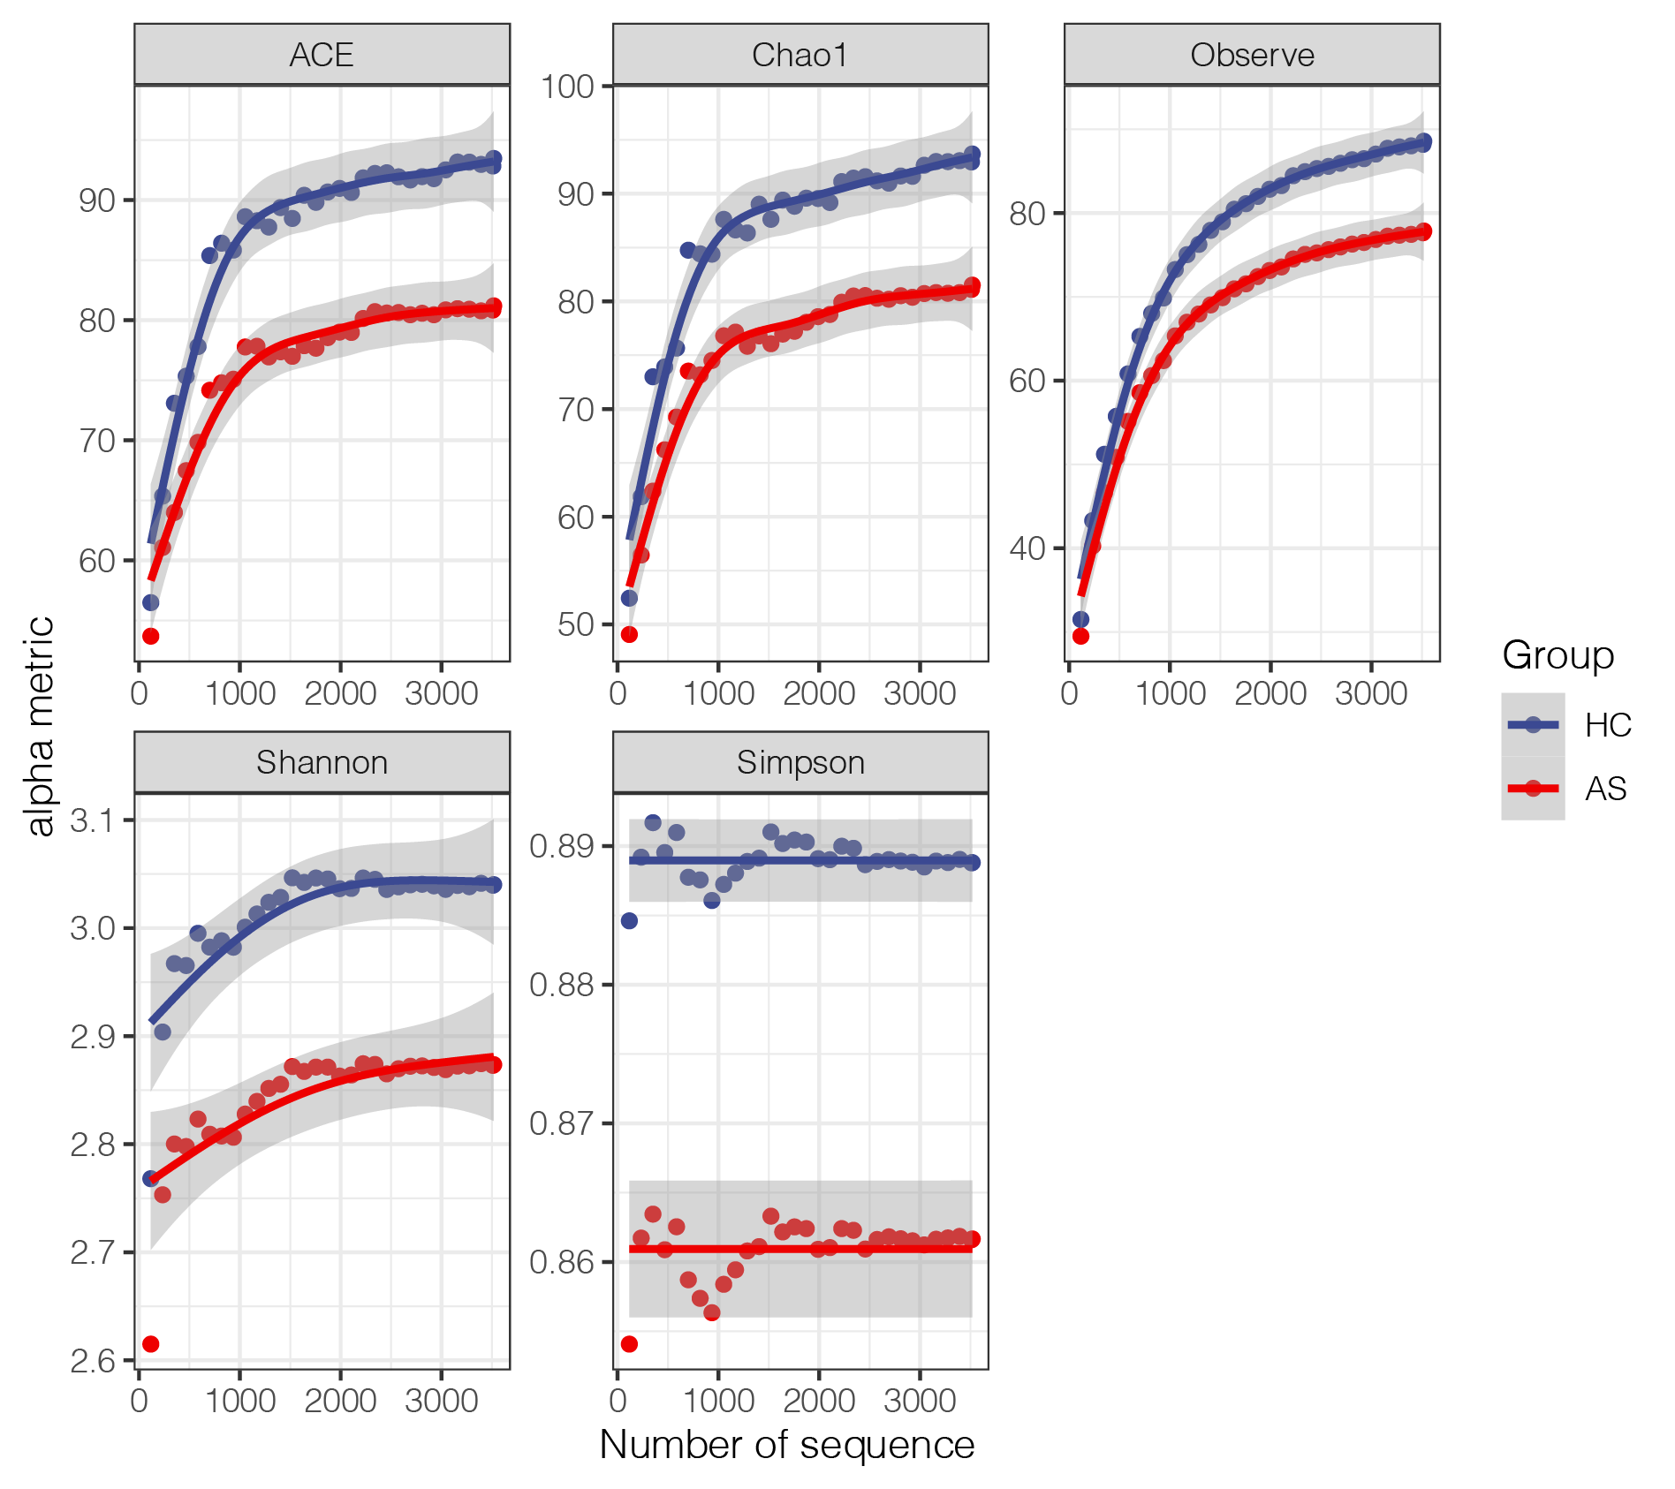
Supplementary Figure 1: Dilution curve of alpha diversity.
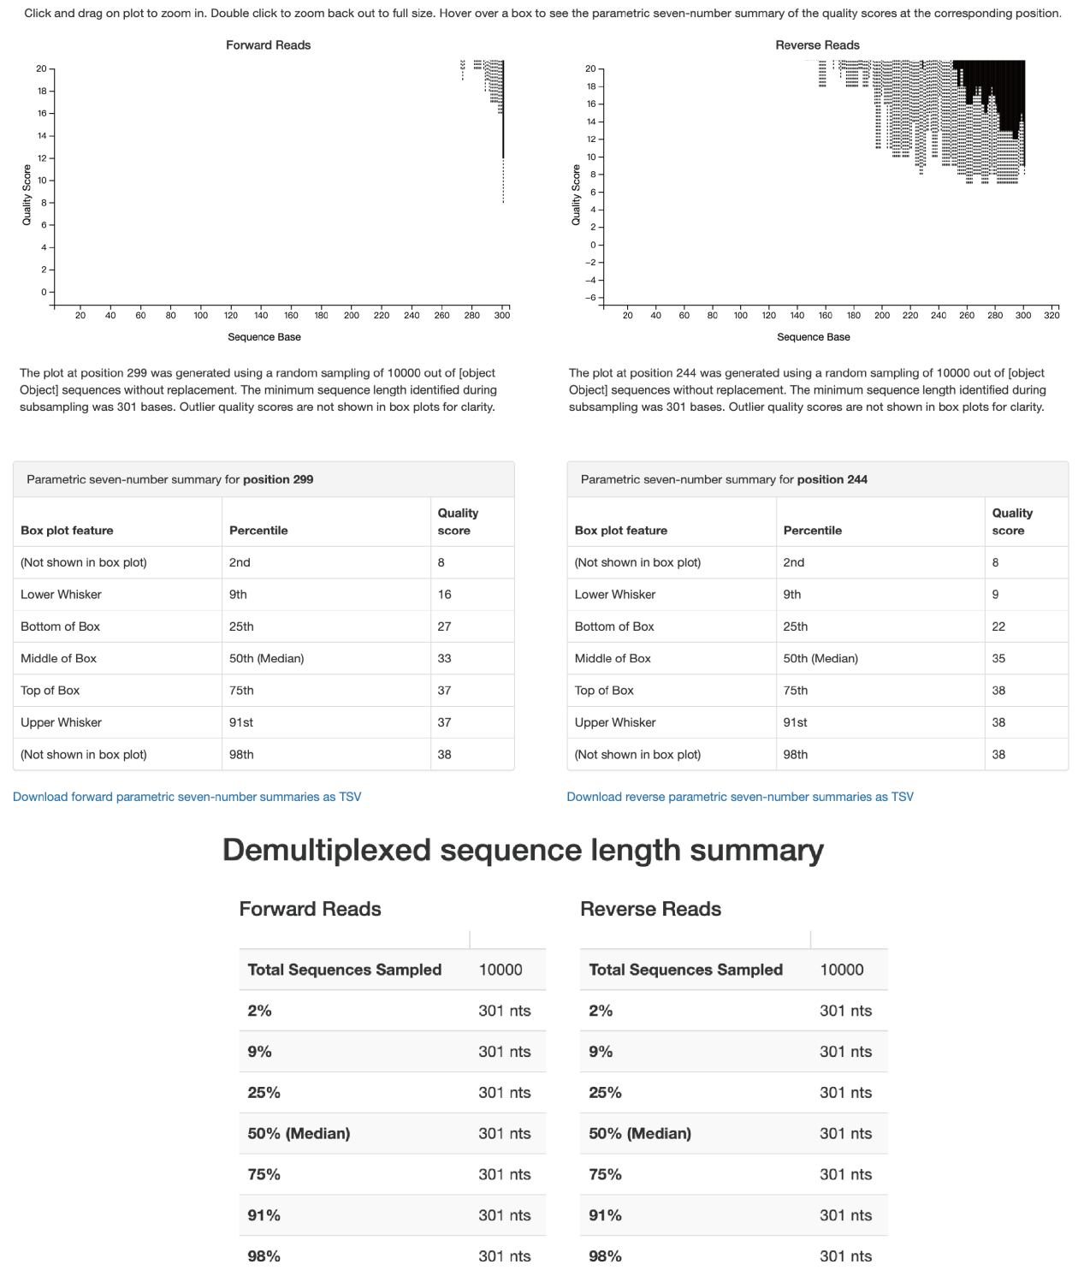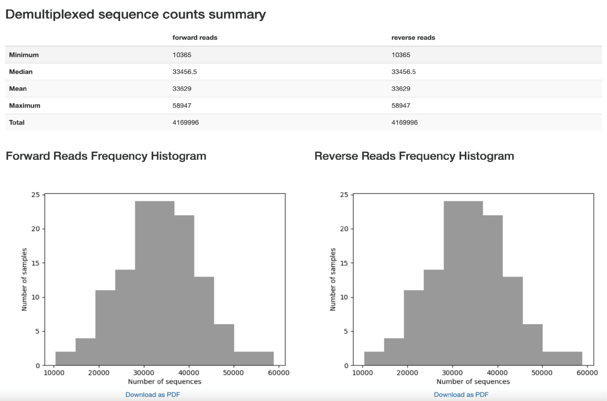
Supplementary Figure 2: The sequence quality information

Supplementary Table

Supplementary Table 1: Correlation results of clinical parameters and specific gut microbiota
clinical parameters | Bacterial taxon | correlation coefficient | P-value
T | Agathobacter | 0.302 | 0.0171
B | Agathobacter | 0.292 | 0.0214
B | Streptococcus | 0.270 | 0.0337
CD4⁺T | Agathobacter | 0.310 | 0.0143
CD4⁺T | Enterobacteriaceae | -0.255 | 0.0457
Th1 | Prevotella | 0.279 | 0.0283
Th1 | CAG-352 | 0.283 | 0.0259
Th2 | Agathobacter | 0.429 | 0.0005
Th2 | Escherichia-Shigella | -0.261 | 0.0401
Th17 | Prevotella | 0.262 | 0.0397
Th17 | Agathobacter | 0.288 | 0.0230
Th17/Treg | Dorea | 0.273 | 0.0319
IL-2 | Agathobacter | 0.443 | 0.0003
IL-4 | Agathobacter | 0.303 | 0.0168
IL-6 | Muribaculaceae | 0.312 | 0.0137
IL-6 | Lachnospiraceae_UCG-004 | 0.320 | 0.0114
IL-10 | Ruminococcus | -0.254 | 0.0465
IL-10 | CAG-352 | -0.284 | 0.0254
IL-17 | [Eubacterium]_hallii | 0.286 | 0.0244
IFN-gama | Phascolarctobacterium | 0.366 | 0.0034
ESR | Roseburia | 0.342 | 0.0065
ESR | Butyricicoccus | 0.310 | 0.0143
ESR | Klebsiella | 0.309 | 0.0146
CRP | Faecalibacterium | 0.352 | 0.0050
CRP | Muribaculaceae | 0.268 | 0.0354
ASDAS-CRP | Faecalibacterium | 0.351 | 0.0051
ASDAS-CRP | Ruminococcus | 0.274 | 0.0314
age | Agathobacter | -0.257 | 0.0437
age | Dorea | -0.294 | 0.0205
age | Butyricicoccus | 0.259 | 0.0423
BMI | Lachnospira | 0.280 | 0.0273
BMI | Lachnospiraceae_UCG-004 | 0.333 | 0.0083
RBC | Dorea | 0.252 | 0.0484
WBC | Agathobacter | 0.251 | 0.0495
WBC | [Eubacterium]_eligens | 0.266 | 0.0369
PLT | Anaerostipes | 0.291 | 0.0220
PLT | Streptococcus | 0.356 | 0.0045
PLT | Clostridium_sensu_stricto_1 | 0.255 | 0.0452
NEUT% | Escherichia-Shigella | 0.313 | 0.0132

