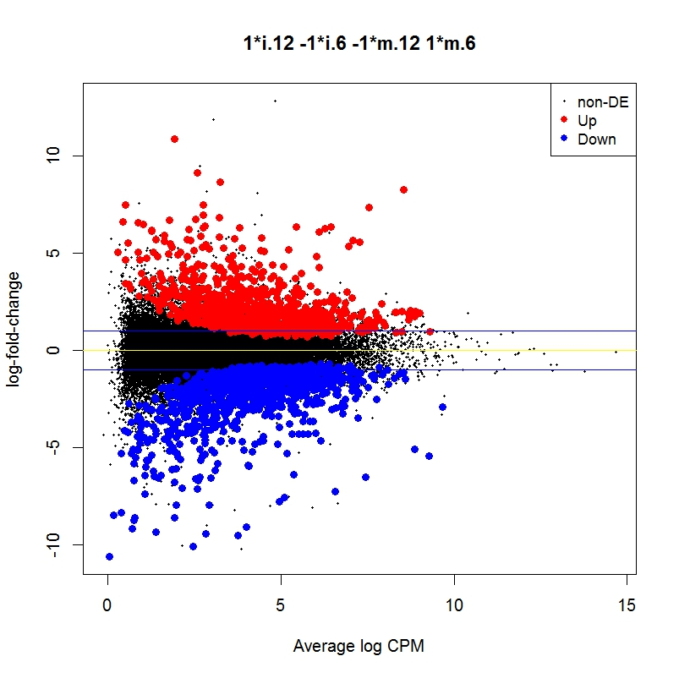
A

.
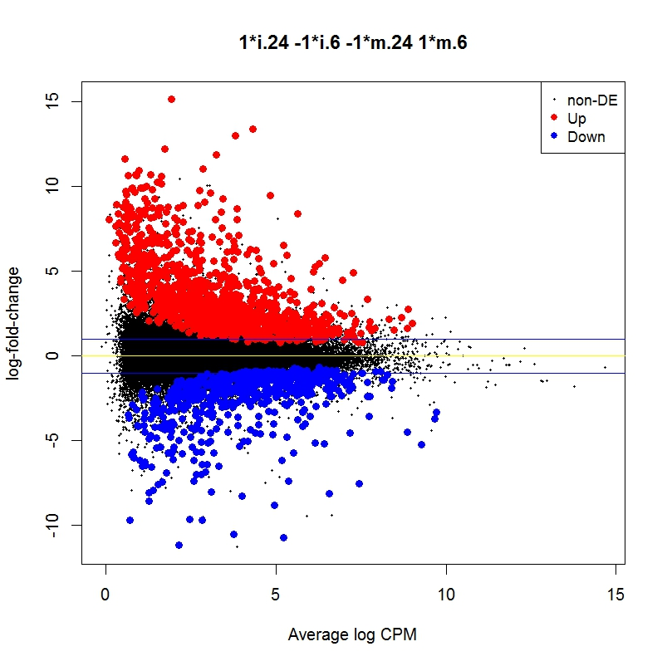
B.

C.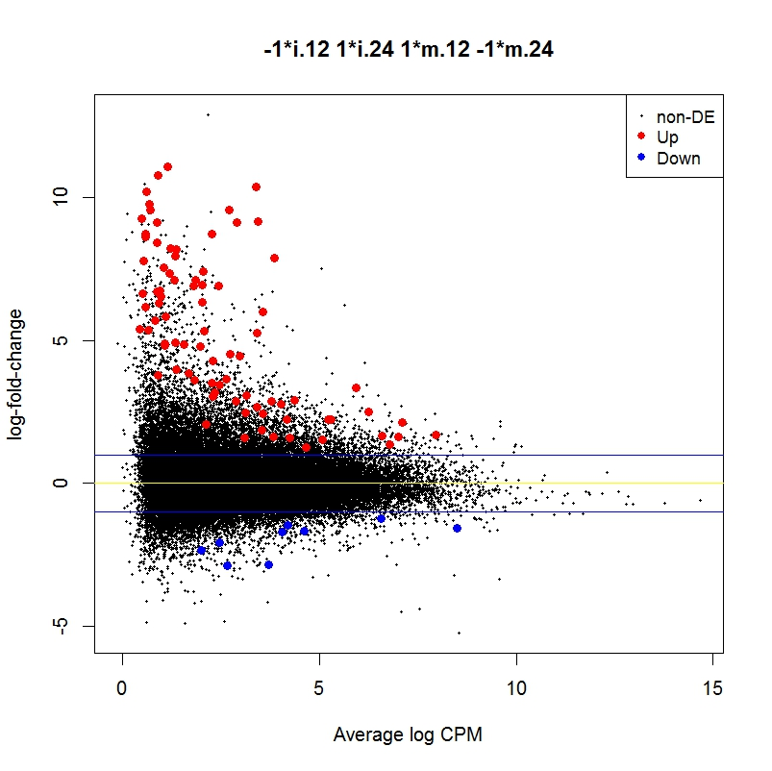

Additional file 4. Mean Difference (MD) plots between Pt- vs Pt-inoculation time comparisons at (A) 12 hai vs 6 hai, (B) 24 hai vs 12 hai and (C) 24 hai vs 6 hai, after removal of the baseline expression differences. Significantly up and downregulated genes at an FDR of 5% are highlighted in red and blue, respectively. Yellow line indicates log₂FC = 0. Blue lines indicate log₂FC > + or -1.

