A1 – Mock-inoculated O hai
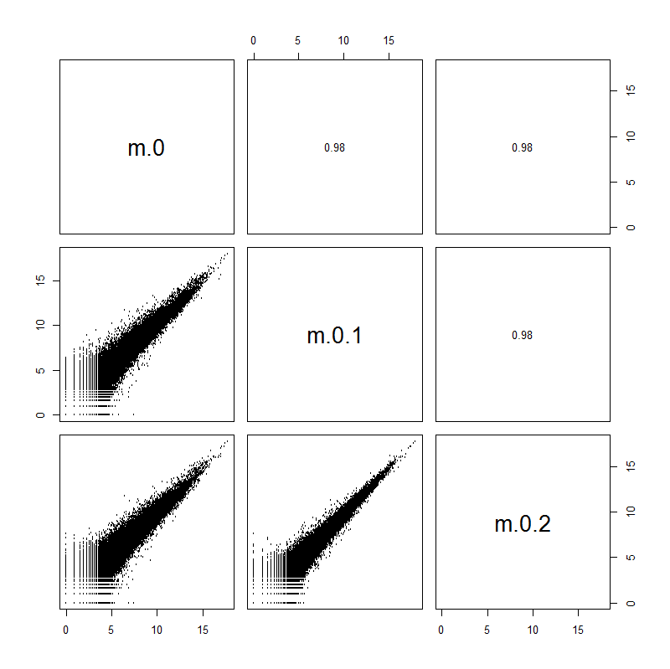

A2 – Pt-inoculated O hai
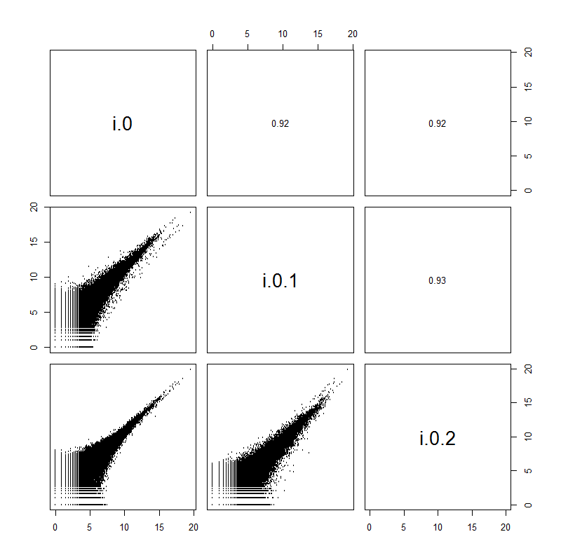

B1 – Mock-inoculated 6 hai

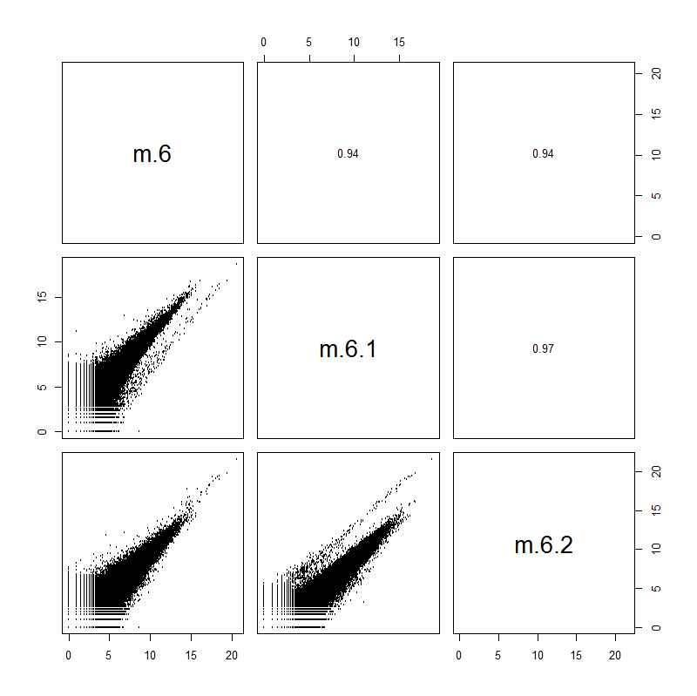

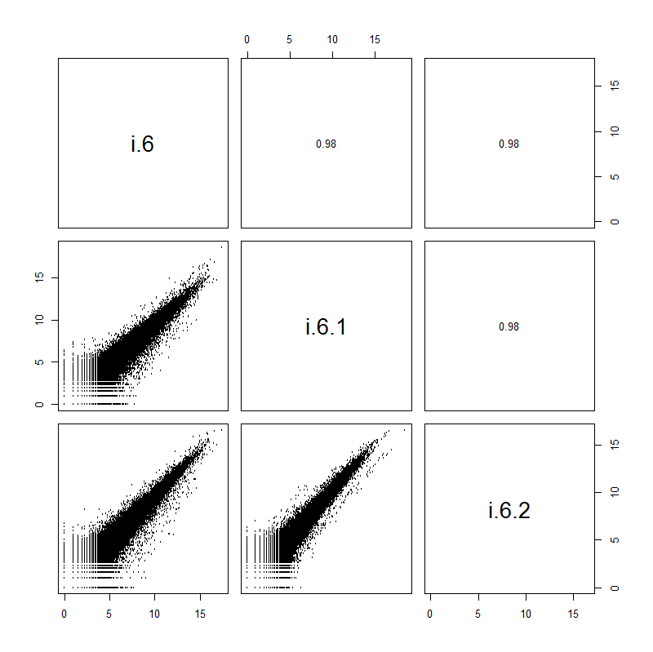
B2 – Pt-inoculated 6 hai
C1 – Mock-inoculated 12 hai
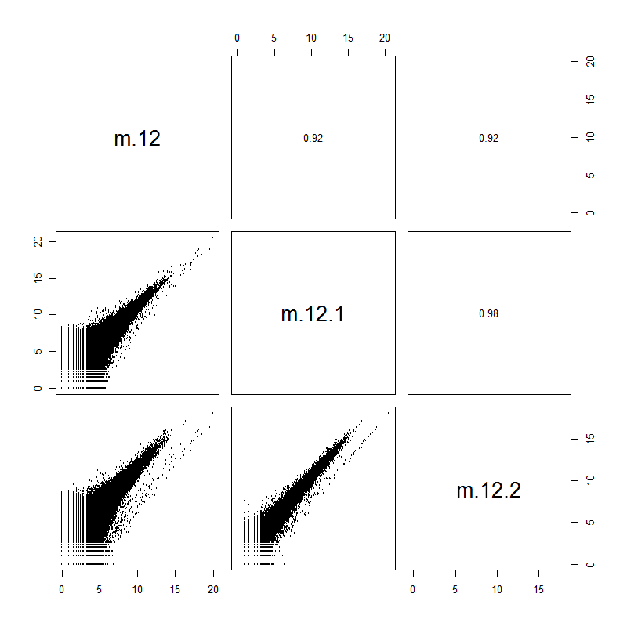

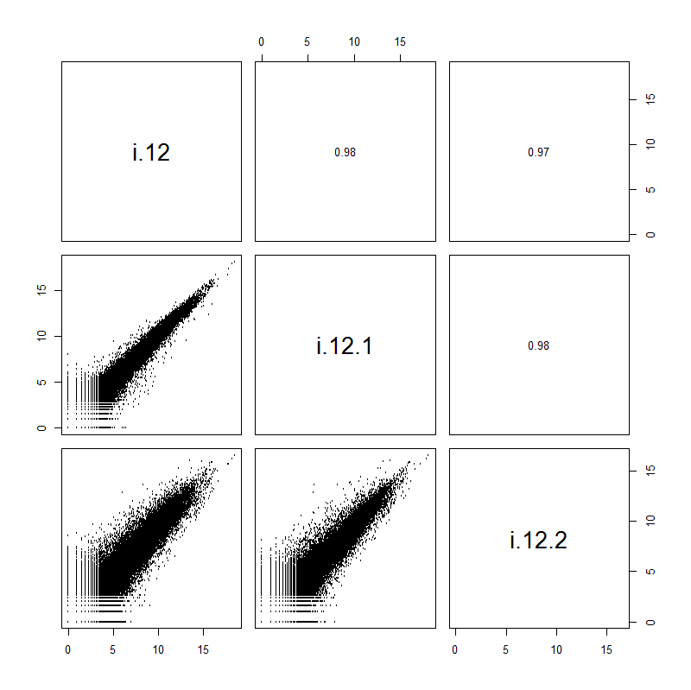
C2 – Pt-inoculated 12 hai

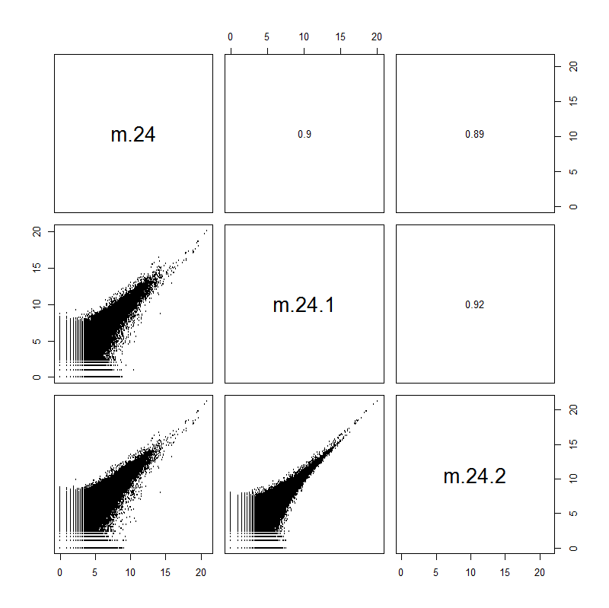
D1 – Mock-inoculated 24 hai

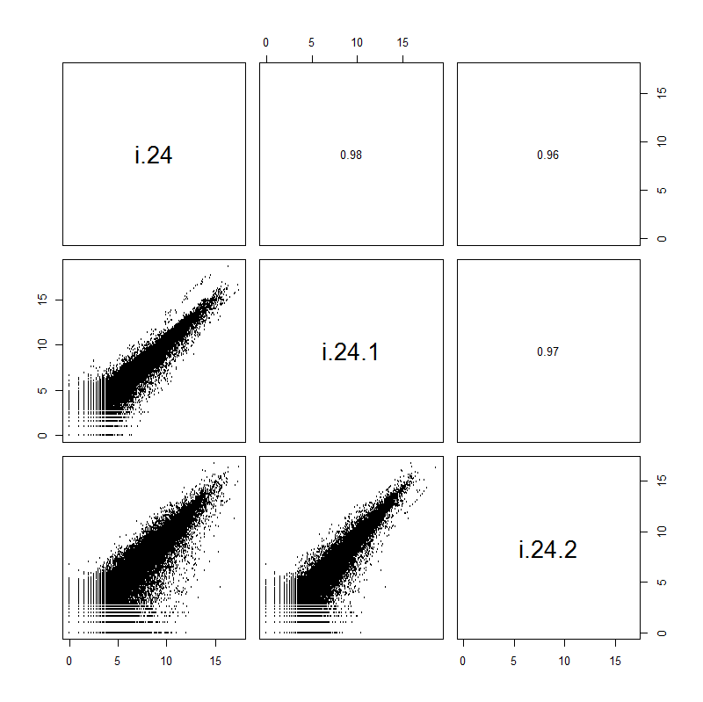
D2 – Pt-inoculated 24 hai

Additional file 2. Pearson’s coefficient of correlation matrix and scatter plots showing relationships between replicate libraries, using log-transformed paired-end read counts Legend: m, Mock-inoculated; i, Pt-inoculated; 0, 6, 12 and 24 hours after inoculation; replicates 1, 2 and 3. Numbers in the upper, right-hand panels indicate Pearson’s coefficient of correlation.

