Supplementary Data
Genome-based reevaluation of the Streptomyces violaceusniger clade and description of Streptomyces sabulosicollis sp. nov. from an Indonesian sand dune
Ali B. Kusuma, Imen Nouioui and Michael Goodfellow

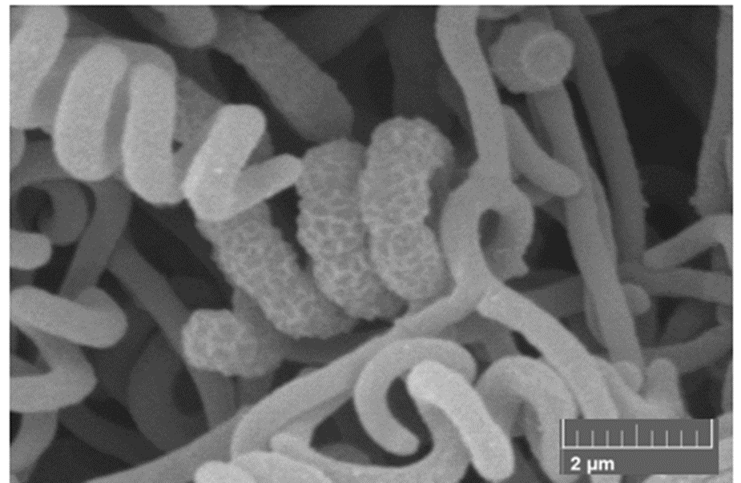

Figure S1. Scanning electron micrograph of isolate PRKS01-29^{T} showing spiral spiral chains of rugose ornamented spores following growth on oatmeal agar at 28°C for 14 days. Bars: 2 μm.

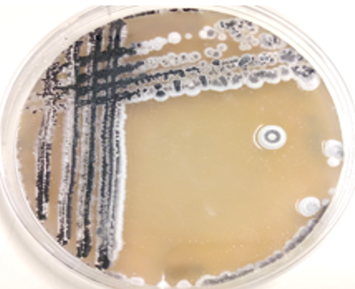

Figure S2. Cultural characteristic of isolate PRKS01-29^{T} showing a grey aerial spore mass which turned black following growth on oatmeal agar after 21 days at 28°C.
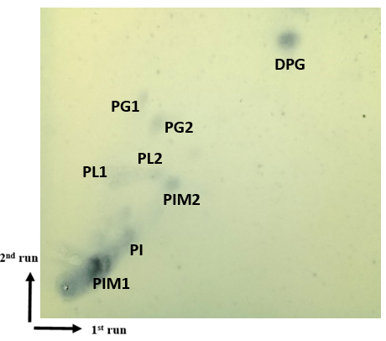

Figure S3. Two-dimensional thin-layer chromatography of the polar lipids of isolate PRKS01-29^{T} stained with molybdatophosphoric acid spray (Sigma P1518). Key: DPG, diphosphatidylglycerol; PG1 and 2, phosphatidylglycerols; PI, phosphatidylinositol; PIM1 and 2, phosphatidylinositolmannosides; PL1 and 2, unidentified phospholipids. Solvent 1: chloroform: methanol: distilled water (65:25:4 v/v); Solvent 2: chloroform: glacial acetic acid: methanol: distilled water (80:12:15:4 v/v). In the first run the TLC plate was positioned in a perpendicular position towards the solvent direction., in the second run, the position of the TLC plate and solvent were in the same direction.

Table S1. Growth and cultural features of isolate PRKS01-29^{T} and reference strains following incubation at 28ºC for 14 days.
Strains | Growth and  cultural characteristics | ISP media
Strains | Growth and  cultural characteristics | 1 | 2 | 3 | 4 | 5 | 6 | 7
Isolate PRKS01-29^{T} | Growth | +++ | +++ | +++ | +++ | +/- | + | +++
Isolate PRKS01-29^{T} | Aerial spore mass | White | Greyish-black | Greyish-black | White | White grey | Light yellow | Greyish-black
Isolate PRKS01-29^{T} | Substrate mycelium | White | Dark brown | Greyish-yellow | Light brown | Colourless | Light yellow | Dark brown
Isolate PRKS01-29^{T} | Diffusible pigments | None | None | None | Brown | None | None | None
S. albiflaviniger DSM 41598^{T} | Growth | +++ | +++ | +++ | +++ | + | + | +++
S. albiflaviniger DSM 41598^{T} | Aerial spore mass | White | White-grey | White | White | White grey | White | White
S. albiflaviniger DSM 41598^{T} | Substrate mycelium | White | Dark brown | Yellow | Orange-grey | Colourless | White | Medium brown
S. albiflaviniger DSM 41598^{T} | Diffusible pigments | None | None | Orange | Orange | None | None | Yellow
S. iranenesis DSM 41954^{T} | Growth | +++ | +++ | +++ | +++ | +++ | +++ | +++
S. iranenesis DSM 41954^{T} | Aerial spore mass | Beige | Beige | Grey | Grey | White | Brown beige | Brown beige
S. iranenesis DSM 41954^{T} | Substrate mycelium | Yellow-brownish | Yellow-brownish | Yellow-brownish | Yellow-brownish | Yellow-brownish | Yellow-brownish | Yellow-brownish
S. javensis DSM 41764^{T} | Growth | +++ | +++ | +++ | +++ | ++ | +++ | +++
S. javensis DSM 41764^{T} | Aerial spore mass | Beige | Medium grey | Grey | White | White | Beige | Black
S. javensis DSM 41764^{T} | Substrate mycelium | White | Dark brown | Greyish-yellow | Light brown | White | Beige | Dark brown
S. javensis DSM 41764^{T} | Diffusible pigments | None | None | Yellow | None | None | None | None
S. rapamycinicus NRRL 5491^{T} | Growth | +++ | +++ | +++ | +++ | +++ | +++ | +++
S. rapamycinicus NRRL 5491^{T} | Aerial spore mass | Beige | Greyish black | Grey | Grey | Cream | Beige | Cream
S. rapamycinicus NRRL 5491^{T} | Substrate mycelium | Beige | Beige | Greyish-yellow | Beige | Beige | Beige | Beige
S. rhizosphaericus NRRL B-24304^{T} | Growth | +++ | +++ | +++ | +++ | ++ | +++ | +++
S. rhizosphaericus NRRL B-24304^{T} | Aerial spore mass | Beige | Greyish black | Grey | Grey | Cream | Beige | Cream
S. rhizosphaericus NRRL B-24304^{T} | Substrate mycelium | Beige | Beige | Greyish-yellow | Beige | Beige | Beige | Beige
S. rhizosphaericus NRRL B-24304^{T} | Diffusible pigments | None | None | Yellow | None | None | None | None
S. violaceusniger DSM 40563^{T} | Growth | +++ | +++ | +++ | +++ | +++ | ++ | +++
S. violaceusniger DSM 40563^{T} | Aerial spore mass colour | White | Dark grey | Grey | White | White-grey | White | Medium grey
S. violaceusniger DSM 40563^{T} | Substrate mycelium colour | White | Dark brown | Greyish-yellow | Light brown | Greyish-yellow | White | Medium brown
Growth: +++, abundant., ++ moderate., + poor growth., - no growth. No diffusible pigments were formed by the S. iranensis, S. rapamycinicus and S. violaceusniger strains.
ISP media : 1, tryptone-yeast extract., 2, yeast extract-malt extract., 3, oatmeal., 4, inorganic-salts-starch., 5, glycerol-asparagine., 6, peptone-yeast extract-iron and 7, tyrosine agar (Shirling and Gottlieb 1966).

