Supporting Information for
A facile and efficient synthesis of highly functionalized pyrroles via a four-component one-pot reaction in the presence of Ni(II) Schiff base/SBA 15 heterogeneous catalyst
Ghasem Rezanejade Bardajee†*, Hossein Mahmoodian†‡*, Fatemeh Aghazadeh†, Zahir Rezanejad†, Seyed Ata Boraghi†‡
†Department of Chemistry, Payame Noor University, P.O.BOX: 19395-3697, Tehran, Iran
‡Department of chemistry and biochemistry, Chemistrytech company, Tehran, Iran.

Correspond author Hossein Mahmoodian
E-mail: Hossein.Mahmoodian@gmail.com
Contents
Supporting Information for 1
1. Copy of ¹H and ¹³C NMR and IR spectra of all compounds 1
1) 1-(2-Methyl-1,4-diphenyl-1H-pyrrol-3-yl) ethanone (5a). 1
2) 1-(2-Methyl-1-phenyl-4-(3,4,5-trimethoxyphenyl)-1H-pyrrol-3-yl) ethanone (5b). 3
3) 1-(4-(4-(Dimethylamino) phenyl)-2-methyl-1-phenyl-1H-pyrrol-3-yl) ethanone (5c). 4
4) 1-(1-(4-Chlorophenyl)-2-methyl-4-phenyl-1H-pyrrol-3-yl) ethanone (5d). 6
5) 1-(2-Methyl-1,4-di-p-tolyl-1H-pyrrol-3-yl) ethanone (5e). 7
6) 1-(1-(4-Fluorophenyl)-2-methyl-4-phenyl-1H-pyrrol-3-yl) ethanone (5f). 9
7) 1-(1-(4-Fluorophenyl)-2-methyl-4-(p-tolyl)-1H-pyrrol-3-yl) ethanone (5g). 10
8) 1-(2-Methyl-1-phenyl-4-(p-tolyl)-1H-pyrrol-3-yl) ethanone (5h). 12
9) 1-(1-(4-Chlorophenyl)-2-methyl-4-(p-tolyl)-1H-pyrrol-3-yl) ethanone (5i). 13
10) 1-(1-(4-Fluorophenyl)-2-methyl-4-(3,4,5-trimethoxyphenyl)-1H-pyrrol-3-yl) ethanone (5j). 15
11) 1-(4-(4-Methoxyphenyl)-2-methyl-1-(p-tolyl)-1H-pyrrol-3-yl) ethanone (5k). 16
12) 1-(4-(4-Chlorophenyl)-2-methyl-1-phenyl-1H-pyrrol-3-yl) ethanone (5l). 17
13) 1-(1-(4-Methoxyphenyl)-2-methyl-4-phenyl-1H-pyrrol-3-yl) ethanone (5m). 19
14) 1-(4-(4-Chlorophenyl)-1-(4-methoxyphenyl)-2-methyl-1H-pyrrol-3-yl) ethenone (5n). 20

Copy of ¹H and ¹³C NMR and IR spectra of all compounds

1-(2-Methyl-1,4-diphenyl-1H-pyrrol-3-yl) ethanone (5a).

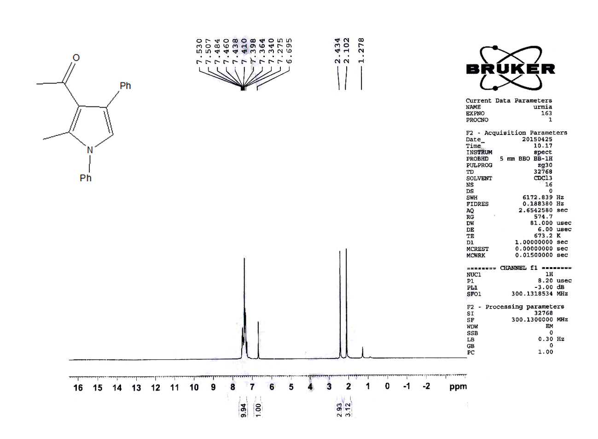

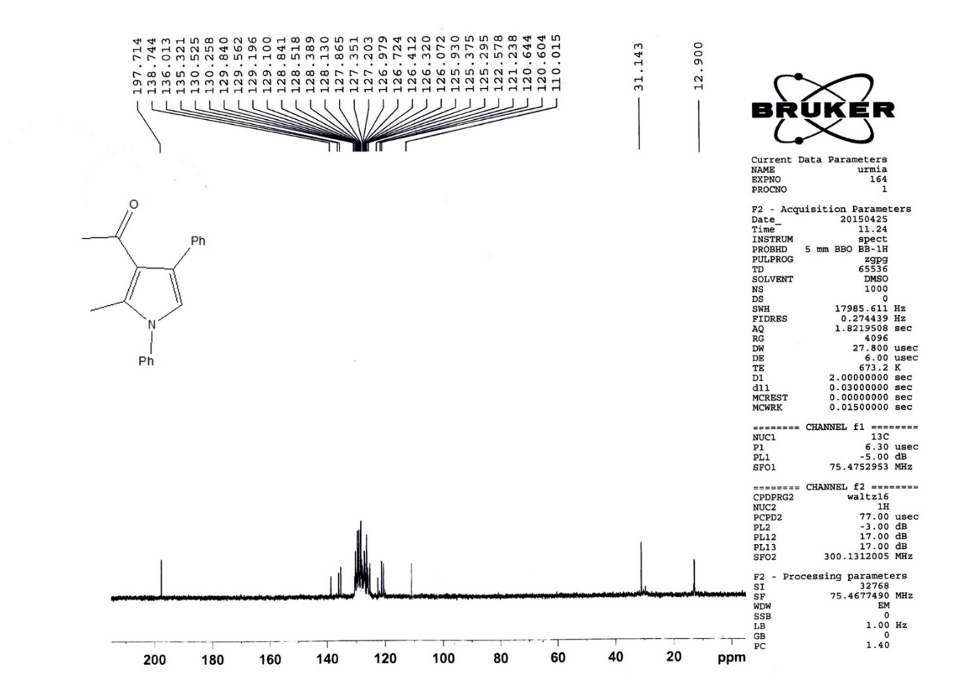

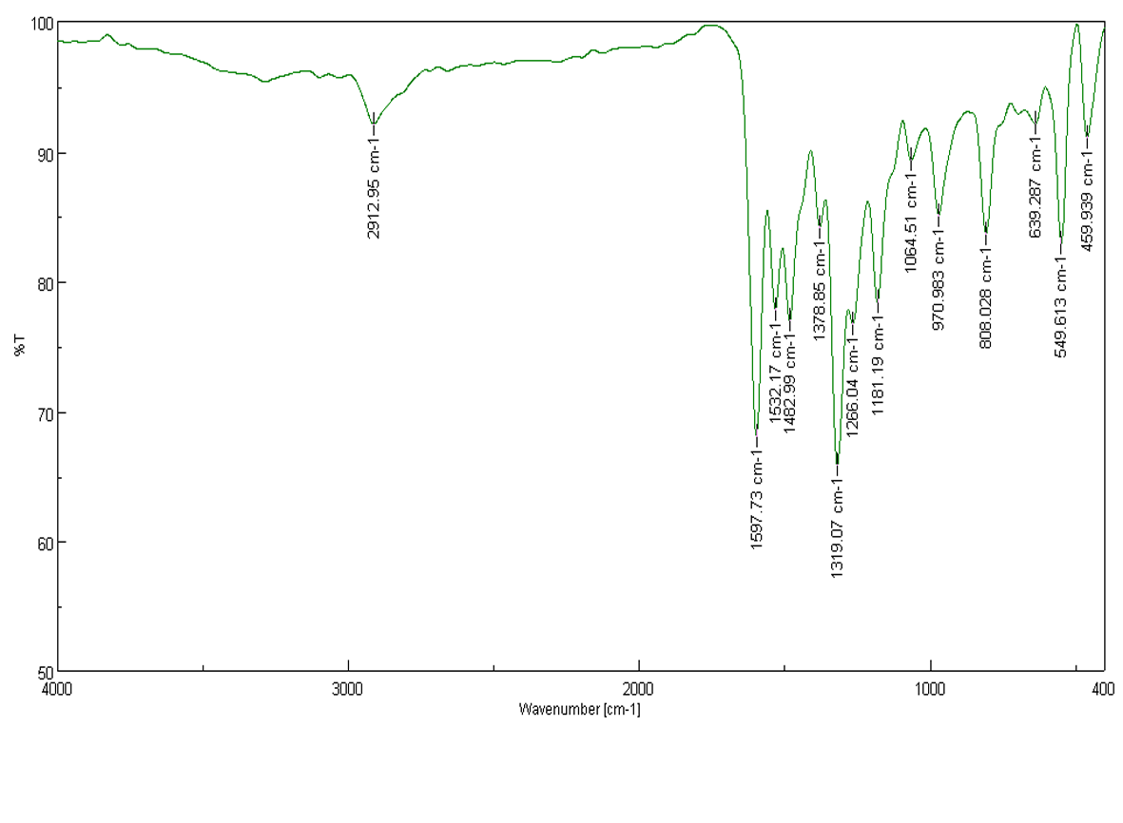

1-(2-Methyl-1-phenyl-4-(3,4,5-trimethoxyphenyl)-1H-pyrrol-3-yl) ethanone (5b).
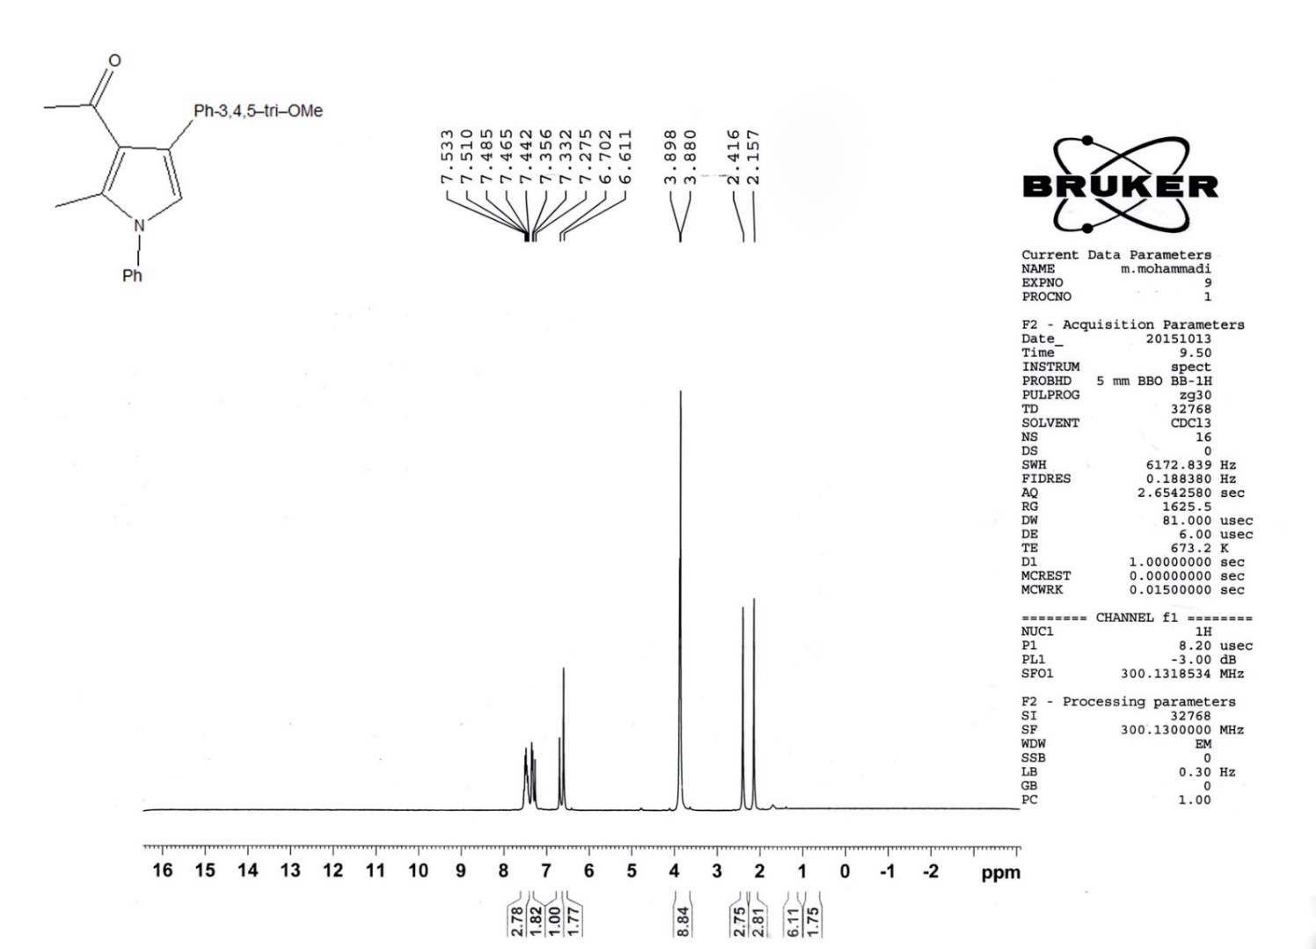
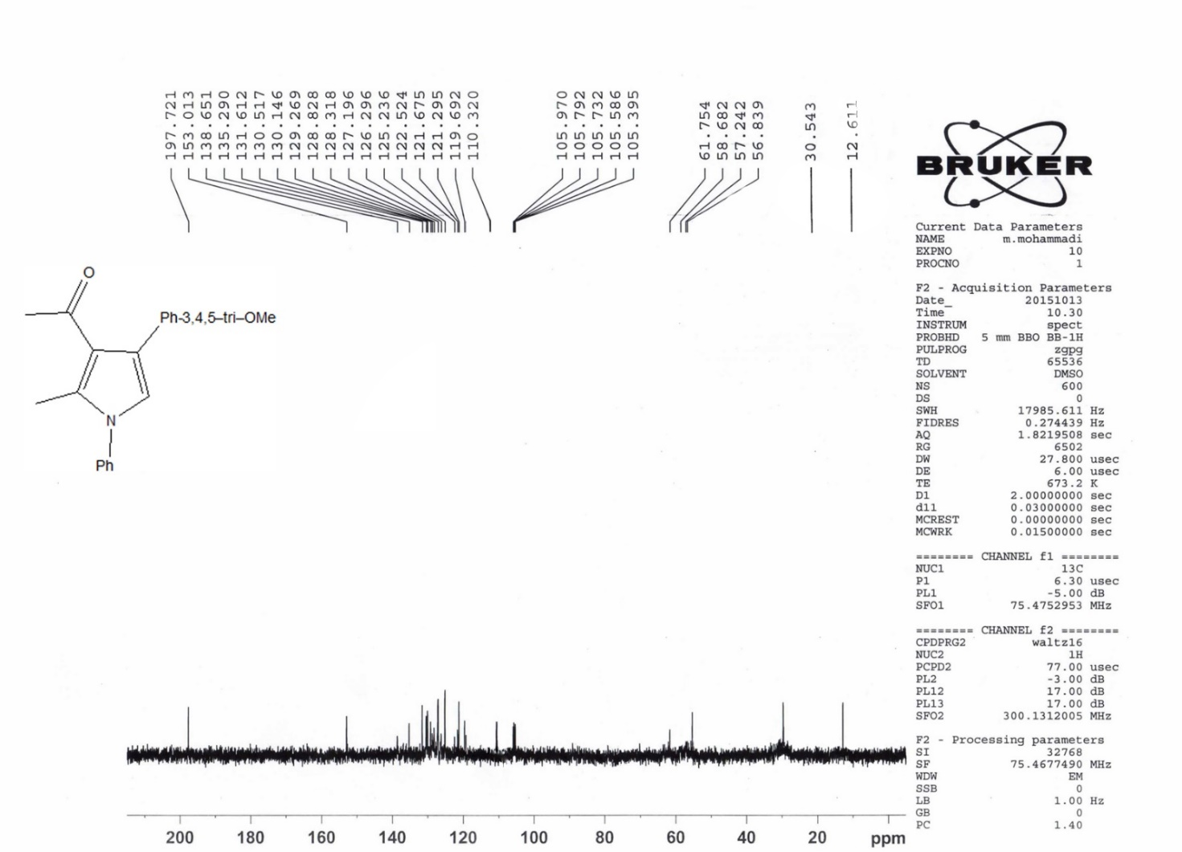

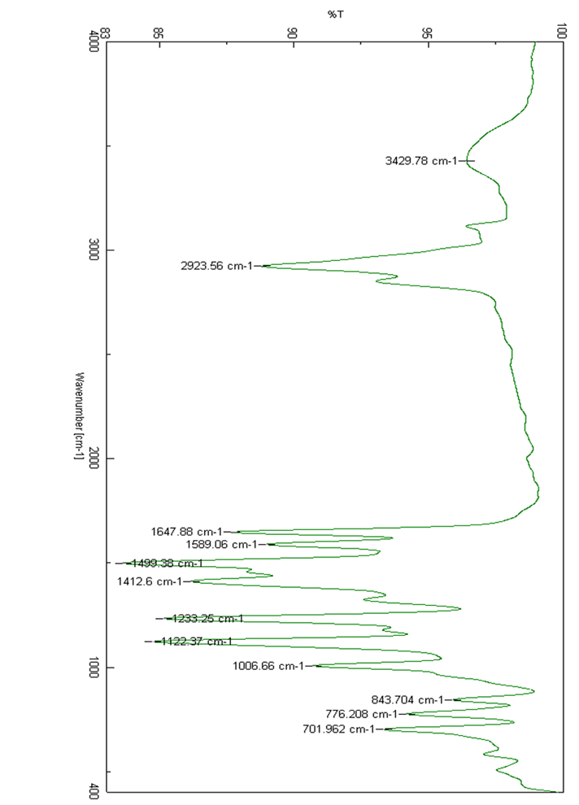

1-(4-(4-(Dimethylamino) phenyl)-2-methyl-1-phenyl-1H-pyrrol-3-yl) ethanone (5c).
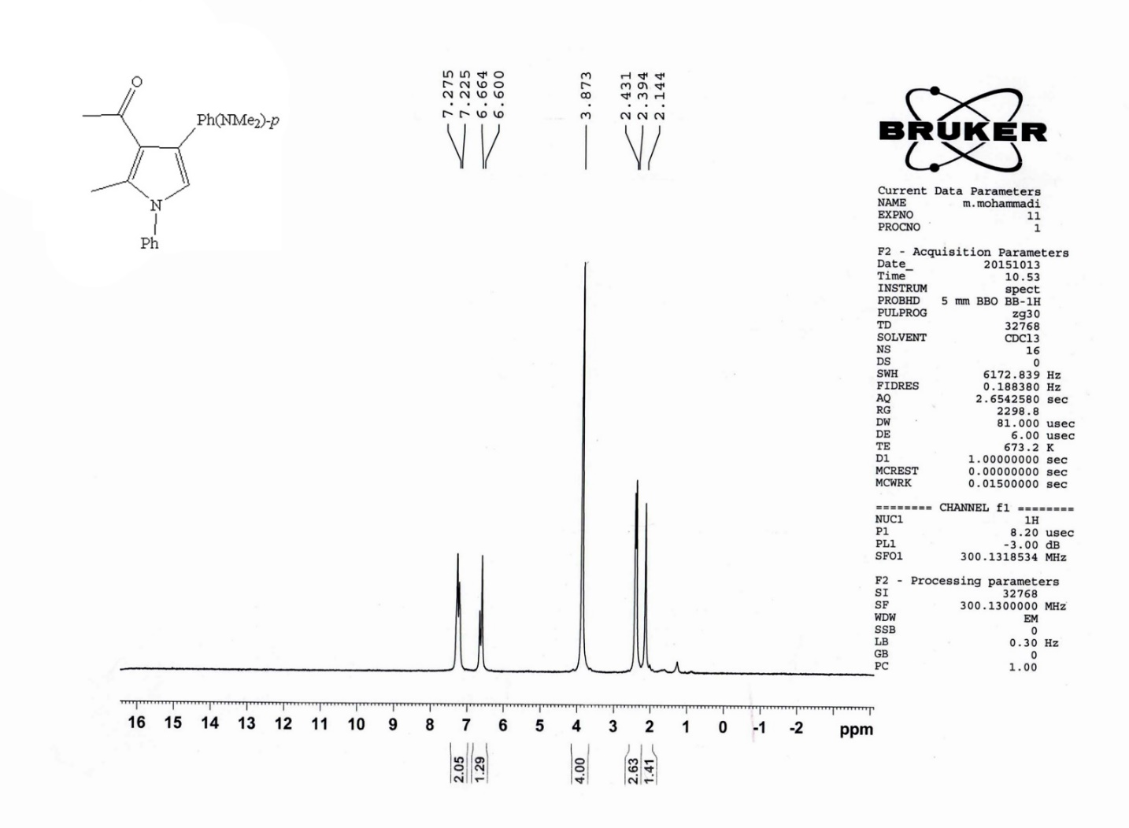

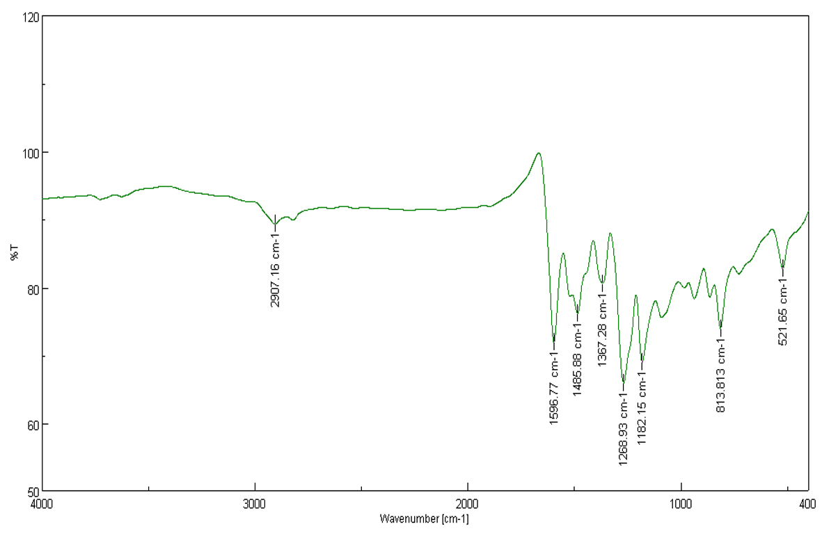
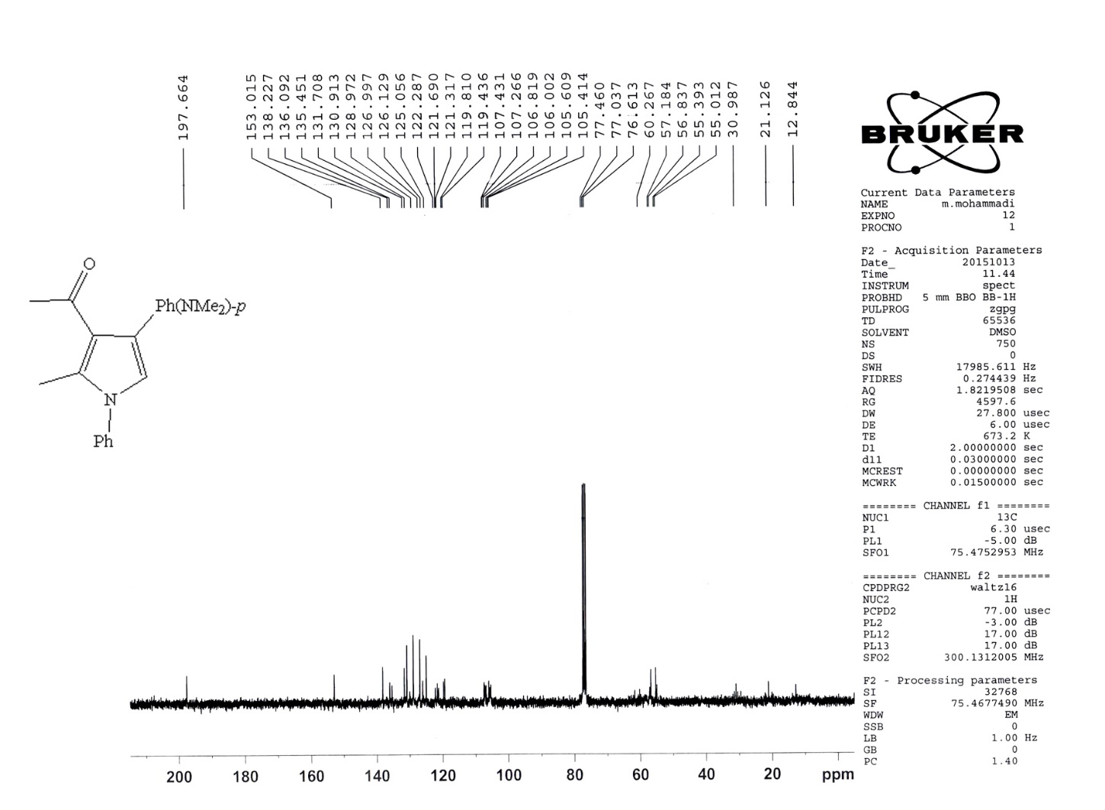

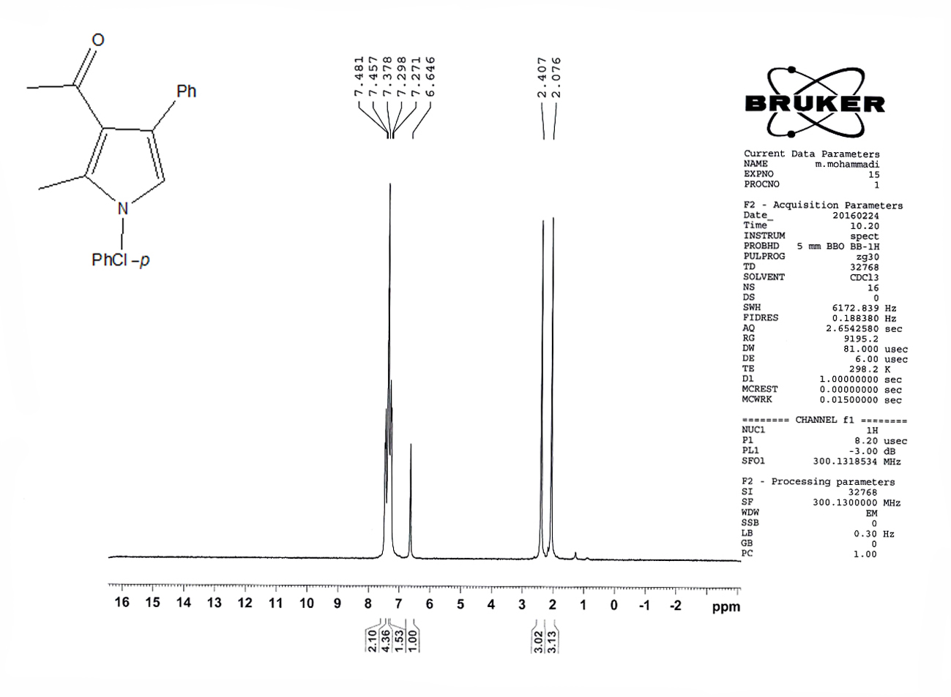
1-(1-(4-Chlorophenyl)-2-methyl-4-phenyl-1H-pyrrol-3-yl) ethanone (5d).
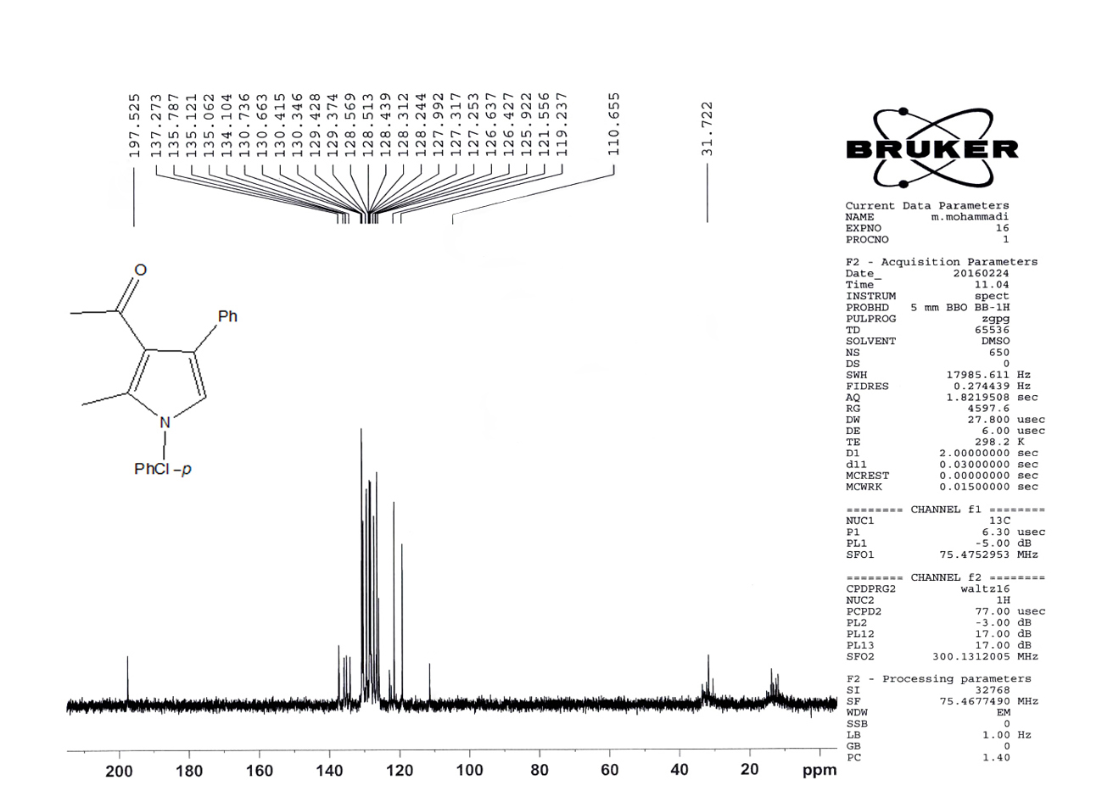

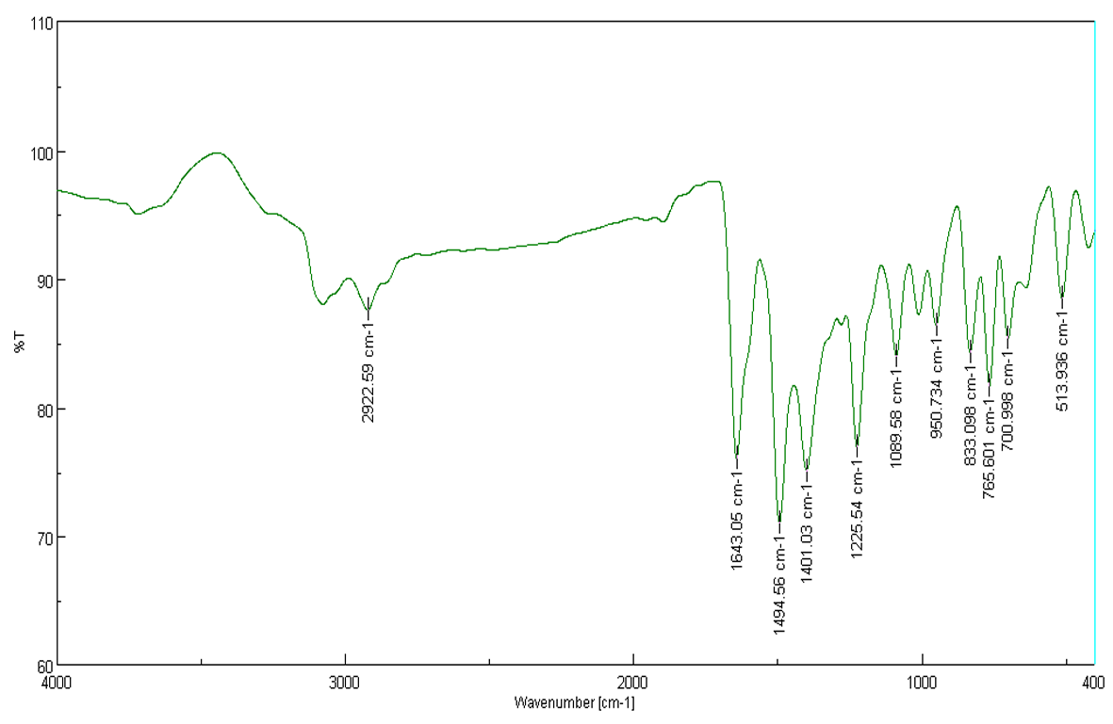

1-(2-Methyl-1,4-di-p-tolyl-1H-pyrrol-3-yl) ethanone (5e).
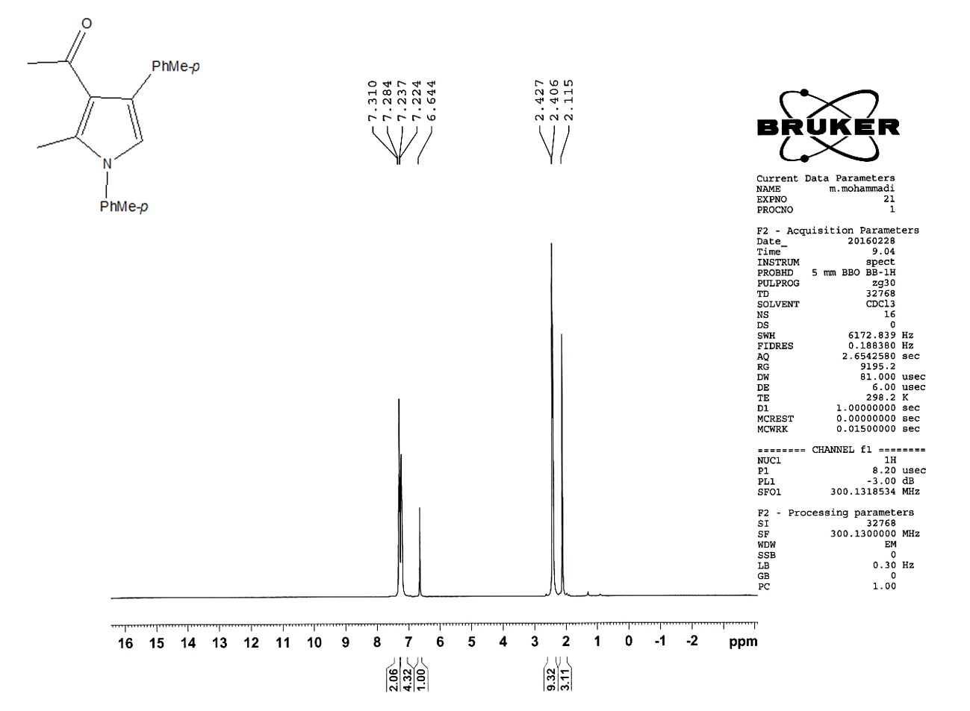
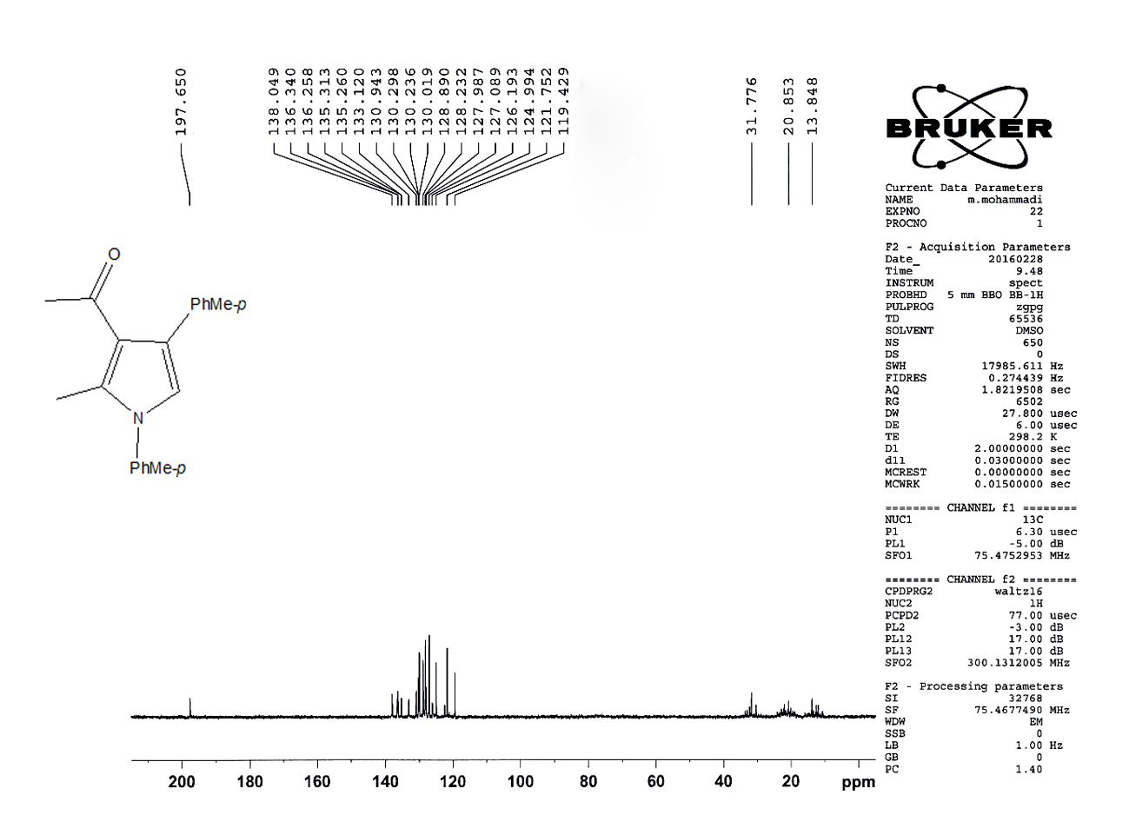
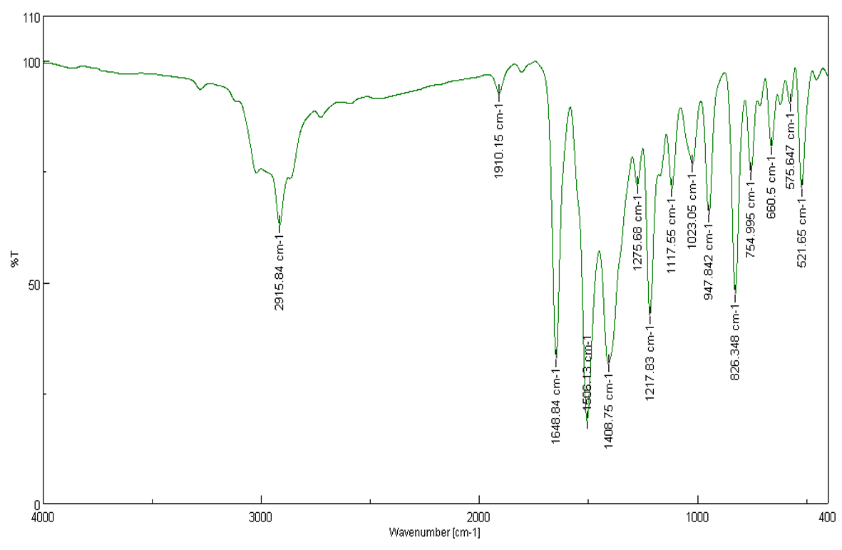

1-(1-(4-Fluorophenyl)-2-methyl-4-phenyl-1H-pyrrol-3-yl) ethanone (5f).
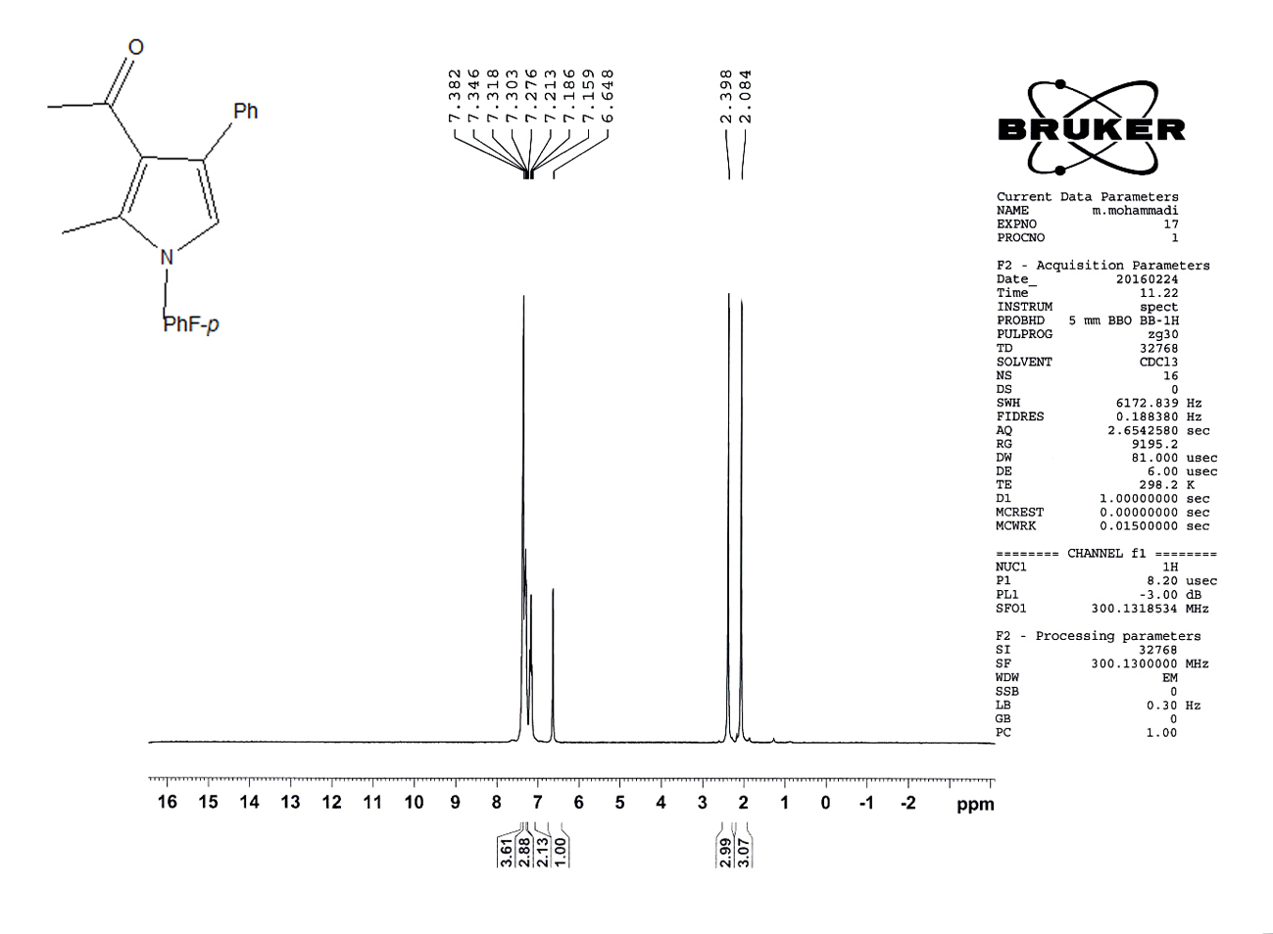
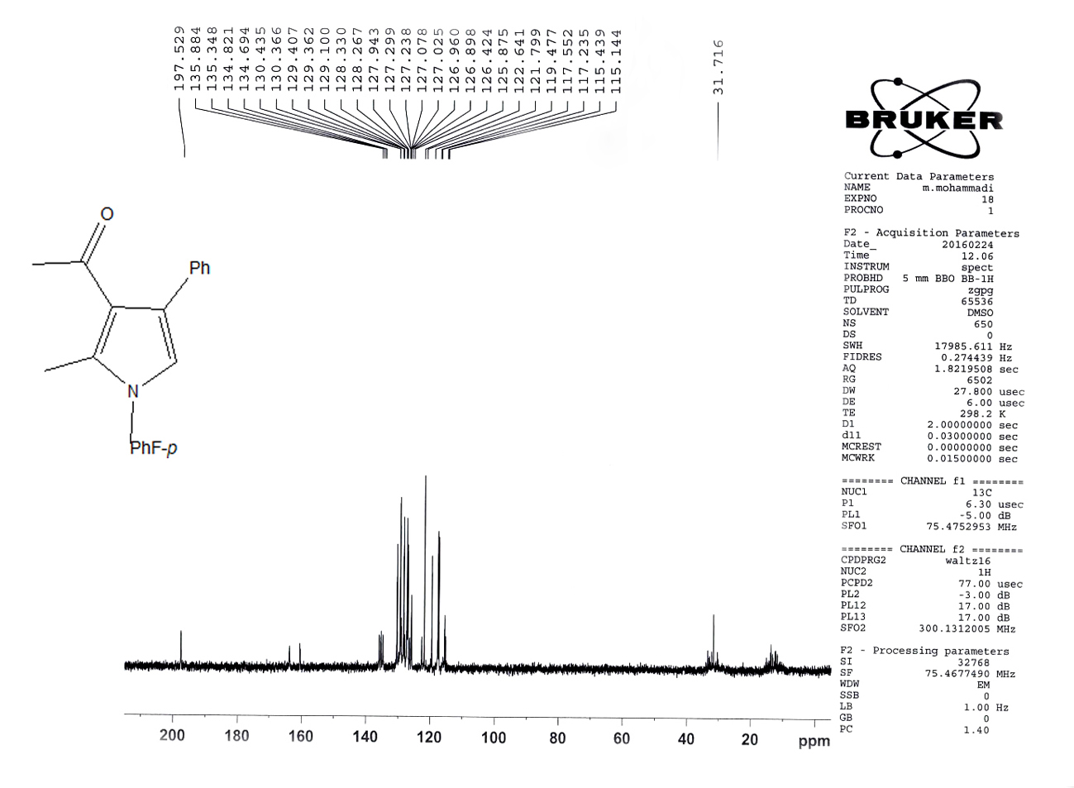

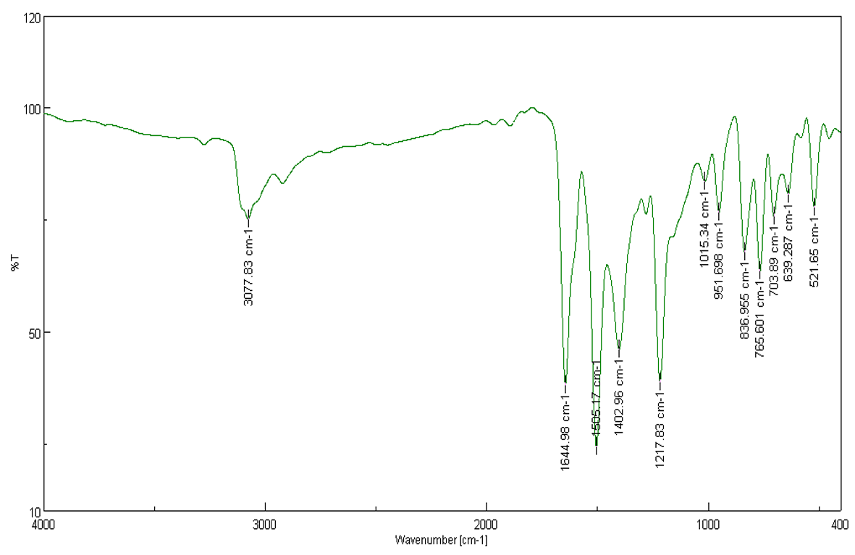

1-(1-(4-Fluorophenyl)-2-methyl-4-(p-tolyl)-1H-pyrrol-3-yl) ethanone (5g).
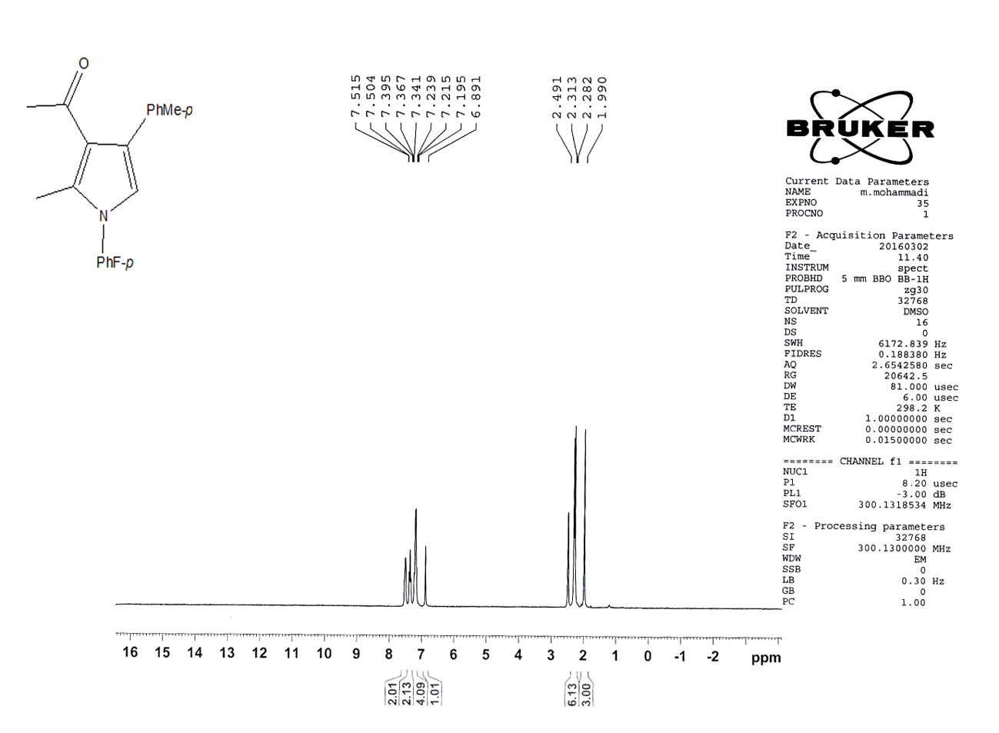

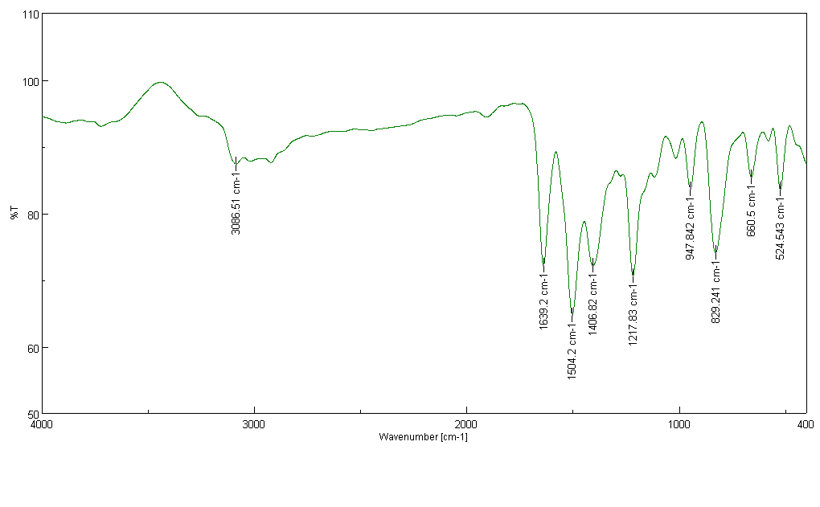
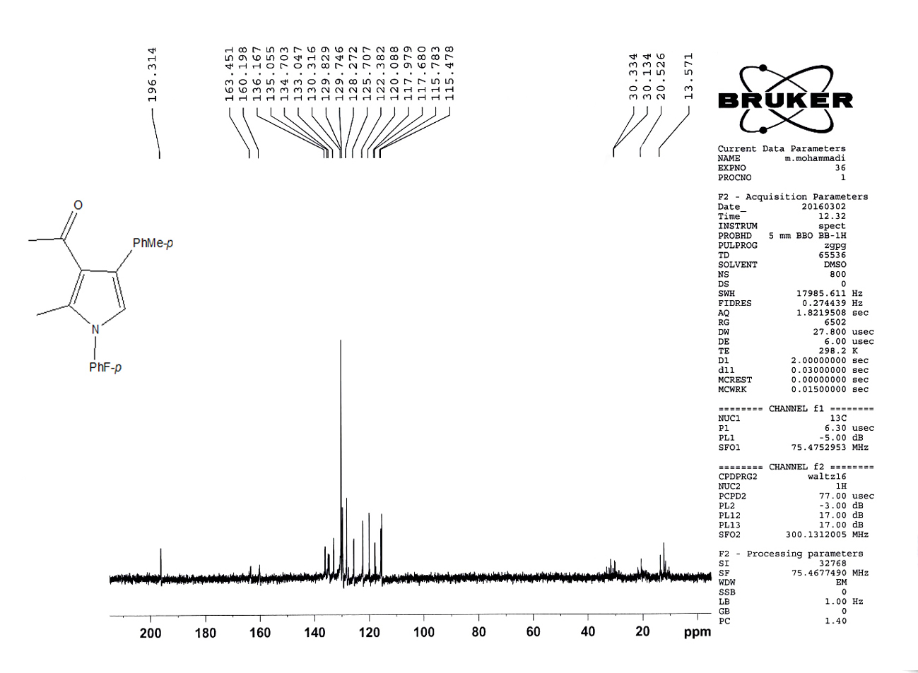

1-(2-Methyl-1-phenyl-4-(p-tolyl)-1H-pyrrol-3-yl) ethanone (5h).
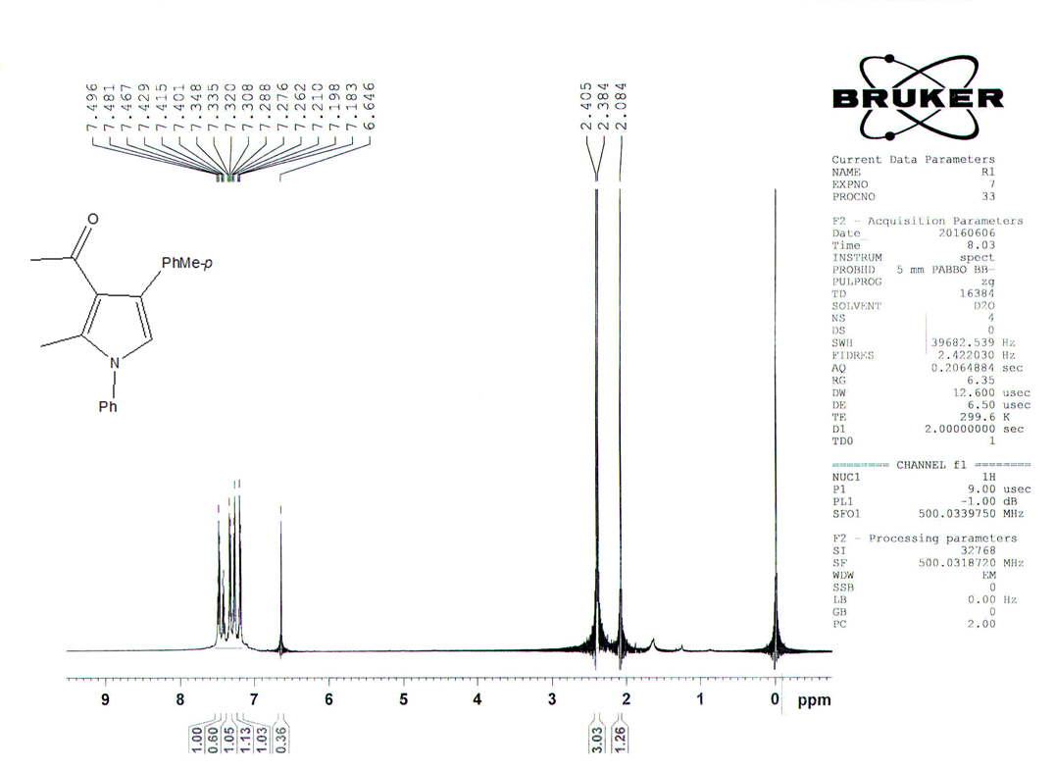
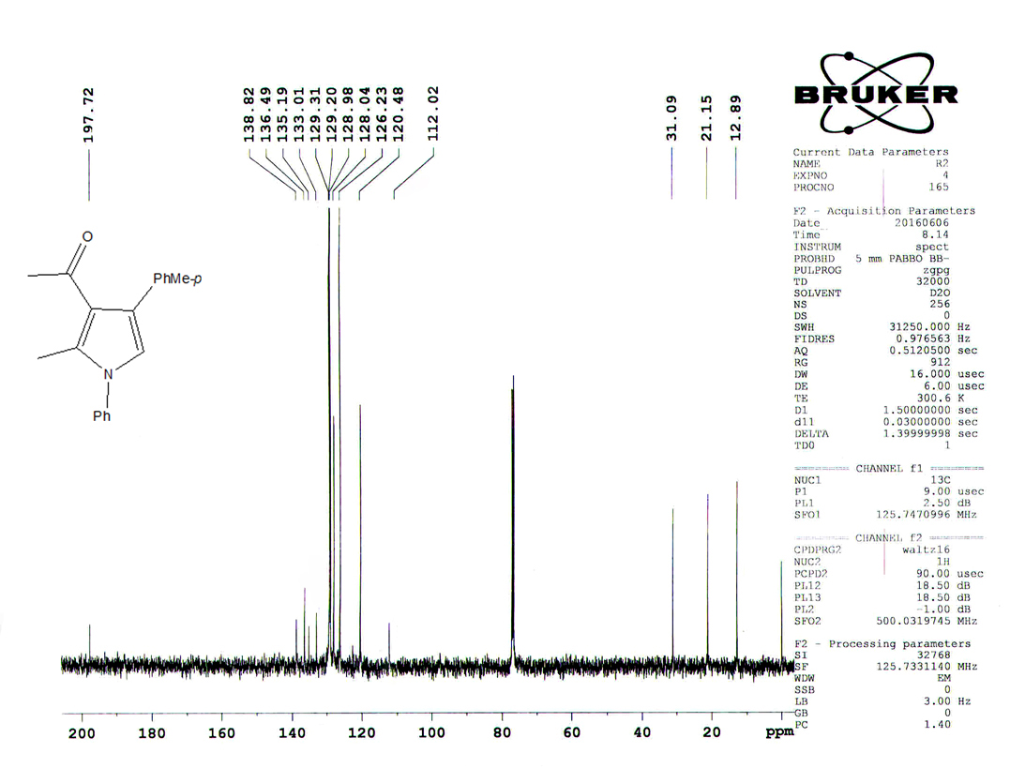
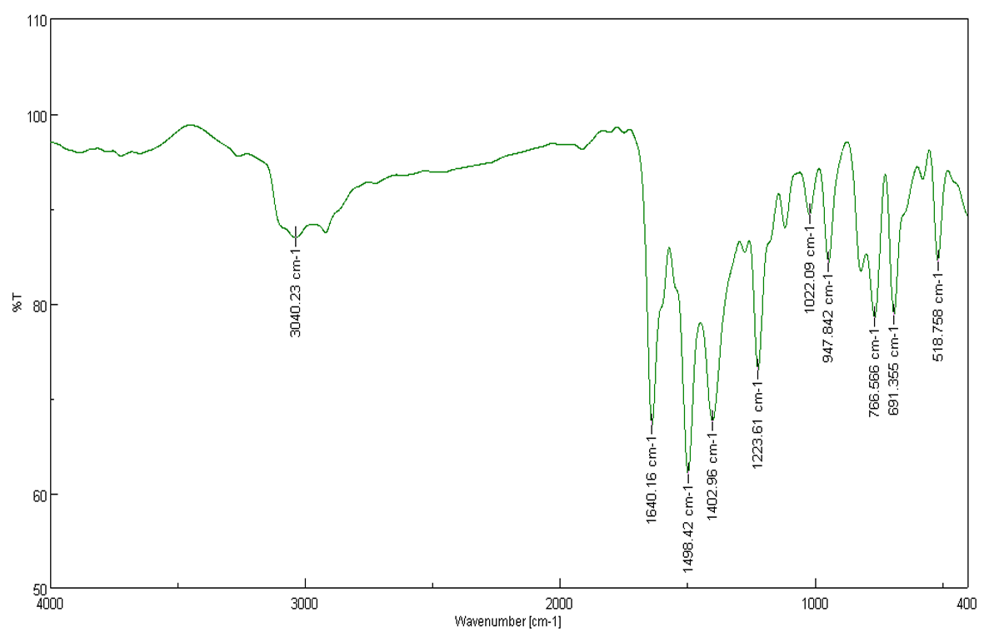

1-(1-(4-Chlorophenyl)-2-methyl-4-(p-tolyl)-1H-pyrrol-3-yl) ethanone (5i).

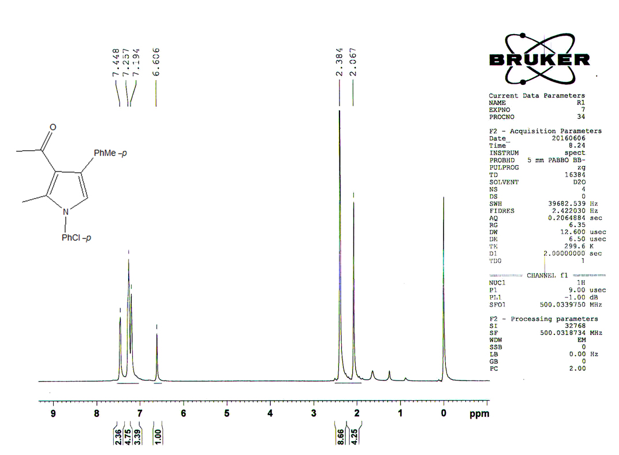

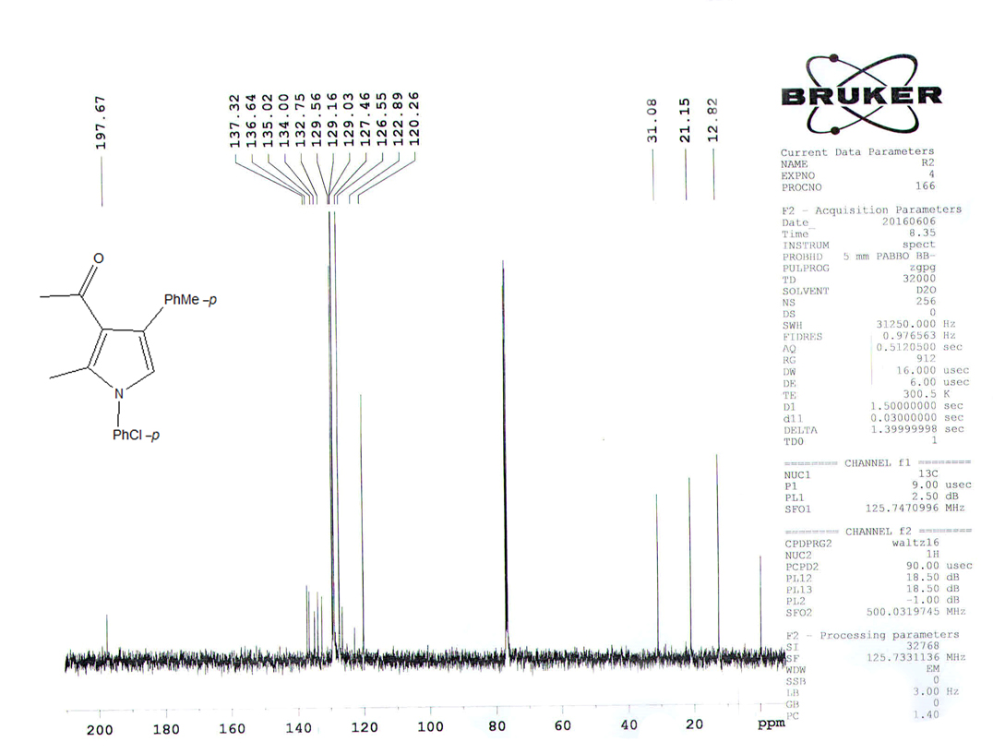

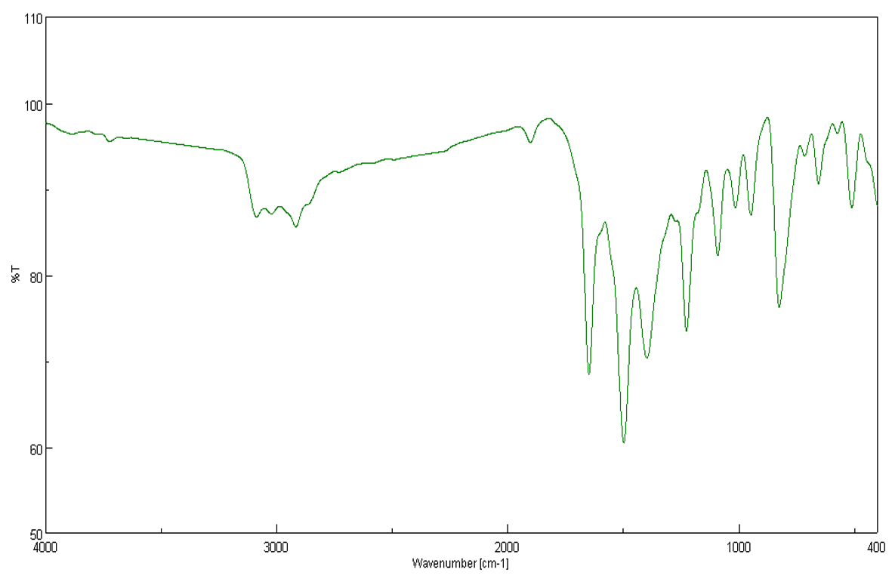

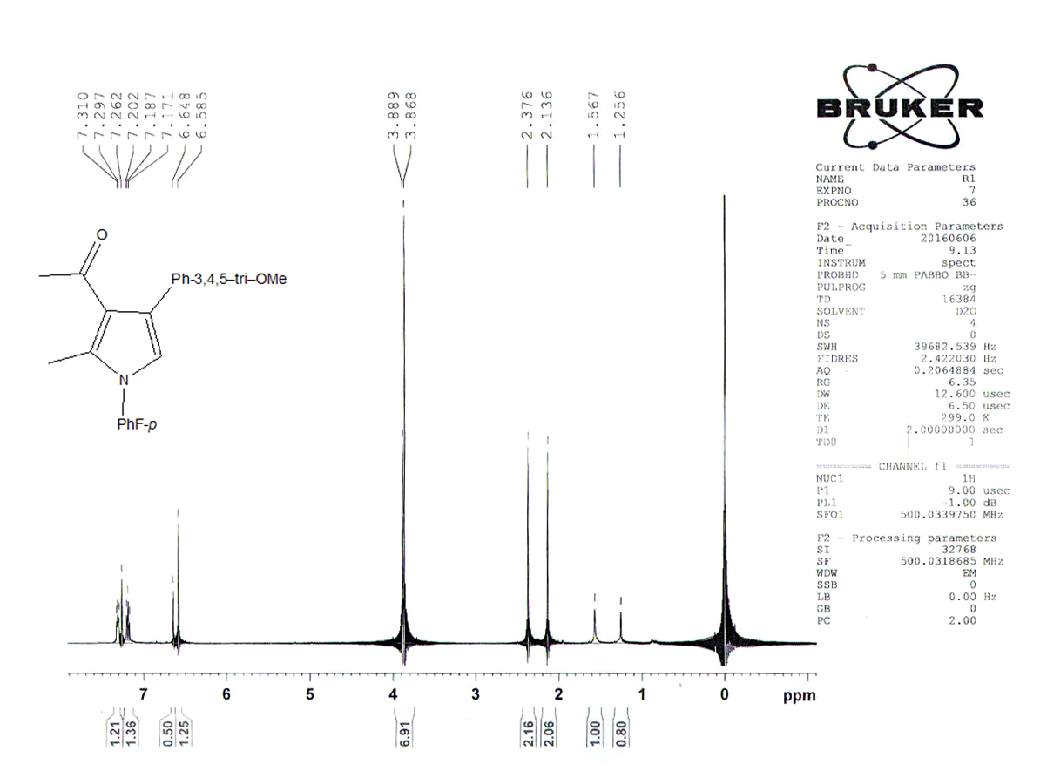
1-(1-(4-Fluorophenyl)-2-methyl-4-(3,4,5-trimethoxyphenyl)-1H-pyrrol-3-yl) ethanone (5j).

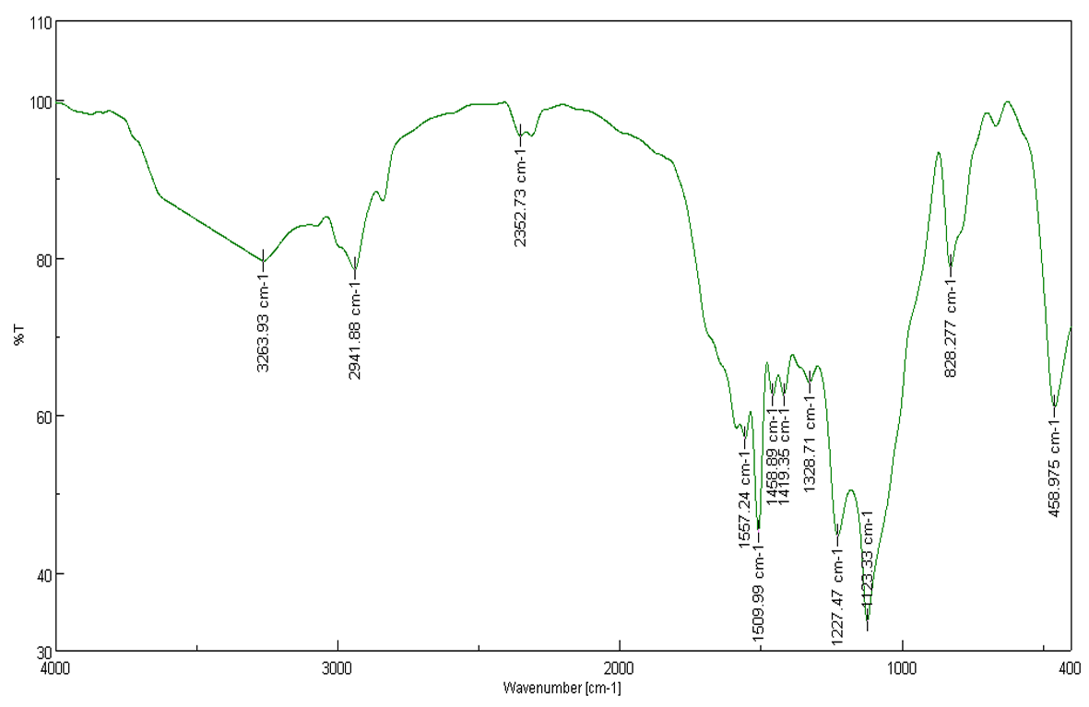

1-(4-(4-Methoxyphenyl)-2-methyl-1-(p-tolyl)-1H-pyrrol-3-yl) ethanone (5k).
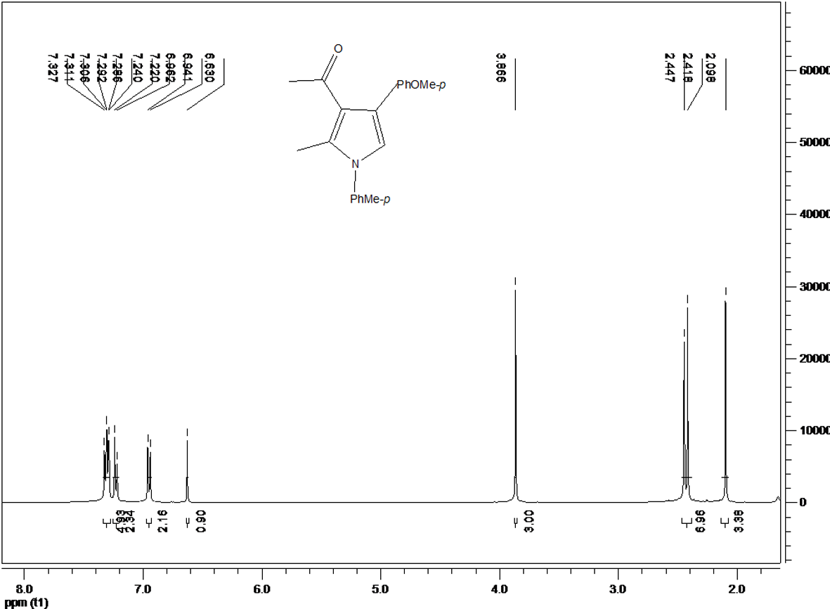
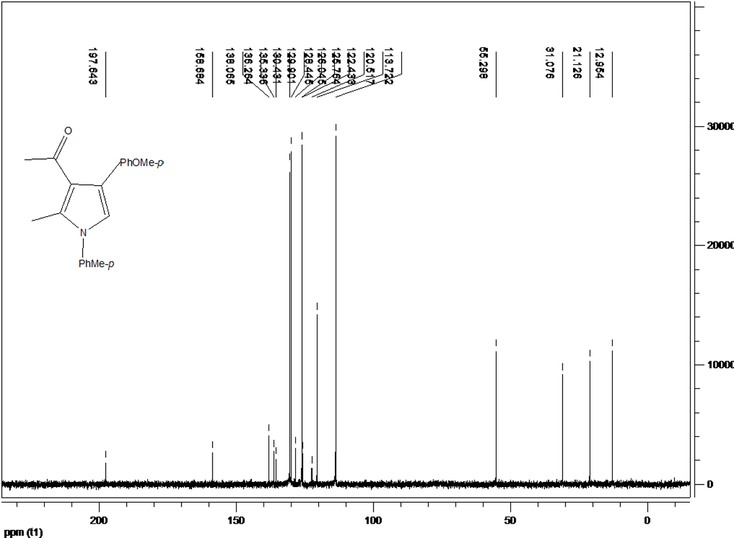

1-(4-(4-Chlorophenyl)-2-methyl-1-phenyl-1H-pyrrol-3-yl) ethanone (5l).
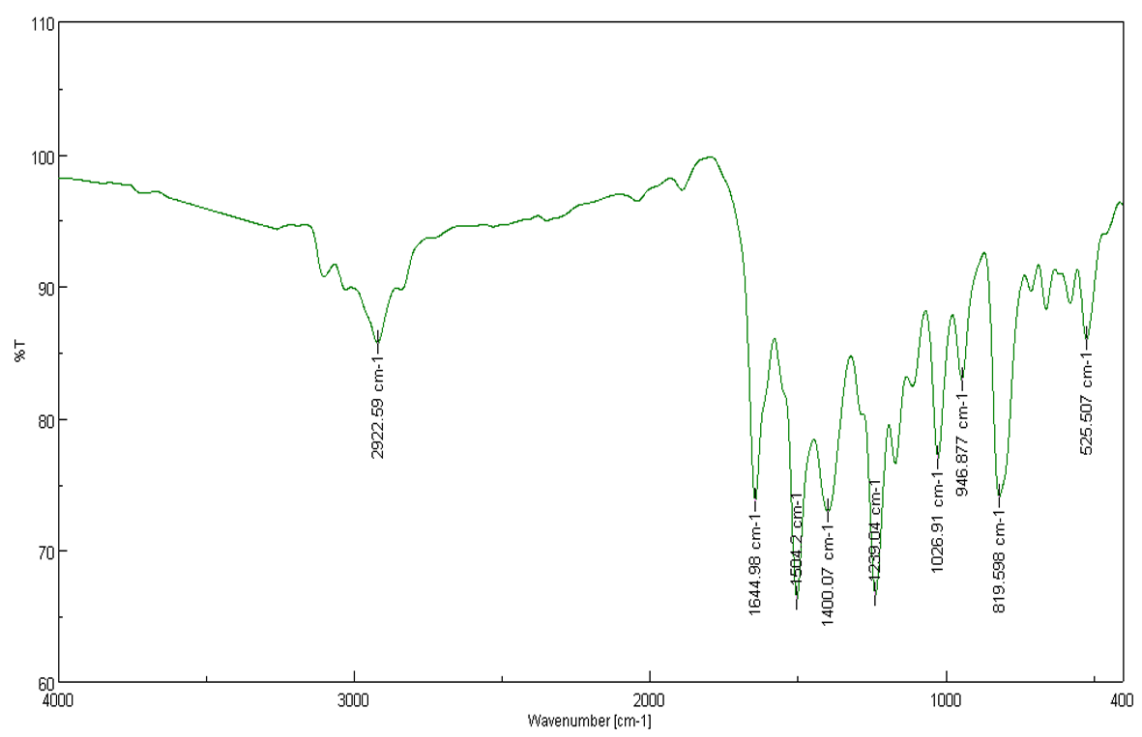
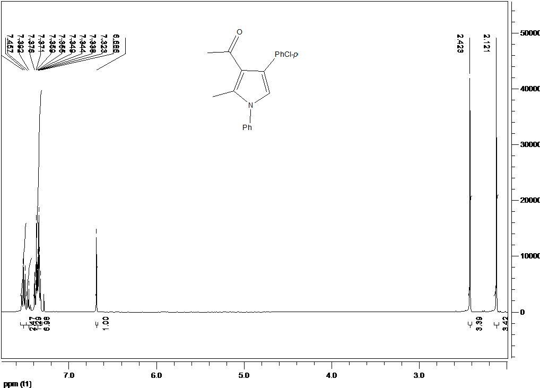

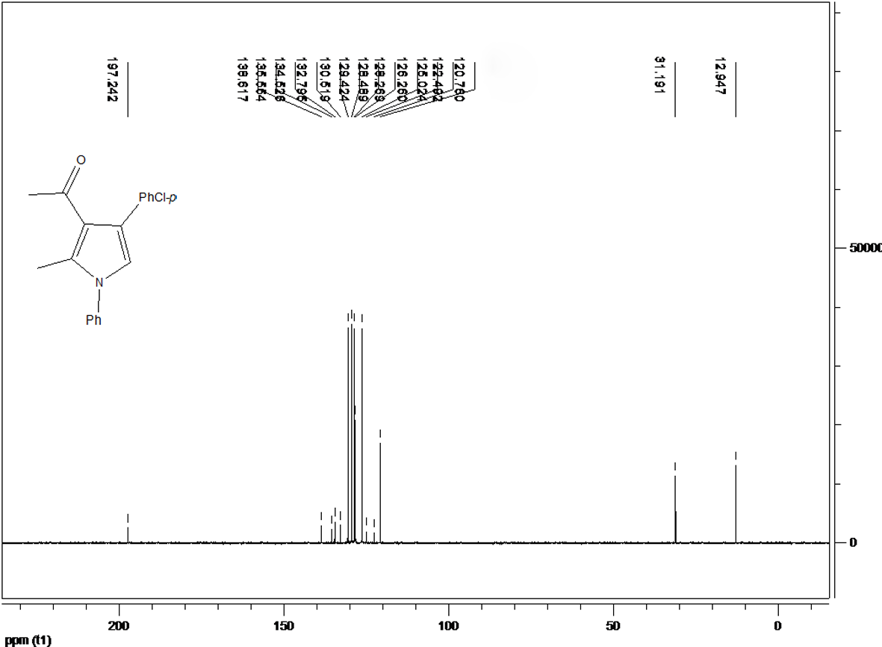
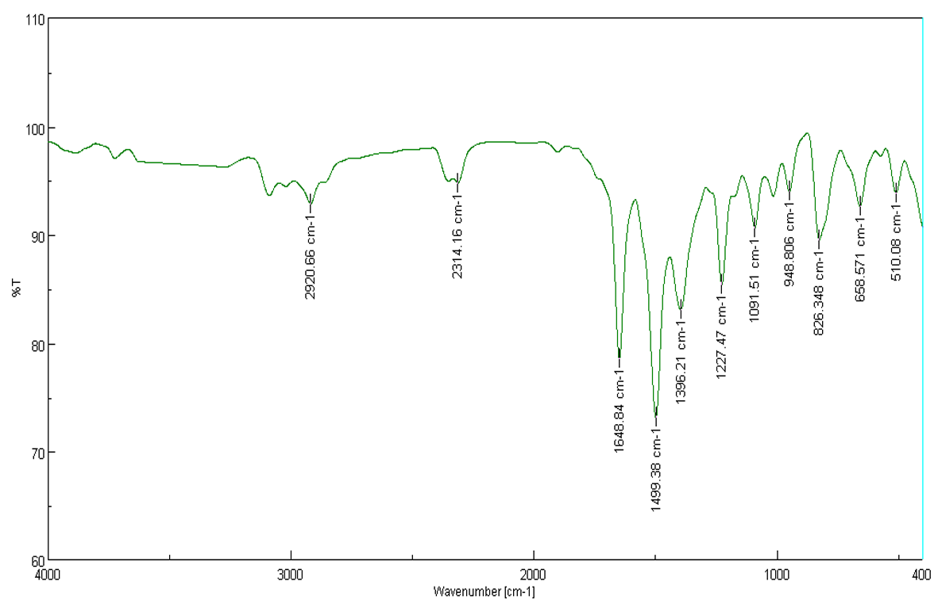

1-(1-(4-Methoxyphenyl)-2-methyl-4-phenyl-1H-pyrrol-3-yl) ethanone (5m).
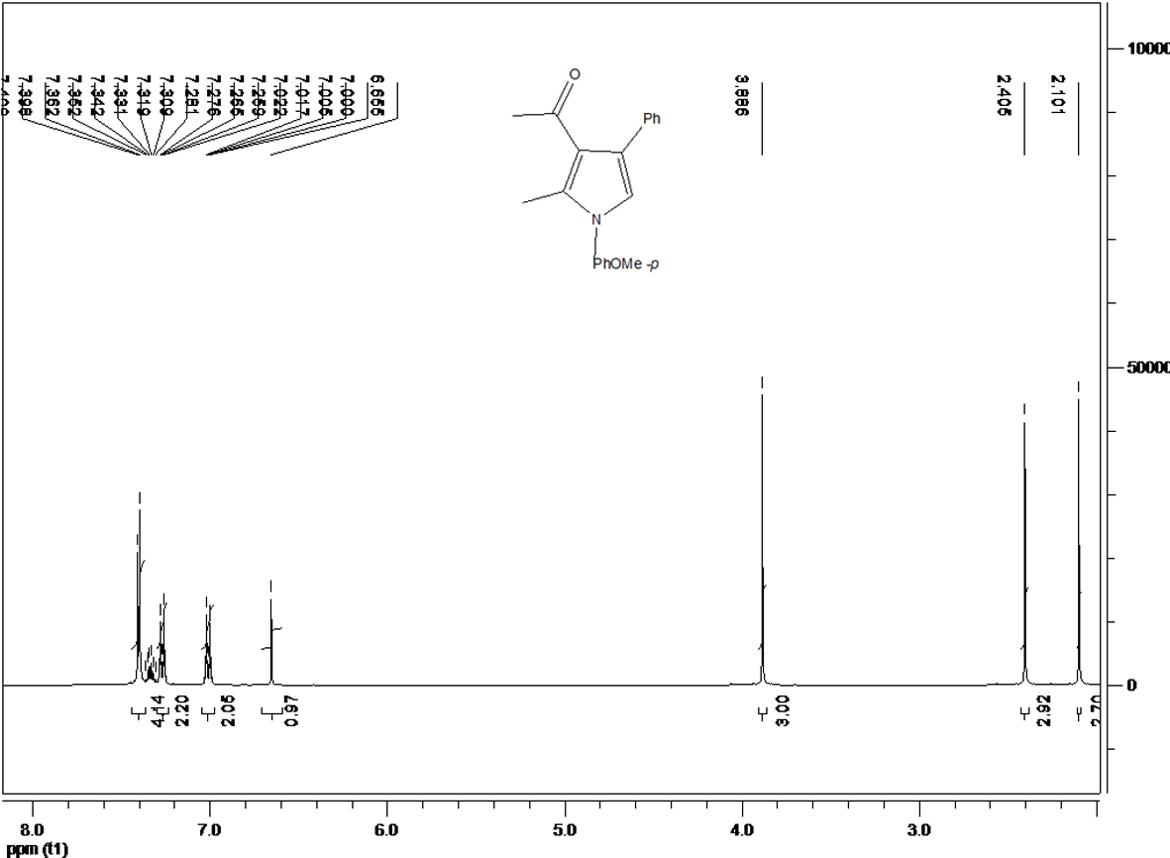

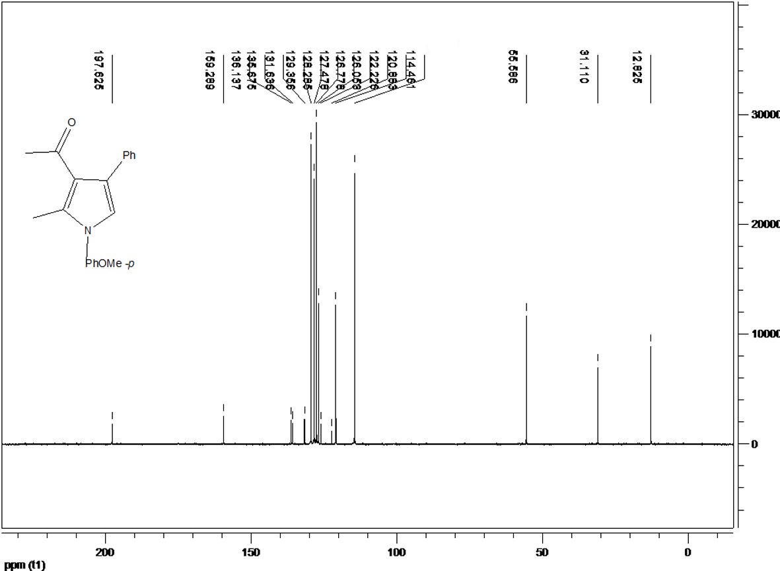

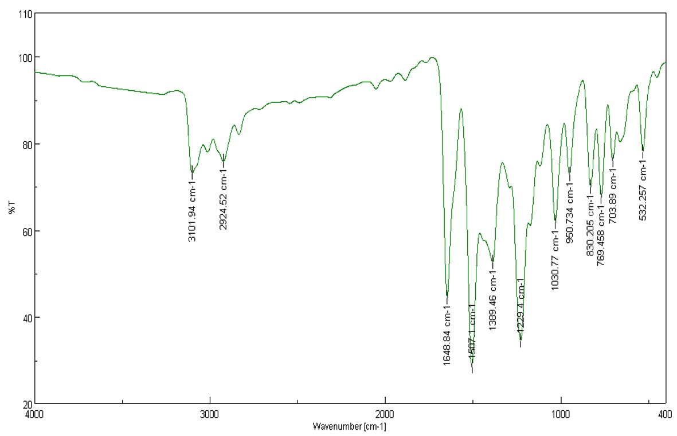

1-(4-(4-Chlorophenyl)-1-(4-methoxyphenyl)-2-methyl-1H-pyrrol-3-yl) ethenone (5n).
