Supplementary File Legends
Supplementary File 1 Cell viability detection, integrated analysis and quality control analysis in Ujumqin and Hulunbuir sheep.
(A) Single-cell viability and concentration detection in Ujumqin and Hulunbuir sheep. (B) Integrating Ujumqin and Hulunbuir sheep analysis using UMAP. (C) Quality control analysis in Ujumqin and Hulunbuir sheep.
Supplementary File 2 Cell cluster biomarker identification
Supplementary File 3 Related gene expression analysis
(A) Analysis of genes with higher expression in Ujumqin sheep. (B and C) PAX3 and T (Brachyury) expression gene analysis in Ujumqin and Hulunbuir sheep. (D) T gene expression detection by UMAP. (E) CDX2 gene expression detection by UMAP.
Supplementary File 4 Hippo- and TGF-beta-related gene expression analysis
(A) YAP1, TAZ, ACTB, MYC and AFP expression detection by qPCR. (B) HOXB9, ACLY, FASN and HOCX12 expression detection by qPCR. (C) BMP2, ACSL1, FABP4, PRKaC, ACACA and ACSL1 expression detection by UMAP in Ujumqin and Hulunbuir sheep. (D) HOXC12 and TNNC1 expression detection by UMAP in Ujumqin and Hulunbuir sheep.
Supplementary File 5 Cell cycle metrics for Ujumqin and Hulunbuir sheep cells.
(A) Cell cycle states in Ujumqin sheep cells projected on UMAP. (B) Cell cycle states in Hulunbuir sheep cells projected on UMAP.

Supplementary File 1

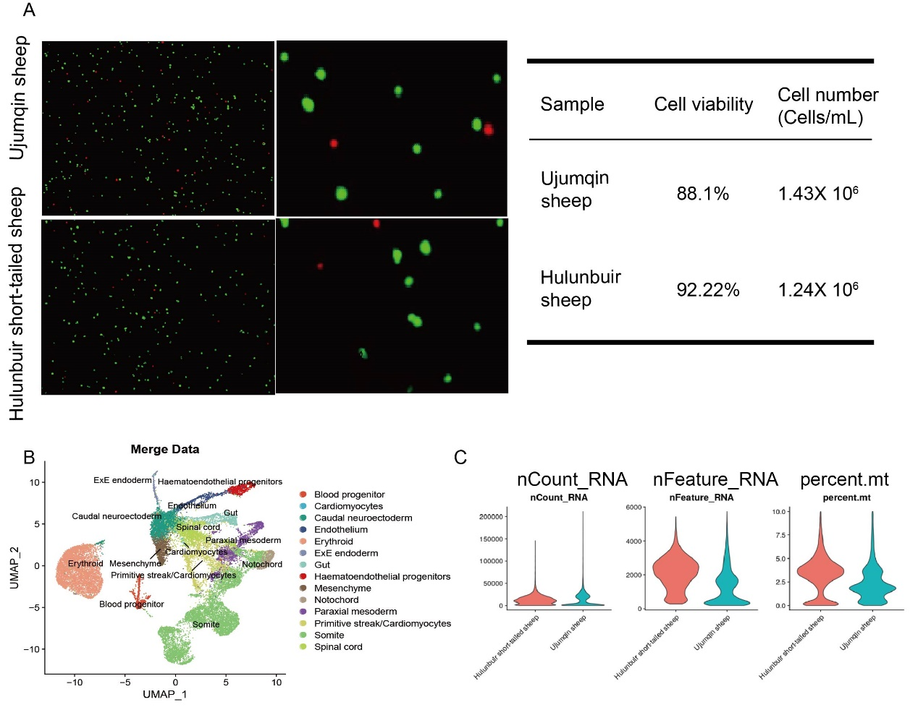

Supplementary File 2
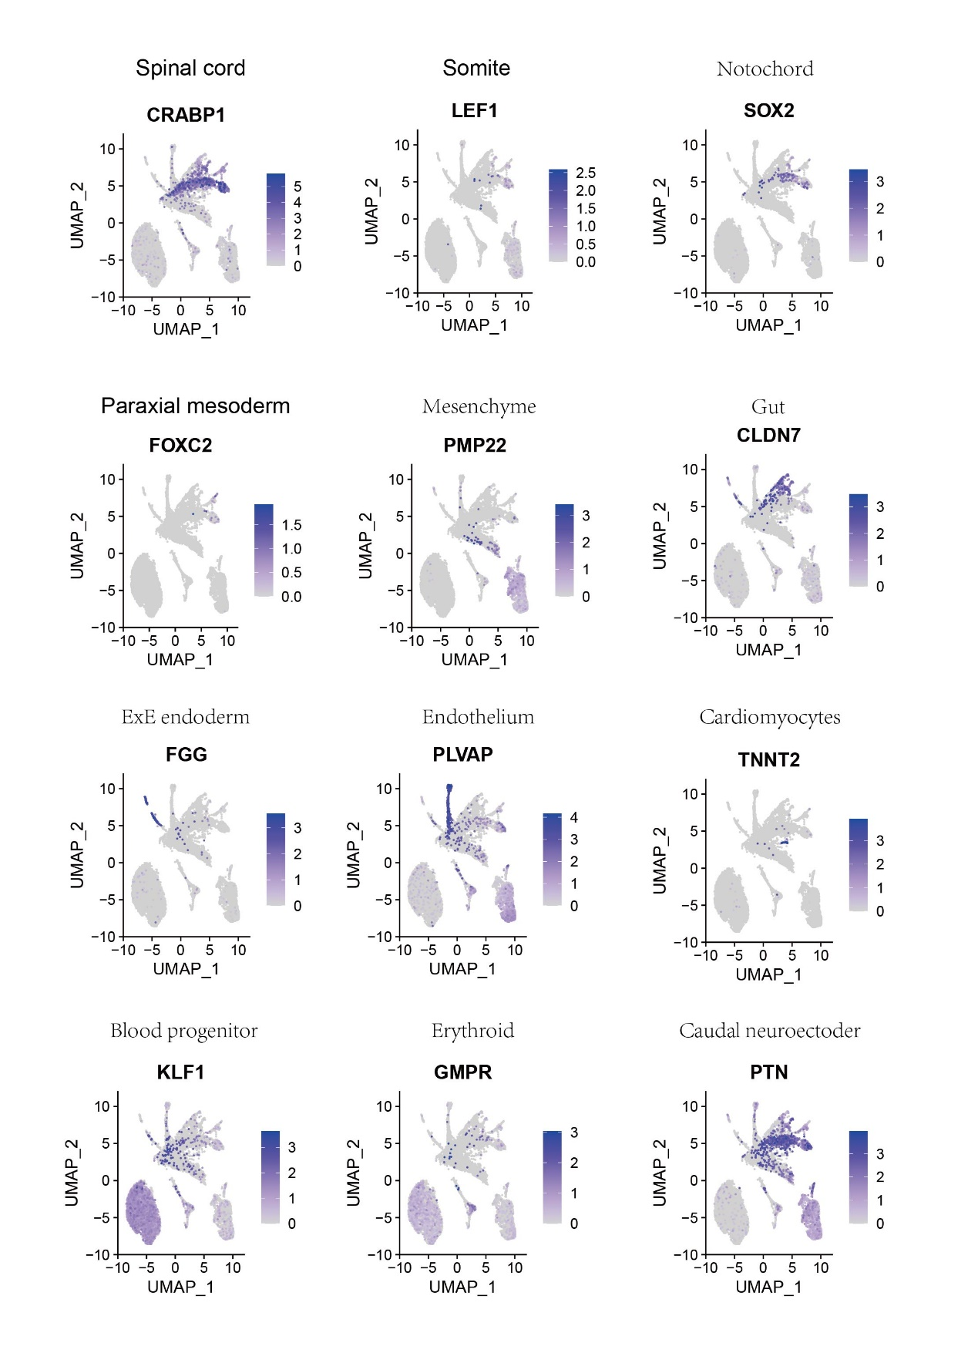

Supplementary File 3
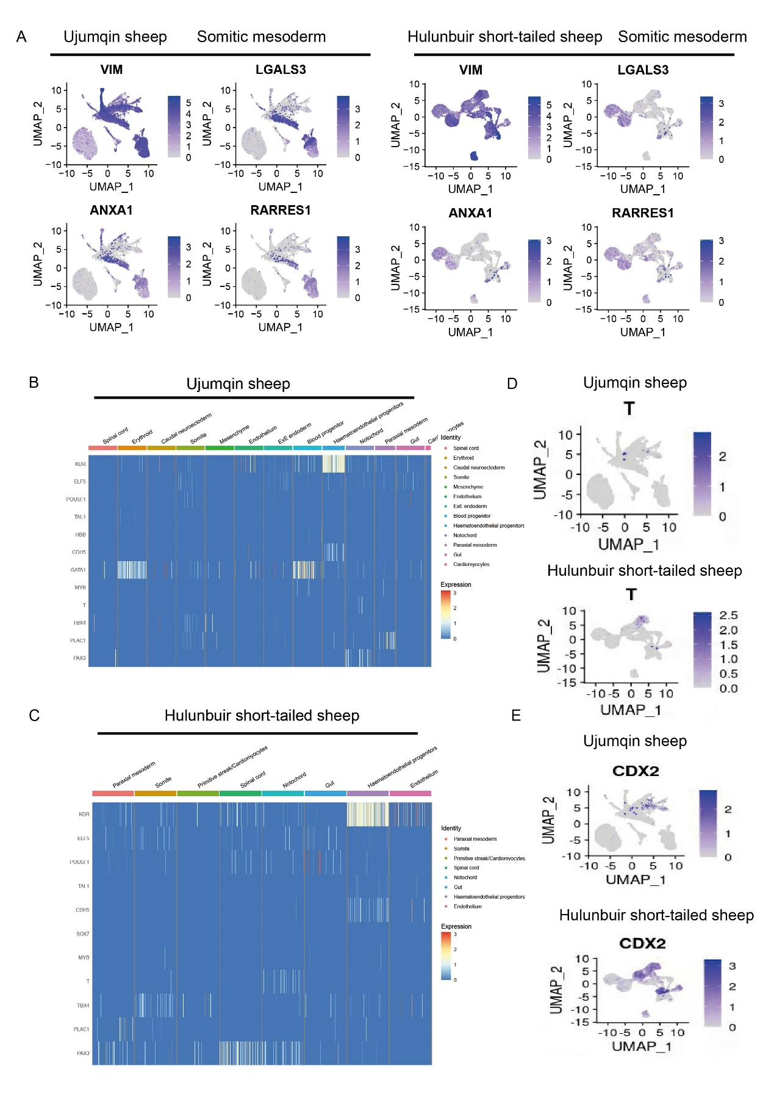

Supplementary File 4

Supplementary File 5

