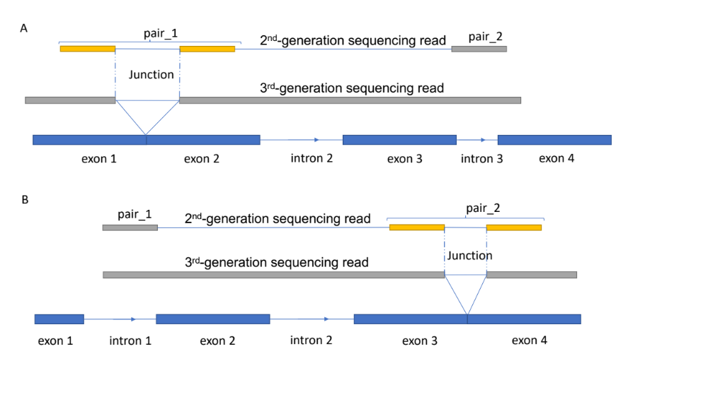
Supplementary Figure 1. A) Reads support that intron 1 is spliced before intron 3. B) Reads support that intron 3 is spliced before intron 1. A read must contain at least one junction to detect the splicing order of a pair of introns. The fragment size must at least be the size of an exon to detect intron splicing order pairs.

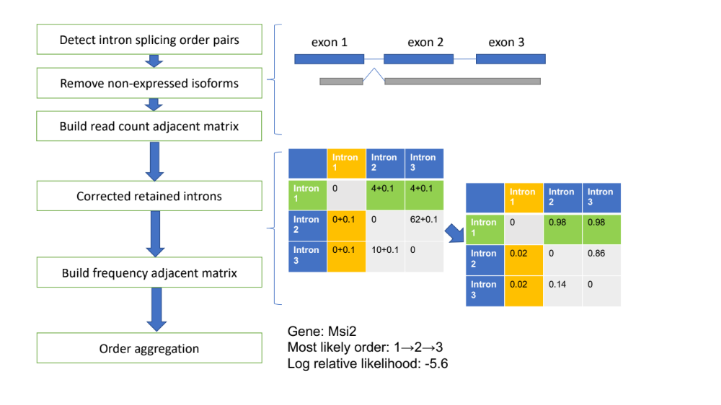
Supplementary Figure 2. The workflow of the method.

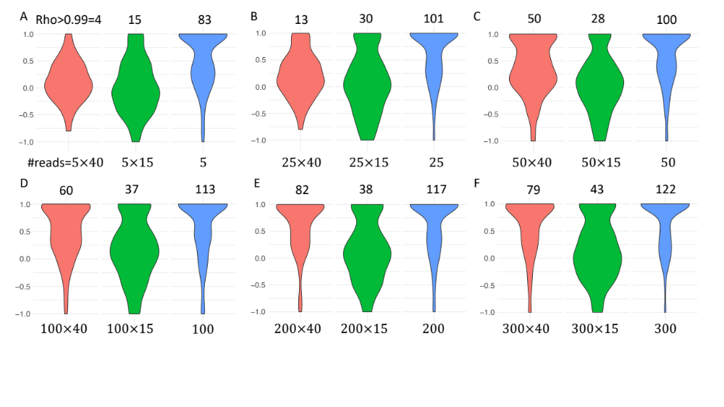
Supplementary Figure 3. Simulation result based on chr21 in humans. The number of reads for each transcript of each simulation is labelled at the bottom. Read length is more important than read count. The total number of reads for each simulation is $\#reads×20K$.

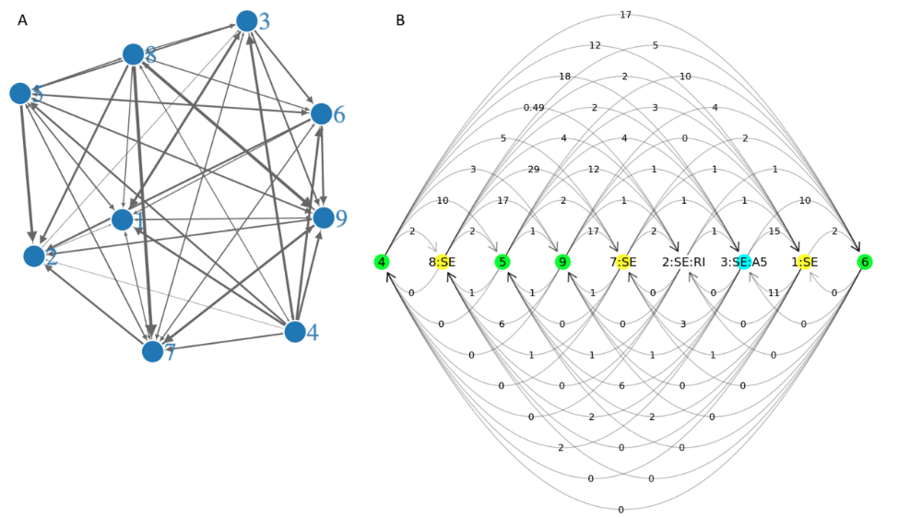
Supplementary Figure 4. Intron splicing order of hnRNP A1. A) The intron splicing order read count graph of hnRNP A1. The intron index number is labelled in the vertex, and arrow from 1 to 2 means intron 1 spliced before intron 2. The width of the arrow line represents the read count supports this intron splicing order pair. B) Reordering the intron splicing order read count graph by the most likely order, arrows above the vertexes point to the slower-spliced introns, arrows below the vertexes point to faster-spliced introns. The values above the vertexes are larger than the values below the vertexes, this supports the most likely order calculated.

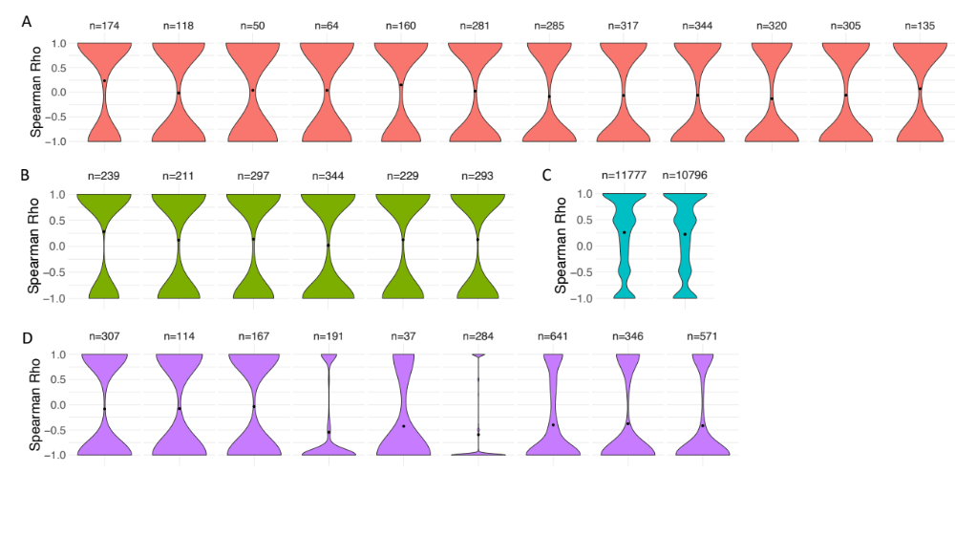
Supplementary Figure 5. Corresponding to Figure 5, each RNA-seq dataset was run separately to check whether the direction of splicing was consistent with the transcription direction. A) S. pombe. B) Fruit fly. C) Arabidopsis thaliana. D) Humans.

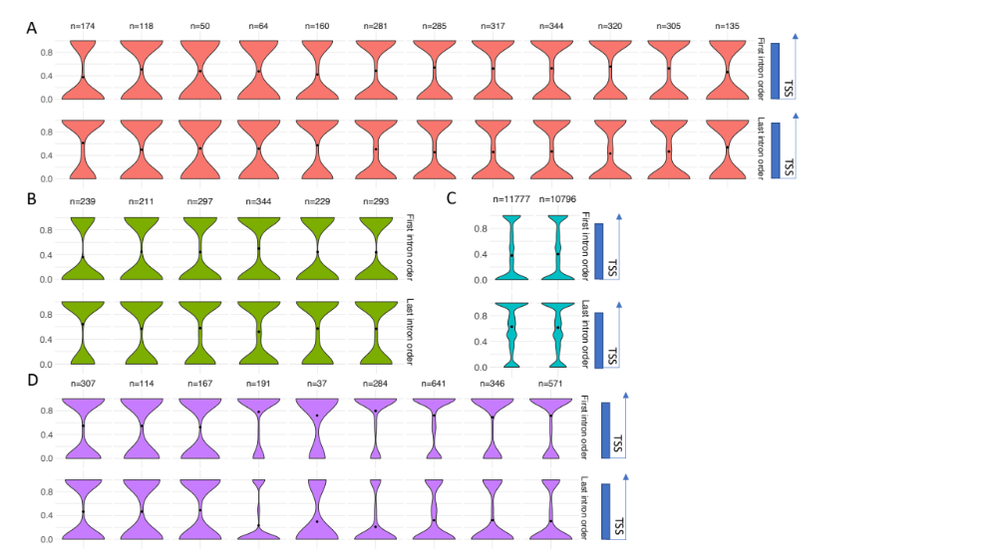
Supplementary Figure 6. Corresponding to Figure 6, each RNA-seq dataset was run separately to check the splicing order of the first introns. A) S. pombe. B) Fruit fly. C) Arabidopsis thaliana. D) Humans.

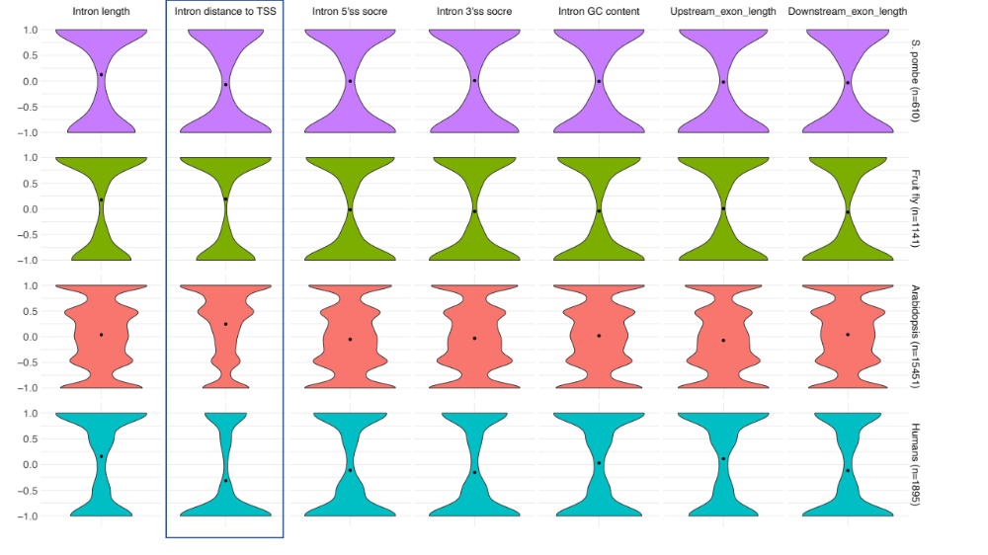
Supplementary Figure 7. Correlation of the calculated most likely orders with introns’ length, introns’ distance to TSS, 5’ splice site maxEntScore, 3’ splice site maxEntScore, intron GC content, upstream exon length and downstream exon length in S. pombe, fruit fly, Arabidopsis thaliana and humans respectively.

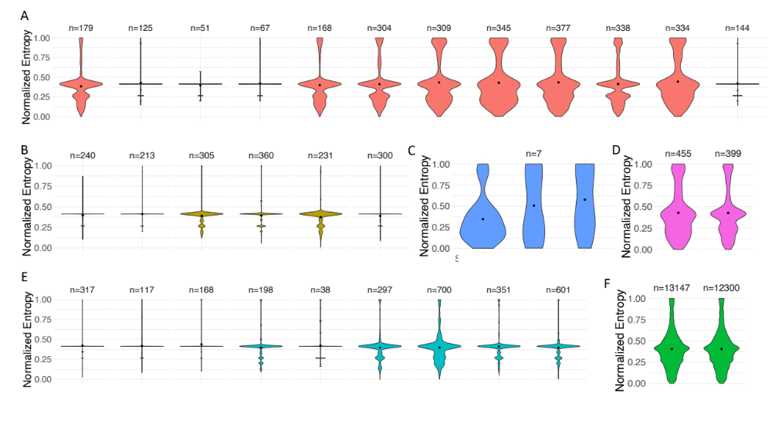
Supplementary Figure 8. Corresponding to Figure 8, the heterogeneity of the intron splicing orders for each RNA-seq dataset. A) S. pombe. B) Fruit fly. C) S. cerevisiae. D Aspergillus nidulans. E) Humans. F) Arabidopsis thaliana.

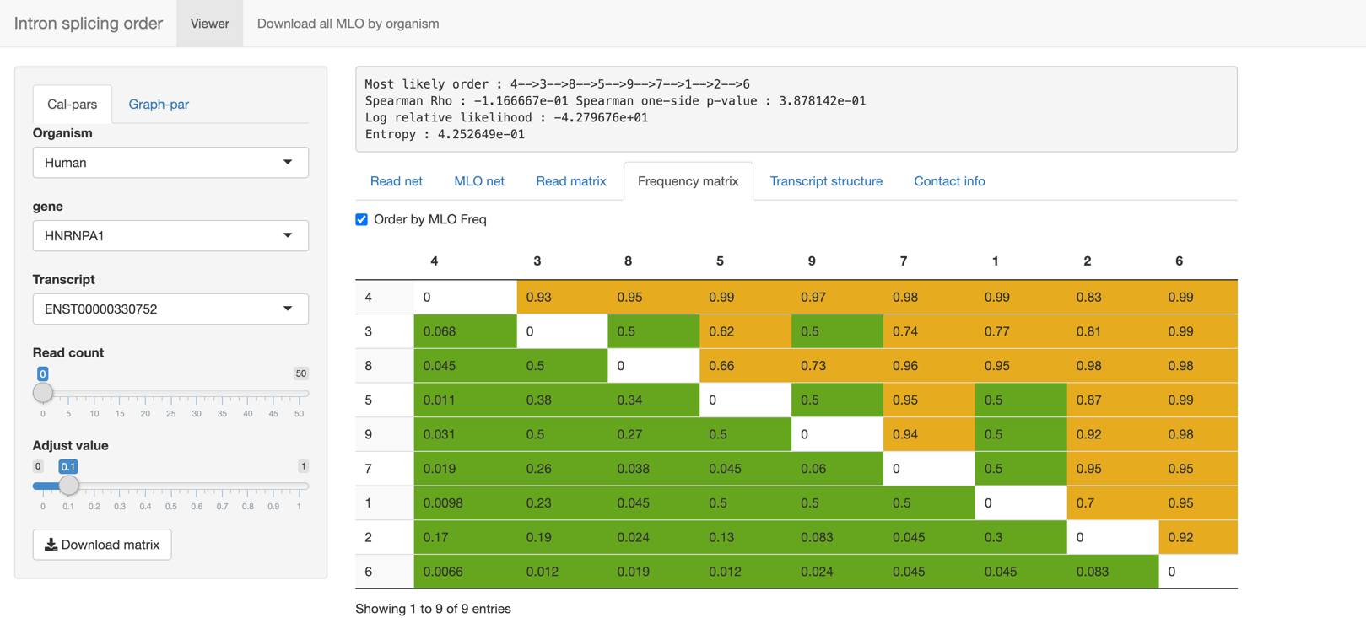
Supplementary Figure 9. Website snapshot.
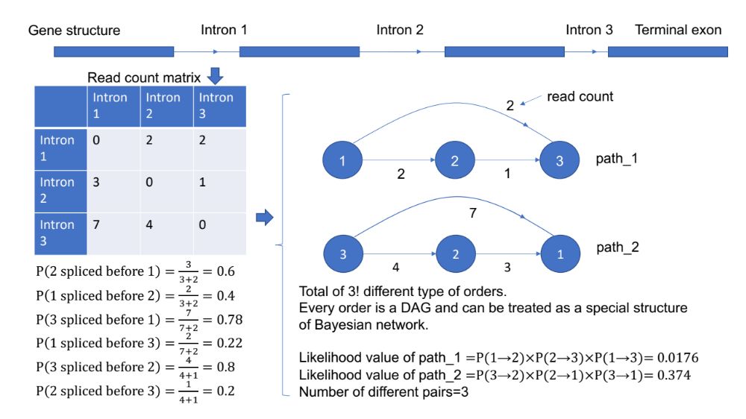
Supplementary Figure 10. An example of the method used here to calculate the likelihood values for two type of orders.

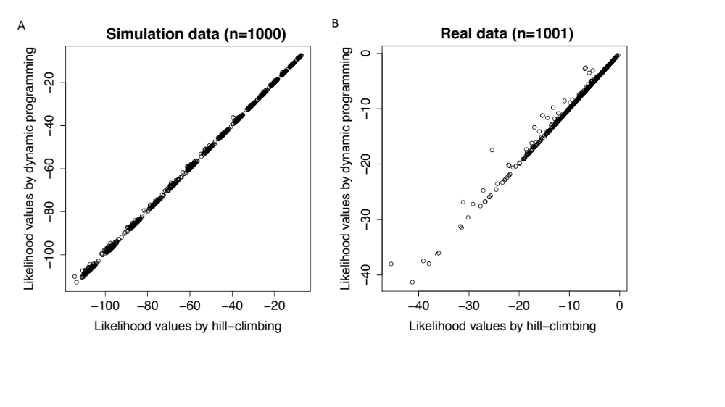
Supplementary Figure 11. Testing the hill-climbing algorithm. A) Comparing the calculated maximum likelihood values by dynamic programming and hill-climbing in a total of 1,000 times for transcripts that contain 6~20 introns. B) Comparing the calculated maximum likelihood values by dynamic programming and hill-climbing using real read count matrixes in Arabidopsis thaliana, only transcripts that contain 6~20 introns were used.
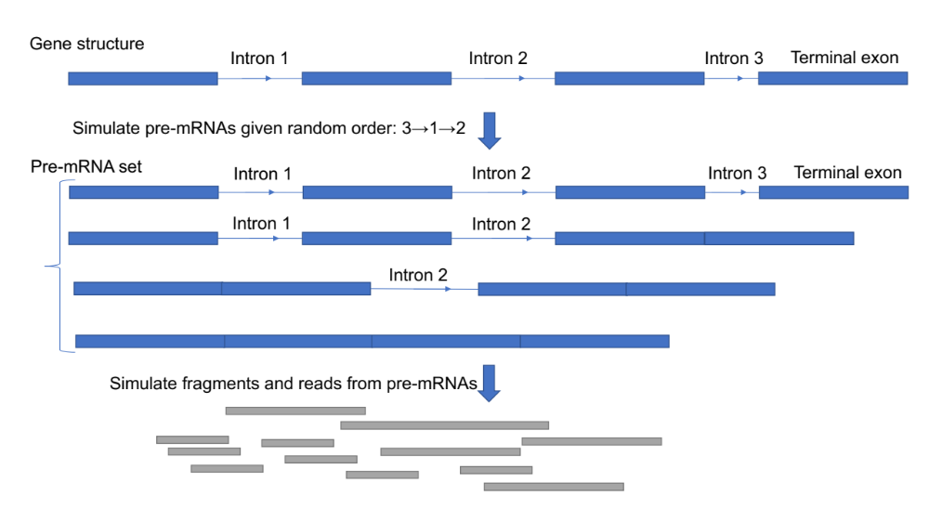
Supplementary Figure 12. A diagram of the method used here to simulate fragments and reads from pre-mRNA given defined order.

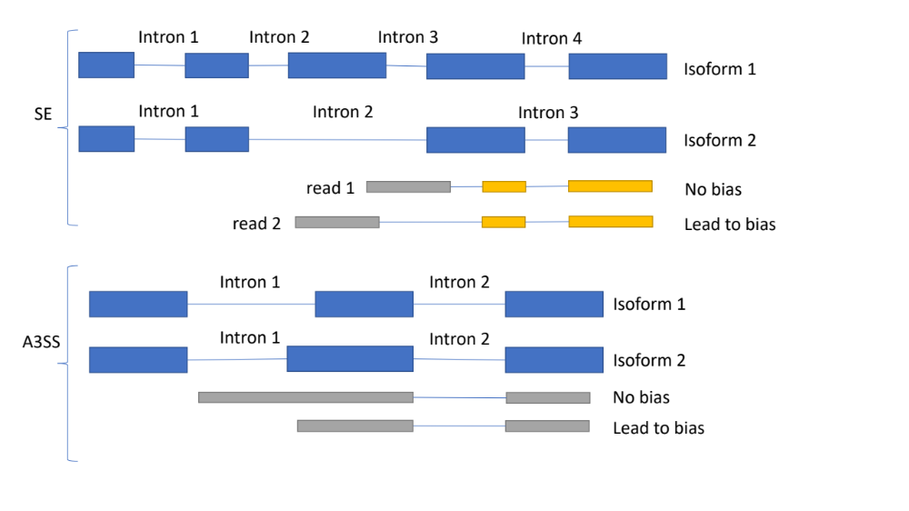
Supplementary Figure 13. The method used to reduce the bias of A3SS, A5SS, and SE events. The idea is enforcing the reads that mapped into the exon-intron border region with enough length.

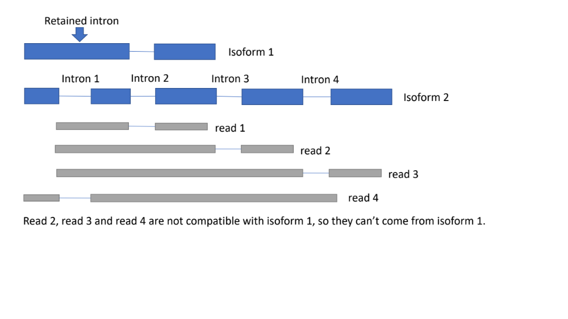
Supplementary Figure 14. Only some introns need to be adjusted for intron retention. Introns that are shared between the inclusion and exclusion isoform need to be corrected. In this figure, only intron 2 needs to adjust the read counts (corresponding to read 1), since read 2 read 3, and read 4 cannot belong to isoform 1.

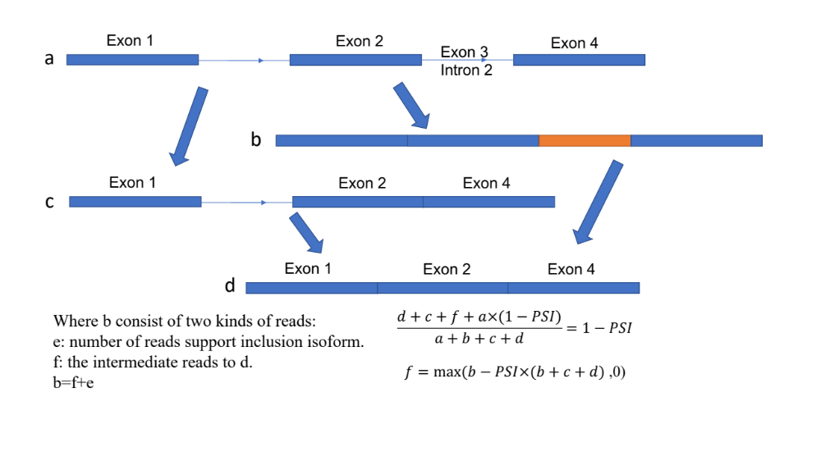
Supplementary Figure 15. The method used here to correct retained introns, where a, b, c, and d are the read counts of the corresponding pre-mRNA.
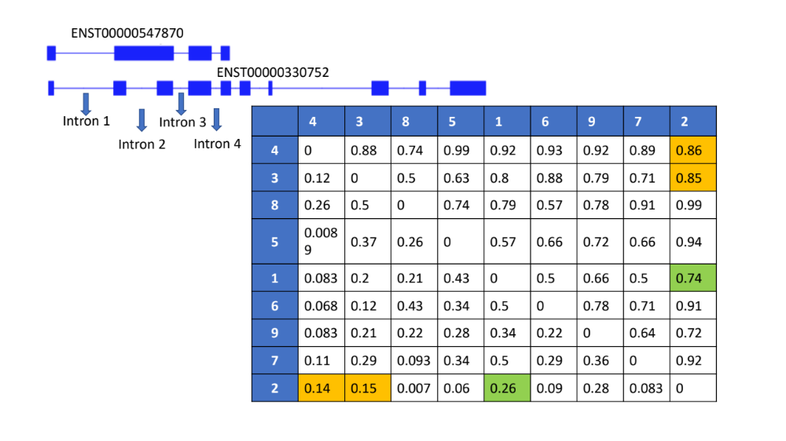
Supplementary Figure 16. The robustness of the method. The most likely order of the lower transcript (ENST00000546500) is 4→3→8→5→1→6→9→7→2. The bias of intron retention came from intron 2. The read count support intron splicing order of introns 2⇔1, 2⇔3 and 2⇔4 can be incorrect, but since the order of intron 2 is fixed by 8→5→1→6→9→7, regardless of the read count between introns 2⇔3 or introns 2⇔4, the overall order does not change. The read counts of introns 2⇔3 and 2⇔4 are highlighted in orange.

