Supporting Information

Engineering of Gold Nanorods as Multifunctional Theranostic Agent for Photothermal-Enhanced Radiotherapy of Cervical Cancer
Lina Xie¹, Xia Ying² Xinyue Li¹, Xinyue Tan¹, Tianzi Zhang³, Xujia Zhang³, Wen Cai³*, Feifei An⁴*, Xiaoli Liu^{5,6}, Suxia Han¹*
1 Department of Radiation Oncology, the First Affiliated Hospital of Xi'an Jiaotong University, Xi'an 710061, Shaanxi, China.
2 Department of Obstetrics and Gynecology, Women'Hospital, School of Medicine, Zhejiang University, Hangzhou 310006, Zhejiang, China.
3 Institute of Medical Engineering, School of Basic Medical Sciences, Health Science Center, Xi’an Jiaotong University, Xi’an 710061, Shaanxi, China.
4 School of public Health, Health Science Center, Xi'an Jiaotong University, No. 76 Yanta West Road, Xi'an 710061, Shaanxi,China
5 Institute of Regenerative and Reconstructive Medicine, Med-X Institute, First Affiliated Hospital of Xi’an Jiaotong University, Xi’an, Shaanxi 710049, China;
6 National Local Joint Engineering Research Center for Precision Surgery & Regenerative Medicine, Shaanxi Provincial Center for Regenerative Medicine and Surgical Engineering, First Affiliated Hospital of Xi’an Jiaotong University, Xi’an, Shaanxi 710061, China
*Corresponding authors: caiwen2016@xjtu.edu.cn (W. Cai); anfeifei@xjtu.edu.cn (F. An); shan87@mail.xjtu.edu.cn (S. Han).

MATERIALS and METHODS
Materials
Bis[4-(N-2-naphthyl-phenylamino)-phenyl]-fumaronitrile (NPAPF) was synthesized following the literature ^{[1]}. Chloroauric acid (HAuCl₄) was bought from Shanghai Acmec Biochemical Co. Ltd. (Shanghai, China); Silver nitrate (AgNO₃) and ascorbic acid (C₆H₈O₆) were purchased from Sinopharm Chemical Reagents Co., LTD. (Shanghai, China); Cetyltrimethylammonium bromide (CTAB), sodium borohydride (NaBH₄), and mPEG5K-SH were from Xi’an Ruixi Biological Technology Co. Ltd. (Xi’an, China); Dulbecco’s Modified Eagle’s Medium (DMEM), fetal bovine serum (FBS), and ethylene diamine tetraacetic acid (EDTA) were from GIBCO (Invitrogen, Germany); Cell Counting Kit-8 (CCK-8) was from TargetMol (Boston, U.S.A); flow cytometry kit (Annexin V-PE/7-AAD) was from Becton Dickinson Company (Franklin Lakes, U.S.A); 2′,7′-dichlorofluorescein diacetate (DCFH-DA) was from Beyotime Institute of Biotechnology (Shanghai, China); 4% paraformaldehyde, 4,6-diamidino-2-phenylindole (DAPI), Triton-X-100, and albumin bovine serum (BSA) were from Hangzhou Fude Biological Technology Co. Ltd. (Hangzhou, China); P-Histone H2A.X (S139) Rabbit mAb was from Cell Signaling Technology (CST) (MA, U.S.A); CoraLite488-conjugated Affinipure Goat anti-Rabbit IgG (H+L) was from Proteintech (Chicago, U.S.A); DAPI-containing antifade solution was from Pioneer Biotech Inc. (SouthernBiotech, U.S.A); transwell chamber was from Corning (New York, U.S.A); Fluorescein (FITC) Tunel Cell Apoptosis Detection Kit, Anti-Ki-67 Rabbit mAb, and HRP conjugated Goat Anti-Rabbit IgG (H+L) were from Servicebio (Wuhan, China). All solvents and reagents applied as received were not further purified.
Preparation of GNRs@CTAB
GNRs were synthesized through the seed-mediated approach. First, gold seeds were prepared by adding 0.25 mL of HAuCl4 aqueous solution (0.01 M) to 7.5 mL of CTAB aqueous solution (0.1 M), which was slightly shaken up and down to obtain a bright brown-yellow solution. Afterward, 0.6 mL of cold NaBH₄ aqueous solution (0.01 M) was added to the obtained solution and violently shaken for 2 min. The solution that turned dully brownish-yellow was stored in a 25℃ water bath. Next, the mixture that contained 4.75 mL of CTAB aqueous solution (0.1 M), 0.2 mL of HAuCl₄ aqueous solution (0.01 M), and 40 µL of silver nitrate aqueous solution (0.01 M) was slightly shaken up and down to acquire a brown-yellow solution. 32 µL of ascorbic acid (0.1 M) was then added to obtain the colorless solution. Finally, 5 µL of the gold seed solution that had been prepared was added to the solution and slightly shaken up and down for 10 s. The solution was purple-red after standing still for over 3 h in a 25 ℃ water bath. Thus, CTAB modified GNRs (GNRs@CTAB) were obtained.
Characterizations of NPAPF-GNRs@PEG
The morphology of NPAPF-GNRs@PEG NPs was examined under a transmission electron microscope (TEM) (H-7650, Hitachi, Japan) with an 80 kV acceleration voltage; the concentration of gold atoms in NPs was assessed by an inductively coupled plasma mass spectrometer (ICP-MS) (NexIONTM 350D, PerkinElmer, USA); the absorbance spectra of NPs were measured through a UV-vis spectrophotometer (UV700, Shimazu, Japan); the zeta potential of NPs was determined by the Malvern Zeta sizer ZS90.
Photothermal Properties of NPAPF-GNRs@PEG NPs
The photothermal properties of NPAPF-GNRs@PEG NPs were investigated through numerous experiments. First, a 790 nm laser (2.0 W/cm²) was applied to irradiate NPAPF-GNRs@PEG solutions at various concentrations (0, 25, 100, and 400 µg/mL) for 15 min. An infrared thermal imager (Xenics GOBI-640, Belgium) was employed to record the temperature fluctuations during radiation every 30 s. Subsequently, the temperature variation of the NPAPF-GNRs@PEG solutions (100 µg/mL) exposed to a 790 nm laser for 15 min at various power densities (1.0, 2.0, and 3.0 W/cm²) was noted through the same approach. To investigate the photothermal stability of NPAPF-GNRs@PEG NPs, a 790 nm laser was utilized to illuminate NPAPF-GNRs@PEG solutions at certain concentrations for 5 min, which was turned off afterward for the dispersions to cool to indoor temperature. The cycle was repeated 6 times. Ultimately, the photothermal conversion effectiveness of NPAPF-GNRs@PEG NPs was determined. The NPAPF-GNRs@PEG NPs were dispersed in PBS at a certain concentration while the light absorption value at 790 nm was determined. The same volume of PBS and NPAPF-GNRs@PEG dispersion solution was irradiated by the 790 nm laser for 15 min, which was turned off afterward to cool for 30 min. The temperature was noted every 30 s with the points taken for mapping. Subsequently, we acquired the cooling curve values of the NPs, plotted the negative values of the natural logarithm of the temperature variation and the cooling time, and fitted the line. The photothermal conversion effectiveness was obtained through η = hA(ΔT_{max}, NPAPF-GNRs@PEG-ΔT_{max}, PBS)/I(1-10^{-Aλ}), where η represents NPAPF-GNRs@PEG NPs’ photothermal conversion effectiveness, I denotes the laser power, Aλ signifies the absorbance of NPAPF-GNRs@PEG solution at a 790 nm wavelength, and hA was acquired from the gradient of the linear relationship between time and -ln(θ), θ=ΔT/ΔT_{max}^{[2]}.
Viability Assay and Cell Uptake
The human normal liver cells (LO₂ cells) and cervical cancer cell lines (HeLa/SiHa cells) were cultivated in DMEM complete medium that contained 1% antibiotics (1000 U mL⁻¹ streptomycin-penicillin) and 10% FBS in a carbon dioxide incubator containing 5% CO₂ at 37℃. The LO₂ cells were cultivated in 96-well plates with 10⁴ cells per well for 24 h. Subsequently, a new cultivation media containing GNRs@CTAB, GNRs@PEG, and NPAPF-GNRs@PEG at various concentrations of gold atoms (6.25-100 µg/mL) was substituted. Those cells incubated for another 24 h were rinsed in PBS, whose viability was evaluated through the CCK-8 assay.
NPAPF-GNRs@PEG’s cell uptake was observed by TEM. After being incubated with NPAPF-GNRs@PEG (25 µg/mL) for 24 h, the HeLa and SiHa cells were rinsed in PBS and fixated in 2.5% (v/v) glutaraldehyde for 6-8 h. Afterward, they were immobilized in 1% (v/v) osmium tetroxide for 3 h, dehydrated in ethanol, and embedded with AGAR resin. The thin sections were prepared on copper mesh, dyed by applying methanol and lead citrate, and analyzed through TEM.
Wound Healing Test and Transwell Chamber Test
The impacts of different treatments on HeLa and SiHa cells’ migration and invasion ability were examined by applying the wound healing test and the transwell chamber test. In the former test, the cells were seeded on a 6-well plate with 5 × 10⁵ cells per well. As the cell fusion rate became 100 %, a 100 μL pipette tip was applied for scratching. These cells were separated into 5 groups, i.e. I: the control group, II: the NPAPF-GNRs@PEG group, III: the X-ray group, VI: the NPAPF-GNRs@PEG + X-ray group, and V: the NPAPF-GNRs@PEG + NIR + X-ray group. Afterward, they were rinsed in PBS, to which serum-free DMEM medium was added. The healing of scratches was assessed under a microscope (Nikon Eclipse-Ti, Tokyo, Japan) at the same site at 0 and 24 h respectively. In the latter test, HeLa and SiHa cells were separated into the same 5 groups like those in the wound healing assay. The Transwell chamber (Corning, U.S.A) was coated with Matrigel and left to stand at 37 °C for 30 min. To the upper chamber 100 μL of DMEM medium including 10⁵ cells was added while to the lower one 500 μL of DMEM medium including 10% FBS was added. After being cultivated for 48 h, the upper-chamber matrix gel and cells were wiped by applying a wet cotton swab. Subsequently, those lower-chamber cells were fixated in 4% paraformaldehyde for 10 min and dyed by applying crystal violet for 30 min. Finally, the cells were rinsed in PBS before being observed under a microscope.
Reactive Oxygen Species (ROS) Detection
HeLa and SiHa cells were seeded on a 12-well plate with 10⁵ cells per well, separated into the same 5 groups, and treated through the same approach as that in the wound healing assay. Subsequently, they were treated with DCFH-DA for 1 h before being observed by an inverted fluorescence microscope (Leica DMi8, Wetzlar, Germany).
Cell Apoptosis
After being cultivated in 6-well plates with 5×10⁵ per well, Hela cells were separated into the same 5 groups like those in the wound healing assay. Subsequently, these cells were cultured for another 6-8 h, rinsed in PBS, digested with trypsin without EDTA, and treated with 500 μL of buffer solution including 5 μL of Annexin V-PE and 5 μL of 7-aad for 15 min at indoor temperature in dark successively. Ultimately, flow cytometry was adopted to detect the apoptosis rate. This experiment was repeated thrice.
Biocompatibility In Vivo
The nine female nude mice were separated into 3 groups, each of which had 3 mice. The first group was the control group injected with 200 μL of PBS through the tail vein, whereas the second and third groups were injected with NPAPF-GNRs@PEG (0.1 mg/mL, 200 µL) through the tail vein 15 days after NPAPF-GNRs@PEG injection. The blood of the mice was acquired from their eyeballs on 30 d after anesthesia. The biochemical blood test (BAC) was performed on the serum while the routine complete blood count (CBC) test was conducted on the whole blood at Wuhan Xavier Biological Technology Co., Ltd. After sacrificing the mice, we dyed their major organs including livers, spleens, lungs, and kidneys by applying hematoxylin and eosin (H&E) and histologically evaluated them.
Statistical Analysis of Metabolomics Analysis
Regarding the statistical analysis of metabolomics, the unsupervised principal component analysis (PCA) was conducted through statistical function prcomp in R (www.r-project.org). The data was the unit variance scaled prior to unsupervised PCA. VIP >= 1 and absolute Log2FC (fold change) >= 1 denotes the remarkably metabolic regulation of groups. The variable importance in projection (VIP) acquired from OPLS-DA contains score and permutation plots produced by applying R package MetaboAnalystR. The data was log transform (log2) and mean centering prior to OPLS-DA. The ranking test (200 rankings) was conducted to avert overfitting. The determined metabolites were annotated by applying KEGG COMPOUND (http://www.kegg.jp/kegg/compound/), whereas annotated metabolites were mapped afterward to the KEGG Pathway (http://www.kegg.jp/kegg/pathway.html). The substantially enriched pathways were determined by applying the p-value of the hypergeometric test in the given list of metabolites.
QC Analysis of Metabolomics Analysis
The repeatability of metabolite extraction and detection was examined by the TIC overlapping display of QC samples. As indicated by the TIC patterns of each group of samples in positive and negative ion detection modes in Figure S13A and Figure S13B respectively, the curves of total ion flow detected by metabolites exhibited a high rate of overlapping, i.e. the retention time was consistent with the peak intensity, implying a dramatically high level of signal stability for the same sample observed at various time points through mass spectrometry. The instrument’s high-level stability guaranteed the reproducibility and credibility of the data. The Pearson correlation analysis was conducted on QC samples, which displayed a high level of stability, as indicated in Figure S14A. The closer the correlation (|r| approaches 1), the higher stability of the testing process and the more satisfying the data quality. As the coefficient of variation, the CV value is the ratio of the original data’s standard deviation to its mean, which could reflect the data dispersion degree. The occurrence frequency of CV was found to be below the reference value through the empirical cumulative distribution function (ECDF). The larger the proportion of substances with relatively low CV values was, the more stable the experimental data would be. The proportion of substances with CV values below 0.5 exceeded 85%, implying that the experimental data was stable, whereas that below 0.3 exceeded 75%, demonstrating that the experimental data was substantially stable (Figure S14B).
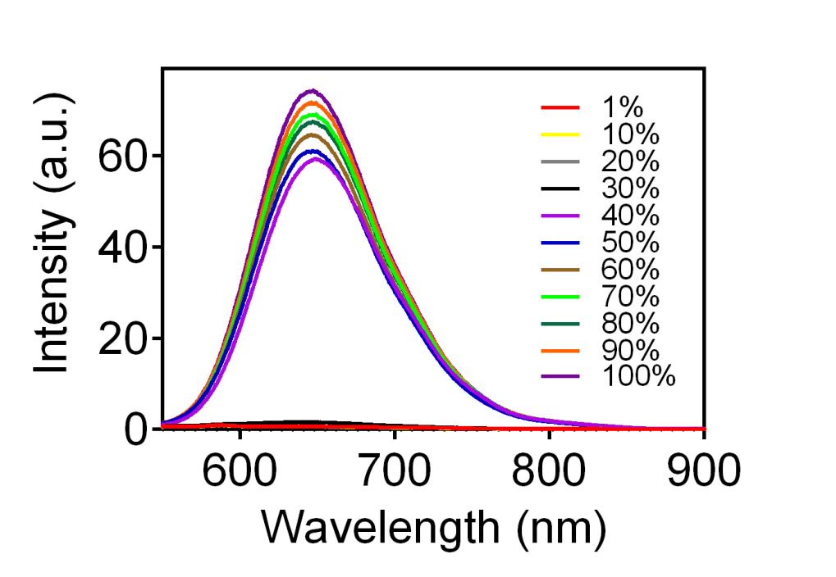
Figure S1. PL spectra of NPAPF-GNRs@PEG NPs in dimethyl sulfoxide (DMSO) with different water contents (excited at 500 nm)

Figure S2. Cell viability of SiHa after various treatments. (I: the control group, II: the NPAPF-GNRs@PEG group; III: the NIR group, IV: the X-ray group, V: the NPAPF-GNRs@PEG + NIR group, VI: the NPAPF-GNRs@PEG + X-ray group, and VII: the NPAPF-GNRs@PEG + X-ray + NIR group) The dosage of NIR and X-ray was 1 W/cm² for 10 min and 6 MV 4 Gy respectively. * and **indicate remarkable differences at levels of p < 0.05 and p < 0.01 respectively (n = 4).

Figure S3. Uptake of NPAPF-GNRs@PEG NPs into SiHa cells. The red arrows denote NPAPF-GNRs@PEG NPs inside the cytoplasm while the red circles indicate NPAPF-GNRs@PEG NPs ingested by cells. Scale bar: 2μm (left) and 200 nm (right).
Figure S4. Effect of various treatments on the invasion and migration, production of ROS and γ-H2AX for SiHa cells. (A) Wound-healing assay. Scale bar: 50 μm. (B) Transwell assay. Scale bar: 50 μm. (C) Intracellular ROS levels under an inverted fluorescence microscope. Scale bar: 100 μm. (D) Immunity fluorescence imaging of γ-H2AX. Scale bar: 100 μm. * and ** imply substantial differences at levels of p<0.05 and p<0.01 respectively. (I: the control group, II: the NPAPF-GNRs@PEG group, III: the X-ray group, VI: the NPAPF-GNRs@PEG+X-ray group, and V: the NPAPF-GNRs@PEG+NIR+X-ray group)
Figure S5. Apoptosis assay in Hela cells (I: the control group, II: the GNRs@PEG group, III: the X-ray group, VI: the GNRs@PEG+X-ray group, and V: the GNRs@PEG+NIR+X-ray group)
Figure S6. H&E stained images of major organs. Scale bar: 250 μm.
Figure S7. Results of the blood chemistry test (A-C) and the blood routine test (D-I) (n=3)

Figure S8 (A) CT images of NPAPF-GNRs@PEG solutions and the linear relationship between HU signals of NPAPF-GNRs@PEG solutions and their concentrations (0, 12.5, 25, 50, and 100 μg/mL). (B) PA images of NPAPF-GNRs@PEG solutions and the linear relationship between PA signals of NPAPF-GNRs@PEG solutions and their concentrations (0, 25, 50, 100, 200, and 400 μg/mL).

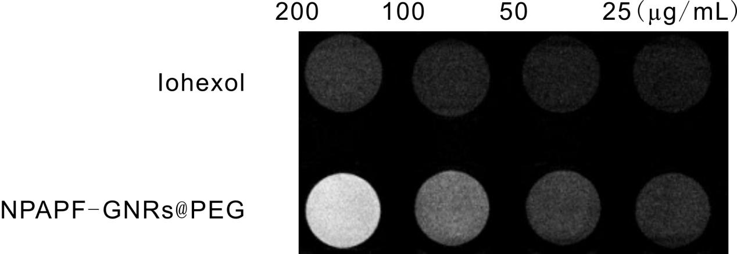

Figure S9. CT images of Iohexol and NPAPF-GNRs@PEG solutions at various concentrations (25, 50, 100, and 200 μg/mL).

Figure S10. Confocal images of HeLa cells noted at 488 nm excitation after they were incubated with NPAPF-GNRs@PEG, GNRs@PEG for 24 h at 50 μg/mL Au concentration. Herein, the fluorescence at 660-750 nm wavelengths was obtained. Scale bars: 50 μm.
Figure S11. AIE fluorescent signals in frozen neoplastic sections. Scale bar: 100 μm.
Figure S12. Tumor images in different groups.

Figure S13. (A) Total ion diagrams of QC neoplastic tissues in the positive ion mode. (B) Total ion diagrams of QC neoplastic tissues in the negative ion mode.

Figure S14. (A) Correlation diagram of the QC samples. The diagonal squares represent the names of the QC samples; the square in the lower-left corner of the diagonal denotes the scatter plot of the correlation among QC samples; the square in the upper-right corner of the diagonal is the Pearson correlation coefficient of the corresponding QC sample; the horizontal and vertical coordinates imply the metabolite contents (log processing); each point denotes a metabolite. (B) The CV distribution map of each group. The abscissa represents the CV value; the ordinate denotes the proportion of substances below the corresponding CV value in the total number of substances; different colors denote different grouped samples; the mix signifies a QC sample; the CV values of the two reference lines perpendicular to the X-axis are 0.3 and 0.5; the substances that correspond to the two reference lines parallel to the X-axis accounts for 75% and 85% of the total number of substances.
Figure S15. PCA score plot of QC samples in each group.
Figure S16. Hierarchical clustering of metabolites of neoplastic tissues in the RT and RT plus PTT groups.

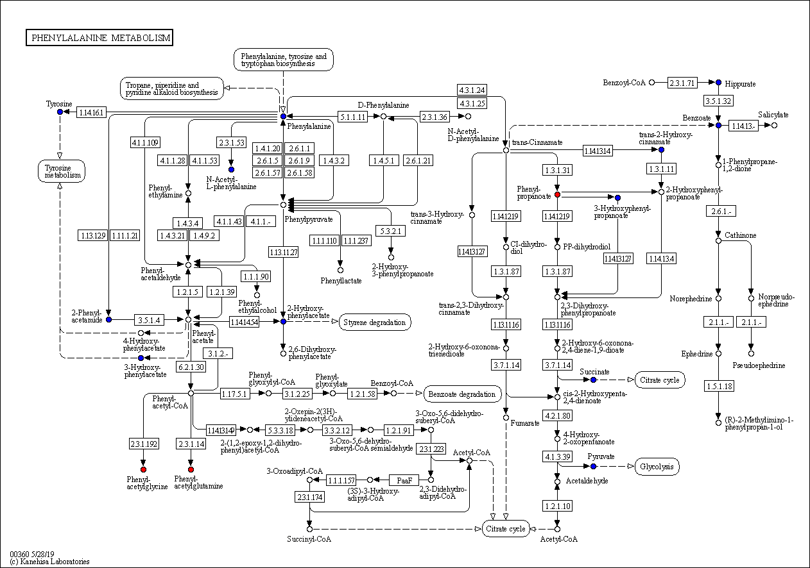
Figure S17. KEGG pathway map of differential metabolites. The red color indicates that the metabolite content was remarkably up-regulated in the experimental group; the blue color denotes that the detected metabolite content did not change dramatically; the green color implies that the metabolite content was substantially down-regulated in the experimental group.
References
1. Yang Y, An F, Liu Z, Zhang X, Zhou M, Li W, Hao X, Lee C-s, Zhang X. Ultrabright and ultrastable near-infrared dye nanoparticles for in vitro and in vivo bioimaging. Biomaterials.2012; 33:7803-7809. http://doi.org/10.1016/j.biomaterials.2012.07.006
2. Liu Y, Ai K, Liu J, Deng M, He Y, Lu L. Dopamine-Melanin Colloidal Nanospheres: An Efficient Near-Infrared Photothermal Therapeutic Agent for In Vivo Cancer Therapy. Advanced Materials.2013; 25:1353-1359. http://doi.org/10.1002/adma.201204683

