Additional data
Table S1. Accession numbers of RopGEF genes and RAC/ROP genes
Gene | Locus | Gene | Locus | Gene | Locus | Gene | Locus
OsRopGEF1 | Loc_Os10g40270 | OsRac1 | Loc_Os01g12900 | AtRopGEF1 | Loc_AT4G38430 | AtROP1 | Loc_AT3G51300
OsRopGEF2 | Loc_Os05g48640 | OsRac2 | Loc_Os02g02840 | AtRopGEF2 | Loc_AT1G01700 | AtROP2 | Loc_AT1G20090
OsRopGEF3 | Loc_Os02g17240 | OsRac3 | Loc_Os02g20850 | AtRopGEF3 | Loc_AT4G00460 | AtROP3 | Loc_AT2G17800
OsRopGEF4 | Loc_Os02g47420 | OsROP4 | Loc_Os02g50860 | AtRopGEF4 | Loc_AT2G45890 | AtROP4 | Loc_AT5G45970
OsRopGEF5 | Loc_Os01g62990 | OsROP5 | Loc_Os02g58730 | AtRopGEF5 | Loc_AT5G05940 | AtROP5 | Loc_AT4G35950
OsRopGEF6 | Loc_Os01g48410 | OsRacB | Loc_Os05g43820 | AtRopGEF6 | Loc_AT3G55660 | AtROP6 | Loc_AT4G35020
OsRopGEF7 | Loc_Os09g37270 | OsRacD | Loc_Os06g12790 | AtRopGEF7 | Loc_AT5G02010 | AtROP7 | Loc_AT5G45970
OsRopGEF8 | Loc_Os01g55520 |  |  | AtRopGEF8 | Loc_AT3G24620 | AtROP8 | Loc_AT2G44690
OsRopGEF9 | Loc_Os04g47170 |  |  | AtRopGEF9 | Loc_AT4G13240 | AtROP9 | Loc_AT4G28950
OsRopGEF10 | Loc_Os05g38000 |  |  | AtRopGEF10 | Loc_AT5G19560 | AtROP10 | Loc_AT3G48040
OsRopGEF11 | Loc_Os07g29780 |  |  | AtRopGEF11 | Loc_AT1G52240 | AtROP11 | Loc_AT5G62880
 |  |  |  | AtRopGEF12 | Loc_AT1G79860
 |  |  |  | AtRopGEF13 | Loc_AT3G16130
 |  |  |  | AtRopGEF14 | Loc_AT1G31650

Table S2. OsRopGEF isogene-specific primers for qPCR and pGREEN cloning.
Genes | Sense Primers | Antisense Primers
qPCR
OsRopGEF2 | 5'-CATTGCTCAGTCAGCTCTTG-3' | 5'-TGAAGAACATCTTCGATTCG-3'
OsRopGEF3 | 5'-TGACGAGGAAGTGGCTGCAG-3' | 5'-AGCGACTCGATGTACACCTC-3'
OsRopGEF6 | 5'-TTCGGTATTCGGGGAGCAGC-3' | 5'-ATGCTGGTTCCATCCGTGGA-3'
OsRopGEF8 | 5'-CAAGTCTTGGACAACGGCGT-3' | 5'-TTGAAGTTGTCCAGGTAATC-3'
pGREEN cloning
OsRopGEF2 | 5'-TCGACGGTATCGATAAGCTT  ATGGCGCGGCCGCTGCTGA-3' | 5'-CAGGAATTCGATATCAAGCTT  GTGTCTAGATATTGGGCT-3'
OsRopGEF3 | 5'-TCGACGGTATCGATAAGCTT  ATGGTGCGGTTCCTCCGG-3' | 5'-CAGGAATTCGATATCAAGCTT  GTGGCGCGCGGAGGGGCT-3'
OsRopGEF6 | 5'-TCGACGGTATCGATAAGCTT  ATGGTGCGGCGGCACCTG-3' | 5'-CAGGAATTCGATATCAAGCTTC  CTATGAGAAAAGCTTTTC-3'
OsRopGEF8 | 5'-TCGACGGTATCGATAAGCTT  ATGGCAGCGAGCGGCGGT-3' | 5'-CAGGAATTCGATATCAAGCTT  ATGGCGACCTGGTGGGCTT-3'

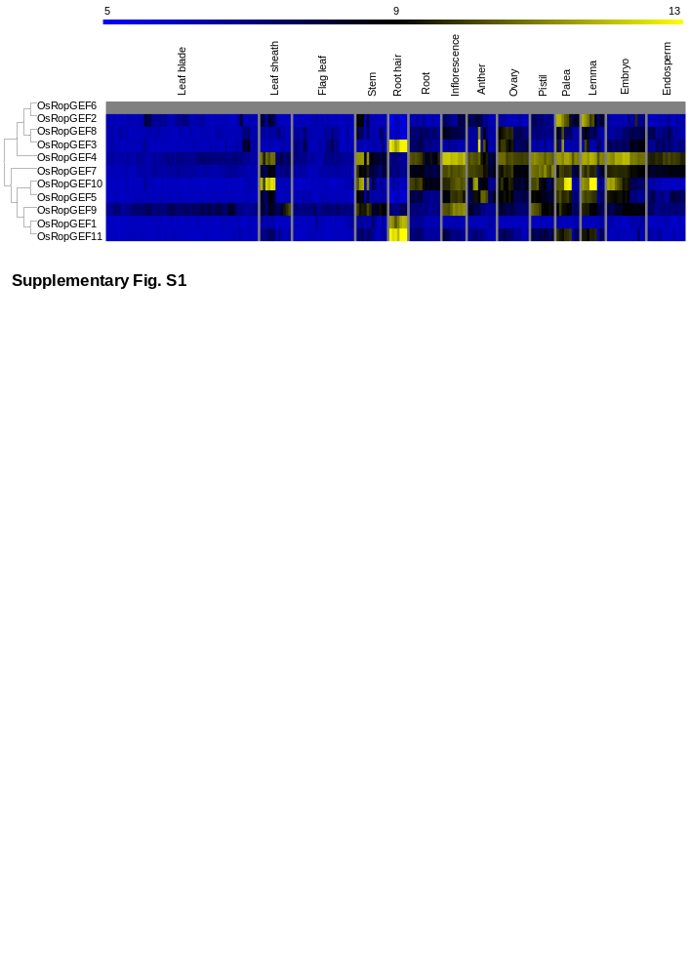
Figure S1. Meta-expression analysis and genome-wide identification of every OsRopGEF. OsRopGEF expression was observed in all tissues except pollen. Yellow color in the heatmap indicates high level of expression; dark blue, low level of expression. Numeric values indicate the average of the normalized log2 intensity of microarray data.

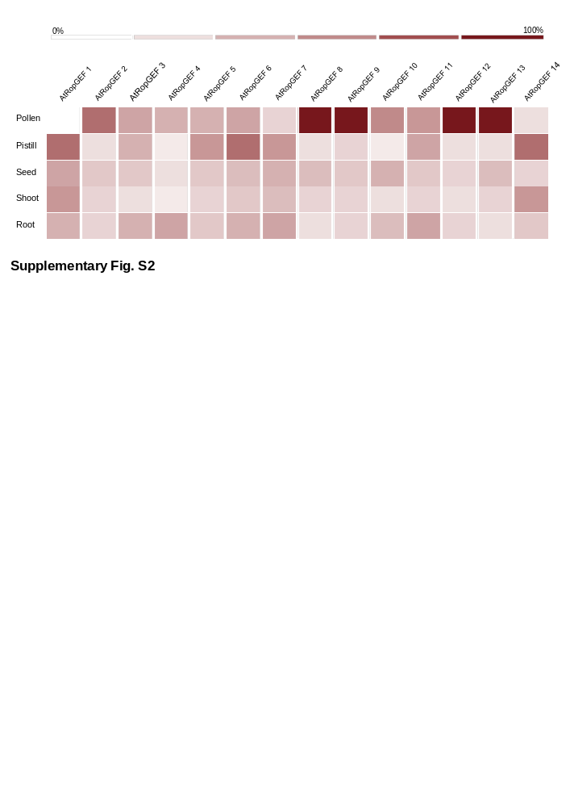
Figure S2. Meta-expression analysis of entire AtRopGEF genes. The heatmap was prepared using the Genevestigator. We chose five representative tissues, including pollen. It revealed that five Arabidopsis RopGEFs were highly expressed in pollen. The dark red color of the heatmap indicated the highest expression; white color, lowest expression.
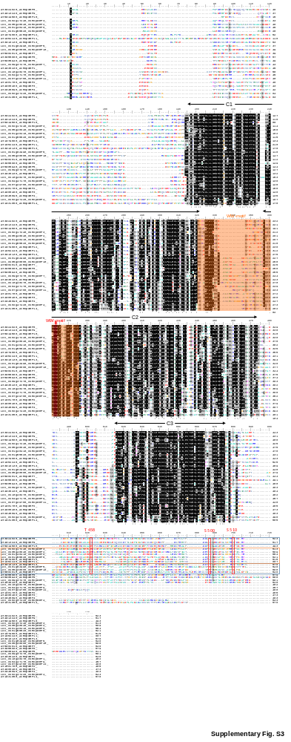
Figure S3. Protein sequence alignment domain analysis and conserved phosphorylated amino acid residues of C-termini of RopGEF genes. Every OsRopGEF and AtRopGEF protein sequence was collected and aligned, followed by the PRONE domain (C1, C2, C3) and the WW-motif. At the end part of the sequence, we found some conserved regions. According to previous studies, S510 in the C-terminus of AtRopGEF12 is involved in the C-terminal inhibition of GEF activity. As in AtRopGEF12, the serine residue is conserved in each of the OsRopGEF2, OsRopGEF3, and OsRopGEF8 genes but not in OsRopGEF6. However, K (Lysine) can also be phosphorylated.
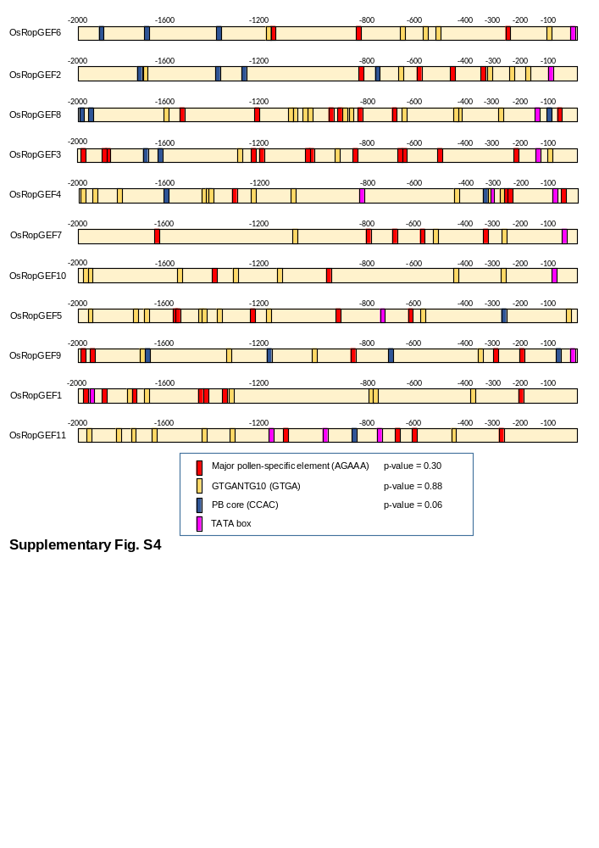
Figure S4. Promoter analysis of each OsRopGEF gene. Specific-CREs known to affect expression in pollen were identified using PLACE database, namely three pollen-CREs and the TATA box. The number above the yellow bar shows the upstream position of the promoter base pair when taken at +1 of ATG. We analyzed up to the upstream 2,000-base pair. The p-values indicate how significantly the four genes exhibiting high expression in pollen differed from the other seven genes.
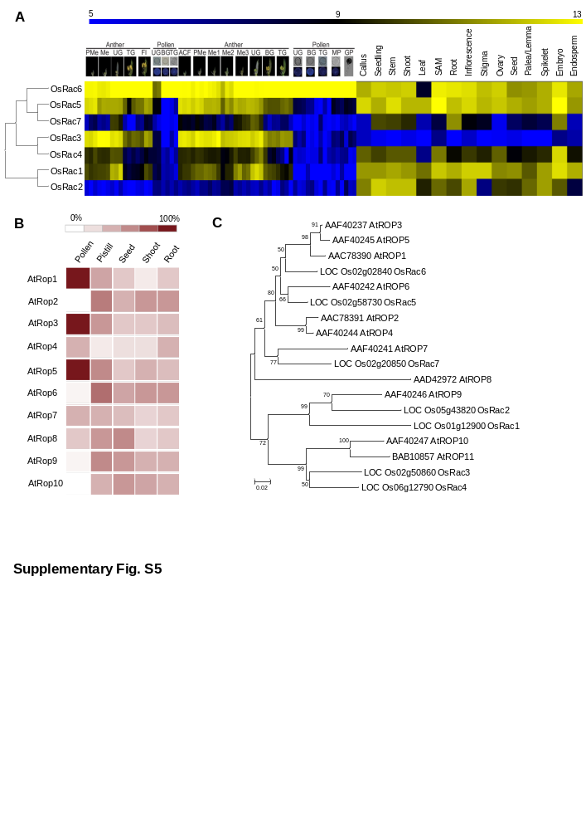
Figure S5. Meta-expression analysis and genome-wide identification of the seven OsRac and ten AtRop genes. (A) Heatmap expression analysis of every OsRac gene. (B) Heatmap of AtRop using Genevestigator. (C) Phylogenetic tree constructs including every OsRac and AtRop.

