Supporting Information

Integrated Opposite Charge Grafting Induced Ionic-junction Fiber

Yi Xing¹†, Mingjie Zhou²†, Yueguang Si³, Chi-Yuan Yang⁴, Liang-Wen Feng⁵, Qilin Wu¹, Fei Wang², Xiaomin Wang², Wei Huang⁶, Yuhua Cheng⁶, Ruilin Zhang⁷, Xiaozheng Duan⁷, Hengda Sun¹, Jiayi Zhang³, Su Jiang², Gang Wang¹*, Meifang Zhu¹

¹ State Key Laboratory for Modification of Chemical Fibers and Polymer Materials, College of Materials Science and Engineering, Donghua University, Shanghai 201620, China
² Hand Surgery Department, Center for the Reconstruction of Limb Function, National Clinical Research Center for Aging and Medicine, Huashan Hospital; Department of Hand and Upper Extremity Surgery, Jing’an District Central Hospital; State Key Laboratory of Medical Neurobiology and Collaborative Innovation Center of Brain Science, Institutes of Brain Science, Fudan University, Shanghai, China 200040
³ State Key Laboratory of Medical Neurobiology, MOE Frontiers Center for Brain Science, Institute of Brain Science, Department of Ophthalmology, Zhongshan Hospital, Fudan University, Shanghai 200032, China.
⁴ Laboratory of Organic Electronics, Department of Science and Technology, Linköping University, SE-601 74, Norrköping, Sweden
⁵ College of Chemistry, Sichuan University, Chengdu, 610064, China
⁶ School of Automation Engineering, University of Electronic Science and Technology of China, Chengdu, 611731, China
⁷ State Key Laboratory of Polymer Physics and Chemistry, Changchun Institute of Applied Chemistry, Chinese Academy of Sciences, Changchun, Jilin 130022, China
*Corresponding author. Email: gwf8707@dhu.edu.cn (G.W.)
†These authors contributed equally to this work.

Supplementary Text
Animal experiments of the ionic-junction fiber in vivo
Animals. Animal care and experiments were performed in accordance with the National Institutes of Health Guide for the Care and Use of Laboratory Animals and were approved by the Animal Care and Use Committee of Shanghai Medical College of Fudan University. C57BL/6 mice were obtained from the Shanghai Laboratory Animal Center, CAS (Shanghai, China). All animals were housed at 22 °C, with 12-h light/dark cycles. Room humidity was controlled at 50%. All experiments were conducted during the light cycle.

Electrical stimulation (ES) signal transmission on sciatic nerve via the ionic-junction fiber. C57BL/6 mice were anesthetized with 0.8-1.0% isoflurane. After shaving and skin disinfection were performed, the vastus lateralis muscle and biceps femoris muscle were bluntly dissected to expose the sciatic nerve. For electrical stimulation of the sciatic nerve, two electrical stimulation needles were positioned at the proximal and distal side of the sciatic nerve distal stump. An electrical stimulatory pulse (duration: 0.1 msec, frequency: 1Hz) was delivered by the Medtronic KeyPoint Portable EMG device. And two-needle recording electrodes were inserted respectively into the tendon and the middle of the anterior tibial muscle to record CMAP. Data were collected using an AM1800 amplifier (Datawave Technology, Inc., USA) and AXON DIGIDATA 1440 A digital-analog converter (AXON Inc., BMU). Different voltages (3-12 V) were randomly applied, and the procedure was repeated ten times.

Ionic-junction fiber implantation and immunofluorescence staining. The ionic-junction fiber was implanted and attached to the sciatic nerve of one side, while the sciatic nerve of the other side was sham-operated. In detail, the sciatic nerve was exposed as described in Fig. 5B. Afterward, a 1cm-long ionic-junction fiber device was implanted, then the muscles above were sutured firmly to ensure the close contact of ionic-junction fiber and sciatic nerve. For the sham-operated side, the surgical procedure was repeated except that an ionic-junction fiber was not implanted. After the operation, the mouse was put in a thermotank and returned to the cage upon its full awake.
After two weeks of implant, the sciatic nerve was exposed again via the original surgical approach, then the sciatic nerve from the nerve root to the popliteal fossa was transected and sectioned for cross-section slice. The immunofluorescence staining of the portion near popliteal fossa where the branches can be observed was shown as a representative in Fig. 5H.
As for immunofluorescence staining, the slices (cross-sections; 4 μm thick) were washed with 0.01M PBS (pH=7.4) 3 times (5 min each) and permeabilized in 0.5% Triton-X-100 for 30 min. The slices were then blocked in 3% BSA for 30 min at room temperature and incubated with primary antibodies overnight at 4 °C (Anti-iba1 Antibody, Alexa Fluor 488 Conjugate (Mouse, Sigma-Aldrich, (MABN92-AF488), 1:200), BMP (Rat, Novus Biologicals, (NB600-717), 1:200)). The slices were rewashed with 0.01M PBS 3 times (5 min each). Secondary antibodies (Servicebio, Inc., China) were applied to the slices and incubated at room temperature for approximately 2 h in the dark. The slices were washed three times (5 min each), stained in a DAPI solution working solution for 10 min and washed 3 more times. Finally, the slides were mounted and photographed with a confocal microscope.
Then the quantitative analysis of mean sheath thickness and mean optical density of MBP for sciatic nerves from both sides was performed in ImageJ, and five-point sampling was adopted for selecting the area for analysis in each slice. Afterwards, Microsoft Excel was used for the statistical analysis of the results, followed by graphing of the analysis result using GraphPad Prism.

Hindlimb movement analysis. The video of hindlimb movement was recorded using Huawei Mate 40 Pro (Huawei Inc. China). The trajectory of the hindlimb was traced with DeepLabCut 2.2.0, and the angle changes of each joint were exported meanwhile. In detail, we define the frame before movement as the rest position and the frame with the maximal ankle and MP joint movement as action position. The reference points were marked at the knee joint, ankle joint, MP joint and the ends of the toes. Then the reference points were connected and joint angle data in rest and action position was measured. The change in joint angle was analyzed by comparing the rest and action position.

Statistical analysis. Statistical analyses were performed in Excel (Microsoft Corporation, Inc., USA) and MATLAB (MathWorks, Inc., USA). Data distributions were tested for normality using the Kolmogorov–Smirnov normality test. For comparison of two groups, data with normal distribution were analyzed using Student’s t-test. If data distributions were not normally distributed, Wilcoxon signed-rank tests were performed. For comparison of multiple groups, data were analyzed using one-way ANOVA followed by Dunnett’s multiple comparisons, if data distribution was normal. P value < 0.05 was considered statistically significant. Data are presented as the mean ± s.e.m. (standard error of mean).

Theoretic modeling of potential distribution profile in the ionic-junction fiber
The potential distribution profile in Fig. 2A and Fig. S9 was simulated with coupled Nernst-Planck-Poisson model, using a commercial finite-element software package COMSOL Multiphysics (version 5.3). In our work, there are fixed anion and mobile Na⁺ present in SEBS-SN, while fixed cation and mobile Cl⁻ present in SEBS-IM. The mobile ions drift through the bilayer interface under applied potential $φ$, in that situation, the following equations applied¹:

$∇∙(-ϵ_{0}ϵ_{r}∇φ)=F\sum_{i}{z_{i}c_{i}+ρ_{fix}}$ (1)

$J_{i}=-D_{i}∇c_{i}-z_{i}u_{i}Fc_{i}∇φ$ (2)

$∇∙J_{i}=0$ (3)

where $F$ is Faraday’s constant; $z_{i}$ is the charge number; $c_{i}$ is the concentration of the mobile ions; and $ρ_{fix}$ is the charge density of the immobilized ions in the matrix; $ϵ_{0}$ is the vacuum dielectric constant, and $ϵ_{r}$ the relative permittivity assumed to be 4 for SEBS like elastomers². The mobility $u_{i}$ and the diffusion coefficient $D_{i}$ are related by the Nernst-Einstein relation:

$u_{i}=\frac{D_{i}}{RT}$ (4)

Where R and T stand for universal gas constant, and absolute temperature. The grafting percentage used in the main text for device fabrication is 40% for SEBS-SN and 100% for SEBS-IM, respectively. Therefore, fixed charge density of 293 mol/m³ for SEBS-SN and 596 mol/m³ for SEBS-IM are used in the simulation, accordingly the initial mobile ion density (293 mol/m³ for $c_{{Na}^{+},0}$ and 596 mol/m³ for $c_{{Cl}^{-},0}$). Since there is sufficient volume for mobile ions to reach equilibrium with the fixed charges after crossing the heterojunction interface, and no mobile ions could penetrate further into the bulk, at and outside the target simulation boundary on x-axis direction, we assume the ion concentrations stays same with the initial value $c_{i,0}$.

Supplementary Figures and Tables
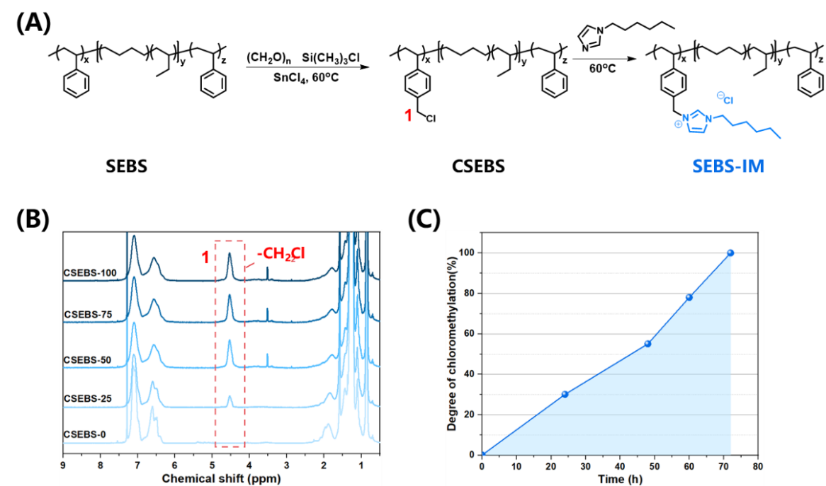
Fig. S1. The synthesis process and NMR spectra of SEBS-IM copolymer with different degrees of chloromethylation. (A) Synthesis scheme and (B) ¹H NMR spectra: ¹H NMR (600 MHz, CDCl₃); (C) Degree of chloromethylation as a function of time.

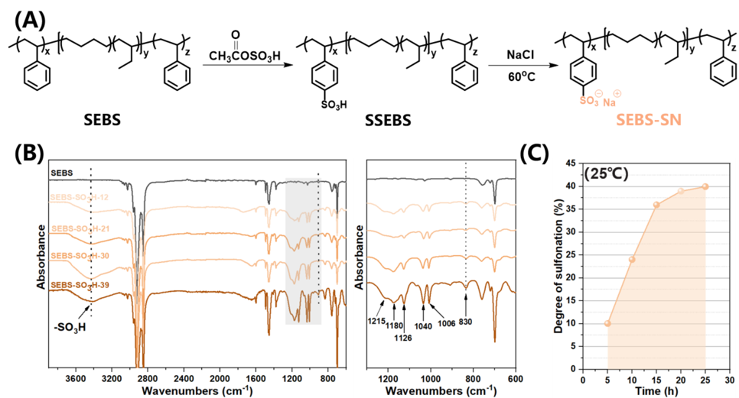
Fig. S2. The synthesis process and ATR-FTIR spectra of SEBS-SN copolymer with different degrees of sulfonation. (A) Synthesis scheme and (B) ATR-FTIR spectra of SSEBS copolymer. (C) Degree of sulfonation as a function of time at 25 ℃.

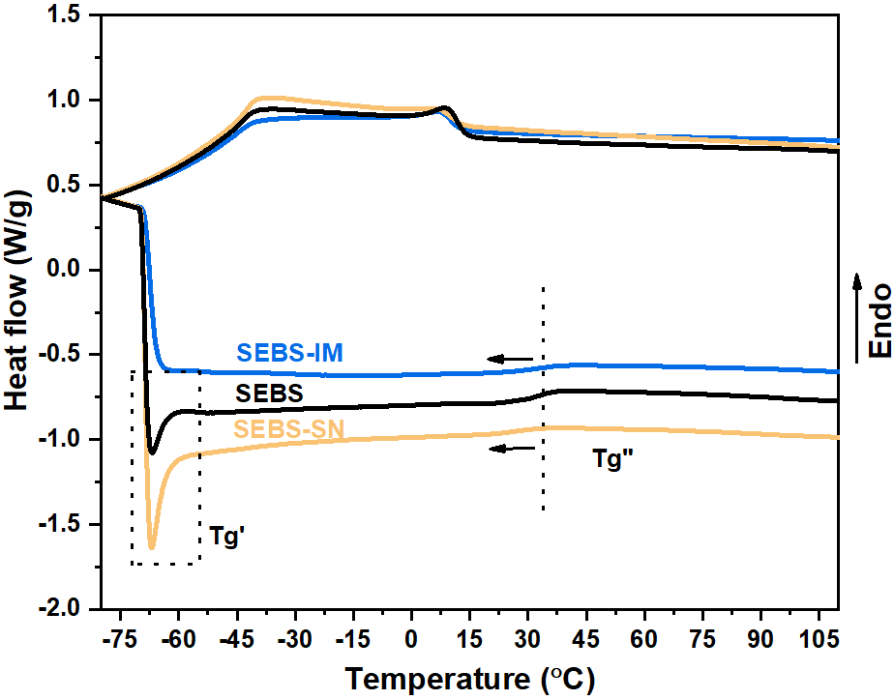
Fig. S3. DSC thermograms of SEBS-IM and SEBS-SN polyelectrolytes. Two glass transitions temperatures (T_{g}) are observed at -60 ºC and 37 ºC for SEBS and two grafted SEBS polyelectrolyte, with SEBS-IM showing slightly lower T_{g} of 35.6 ºC.

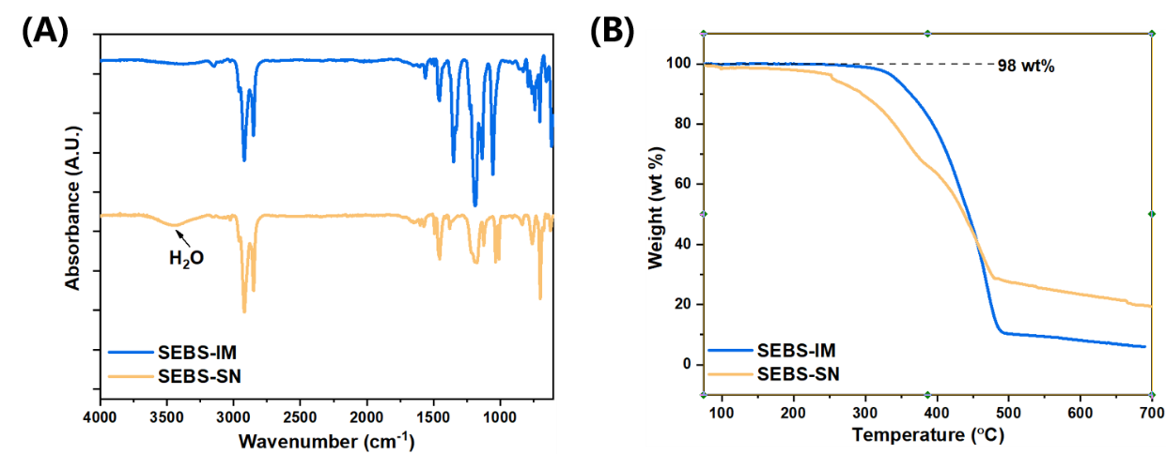
Fig. S4. Contents of residual water for SEBS-IM and SEBS-SN polyelectrolytes. (A) The vibration peak of H₂O in the range of 3300 - 3500 cm⁻¹ is observed for SEBS-SN in ATR-FTIR. (B) Thermogravimetric analysis (TGA) of polyelectrolytes with a heating rate of 10 ºC/min. A small amount of residual water of 2 wt% weight loss in SEBS-SN can be observed at 100 ℃.

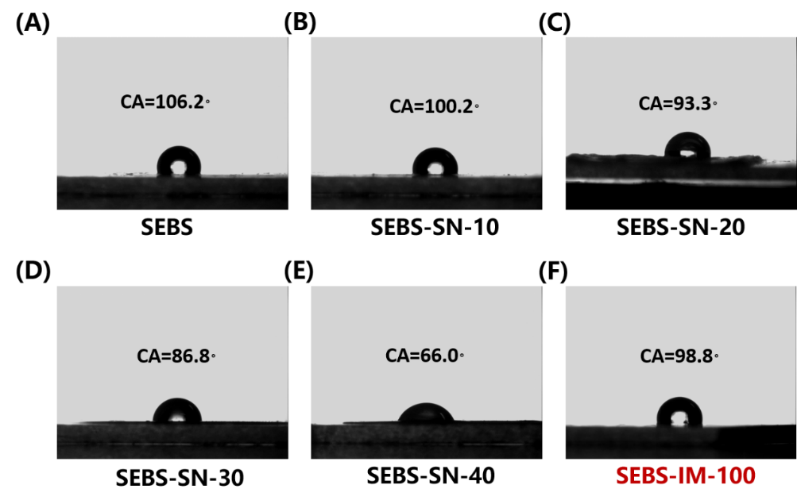
Fig. S5. Contact angle (CA) of dried polyelectrolyte membranes. (A) SEBS, (B) SSBS-SN-10, (C) SSBS-SN-20, (D) SSBS-SN-30, (E) SSBS-SN-40 and (F) SEBS-IM-100.

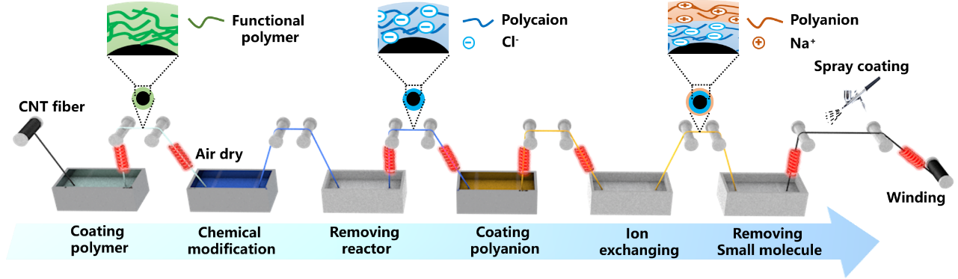
Fig. S6. Schematic diagram of the home-made integrated fabrication instrument for ionic-junction fiber. CSEBS slurry, 1-hexylimidazole, DI water, SSEBS slurry and NaCl solution were sequentially placed in the coating tank to carry out a series of process steps including CSEBS coating, quaternization reaction, small molecule removal, SSEBS coating and ion exchange. Fibers were dried and annealed at 120 ℃ in heating drums.

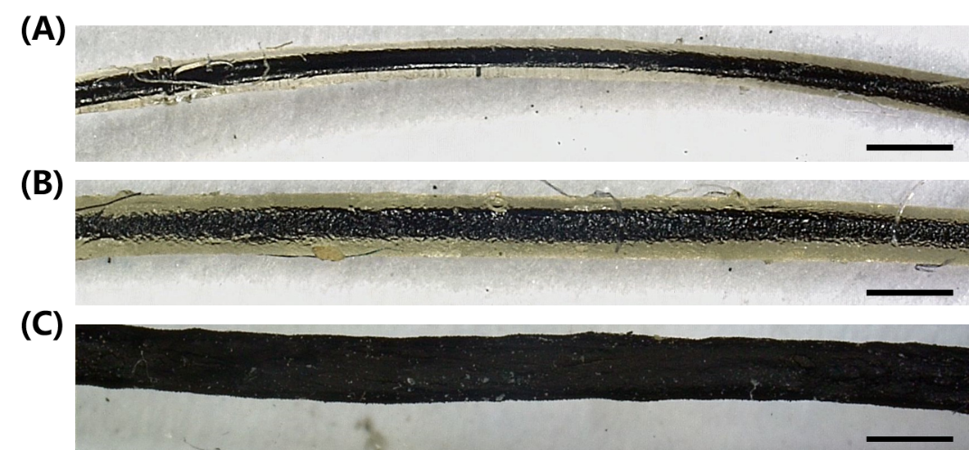
Fig. S7. Optical photograph of the completed fiber. (A) CNT@SEBS-IM fiber (250-300 μm), (B) CNT@SEBS-IM@SEBS-SN fiber (400-450 μm) and (C) CNT@SEBS-IM@SEBS-SN@CNT fiber (480-520 μm). (The scale bar is 500 μm).

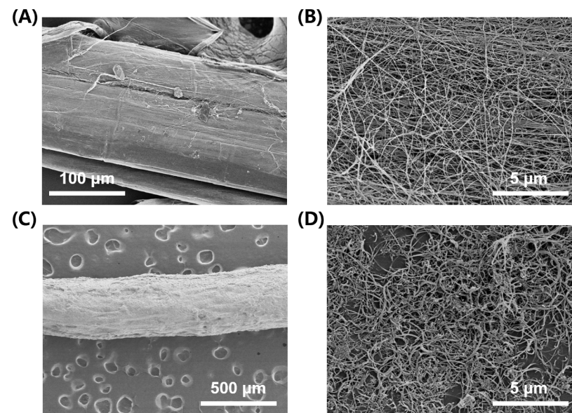
Fig. S8. SEM images of the CNT fiber before and after surface coating. (A) CNT fiber (core layer) and (B) fiber under magnification; (C) CNT fiber after surface coating (sheath layer) and (D) coating under magnification.

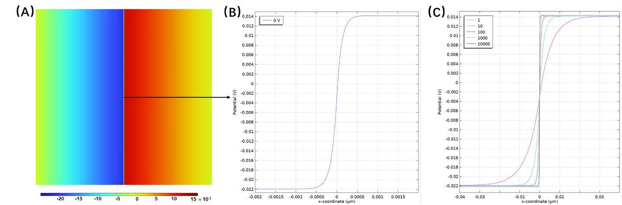
Fig. S9. Simulated induced potential distribution profile along the thickness direction of the fiber-shaped ionic diode by at zero bias. (A) 2D image of the simulation, (B) using relative permittivity of 4, and (C) using different assumed relative permittivity values.

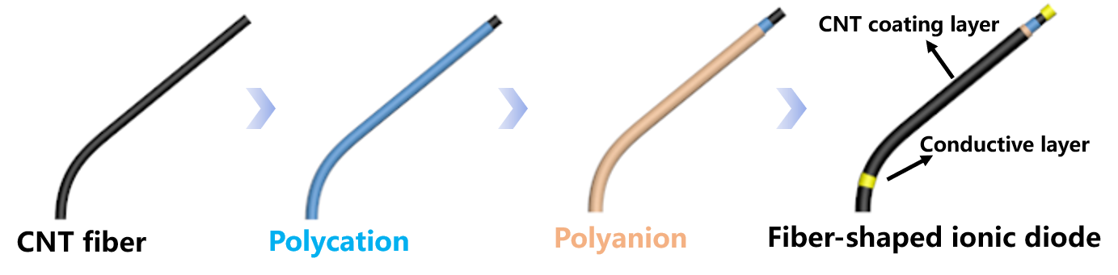
Fig. S10. Schematic illustration of the preparation of the fiber-shaped ionic diode.

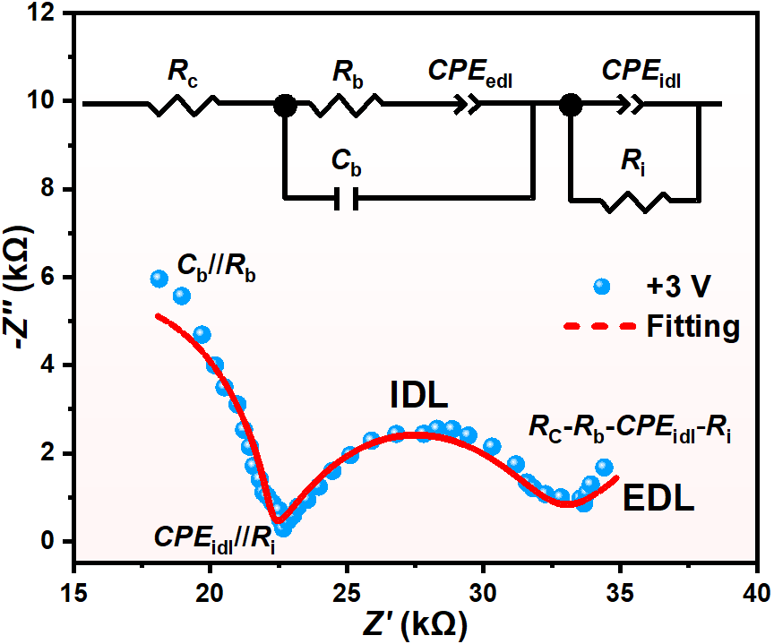
Fig. S11. Nyquist plot of SEBS-IM / SEBS-SN under +3.0 V. (Inset, the equivalent circuit model for a SEBS-IM / SEBS-SN junction under DC bias.) In the model contains, a dielectric capacitance (C_{b}) is the polarization of the ions at high frequency. A resistor (R_{b}) is connected in parallel and it reflects the drift of free ions at moderate frequency. Contact resistance (Rc) is added in series with the whole circuit. At low frequency, free ions accumulate at the interface and form an EDL or IDL that can be described by a constant phase element (CPE). CPE_{edl} describing the EDL capacitance and CPE_{idl} describing the IDL capacitance. R_{i} is a resistor for interfacial ionic current. CPE_{idl} and R_{i} are connected in parallel, and they are added in series with SEBS-IM/SEBS-SN. Fitting parameters for the circuit components in the equivalent circuit model were listed in Table S1.

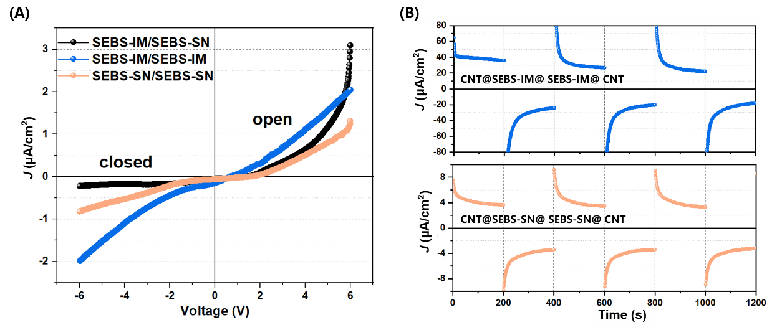
Fig. S12. Full J-V characteristics of ionic polyelectrolyte junctions (SEBS-IM/SEBS-IM, SEBS-SN/SEBS-SN and SEBS-IM/SEBS-SN). (A) Curves at a scan voltage from -6.0 V ~ 6.0 V. (B) Rectification of different junctions at a bias voltage of ±3.0 V (The CNT@SEBS-IM@ SEBS-IM@ CNT was a device that composed of a SEBS-IM/SEBS-IM junction; The CNT@SEBS-SN@ SEBS-SN@ CNT was a device that composed of a SEBS-SN/SEBS-SN junction).

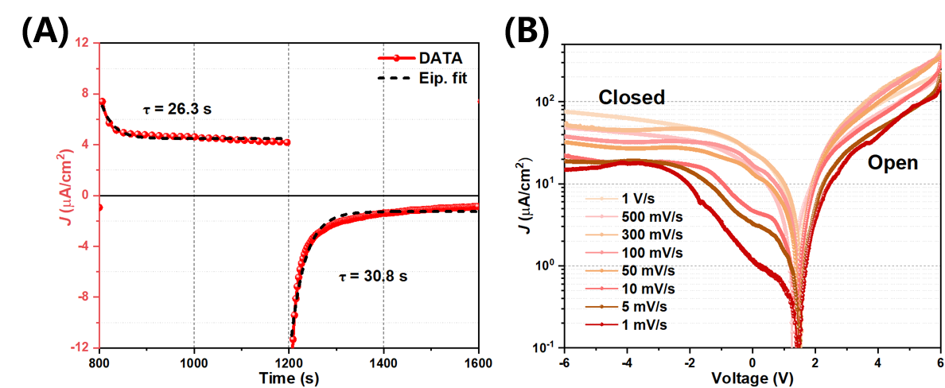
Fig. S13. Transient response of fiber-shaped ionic diodes and rectification property at different scan rates. (A) Transient response of current density as reported in Fig. 2F of the main text. A forward bias of +3.0 V and a reverse bias of -3.0 V was applied. The black dotted line was an exponential fit with a storage time constant of 26.3 s and a transition time of 30.8s for the switch-on in the fiber-shaped ionic diode. (B) The rectifying behaviors at different scan rates from 1 mV/s to 1 V/s was evaluated via linear sweep voltammetry.

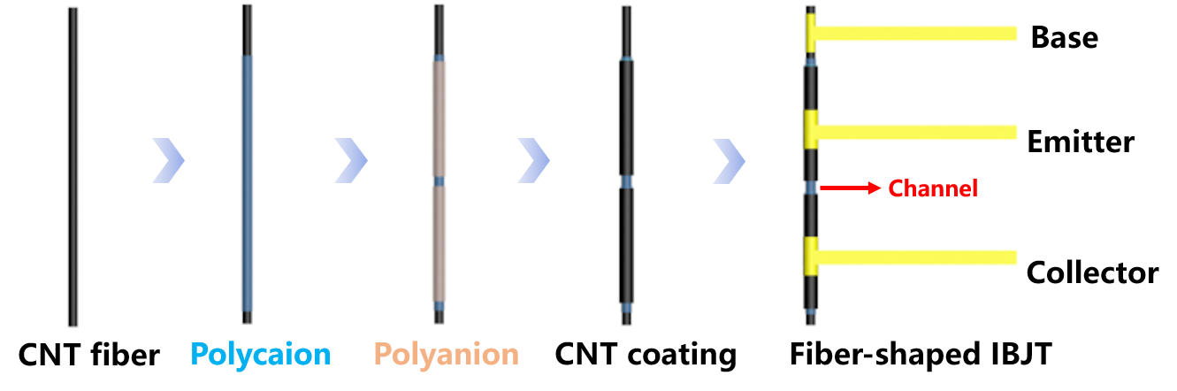
Fig. S14. Schematic illustration of the preparation of the fiber-shaped IBJT.

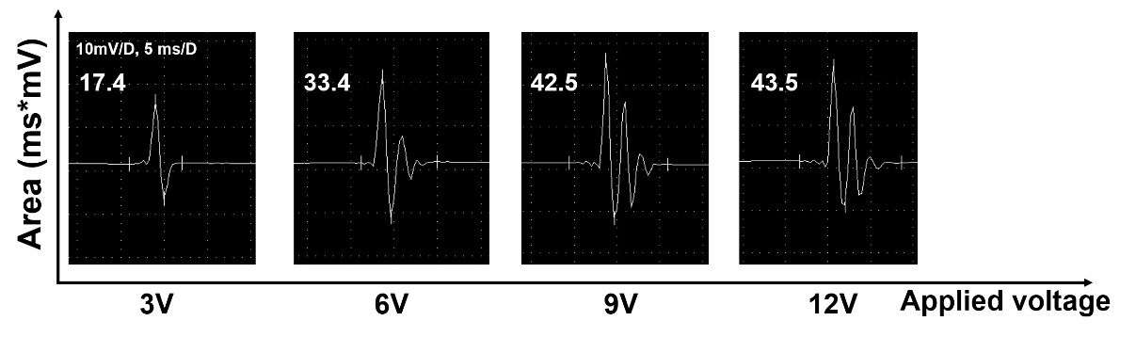
Fig. S15. Compound muscle action potentials of tibialis anterior muscle with increasing amplitudes were induced by different stimulating voltages (3-12 V) with a stimulus frequency of 1 Hz and a duration of 0.1 ms.

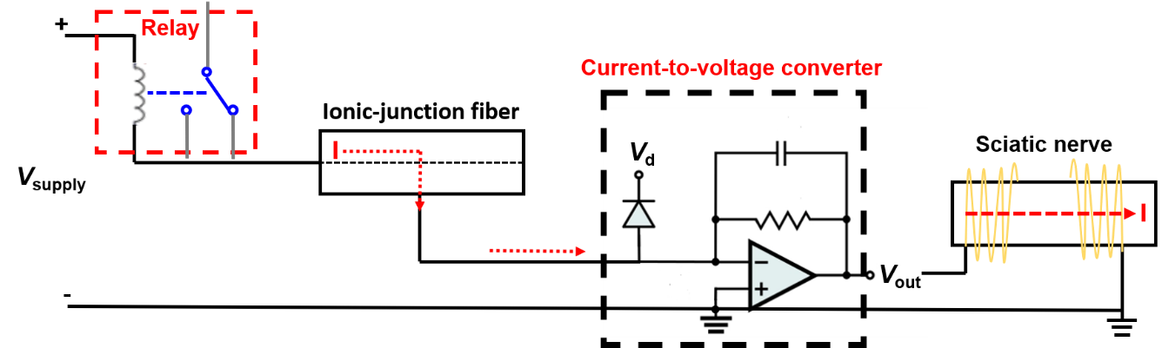
Fig. S16. A current-to-voltage signal amplifier converter was applied between the ionic-junction fiber and the sciatic nerve³. A voltage of 0.5 V is amplified to stimulate biological efferent nerves and muscles to initiate movement, which results in inducing a significant movement of the hind limb. (V_{supply}: supplied voltage to the circuit; V_{d}: supply voltage to the amplifier; V_{out}: output voltage from amplified to nerves.) The whole amplifier circuit is composed of an Arduino relay, an ionic-junction fiber, a current-to-voltage signal amplifier converter and the sciatic nerve in a rat.

Table S1. Fitting parameters for circuit components in the equivalent circuit model under a forward bias of +3.0 V.

Element | R_{c}  (kΩ) | R_{b}  (kΩ) | C_{b}  (nF) | CPE_{idl} | CPE_{edl} | R_{i}  (kΩ)
SEBS-IM / SEBS-SN  (+ 3.0 V) | 10.36  ± 0.46 | 11.64  ± 0.43 | 98.42  ± 8.13 | 0.63  ± 0.03 | 0.36  ± 0.13 | 10.14  ± 0.97

Supplementary Movies

Movie S1. Integrated opposite charge grafting fabrication technique of ionic-junction fibers.

Movie S2. The movements of the hindlimb induced via an ionic-junction fiber at different stimulating voltages.

Movie S3. The movements of the hindlimb induced via a current-to-voltage signal amplifier converter between the ionic-junction fiber and the sciatic nerve.

Reference

1. Kodým, R., Šnita, D. & Bouzek, K. Mathematical Modeling of Electromembrane Processes. In: Current Trends and Future Developments on (Bio-) Membranes) (Elsevier, Amsterdam, 2019).
2. Butkewitsch, S. & Scheinbeim, J. Dielectric properties of a hydrated sulfonated poly(styrene-ethylene/butylenes-styrene) triblock copolymer. Appl. Surf. Sci. 252, 8277-8286 (2006).
3． Kim, Y. et al. A bioinspired flexible organic artificial afferent nerve. Science 360, 998-1003 (2018).

