Reduced Southern Ocean Warming Enhances Global Skill and Signal-to-Noise in an Eddy-Resolving Decadal Prediction System (Supplementary Material)
Stephen G. Yeager*¹, Ping Chang², Gokhan Danabasoglu¹, Nan Rosenbloom¹, Qiuying Zhang², Fred S. Castruccio¹, Abishek Gopal², M. Cameron Rencurrel², Isla Simpson¹

¹National Center for Atmospheric Research, Boulder, Colorado, USA
²Department of Oceanography and Department of Atmospheric Sciences, Texas A&M University, College Station, Texas, USA

Correspondence to: Stephen G. Yeager (yeager@ucar.edu)

Contents: Supplementary Table 1 and Supplementary Figures 1-14

 | SAT |  | PRE |  | SLP
Annual ACC  (Fig. 1) | 26%  +0.24 | 23%  -0.13 | 25%  +0.44 | 17%  -0.38 | 30%  +0.34 | 9%  -0.26
Annual MSSS  (Fig. 2) | 39%  +3.9 | 17%  -3.9 | 27%  +0.70 | 20%  -0.43 | 25%  +0.35 | 24%  -0.36
Detrended Annual  ACC (Fig. 3) | 27%  +0.32 | 17%  -0.31 | 17%  +0.40 | 16%  -0.42 | 15%  +0.36 | 12%  -0.32
Detrended Annual  MSSS (Supp. Fig. 3) | 24%  +2.13 | 24%  -4.18 | 19%  +0.66 | 18%  -0.50 | 13%  +0.37 | 24%  -0.36
DJFM ACC  (Supp. Fig. 4) | 29%  +0.22 | 17%  -0.21 | 24%  +0.42 | 14%  -0.39 | 28%  +0.38 | 10%  -0.27
DJFM MSSS  (Supp. Fig. 5) | 37%  +0.98 | 13%  -0.73 | 24%  +0.78 | 15%  -0.43 | 28%  +0.36 | 14%  -0.42
JJAS ACC  (Supp. Fig. 6) | 24%  +0.27 | 25%  -0.14 | 21%  +0.44 | 18%  -0.42 | 17%  +0.34 | 19%  -0.34
JJAS MSSS  (Supp. Fig. 7) | 36%  +2.23 | 16%  -0.33 | 22%  +3.34 | 19%  -0.49 | 15%  +0.36 | 29%  -0.43
Supplementary Table 1: Skill Score Difference Summary Metrics. For each global skill comparison (figure) listed on the left, the percentage of global (80°S-80°N) surface area where HRDP(10) scores are significantly greater than (top left, in black) or less than (top right, in grey) DPLE(10) scores. Area-weighted mean score differences are given below the corresponding percentage area values.

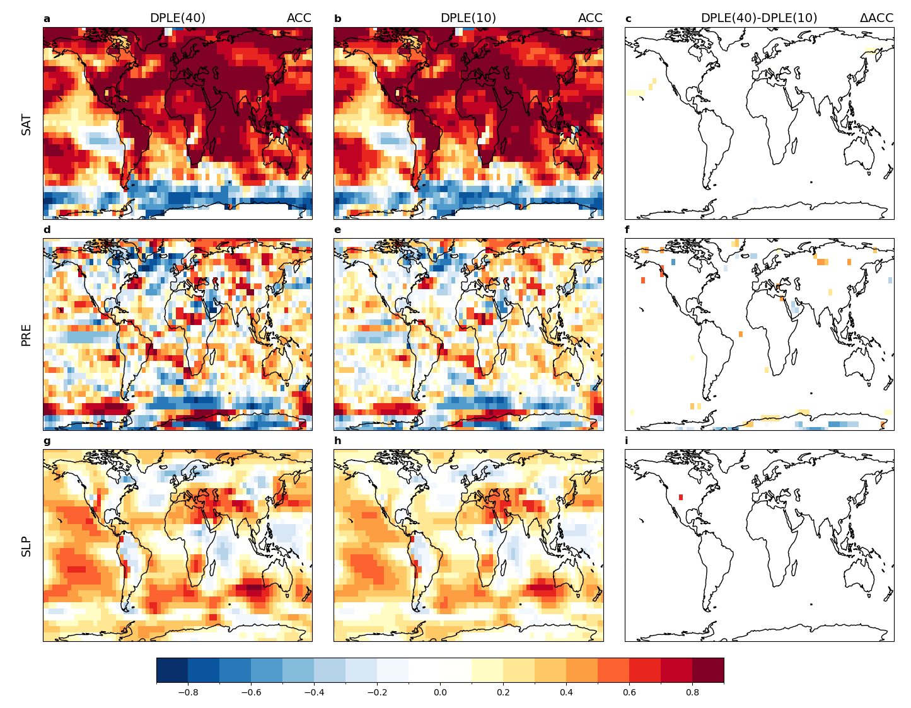Supplementary Fig. 1: Correlation comparison for annual fields. ACC skill for 40-member DPLE (a,d,g), 10-member DPLE (b,e,h), and their difference (c,f,i) for years 1-5 forecasts of annual surface air temperature (top), precipitation (middle), and sea level pressure (bottom). Difference values in (c,f,i) are non-zero only where 40-member DPLE skill is significantly higher or lower than 10-member DPLE skill at the 90% confidence level (see Methods).
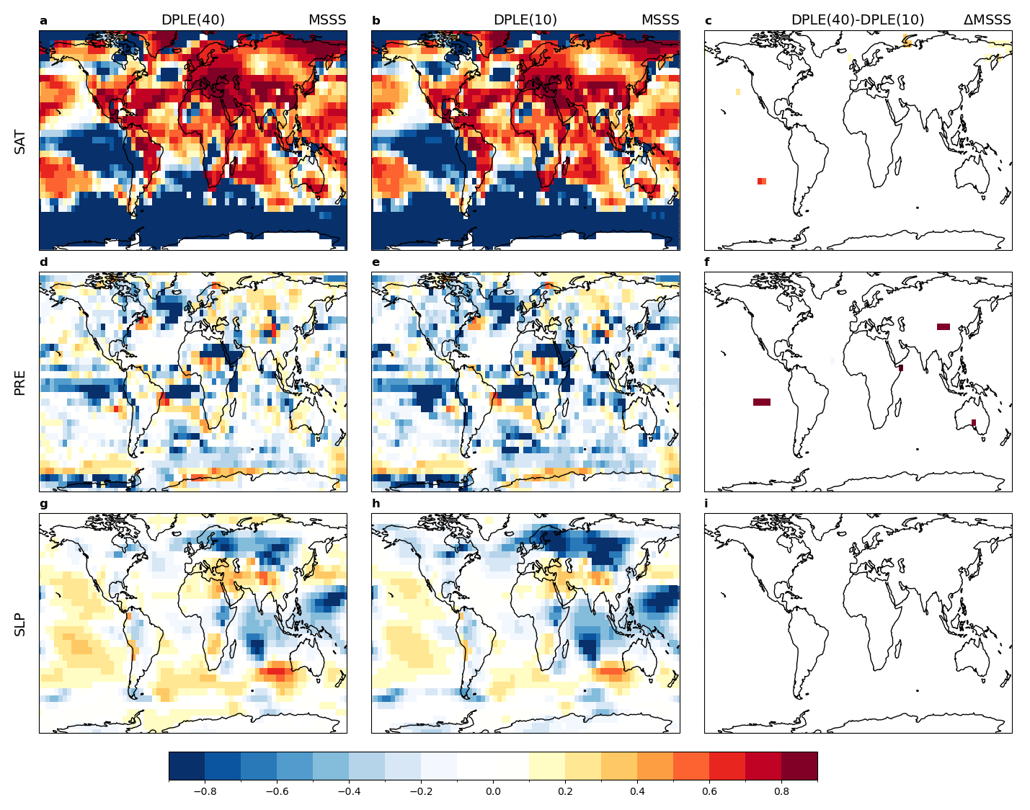Supplementary Fig. 2: Mean square skill score comparison for annual fields. MSSS skill for 40-member DPLE (a,d,g), 10-member DPLE (b,e,h), and their difference (c,f,i) for years 1-5 forecasts of annual surface air temperature (top), precipitation (middle), and sea level pressure (bottom). Difference values in (c,f,i) are non-zero only where 40-member DPLE skill is significantly higher or lower than 10-member DPLE skill at the 90% confidence level (see Methods).

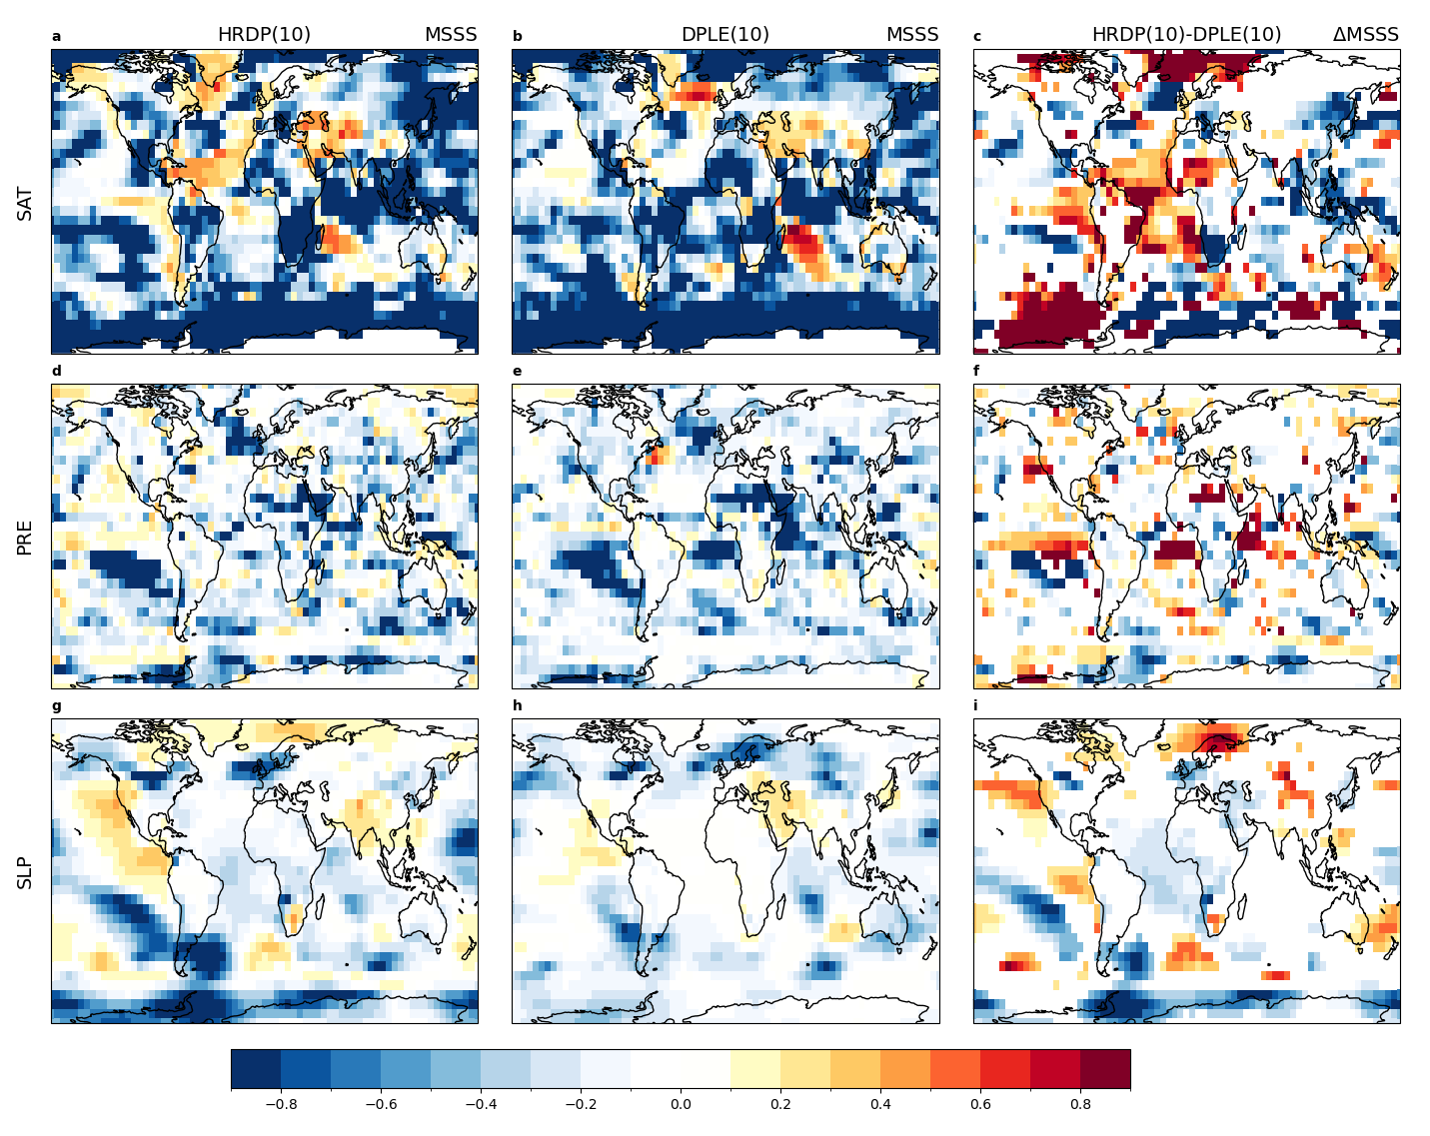Supplementary Fig. 3: Mean square skill score comparison for detrended annual fields. MSSS skill for 10-member HRDP (a,d,g), 10-member DPLE (b,e,h), and their difference (c,f,i) for years 1-5 forecasts of annual surface air temperature (top), precipitation (middle), and sea level pressure (bottom). Difference values in (c,f,i) are non-zero only where 10-member HRDP skill is significantly higher or lower than 10-member DPLE skill at the 90% confidence level (see Methods). All time series were linearly detrended prior to MSSS computation. See Supplementary Table 1 for a quantitative summary of skill differences plotted here.

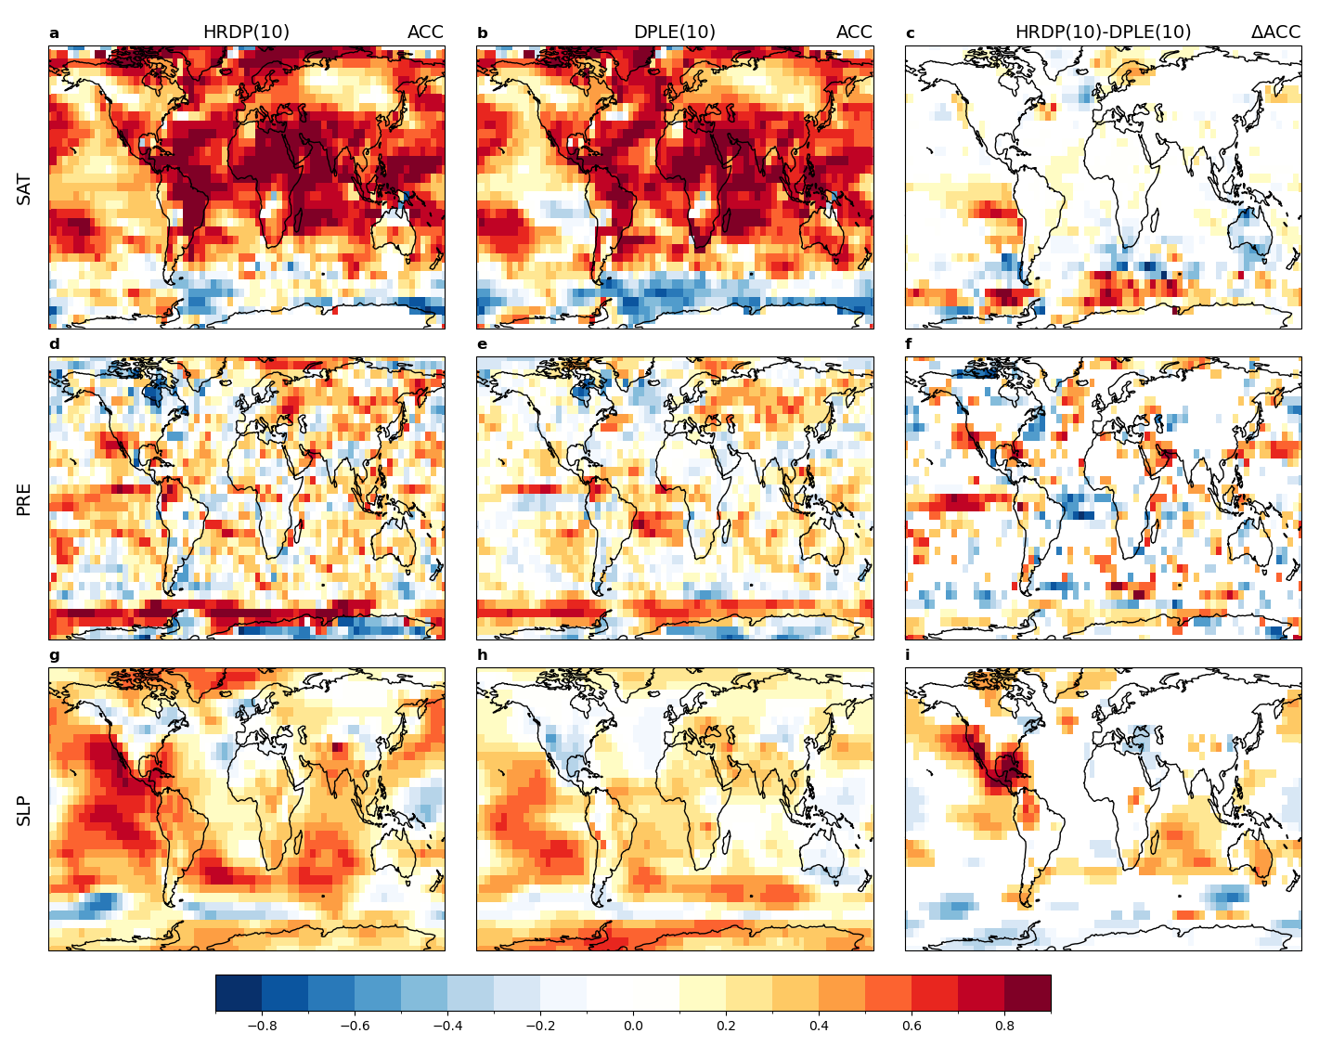
Supplementary Fig. 4: Correlation comparison for DJFM fields. ACC skill for 10-member HRDP (a,d,g), 10-member DPLE (b,e,h), and their difference (c,f,i) for years 1-5 forecasts of boreal winter (DJFM) surface air temperature (top), precipitation (middle), and sea level pressure (bottom). Difference values in (c,f,i) are non-zero only where HRDP skill is significantly higher or lower than DPLE skill at the 90% confidence level (see Methods). See Supplementary Table 1 for a quantitative summary of skill differences plotted here.

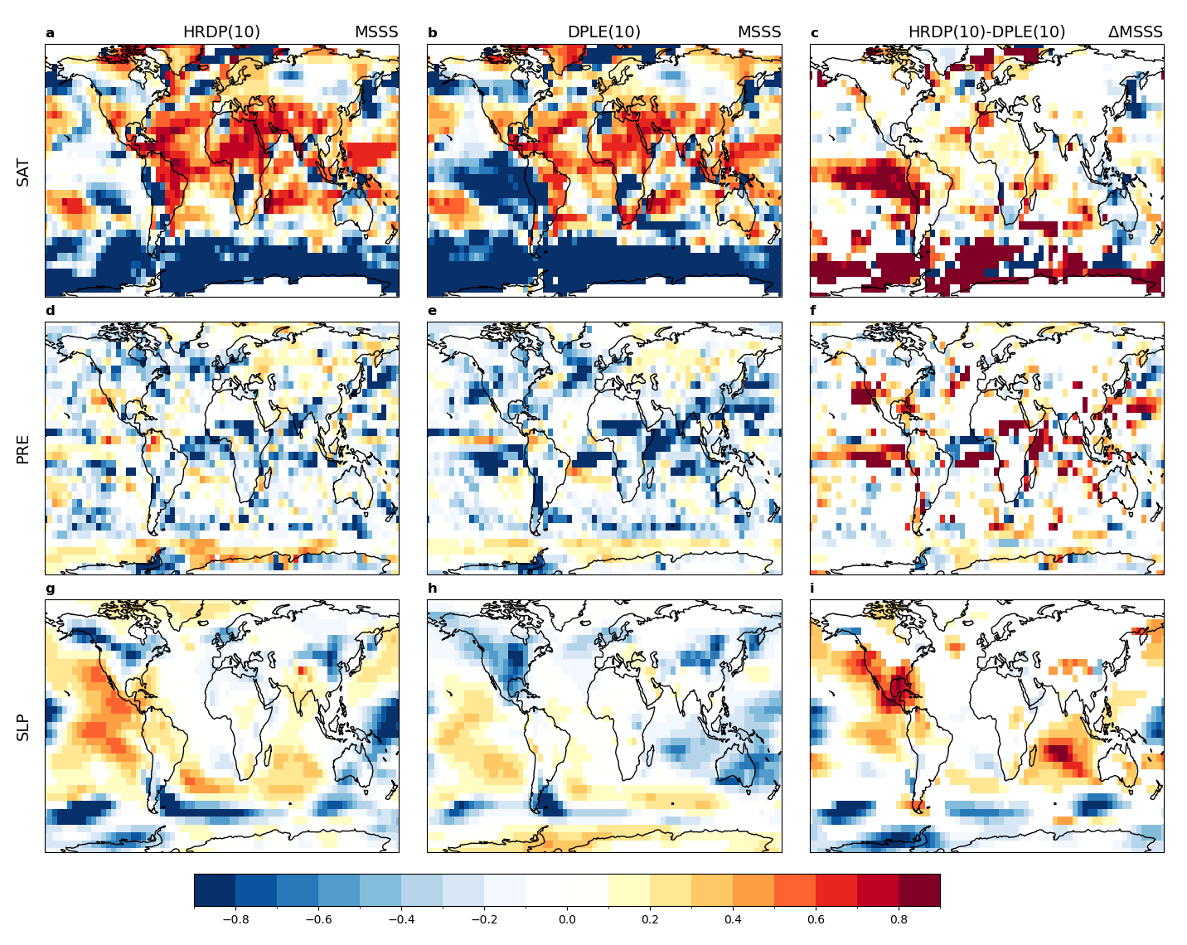
Supplementary Fig. 5: Mean square skill score comparison for DJFM fields. MSSS skill for 10-member HRDP (a,d,g), 10-member DPLE (b,e,h), and their difference (c,f,i) for years 1-5 forecasts of boreal winter (DJFM) surface air temperature (top), precipitation (middle), and sea level pressure (bottom). Difference values in (c,f,i) are non-zero only where HRDP skill is significantly higher or lower than DPLE skill at the 90% confidence level (see Methods). See Supplementary Table 1 for a quantitative summary of skill differences plotted here.

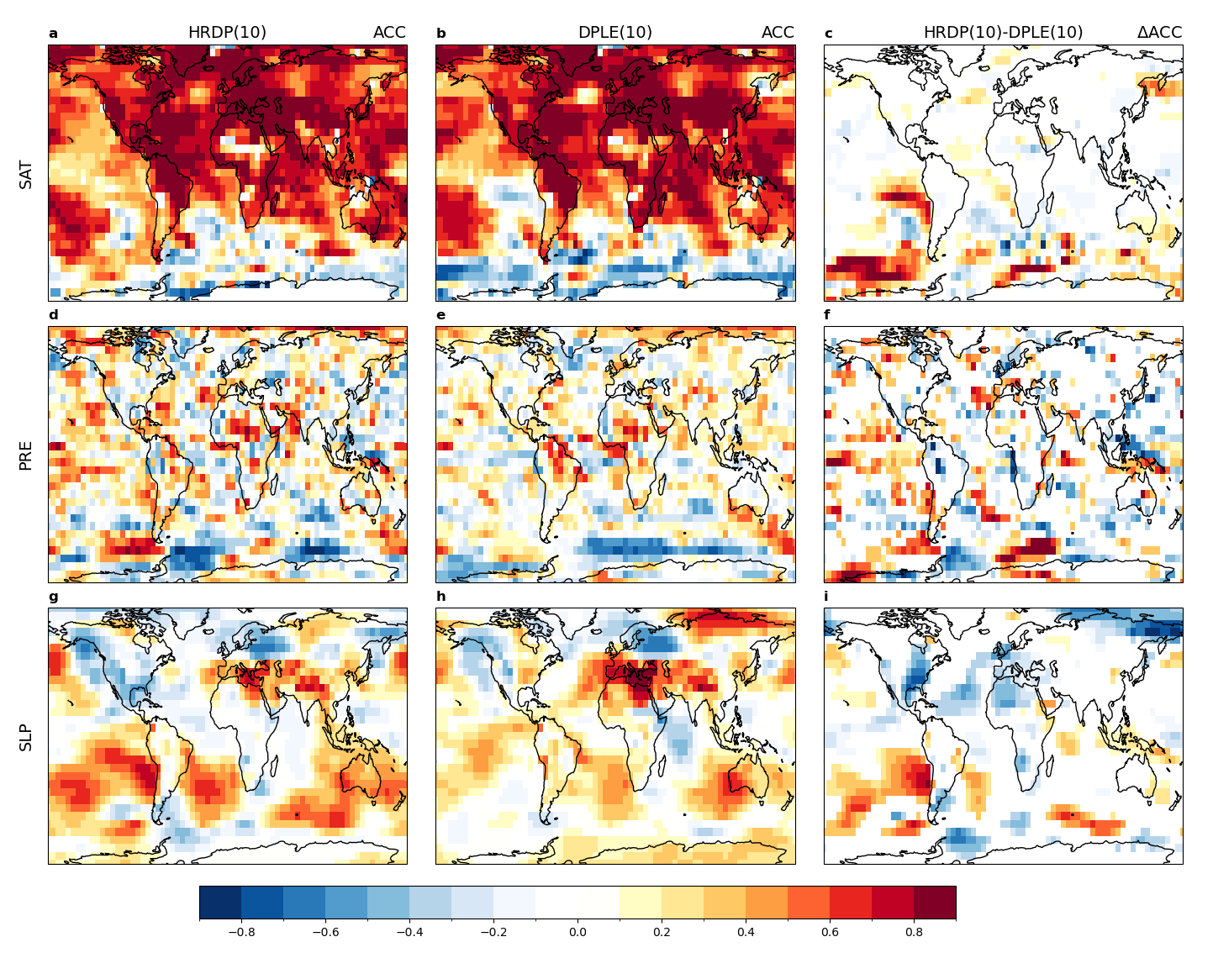
Supplementary Fig. 6: Correlation comparison for JJAS fields. ACC skill for 10-member HRDP (a,d,g), 10-member DPLE (b,e,h), and their difference (c,f,i) for years 1-5 forecasts of boreal summer (JJAS) surface air temperature (top), precipitation (middle), and sea level pressure (bottom). Difference values in (c,f,i) are non-zero only where HRDP skill is significantly higher or lower than DPLE skill at the 90% confidence level (see Methods). See Supplementary Table 1 for a quantitative summary of skill differences plotted here.

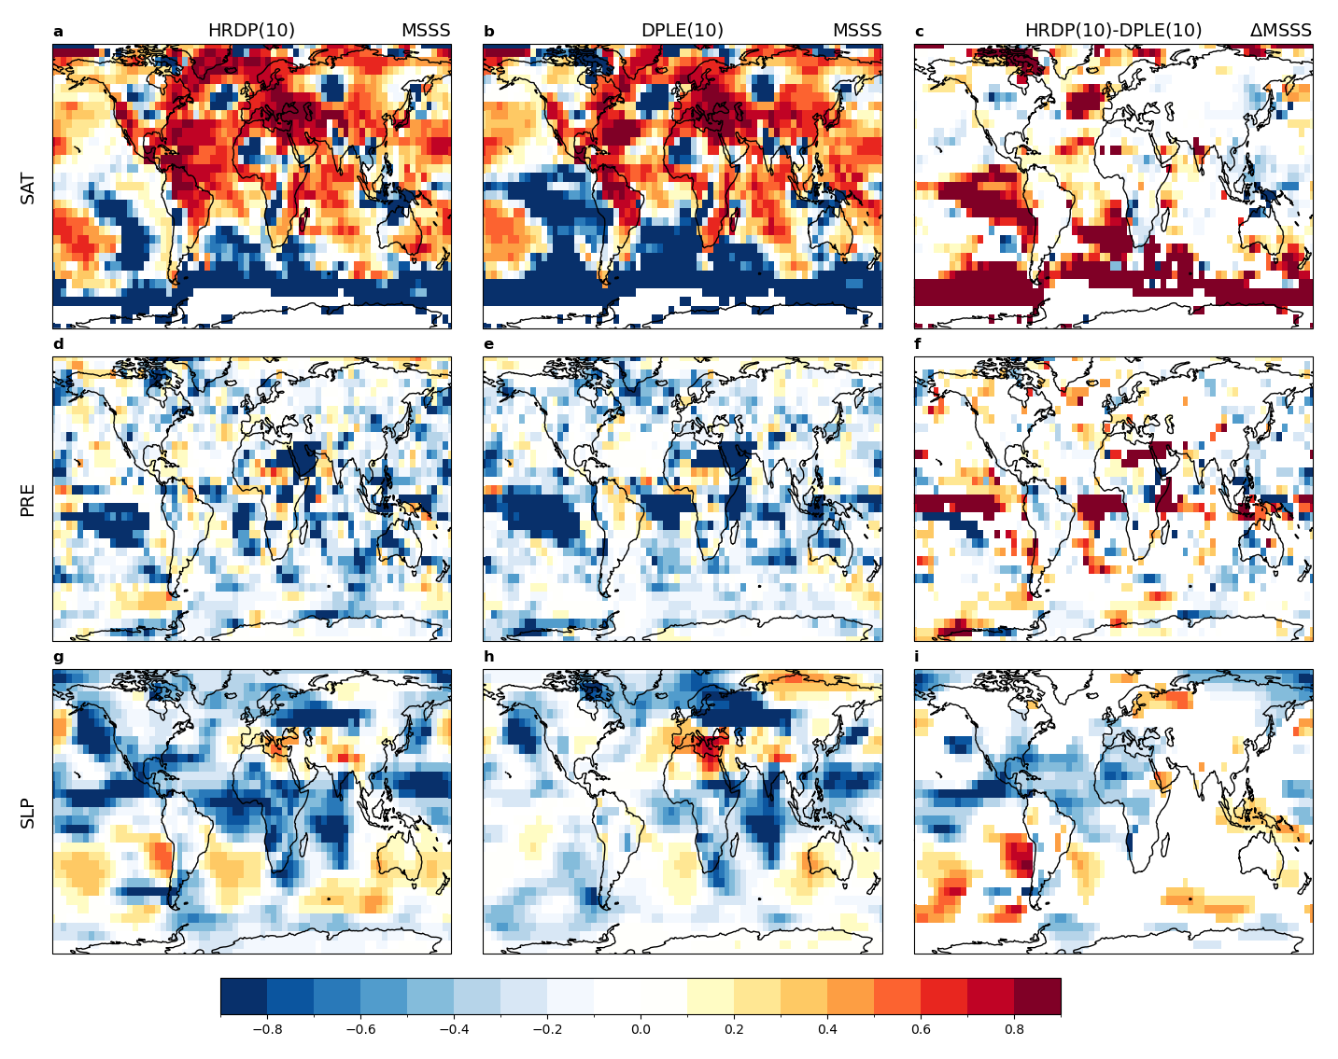
Supplementary Fig. 7: Mean square skill score comparison for JJAS fields. MSSS skill for 10-member HRDP (a,d,g), 10-member DPLE (b,e,h), and their difference (c,f,i) for years 1-5 forecasts of boreal summer (JJAS) surface air temperature (top), precipitation (middle), and sea level pressure (bottom). Difference values in (c,f,i) are non-zero only where HRDP skill is significantly higher or lower than DPLE skill at the 90% confidence level (see Methods). See Supplementary Table 1 for a quantitative summary of skill differences plotted here.

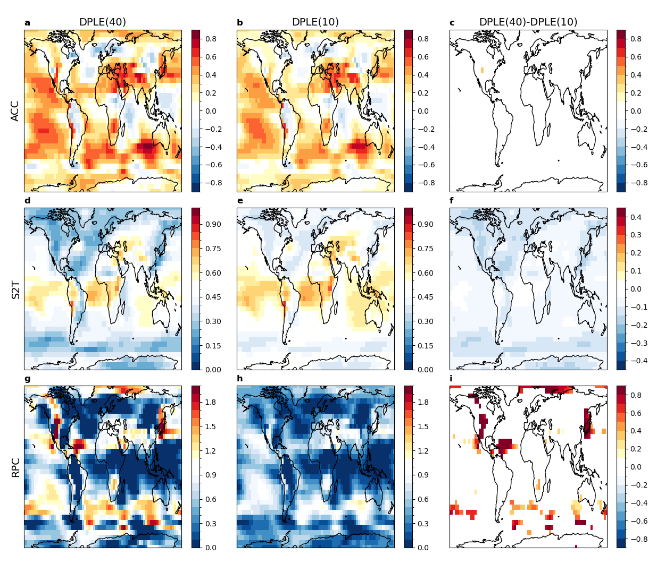
Supplementary Fig. 8: Signal-to-noise metrics for annual SLP. ACC, S2T, RPC for 40-member DPLE (a,d,g), 10-member DPLE (b,e,h), and their difference (c,f,i) for years 1-5 forecasts of annual sea level pressure. Difference values in (c,f,i) are non-zero only where DPLE(40) values are significantly higher or lower than DPLE(10) values at the 90% confidence level (see Methods).

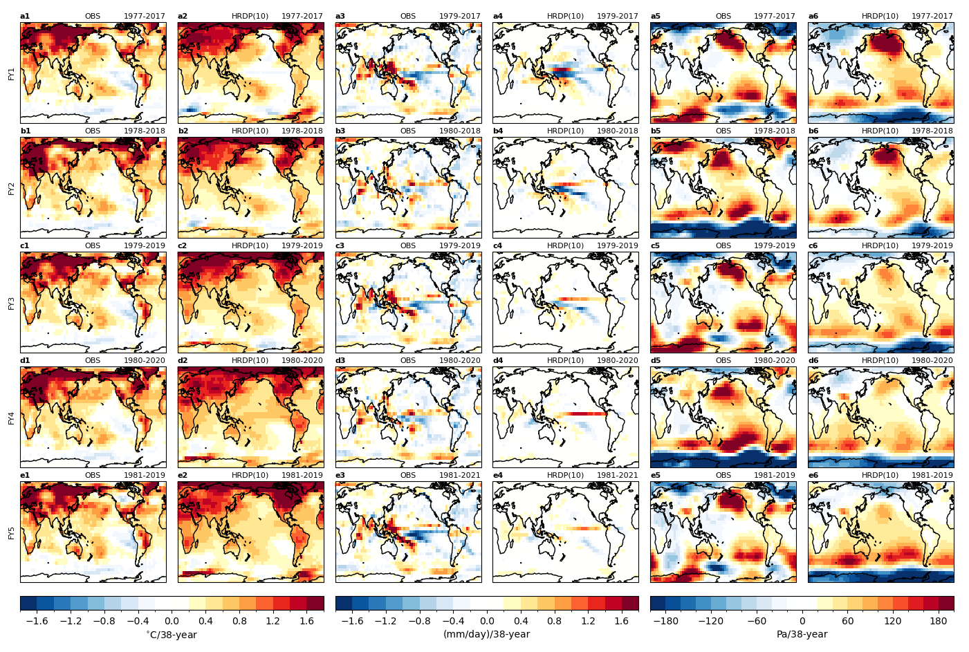Supplementary Fig. 9: SAT, PRE, and SLP trends from HRDP. Trends computed from unsmoothed annual fields from observation (OBS) and 10-member HRDP for SAT (leftmost columns), PRE (middle columns), and SLP (rightmost columns). Rows correspond to forecast years 1 through 5 of HRDP, and the years used in the computation reflect the intersection of available years from HRDP and observations. For example, FY1 SAT trends are based on 21 years of data (1977, 1979, …, 2017) whereas FY1 PRE trends are based on 20 years (since GPCP observations begin in 1979). All trends are normalized to reflect changes over a 38-year interval (to facilitate comparison with Fig. 6 of Main Text).

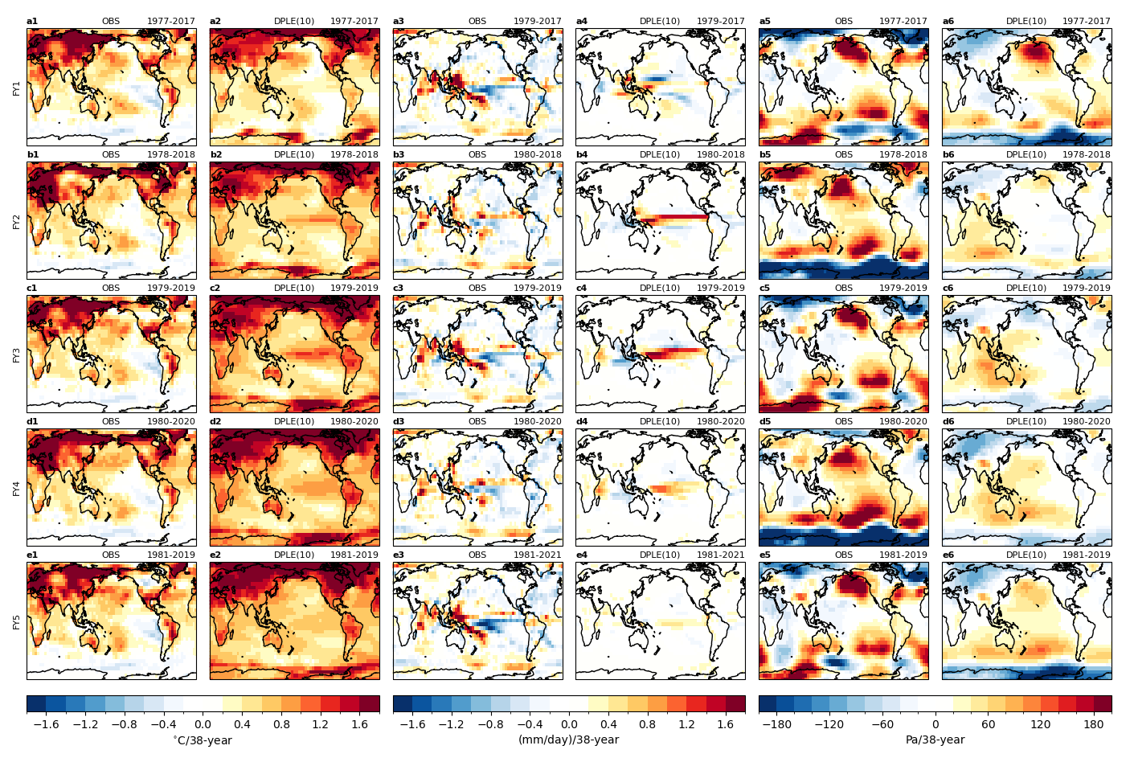
Supplementary Fig. 10: SAT, PRE, and SLP trends from DPLE. Trends computed from unsmoothed annual fields from observation (OBS) and 10-member DPLE for SAT (leftmost columns), PRE (middle columns), and SLP (rightmost columns). Rows correspond to forecast years 1 through 5 of DPLE, and the years used in the computation are equivalent to those used in Supplementary Fig. 11 (reflecting the intersection of available years from HRDP and observations). All trends are normalized to reflect changes over a 38-year interval (to facilitate comparison with Fig. 6 of Main Text).

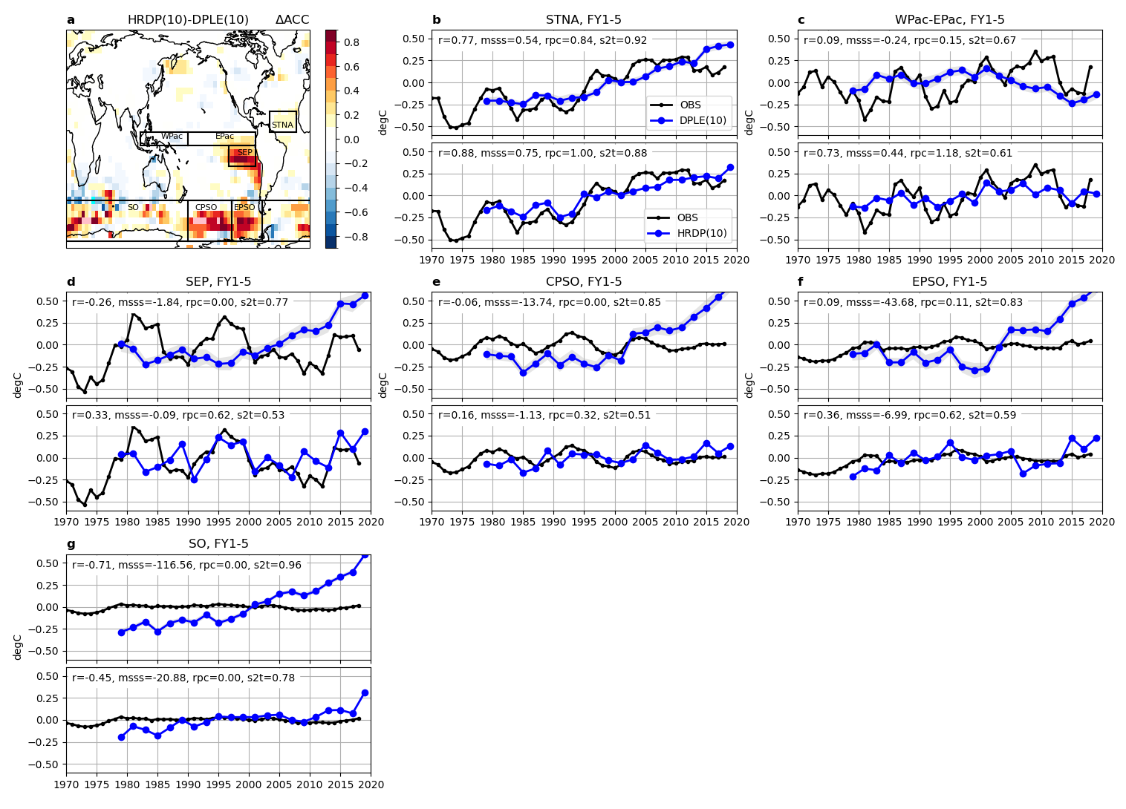
Supplementary Fig. 11: Surface air temperature time series. a ACC skill difference for FY1-5 SAT (same as Fig. 1c of Main Text), (b-g) regional SAT anomalies from observations (black, after applying a 5-year running smoother), 10-member DPLE FY1-5 (top panels; shading shows the 0.1-0.9 quartile range from the resampled distribution of 10-member means while blue curve shows the mean 10-member mean), and 10-member HRDP FY1-5 (bottom panels). Skill metrics (ACC, MSSS, RPC, and S2T) are noted in each panel. Regions considered (refer to boxes in panel a) are: b subtropical North Atlantic (STNA; 60°W-20°W, 5°N-20°N), c western equatorial Pacific (WPac; 110°E-180°E, 5°S-5°N) minus eastern equatorial Pacific (EPac; 180°W-80°W, 5°S-5°N), d southeastern Pacific (SEP; 120°W-80°W, 20°S-5°S), e central Pacific Southern Ocean (CPSO; 180°W-115°W, 75°S-45°S), f eastern Pacific Southern Ocean (EPSO; 115°W-70°W, 75°S-45°S), and g Southern Ocean (SO; 180°W-180°E, 75°S-45°S).

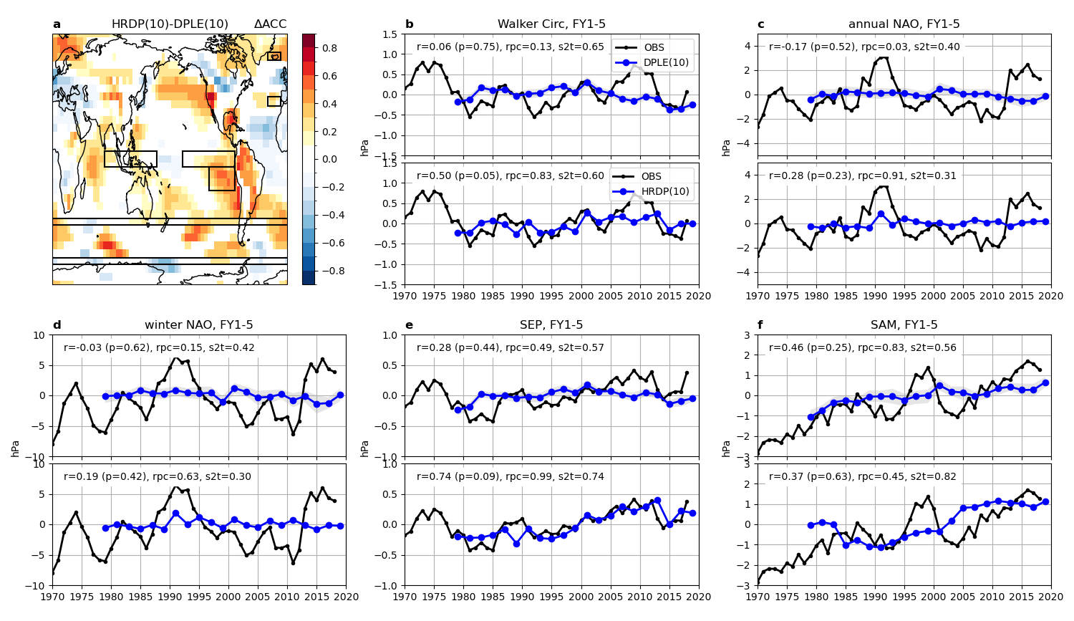
Supplementary Fig. 12: Sea level pressure time series. a ACC skill difference for annual FY1-5 SLP (same as Fig. 1i of Main Text), (b-g) regional SLP indices from observations (black, after applying a 5-year running smoother), 10-member DPLE FY1-5 (top panels; shading shows the 0.1-0.9 quartile range from the resampled distribution of 10-member means while blue curve shows the mean of 10-member means), and 10-member HRDP FY1-5 (bottom panels). ACC (with p-values), RPC, and S2T metrics are noted in each panel. Indices shown (refer to boxes in panel a) are: b Walker circulation strength, defined as the difference between eastern tropical Pacific (160°W-80°W, 5°S-5°N) and western tropical Pacific (80°E-160°E, 5°S-5°N) annual SLP, c annual NAO, defined as the difference between regional averages centered over the Azores (30°W-10°W, 34°N-40°N) and Iceland (30°W-10°W, 63°N-68°N), d winter NAO (same as annual NAO but using DJFM fields), e annual SLP over southeastern Pacific (SEP; 120°W-80°W, 20°S-5°S), and f Southern Annular Mode (SAM), defined as the difference between zonally-averaged SLP at 40°S (180°W-180°E, 42°S-38°S) and at 65°S (180°W-180°E, 67°S-63°S).

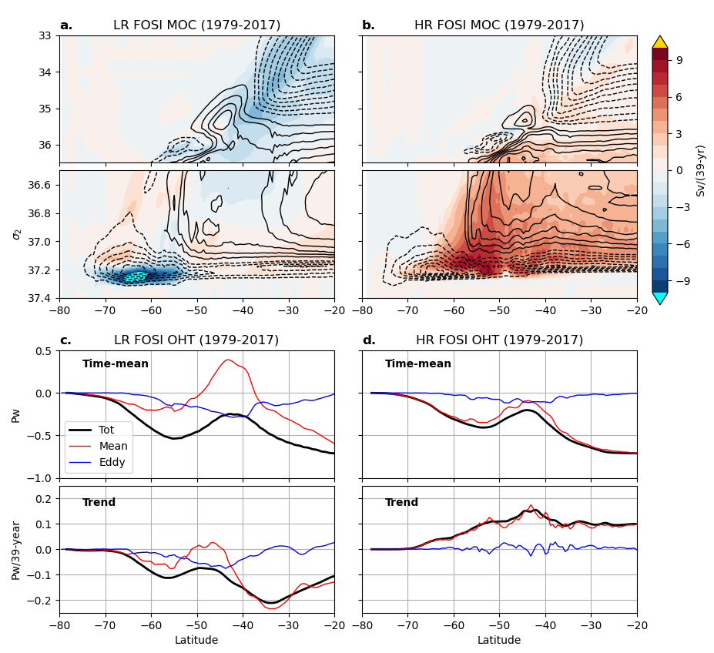
Supplementary Fig. 13: Southern Ocean trends in FOSI simulations. Residual mean ocean overturning circulation from (a) LR FOSI and (b) HR FOSI with time-mean shown by contours at 2 Sv intervals (skipping 0) and trend shown by shading. Zonally-integrated meridional ocean heat transport from (c) LR FOSI and (d) HR FOSI. In (c,d), top panels show time-mean and bottom panels show trend, and total heat transport is decomposed into mean-flow and eddy components.

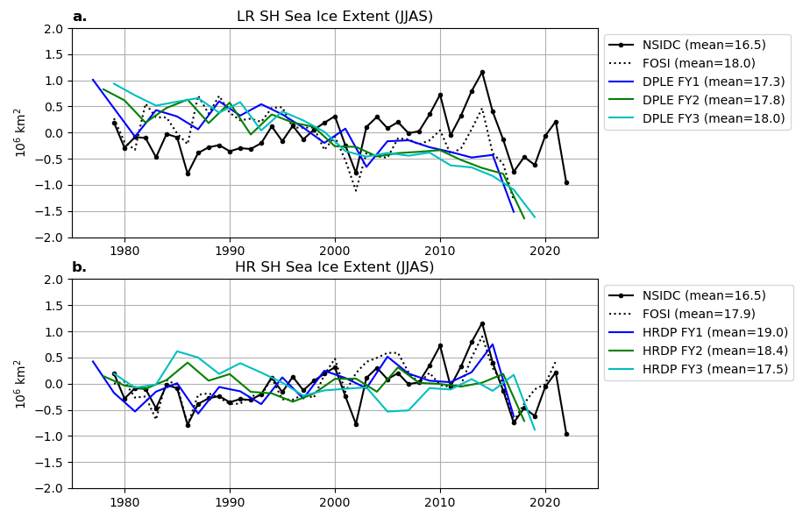Supplementary Fig. 14: Southern Hemisphere winter sea ice extent. Sea ice extent (SIE) computed as the sum of grid cell area where sea ice fraction exceeds 0.15 in austral winter (JJAS) from (a) LR simulations including LR FOSI and DPLE(40) for forecast years 1-3, and (b) HR simulations including HR FOSI and HRDP(10) for forecast years 1-3. Both panels show observed SIE from the National Snow and Ice Data Center (NSIDC) Sea Ice Index⁷³ version 3.0.

