Realization of Tunable Plasticity in Porous Synaptic Memristors for Neuromorphic Computing

Qin Gao, ¹ Jiangshun Huang, ¹ Yuhang Ji,¹ Juan Gao, ¹ Mei Wang,¹ Zhisong Xiao, ¹
Ying Zhu,² Paul K. Chu,³ Anping Huang^{1*}
¹ School of Physics and School of Chemistry, Beihang University, Beijing 100191, China
² Key Laboratory of Bio-Inspired Smart Interfacial Science and Technology of Ministry of Education, School of Chemistry, Beihang University, Beijing 100191, China
³ Department of Physics, Department of Materials Science and Engineering, and Department of Biomedical Engineering, City University of Hong Kong, Tat Chee Avenue, Kowloon 999077, Hong Kong, China

* Corresponding author: aphuang@buaa.edu.cn (Dr. A. P. Huang); Tel: 86-10-82338779; Fax: 86-10-82338779

- Electrical analysis of Pt/PLiCoO₂/PSiO_{x}/Si
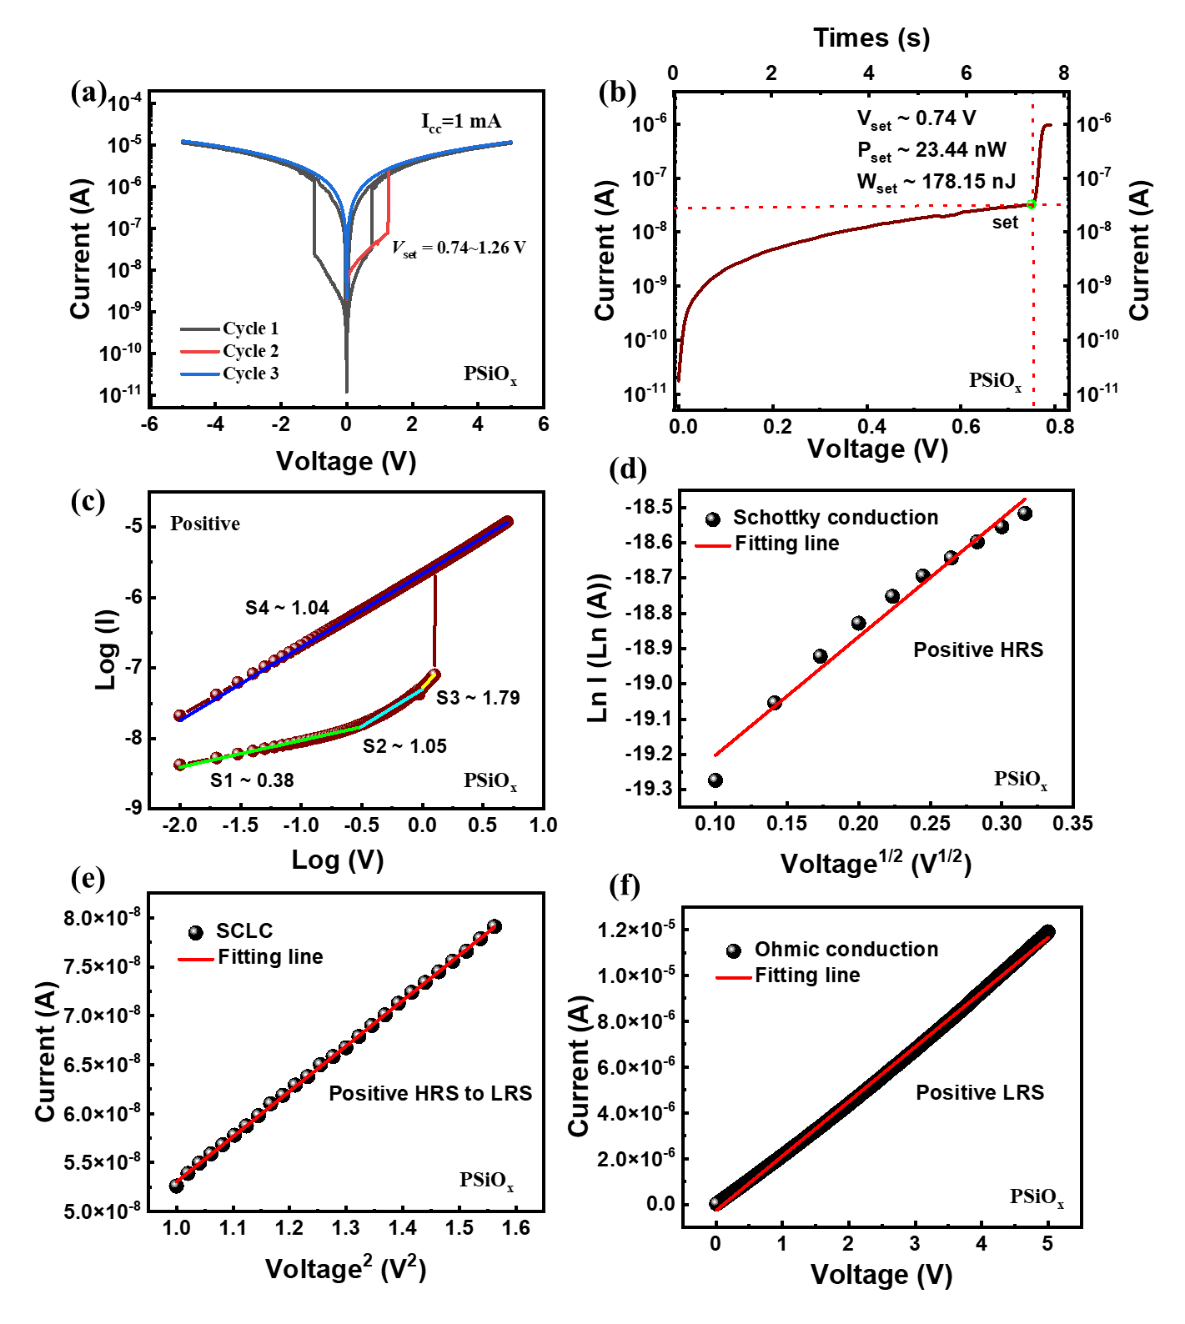
Figure S1. (a) I-V curve of PSiO_{x}; (b) I-V and I-t curve; (c) Log I - Log V with fitted conduction mechanism for the positive voltage sweep; (d) lnI-V^{1/2} plots in HRS for positive voltage sweeps; (e) I-V² plots from the HRS to LRS for positive voltage sweeps; (f) I-V plots in the LRS for positive voltage sweeps. The straight lines are linear fits.

- The mechanism analysis of Pt/PLiCoO₂/QDs@PSiO_{x}/Si
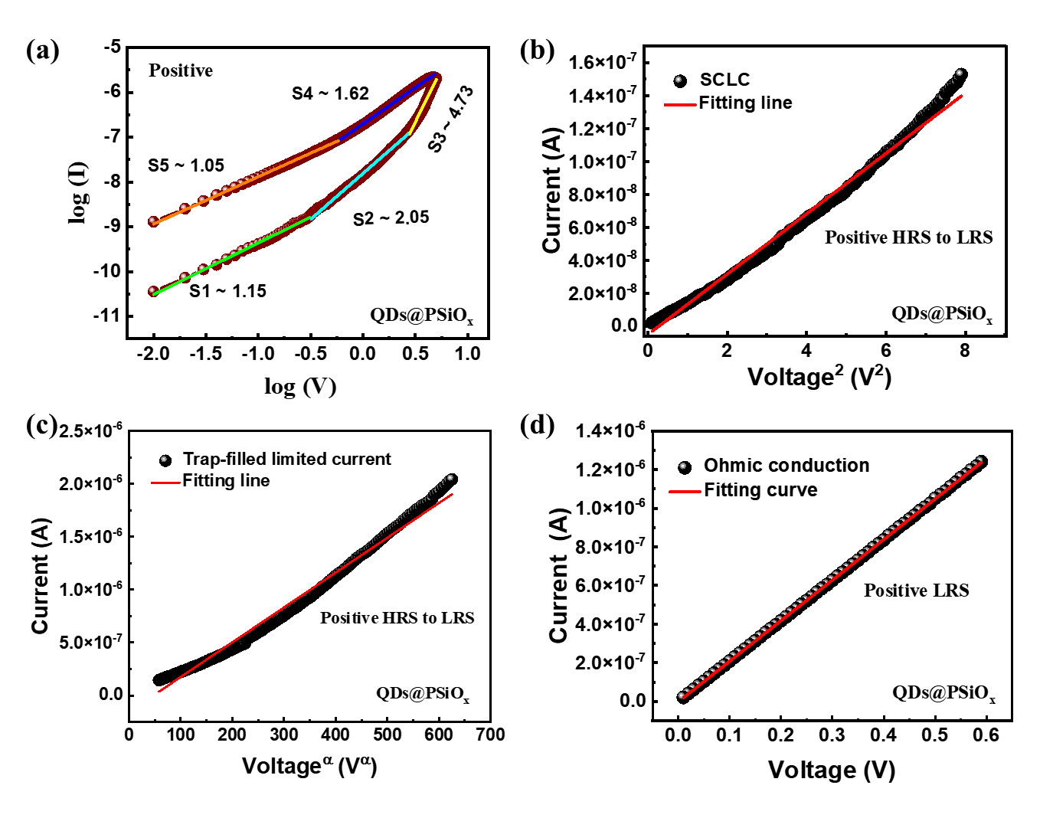
Figure S2. (a) Log I - Log V with fitted conduction mechanism for the positive voltage sweep (b) I-V² plots from the HRS to LRS for positive voltage sweeps; (c) I-Vª plots from the HRS to LRS for positive voltage sweeps; (d) I-V plots in the LRS for positive voltage sweeps. The straight lines are linear fits.

- Synaptic plasticity of Pt/PLiCoO₂/PSiO_{x}/Si for different pulse widths
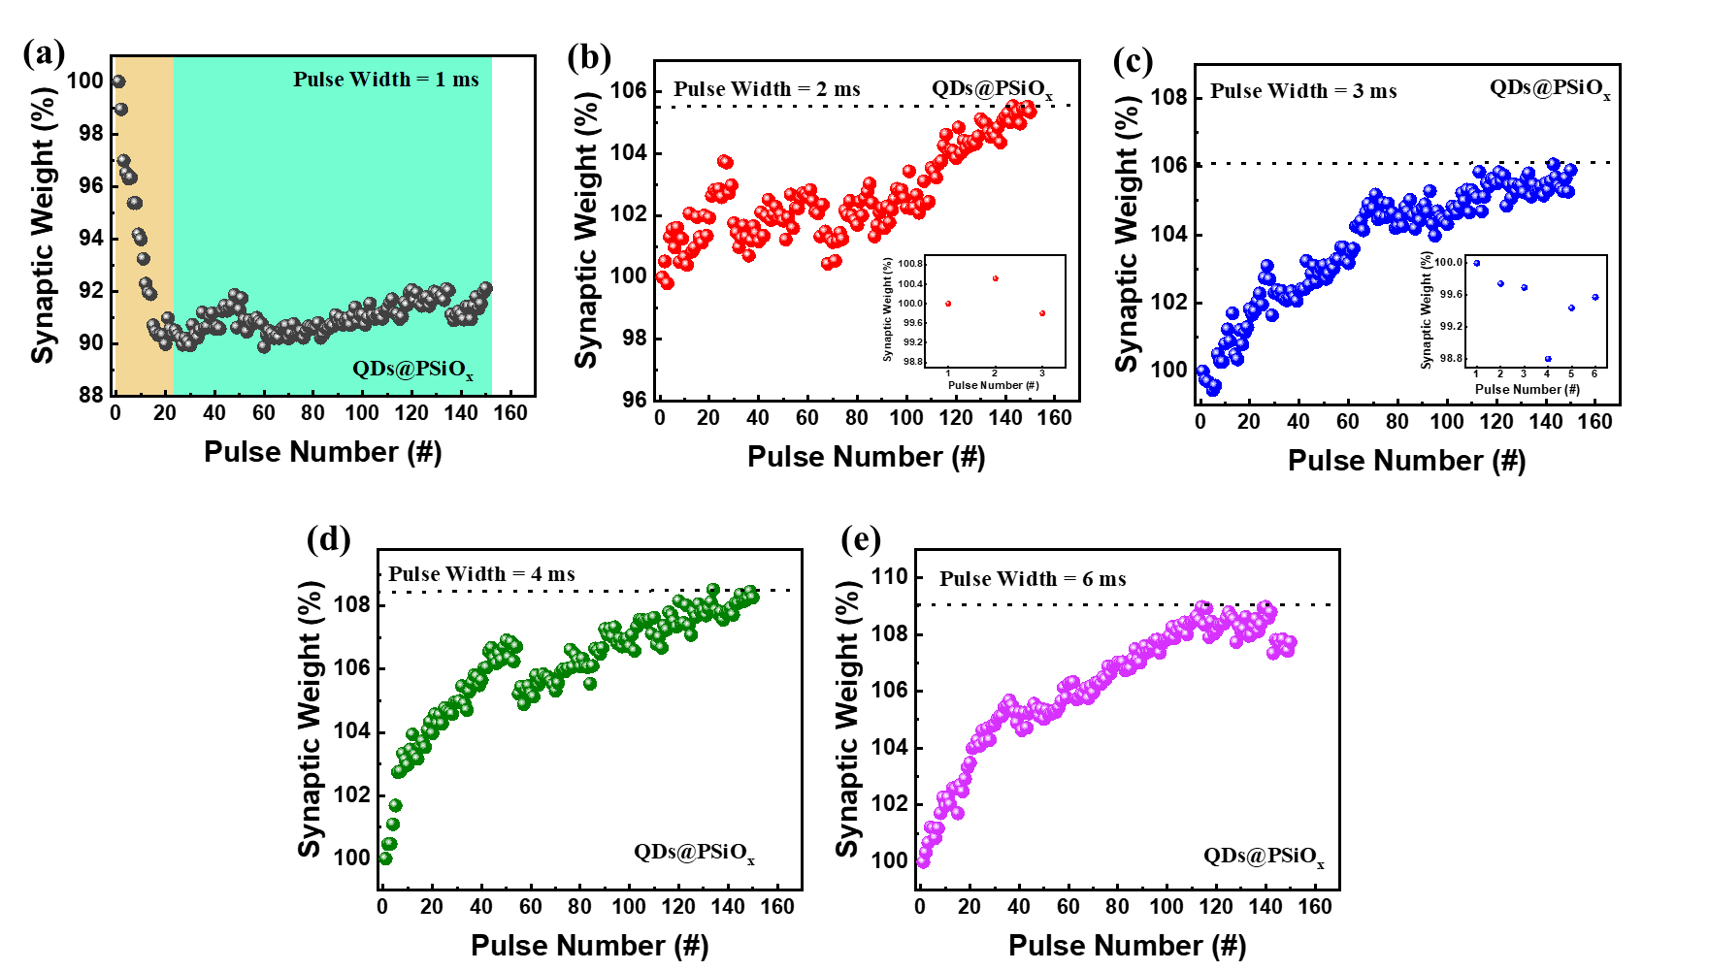
Figure S3. Synaptic plasticity for different pulse widths: (a) 1 ms, (b) 2 ms, (c) 3 ms, (d) 4 ms, and (e) 6 ms.

- Synaptic plasticity of Pt/PLiCoO₂/PSiO_{x}/Si for different pulse intervals
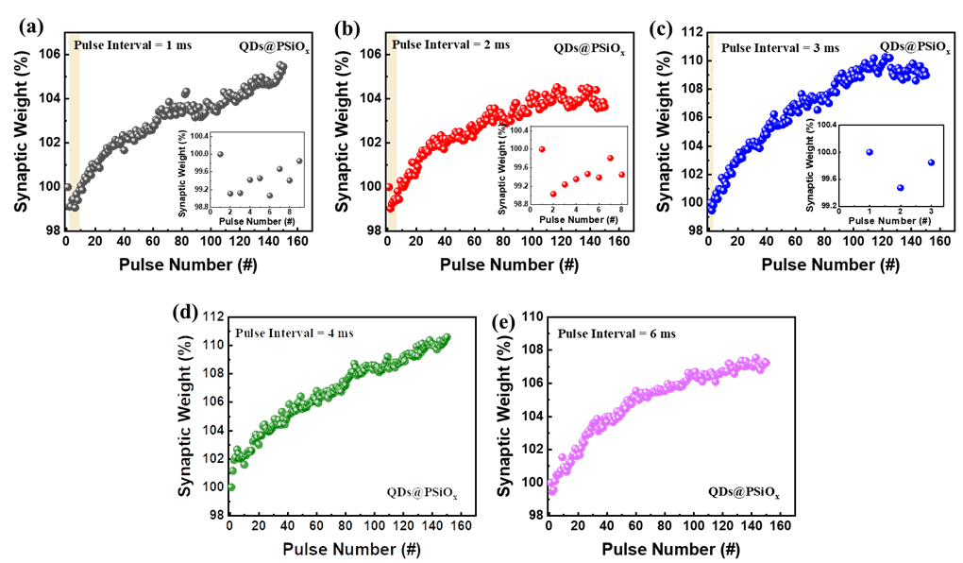
Figure S4. Synaptic weights for different pulse intervals: (a) 1 ms, (b) 2 ms, (c) 3 ms, (d) 4 ms, and (e) 6 ms.

- Synaptic plasticity of Pt/PLiCoO₂/PSiO_{x}/Si for different pulse widths
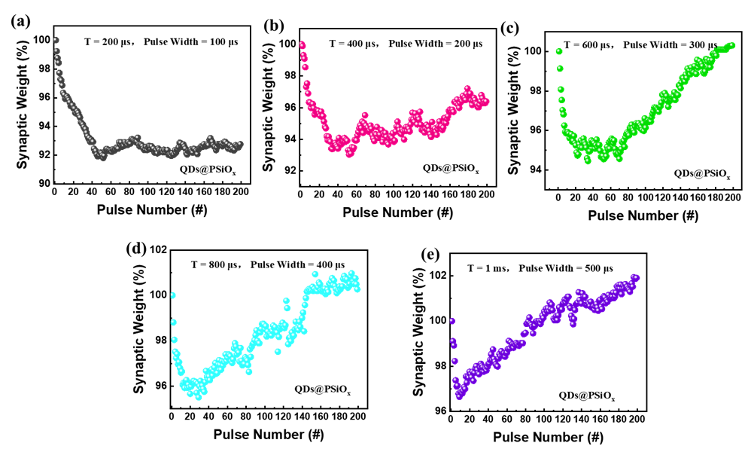
Figure S5. Synaptic weights for different pulse widths: (a) 200 μs, (b) 400 μs, (c) 600 μs, (d) 800 μs, and (e) 1 ms.

- EPSC behavior of Pt/PLiCoO₂/PSiO_{x}/Si
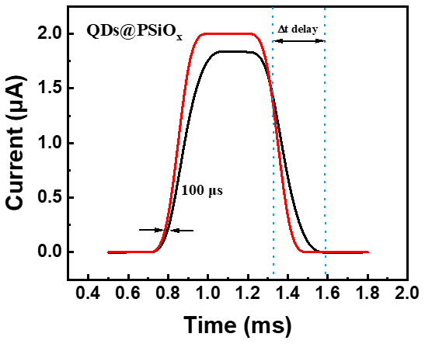

Figure S6. EPSC behavior: The synaptic weight can be dramatically modulated by the pulse interval between the excitatory postsynaptic current (EPSC) and spikes. A single synaptic spike (5 V, 1 ms) can trigger EPSC and the intensity declines gradually to zero in a few hundred microseconds after the pulse. It may be because after the pulse voltage is removed, lithium ions can still traverse a short distance due to inertia. ^{[1]}

- Preparation of QDs@PSiO_{x}/Si
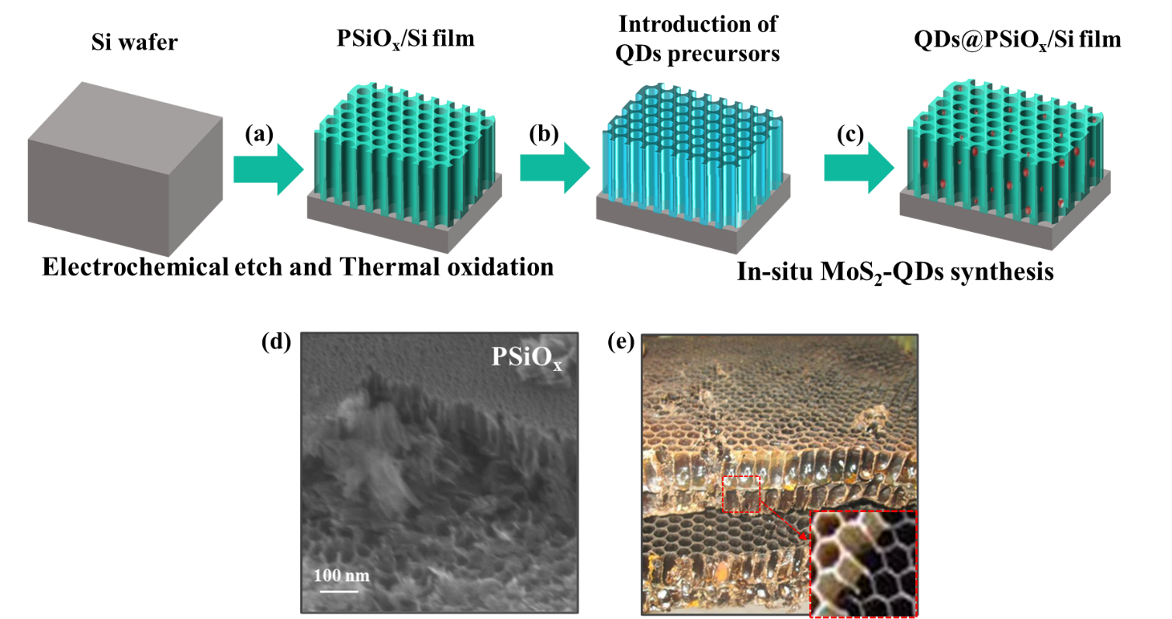

Figure S7. (a)-(c) Fabrication process of the PSiO_{x}/Si film by electrochemical etching and thermal oxidation; (d) Cross-section of PSiO_{x}; (e) Natural honeycomb structure and the lower right corner is enlarged image of the red square.

References
- T D. Shamiryan, T. Abell, F. Lacopi, K. Maex, Mater. Today 2004, 7, 34.

