Supplementary figures
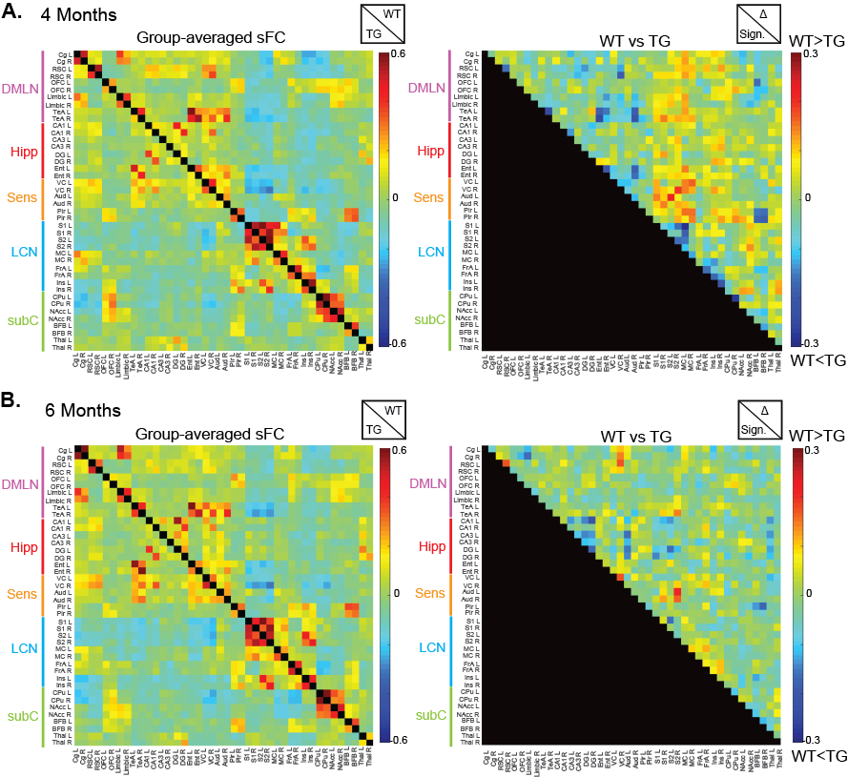
Supplementary figure 1: ROI based analysis demonstrates no significant differences in static FC between TgF344-AD (TG) rats and Wild-type (WT) littermates. ROI based matrices which displays the z-scored FC between ROI-pairs for the WT (top half of matrix) and TG (bottom half of matrix) at 4 months of age (A) and 6 months of age (B). Two-sample t-test (FDR p<0.05) demonstrates no significant differences in FC between groups, as is shown on the right matrix. DMLN = default mode-like network, Hipp = hippocampal network, Sens = sensory network, LCN = lateral cortical network, subC = subcortical network, L = left, R = right, Cg = cingulate cortex, RSC = retrosplenial cortex, OFC = orbitofrontal cortex, TeA = temporal association cortex, DG = dentate gyrus, VC = visual cortex, Aud = auditory cortex, Pir = Piriform cortex, S1 = primary somatosensory cortex, S2 = secondary somatosensory cortex, MC = motor cortex, FrA = frontal association cortex, Ins = insular cortex, CPu = caudate putamen, NAcc = nucleus Accumbens, BFB = basal forebrain, Thal = thalamus
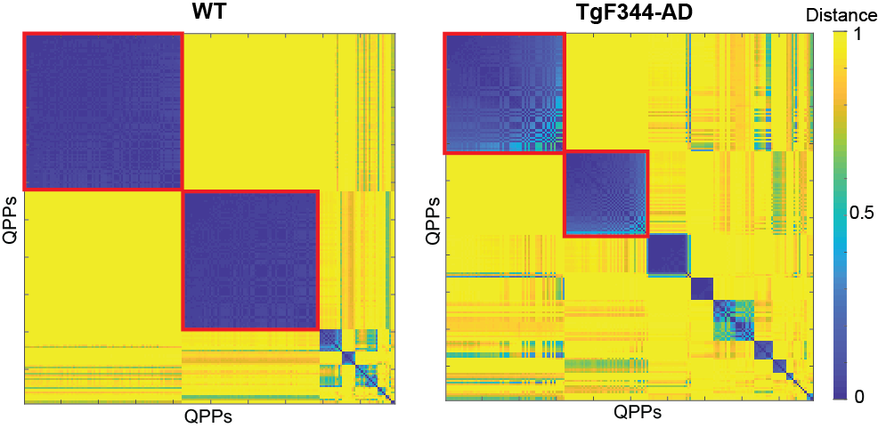
Supplementary figure 2: Hierarchical clustering based on Spatiotemporal properties of QPPs of 4-month-old WT and TgF344-AD rats. Distance matrices of the clustering solution in the wild-type (WT) animals (left) and TgF344-AD rats (right). Colors indicate the distance between a pair of QPPs. Red squares mark the clusters of QPPs which were robust according to the criteria, and which were used in further analysis.
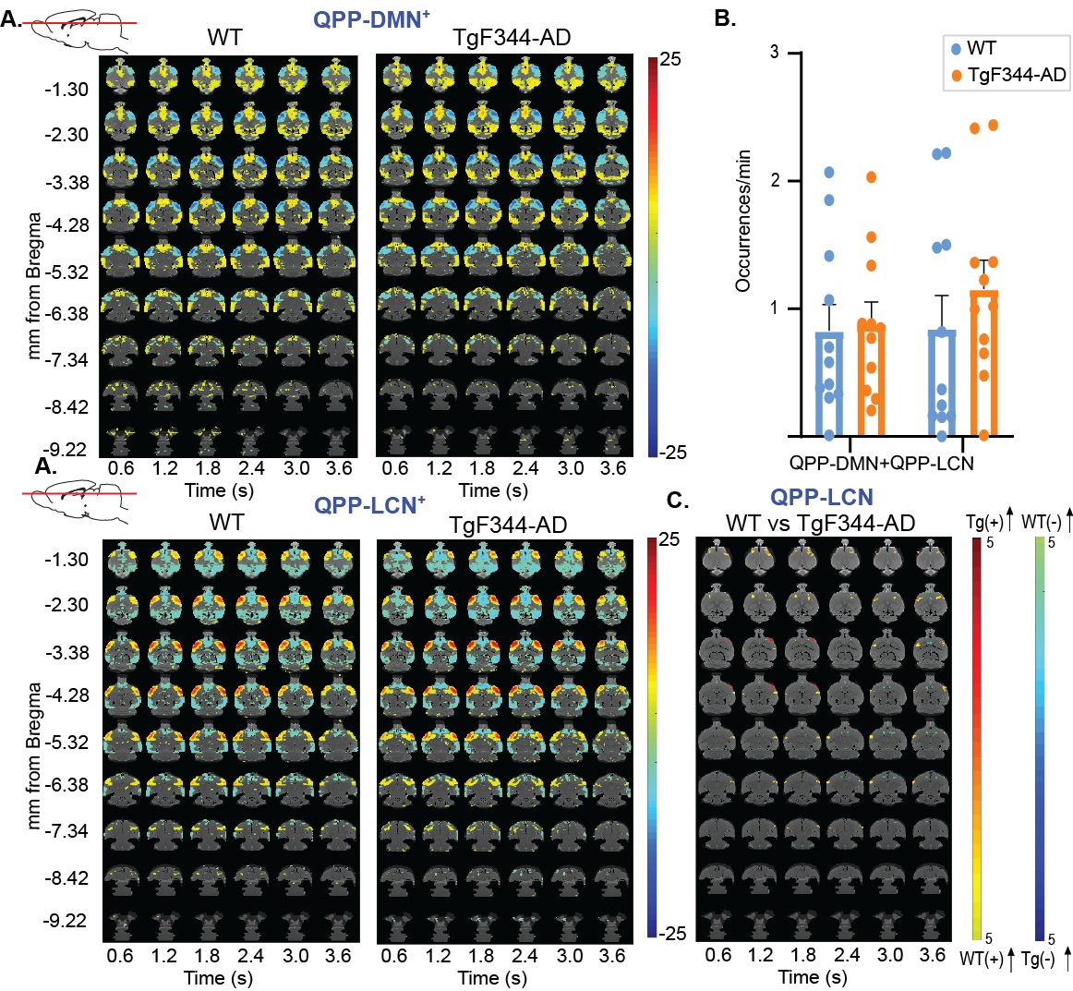
Supplementary figure 3: Spatiotemporal alterations in network activity in 6-month old TgF344-AD rats (Tg) as compared to control littermates (WT). A) T-maps (two-tailed one sample T-tests, FDR p<0.05, minimal cluster size 10) show the two rQPPs in each group. Comparison of cluster wise-occurrence rates between groups (two-sample t-test, two-tailed, FDR p<0.05) demonstrate no significant differences in occurrence of both QPPs between groups. C) T-maps (two-tailed two sample T-tests, FDR p<0.05, minimal cluster size 10) between rQPP-LCN. The warm colors (red/yellow) indicate a significant difference in BOLD activity between groups for voxels which are positive (activated) in the original QPP of the WT group. The right color bar (light blue/dark blue) indicate significant genotype differences for voxels which were deactivated in the original QPP of the WT group.
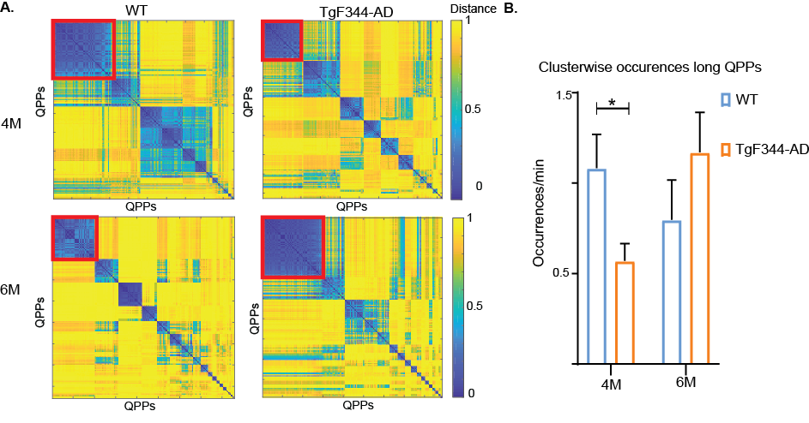
Supplementary figure 4: Analysis of 9 second long QPPs at 4 and 6 months-old TgF344-AD and WT rats. A) Distance matrices based on the results of the hierarchical clustering of all 200 extracted QPPs. Yellow colors indicate a high distance, while blue colors mean a small distance (high similarity). After applying all criteria to select robust clusters, only 1 cluster remained for each group at each time point. B) Statistically lower cluster wise occurrence rates for long QPPs at 4 months, but not at 6 months (two sample t-tests, FDR p<0.05)
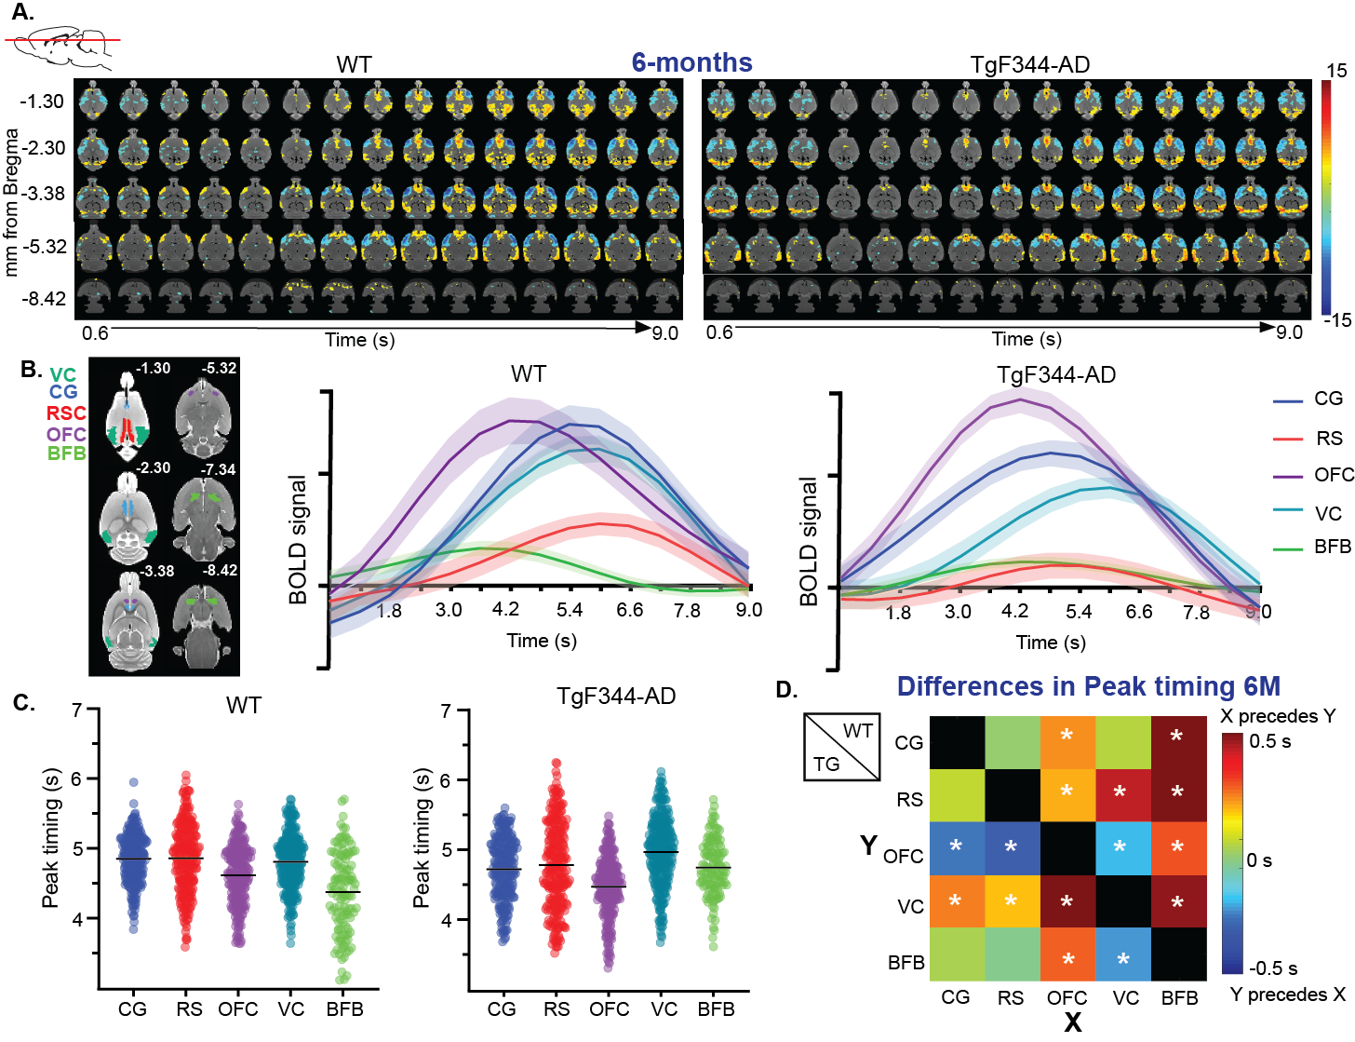
- Supplementary figure 5: Long QPPs to investigate propagation of network activity at the early-plaque stage A) T-maps (two-tailed one sample t-tests, FDR p<0.05, minimal cluster size 10) show the long rQPPs in each group. Colors indicate T-values. B) average BOLD timecourses within regions of interest during 9-second QPPs. C) Peak timings averaged across occurrences for each voxel within a certain region. Dots represent the distribution of average peak timing of individual region of interest (ROI)-specific voxels; the black lines represent the mean peak timing across all ROI-specific voxels. D) Differences (peak_{y}-peak_{x}) in mean peak timing across voxels for each connection (X=row, Y=column). The top half represents the wildtype (WT) animals, while the lower half represents the TgF344-AD rats (Tg). Unpaired two-sample t-tests (FDR p<0.05) between regions were performed to evaluate if peak timing was significantly different between ROIs. CG = Cingulate cortex, OFC = orbitofrontal cortex, RSC = retrosplenial cortex, HC = hippocampus, BFB = basal forebrain. * p<0.05
Supplementary tables
Supplementary Table 1: p-values two-way ANOVA pTau
pTau | Age*Genotype | Genotype | Age
CG | 0,9699 | 0,8299 | 0,0016
RS | 0,3607 | 0,8738 | 0,0109
Ent | 0,9525 | 0,0559 | 0,0007
SS | 0,2271 | 0,8903 | 0,0685
CA1 | 0,3425 | 0,0066 | 0,0008
DG | 0,9027 | 0,049 | 0,0537
MS | 0,9137 | 0,6721 | 0,0019
HDB/SI | 0,7068 | 0,6779 | 0,0004
NBM | 0,5721 | 0,2408 | 0,001
LC | 0,1473 | 0,0169 | 0,0596
Statistical analysis of the %area pTau between groups and ages. CG = cingulate cortex, RS = retrosplenial cortex, Ent = entorhinal cortex, SS = somatosensory cortex, DG = dentate gyrus, MS = medial septum, HDB/SI = horizontal limb of the diagonal band of Broca/substantia innominata, NBM = nucleus basalis of Meynert, LC = locus Coeruleus.

Supplementary Table 2: p-values statistical comparison voxel-wise mean peak timings
 | 4M |  |  |  | 6M
 | WT |  | TG |  | WT |  | TG
 | Diff (s) | FDR  p<0,05 | Diff (s) | FDR  p<0,05 | Diff (s) | FDR p<0,05 | Diff (s) | FDR p<0,05
CG-BFB | 0,4380 | <0,0001 | -0,1103 | 0,0036 | 0,5149 | <0,0001 | -0,0232 | 0,6230
CG-OFC | 0,0384 | 0,3330 | 0,0877 | 0,0017 | 0,2237 | <0,0001 | 0,2518 | <0,0001
CG-RS | -0,0288 | 0,5346 | 0,2286 | 0,4210 | -0,0056 | 0,8806 | -0,0587 | 0,3640
CG-VC | -0,2658 | <0,0001 | -0,1205 | 0,0014 | 0,0442 | 0,1275 | -0,2455 | <0,0001
RS-VC | -0,2370 | <0,0001 | 0,1438 | <0,0001 | 0,4235 | 0,123 | -0,1867 | 0,0014
RS-OFC | 0,0672 | 0,1020 | 0,0684 | 0,02110 | 0,1901 | <0,0001 | 0,3102 | <0,0001
RS-BFB | 0,4668 | <0,0001 | -0,0129 | 0,0004 | 0,5205 | <0,0001 | 0,0354 | 0,5590
OFC-VC | -0,3042 | <0,0001 | 0,1991 | <0,0001 | -0,1901 | <0,0001 | -0,4968 | <0,0001
OFC-BFB | 0,3996 | <0,0001 | -0,1980 | <0,0001 | 0,2912 | <0,0001 | -0,2748 | <0,0001
VC-BFB | 0,7038 | <0,0001 | 0,01344 | 0,8440 | 0,4707 | <0,0001 | 0,222 | <0,0001
Differences (Diff) in mean voxel-wise peak timings between different regions in seconds in wildtype (WT) and TgF344-AD rats (TG). Significant difference in peak timings between regions was evaluated using a two-sample t-test with FDR correction (p < 0.05).

Supplementary Table 3: p-values two-way ANOVA Astrogliosis
GFAP | Age*Genotype | Genotype | Age
CG | 0,3614 | 0,0724 | 0,9826
RSC | 0,0936 | 0,0372 | 0,8474
mENT | 0,3602 | 0,182 | 0,5808
SS | 0,0657 | 0,6707 | 0,3552
MS | 0,8643 | 0,8081 | 0,958
NBM | 0,0581 | 0,0269 | 0,0027
HDB/SI | 0,0262 | 0,0183 | 0,9064
Statistical analysis of the %area GFAP between groups and ages. CG = cingulate cortex, RS = retrosplenial cortex, Ent = entorhinal cortex, SS = somatosensory cortex, MS = medial septum, HDB/SI = horizontal limb of the diagonal band of Broca/substantia innominata, NBM = nucleus basalis of Meynert

Supplementary Table 4: p-values two-way ANOVA Microgliosis
Iba-1 | Age*Genotype | Genotype | Age
CG | 0,1571 | 0,8388 | 0,3466
RSC | 0,2556 | 0,37 | 0,3707
Ent | 0,1241 | 0,0937 | 0,0003
SS | 0,5429 | 0,6633 | 0,0001
MS | 0,3092 | 0,6105 | 0,0529
HDB/SI | 0,3118 | 0,1338 | 0,55
NBM | 0,8146 | 0,2123 | 0,0001

Statistical analysis of the %area Iba-1 between groups and ages. CG = cingulate cortex, RS = retrosplenial cortex, Ent = entorhinal cortex, SS = somatosensory cortex, MS = medial septum, HDB/SI = horizontal limb of the diagonal band of Broca/substantia innominata, NBM = nucleus basalis of Meynert

Supplementary table 5: p-values two-way ANOVA vGLUT/vGAT
vGLUT/vGAT | Age*Genotype | Genotype | Age
CG | 0,2649 | 0,0199 | 0,0879
RSC | 0,3099 | 0,0283 | 0,0001
Ent | 0,3686 | 0,1561 | 0,5679
SS | 0,0548 | 0,0792 | 0,0469
MS | 0,0232 | 0,7135 | 0,0001
HDB/SI | 0,505 | 0,6998 | 0,95
NBM | 0,7753 | 0,1531 | 0,0427

Statistical analysis of the ratio of glutamatergic and gaba-ergic synapses between groups and ages. CG = cingulate cortex, RS = retrosplenial cortex, Ent = entorhinal cortex, SS = somatosensory cortex, MS = medial septum, HDB/SI = horizontal limb of the diagonal band of Broca/substantia innominata, NBM = nucleus basalis of Meynert
Supplementary table 6: p-values ANOVA cholinergic synaptic count
#Cholinergic | Age*Genotype | Genotype | Age
CG | 0,4059 | 0,8895 | 0,4253
RSC | 0,2947 | 0,2502 | 0,6918
Ent | 0,8684 | 0,9815 | 0,0402
SS | 0,8174 | 0,9282 | 0,1037
MS | 0,472 | 0,3097 | 0,336
HDB/SI | 0,5189 | 0,7353 | 0,0001
NBM | 0,1872 | 0,2538 | 0,5551

Statistical analysis of the number of cholinergic synapses between groups and ages. CG = cingulate cortex, RS = retrosplenial cortex, Ent = entorhinal cortex, SS = somatosensory cortex, MS = medial septum, HDB/SI = horizontal limb of the diagonal band of Broca/substantia innominata, NBM = nucleus basalis of Meynert

