Supplementary Information

A New Denitrification Pathway in Oxygen-Rich Aquatic Environments through Long-Distance Electron Transfer

Ming-Zhi Wei¹, Qin-Zheng Yang², An Xue¹, Lea R. Winte³, Menachem Elimelech³*, Hua-Zhang Zhao^{1,4}*

¹Key Laboratory of Water and Sediment Sciences (Ministry of Education), College of Environmental Sciences and Engineering, Peking University, Beijing 100871, China.
²State Key Laboratory of Biobased Material and Green Papermaking, Qilu University of Technology, Shandong Academy of Sciences, Jinan 250353, China.
³Department of Chemical and Environmental Engineering, Yale University, New Haven, CT 06520-8286, USA.
⁴Shanxi Laboratory for Yellow River, College of Environmental and Resource Sciences, Shanxi University, Taiyuan 030006, China.

*Corresponding author. Email: zhaohuazhang@pku.edu.cn, menachem.elimelech@yale.edu

Experiments of other sediment-water systems
The water-soaked iron rod was prepared by immersing an iron rod in water for two weeks at room temperature. The air-calcined iron rod was prepared by calcining an iron rod at 800 °C in ambient air for one hour, which produced various iron oxides films on the surface of the rod. Different systems equipped with different conductive rods were prepared following similar procedures. Briefly, 600 mL sediment freshly collected from Beijing Purple Bamboo Park was added to a 48 cm-high, 2 L graduated cylinder (I.D. 9.0 cm). A 0.3 cm-thick carbon felt with the diameter of 7.0 cm was put at the position of 300 mL in the cylinder. Two liters of 2.1 mg-N/L sodium nitrate solution prepared with municipal tap water were added to the cylinder as the overlying solution. The 25.0 cm conductive rod with a diameter of 1.0 cm was inserted vertically into the sediment with the bottom end in tight contact with the carbon felt. The top of the rod was 10.0 cm below the surface of the water.

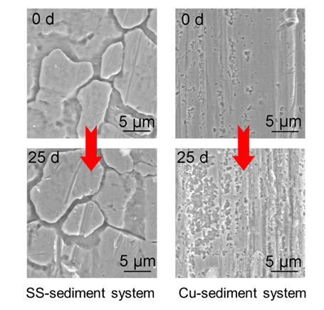

Supplementary Fig. 1. SEM images of the rod surfaces in SS-sediment system and Cu-sediment system before (Day 0) and after nitrate reduction (Day 25).

Supplementary Fig. 2. NO₃⁻ degradation efficiencies of systems with only sediment, only iron rod, SS-sediment system, and Cu-sediment system.

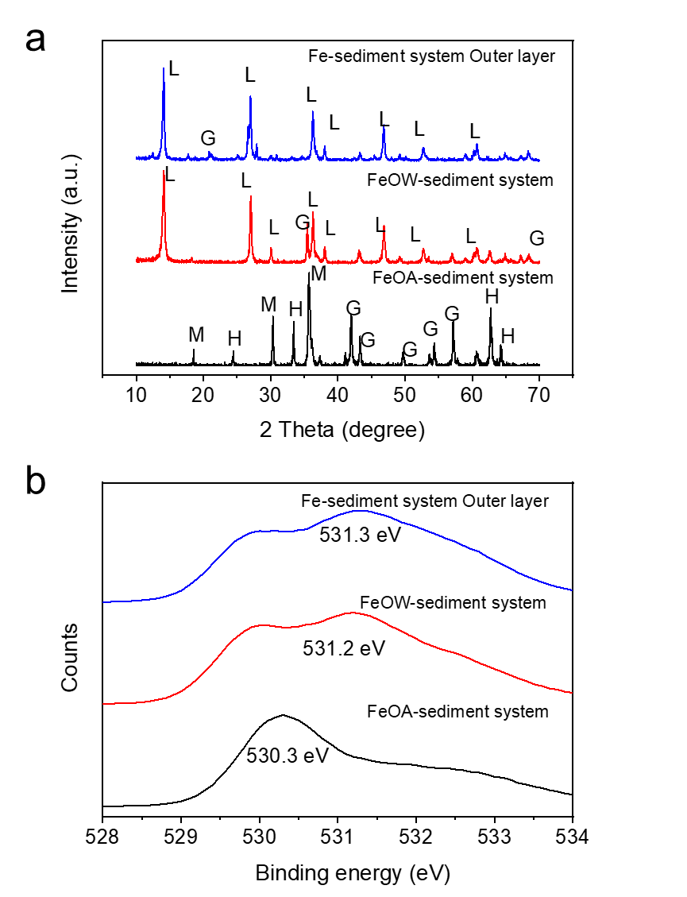

Supplementary Fig. 3. XRD spectra (a) and O1s XPS spectra (b) of the iron oxides on the outer layer of rods in Fe-sediment, FeOW-sediment, and FeOA-sediment systems on Day 25 (M, magnetite; H, hematite; and G, goethite).

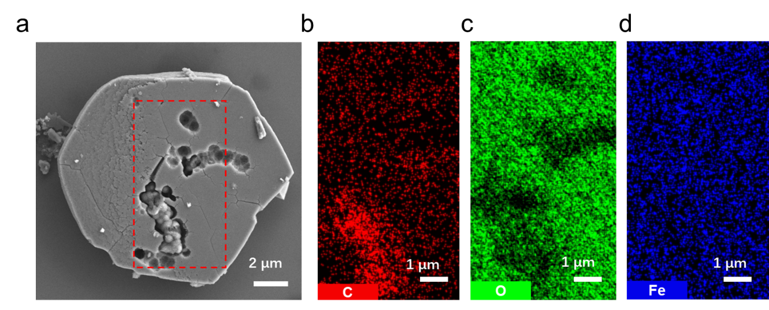

Supplementary Fig. 4. SEM images (a) and EDS analysis of C (b), O (c), and Fe (d) of microbial corrosion and coexistence of microorganisms with green rust crystals (C, red; O, green; Fe, blue).

Supplementary Fig. 5. Nitrate reduction efficiencies of Fe-sediment system, FeOW-sediment system and FeOA-sediment system.

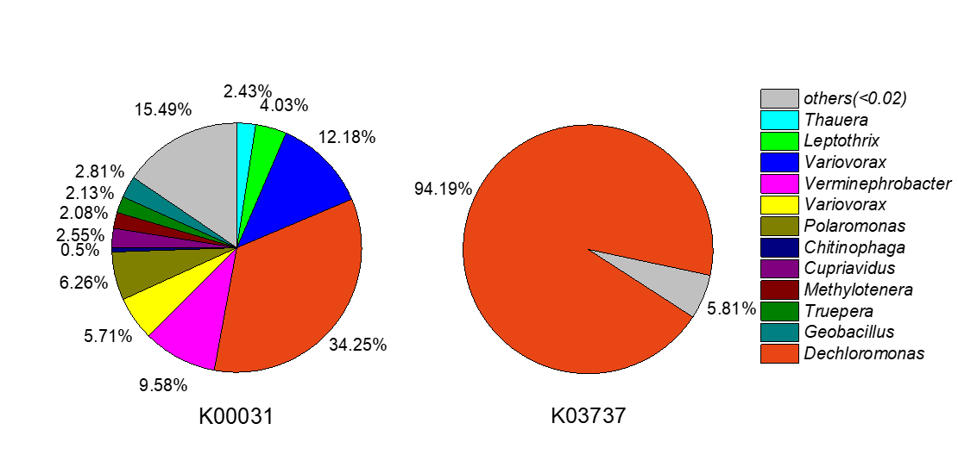

Supplementary Fig. 6. Distribution of CO₂ fixation genes K00031 and K03737 in iron rod microstructure on Day 25.

Supplementary Fig. 7. Time-dependent XPS O1s spectra of the iron oxides on the iron rod of Fe-sediment system.

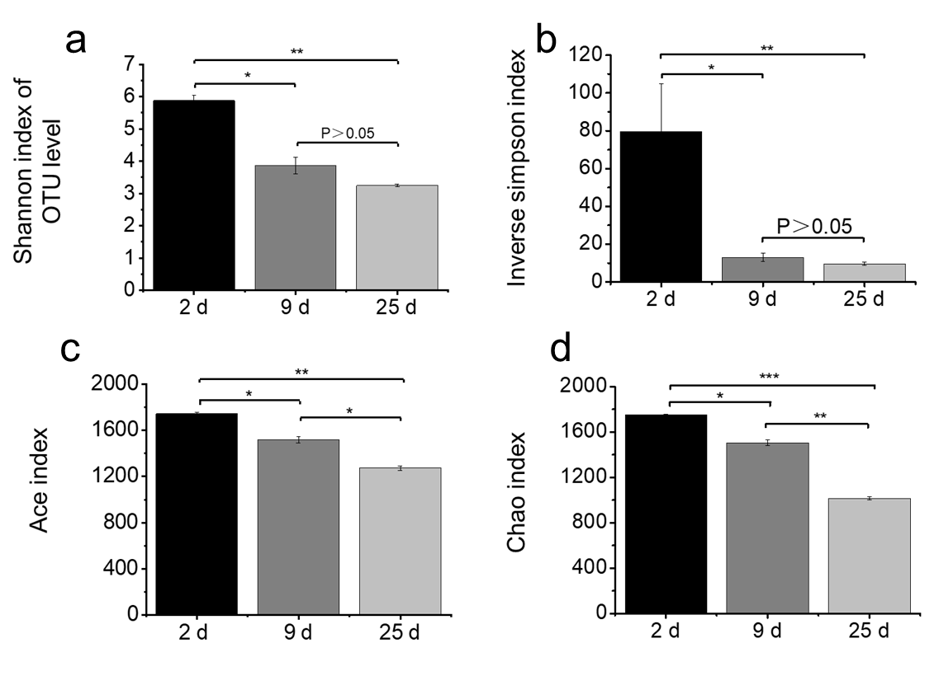

Supplementary Fig. 8. Significance of the α diversity of the cathode bacteria at OTU level in the microstructure of iron rod at different times. ∗0.01 < P ≤ 0.05, ∗∗0.001 < P ≤0.01, and ∗∗∗P≤0.001. (a) Shannon index; (b) Inverse Simpson index; (c) Ace index; (d) Chao1 index.

Supplementary Table 1. Distribution of the genes related to CO2 fixation in the bacterial flora on the iron rod.
KO | KO-containing bacteria | Number of reads for KO | Ratio in KO reads (%) | Ratio in reads for CO₂ fixation genes (%)
K03737 | Dechloromonas aromatica | 9778 | 94.11 | 24.28
K03737 | Allochromatium vinosum | 88 | 0.85 | 0.22
K03737 | Anaeromyxobacter dehalogenans 2CP-1 | 86 | 0.83 | 0.21
K03737 | Sideroxydans lithotrophicus | 106 | 1.02 | 0.26
K03737 | Synechococcus sp. PCC7002 | 132 | 1.27 | 0.33
K03737 | Methylococcus capsulatus | 26 | 0.25 | 0.06
K03737 | Maribacter sp. HTCC2170 | 96 | 0.92 | 0.24
K03737 | Candidatus Solibacter usitatus | 16 | 0.15 | 0.04
K03737 | Methylomonas methanica | 6 | 0.06 | 0.02
K03737 | Anaerolinea thermophila | 14 | 0.14 | 0.04
K03737 | Intrasporangium calvum | 22 | 0.21 | 0.05
K03737 | Aeromonas hydrophila subsp. hydrophila ATCC 7966 | 20 | 0.19 | 0.05
K03737 | Total | 10390 | 100 | 25.80
K00031 | Thauera sp. MZ1T | 584 | 2.44 | 1.45
K00031 | Leptothrix cholodnii | 968 | 4.04 | 2.40
K00031 | Variovorax paradoxus EPS | 2922 | 12.184 | 7.26
K00031 | Dechloromonas aromatica | 8220 | 34.28 | 20.41
K00031 | Verminephrobacter eiseniae | 2298 | 9.58 | 5.71
K00031 | Meiothermus ruber DSM 1279 | 428 | 1.78 | 1.06
K00031 | Variovorax paradoxus S110 | 1370 | 5.71 | 3.40
K00031 | Polaromonas sp. JS666 | 1502 | 6.26 | 3.73
K00031 | Methylovorus glucosetrophus | 446 | 1.86 | 1.10
K00031 | Chitinophaga pinensis | 120 | 0.50 | 0.30
K00031 | Accumulibacter phosphatis | 342 | 1.42 | 0.85
K00031 | Cupriavidus taiwanensis | 612 | 2.55 | 1.52
K00031 | Methylotenera mobilis | 498 | 2.08 | 1.24
K00031 | Truepera radiovictrix | 512 | 2.13 | 1.27
K00031 | Geobacillus sp. WCH70 | 674 | 2.81 | 1.67
K00031 | others (＜1%) | 2138 | 8.91 | 5.31
K00031 | Total | 23634 | 100 | 58.70

Supplementary Table 2. Abundance of denitrification and EET-related genes. The number of total sequences is 11,108,018 based on KEGG by the all-annotation tool in MG-RAST.
Function | Gene | Reads | Proportion
Denitrification | Nitrate reductase (NarG) | 62828 | 0.57 %
 | Nitrate reductase (NasA) | 22174 | 0.20 %
 | Nitrite reductase (NO-forming) | 2264 | 0.02 %
 | Nitrous-oxide reductase (NosZ) | 13982 | 0.13 %
 | Nitric oxide reductase (NorB) | 9466 | 0.09 %
Extracellular electron transfer (EET) | c-type cytochrome | 50492 | 0.45 %

Supplementary Table 3. Abundance of denitrification and EET-related genes. The number of total sequences is 11,108,018 based on KEGG by the all-annotation tool in MG-RAST.
KO | Gene name | Definition
K02014 | TC.FEV.OM | Iron complex outer membrane receptor protein
K04759 | FeoB | Ferrous iron transport protein B
K02012 | fbpA | Iron(III) transport system substrate-binding protein
K02015 | ABC.FEV.P | Iron complex transport system permease protein
K02011 | fbpB | Iron(III) transport system permease protein
K02010 | fbpC | Iron(III) transport system ATP-binding protein
K07243 | CYP2W1 | High-affinity iron transporter
K07239 | TC.HME | Heavy-metal exporter, HME family
K04090 | E1.2.7.8 | Indole-pyruvate ferredoxin oxidoreductase
Total |  | 45650 reads

