Supplementary Materials for

METTL3 stabilization by PIN1 promotes breast tumorigenesis via enhanced m⁶A-dependent translation

Poshan Yugal Bhattarai, Garam Kim, Muna Poudel, Sung-Chul Lim, Ramesh Mariappan, Takbum Ohn, Hong Seok Choi.

Correspondence to: chs@chosun.ac.kr

This PDF file includes:

Materials and Methods
Figures S1 to S2

Materials and Methods

Cell Culture and Establishing Stable Cell Lines
MCF7 and HEK293 cells purchased from the American Type Culture Collection (ATCC) were maintained in Dulbecco’s modified Eagle’s medium (DMEM) supplemented with 10% fetal bovine serum (FBS) at 37 °C in a humidified atmosphere containing 5% CO₂. Cells (4T1) obtained from the ATCC were maintained in RPMI 1640 medium supplemented with 10% FBS. Cells were transfected with the pcDNA4-His/XP-PIN1 construct and selected with zeocin (300 µg/mL for MCF7 and 250 µg/mL for 4T1) for several weeks until resistant colonies were formed to establish MCF7 and 4T1 cells stably overexpressing PIN1. Cells from the resistant colonies were pooled together and maintained in the respective media for each cell line.

Antibodies and Reagents
Antibodies against METTL3 (96391, WB 1:1000, IP 1 µL) and TAZ (8418, WB 1:1000) were purchased from Cell Signaling Technology Inc. (Danvers, MA, USA). The anti-METTL3 antibody (195352, IHC 1:500) was purchased from Abcam (Cambridge, USA). Antibodies against EGFR (sc-373746 WB 1:1,000; IP 1 µg), eIF3b (sc-137214 WB 1:1000), eIF4E (sc-9976, WB 1:1000), PIN1 (sc-46660, WB 1:5000; IP 1 µg), and GFP (sc-8334 WB 1:5000) were purchased from Santa Cruz Biotechnology (Dallas, TX, USA). Anti-β-actin (A1978 1:10,000) and anti-FLAG (F3165, 1:5,000) antibodies were purchased from Sigma-Aldrich (St. Louis, MO, USA). Anti-m⁶A antibody (dot blot 1:1,000; IP 1 µg) was obtained from Synaptic Systems (Goettingen, Germany). The antibody against puromycin (MABE343, WB 1:5,000) was purchased from Merck Millipore (Burlington, MA, USA). PD98059 (513000) was purchased from Calbiochem (San Diego, CA, USA). Trametinib (HY-10999) was purchased from MedChemExpress (NJ, USA). ATRA (R2625) was purchased from Sigma-Aldrich. The EpiQuik m⁶A RNA methylation quantification kit (colorimetric) was obtained from Epigentek (P-9005-96). The jetPEI® transfection reagent was obtained from Polyplus-transfection (Illkrich, France). Lipofectamine 3000 transfection reagent was purchased from Invitrogen (Carlsbad, CA, USA).

CRISPR/Cas9 Knockout and Mammalian Expression Vectors
Genes were knocked out using the CRISPR/Cas9 system with guide RNAs targeting human METTL3 (1st, 5′-GAGTTGATTGAGGTAAAGCG-3′; 2nd, 5′-GTATCTCCAGATCAACATCTG-3′), human PIN1 (1st, 5′-GATGAGCGGGCCCGTGTTCA-3′; 2nd, 5′-GAAGATCACCCGGACCAAGG-3′), and mouse Mettl3 (1st, 5′-GAGTTGATTGAGGTAAAGCG-3′; 2nd 5′-GGGCAAATTTGCAGTTGTGA-3′) designed using the Broad Institute CRISPick portal (https://portals.broadinstitute.org/gppx/crispick/public) and cloned into the BbsI site of peSpCas9(1.1)-T2A-puro vector (Addgene #101039, a gift from Andrea Nemeth). Cells were transfected with plasmid DNA using Lipofectamine 3000 for 48 h, and then harvested and used for the experiment without single-cell isolation. METTL3-KO stable cells were established after transfection with sgMETTL3 and selection with 2 µg/mL puromycin for 48 h (Figure 4h). The surviving cells were passaged three times before being used for the experiment. pcDNA3-Flag-METTL3 (Addgene #53739) and pcDNA3-Flag-METTL14 (Addgene #53740) were gifts from Chuan He. pBiFC-VN173 (Addgene #22010) and pBiFC-VC155(Addgene #22011) were gifts from Chang-Deng Hu. The pRSTF-tagged cap (Addgene #35572) and pQCXIP-MS2-HB (Addgene #35573) were gifts from Marian Watermen. pCMV-FLAG-TAZ (Addgene #24809) was a gift from Jeff Wrana. pcDNA3-myc-EGFR has been previously described [1]. pACT, pBIND, and pG5-luc plasmids were obtained from Promega (Madison, WI, USA). psiCHECK3 was a gift from Anthony Leung (Addgene, #136010). The construction of pcDNA4-His/XP-PIN1, GST-PIN1(WT), GST-PIN1(WW), and GST-PIN1(PPIase) has been described previously [2]. pACT-PIN1 was constructed using PCR that involved amplification of the PIN1 open reading frame (ORF) from pcDNA4-His/XP-PIN1 and cloning it into the Sal/NotI site of the pACT vector. The ORF was PCR-amplified from pcDNA3-Flag-METTL3, pCDNA3-Flag-METTL14, pcDNA3-Flag-WTAP, and pGEM-WTAP (Sinobiological #HG12018-G) and cloned into the SalI/NotI sites of pBIND vector. pBIND-SGK1 plasmid was a gift from Zigang Dong (Hormel Institute). pBiFC-VN-METTL3 and pBiFC-VC-PIN1 were constructed using PCR involving amplification of the ORFs of METTL3 and PIN1 from pcDNA3/Flag-METTL3 and pcDNA4-His/XP-PIN1 vectors, respectively, and cloning them into HindIII/XbaI and EcoRI/XhoI sites, respectively. The strategy used for the construction of psiCHECK3-EGFR has been described previously [1]. psiCHECK3-TAZ vector was constructed by PCR amplification of a putative m⁶A modification site of TAZ (NM_015472.6, nucleotides 1245–1467) from cDNA prepared from MCF7 cells, then cloned into the XhoI site of psiCHECK3 vector. pcDNA3-4X(MS2) vector was constructed by PCR-amplification of the MS2 hairpin loop from the pRSTF-MS2-tagged cap vector and cloning it into the BbsI site located at the 3’ UTR of pcDNA3.1-Myc/HisA vector. pcDNA3-myc-EGFR-4x(MS2) and pcDNA3-Flag-TAZ-4x(MS2) were constructed by digesting pcDNA3-Myc-EGFR and pCMV5-Flag-TAZ vectors with MluI/XbaI and KpnI/EcoRI, respectively, and the ORF was subcloned into pcDNA3-4X(MS2) vector. Mutagenesis was performed using the Quick-change II kit (Agilent, Santa Clara, CA, USA) according to the manufacturer’s instructions. The primer list used for cloning has been provided in Supplementary Table 4.

Mammalian Two-Hybrid Assay
pACT-PIN1 and pBIND vectors were combined with pG5-luc vectors in equal molar ratios. DNA (100 ng) was transfected into HEK293 cells cultured in 48-well plates using jetPEI reagent for 48 h followed by cell lysis in passive lysis buffer (Promega, Madison, WI, USA). Firefly- and Renilla luciferase activities in the cell lysates were measured using the Dual-Luciferase reporter assay system (Promega). Renilla activity was used to normalize the transfection efficiency.

Polysome Fractionation
Polysome fractionation was performed as described previously [3] with some modifications. Briefly, MCF7 cells transfected with sgCtrl or sgPIN1 were treated with 100 µg/mL cycloheximide for 10 min at 37 °C. Cells were harvested and lysed in polysome lysis buffer (20 mM HEPES-NaOH pH 7.6, 5 mM MgCl₂, 125 mM KCl, 1% NP-40, 2 mM ethylenediaminetetraacetic acid (EDTA), 100 µg/mL cycloheximide, EDTA-free protease inhibitors, and RNAsin). An equal amount of lysate was layered onto 10 mL of a 17.5–50% sucrose gradient and centrifuged at 31,000 rpm using a Beckman SW-41Ti rotor for 3 h at 4 °C. The gradients were fractionated and monitored at 254 nm using gradient fractionation system (Brandel, Gaithersburg, MD, USA). The collected fractions were analyzed by immunoblotting or RT-PCR.

Cell Proliferation Assay (BrdU Incorporation)
Cell proliferation was assessed using a cell proliferation ELISA kit (Roche Life Sciences, Penzberg, Germany) in accordance with the manufacturer’s instructions. Briefly, MCF7 cells were seeded (5,000 cells per well) in 96-well plates and cultured in 100 µL medium supplemented with 10% FBS for 24 h. Cells were treated with PD98059 (10 µM) and ATRA (20 mM) for 24 h in serum-free media, labeled with 10 μL/well BrdU-labeling solution, and incubated for an additional 4 h at 37 °C in 5% CO₂. The medium containing BrdU-labeling reagent was aspirated, and FixDenat solution (Roche) was added to each well. The plate was incubated for 30 min at room temperature (25 °C) after which the media was aspirated. Anti-BrdU-POD working solution was then added to each well and incubated for an additional 90 min. Cells were washed three times with washing solution, followed by the addition of 100 µL substrate solution to each well, and incubation for another 30 min. Cell proliferation was estimated by measuring the absorbance at 370 nm in multiplate spectrophotometer (Molecular Devices, San Jose, CA, USA).

GST Pulldown Assay
Cells were transfected with the indicated plasmid DNA for 48 h, lysed in NET-NL buffer, and the lysate was incubated with glutathione-sepharose beads (GE Healthcare, Chicago, IL, USA) containing GST or GST-PIN1 for 4 h at 4 °C. Precipitated proteins were resolved using sodium dodecyl sulfate-polyacrylamide gel electrophoresis (SDS-PAGE) and detected by immunoblotting.

Ni-NTA Pulldown Assay
HEK293 and MCF7 cells were lysed in His-lysis buffer (50 mM Tris-HCl pH 8.0, 150 mM NaCl, 0.5% NP-40, 0.1 mM ethylenediaminetetraacetic acid, 1 phenylmethylsulphonyl fluoride, 25 mM imidazole). The lysate was incubated with His-Pur resin (ThermoScientific, Waltham, MA, USA) for 1 h at 4 °C, followed by washing with His-lysis buffer or high-salt buffer (His-lysis buffer with 500 mM NaCl). Precipitated proteins were eluted by boiling with 2X Laemmli sample buffer, resolved using SDS-PAGE and detected by immunoblotting.

Bimolecular Fluorescence Complementation (BiFC) and Immunofluorescence
MCF7 cells were seeded onto coverslips and transfected with the indicated BiFC plasmids. Cells were fixed using 4% formaldehyde, washed with phosphate-buffered saline (PBS), mounted onto slides using ProLong Gold Antifade mountant containing DAPI (Thermo Fisher Scientific), and examined under a fluorescence microscope (Axiovert 200M, Zessis) using a GFP filter. Immunofluorescence was assessed by transfecting MCF7 cells with sgCtrl or sgPIN1 plasmids, treating with puromycin (2 µg/mL) for 1 h at 37 °C, fixing with Cytofix/Cytoperm™ reagent (BD Biosciences, San Diego, CA, USA), probing with anti-puromycin antibody, followed by anti-mouse IgG-Texas Red antibody (Thermo Fisher Scientific). The coverslips were mounted on slides using ProLong Gold Antifade mountant containing DAPI and examined under a fluorescence microscope. Fluorescence intensity was measured using the Fiji software downloaded from https://fiji.sc/. Briefly, the fluorescence intensity was calculated as the corrected total cell fluorescence (CTCF) using the following formula: CTCF = integrated density − (area of selected cell × mean fluorescence of background readings). The fluorescence intensity of cells (N = 6) from each group was calculated using the above formula. Variations in intensity arising from the imaging conditions were minimized by simultaneously capturing fluorescence microscopy images and keeping the exposure times constant.

Protein Immunoblotting and Immunoprecipitation
Immunoblotting involved growing cells in monolayers, followed by harvesting through centrifugation at 12000×g, washing in PBS, and lysis using RIPA buffer (150 mM NaCl, 50 mM Tris-HCl (pH 7.4), 0.25% sodium deoxycholate, 1 mM EDTA, 1% NP40, 1 mM NaF, 0.2 mM phenylmethylsulphonyl fluoride, 0.1 mM sodium orthovanadate, and protease/phosphatase inhibitor cocktail). Protein samples (10–30 µg) were resolved using SDS-PAGE, blotted onto polyvinylidene fluoride membranes (Millipore, MA, USA) and probed using the indicated antibodies. Co-immunoprecipitation involved harvesting cells, lysis using NET-NL buffer (50 mM Tris-HCl (pH 7.5), 150 mM NaCl, 0.5% NP-40, 1 mM EDTA, 1 mM dithiothreitol, 0.2 mM phenylmethylsulphonyl fluoride, protease inhibitor cocktail (Roche Life Sciences, Indianapolis, IN, USA), and phosphatase inhibitor cocktail (Thermo Fisher Scientific)). The lysate was immunoprecipitated with the indicated antibodies and immunoblotted. Immunoblots were visualized using SuperSignal West Femto chemiluminescence substrate (Thermo Fisher Scientific) and Amersham Imager 680 (GE Healthcare, Chicago, IL, USA).

Immunohistochemistry
Informed consent was obtained from all patients. All research protocols were approved by the ethics committee of the Chosun University Hospital. Tissues from 30 patients with invasive breast carcinoma (age range, 42–72 years) were collected. IHC was performed as described previously [4]. For METTL3, each sample was scored as the percentage of positively stained cells (percentage score: 1–5) and the staining intensity (intensity score: 1–5). The IHC score was calculated by multiplying the percentage and intensity scores. For PIN1, the IHC stain was scored based on the percentage of positively stained cells (score range: 0-3).

Poly(A) RNA Dot Blotting
Dot blotting was performed as described previously [5]. Total RNA was isolated from cells using TRIzol (Invitrogen, Carlsbad, CA, USA). Poly(A) RNA was purified from total RNA using an Oligotex mRNA mini kit (Qiagen, Hilden, Germany). Poly(A) RNA (100 ng) was then cross-linked onto a Hybond N+ membrane using a UV crosslinker. The membrane was probed using an anti-m⁶A antibody, and the bands were visualized using a SuperSignal West Femto chemiluminescence substrate with Amersham Imager 680.

meRIP-PCR
Total RNA (100 µg) was precleared by incubation with 20 µL of recombinant protein-G sepharose bead suspension (Invitrogen) in meRIP buffer (10 mM Tris-HCl, pH 7.5, 150 mM NaCl, 0.1% NP-40, 2 mM ribonucleoside vanadyl complexes, and 200 U/mL RNasin) for 1 h at 4 °C. The precleared RNA was incubated with 1 µg anti-m⁶A antibody for 4 h at 4 °C. Recombinant protein-G sepharose beads (50 µL) were blocked using 0.5 mg/mL bovine serum albumin in meRIP buffer for 1 h at 4 °C. The RNA-antibody mixture was incubated with the precleared beads and for 2 h at 4 °C. Then, the beads were washed five times with the meRIP buffer, and the mRNA bound to the beads was eluted using 100 µL elution buffer (meRIP buffer supplemented with 6.7 mM N6-methyladenosine base; Selleckchem, Houston, TX, USA) at 4 °C for 1 h. The eluted RNA was purified using a RNeasy mini kit (Qiagen). Purified eluate (5 µL) was reverse-transcribed into first-strand cDNA using TOPscript™ RT DryMIX dT18 plus (Enzynomics, Daejeon, Republic of Korea). The reverse transcription product was diluted in nuclease-free water at a ratio of 1:10 and used for real-time or semi-quantitative endpoint PCR. Real-time PCR was performed using Fast SYBR Green master mix on a StepOne Real-Time PCR system (Thermo Fisher Scientific). Semi-quantitative endpoint PCR was performed using AccuPower PCR premix (Bioneer, Daejeon, Republic of Korea). Primer sequences are listed in Supplementary Table S4.

Puromycin Labeling and Immunoprecipitation
MCF7 cells were treated with 2 µg/mL puromycin for 1 h at 37 °C. Cells were harvested and lysed in NET-NL buffer (50 mM Tris-HCl (pH 7.5), 150 mM NaCl, 0.5% NP-40, 1 mM ethylenediaminetetraacetic acid, 1 mM dithiothreitol, 0.2 mM phenylmethylsulphonyl fluoride, protease inhibitor cocktail (Roche Life Sciences, Indianapolis, IN, USA), and phosphatase inhibitor cocktail (Thermo Fisher Scientific). The lysate was immunoprecipitated using anti-puromycin antibody, followed by immunoblotting.

Luciferase Assay
Renilla luciferase activity in lysates prepared from MCF7 cells transfected with psiCHECK3 vectors was measured using the Dual-Luciferase Reporter assay system (Promega, Madison, WI, USA). Transfection efficiency was normalized based on the firefly luciferase activity.

Cell Cycle Analysis
Cells were seeded, transfected with the indicated plasmids, treated with drugs for 24 h, washed, fixed with 70% ethanol, and exposed to 200 μL Muse™ cell cycle reagent (Merck Millipore, Burlington, MA, USA). Then, cells were incubated for 30 min at 25 °C in the dark.

Ki67 Staining
Proliferation cells with Ki67 were analyzed using the Muse® Ki67 proliferation kit in accordance with the manufacturer’s instructions. Briefly, formaldehyde-fixed MCF7 cells were probed with either phycoerythrin (PE)-conjugated Ki67 antibody or normal IgG-PE and analyzed using a Muse cell analyzer.

MS2-tagged RNA Pulldown Assay
Pulldown assays were performed as described previously [6], with some modifications. Briefly, MCF7 cells transfected with the indicated plasmids were cross-linked using UV irradiation (400 mJ/cm²). Cells were lysed in lysis buffer (25 mM Tris-HCl pH 8.0, 300 mM NaCl, 25 mM imidazole, 10 mM ribonucleoside vanadyl complex, and protease inhibitor cocktail), and the lysate was incubated with HisPur resin for 1 h at 4 °C. Immunoprecipitated proteins were detected by immunoblotting after digesting RNA with RNase A (10 µg/mL) for 1 h. To perform RT-PCR, immunoprecipitated proteins were digested with proteinase K (50 µg/mL) at 55 °C for 3h, and the RNA was purified using TRIzol reagent. Purified RNA was reverse transcribed into cDNA using random hexamer primers and TOPscript reverse transcriptase (Enzynomics) before proceeding for RT-PCR.

Anchorage-independent Cell Transformation (Soft Agar Assay)
Briefly, 8,000 cells transfected with the indicated plasmids were grown in 1 mL of 0.3% Eagle’s basal medium supplemented with 10% FBS. Cultures were maintained at 37 °C in a 5% CO₂ incubator for 14 d. The resultant cell colonies were scored using an Axiovert 200M microscope and Axio Vision software (Carl Zeiss, Oberkochen, Germany). Six images were obtained for each group. Colony size and number were evaluated using ImageJ (NIH, Version 1.8.0_172) Bethesda, MD, USA).

Mouse orthotopic model
Female BALB/c mice (6 weeks old) were obtained from OrientBio (Seongnam, Republic of Korea) and maintained in cages in light- and temperature-controlled rooms. The animals were fed commercial rat chow (OrientBio, Co., Seongnam, Korea) with ad libitum access to water. Mice were randomly divided into four groups at the indicated number of mice in each group stated for each experiment. Cells (4T1-mock or 4T1-XP-PIN1 stable cells) transfected with sgCtrl, sgMettl3-1, or sgMettl3-2 knockout plasmids were then injected into the abdominal mammary glands (2 × 10⁶ cells in 100 µL volume) of the mice and allowed to grow until tumor formation (16 d). The mice were observed daily for tumor growth. Tumor volume was calculated using the following formula: Volume = 0.5 × [(large diameter) × (small diameter)²]. This study was approved by the Animal Experiments Committee of Chosun University (CIACUC 2020-S0022).

Bioinformatic Analyses
Bioinformatics analyses were performed using the data available in the DepMap portal (retrieved from https://depmap.org/portal/) and TCGA (retrieved from https://www.cbioportal.org/). The data were processed in R (Version 4.1) using the dplyr, tidyr, and ggVennDiagram packages. m⁶A-seq data (Figure 5a) was generated by downloading the sequence read archive (SRA) files from the Gene Expression Omnibus (GSE37003) using the SRA toolkit (version 2.11.1) and analysis was performed as described previously [7] using the Linux operating system (Ubuntu 22.04 LTS).

Statistical Analysis
Statistical analyses were performed using Prism 8 software (GraphPad Software, San Diego, CA, USA). Venn diagrams were constructed using R software (version 4.0.5; http://www.r-project.org) with the ggVennDiagram package. A two-tailed Student’s t-test was used to compare two independent groups. One-way analysis of variance (ANOVA) followed by Tukey’s multiple comparisons test were used for multiple comparison analyses. P < 0.05 was considered statistically significant.

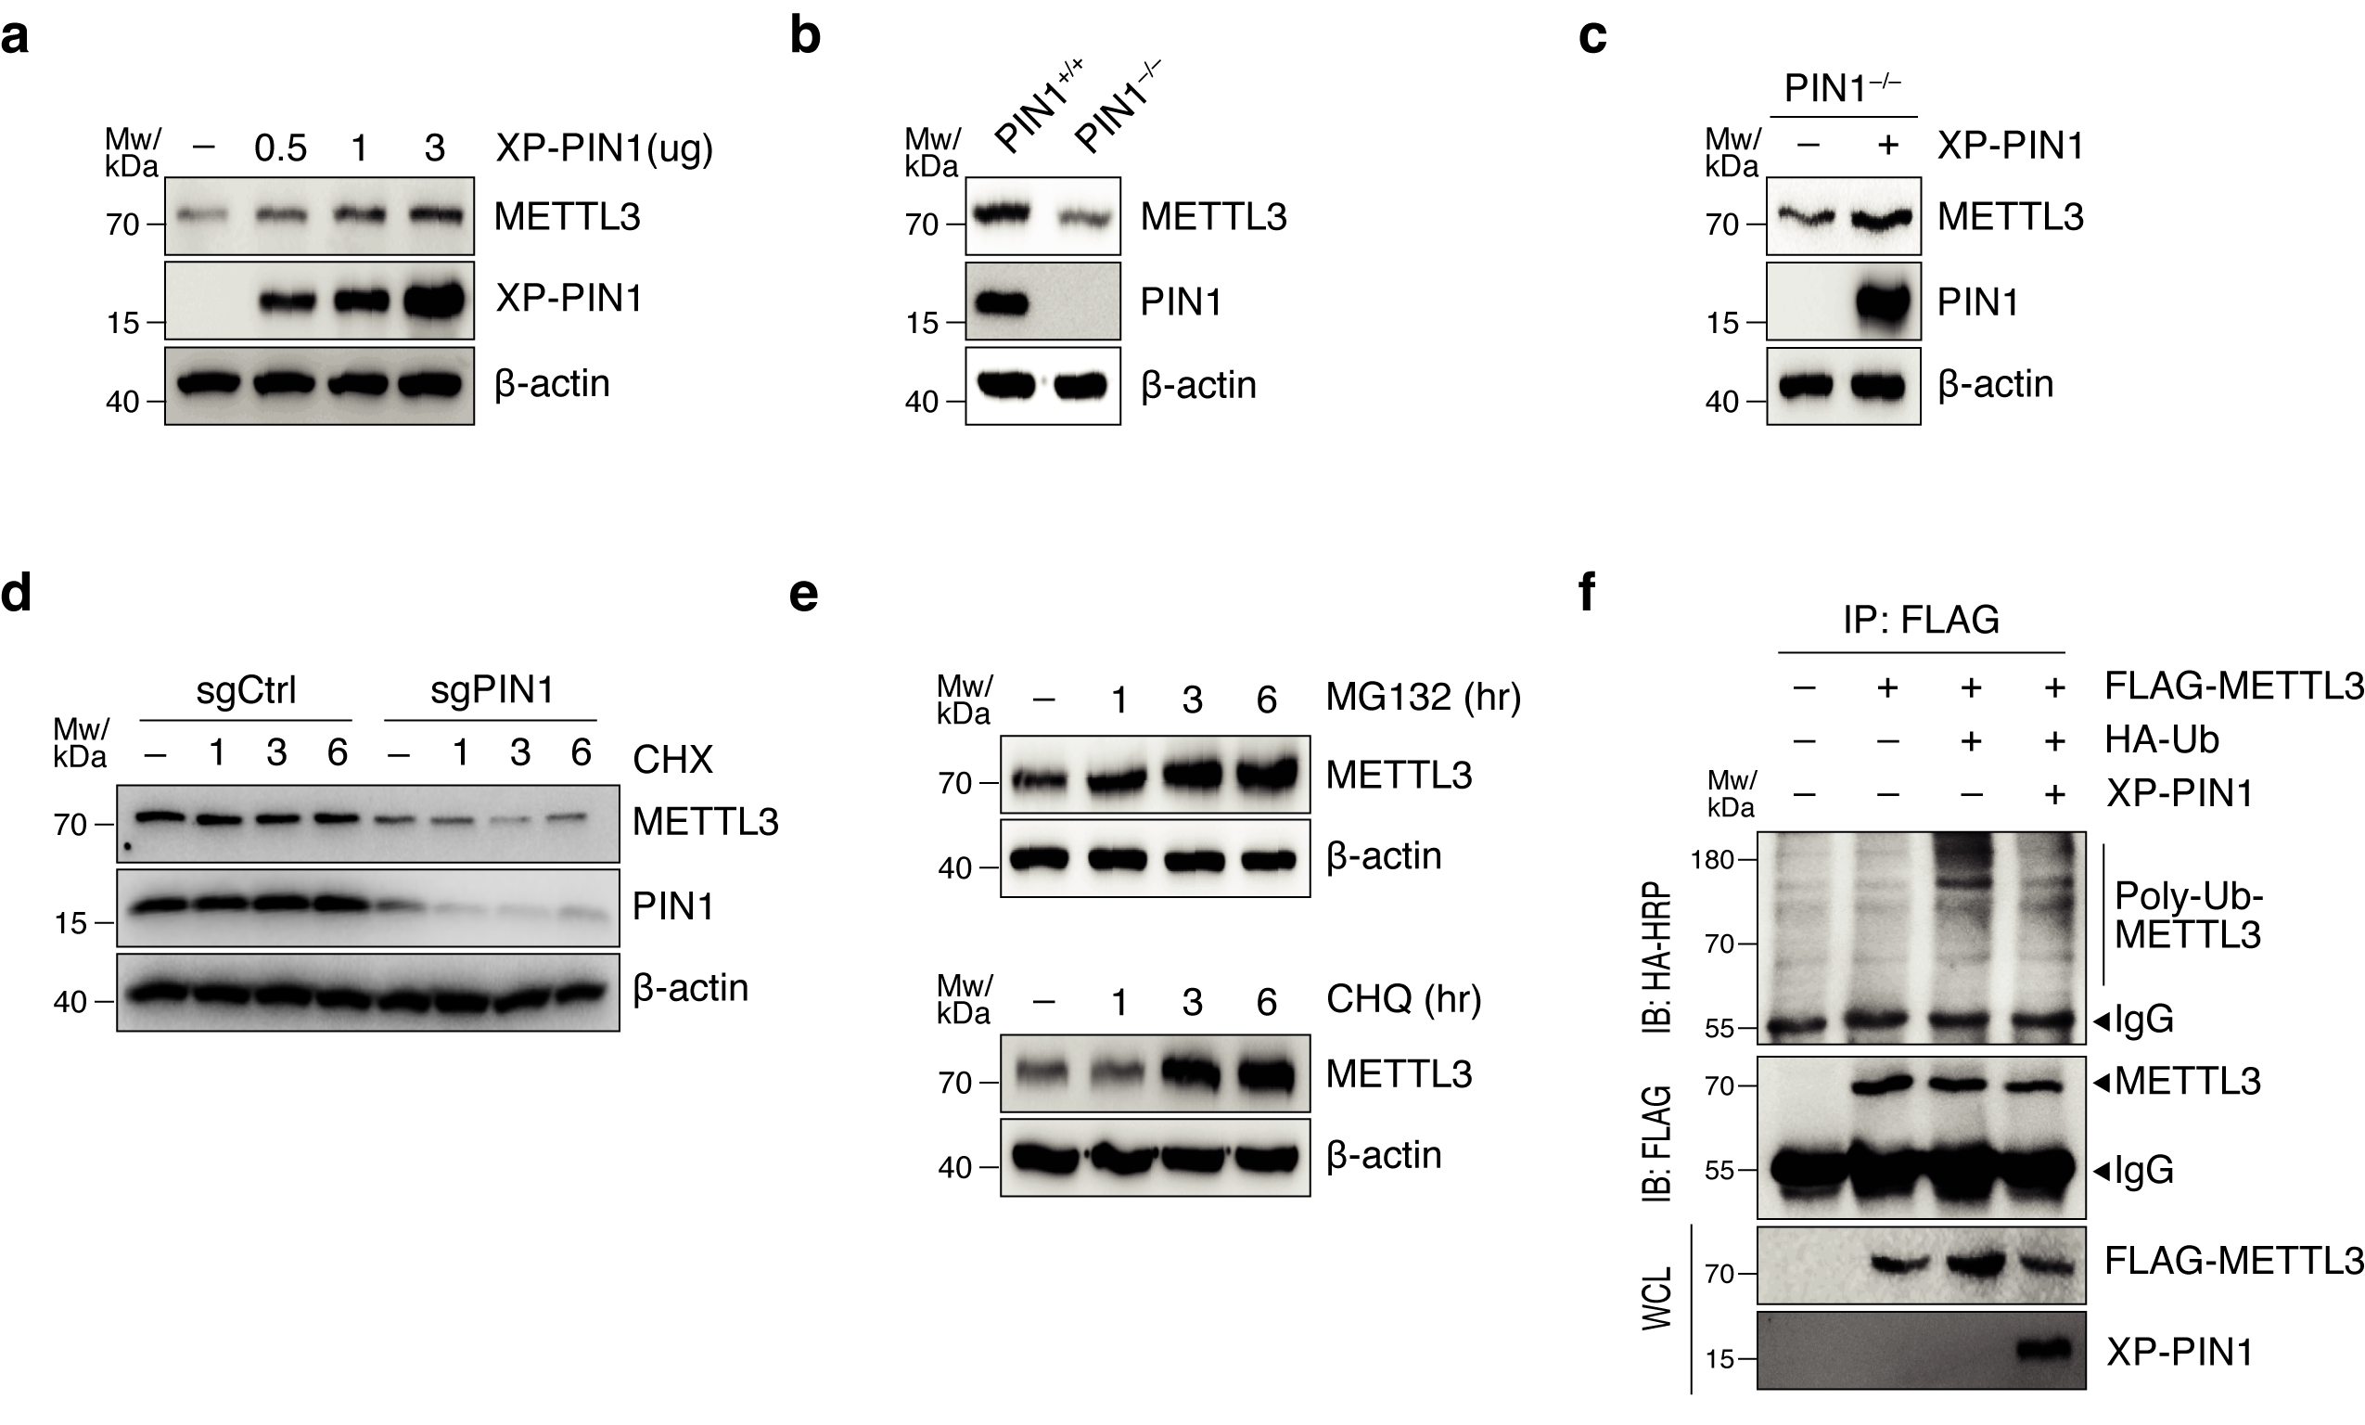

Figure S1. PIN1 increased METTL3 expression by reducing proteasomal degradation.
(a) PIN1 overexpression increased METTL3 expression. MCF7 cells were transfected with increasing amounts of XP-PIN1 plasmid followed by immunoblotting (IB) using the indicated antibodies. (b) METTL3 expression was reduced in PIN1-knockout MEF cells. IB of cell lysates from PIN1+/+ and PIN1-/- MEF was detected using the indicated antibodies. (c) Ectopic PIN1 expression in PIN1-/- MEF restored METTL3 expression. PIN1-/- MEF were transfected with human XP-PIN1, and protein expression in cell lysates was detected with IB using the indicated antibodies. (d) PIN1 knockout reduced METTL3 stability in MCF7 cells. MCF7 cells transfected with sgCtrl or sgPIN1 plasmids were treated with CHX (100 µg/mL) for the indicated times, and proteins in the cell lysates were detected by IB using the indicated antibodies. (e) METTL3 was degraded via the proteasomal- and lysosomal degradation pathways. MCF7 cells were treated with MG132 (20 µM) (upper) or chloroquine (CHQ, 100 µg/mL) (lower) for the indicated times. Protein expression in cell lysates was detected by IB using the indicated antibodies. (f) PIN1 overexpression reduced METTL3 polyubiquitination. MCF7 cells were transfected with FLAG-METTL3, HA-Ub, or XP-PIN1. The lysate was immunoprecipitated using an anti-FLAG antibody, followed by IB using an anti-HA antibody. Proteins in the lysate were detected by IB using the indicated antibodies.

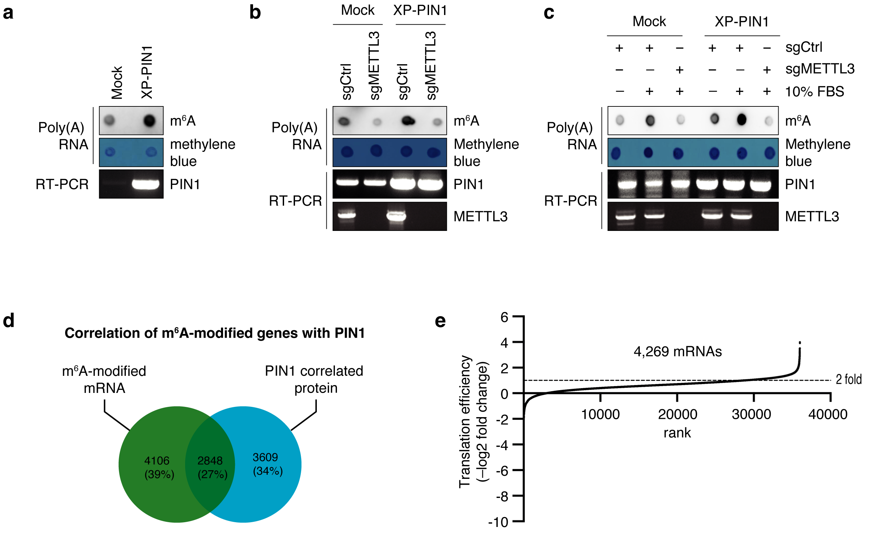

Figure S2. Examination of PIN1-regulated global m⁶A levels and potential m⁶A-modified mRNA in breast cancer cells.
(a) PIN1 overexpression increased global m⁶A levels. Dot blot of poly(A) RNA isolated from MCF7 cells using m⁶A antibody. Methylene blue was used as a loading control. (b) PIN1 increased m⁶A modification in a METTL3-dependent manner. MCF7 cells overexpressing PIN1 were transfected with sgCtrl or sgMETTL3, and m⁶A levels in poly(A) RNA were detected by dot blotting using m⁶A antibody. Methylene blue was used as a loading control. (c) PIN1 enhanced m⁶A modification induced by FBS stimulation in a METTL3-dependent manner. MCF7 cells overexpressing PIN1 were transfected with sgCtrl or sgMETTL3 and FBS-starved for 24 h, followed by treatment with 10% FBS for 30 min. The m⁶A level in poly(A) RNA was detected using anti-m⁶A antibody. Methylene blue was used as a loading control. (d-e) Screening of mRNA regulated by METTL3. Venn diagram showing mRNA containing m⁶A peaks and genes that are positively correlated with PIN1 protein expression. Data were obtained from Dominissini et al.⁵ and DepMap (d). Effect of METTL3 on translation efficiency obtained from a published dataset [4] (e). mRNAs (X-axis) were ranked according to the fold-change in translation efficiency (Y-axis). A fold change of 2 indicated that translation efficiency was reduced two-fold after METTL3 knockdown.

References

1 Bhattarai PY, Kim G, Poudel M, Lim S-C, Choi HS. METTL3 induces PLX4032 resistance in melanoma by promoting m6A-dependent EGFR translation. Cancer Letters 2021; 522: 44-56.

2 Khanal P, Yun HJ, Lim SC, Ahn SG, Yoon HE, Kang KW et al. Proyl isomerase Pin1 facilitates ubiquitin-mediated degradation of cyclin-dependent kinase 10 to induce tamoxifen resistance in breast cancer cells. Oncogene 2012; 31: 3845-3856.

3 Lin S, Choe J, Du P, Triboulet R, Gregory RI. The m(6)A Methyltransferase METTL3 Promotes Translation in Human Cancer Cells. Mol Cell 2016; 62: 335-345.

4 Choe J, Lin S, Zhang W, Liu Q, Wang L, Ramirez-Moya J et al. mRNA circularization by METTL3–eIF3h enhances translation and promotes oncogenesis. Nature 2018; 561: 556-560.

5 Shen L, Liang Z, Yu H. Dot Blot Analysis of N6-methyladenosine RNA Modification Levels. Bio-protocol 2017; 7: e2095.

6 Tsai BP, Wang X, Huang L, Waterman ML. Quantitative profiling of in vivo-assembled RNA-protein complexes using a novel integrated proteomic approach. Molecular & cellular proteomics : MCP 2011; 10: M110.007385-M007110.007385.

7 Dominissini D, Moshitch-Moshkovitz S, Salmon-Divon M, Amariglio N, Rechavi G. Transcriptome-wide mapping of N6-methyladenosine by m6A-seq based on immunocapturing and massively parallel sequencing. Nature Protocols 2013; 8: 176-189.

Table S1. Genetic correlation of PIN1 in breast cancer patients using the DAVID tool.

Table S2. Expression correlation of PIN1 with RNA methyltransferases in breast cancer patients.

Table S3. DepMap CERES dependency score of PIN1 and METTL3 in breast cancer cell lines.

Table S4. Primers used for RT-PCR and molecular cloning.

