- Introduction
Heart disease is now the top reason of death in many countries. The term "heart disease" comprises issues in heart. Coronary artery disease (CAD), the most frequent type of heart disorder in which can increase the risk. Heart disease can be "silent” heart attack or heart failure occurs [1] with no sign of symptoms. There are various types of heart diseases. Although certain overlap exists, each disease has its own symptoms and treatments [3].
Below mentioned are few types of heart diseases:
- Cardiovascular disease
- Heart defect from birth
- Arrhythmia
- Cardiomyopathy with dilated blood vessels
- Acute Myocardial Infraction
- Cardiac Arrest
- Cardiomyopathy with hypertrophy
- Prolapse of the mitral valve
- Aortic stenosis

And the factors can lead to the risk of heart disease:
- Family history of heart disease
- Consumption of Tobacco
- Low nutrition intake
- High pulse
- Cholesterol
- Hypercholesterolemia
- Fatness
- Physical lethargy

- Data Mining in Health Care

Data mining is used to identify relevant and intelligible patterns in huge volume of data, whether in healthcare or business. Certain knowledge outlines assist in the estimate of information trends and the associated decision-making process.
Data mining can be applied in the healthcare industry to minimize overheads by enhancing productivities, better patient safety in terms of carefulness, and, most considerably, more patients' lives saved [2]. Predictive treatment, customer relationship management, uncover the pattern of scam and misuse in medical sector, healthcare management, and monitoring the success of particular medications have all been demonstrated to be effective with data mining in healthcare. Every hospital collects a large amount of data about patients during their admission time and treatment time. These data will be stored in the Electronic Health Record form. From these records, data mining helps to physicians to discover the disease pattern earlier and prescribe better treatments. Data mining can help identifying the best treatment for specific diseases by comparing the causes and symptoms of diseases. Other data mining applications recommended for effective treatment associating the various side-effects of treatment and find the most effective medicine for particular diseases.
Two major data mining examples in medical filed are explained below: Measuring treatment effectiveness:
Use of healthcare data mining is evaluating health indications, reasons, and treatment options in order to regulate the best effective treatment option for a certain medical problem. For example, you can compare patients treated with different medications, choose an effective treatment strategy, and minimize costs. Consistent application of this data mining technique, on the other hand, provides standardize a treatment procedure for certain diseases, making the care and management process much faster.
- Classification Techniques
To categorize the dataset into a number of classes, the classification technique is more commonly used in the field of disease diagnostics.
Learning can be used to create a classifier model. It is used to describe a set of class labels or concepts [4]. The model is built using available data, such as classified examples. These samples include a range of characteristics. This model is created via supervised learning, with the classified instances serving as training data. The classification technique is supplied with training example and is allowed to extract specific knowledge eventually. After, classifier has been developed, the model is tested based on the accuracy of the results it provides during the testing process.
  - Logistic Regression (LR)

An approach for estimating the likelihood of a given variable is known as logistic regression. True or false is the most common binary response in logistic regression models. For classification problems, logistic regression is an effective analyzer. It is a multiclass classification statistical method that can be generalized from binary classification.

  - K-Nearest Neighbour(KNN)
This method is based on the idea that because the neighbour is adjacent in the feature set, it is more likely to be comparable to the item being categorized and so belong to the same class. The nearest neighbor algorithms works as follows,
Step 1: To implement KNN, a dataset needed. Both training data and test data must loaded in the first stage.
Step 2: Locate the nearest data point's value, i.e. K. (any integer).
Step 3: By using Euclidean or Hamming distance methods, calculate the distance between each data point in the test data.
  - Naïve Bayes (NB)
A Naïve Bayesian classification method uses the Bayes theorem for classification. It is an eager learning algorithm. Since it does not wait for test data to learn, it can classify the new instance faster. It follows the Bayes theorem is,

P (X) P (attributes | X) P (X | attributes) =
P (attributes)
`

Here, (X | attributes) → next possibility of class.
𝑃 (X) →previous possibility of class.
𝑃 (attributes | X) Probability predictor of a given class.
𝑃 (attributes) → prior possibility of predictor.
  - Support Vector Machine (SVM)
The SVM method seeks a hyper plane that distinguishes between data points in an N-dimensional space to divide the two sorts of data points, you can choose from a variety of hyper planes. The goal is to find a plane where the distance between data points from both classes is the shortest. Raising the margin distance provides some feedback, formulating new data points simpler to classify.

  - Decision Tree (DT)
A DT is a hierarchal structure where each internal nodes represents an attribute testing, each split denotes a test conclusion, and each leaf node represents a class label.

- Related Work

Data mining techniques have been used by many researchers to identify and forecast cardiac disease.
Sarath Babu et al., [2017], has worked on diagnosis of heart disease by data mining techniques. The authors selected the various data mining techniques, such as genetic,k-means,MAFIA algorithms and decision tree classification to diagnosing heart disease earlier. Genetic algorithm used to select important attributes from large number of attribute in the dataset. K-means is applied to calculate the low risk and high risk patient groups, MAFIA algorithm is used to extract the best item set from the dataset, and decision tree applied to construct the classification tree.
Anjan Nikhil Repaka et al., [2019] have worked on heart disease prediction using naïve Bayesian technique. The researchers proposed an architecture to perform the processes, includes data collection, pre-processing and applied the naïve bayesian classification method. The proposed technique is more efficient than other prevailing techniques applied before. The proposed method is gives 89.77% accuracy towards the predict heart disease.
Pratiksha Shetgaonkar et al., [2021] use of data mining techniques as a means for predicting heart disease is discussed. The authors have chosen the better and more efficient classification techniques to predict the heart diseases, such as neural network, NB and decision tree in terms of accuracy. The dataset selected 678 records with 14 attributes. Finally, conclude that accuracy with 81.83% (neural network), 85.01% (naïve Bayes), and 98.54% (decision tree).
Barbara Martins et al., [2021], has worked for cardiovascular disease prediction using data mining techniques. The researchers uses the CRISP-DM methodology to predict the outcome. Five classifiers namely Optimized Random Forest, Decision Tree and Deep Learning applied in RapidMiner and Weka software tool with split validation method and achieved accuracy 73.02%, 73.54%, 71.91%, and 71.94% respectively. And then applied defined threshold to get best result.

Proposed Methodology
Figure.5 depicts the proposed methodology for predicting the outcome of heart disease.

The research provides heart disease prediction with different data collected online. The experimentation led by two different dataset with unlike features. First dataset Framingham with 4238 records and 14 columns are used for experimentation. Another Cleveland dataset with 303 records and 13 columns. In the Framingham dataset overall rows with missing values is 582 entries; however, because this represents only 14% of the entire dataset, these rows are removed. After selection dataset, data prepared for mining with pre-processing techniques. The dataset was split into trained and test data respectively. Five Classifications such as SVM, Decision Tree, Naive Bayes, Logistic Regression and Nearest Neighbor are applied on dataset to predict the heart disease. The following table consists the attributes of the dataset.

SL No | Attributes | Meaning
1 | Gender | Male or Female
2 | Age | Patient age
3 | Current Smoker | Presently smoking or not
4 | Cigs Per Day | Average cigarettes per day
5 | BP Meds | Medicated under BP
6 | Prevalent Stroke | History of stroke
7 | Prevalent Hyp | Hypertension condition
8 | Diabetis | Diabetics
9 | Tot Chol | Blood cholesterol level
10 | Sys BP | Systolic blood pressure
11 | Dia BP | Diastolic blood pressure
12 | BMI | Body Mass Index
13 | Heart Rate | Patient Heart Beat
14 | Glucose | Blood glucose level
Table.1. Framingham data attributes

SL No. | Attributes | Meaning
1 | age | Patient age
2 | Sex | Male or Female
3 | Cpt | Type of chest pain
4 | restbp | BP in rest
5 | chol | Cholesterol level
6 | Fbs | Blood sugar level in fasting
7 | restecg | ECG in resting
8 | thalach | Maximum heart rate
9 | exang | Angina induced by exercise
10 | oldpeak | ST depression
11 | slope | ST segment
12 | Ca | Vessels
13 | thal | thalassemia
Table.2. Cleveland data attributes

- Experimentation Result and Discussion

An experiment was conducted using following techniques, such as Nearest Neighbor (KNN), and Naive Bayes (NB), Logistic Regression (LR), Support Vector Machine (SVM), Decision Tree (DT).
The aim of the study is to discover the most effective data mining methods for predicting heart disease on different dataset. An experiment was done on the heart disease dataset to find the best prediction system. Different classification techniques to see which ones provide the most accurate results for heart disease prediction. For five distinct classification algorithms, the result achieves accuracy and different metrics used to evaluate the performance.
Accuracy: The percentage of all successful predictions divide by the number of samples is used to calculate a classifier's accuracy. If the accuracy of the classifier is satisfied, it can be used on upcoming item sets for which the class label is unknown.

Number of exact likelihoods
Accuracy =
Total number of likelihoods

ROC-AUC: A ROC (Receiver Operating Characteristics) curve is a possibility curve. AUC (Area Under the Curve) is a statistical curve. ROC, on the other hand, is a measure of interpretability. It shows how the model can differentiate between classes.
Recall: The capability of a model to discover all the significant samples in a given dataset. Statistically, recall is also defined as number of correct predicted records divided by the number of correct predicted records in addition to the number of wrong predicted records.

True Positive

True Positive + False Negative
Recall =

Precision is the no of positive class forecasts that truly belong to the positive class. Mathematically, In addition to the number of false positive values, accuracy is defined as the total number of correct predicted records divided by the number of correct predicted records.

True Positive
True Positive + False Positive
Precision =

F1 score: F1-score uses the harmonic mean (HM) of a classifier's precision and recall to establish a single measure.
F1-score =
2 x Precision x Recall

Precision + Recall

Methods | Accuracy (%) | ROC_CUV | Recall | Precision | F1
Logistic Regression | 89.18 | 0.73 | 0.06 | 0.64 | 0.11
SVM | 86.14 | 0.62 | 0.02 | 0.50 | 0.04
Nearest Neighbor | 84.41 | 0.60 | 0.08 | 0.28 | 0.12
Naïve Bayes | 83.96 | 0.71 | 0.18 | 0.35 | 0.23
Decision Tree | 77.30 | 0.56 | 0.26 | 0.27 | 0.27
Table.3. Performance Evolution of Framingham dataset.

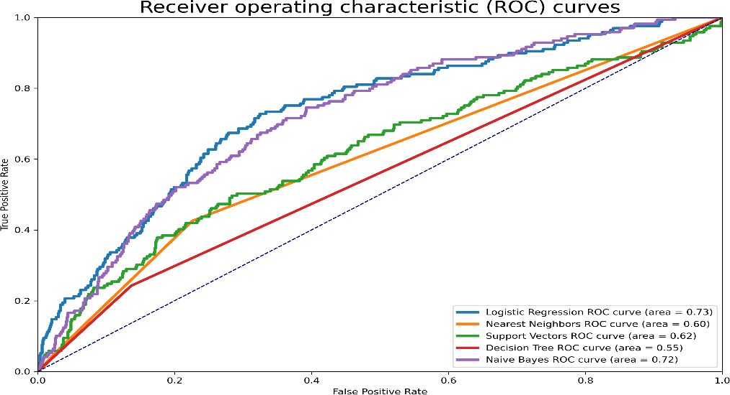
From the above table values, LR method shows the better accuracy compare to other techniques i.e., 89.18% and SVM, KNN, NB, and DT, and classification techniques are achieves the accuracy of 86.14 %, 84.41 %, 83.96 % and 77.30% respectively. SVM classifier also gives the good result after logistic regression is 86.14%, only 0.37% difference accuracy. NB also perform well after LR and SVM classifier, Decision Tree gives the least accuracy compare to other techniques i.e., 77.30%.

Figure.6. ROC curves for Framingham dataset

Methods | Accuracy (%) | ROC_CUV | Recall | Precision | F1
Logistic Regression | 90.00 | 0.94 | 0.79 | 0.94 | 0.86
Naïve Bayes | 82.00 | 0.85 | 0.82 | 0.82 | 0.82
SVM | 87.00 | 0.73 | 0.87 | 0.87 | 0.87
Nearest Neighbour | 89.00 | 0.90 | 0.88 | 0.89 | 0.88
Decision Tree | 77.00 | 0.76 | 0.77 | 0.77 | 0.77

Table.4. Performance Evolution of Cleveland dataset.

From the above table values, LR method shows the better accuracy compare to other techniques i.e., 90% and NB, DT, SVM, and, KNN and classification techniques are achieves the accuracy of 82 %, 77 %, 87 % and 89% respectively. Nearest Neighbor classifier also gives the good result after logistic regression is 89%. Decision tree gives the least accuracy compare to other techniques i.e., 77%.

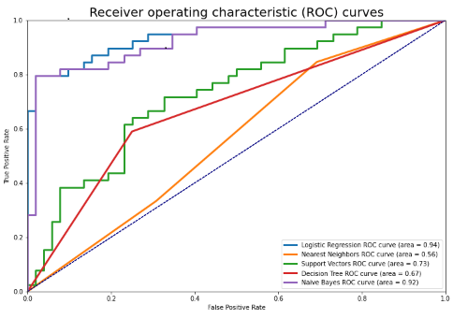

Figure.7.ROC curves for Cleveland dataset

Based on the experiment results, two dataset with different attributes performs differently through classification techniques. For both dataset LT gives the better accuracy.

Conclusion and Future Enhancement

The main focus of this study explores the application of different classifiers in healthcare especially in diagnose and prediction heart disease. Heart disease is a dangerous condition that can lead to death. Data from online cardiac patients is gathered and used to run an experiment. The following algorithms were used to implement the classification, which is a data mining technique. Logistic Regression, Decision Tree, SVM, KNN and Naive Bayes. Different performance criteria were used to evaluate the algorithms performance, including accuracy, ROC curve, Recall, precision, and F1- score.
According to the experiment, the Logistic Regression algorithm has the highest accuracy of all, at 89.18% and 90% for Framingham and Cleveland dataset with their different attributes. This study demonstrates how accurately and efficiently can be predicted for cardiac diseases with the help of data mining. The results or outcomes of these experiments could be utilized as an aid in making more consistent heart disease diagnoses. Individual procedures are not enough to get the intended result. Ensemble approaches will be used in the future to improve accuracy.
- Computer Programs
Python pandas with Anaconda 3.0 is used to perform the experimentation.
- Authors Contribution
Uma K involved in all aspects to complete the final manuscript includes, paper writing, applying classification techniques in python, and final reading and approving.

