Supporting Information

Non-thermal plasma synthesis of supported Cu-Mn-Ce mixed oxides catalyst towards highly improved catalytic performance for volatile organic compounds combustion
Chen Ye, Tingwei Fang, Xinyi Long, Hui Wang*, Shao Chen, Jie Zhou*
College of Materials and Environmental Engineering, Hangzhou dianzi University, Xiasha University Park, Hangzhou, Zhejiang 310018, China.
*Corresponding author
E-mail: wang_hui@hdu.edu.cn; jane@hdu.edu.cn

Supporting Figure Captions
Fig. S1. Diagram for the dielectric barrier discharge (DBD) reactor
Fig. S2. Experimental setup for the catalytic combustion of VOCs
Fig. S3. Cu 2p and Mn 2p XPS spectra of 10%CMC/SiO₂ and 10%CMC/SiO₂–P
Fig. S4. Catalytic activities over 15%CMC/SiO₂–P and 0.5%Pd/SiO₂ in the reaction of hexane catalytic combustion
Fig. S5. Dependencies of the discharge power on the catalytic activities over 15%CMC/SiO₂–P in the catalytic combustion of toluene

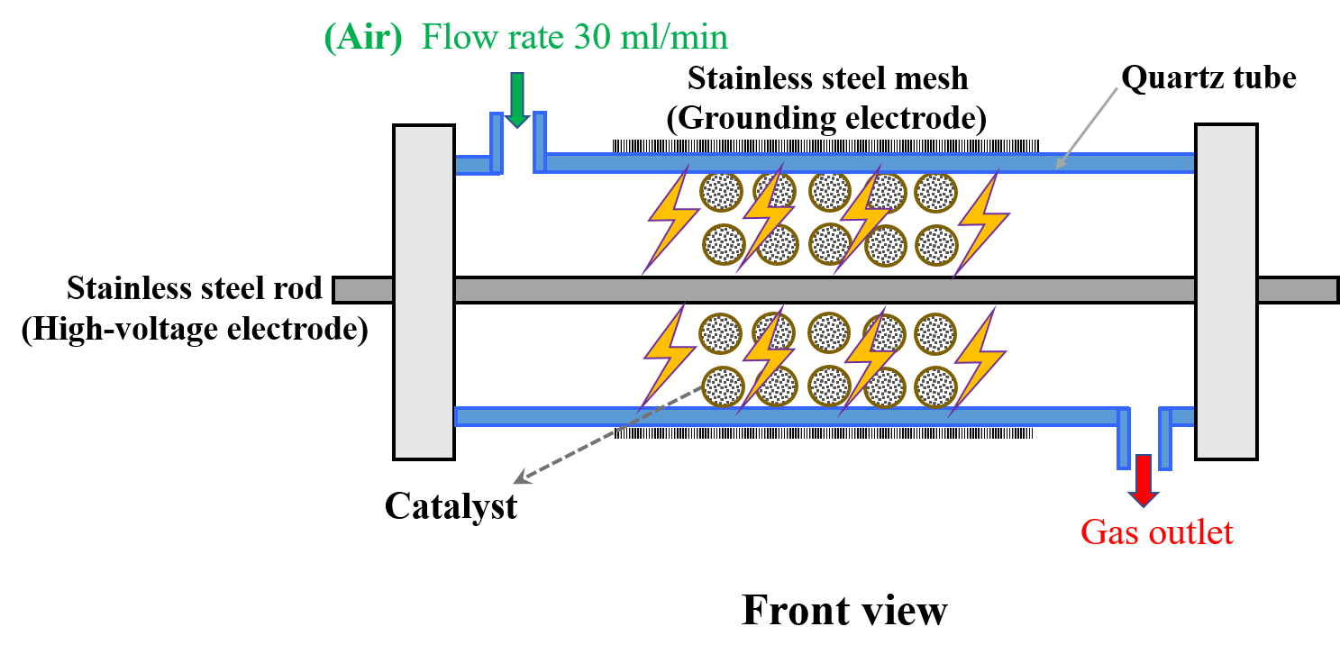
Fig. S1. Diagram for the dielectric barrier discharge (DBD) reactor

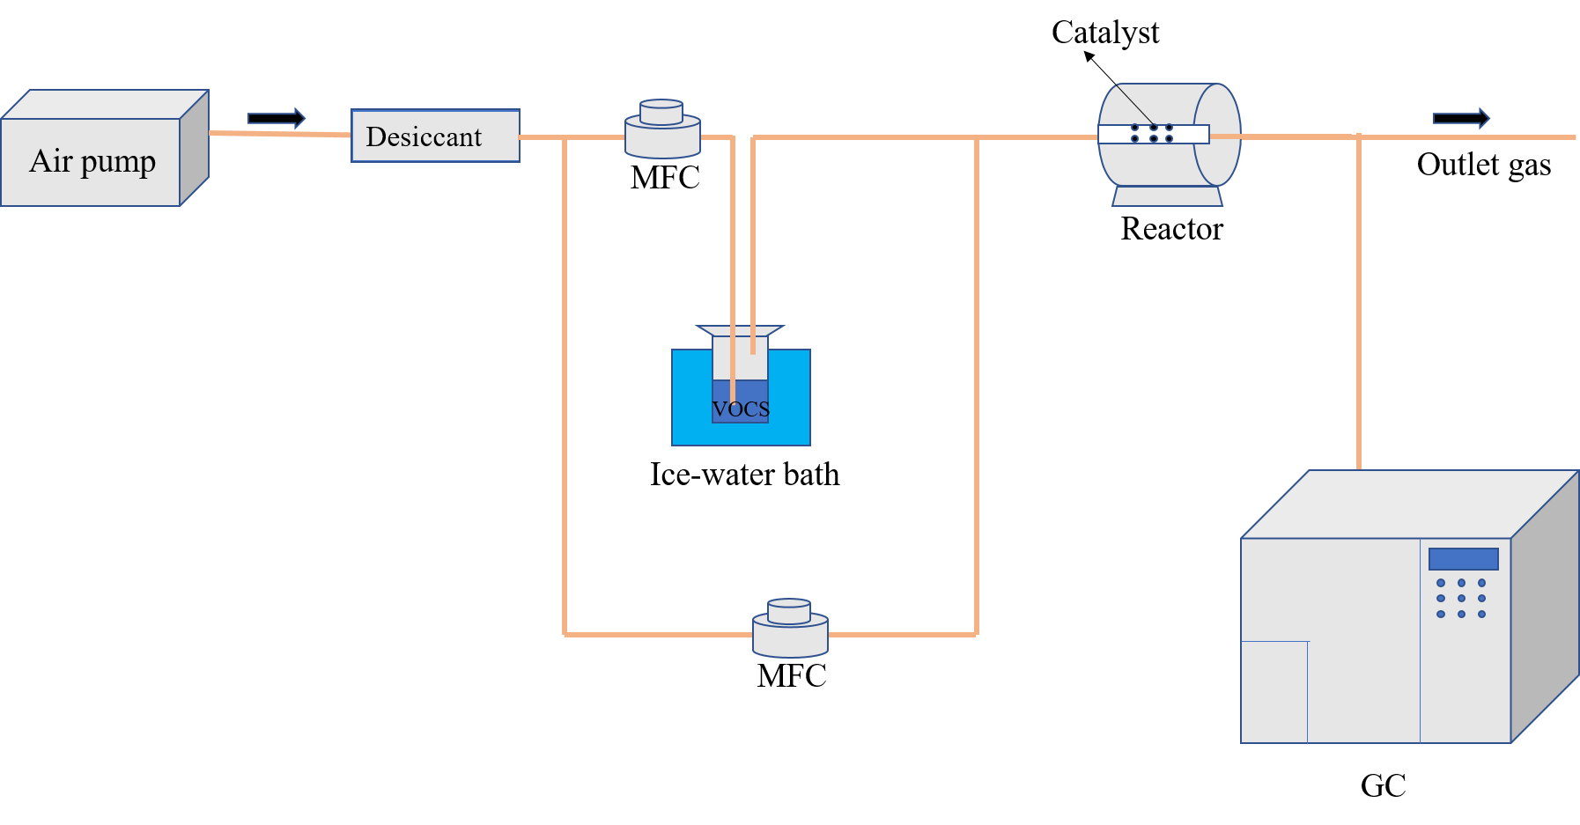
Fig. S2. Experimental setup for the catalytic combustion of VOCs

Fig. S3. Cu 2p and Mn 2p XPS spectra of 10%CMC/SiO₂ and 10%CMC/SiO₂–P

Fig. S4. Catalytic activities over 15%CMC/SiO₂–P and 0.5%Pd/SiO₂ in the reaction of hexane catalytic combustion
Fig. S5. Dependencies of the discharge power on the catalytic activities over 15%CMC/SiO₂–P in the catalytic combustion of toluene

