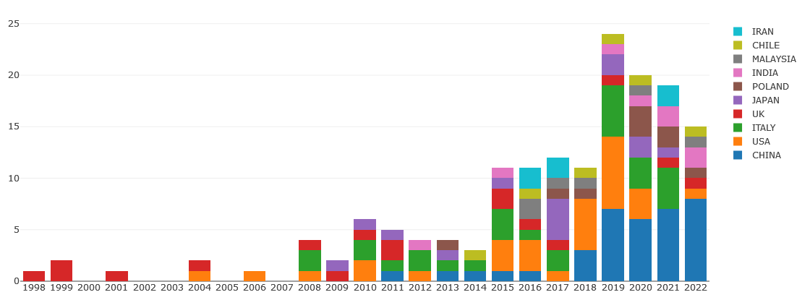
Figure S1. Global number of the published publications by countries in the field of helicobacter biofilm from 1998 to 2022.

Figure S2. Global annual cumulative number of the published publications in the field of helicobacter biofilm from 1998 to 2022.

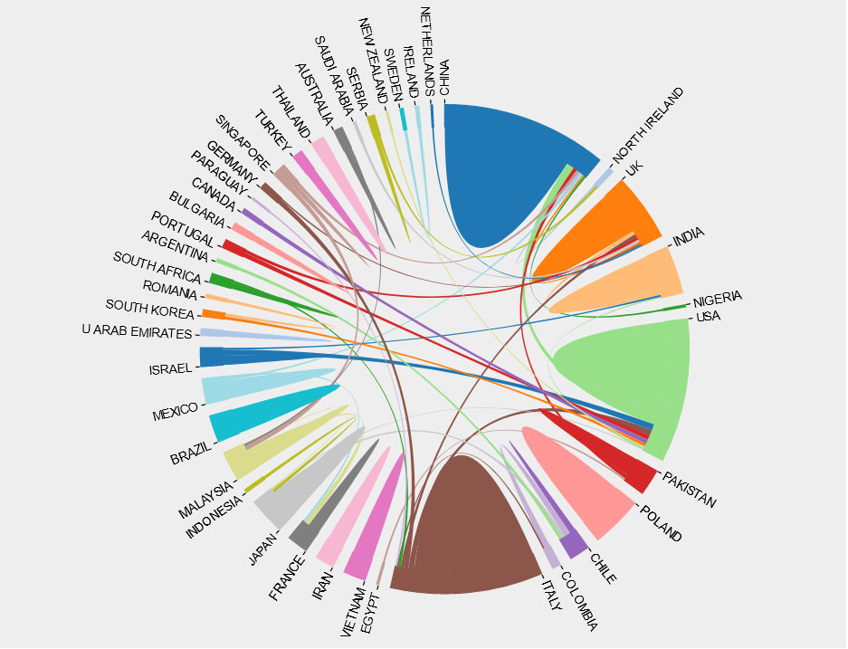
Figure S3. International collaboration between countries in the field of helicobacter biofilm. The countries were labeled using different colors and the links represented international collaborations.

