Reducing the production of Acrylamide During the Roasting of Balloon Flower Roots in Consumer Appliances and Industrial Equipment

Preliminary experiment

A preliminary survey was conducted by targeting four domestic companies in South Korea, and the ranges of roasting temperatures and times used at industrial sites were confirmed (Table S1) to determine the experimental process and conditions. The temperatures varied from 80 to 270℃, and the times varied from 5 to 60 min. Five commercial samples from four domestic companies were examined to quantitatively evaluate the content of five hazardous substances, which were acrylamide, eight polycyclic aromatic hydrocarbons (PAH8), furan, 3-chloro-1,2-propanediol (3-MCPD), and nitrosamine, in the balloon flower root analysis. Of these five hazardous substances, acrylamide was the only substance that exceeded the level considered safe, 1,000 µg/kg (Table S1). Three of the five product samples had more acrylamide than was deemed safe, and they were roasted at a temperature of 150 – 250℃. As a result, it was hypothesized that the temperature and time conditions were closely related to the acrylamide yield and that the acrylamide yield could be adjusted by controlling those two conditions.
In practice, a roasting temperature of 150℃ or higher was the upper limit for balloon flower root quality, and samples roasted for more than 15 min were considered over-roasted and tasted bitter. Moreover, the outer skin had already begun to burn before the cores of those samples were roasted. Thus, products roasted at under 150℃ and for less than 15 min were the most suitable ones for consumption.

Determination of the target manufacturing process

According to the preliminary investigation, the manufacturing process was normally divided into six steps (Fig. S1). Since acrylamide was reported to be formed by the reaction of sugar and protein during the heating process, the drying and roasting processes were initially considered as target manufacturing processes for the study. To see whether this assumption would offer accurate findings, the acrylamide yields after the drying and roasting process were measured. The acrylamide yield after the drying process was 15.2 ± 4.4 µg/kg and after the roasting process was 130.2 – 8,333.1 µg/kg. Therefore, it was judged that acrylamide was mainly generated in the roasting process rather than the drying process, and the temperature and time conditions of the roasting process were set as the variables.

Temperature profile measurements

Roasting was conducted under conditions determined through the preliminary survey, but the appearance and odor of the roasted sample varied for each device (Fig. S2 and S3) at the same set temperature. Temperature profile measurements were performed during the roasting process in the consumer appliances and industrial equipment to establish the criteria that would take into account the characteristics of the different types of equipment. The temperatures were measured by using T-type thermocouples (polytetrafluoroethylene welded-tip insulated thermocouple; wire dimension, 1/0.2 mm; insulation diameter, 0.6 mm; wire, copper/copper–nickel). Fig. S4 shows the locations at which temperatures were measured (i.e., the internal surface, internal core, and outer surface, and the room temperature). Temperature data were recorded by the data logger MX100 (Yokogawa Co., Ltd) at 2-s intervals. Measurements for each piece of equipment were carried out for 1 h at three temperatures (100, 120, and 140℃).
The mean temperature and standard deviation of the consumer appliance and the industrial equipment are shown in Table S2. The highest temperature (121.3℃) was measured on the internal surface at 140℃, and the lowest temperature (41.3℃) was measured on the outer surface at 100℃ in a consumer appliance. In addition, when the set temperature was 100℃, the internal surface temperature was 84.6℃, the internal core temperature was 81.1℃, and the outer surface temperature was 41.3℃. The experiments showed that the internal surface temperature deviation was smaller than that of the internal core or outer surface, where the set temperatures were 100, 120, and 140℃.
When the set temperature of the industrial equipment was 140℃, the temperature of the outer surface (141.8℃) was higher than any other temperature with the industrial equipment. On the other hand, the lowest temperature recorded was 75.2℃ when the internal surface temperature was measured at 100℃. The experimental results showed that the deviation of the internal core temperature was smaller than the deviation of the internal surface or outer surface temperature with a set temperature of 100, 120, and 140℃.
These measurements revealed an average temperature difference of up to 82.6℃ in outer surface temperature between different types of roasting equipment, and these differences were similar to those of other spots’ temperatures. In addition, it was confirmed that balloon flower roots burned when the internal surface temperature of the consumer appliance or the internal core temperature of the industrial equipment was 150℃ or higher. Therefore, it was confirmed that the amount of heat energy transferred to the sample varied by type of equipment even at the same set temperature. Consequently, it was necessary to set a reference temperature suitable for the particulars of the equipment.

Tables

Table S1. 5 Hazardous Substance Content and Roasting Conditions of Commercial Samples

Sample | Temperature  (℃) | Time  (min) | Acrylamide  (µg/kg) | PAH8  (µg/kg) | Furan  (µg/kg) | 3-MCPD  (µg/kg) | Nitrosamine  (µg/kg)
A | 80 to 120 | 10 to 60 | 130.2 | 2.7 | 3.1 | 124.4 $±$ 22.8 | 5.64 $±$ 0.23
B | 150 | 20 | 394.4 | 3.5 | 9.1 | N.D. | 0.87 $±$ 0.18
C | 230 to 250 | 12 | 1,125.2 | 4.1 | 16.1 | N.D. | 1.04 $±$ 0.12
D | 250 to 270 | 7 | 4,131.5 | 17.4 | 51.5 | N.D. | 0.76 $±$ 0.05
E | 150 to 200 | 5 | 8,333.1 | 3.2 | 40.2 | N.D. | 1.38 $±$ 0.05
N.D., not determined.

Table S2. Mean Temperature and Standard Deviation at Different Locations of Consumer Appliance and Industrial Equipment

Set temperature (℃) | Equipment | Temperature (℃) at different locations
Set temperature (℃) | Equipment | Internal surface | Internal core | Outer surface | Room
100 | Consumer appliance | 84.6 $±$ 5.8 | 81.1 $±$ 6.6 | 41.3 $±$ 2.4 | 24.6 $±$ 0.3
100 | Industrial equipment | 75.2 $±$ 4.5 | 82.7 $±$ 5.7 | 93.8 $±$ 7.1 | 23.7 $±$ 0.8
120 | Consumer appliance | 96.1 $±$ 6.2 | 90.4 $±$ 7.1 | 48.8 $±$ 4.1 | 24.4 $±$ 0.8
120 | Industrial equipment | 94.5 $±$ 7.1 | 104.2 $±$ 7.9 | 118.1 $±$ 9.4 | 24.6 $±$ 1.1
140 | Consumer appliance | 121.3 $±$ 7.1 | 118.3 $±$ 7.6 | 59.2 $±$ 5.1 | 24.9 $±$ 0.7
140 | Industrial equipment | 117.0 $±$ 8.8 | 128.1 $±$ 6.3 | 141.8 $±$ 10.1 | 25.7 $±$ 1.8

Figures
Selection
Washing
Drying
Cutting
Grinding
Roasting

Fig. S1 Manufacturing process of balloon flower tea

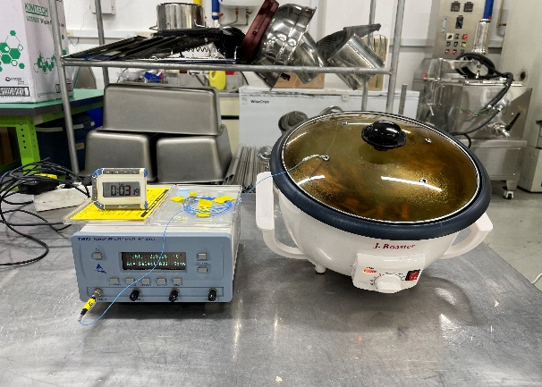
Fig. S2 Consumer appliance

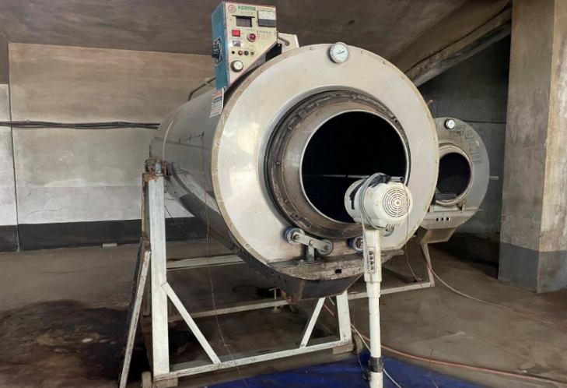
Fig. S3 Industrial equipment

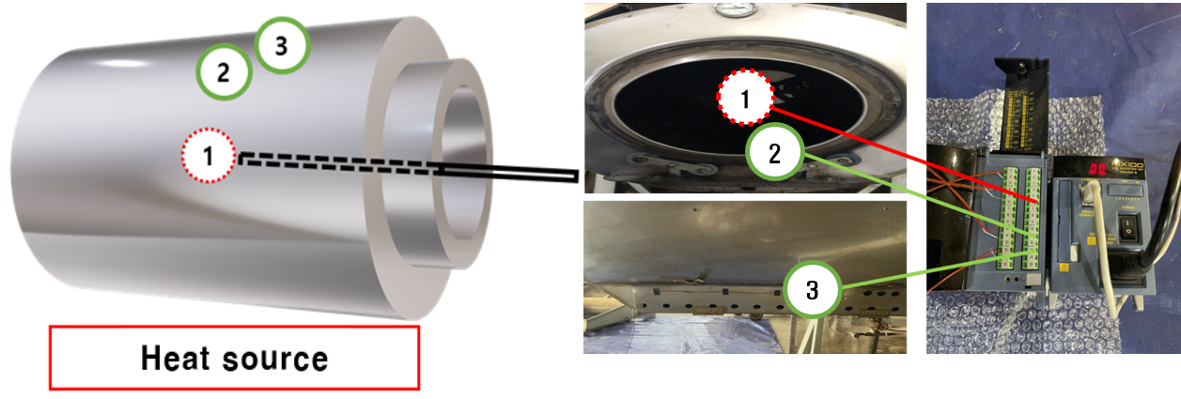
Fig. S4 Schematic overview of temperature measurement for industrial equipment
Site 1 represents internal core, site 2 represents internal surface, and site 3 represents outer surface.

