Supplementary as they contain Supplementary of main manuscript
Exceptionally well-preserved crocodilian coprolites from the Late Eocene of Northern Vietnam (Na Duong Formation) and their coproecological implications

Kazım Halaçlar, Paul Rummy, Jia Liu, Adrian P. Hunt, Truong Van Do, Minh Trung Nguyen, Tao Deng
Supplementary Table 1 Past studies on purported/possible crocodilian coprolites in history (modified from Hunt and Lucas, 2010).
Identification of Coprolite Producer | Age | Location | References | Notes
Possibly crocodilian | Early Cretaceous | Belgium | Bertrand (1903); Abel (1935)
Crocodylomorphs | Early Cretaceous | Tunisia | Dridi (2022)
Crocodilian | Early Cretaceous | France | Rozada et al. (2020)
Crocodylomorph | Late Cretaceous | Brazil | Souto (2010)
Crocodilian | Late Cretaceous | Canada | Waldman (1970) | Fisher (1981) doubts crocodilian origin
Mariliasuchus amarali | Late Cretaceous | Brazil | Nobre et al. (2008)
Deinosuchus rugosus, Borealosuchus | Late Cretaceous | USA | Schwimmer (2002); Harrell and Schwimmer (2010) | Hunt and Lucas (2010) consider the putative Deinosuchus coprolites to be concretions
Crocodylomorphs | Late Cretaceous | Brazil | De Oliveira et al. (2021)
Pseudosuchia | Late Triassic | Greenland | Milàn et al. (2021)
Leidyosuchus formidabilis | Paleocene | USA | Sawyer (1981)
Asiatosuchus nanlingensis | Paleocene | China | Young (1964)
Eoalligator chuyii | Paleocene | China | Young (1964)
Crocodilian | Paleocene | USA | Sawyer (1988)
Crocodile | Paleocene | Denmark | Milàn (2010)
Crocodilian | Upper Paleocene | USA | Godfrey et al. (2020)
Crocodilian | Eocene | Argentina | Krause and Piña (2012)
Crocodile gastrointestinal contents or coprolites | Eocene | Germany | Walther and Weigelt (1932); Fikentscher (1933); Numberger (1933, 1934); Voigt (1934)
Crocodilian | Eocene | USA | Jepsen (1963) | Fisher (1981) doubts crocodilian origin
Crocodilian (?) | Eocene | France | Robert (1832-1833)
Crocodilian | Early Eocene | USA | Hunt et al. (2012)
Crocodilian | Oligocene | Denmark | Milàn et al. (2018)
Possibly crocodile or large fish | Miocene | USA | Wetmore (1943); Davis and Briggs (1995) | Contains feather. Fisher (1981) doubts crocodilian origin and suggests it may not be crocodile at all
Crocodilian | Miocene | USA | Stirton (1959)
Crocodilian | Miocene | Czech Republic | Mikulas and Dvorak (2010)
Crocodilian | Late Miocene | Venezuela | Dentzien-Dias et al. (2017)
Crocodilian | Plio-Pleistocene | Ethiopia | Butzer (1971)
Crocodylus niloticus | Mid Holocene | Sahara region | De Smet (1998)

Supplementary Table 2 List of all the well-preserved coprolites collected from the Na Duong Formation in Northern Vietnam. Their length and width are measured.

Specimen Number (IVPP V 27941/) | Length | WMAX | Wsec | Variation
1 | 102.15 | 44.11 | 18 | A
2 | 79.82 | 32.7 | 19.79 | A
3 | 103.22 | 38.68 | 19.4 | A
4 | 79.75 | 36.73 | 20.1 | A
5 | 109.33 | 47.14 | 27.54 | A
6 | 59.4 | 31.35 | 21.78 | A
7 | 111.67 | 45.05 | 27.41 | A
8 | 65.95 | 29.37 | 15.57 | A
9 | 97.82 | 37.08 | 18.29 | A
10 | 80.98 | 33.81 | 20.09 | A
11 | 88.79 | 38.03 | 26.53 | A
12 | 74.75 | 33.4 | 18.03 | A
13 | 81.1 | 39.61 | 19.35 | A
14 | 80.72 | 32.29 | 26.77 | A
15 | 92.76 | 36.53 | 22.61 | A
16 | 62.94 | 35.2 | 23.27 | A
17 | 72.28 | 34.6 | 22.94 | A
18 | 78.93 | 46.01 | 28.58 | A
19 | 92.29 | 30.64 | 22.14 | A
20 | 89.87 | 29.88 | 25.29 | A
21 | 105.21 | 46.61 | 38.41 | A
22 | 99.76 | 54.51 | 35.02 | A
23 | 102.56 | 51.88 | 35.22 | A
24 | 72.1 | 38.5 | 25.65 | A
25 | 104.31 | 40.22 | 31.82 | A
26 | 84.31 | 40.58 | 30.36 | A
27 | 145.24 | 34.6 | 23.41 | A
28 | 46.24 | 34.6 | 23.41 | A
29 | 33.38 | 15.17 | 11.1 | A
30 | 83.02 | 37.77 | 33.23 | A
31 | 79.79 | 45.28 | 22.71 | A
32 | 111.05 | 40.58 | 18.84 | A
33 | 114.33 | 35.73 | 23.76 | A
34 | 113.95 | 44.05 | 23.78 | A
35 | 106 | 47 | 21 | A
36 | 98.39 | 44.45 | 40.52 | B
37 | 82.67 | 49.83 | 36.26 | B
38 | 109.5 | 45.51 | 34.58 | B
39 | 94.43 | 44.68 | 44.12 | C
40 | 77.93 | 47.36 | 34.64 | C
41 | 97.32 | 51.55 | 42.16 | C
42 | 57.82 | 42.4 | 33.73 | C
43 | 92.51 | 47.16 | 41.43 | C
44 | 120.49 | 63.46 | 45.08 | D
45 | 116.81 | 64.83 | 43.03 | D
46 (Holotype) | 144.29 | 64.28 | 35.54 | D
47 | 201.69 | 58.33 | 41.7 | D
48 | 63.58 | 30.39 | 20.43 | U
49 | 121.28 | 26.83 | 25.24 | U
50 | 68.48 | 41.06 | 30.28 | U
51 | 65.74 | 44.72 | 17.98 | U
52 | 72.86 | 41.16 | 37.77 | U
53 | 69.81 | 52.02 | 24.31 | U
54 | 80.42 | 58.34 | 27.28 | U
55 | 77.51 | 60.69 | 24.92 | U

Supplementary Table 3 Ichno-variations of Crococopros naduongensis ichnogen. et ichnosp. nov. as to their morphologies. Number of specimens for each variation correlated to their longitudinal and transverse views. Abbreviation as indicated in text.

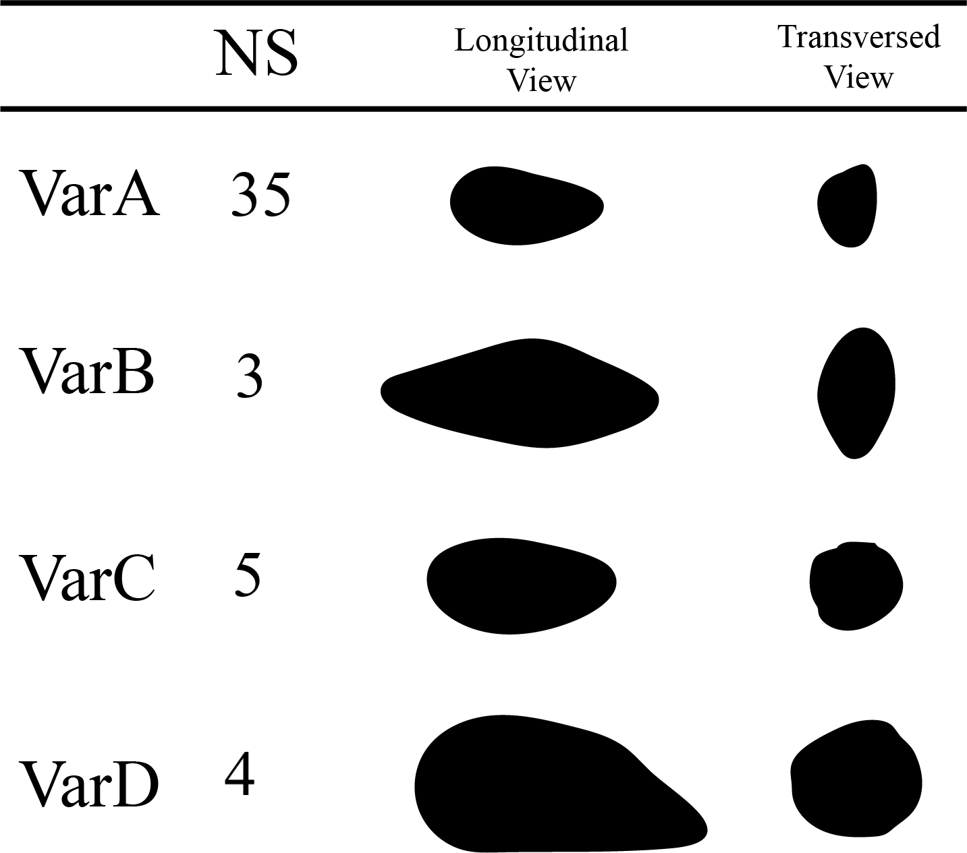

Supplementary Table 4 Possible matching between variations of Crococopros naduongensis ichnogen. et ichnosp. nov. and morphotypes of Na Duong crocodilians. Diagram indicates two possible matches without any gavialoid type. Abbreviation: BL – Body length; ND – Na Duong coal mine.

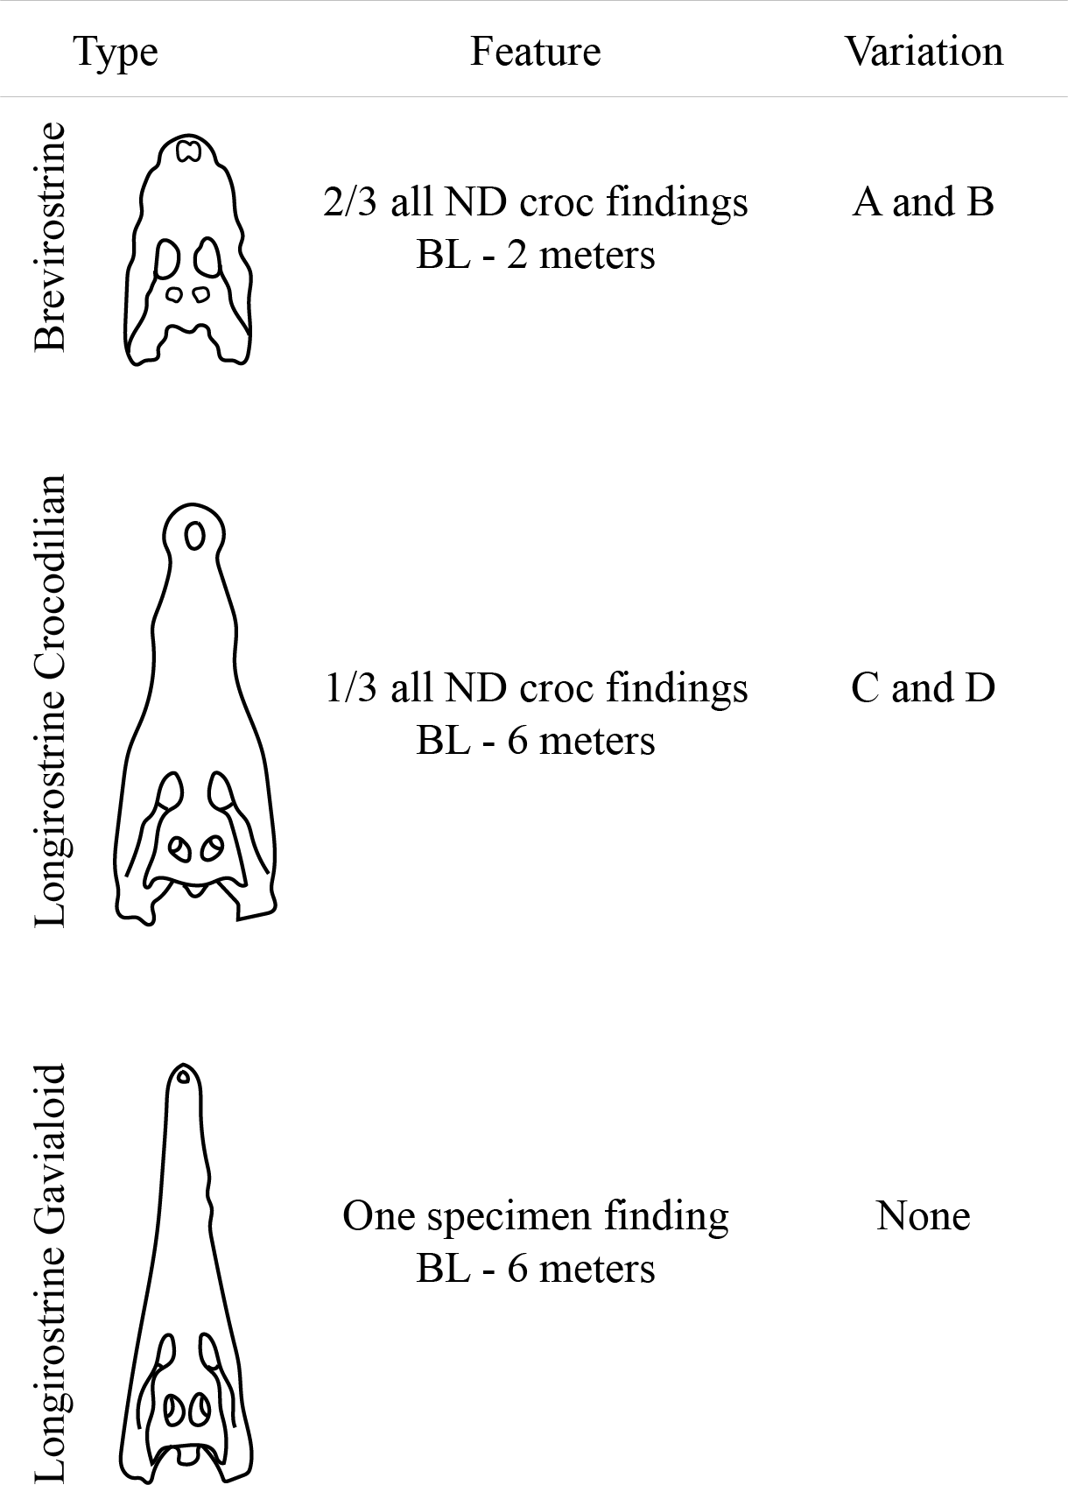

Supplementary Table 5 Variations of Crococopros naduongensis ichnogen. et ichnosp. nov. coprolites.
Variation | Number of Specimen | Average Length | Max length | Min length | Average Wmax | Max Wmax | Min Wmac | Average Wsec | Max Wsec | Min Wsec
 | 55 | 98 | 201 | 33 | 47.6 | 64 | 15 | 33.4 | 45 | 11
A | 35 | 88.7 | 145 | 33 | 38.2 | 54.5 | 15 | 24 | 38.5 | 11
B | 3 | 96 | 109.5 | 82.6 | 46.5 | 49.8 | 44.4 | 37 | 40.5 | 34.5
C | 5 | 84 | 97 | 57.8 | 46.6 | 51.5 | 42.4 | 39 | 44 | 33.7
D | 4 | 145 | 201 | 116 | 62.7 | 64 | 58 | 41 | 45 | 35.5
Uncategorized | 8 | 77 | 121 | 63 | 44 | 60 | 26 | 26 | 37 | 18

Supplementary Table 6 SEM images and EDS analyses of Na Duong coal mine sediment and Crococopros naduongensis ichnogen. et ichnosp. nov. specimens. Abbreviations as indicated in the text.
Sample number | Element compositions | SEM images | Elemental graphs
Na Duong sediment | C, K, O, Fe, Na, Al, Si, S, K | 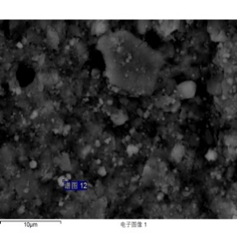 | 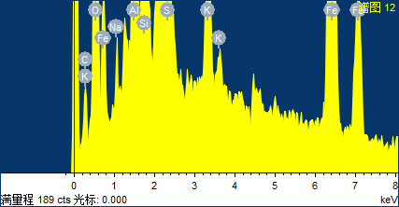
IVPP V 27941/3 | C, Ca, P | 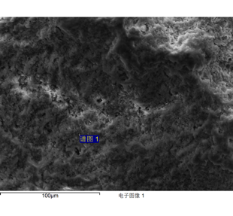 | 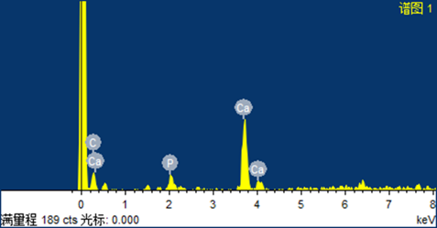
IVPP V 27941/45 | C, Ca, P, Fe | 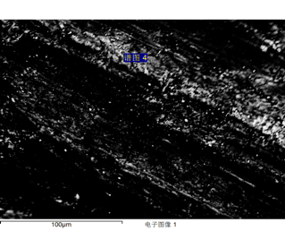 | 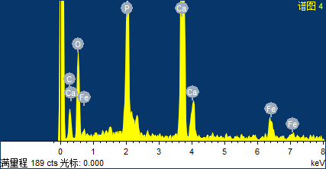
IVPP V 27941/49 | C, Ca, P, Fe | 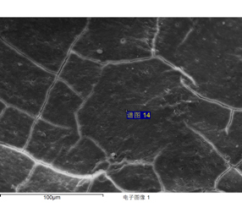 | 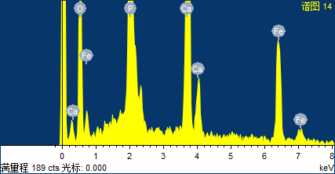

Supplementary Table 7 A list of common palynomorphs retrieved from palynology analysis on Crococopros naduongensis ichnogen. et ichnosp. nov. specimens and their surrounding rocks in Na Duong coal mine.
 | Palynomorph types
Gymnosperm | Abietineaepollenites sp., Ephedripites sp., Pinuspollenites sp., Podocarpidites sp., Taxodiaceaepollenites hiatus
Angiosperm | Aceripollenites sp., Alangiopollis sp., Alnipollenites sp., Alnipollenites verus, Arecaceae-type, Betulaepollenites plicoides, Betulaepollenites sp., Boehlensipollis sp., Carpinipites sp., Caryapollenites granulatus, Caryapollenites polarannulus, Celtispollenites sp., Coriaripites minor, Cornaceoipollenites sp., Cupanieidites sp., Cupuliferoipollenites oviformis, Cupuliferoipollenites pusillus, Cyrillaceaepollenites sp., Engelhardtioidites sp., Euphorbiacites sp., Faguspollenites sp., Ficus-type, Fraxinoipollenites sp., Fupingopollenites imbecillus, Fupingopollenites sp., Haloragacidites sp., Ilexpollenites sp., Juglanspollenites sp., Lemna-type, Liquidambarpollenites sp., Magnolipollis sp., Meliaceoidites sp., Momipites sp., Monocolpopollenites sp., Moraceoipollenites sp., Myricipites sp., Nothopollenites sp., Nymphaeacidites sp., Oleoidearumpollenites sp., Operculumpollis operculatus, Ostryoipollenites sp., Persicarioipollis communis, Persicarioipollis welzowensis, Platycaryapollenites sp., Polycolpites sp., Potamogetonacidites sp., Pterocaryapollenites sp., Quercoidites sp., Ranunculacidites sp., Retitricolpites alveolatus, Retitricolpites sp., Rhoipites sp., Rutaceoipollenites sp., Rutaceoipollis sp., Salixipollenites sp., Sapotaceoidaepollenites sp., Shorea-type, Sparganiaceaepollenits sparganioides, Striacolporites sp., Tricolpites sp., Tricolpopollenites megagranulatus, Tricolpopollenites psilatus, Tricolpopollenites sp., Ulmipollenites sp., Ulmoideipites sp., Zelkovaepollenites sp.
Fern | Deltoidospora sp., Osmundacidites microquintus, Polypodiaceaesporites sp.
Algae | Pediastrum sp. (aff. Pediastrum simplex var. sturmii), Multispinula sp.

Supplementary Table 8 Paleogeography comparisons between Eocene localities of crocodilian coprolites.

Locality\Factors | Age | Coprolite morphology | Coprolite Inclusion | Coprolite geochemical | Coprolite Palynology | Coprolite Cysts | climate | environment | Paleoecology | Fauna | Flora | References
Na Duong | Late Eocene early Oligocene | circular cross section, tapered and flattened ends, CCM | no inclusion | P, C, Ca | 5 of gymnosperms, 66 of angiosperms, 3 of ferns, and 2 of algae | no | tropical/ subtropical paleoclimates | a freshwater basin with standing or slowly flowing water, under humid climatic conditions, without any dry condition | wet forest swamp combining the swamp, lake-margin, and lacustrine facies association | 6 taxa turtles, 3 crocs morphotypes | Megaflora, decidius oak and shorea | This work.  Bohme et al. 2013, Wysocka et al. 2020
Viborg Formation | Late Eocene early Oligocene | tapering towards the ends, circular CS, CCM150 | no inclusion | NA | NA | dinoflagellate cysts | warm-temperate to subtropical. | The Viborg Formation was deposited in a relatively deep marine environment (> 300 m of water) at a minimum of 150 km from the shoreline. | Spit systems and barrier–lagoon complexes formed in between the major delta lobes. The coastline was dominated by mangrove swamp, and on elevated areas in the hinterland sequoia and oaks vegetated the landscape. | Cetacea and sharks | no | Milan et al. 2018
Zaysan Basin | late Eocene | rounded ends and cylindrical CS | no inclusion | NA | NA | NA | warm-temperate to subtropical? | Lacustrine and/or lacustrine margin deposits | old shoreline or beach of paleo-lake | ostracods, unionid bivalves, non-marine gastropods, freshwater fishes, turtles, mammals, and Crocodilian. | megaflora, charophytes, | Lucas et al. 2012
Nanxiong Localities  (L4 L5) | Late Eocene | Slightly flatted and curved with more or less distinct tapered ends | no inclusion | P2O5 (%11.35) | NA | NA | ? | ? | ? | 2 types of crocs | ? | Young 1964
Pico Salamanca (Las flores formation) | Late Paleocene early Eocene | fusiform and six have a subcylindrical shape. Transverse sections show sub-circular to sub-elliptical shapes | no inclusion | O, Ca, P, C, Si | NA | NA | tropical/ subtropical paleoclimates | The sections were deposited within a fluvial mixed-load system | alluvial plain with meandering channels and broad floodplains | no crocs but central Patagonia has two types | non | Krause and Pina 2012

*References were included in the main article.

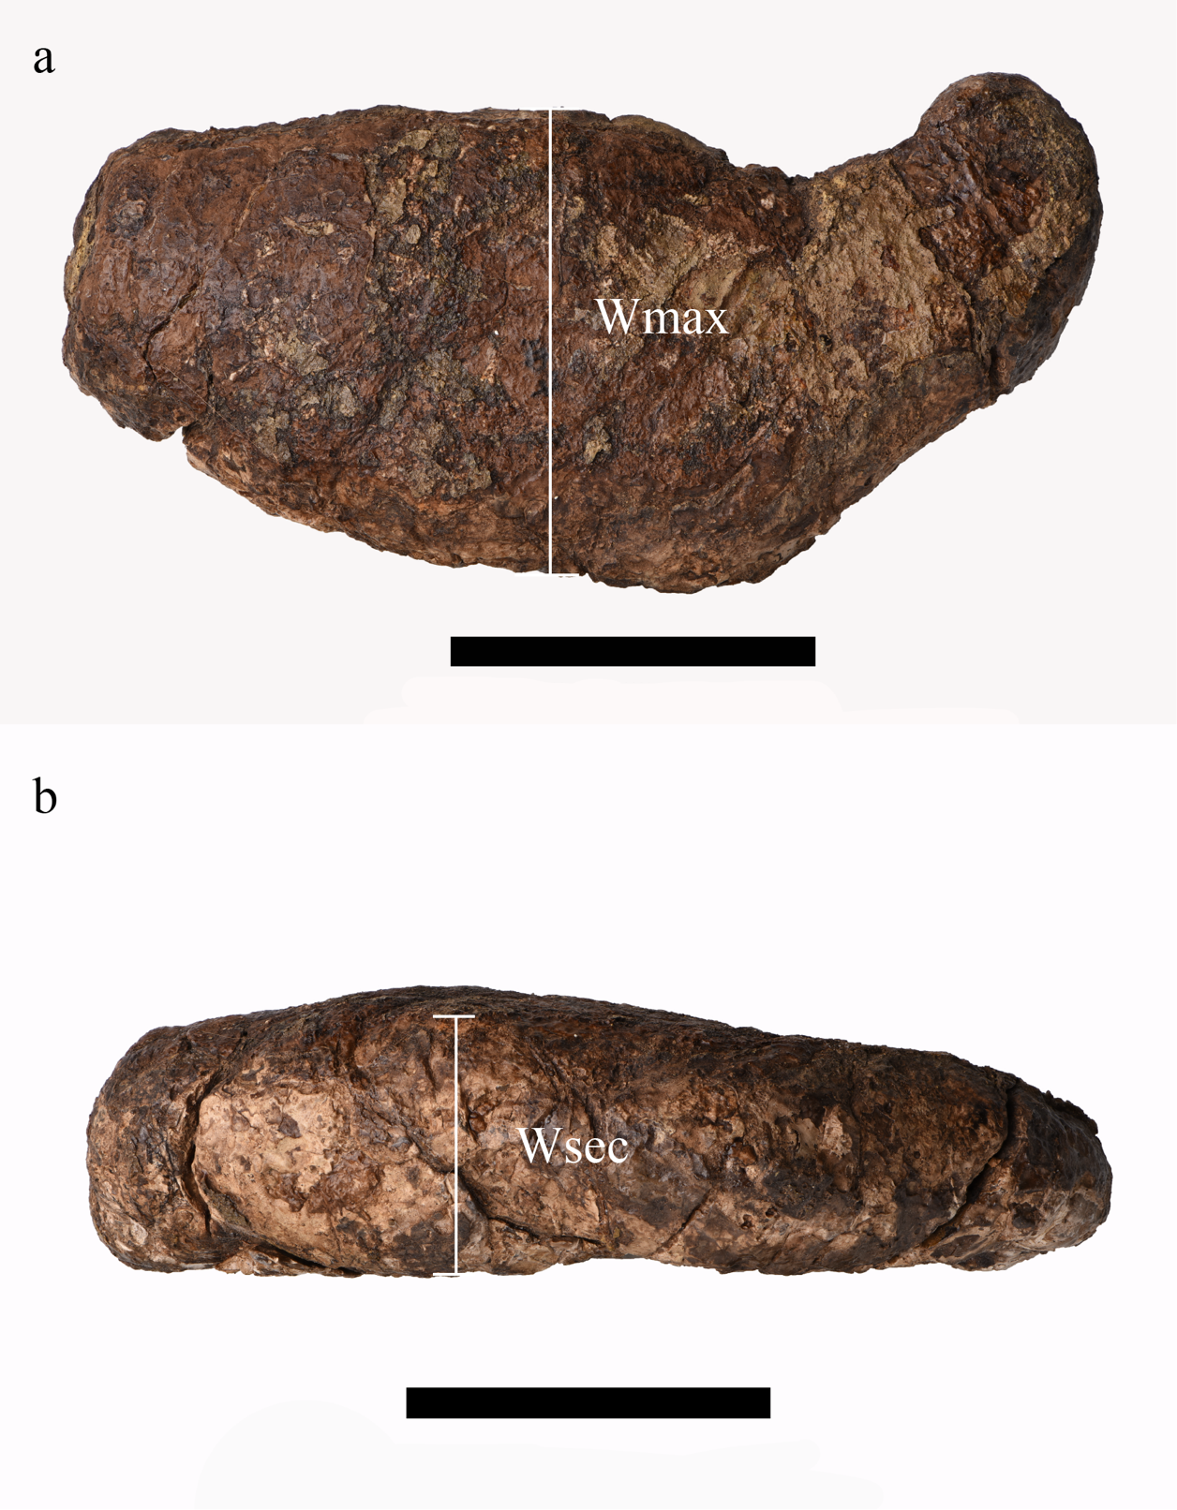
Supplementary Figure 1 Two width measurement methods were used. a, one at the widest diameter and another; b, at 90 degrees to the first width. Scale bar equals 5 cm.

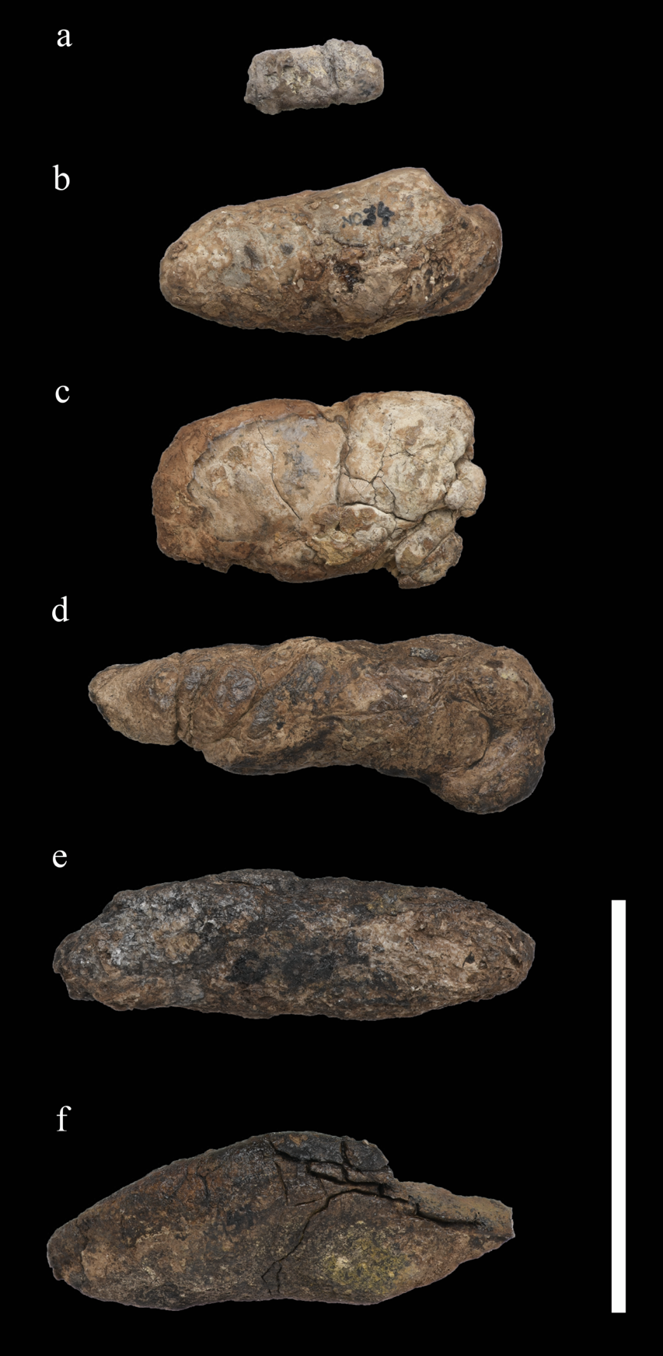

Supplementary Figure 2 Variation A Crococopros naduongensis ichnogen. et ichnosp. nov. (Plate 4-Dorsal). a, IVPP-V-27941/29; b, IVPP-V-27941/30; c, IVPP-V-27941/31; d, IVPP-V-27941/32; e, IVPP-V-27941/33; f, IVPP-V-27941/34. Scale bar equals 10 cm.

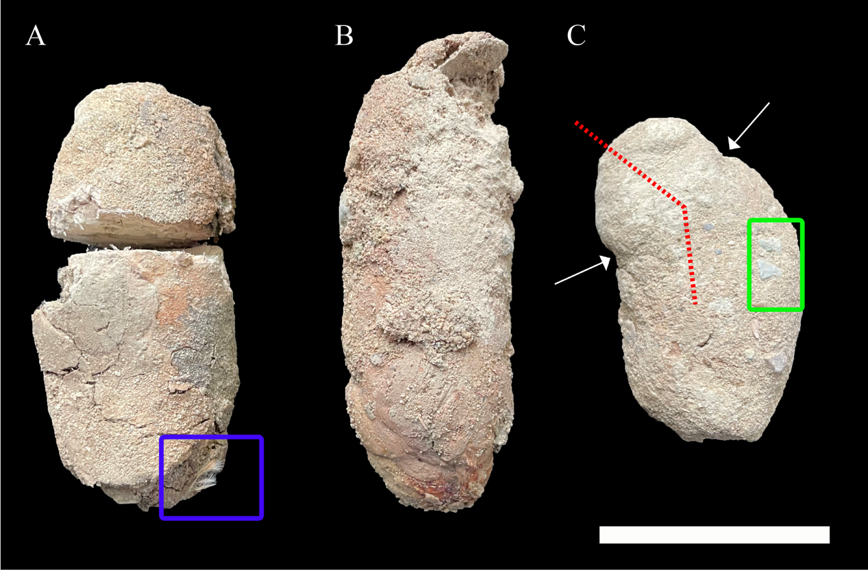
Supplementary Figure 3. Extant Crocodylus siamensis feces from Charoen Pokphand (CP) Group Crocodile Farm. Shape and size of three Crocodylus siamensis feces are almost identical. a, blue box indicate traces of feathers; b, sand particles adhere to the fresh feces; and c, green box indicate pebbles which could represent gastroliths, red broken line and arrows show circumferential constriction mark. Scale bar equals to 5 cm.

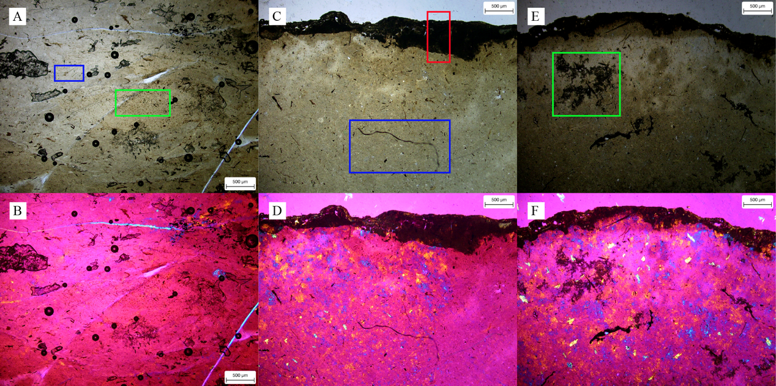
Supplementary Figure 4. Histological characteristics of Crococopros naduongensis ichnogen. et ichnosp. nov. under normal light and cross-polarized light with lambda compensator. a & b were from specimen IVPP 27941/3; c & d were from specimen IVPP 27941/45, and; e & f were from specimen IVPP 27941/49. Green boxes indicate possible soft-tissues or organic matters preservation; red box indicates the superimposed layer of the coprolite; blue boxes indicate filamentous elements. Scales as indicated in diagrams.

