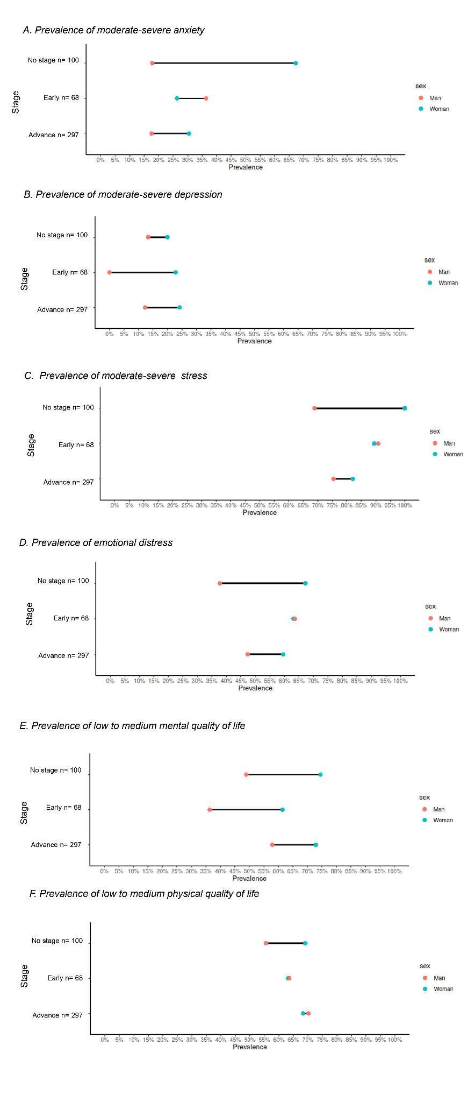
Supplementary material 1. Prevalence of mental health and quality of life outcomes according to clinical stage of cancer and gender

