Supplementary Information

Phragmites australis dieback in the Mississippi River Delta: Chemical profiles of healthy, dieback and dredge soils and impacts on plant biomass
Herie Lee¹, Rodrigo Diaz², and James T. Cronin^{1*}

¹ Department of Biological Sciences, Louisiana State University, Baton Rouge, LA, USA 70803
² Department of Entomology, Louisiana State University, Baton Rouge, LA, USA 70803

*Corresponding author:
James T. Cronin, Department of Biological Sciences, Louisiana State University, 202 Life Sciences Building, Baton Rouge, LA 70803, USA. Tel: 225-578-7218; E-mail address: jcronin@lsu.edu

Table S1. Origin and soil type designations for soil surveys (Winter and Spring) and Winter-Spring and Spring-Summer Experiment.
Season | Soil Type | Latitude | Longitude
A) Winter Soil Survey | Healthy | 29.09262 | -89.21034
 | Healthy | 29.08813 | -89.22776
 | Healthy | 29.12298 | -89.23856
 | Dieback | 29.08304 | -89.21557
 | Dieback | 29.12079 | -89.25319
 | Dieback | 29.11735 | -89.20336
B) Spring Soil Survey | Healthy | 29.103837 | -89.220137
 | Healthy | 29.083732 | -89.247022
 | Dieback | 29.082775 | -89.214178
 | Dieback | 29.117257 | -89.203218
 | Dredge | 29.137427 | -89.217168
 | Dredge | 29.137412 | -89.217142

Table S2. Overview of soil testing methods conducted by the LSU AgCenter Soil testing and Plant Analysis Lab.
Soil Test | Extractant | Conditions | Analysis | Reference
Phosphorous, Potassium, Calcium,  Magnesium, Sodium,  Sulfur,  Copper,  Zinc | Mehlich 3 | 2 g soil/20 mL solution, 5 min shaking  (3.75 M NH4F – 0.25 M EDTA NH4NO3, CH3COOH, and HNO3) | ICP | Mehlich, 1984
pH | Water | 10 g soil / 10 mL deionized H2O 2 hr. equilibration | pH meter +  electrode | McLean, 1982
Organic Matter | 1 g soil / 10 mL 1 N K2Cr2O7 + 20 mL conc. H2SO4 (wait 2 hours) + 90 mL H2O, 16 hr. equilibration | 1 g soil / 10 mL 1 N K2Cr2O7 +  20 mL conc. H2SO4 (wait 2 hours) +  90 mL H2O, 16 hr. equilibration | Nelson and Sommer, 1982 | Nelson and Sommer, 1982
Manganese, Iron, Copper, Zinc | DTPA | 10 g soil / 20 mL pH 7.3, 0.005 M DTPA, 2 hr. shaking | ICP | Baker and Amacher, 1982
Aluminum | BaCl2 / NH4Cl | 2 g soil / 20 mL 0.1 M BaCl2 / NH4Cl, 15 min shaking | ICP | Barnhisel and Bertsch, 1982
% C and % N |  | 0.25 g soil | LECO Carbon/Nitrogen Dumas Analyzer. | Dumas Dry-Combustion

Table S3. Lineage, location of origin and coordinates for P. australis populations used in (A) Winter-Spring and (B) Spring-Summer Experiments.
Code | Lineage | Location of Origin | Latitude | Longitude
(A) Winter-Spring Experiment
PLM | Delta | Lower Mississippi River Delta | 29.13 | -89.23
Earl3 | Delta | Lower Mississippi River Delta | 29.17649 | -89.28638
Ear4 | Delta | Lower Mississippi River Delta | 29.05301 | -89.3327
EU3 | EU | Plaquemines Parish, LA, USA | 29.14991 | -89.19962
HI | Gulf | High Island, TX | 29.55194 | -94.389531
SAU | Gulf | Bayou Sauvage NWR | 30.06676 | -89.8273
(B) Spring-Summer Experiment
Earl3 | Delta | Lower Mississippi River Delta | 29.17649 | -89.28638
Ear4 | Delta | Lower Mississippi River Delta | 29.05301 | -89.3327
TELM | EU | Missouri | 38.42155 | -90.34016
EU3 | EU | Plaquemines Parish, LA, USA | 29.14991 | -89.19962

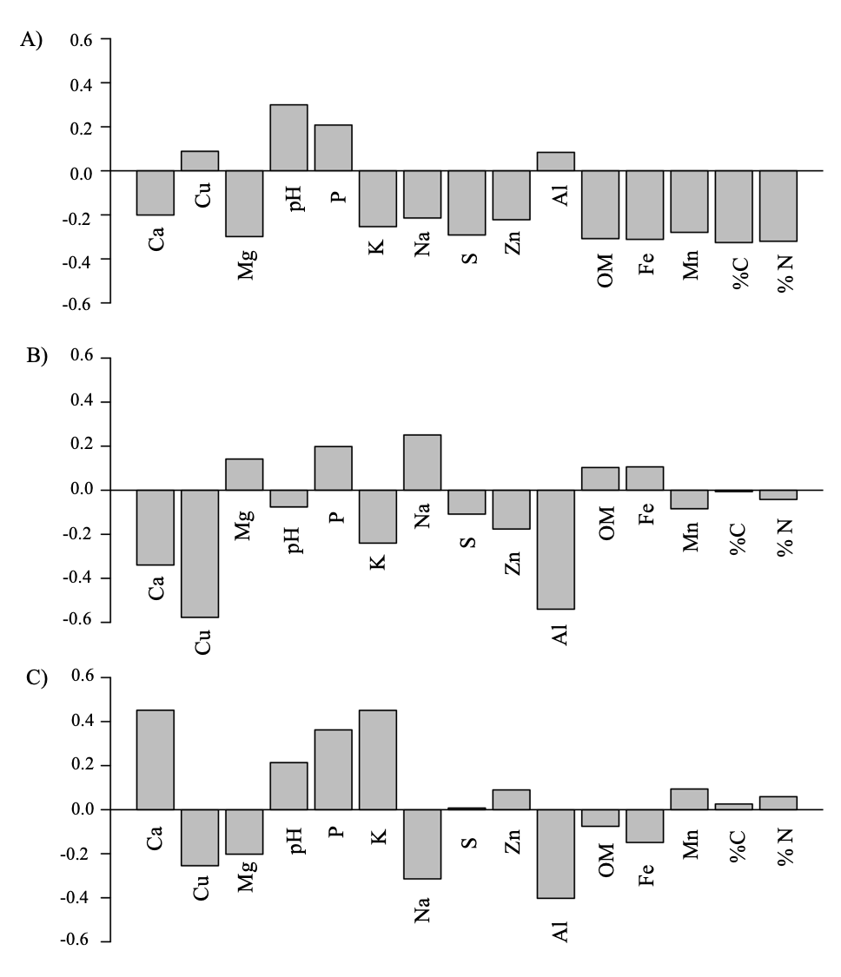 Figure S1. The individual loadings of soil chemical properties for (A) PC1, (B) PC2 and (C) PC3 from the principal component analysis of Winter Survey.
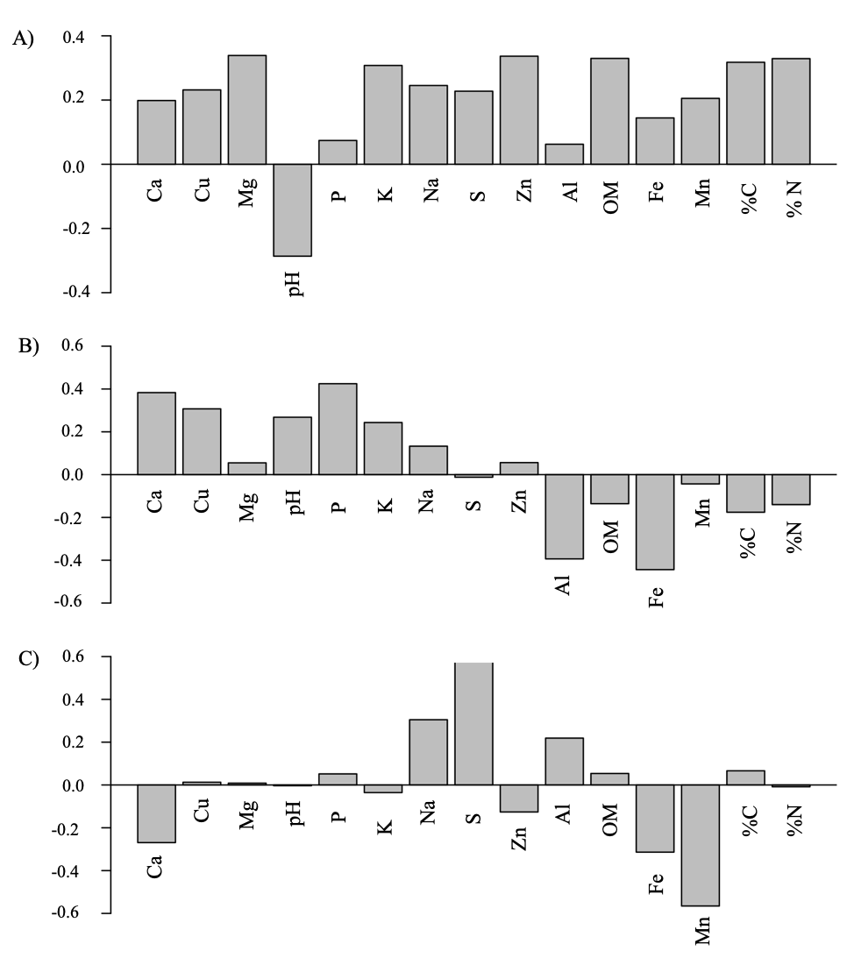
Fig. S2. The individual loadings of soil chemical properties for (A) PC1, (B) PC2 and (C) PC3 from the principal component analysis of Spring Survey.

Table S4. Correlation matrix (Pearson’s product moment correlation, R) of correlations between soil chemical properties for the soils in the (A) Winter and (B) Spring surveys. Values in bold indicate strong correlations (critical value > 0.80) *** P ≤ 0.001, ** 0.001 < P < 0.01, * 0.01 < P ≤ 0.05.
A) Winter Survey
 | Ca | Cu | Mg | pH | P | K | Na | S | Zn | Al | %OM |  | Fe | Mn | %C | %N
Ca | 1.00
Cu | -0.24 | 1.00
Mg | 0.70** | -0.71** | 1.00
pH | -0.72** | 0.65** | -0.99*** | 1.00
P | -0.82*** | 0.31 | -0.86*** | 0.87*** | 1.00
K | 0.96*** | -0.45 | 0.85*** | -0.86*** | -0.86*** | 1.00
Na | 0.53* | -0.79*** | 0.95*** | -0.91*** | -0.75** | 0.69** | 1.00
S | 0.85*** | -0.55* | 0.95*** | -0.96*** | -0.93*** | 0.94*** | 0.84*** | 1.00
Zn | 0.79*** | -0.42 | 0.87*** | -0.91*** | -0.80*** | 0.90*** | 0.69** | 0.89*** | 1.00
Al | -0.27 | 0.99*** | -0.68** | 0.62* | 0.27 | -0.47 | -0.74** | -0.53* | -0.42 | 1.00
%OM | 0.74** | -0.71** | 1.00*** | -0.99*** | -0.86*** | 0.88*** | 0.94*** | 0.95*** | 0.88*** | -0.68** | 1.00
Fe | 0.72** | -0.70** | 0.99*** | -0.99*** | -0.86*** | 0.87*** | 0.93*** | 0.96*** | 0.88*** | -0.67** | 0.99*** |  | 1.00
Mn | 0.85*** | -0.58* | 0.94*** | -0.94*** | -0.92*** | 0.94*** | 0.85*** | 0.99*** | 0.84*** | -0.57 | 0.95*** |  | 0.96*** | 1.00
%C | 0.80*** | -0.64** | 0.98*** | -0.99*** | -0.89*** | 0.92*** | 0.89*** | 0.98*** | 0.91*** | -0.62* | 0.99*** |  | 0.99*** | 0.98*** | 1.00
%N | 0.82*** | -0.61* | 0.97*** | -0.98*** | -0.90*** | 0.94*** | 0.86*** | 0.99*** | 0.92*** | -0.60* | 0.98*** |  | 0.98*** | 0.98*** | 1.00*** | 1.00

B) Spring Survey
 | Ca | Cu | Mg | pH | P | K | Na | S | Zn | Al | %OM |  | Fe | Mn | %C | %N
Ca | 1.00
Cu | 0.29 | 1.00
Mg | 0.65** | 0.08 | 1.00
pH | -0.12 | -0.11 | -0.72 | 1.00
P | 0.20 | 0.71** | -0.12 | 0.17 | 1.00
K | 0.81*** | 0.37 | 0.88*** | -0.53* | 0.24 | 1.00
Na | 0.45 | -0.07 | 0.79 | -0.40 | 0.04 | 0.74 | 1.00
S | 0.17 | 0.14 | 0.65** | -0.55* | -0.14 | 0.55* | 0.67** | 1.00
Zn | 0.45 | 0.80*** | 0.52* | -0.58* | 0.56* | 0.68** | 0.27 | 0.28 | 1.00
Al | -0.22 | -0.20 | 0.17 | -0.29 | -0.28 | -0.12 | 0.13 | 0.26 | 0.00 | 1.00
%OM | 0.33 | 0.36 | 0.79 | -0.90*** | 0.09 | 0.70** | 0.49* | 0.62** | 0.78 | 0.28 | 1.00
Fe | -0.06 | -0.20 | 0.35 | -0.60* | -0.45 | 0.13 | 0.14 | 0.03 | 0.37 | 0.56* | 0.48* |  | 1.00
Mn | 0.38 | 0.37 | 0.55* | -0.48* | 0.08 | 0.49* | 0.25 | 0.04 | 0.59* | 0.00 | 0.50* |  | 0.50* | 1.00
%C | 0.24 | 0.27 | 0.76 | -0.90*** | 0.10 | 0.64** | 0.54* | 0.58* | 0.72 | 0.31 | 0.97*** |  | 0.53* | 0.50* | 1.00
%N | 0.33 | 0.35 | 0.78 | -0.92*** | 0.11 | 0.70** | 0.48* | 0.56* | 0.78 | 0.26 | 0.99*** |  | 0.52* | 0.55* | 0.98*** | 1.00

Table S5. Separate t-test results for the difference in soil chemicals between healthy and dieback sites from the Winter Survey. Significance, denoted by * adjacent to the P-value, was determined using Bonferroni-corrected values of α.
Variable | Soil Type | n | Mean | SE | t | P-value
Al (ppm) | Dieback | 8 | 0.58 | 0.10 | -1.22 | 0.308
Al (ppm) | Healthy | 7 | 2.58 | 1.64
Ca (ppm) | Dieback | 8 | 3992.48 | 297.21 | 0.04 | 0.968
 | Healthy | 7 | 4017.69 | 284.89
Cu (ppm) | Dieback | 8 | 1.16 | 0.11 | -1.40 | 0.261
 | Healthy | 7 | 1.89 | 0.53
Fe (ppm) | Dieback | 8 | 160.82 | 16.12 | 5.33 | <0.001*
 | Healthy | 7 | 71.06 | 4.93
K (ppm) | Dieback | 8 | 261.66 | 28.61 | 0.90 | 0.414
 | Healthy | 7 | 231.66 | 23.37
Mg (ppm) | Dieback | 8 | 1174.23 | 53.25 | 7.47 | <0.001*
 | Healthy | 7 | 620.78 | 52.18
Mn (ppm) | Dieback | 8 | 127.84 | 52.49 | 1.85 | 0.145
 | Healthy | 7 | 30.27 | 6.28
Na (ppm) | Dieback | 8 | 426.77 | 51.71 | 2.98 | 0.027*
 | Healthy | 7 | 230.48 | 28.65
% OM | Dieback | 8 | 5.77 | 0.34 | 5.21 | <0.001*
 | Healthy | 7 | 3.07 | 0.36
P (ppm) | Dieback | 8 | 27.76 | 1.42 | -2.21 | 0.085
 | Healthy | 7 | 34.20 | 2.46
pH | Dieback | 8 | 5.80 | 0.27 | -6.55 | <0.001*
 | Healthy | 7 | 7.40 | 0.06
S (ppm) | Dieback | 8 | 1121.41 | 404.80 | 2.19 | 0.106
 | Healthy | 7 | 280.07 | 57.66
Zn (ppm) | Dieback | 8 | 9.07 | 0.57 | 1.94 | 0.112
 | Healthy | 7 | 7.28 | 0.58
% C | Dieback | 8 | 5.51 | 0.80 | 3.84 | 0.011*
 | Healthy | 7 | 2.19 | 0.30
% N | Dieback | 8 | 0.51 | 0.08 | 3.69 | 0.014*
 | Healthy | 7 | 0.19 | 0.02

Table S6. Analysis of variance results for the effect of different soil types (healthy, dieback, dredge) on separate soil chemical characteristics from the Spring survey. Post-Hoc Tukey HSD tests were used to assess differences between treatment pairs. For each variable, means with different letters are significantly different (P ≤ 0.05). Significance denoted by * adjacent to the P-value.
Variable | Soil Type | Mean | SE | F | P-value
Al (ppm) | Healthy | 0.64ª | 0.05 | 1.51 | 0.25
Al (ppm) | Dieback | 0.93ª | 0.07
Al (ppm) | Dredge | 0.79ª | 0.18
Ca (ppm) | Healthy | 3546.70ª | 366.1 | 12.30 | 0.001*
Ca (ppm) | Dieback | 2412.31^{b} | 199.37
Ca (ppm) | Dredge | 1653.18^{b} | 218.48
Cu (ppm) | Healthy | 1.57ª | 0.26 | 5.983 | 0.012*
Cu (ppm) | Dieback | 1.09^{ab} | 0.14
Cu (ppm) | Dredge | 0.74^{b} | 0.03
Fe (ppm) | Healthy | 64.3^{ab} | 7.52 | 4.41 | 0.033*
Fe (ppm) | Dieback | 114.01ª | 20.04
Fe (ppm) | Dredge | 51.11^{b} | 15.83
K (ppm) | Healthy | 219.87ª | 21.45 | 14.51 | <0.001*
K (ppm) | Dieback | 209.63^{b} | 23.83
K (ppm) | Dredge | 82.47^{b} | 13.52
Mg (ppm) | Healthy | 617.43ª | 94.82 | 31.87 | <0.001*
Mg (ppm) | Dieback | 823.07ª | 76.96
Mg (ppm) | Dredge | 279.04^{b} | 23.55
Mn (ppm) | Healthy | 136.84^{ab} | 36.66 | 5.33 | 0.02*
Mn (ppm) | Dieback | 153.66ª | 28.40
Mn (ppm) | Dredge | 42.25^{b} | 12.68
(table cont’d.)

Variable | Soil Type | Mean | SE | F | P-value
Na (ppm) | Healthy | 282.87ª | 66.58 | 2.072 | 0.161
Na (ppm) | Dieback | 381.88ª | 87.75
Na (ppm) | Dredge | 192.60ª | 29.1
% OM | Healthy | 2.89ª | 0.23 | 35.75 | <0.001*
% OM | Dieback | 5.29^{b} | 0.61
% OM | Dredge | 0.73^{c} | 0.12
P (ppm) | Healthy | 72.89ª | 8.75 | 1.973 | 0.174
P (ppm) | Dieback | 54.10ª | 6.39
P (ppm) | Dredge | 58.7ª | 5.33
pH | Healthy | 7.43ª | 0.06 | 104.20 | <0.001*
pH | Dieback | 6.41^{b} | 0.09
pH | Dredge | 7.71ª | 0.04
S (ppm) | Healthy | 44.70^{ab} | 10.37 | 4.171 | 0.036*
S (ppm) | Dieback | 100.89ª | 29.98
S (ppm) | Dredge | 27.68^{b} | 7.02
Zn (ppm) | Healthy | 7.58ª | 0.89 | 15.70 | <0.001*
Zn (ppm) | Dieback | 7.34ª | 0.22
Zn (ppm) | Dredge | 3.01^{b} | 0.89
% C | Healthy | 1.42ª | 0.12 | 25.79 | <0.001*
% C | Dieback | 3.04^{b} | 0.42
% C | Dredge | 0.49^{c} | 0.27
% N | Healthy | 0.05ª | 0.01 | 31.77 | <0.001*
% N | Dieback | 0.30^{b} | 0.04
% N | Dredge | 0.17^{c} | 0.00

Table S7. Analysis of variance results for the effects of soil type (dieback, healthy), P. australis lineage (Delta, EU, Gulf), and the lineage × soil type interaction on A) ln total stem count per pot and B) max stem height for Winter-Spring Experiment and for the effects of soil type (dieback, healthy, dredge), P. australis lineage (Delta, EU), and the lineage × soil type interaction on C) total stem count per pot and D) max stem height for Spring-Summer Experiment. Bolded sources of variation indicate significance (P ≤ 0.05).
 | Sums of Squares |  | df (num) | df (denom) | F | P-value
WINTER-SPRING EXPERIMENT
A) ln total stem count per pot
Lineage | 0.38 | 2 |  | 2.99 | 1.87 | 0.297
Soil Type | 0.78 | 1 |  | 9.5 | 7.7 | 0.021*
Lineage × Soil Type | 0.12 | 2 |  | 225.63 | 0.58 | 0.562
B) Max stem height
Lineage | 0.15 | 2 |  | 3 | 2.16 | 0.263
Soil Type | 0.01 | 1 |  | 228.26 | 0.19 | 0.66
Lineage × Soil Type | 0.13 | 2 |  | 228.3 | 1.91 | 0.151
SPRING-SUMMER EXPERIMENT
C) Total stem count per pot
Lineage | 2.67 | 1 |  | 1.77 | 0.16 | 0.733
Soil Type | 405.9 | 2 |  | 22.86 | 12.1 | < 0.001*
Lineage × Soil Type | 15.06 | 2 |  | 122.64 | 0.45 | 0.639
D) Max stem height
Lineage | 818.5 | 1 |  | 1.68 | 3.66 | 0.22
Soil Type | 784.74 | 2 |  | 17.51 | 1.75 | 0.202
Lineage × Soil Type | 1579.58 | 2 |  | 113.07 | 3.53 | 0.033*

Fig. S4. The effects of soil type (dieback, healthy) and P. australis lineage (Delta, EU, Gulf) on A) ln total stem count per pot and B) max stem height (cm) for Winter-Spring Experiment and the effects of soil type (dieback, healthy, dredge) and P. australis lineage (Delta, EU) on C) total stem count per pot and D) max stem height (cm) for Spring-Summer Experiment. Reported values are marginal means ± SE. Different letters between groups indicate significant differences at P ≤ 0.05.

