Supplementary Figure 1.

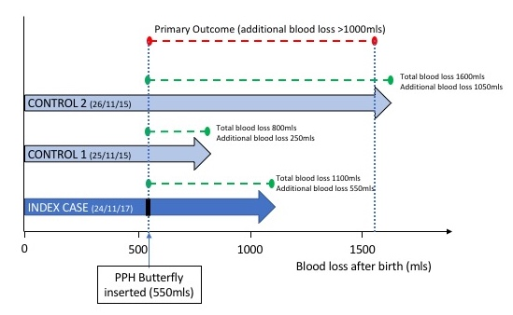

Figure S1. Primary outcome assessment in control group
Hypothetical outline of study outcomes in those in the PPH group and controls, designed to mimic a randomised trial where randomisation occurs at the time of device insertion. In the index case above, the total blood loss was 1100mls. Blood loss on insertion of the PPH Butterfly device was 550mls and therefore additional blood loss was 1100 – 550 = 550mls. Since this is lower than 1000mls the primary outcome value would be ‘No’. The two controls are selected from 2 years prior to the index case, progressing forward from exactly 2 years previously until 2 matches are found who had at least the amount of blood loss at which the device was used in the index case (550mls in this case). The comparable outcome in the controls is the blood loss beyond the amount at which the device was inserted in the index case. For control 1, ‘additional blood loss’ is calculated as 800 – 550 = 250mls. For control 2 the ‘additional blood loss’ is calculated as 1600 – 550mls = 1050mls. Control 1 would therefore have primary outcome value as ‘No’ and control 2 would have a ‘Yes’.

