Online Resource: Table S1. Treatment delivery and dose-volume constraints for organs at risk.
 | IMRT | SBRT
Treatment delivery
PTV coverage | >98% | >97%
median BED10 (range),Gy | 73 (31-95) | 90 (36-116)
median final radiation dose (range),Gy | 51 (30-60 ) | 42 (30–50)
median per dose (range),Gy | 4 (2.5-7 ) | 11 (7-15)
median fractions (range),fraction | 12 (7-20) | 4 (3–5)
median total irradiation time (range),days | 25 (15-50 ), every other day | 4 (3–5), on consecutive days
Dose-volume constraints for organs at risk
normal liver | Dmean<23Gy, V20 <48% | VS15≥700ml, V15<1/3 Vtotal
stomach and small intestine | Dmax<40-45 Gy，V35<45%, V40≤5% | Dmax<27 Gy; D_{1ml}<21Gy
spinal cord | Dmax<40 Gy | Dmax<20Gy, D_{1mL}<15 Gy
kidneys | Dmean≤15Gy, V20≤33%# | Dmean<10Gy,V15<1/3 Vtotal
*Abbreviation：IMRT: intensity modulated radiation therapy; SBRT: stereotactic body radiotherapy; BED10: biologically effective dose assumed an a/b ratio of 10; Dmean: mean dose; Dmax:maximum dose; D1mL: the maximum doses to 1mL; Vx: the percentage of normal liver volume receiving x Gy; VS15: The absolute liver volume (mL) spared from 15 Gy; Vtotal: total volume.
# the other kidney should be spared if the mean dose of one kidney is higher than 19Gy.

Online Resource: Table S2. Univariable and multivariable Cox analyses for OS, PFS, and IC after PSM.
 |  | OS |  |  | PFS |  |  | IC |  |  | LC
 |  | Univariable | Multivariable |  | Univariable | Multivariable |  | Univariable | Multivariable |  | Univariable | Multivariable
 |  | P | P | HR | P | P | HR | P | P | HR | P | P | HR
treat |  | 0.165 |  |  | 0.758 |  |  | 0.159 |  |  | 0.203
HBV |  | 0.729 |  |  | 0.968 |  |  | 0.251 |  |  | 0.998
TACE-refractory disease |  | 0.034 | 0.238 | 0.818 | 0.206 |  |  | 0.201 |  |  | 0.273
AFP |  | 0.009 | 0.023 |  | 0.056 | 0.093 |  | 0.117 |  |  | 0.067
 | 0
 | 1 | 0.899 |  | 0.912 | 0.522 | 0.692 | 1.104 | 0.201
 | 2 | 0.276 |  | 0.66 | 0.199 | 0.212 | 0.624 | 0.16
 | 3 | 0.169 |  | 0.591 | 0.161 | 0.134 | 0.547 | 0.352
 | 4 | 0.061 |  | 1.433 | 0.205 | 0.322 | 1.227 | 0.402
PT |  | 0.884 |  |  | 0.86 |  |  | 0.763 |  |  | 0.579
Tbil |  | 0.144 |  |  | 0.161 |  |  | 0.218 |  |  | 0.305
ALP |  | 0.673 |  |  | 0.894 |  |  | 0.845 |  |  | 0.42
BUN |  | 0.369 |  |  | 0.706 |  |  | 0.55 |  |  | 0.478
ALBI score |  | <0.001 | 0.001 | 1.86 | 0.002 | 0.005 | 1.609 | 0.112 |  |  | 0.385
Gender |  | 0.455 |  |  | 0.375 |  |  | 0.064 |  |  | 0.066
age |  | 0.125 |  |  | 0.397 |  |  | 0.958 |  |  | 0.428
BED₁₀ |  | 0.001 |  |  | 0.019 |  |  | <0.001 |  |  | 0.118
size |  | 0.489 |  |  | 0.44 |  |  | 0.436 |  |  | 0.416
PVTT type |  | 0.272 |  |  | 0.864 |  |  | 0.235 |  |  | 0.526
 | 1 | 0.057 |  |  | 0.515 |  |  | 0.061 |  |  | 0.326
 | 2 | 0.86 |  |  | 0.869 |  |  | 0.899 |  |  | 0.278
 | 3 | 0.371 |  |  | 0.69 |  |  | 0.0704 |  |  | 0.496
 | 4 | 0.388 |  |  | 0.374 |  |  | 0.518 |  |  | 0.520
effective PTV volume |  | 0.416 |  |  | 0.587 |  |  | 0.302 |  |  | 0.397

Online Resource: Table S3. Results of ROC analyses and Kaplan-Meier analysis with a BED cutoff value of 100Gy.
Unmatched cohort
IMRT |  | AUC | Cutoff obtained by ROC (Gy) | P(100Gy)
 | OS | 0.404 | - | -
 | PFS | 0.343 | - | -
 | IC | 0.555 | 79 | 0.18
 | LC | 0.498
SBRT
 | OS | 0.608 | 78 | 0.008
 | PFS | 0.662 | 100 | 0.001
 | IC | 0.559 | 100 | 0.006
 | LC | 0.554 | 100 | 0.04
Matched cohort
IMRT
 | OS | 0.420 | - | -
 | PFS | 0.405 | - | -
 | IC | 0.568 | 58 | 0.02
 | LC | 0.486
SBRT
 | OS | 0.601 | 100 | 0.004
 | PFS | 0.670 | 100 | ＜0.001
 | IC | 0.601 | 100 | 0.001
 | LC | 0.598 | 100 | 0.021

Online Resource: Figure S1.
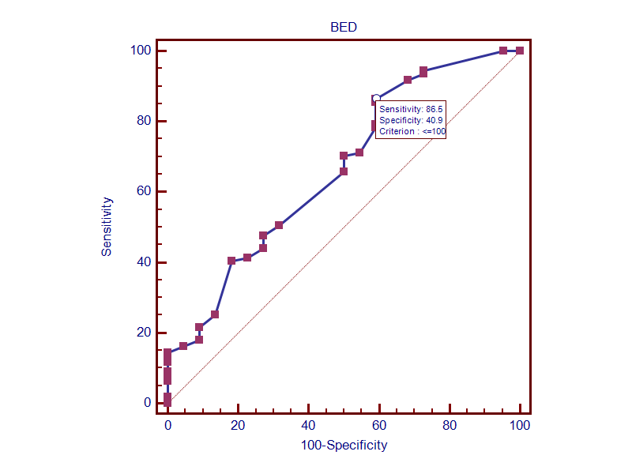
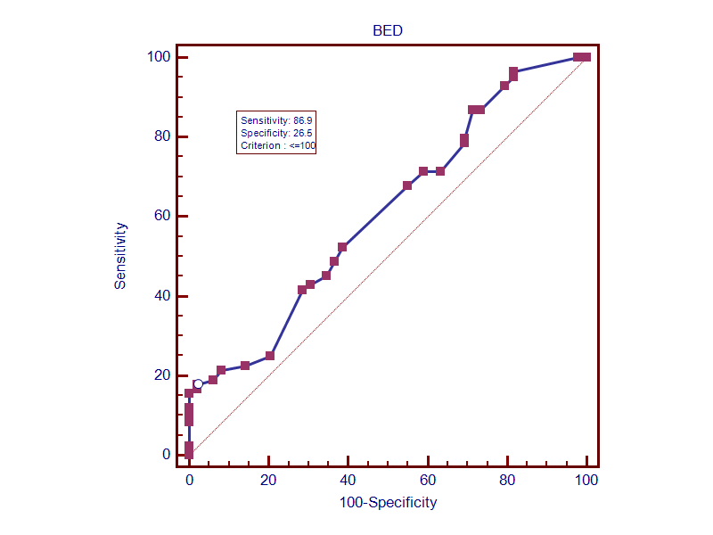

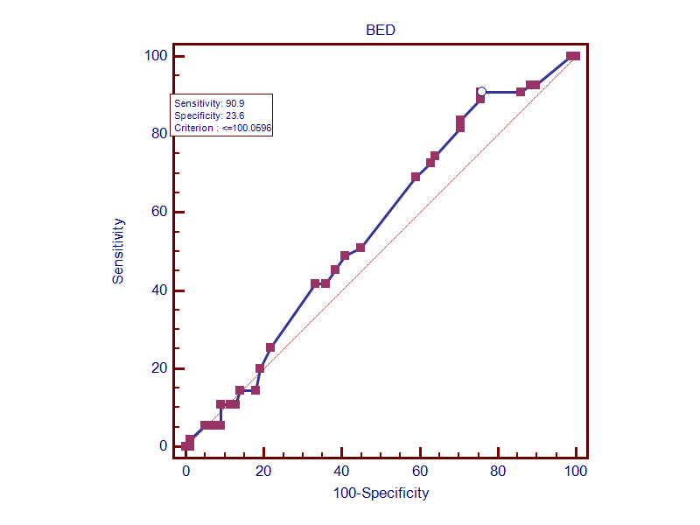
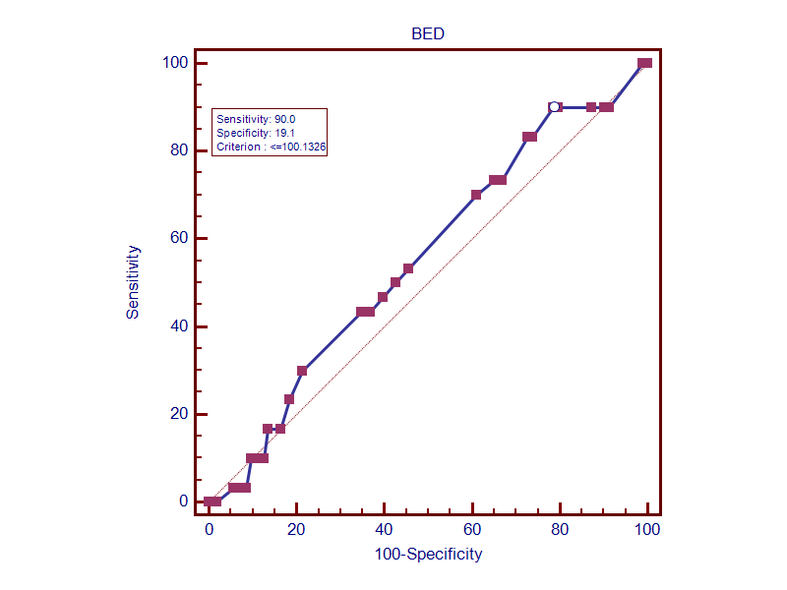
Figure S1a Figure S1b
Figure S1c Figure S1d
ROC curves of BED in unmatched SBRT group. (a) overall survival; (b) progression-free survival; (c) intrahepatic control; (d) local control.

