Additional files

Additional file 1
Fig. S1 Conventional 3D-conformal radiotherapy technology for left and right whole breast irradiation
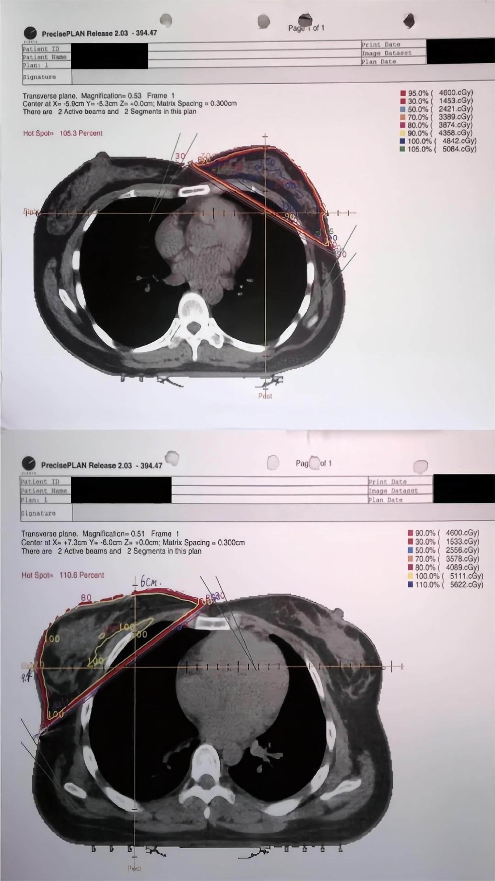

Additional file 2
Table S1 Multivariate analysis for 10-year disease free survival and overall survival in SB and CB groups
Variables | 10-year DFS |  |  | 10-year OS
Variables | HR | 95% CI | P | HR | 95% CI | P
Pathological T stage  (pT0~1 vs. pT2) | 2.765 | 1.008-7.589 | 0.048 | 2.742 | 0.993-7.572 | 0.052
Pathological N stage  (pN0 vs. pN+) | 4.932 | 1.830-13.294 | 0.002 | 4.727 | 1.765-12.663 | 0.002
Hormonal therapy  (yes vs. no) | 0.413 | 0.150-1.139 | 0.088 | 0.439 | 0.159-1.215 | 0.113
Boost (SB vs. CB) | 0.282 | 0.062-1.281 | 0.101 | 0.287 | 0.063-1.298 | 0.105
Abbreviations: SB= sequential boost irradiation; CB= concomitant boost irradiation; DFS= disease free survival;
OS= overall survival.

