Investigation of the reactivity properties of a thiourea derivative with anticancer activity by DFT, MD simulations

Y.Sheena Mary^{a*}, Y.Shyma Maryª, Anna Bielenica^{b}, Stevan Armaković^{c}, Sanja J. Armaković^{d}, Vivek Chandramohan^{e}, Manjunath Dammalli ^{e}

ª Researcher, Thushara, Neethinagar-64, Kollam, Kerala, India
^{b}Chair and Department of Biochemistry, Medical University of Warsaw, 02-097 Warszawa, Poland
^{c}University of Novi Sad, Faculty of Sciences, Department of Physics,
Trg D. Obradovića 4, 21000 Novi Sad, Serbia
^{d}University of Novi Sad, Faculty of Sciences, Department of Chemistry, Biochemistry and Environmental Protection, Trg D. Obradovića 3, 21000 Novi Sad, Serbia
^{e}Department of Biotechnology, Siddaganga Institute of Technology, Tumakuru, 572103, Karnataka, India

*author for correspondence: marysheena2018@rediffmail.com

Fig.S1 FT-IR spectrum of FPTT
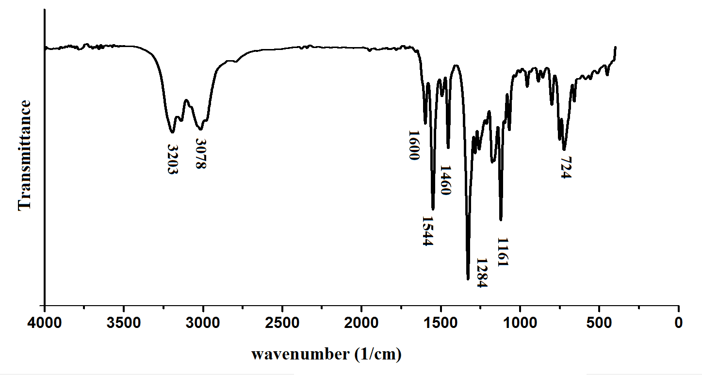

Fig.S2 FT-Raman spectrum of FPTT
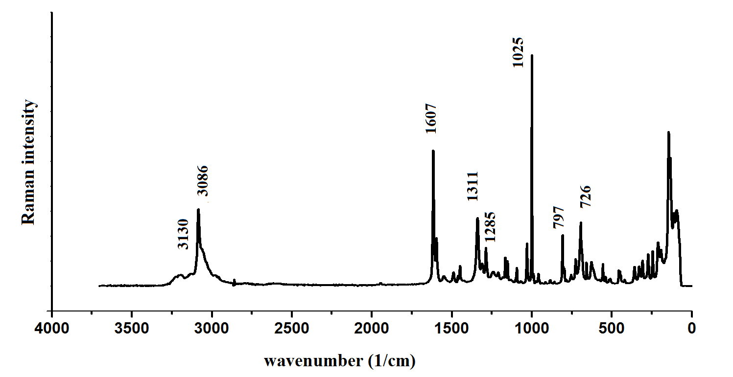

Fig.S3 Formed noncovalent interactions between FPTT and water as obtained by DFT calculations (structures extracted from the representative MD frame)
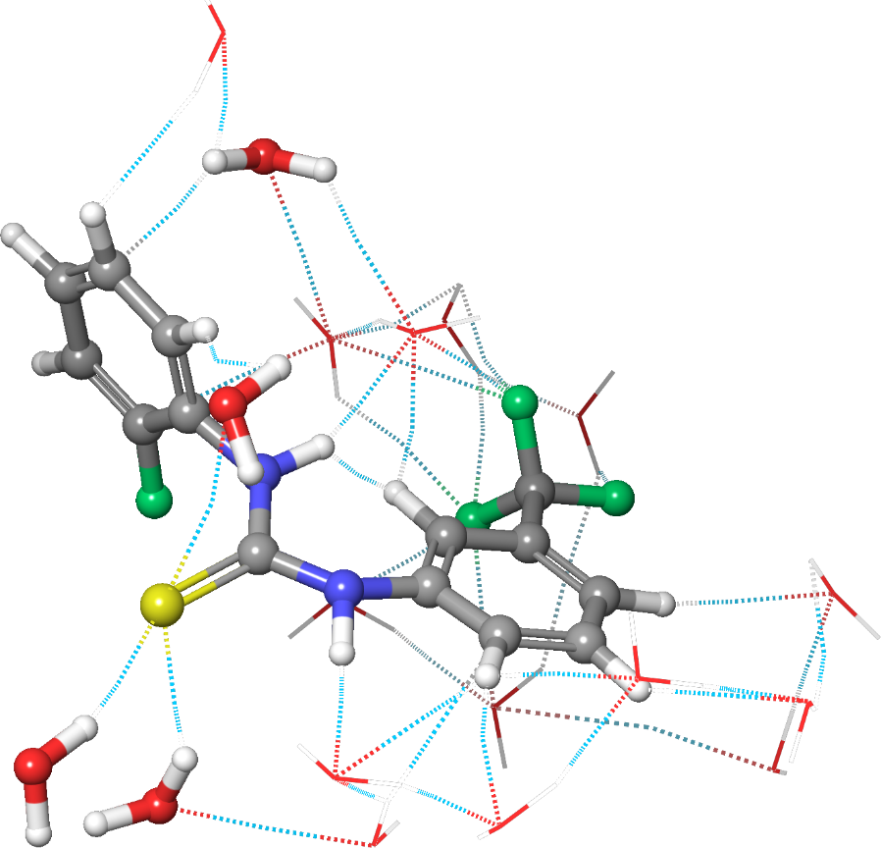
Fig.S4 2D interactions of (a) 2PSQ, (b) 5AEP, (c) 2V3Q and FPTT complex

- 2PSQ -FPTT
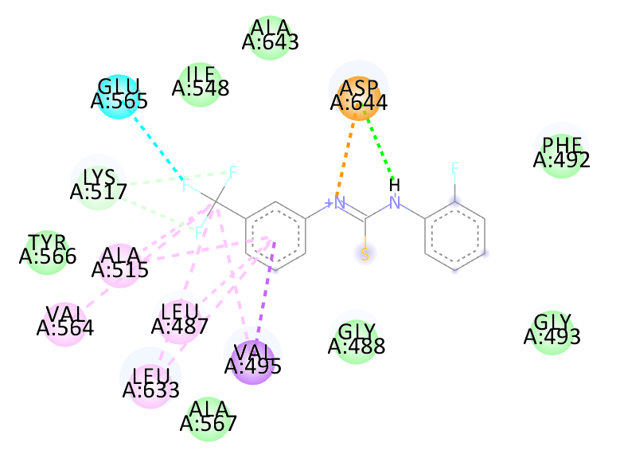

- 5AEP-FPTT
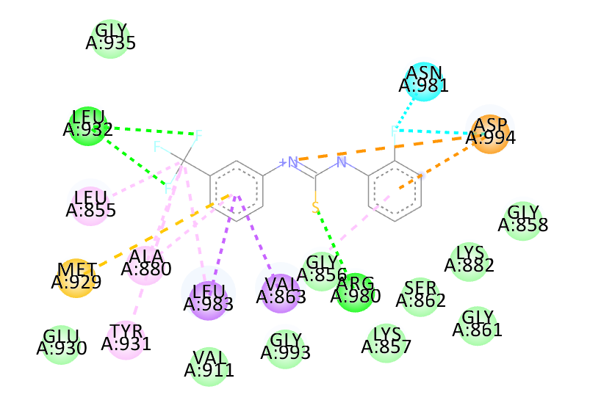

© 2V3Q-FPTT
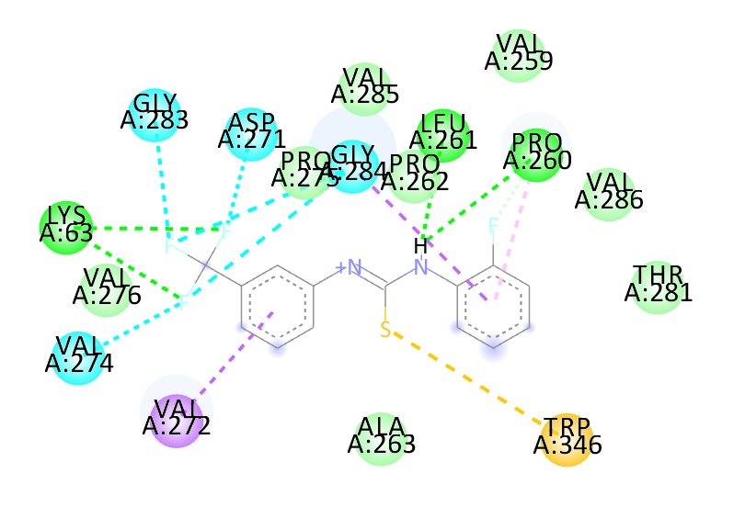

Fig.S5 Surface view of the ligand at the active site of the receptor: (a) 2PSQ, (b) 5AEP, (c) 2V3Q and FPTT complex

(a) 2PSQ-FPTT
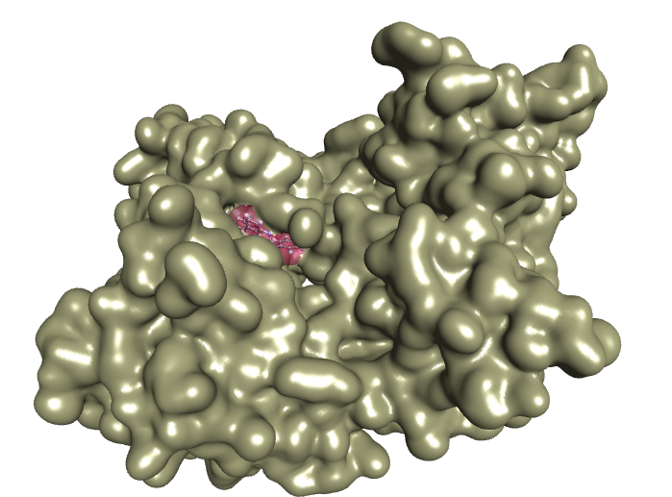

(b) 5AEP-FPTT
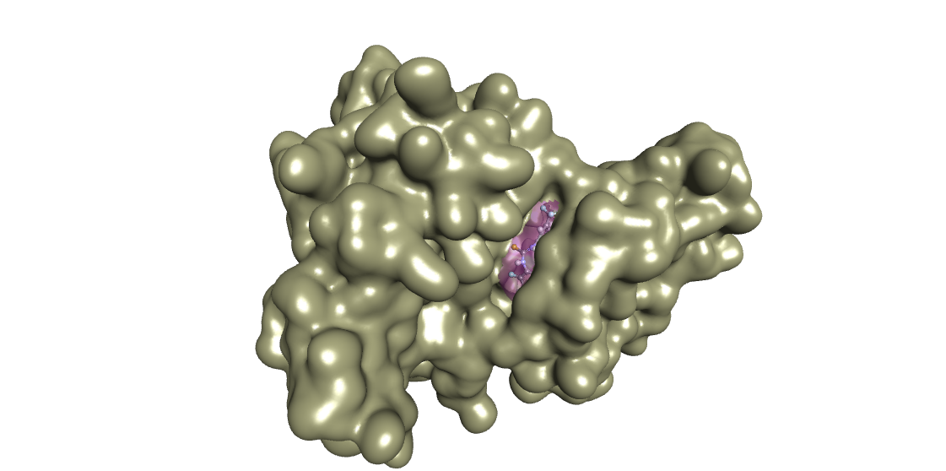

(c) 2V3Q-FPTT
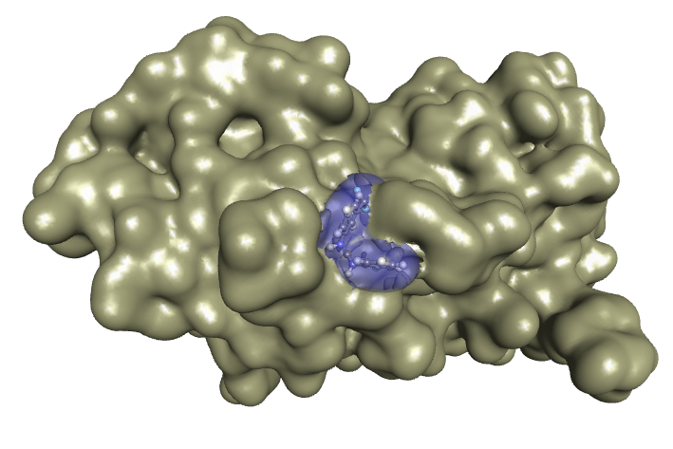

Fig.S6 RMSD plots of 2PSQ, 2V3Q, 5AEP and FPTT