Supplemental Material

Transmucosal passage of food-grade titanium dioxide in pig oral cavity and human TR146 cells, and in vitro toxicity study on human buccal epithelial cells
Vignard J^{1*}, Pettes-Duler A¹, Gaultier E¹, Cartier C¹, Weingarten L², Biesemeier A³, Taubitz T³, Pinton P¹, Bebeacua C⁴, Devoille L⁵, Dupuy J¹, Boutet-Robinet E¹, Feltin N⁵, Oswald IP¹, Pierre FHF¹, Lamas B¹, Mirey G¹, Houdeau E^{1*}

Contents of Supplemental Material

Supplemental Figure 1
Supplemental Figure 2
Supplemental Figure 3

Supplemental Table 1

Figure S1 : Complementary TEM-EDX analysis of ultrathin sections from buccal floor and submandibular lymph nodes of pigs exposed to food-grade TiO₂ particles by repeated sublingual deposition of E171 for 4h. a: TEM image showing particles into the lumen of a blood capillary. b-c: TEM images (b1-c1) and the corresponding EDX spectra (b2-c2) of aggregated Ti(O₂) particles in the buccal mucosa. d: TEM image (d1) and corresponding EDX analysis (d2) of a small aggregate of Ti(O₂) particles translocated into a submandibular lymph node. Copper (Cu) and lead (Pb) are from the sample grid and lead citrate staining, respectively.

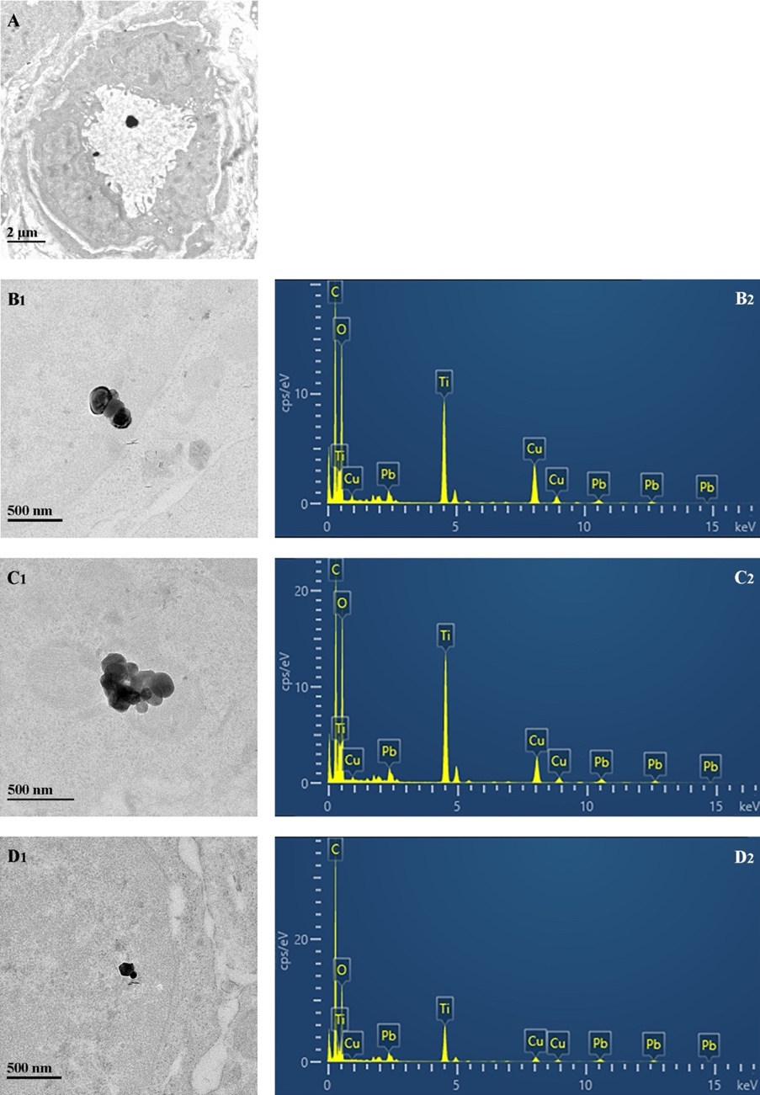

Figure S2 : TEM-EDX analysis from a submandibular lymph node of a control pig exposed for 4h to water in the sublingual region. TEM image (a) and corresponding EDX analysis (b) of one electron-dense particulate deposit showing Ti, Al, and Si signals. Note the irregular form of the particulate agregate which differs morphologically from food-grade TiO₂ as shown in the study. Copper (Cu) and lead (Pb) are from the sample grid and lead citrate staining, respectively.

Figure S3 : TEM-EDX analysis of buccal floor and submandibular lymph nodes from pigs exposed to food-grade TiO₂ particles by repeated sublingual deposition for 4h of E171 without sonication. a-b: TEM images (a1-b1) and corresponding EDX spectra (a2-b2) of two particle aggregates in the buccal mucosa. Note the presence of both (1) Ti(0₂) and (2) iron (Fe) particulate deposit in the same field d: TEM image (c1) with EDX analysis (c2) of an isolated Ti(O₂) particle in the submandibular lymph node.

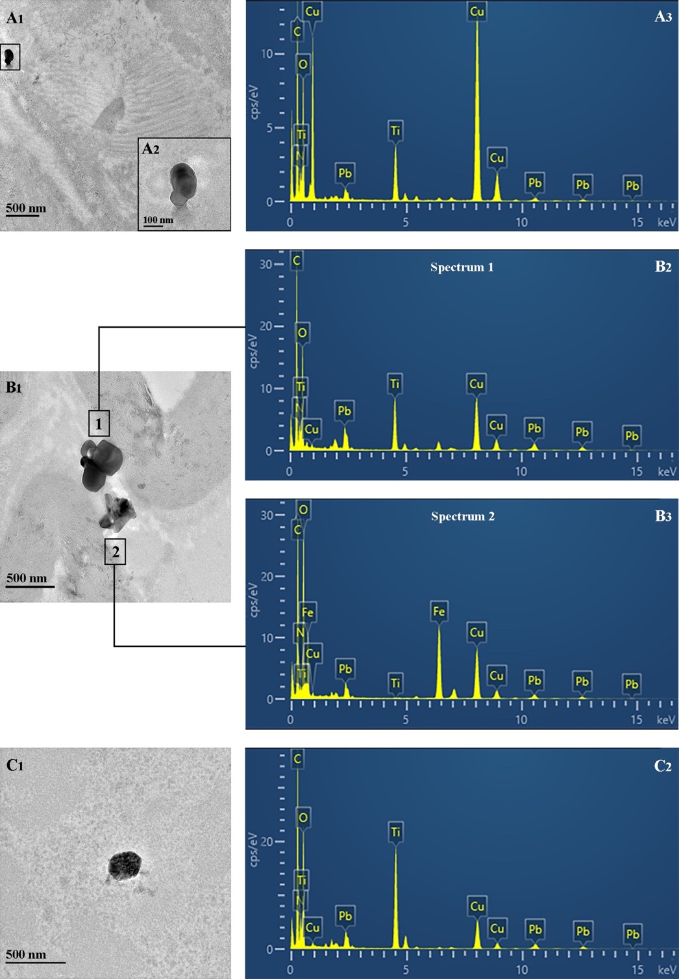

Table S1 TiO₂ particles in pig buccal mucosa and submandibular lymph nodes after repeated sublingual deposition for 4h of non sonicated (raw powder) E171 in water suspension
 | Number of analysed  electron-dense particles |  |  | Ti-positive particles  (D_{MinFeret} / D_{MaxFeret} ±SD in nm)
Tissue sample |  |  |  |  | isolated | aggregates
Buccal floor |  | 26 |  |  | 1 (85/105) | 6 (199±95/301±120)
Submandibular lymph nodes |  | 17 |  |  | 2 (169±69/210±97) | 1 (339/540)
D_{MinFeret} / D_{MaxFeret}: minimum and maximum Feret Diameters.

