SUPPLEMENTARY MATERIAL.
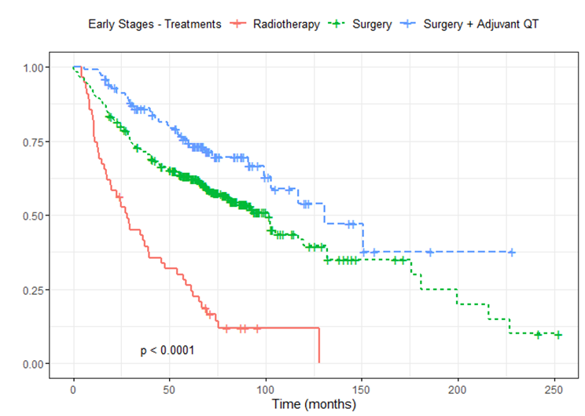
Figure S1. Survival analysis using Kaplan Meier estimates in stages I and II according to treatments, including radiotherapy.
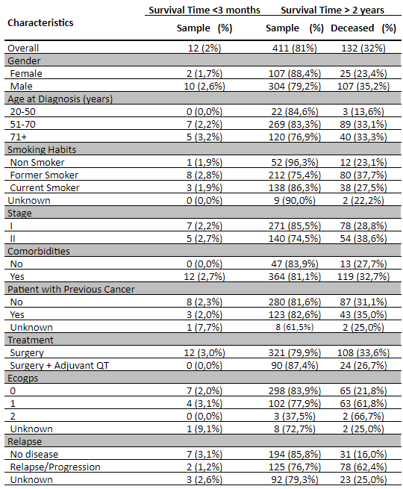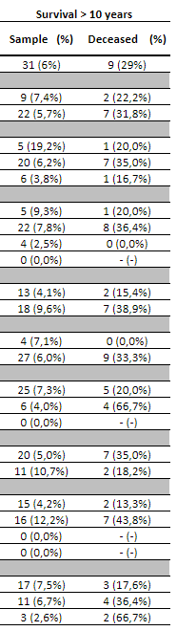
Table S1. Survival time (in months) since diagnosis under 3 months, more than 2 years, and over 10 years.

