Disutility of climate change damages warrants much stricter climate targets

Shridhar Kulkarni^{1*}, Andries Hof^{1,2}, Kaj-Ivar van der Wijst¹, and Detlef van Vuuren^{1,2}
¹ Copernicus Institute of Sustainable Development, Utrecht University, Utrecht, The Netherlands.
² PBL Netherlands Environmental Assessment Agency, The Hague, The Netherlands.
*s.g.kulkarni@uu.nl

Supplementary Information

SI.1. Sensitivity analysis
Sensitivity analysis is used to investigate the influence of the variation in input parameter on the variance in outcome values. It is often as important to determine the input parameters that have the most influence on the variance in the outcomes of interest, as those that have the least influence. Global sensitivity analysis evaluates the output uncertainty over the entire range of input parameters. The ranking order of influence informed by the global sensitivity analysis can be most useful in understanding the relative importance of uncertain variables¹.
The feature scoring method is a random trees based machine learning algorithm, which is strictly speaking not a global sensitivity analysis method. However, it is a useful alternate to the traditional GSA methods, that gives insight on the relative influence of input parameters at the fraction of the computational costs². We choose the computationally inexpensive feature scoring sensitivity analysis method, in lieu of more intensive methods such as those based on Sobol sequences, or Fourier amplitudes. The sensitivity analysis is performed for individual outcomes.
Fig. SI.1 shows the relative influence of input variance for selected parameters on the corresponding variance in optimal annual emission and corresponding temperature outcomes.
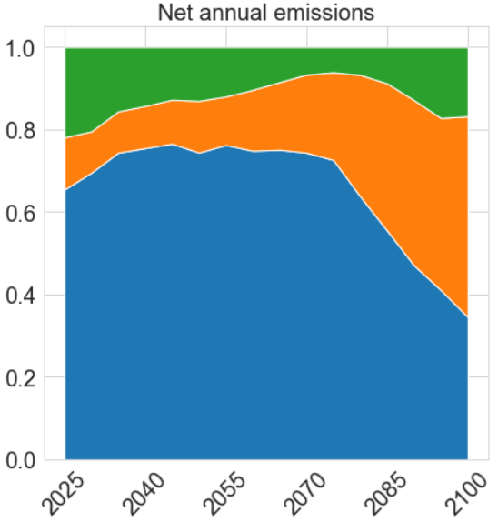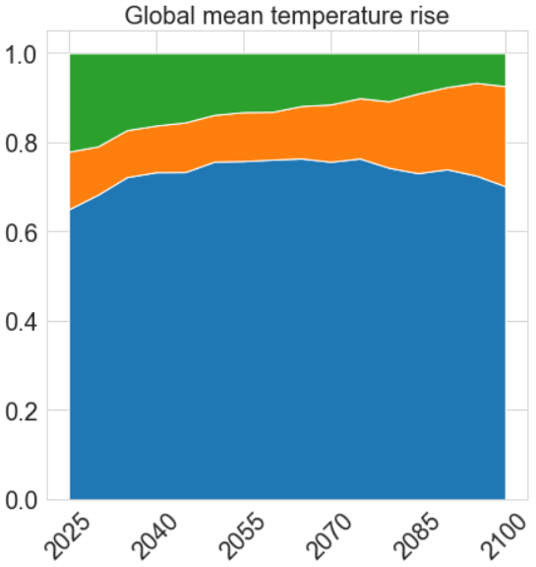
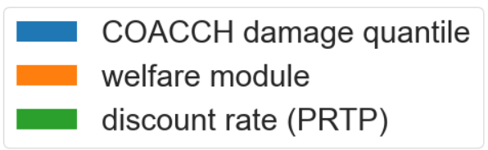
Figure SI.1: Relative sensitivity of a. net annual emissions, and b. global mean temperature rise to variance in input parameters

SI.2. Optimal pathways with varying carbon budget constraints

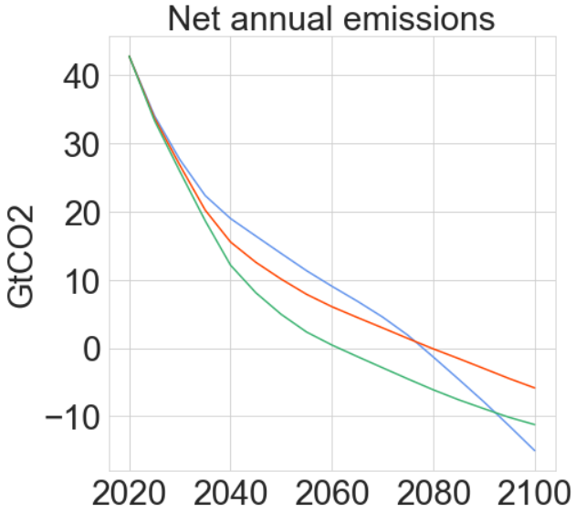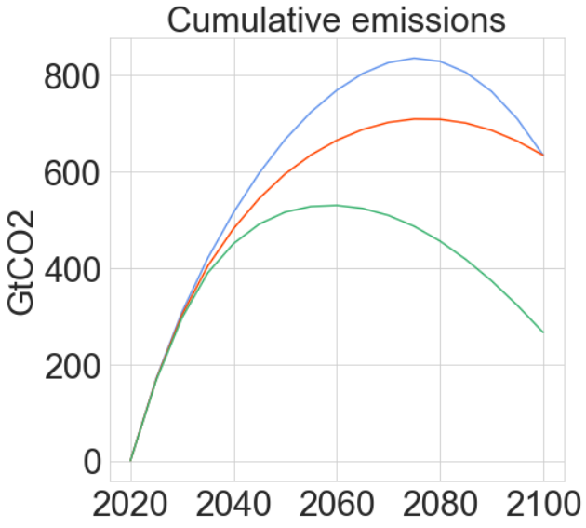
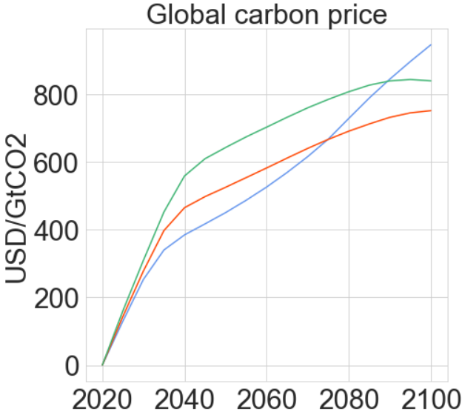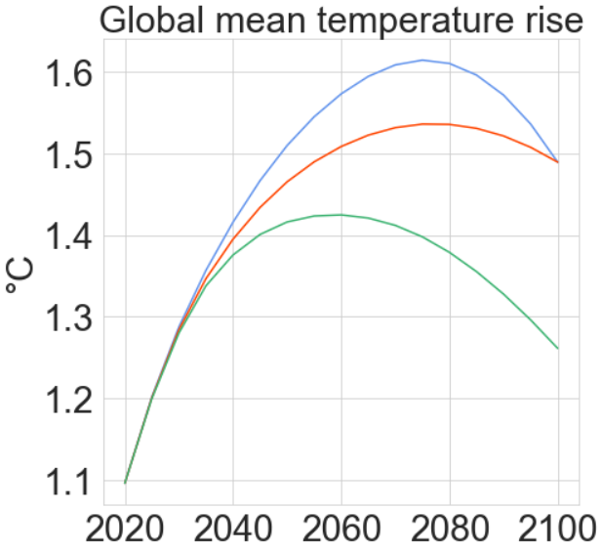
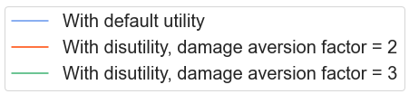
Figure SI.2.1. Optimal pathways with a fixed carbon budget of 633 GtCO₂. Panels, a: net annual emissions, b: cumulative emissions, c: population-weighted global carbon price, d: global mean temperature rise
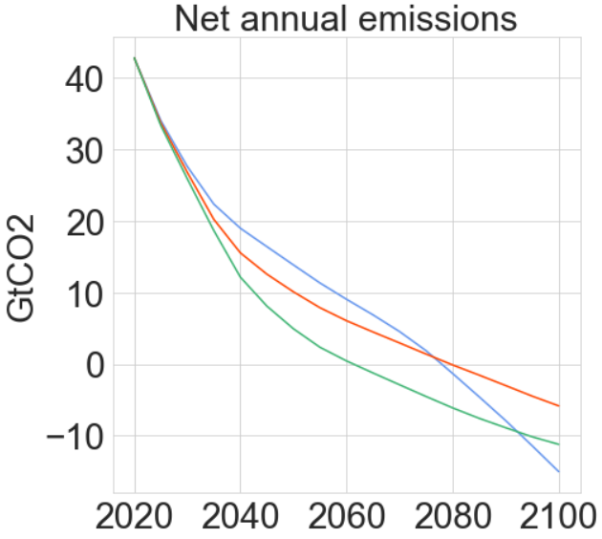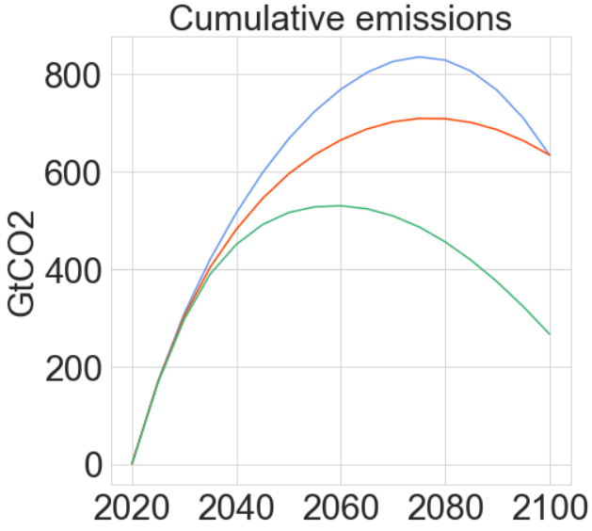
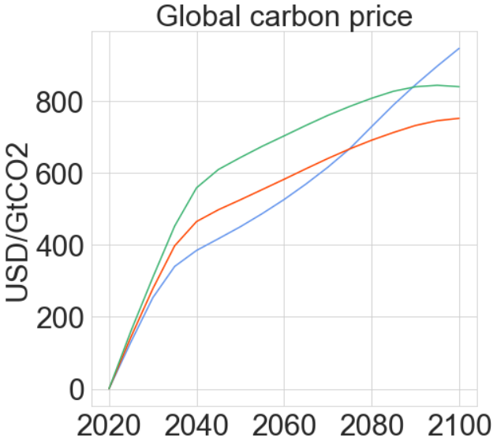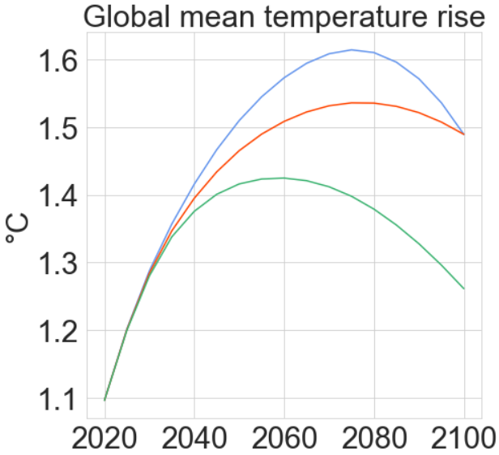
Figure SI.2.2. Optimal pathways with a fixed carbon budget of 1344 GtCO₂. Panels, a: net annual emissions, b: cumulative emissions, c: population-weighted global carbon price, d: global mean temperature rise

SI.3. Optimum pathways with a carbon budget 633 GtCO₂ across varying estimates of damage costs

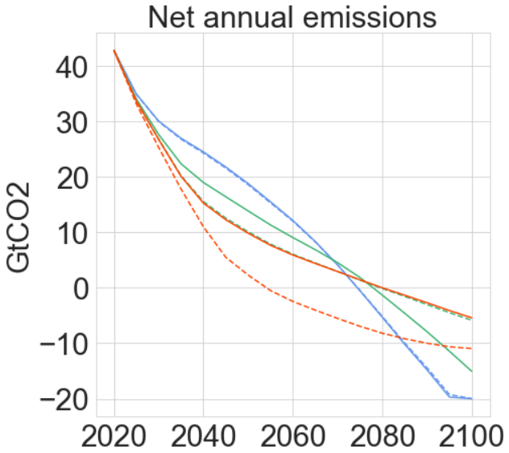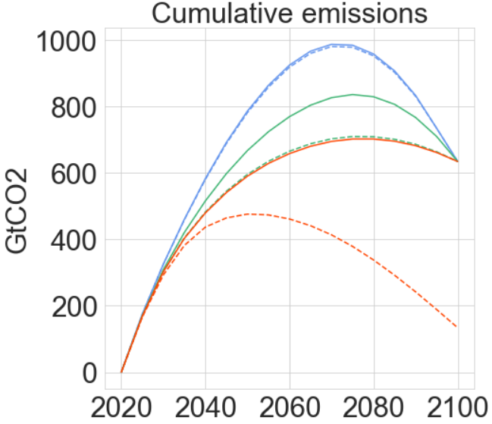
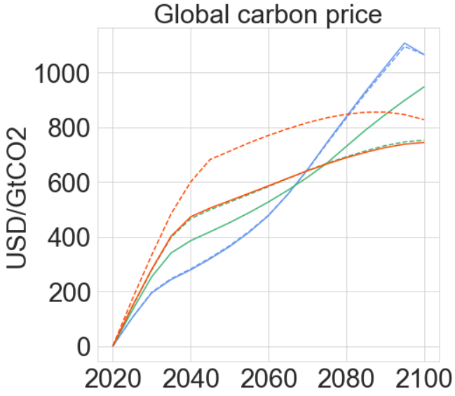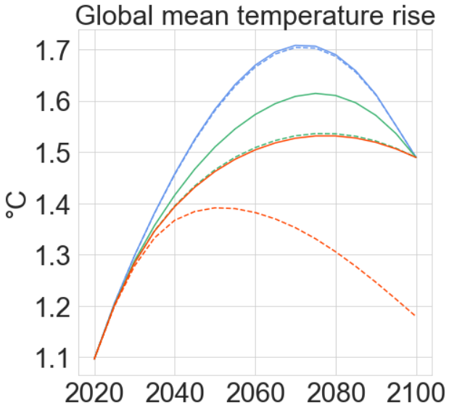

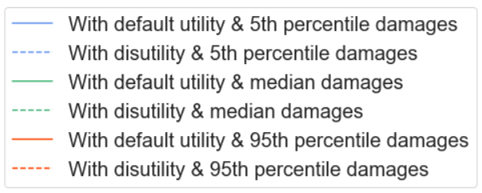
Figure SI.3. Impact of disutility (aversion factor 2) for low, median, and high COACCH damage function estimates. Panels, a: net annual emissions, b: cumulative emissions, c: population-weighted global carbon price, d: global mean temperature rise

SI.4. Optimum pathways with a carbon budget 633 GtCO₂ across varying discount rates

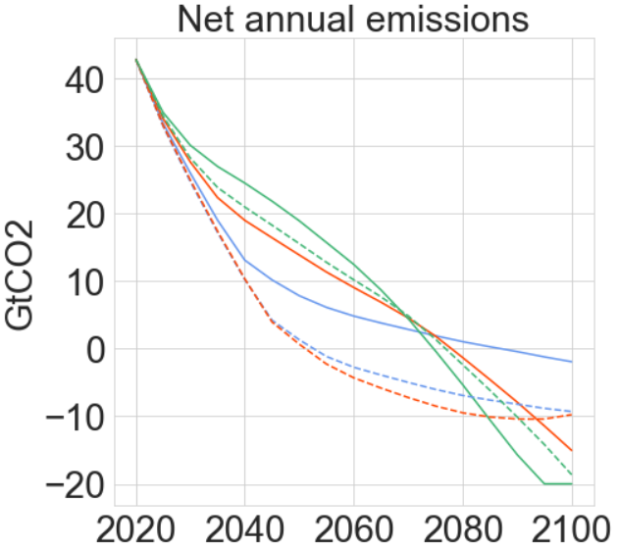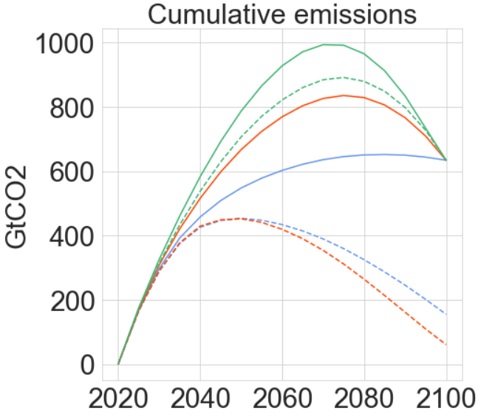
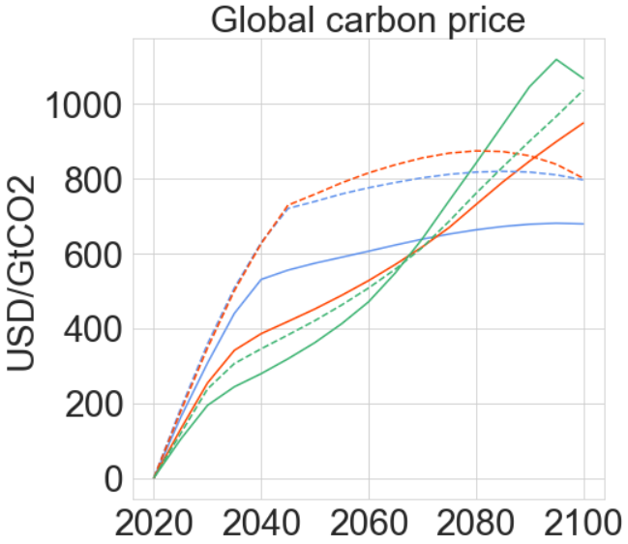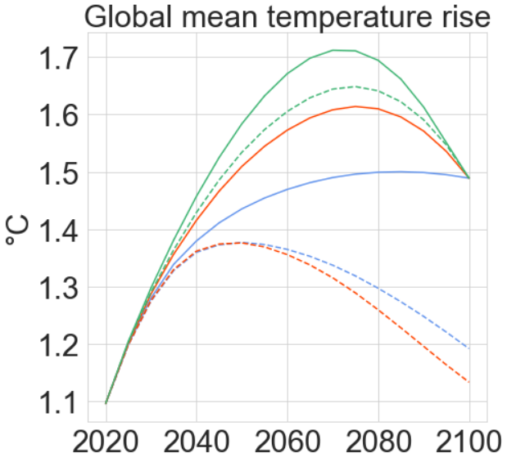
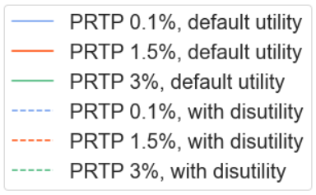
Figure SI.4. Impact of disutility (aversion factor 2) for varying discount rates (PRTP). Panels, a: net annual emissions, b: cumulative emissions, c: population-weighted global carbon price, d: global mean temperature rise
References
1. Tol, R. S. J., Downing, T. E., Kuik, O. J. & Smith, J. B. Distributional aspects of climate change impacts. Glob. Environ. Chang. 14, 259–272 (2004).
2. Kwakkel, J. H. The Exploratory Modeling Workbench: An open source toolkit for exploratory modeling, scenario discovery, and (multi-objective) robust decision making. Environ. Model. Softw. 96, 239–250 (2017).

