Supplementary information

Binding landscape of four seed-specific bZIP transcription factors in hexaploid wheat using Bind-n-seq in vitro analysis

Koushik Shah¹,Raminder Kaur¹,Nishtha Sharma¹, Prateek Jain¹ and Vikas Rishi¹*

¹National Agri-Food Biotechnology Institute, Knowledge City, Sector 81, Mohali, Punjab 140306, India
²Department of Biotechnology, Panjab University, Chandigarh, India

*To whom correspondence should be addressed.
Vikas Rishi, PhD (Scientist-F)
National Agri-Food Biotechnology Institute (Department of Biotechnology, Government of India)
Room No 028, Ground Floor, NABI Research Building, Knowledge City, Sector 81, Mohali Punjab, India-140306
Tel: +91 172 5221123
Email: vikasrishi@nabi.res.in; vrishi09@gmail.com
www.nabi.res.in

Supplementary Information:
Amino acid sequences of cloned bZIP TFs (all sequences represent DNA binding domains of bZIP proteins were cloned and in vitro expressed for studies.All expressed bZIP proteins have GST fusion tag at C-terminal).

AT-hy5(Long Hyptocol5) bZIP:
M G R T P A E K E N K R L K R L L R N R V S A Q Q A R E R K K A Y L S E L E N R V K D L E N K N S E L E E R L S T L Q N E N Q M L R H I L K N T T G N K R G G

TabZIP-1:
M P W M Q D E R E L K R Q K R K Q S N R D S A R R S R L R K Q A E C E E L A Q R A E V L K Q E N A S L K D E V S R I R K E Y D E L L S K N S S L K D N V G D K Q H K T D E A G L D N K L Q H S G D D S Q K D T N

TaEmbp-1:
M D E R E L K R E R R K Q S N R E S A R R S R L R K Q Q E C E E L A Q K V S E L T A A N G T L R S E L D Q L K K D C K T M E T E N K Q L M G K I L S H D D K M Q Q S E G P S V V T T L S I Q V E A P D P H Q G G D G K A S

TaABI-5:
M A P E D Q S C E R S I E R R H R R M I K N R E S A A R S R A R K Q A Y T V E L E A E L N H L K E E N A R L K A E E K T I L L T K K Q M L V E K M I E Q S K E N V N V K K G

TaABFB:
M E E D Q S C E R S I E R R H R R M I K N R E S A A R S R A R K Q A Y T V E L E A E L N H L K E E N A R L K A E E K T I L L T K K Q M L V E K M I E Q S K E N V

Supplementary Table S1:
List of primer sequences for cloning of seed-specific bZIPs NcoI-SacI sites in pETGEX-CT expression vector. Restriction sites(NcoI and SacI) used for cloning are underlined.
GENE | Primer sequences (5’>>>>>>>>3’)  (GA is added in Forward primer after NcoI site to keep protein in frame for expression_
AT-HY5 | Forward: TCATGCCATGGGAGGGAGGACACCGGCGGAGAAAG  Reverse: ACGATCGAGCTCACCTCCTCTCTTGTTTCCTGTTG
TaABI-5 | Forward: TCATGCCATGGGAGAGGATCAGTCCTGCGAGAGGA  Reverse: ACGATCGAGCTCACCCTTCTTGACGTTCACGTTC
TaABFB | Forward: TCATGCCATGGGACCAGAGGATCAGTCTTGCGAGA  Reverse: ACGATCGAGCTCCGAGAGGGGGGCACCCTTCTTG
TaEMBP-1 | Forward: TCATGCCATGGGAGATGAACGGGAACTGAAGAGG  Reverse: ACGATCGAGCTCAGTCACAACGCTAGGGCCCTC
Tabzip-1 | Forward: TCATGCCATGGGACCGTGGATGCAGGATGAACGTG  Reverse: ACGATCGAGCTCATTAGTGTCCTTCTGGCTGTCAT

Supplementary Table S2:
List of primer sequences used for seed-specific expression analysis of bZIPs using qRT-PCR
GENE | Primer sequences (5’>>>>>>>>3’)
TaABI-5 | Forward: AAGAACCGTGAGTCAGCCG  Reverse: GGACTGTTCTATCATCTTCTCC
TaABFB | Forward: CCC CAG AGG ATC AGT CTT G  Reverse: GTC TTC TCC TCG GCT TTC AG
TaEMBP-1 | Forward: TGC CGT TCC CCA TGT ACC A  Reverse: TCA GAT GAC CCC TGG CTC C
Tabzip-1 | Forward: CCC AGG CGC AGT TGA AGC A  Reverse: TGC ATC CAC GGC TCT GTT G

Supplementary Table S3.
List of oligomer and Primer sequences used in Bind-n-Seq for bZIP binding studies

Oligo | Sequence | Note
Bind-n-Seq 108 mer  Bind-n-Seq Random | 5′AATGATACGGCGACCACCGAGATCTACACTCGTCGGCAGCGTCAGATGTGTATAAGAGACAGCCACAAACGT(N¹⁴)GTCGTGGTAAATTTAATCGCAT 3′  5′AATGATACGGCGACCACCGAGATCTACACTCGTCGGCAGCGTCAGATGTGTATAAGAGACAGCCACAA(N¹⁸)GTCGTGGTAAATTTAATCGCAT 3′ | ACGT-box highlighted in bold (AAA) and barcode underlined.
Primer 1 | 5′- ATG CGA TTA AAT TTA CCA CGA C -3′ | Used in initial primer extension reaction.
Primer 2 | 5′-AAT GAT ACG GCG ACC ACC GAG ATC TAC ACT CTT TCC CTA CAC GAC GCT CTT CCG ATC T-3′ | Used in final PCR amplification reaction.
Primer 3 | 5′-CAA GCA GAA GAC GGC ATA CGA GAT CGT GAT GTG ACT GGA GTT CAG ACG TGT GCT CTT CCG ATC TCA AGC AGA AGA CGG CAT ACG A-3′ | Used in final PCR amplification reaction.

Supplemental Methods

1. Bind-n-Seq library preparation and sequencing
For sequencing , adaptors were added to amplicon libraries using QIAseq 1-Step Amplicon library kit (Qiagen, USA) and compatible with the Illumina (MiSeq) NGS platform. All output DNA were quantified using fluorometric method (RT-PCR) and usually had 50-100 ng multiplex PCR product in 20 µl elution buffer. All the reagents were placed on ice, 20-25 µl of the DNA sample from each protein mixed with 12.5 µl 1-step amplicon mix buffer (4x),4 µl of QIAseq adaptors and 2 µl of Amplicon enzyme mix was added and final volume was made up to 50 µl with water. After ideal mixing by pipetting and a quick spin, the mixture tube was placed in the thermo cycler at 25˚C for 30 minutes. After completion of reaction, mix was put on ice followed by clean up step using Pronex size selection beads to remove adaptor dimers.
Pronex size selection beads (Promega, USA) were placed at room temperature and resuspended by brief vortexing on vortex mixer. The ligation reaction transferred to a labeled Lobind tubes (Thermo scientific) and 50 µl water was added, ensured the correct PEG concentration for bead-DNA binding. The reaction was mixed well by pipetting up and down several times, then 75 µl of the beads were added to ligation mixture and incubated at RT for 10 minutes. The tube was placed on a magnetic stand to separate the beads from the supernatant and left for 10 minutes until the solution was clear. The supernatant was then carefully transferred to new tube without disturbing the beads that contained the unwanted DNA targets. 75 µl of Pronex beads were added to mixed well and incubated for 10 minutes.The beads were washed by adding 200 µl of 80% (v/v) freshly prepared ethanol (CDH). The washing step was repeated for two times and beads were air dried for 10 minutes. To elute the DNA target from the beads, 25 µl of elution buffer (Promega) was added, mixed by pipetting, quickly centrifuged and then placed on the magnetic stand until the solution was clear.

Finally, 23.5 µl of the solution is transferred to a new PCR tube. The 23.5 µl of the adaptor ligated DNA was mixed with 25 µl QIAseq HiFi 2XPCR master mix and 1.5 µl of Primer mix.
50 µl of the beads were added to the 50 µl of PCR reaction mixture, mixed by pipetting and vortexing before incubation for 5 minutes at RT. The cleanup and washing steps for amplified library were similar to above clean up method.To elute the DNA target from the beads, 25 µl of 0.1X TE (Promega) was added, mixed by pipetting, quickly centrifuged and then placed on the magnetic stand until the solution was clear. Finally, 20 µl of the supernatant was transferred to a new PCR tube and stored at -20°C until use.
The resulting pooled library was diluted to 2nM with NaOH and 10μL transferred into 990 μL Hybridization Buffer (HT1) (Illumina) to give a final concentration of 10 pM. A volume of 600 μl of the diluted library pool was spiked with 10% PhiX control v3 and placed on ice before loading into the Illumina MiSeq cartridge following the manufacturer’s instructions.The MiSeq Reagent Kit v3 (150 cycles) sequencing chemistry was utilized with run metrics of 150 cycles for paired end read using MiSeq Control Software 2.4.1.3 and Real-Time Analysis (RTA) 1.18.54. The multiplexed sample of DNA template was sequenced with Illumina MISeq system with (75bp) reads in two directions with paired end sequencing. The obtained reads were filtered and sorted according to their barcode tags. Filters included definite base calling (A, C, G and T), valid barcode(4bp) and constant leader bases (2bp), and unique random sequence was the length of 18 bp. After quality control, the „clean‟ data of 108-mer reads was obtained and used in bioinformatics analyses.
The motif analysis was performed with MEME 4.5.0 in parameters of –dna – comp –w 6+18 –n motifs. The fold enrichment of a motif was calculated as the ratio of the reads containing the motif in a selected binding reaction. Reads were calculated for the occurrence of motifs using FIMO of MEME software with a threshold score of P-value of 0.001. Sequence and frequency logos of binding motifs were generated using the WEBLOGOS web tool (Crooks et al., 2004)

2. Gene ontology and functional enrichment analysis
GO analysis of seed-specific bZIPs was performed to predict the functions of bZIP proteins. All bZIPs ABI5,ABFB,bZIP1 and Embp1 transcript and gene Id were submitted in goprofiler functional enrichment analysis tool. bZIPs were potentially involved biological processes in common such as positive regulation of metabolic processes, regulation of the cellular process, organic substance metabolic process, primary metabolic process, regulation of the metabolic process, biosynthetic process, cellular metabolic process, nitrogen compound metabolic process. In addition, all bZIPs were involved in molecular function as protein binding, heterocyclic compound binding, transcription factor activity sequence-specific DNA binding.

LEGENDS OF SUPPLEMENTARY FIGURES:
Supplementary Figure S1: Protein expression of TaABI-5, Embp-1 and ABFB. Figure (A) SDS PAGE of expressed GST tagged TaABI-5 and Embp-1 bZIP proteins: BI (Before Induction), 1 hr AI (After Induction), 2 hr AI, 3 hr AI and AD (After dialysis). Arrow indicate the expressed bZIP protein in E. coli system. (B) Expression and purification of TaABFB protein. Protein expression and SDS-PAGE analysis of TabZIP-1 and Hy5. Figure (A) SDS PAGE of expressed GST tagged At-Hy5 and TabZIP-1 proteins: BI (Before Induction), 1 hr AI (After Induction), 2 hr AI, 3 hr AI. Arrow indicate the expressed bZIP protein in E. coli system. (B) Expression and purification of TabZIP-1 protein.

Supplementary Figure S2: Quantification GST tagged bZIP protein. Concentrations of proteins were estimated by absorption spectrum from 320 nm to 220nm. GST tagged bZIP proteins concentration was estimated by taking absorption at 280 nm which gives sharp peak due to aromatic amino acid tyrosine and tryptophan. Figure 31│Quantification GST tagged bZIP protein. Concentrations of proteins were estimated by absorption spectrum from 320 nm to 220nm. GST tagged bZIP proteins concentration was estimated by taking absorption at 280 nm which gives sharp peak due to aromatic amino acid tyrosine and tryptophan.

Supplementary Figure S3 Bind-n-seq libraries synthesis and conditions used for binding (A) Figure shows the various experimental conditions of salt (10 to 300m) and protein (5 nM to 500 nM) concentration, GS (Gel-shift) affinity capture and random core for Bind-n-Seq in vitro methodology.(B) Figure shows PCR amplification of single stranded oligo library (ACGT core) and random core library by primer extension. Size selection was performed on 2.5% agarose gel.

Supplementary Figure S4: Figure describes overview of the Sequencing Analysis Software (SAV) for MiSeq (75bpⅹ2) run. It shows the distribution of different parameters (intensity, Q30, Error rate, Density PF). This schematic view checks if any specific area of the flow cell is affected. (A) “Data by Cycle”, describe a graph in which different factors intensities, percentage of bases and, the Q30 were inspected lane by lane per each cycle. (B) The “QScore Distribution” graph shows the percentage of bases with a Q- Score above 30 which is logarithmically correlated to the base calling error probability. Therefore, a Q-score of 30 (Q30) indicate the probability of inserting one incorrect base every 1,000 times (base call accuracy of 99.9%). (C) The “Data by Lane” shows the density of reads that passed through filter (D) The Q-Score Heat Map provides an overview of quality scores across each cycle of sequencing. All values were checked and analysed before processing of sequencing data.

Supplementary Figure S5: Manhattan plot describes go profiler functional enrichment analysis of bZIP transcription factors. On this plot, the x-axis shows the terms and y-axis shows the enrichment P-values on − log10 scale. Each circle on this plot corresponds to a single term.All bZIPs were potentially involved in several important biological processes in common such as positive regulation of metabolic processes, regulation of the cellular process, protein binding, heterocyclic compound binding, transcription factor activity sequence-specific DNA binding.

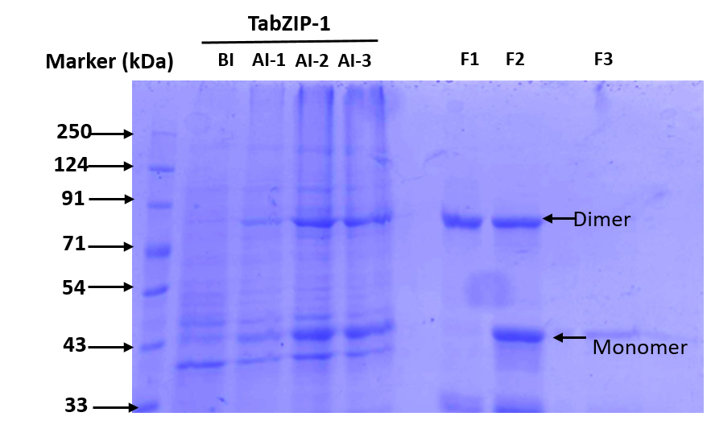
Supplemental Figure1
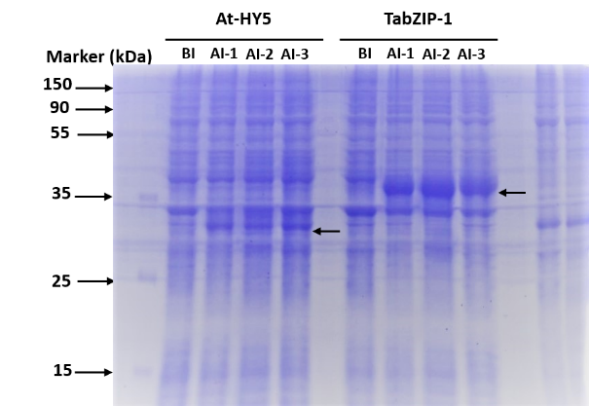

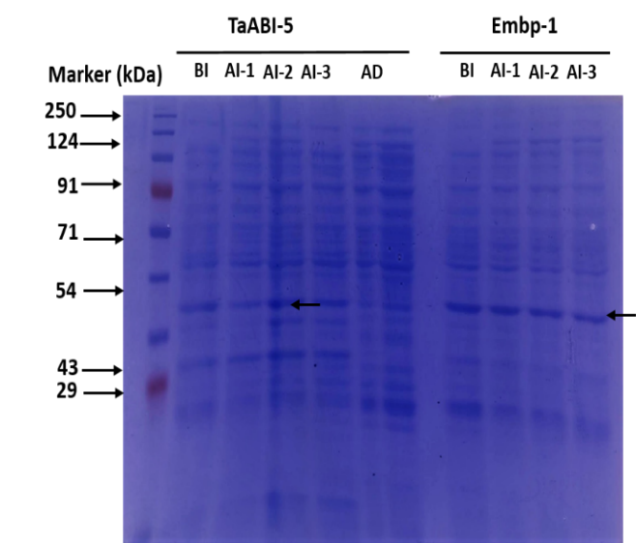
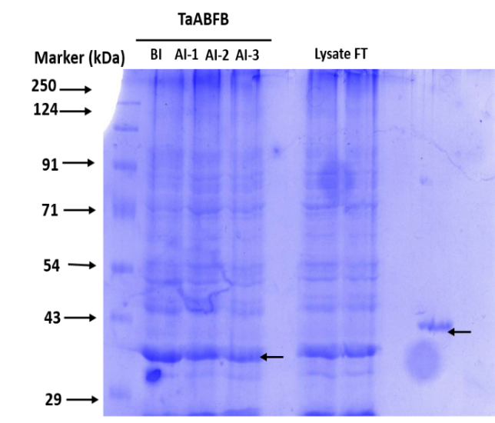

Supplemental Figure2
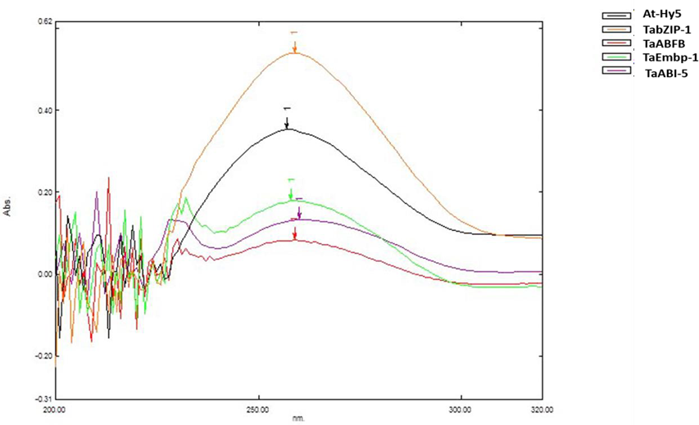

Supplementary Figure 3. Bind-n-seq Library design and synthesis for bZIP binding

Supplemental Figure 3
(A)

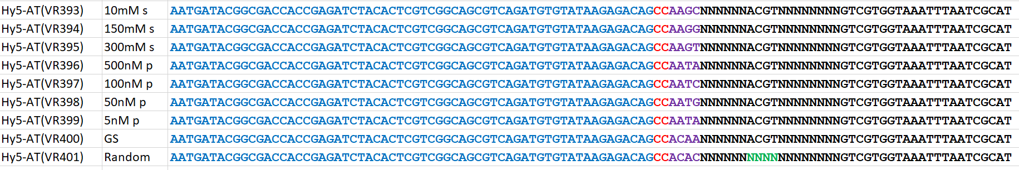

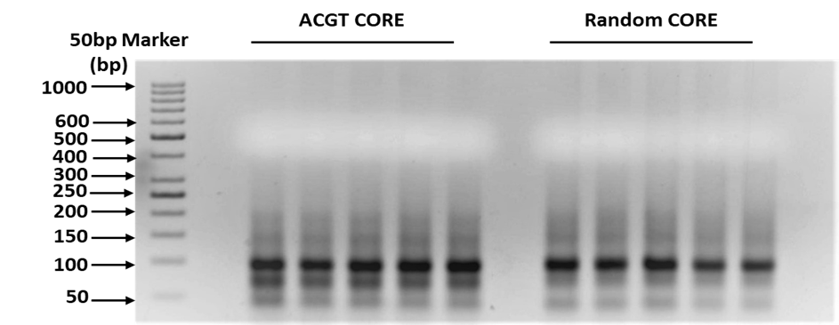

(B)

Supplemental Figure 4

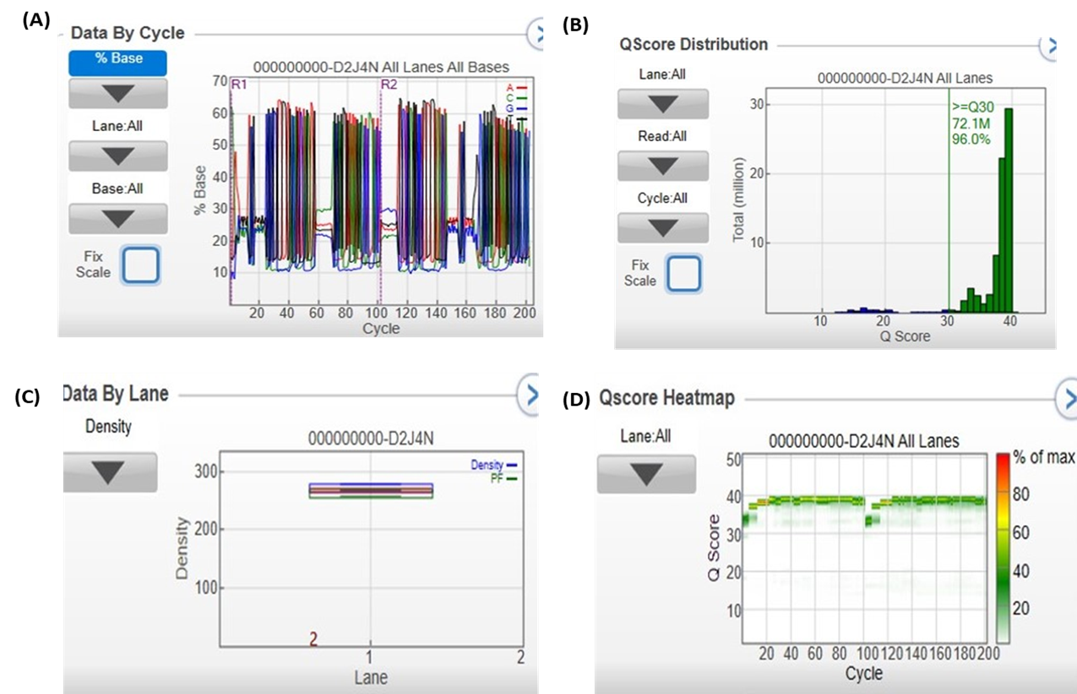

Supplementary Figure.5

Supplementary Table 4│DNA binding specificities of At-Hy5 bZIP in different salt and protein concentrations

S. No. | bZIP protein | Salt and protein concentrations | Binding site (Frequency logo)
1. | At-HY5 | 10 mM salt (KCl) | 
2. | At-HY5 | 150 mM salt (KCl) | 
3. | At-HY5 | 300 mM salt (KCl) | 
4. | At-HY5 | 500 nM protein | 
5. | At-HY5 | 100 nM protein | 
6. | At-HY5 | 50 nM protein | 
7. | At-HY5 | 5 nM protein | 
8. | At-HY5 | GS affinity | 
9. | At-HY5 | Random Core | 

Supplementary Table 5. DNA binding specificities of TaABI-5 bZIP in different salt and protein concentrations

S. No. | bZIP protein | Salt and protein concentration | Binding site (Frequency logo)
1. | TaABI-5 | 10 mM salt (KCl) | 
2. | TaABI-5 | 150 mM salt (KCl) | 
3. | TaABI-5 | 300 mM salt (KCl) | 
4. | TaABI-5 | 500 nM protein | 
5. | TaABI-5 | 100 nM protein | 
6. | TaABI-5 | 50 nM protein | 
7. | TaABI-5 | 5 nM protein | 
8. | TaABI-5 | GS affinity | 
9. | TaABI-5 | Random Core | 

Supplementary Table 6. DNA binding specificities of TaABFB bZIP in different salt and protein concentrations

S.No. | bZIP protein | Salt and protein  concentration | Binding site  (Frequency logo)
1. | TaABFB | 10 mM salt (KCl) | 
2. | TaABFB | 150 mM salt (KCl) | 
3. | TaABFB | 300 mM salt (KCl) | 
4. | TaABFB | 500 nM protein | 
5. | TaABFB | 100 nM protein | 
6. | TaABFB | 50 nM protein | 
7. | TaABFB | 5 nM protein | 
8. | TaABFB | GS affinity | 
9. | TaABFB | Random Core | 

Supplementary Table 7. DNA binding specificities of TabZIP-1 bZIP in different salt and protein concentrations

S.No. | bZIP protein | Salt and protein concentration | Binding site (Frequency logo)
1. | TabZIP-1 | 10 mM salt (KCl) | 
2. | TabZIP-1 | 150 mM salt (KCl) | 
3. | TabZIP-1 | 300 mM salt (KCl) | 
4. | TabZIP-1 | 500 nM protein | 
5. | TabZIP-1 | 100 nM protein | 
6. | TabZIP-1 | 50 nM protein | 
7. | TabZIP-1 | 5 nM protein | 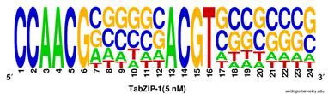
8. | TabZIP-1 | GS affinity | 
9. | TabZIP-1 | Random Core | 

Supplementary Table 8. DNA binding specificities of TabZIP-1 bZIP in different salt and protein concentrations

S. No. | bZIP  protein | Salt and protein  concentration | Binding site  (Frequency logo)
1. | TaEmbp-1 | 10 mM salt (KCl) | 
2. | TaEmbp-1 | 150 mM salt (KCl) | 
3. | TaEmbp-1 | 300 mM salt (KCl) | 
4. | TaEmbp-1 | 500 nM protein | 
5. | TaEmbp-1 | 100 nM protein | 
6. | TaEmbp-1 | 50 nM protein | 
7. | TaEmbp-1 | 5 nM protein | 
8. | TaEmbp-1 | GS affinity | 
9. | TaEmbp-1 | Random Core | 

