Supporting Information
An acid-triggered reactive and enhanced fluorescent probe for selective detection of Al³⁺/H⁺ and its application in real water samples and living cells
Zhigang Li ª, Bing Zhao ^{a, b}*, Wei Kan ^{a, b}*, Fanqiang Bu ª, Xin Qi ª, Liyan Wang ^{a, b}, Bo Song ^{a, b}, Limin Ding ^{c}
ª Chemistry and Chemical Engineering Institute, Qiqihar University, Qiqihar 161006, China
^{b} Heilongjiang Provincial Key Laboratory of Surface Active Agent and Auxiliary, Qiqihar University, Qiqihar 161006, China
^{c} Cadre Ward, First Hospital of Qiqihar City, Qiqihar 161005, China

Contents
Fig. S1 The ¹H NMR spectrum of di-PIP.
Fig. S2 The ¹³C NMR spectrum of di-PIP.
Fig. S3 ESI−MS of di-PIP.
Fig. S4 The naked eye effect of di-PIP after adding various metal ions under daylight and 365 nm UV-vis light.
Fig. S5 Job plot for the determination of the stoichiometry of di-PIP and Al³⁺ in the complex in DMF/ HEPES buffer solution (7:3, v/v, pH = 7.40) solution.
Fig. S6 The emission spectra of anti-interference experiments of di-PIP (10 μmol·L^{–1}) with Al³⁺(20 μmol·L^{–1}) and various metal ions (40 μmol·L^{–1}).
Fig. S7 The pH reversibility study of di-PIP in PBS buffer between pH 3 and pH 8.
Fig. S8 Plot of pH vs log[(I_{max}-I)/(I-I_{min})]. The x-intercept is the pK_{a} value 5.21 of the probe.
Fig. S9 ¹H NMR spectra of PI-aniline.
Fig. S10 ESI-mass spectrum of di-PIP+Al³⁺ complex.
Fig. S11 Cell viability of HeLa cells stained with different concentrations (0~50 μμmol·L^{–1}) of di-PIP.

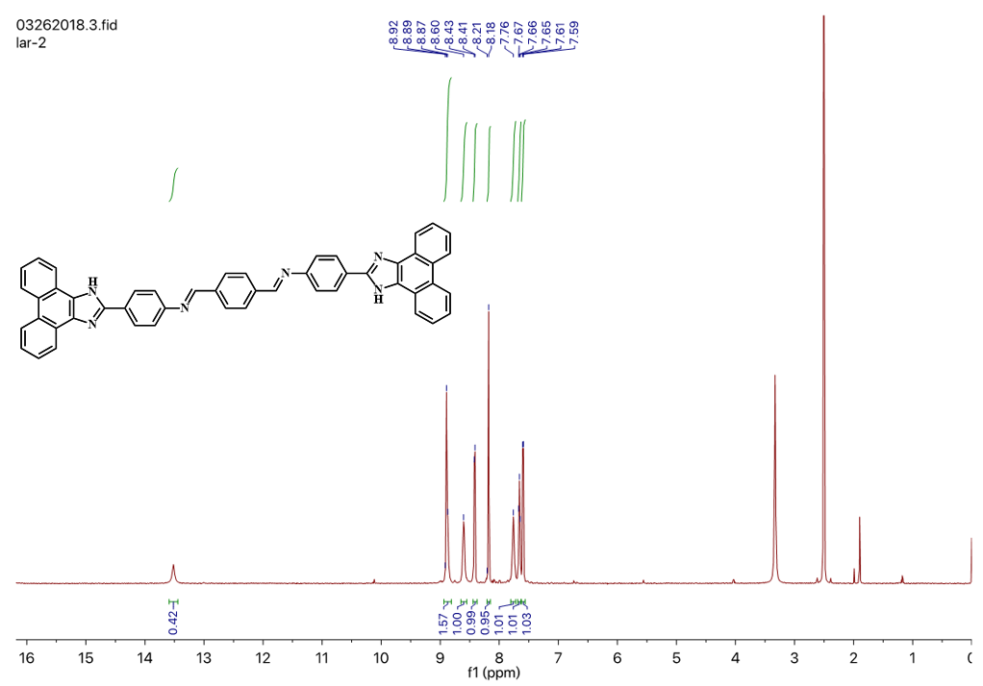
Fig. S1 The ¹H NMR spectrum of di-PIP.

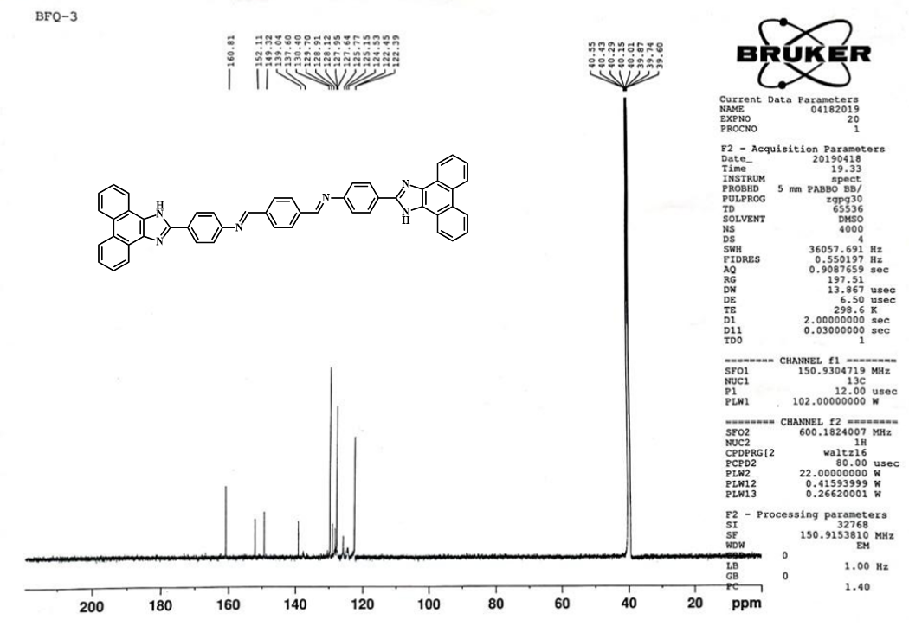
Fig. S2 The ¹³C NMR spectrum of di-PIP.

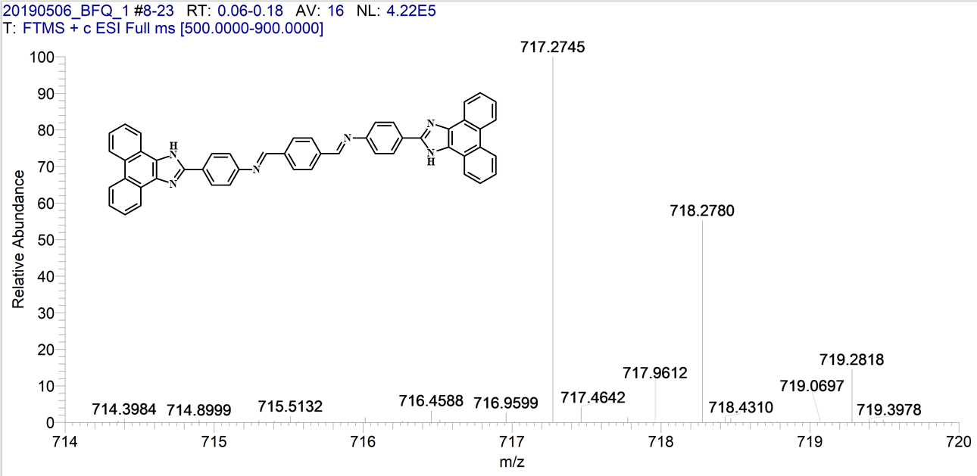
Fig. S3 ESI−MS of di-PIP.

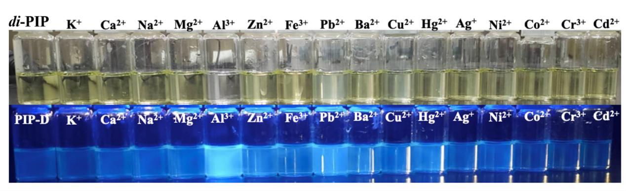
Fig. S4 The naked eye effect of di-PIP after adding various metal ions under daylight and 365 nm UV-vis light.

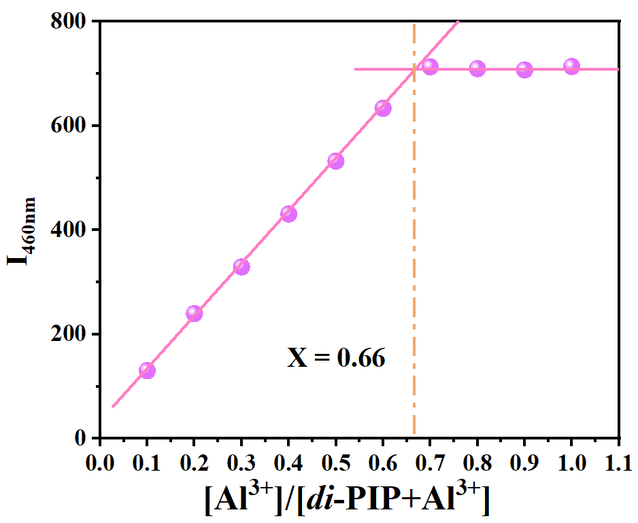
Fig. S5 Job plot for the determination of the stoichiometry of di-PIP and Al³⁺ in the complex in DMF/HEPES buffer solution (7:3, v/v, pH = 7.40) solution.

Fig. S6 The emission spectra of anti-interference experiments of di-PIP (10 μmol·L^{–1}) with Al³⁺(20 μmol·L^{–1}) and various metal ions (40 μmol·L^{–1}).

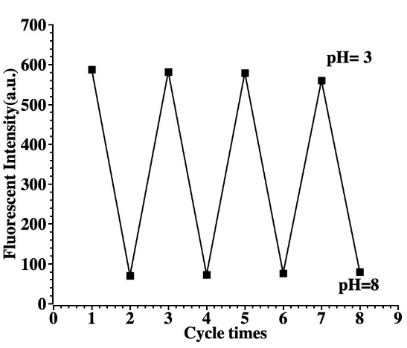
Fig. S7 The pH reversibility study of di-PIP in PBS buffer between pH 3 and pH 8.

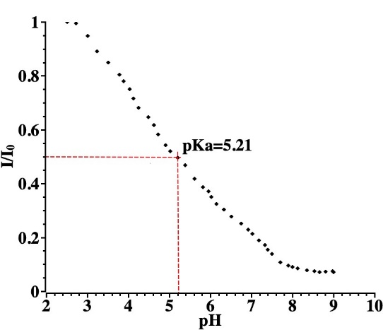
Fig. S8 Plot of pH vs log[(I_{max}-I)/(I-I_{min})]. The x-intercept is the pK_{a} value 5.21 of the dye.

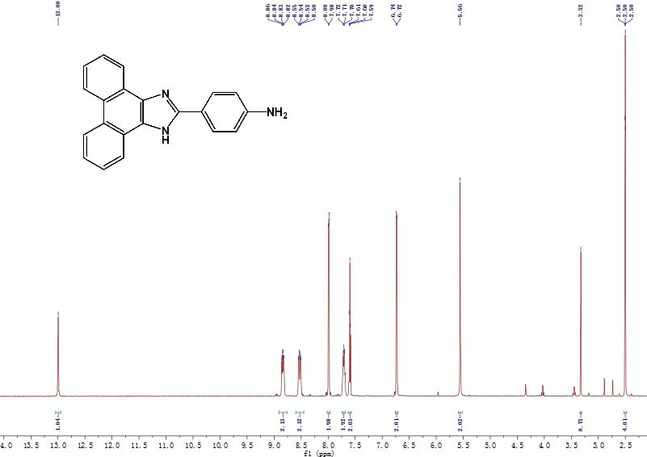
Fig. S9 ¹H NMR spectra of PI-aniline.

Fig. S10 ESI-mass spectrum of di-PIP+Al³⁺ complex.

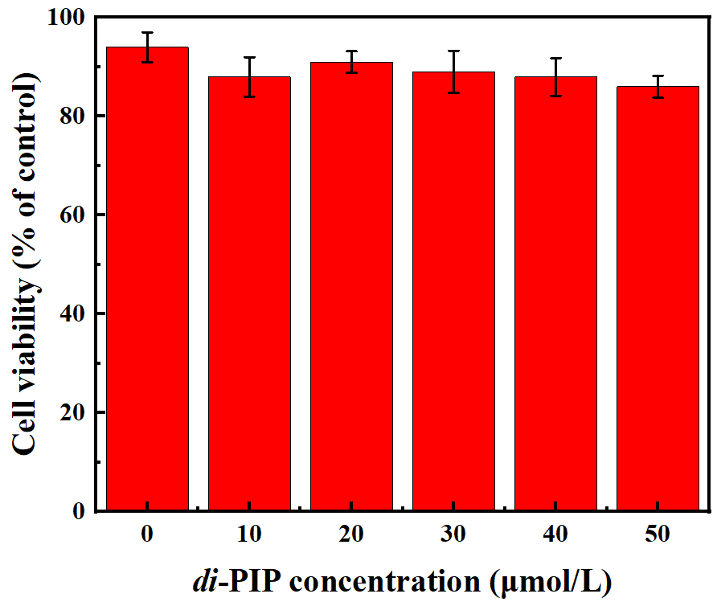
Fig. S11 Cell viability of HeLa cells stained with different concentrations (0~50 μmol·L^{–1}) of di-PIP.

* Corresponding authors. Tel.: +86 452 2738948; fax: +86 452 2738948. E-mail address: zhao_submit@aliyun.com (Bing Zhao)
* Corresponding authors. Tel.: +86 452 2738948; fax: +86 452 2738324. E-mail address: kan_submit@aliyun.com (Wei Kan)

