Supporting information 1 for:
Priority planting area planning for L. chuanxiong under soil Cd pollution and climate change
Ping Heª, Tongtong Huoª, Fanyun Mengª, Cheng Peng^{b}
ªFaculty of Geographical Science, Beijing Normal University, Beijing 100875 China
^{b}School of Pharmacy, Chengdu University of TCM, Chengdu 611137 China
*Corresponding author: Fanyun Meng (mfy@bnu.edu.cn)
Contents of this file:
Figures S1, S2, S3, and S4.
Table S1.

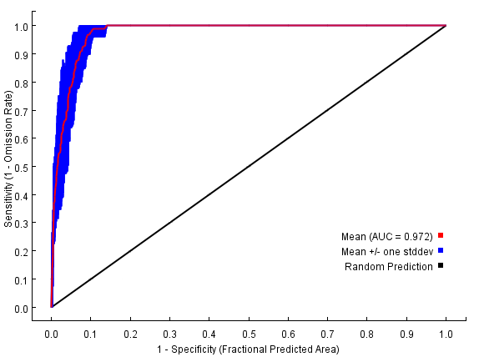
Fig. S1. AUC training values for L. chuanxiong under current climate changes.

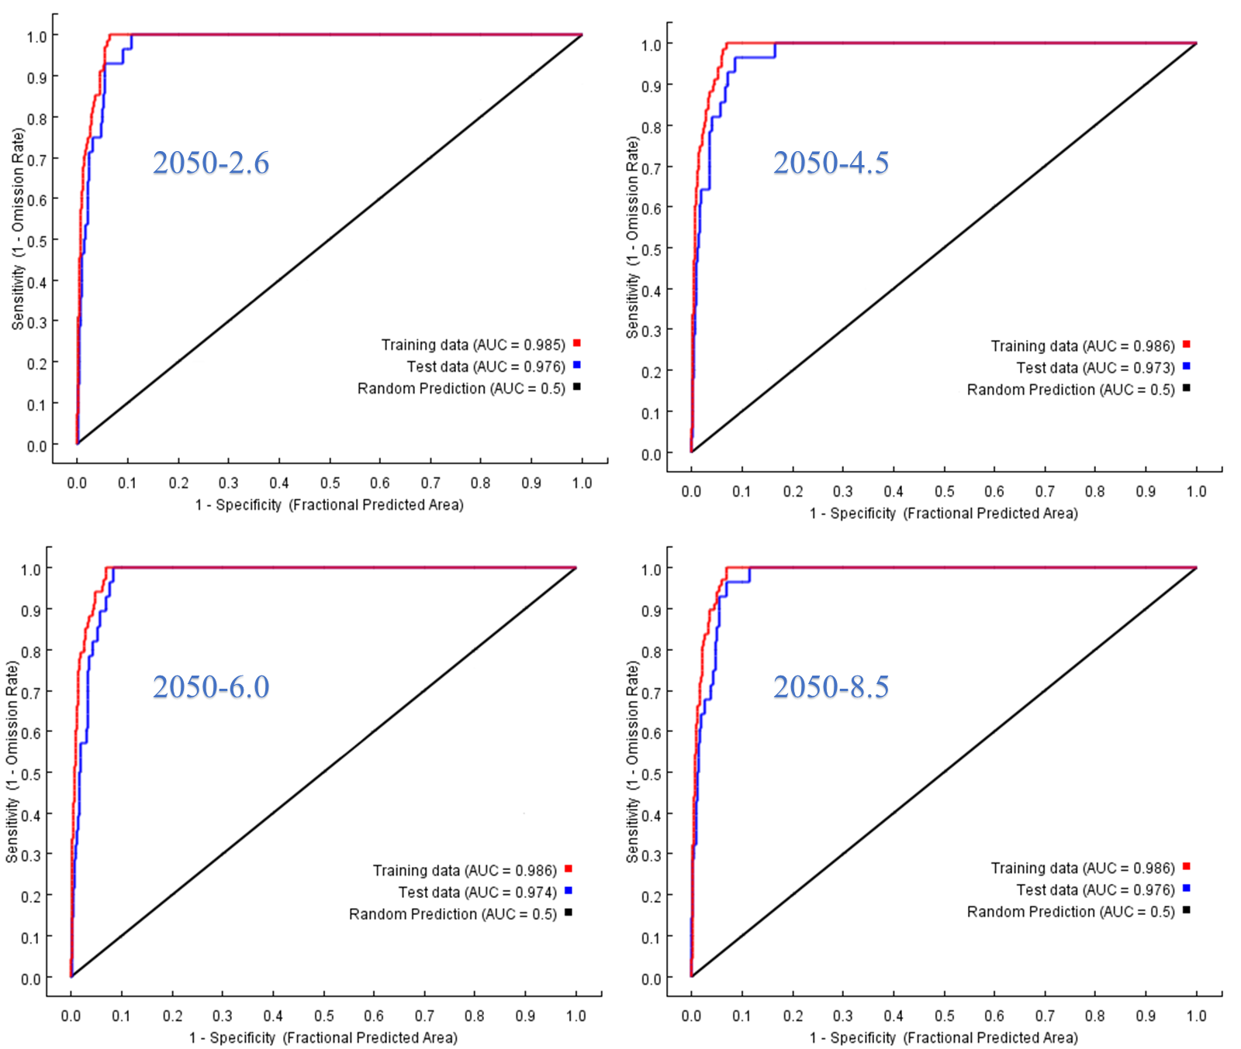
Fig. S2. AUC training values for L. chuanxiong in 2050.
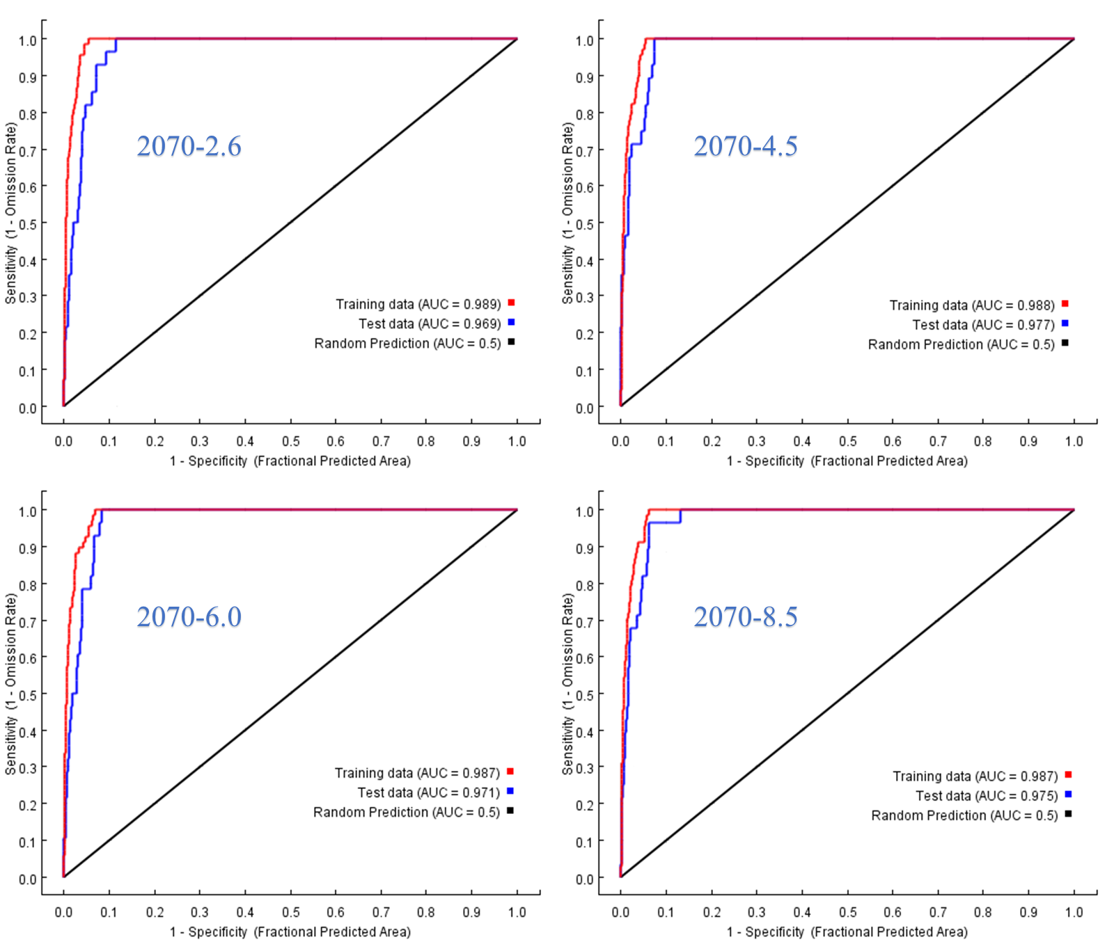
Fig. S3. AUC training values for L. chuanxiong in 2070.\
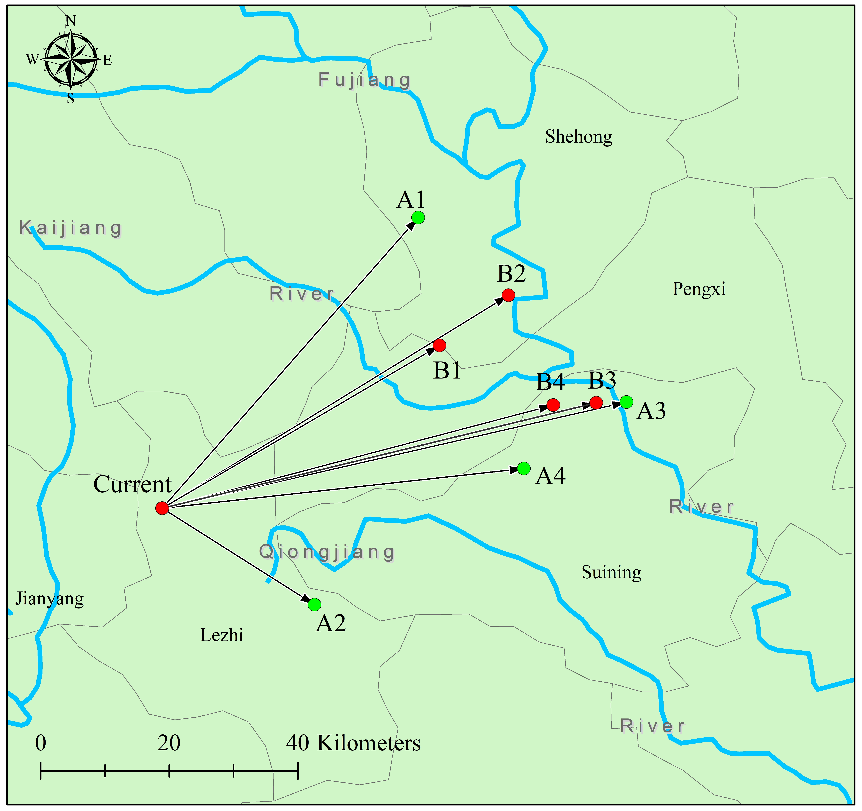
Fig. S4. Migration trend of the centroid of highly and moderately suitable areas for L. Chuanxiong under future climate change.

Table S1. Number of occurrences of the top ten counties under each soil cadmium pollution forecast scenario.
County | Occurrences in 2050 |  |  | Occurrences in 2070
County | Optimistic | Default | Pessimistic | Optimistic | Default | Pessimistic
ZiYang | / | / | / | 4 | 8 | 4
Chongqing | / | / | / | 4 | 8 | 4
Pingwu | 4 | 4 | / | / | / | /
Guanyuan | 4 | / | 7 | / | / | /
Renshou | / | 8 | 4 | / | / | /
Jiange | / | 4 | 4 | / | / | /
Qionglai | / | 4 | / | / | / | 4
Pujiang | / | 4 | / | / |  | 4
Wangcang | / | / | 4 | / | / | 6
Zigong | / | / | / | 4 | 4 | /
Zhongjiang | / | / | / | 4 | 4 | /
Yanyuan | / | / | / | / | 4 | 8
Yanbian | / | / | / | / | 4 | 7
Yibin | / | / | / | / | 8 | 4
Chongqing | 4 | / | / | / | / | /
Shizhu | 4 | / | / | / | / | /
Pengshui | 4 | / | / | / | / | /
Wulong | 4 | / | / | / | / | /
Pengshan | / | 4 | / | / | / | /
Meishan | / | 4 | / | / | / | /
Shuangliu | / | 4 | / | / | / | /
Rong | / | 4 | / | / | / | /
Cangxi | / | / | 5 | / | / | /
Zhong | / | / | / | 4 | / | /
Zhenping | / | / | / | 4 | / | /
Zhen’an | / | / | / | 4 | / | /
Youyang | / | / | / | 4 | / | /
Xiushan | / | / | / | 4 | / | /
Xiaojin | / | / | / | 4 | / | /
Zitong | / | / | / | / | 4 | /
Zizhong | / | / | / | / | 7 | /
Changshou | / | / | / | / | 7 | /
Chnagning | / | / | / | / | 4 | /
Ningqiang | / | / | / | / | / | 4
Nanzheng | / | / | / | / | / | 4
Nanping | / | / | / | / | / | 4
Nanjiang | / | / | / | / | / | 4
Mingshan | / | / | / | / | / | 4
Yilong | / | / | / | / | / | 4
Xinjin | / | / | / | / | / | 4

Corresponding author (mfy@bnu.edu.cn);

