Supporting Information
Unsaturated phospholipid modified FeOCl nanosheets for enhancing tumor ferroptosis
Zi He†, Yijun Guo†, Jinzhu Chen, Huiling Luo, Xinxin Liu, Xiuming Zhang, Yanan Sun, Dongtao Ge*, Shefang Ye*, Wei Shi*
The Higher Educational Key Laboratory for Biomedical Engineering of Fujian Province/Research Center of Biomedical Engineering of Xiamen, Department of Biomaterials, College of Materials, Xiamen University, Xiamen, 361005, China

†Zi He and Yijun Guo contributed equally to this work.
*Correspondence: gedt@xmu.edu.cn, yeshefang@xmu.edu.cn, shiwei@xmu.edu.cn

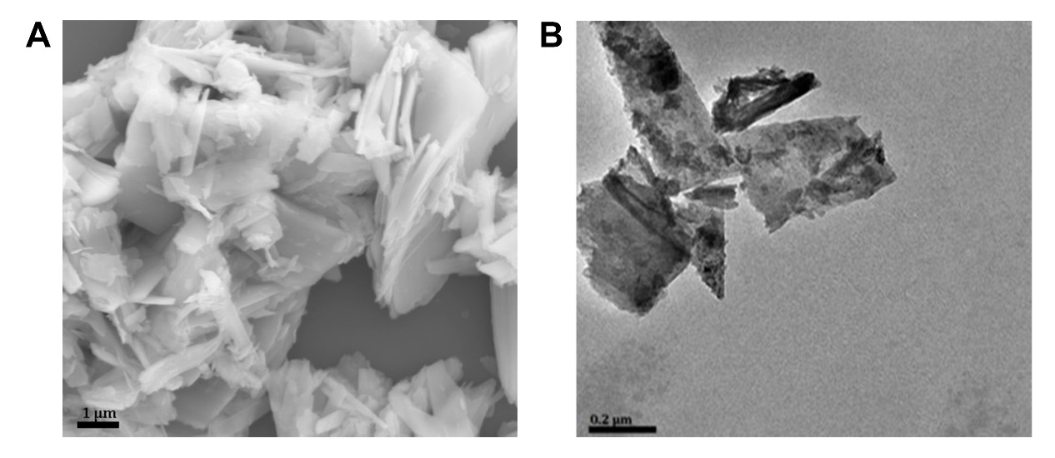
Fig. S1 (A) SEM images of FeOCl plate. (B) TEM images of FeOCl plate.

Fig. S2 XRD pattern of FeOCl before and after exfoliation.

Fig. S3 XPS spectrum of FeOCl before and after exfoliation.

Fig. S4 The release curves of iron in different pH from FeOCl before and after exfoliation.

Fig. S5 The ESR spectra of FeOCl, FeOCl@PAA and FeOCl@PAA-Lip at pH 7.4, pH 6.5 and pH 5.0.

Fig. S6 (A) The TA fluorogram of FeOCl@PAA in different pH conditions. (B) Comparison of TA fluorescence values at 426 nm between FeOCl@PAA and FeOCl@PAA-Lip under different pH conditions.
Fig. S7 (A) The degradation curve of MB after treatment with FeOCl@PAA in different concentration of H₂O₂. (B) Comparison of MB absorbance value between FeOCl@PAA and FeOCl@PAA-Lip at 660 nm in different concentration of H₂O₂.

Fig. S8 Calcein-AM/PI straining of 4T1 cells treated with FeOCl@PAA, FeOCl@PAA-Lip, FeOCl@PAA+H₂O₂ and FeOCl@PAA-Lip+H₂O₂.

Fig. S9 Blood biochemical indexes aspartate aminotransferase (AST), (alanine aminotransferase (ALT), alkaline phosphatase (ALP), creatinine (CREA) and urea nitrogen (BUN) indicators) of mice treated with PBS, FeOCl@PAA and FeOCl@PAA-Lip after 7 days.
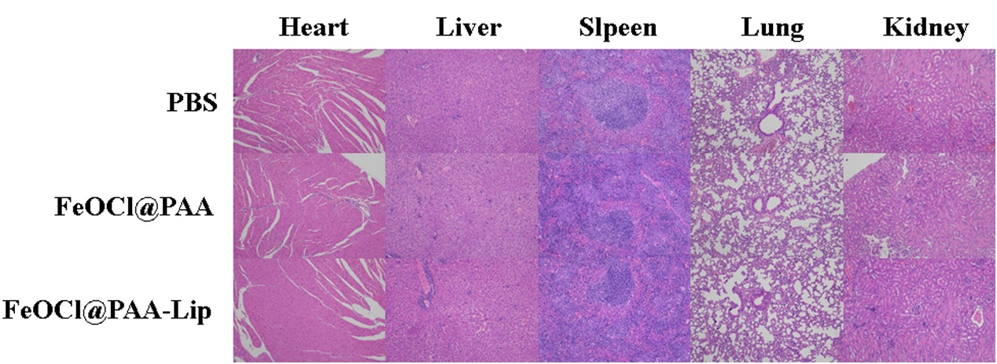
Fig. S10 H&E-stained images of the major organs of mice treated with PBS, FeOCl@PAA and FeOCl@PAA-Lip after 14 days.

