Supplementary figures legend.
Fig.1 Image showed SNPs and GAPs between EG.SmE2 isolate (MW311371.1) and the nearest sequence (MT621365.1) deposited in GenBank
Fig.2 Image showed SNPs and GAPs between EG.SmE1 isolate (MW311328.1) and the nearest sequence (MT621365.1) deposited in GenBank
Fig.3 Image showed SNPs and GAPs between EG.SmT3 isolate (MW310702.1) and the nearest sequence (MT621352.1) deposited in GenBank
Fig.4 Image showed SNPs and GAPs between EG.SmT2 isolate (MN822653.1) and the nearest sequence (CP051276.1) deposited in GenBank
Fig.5 Image showed SNPs and GAPs between EG.SmT1 isolate (MN820824.1) and the nearest sequence (CP051276.1) deposited in GenBank

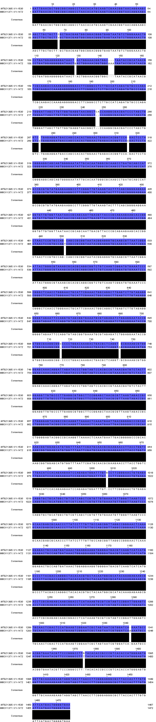Fig.1
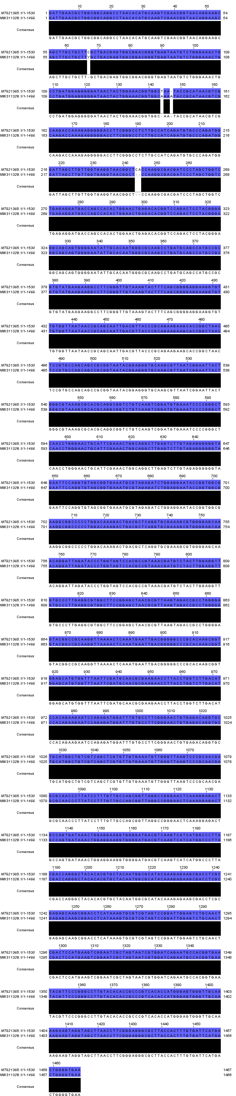

Fig.2
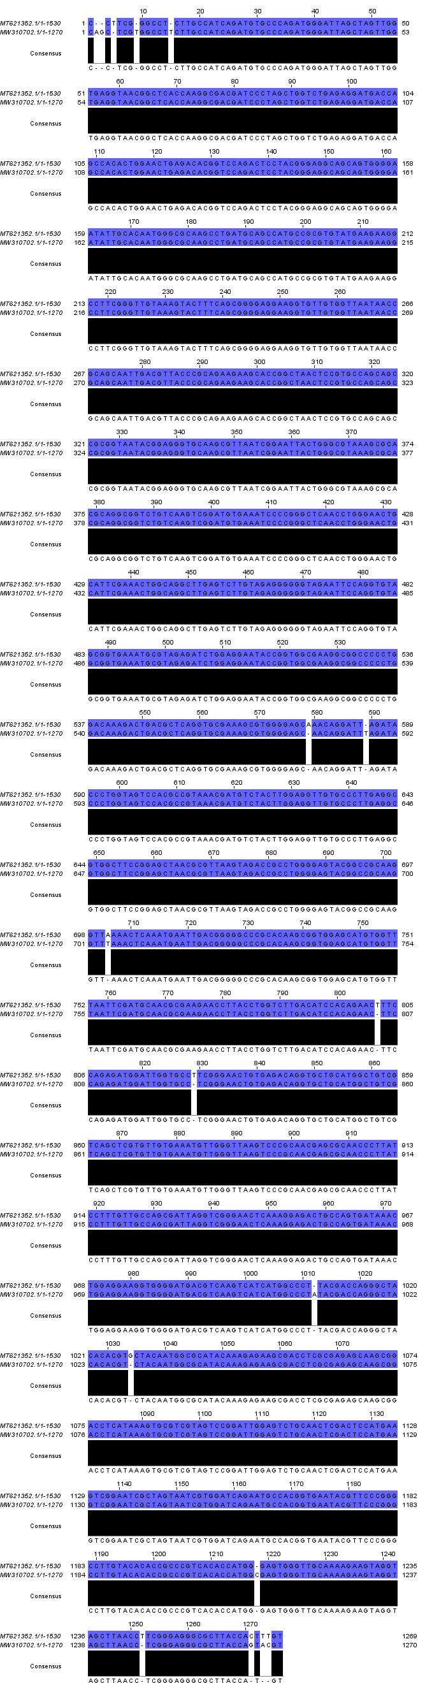
Fig.3
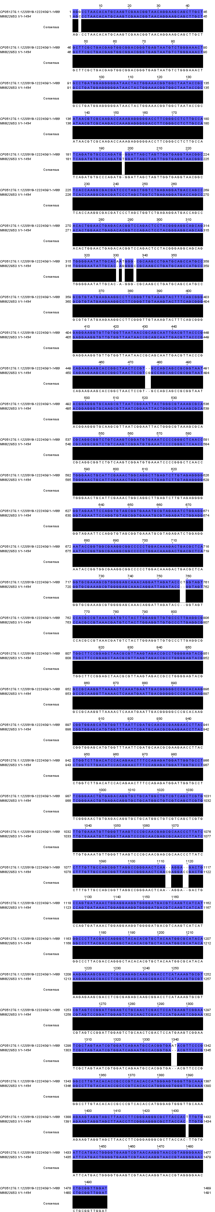
Fig.4
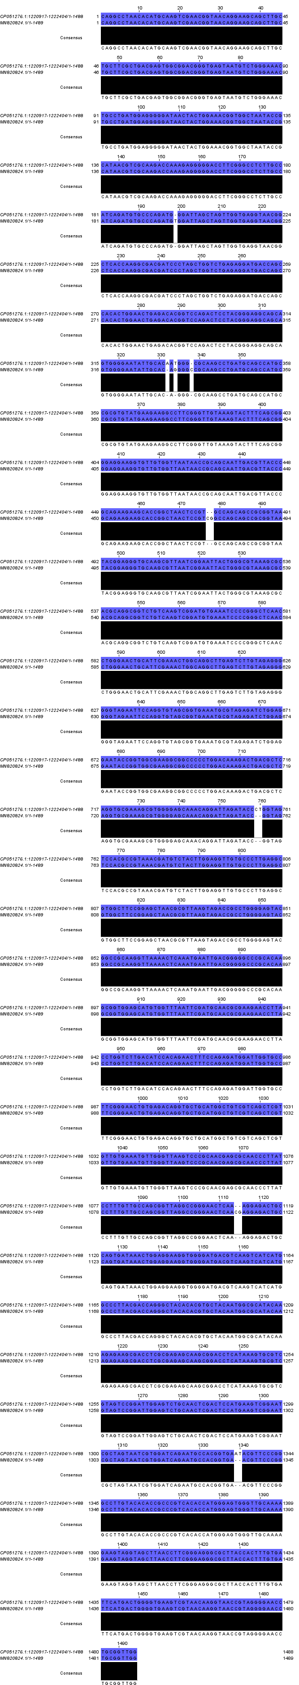
Fig.5

