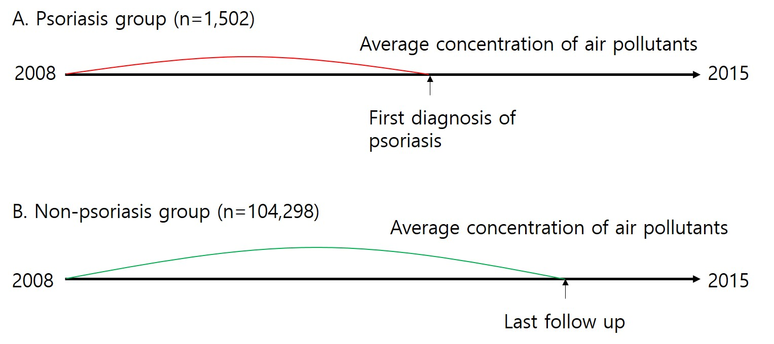
Supplementary Fig 1. (A) The average concentration of air pollutants from January 1, 2008, to the first diagnosis was calculated for the psoriasis group. (B) For subjects who were not diagnosed with psoriasis, the average concentration of exposure was calculated from January 1, 2008, to the end of follow-up.

