Extended Data
An Immunostimulatory Glycolipid That Blocks
SARS-CoV-2, RSV, and Influenza Infections In Vivo
Materials and Methods
Data reporting
Power analysis based on guidelines by Institute for Laboratory Animal Research were used to predetermine sample size to estimate minimum number of animals required to detect significant effect of 7DW8-5 glycolipid, if one is detected. The experiments were not randomized, and the investigators were not blinded to allocation during experiments and outcome assessment.

Ethics statement
Human peripheral blood mononuclear cells (PBMCs) from anonymous blood donors were obtained from leukopacks provided by the New York Blood Center (NYBC). The NYBC does not select donors on the basis of gender or race but ensures that all donors are above 18 years of age. Therefore, the work we performed did not require approval from the Institutional Review Board. All animal experiments were carried out in strict accordance with the Policy on Humane Care and Use of Laboratory Animals of the United States Public Health Service. The protocol was approved by the Institutional Animal Care and Use Committee (IACUC) at The Columbia University (Animal Welfare Assurance no. D16-00003) and the Washington University School of Medicine (Animal Welfare Assurance no. A3381–01). Virus inoculations were performed under anesthesia that was induced and maintained with ketamine hydrochloride and xylazine, and all efforts were made to minimize animal suffering. Mice and hamsters were euthanized with CO₂, with every effort made to minimize suffering.

Animals
Female BALB/c mice with 10-15 weeks of age and female C57BL/6 mice with 14-15 weeks of age, as well as female BALB/c mice lacking CD1d1 and CD1d2 genes (strain: C.129S2-Cd1tm1Gru/J) and female C57BL/6 mice lacking IFN-$γ$ (strain: B6.129S7-Ifngtm1Ts/J) were purchased from The Jackson Laboratory (Bar Harbor, ME) and maintained under specific pathogen-free conditions in the animal facility at Columbia University Irving Medical Center. Heterozygous 8-9 weeks old female K18-hACE C57BL/6J mice (strain: 2B6.Cg-Tg(K18-ACE2)2Prlmn/J) were obtained from The Jackson Laboratory and housed in a pathogen-free animal facility at Washington University School of Medicine. Male Syrian hamsters with 5-6 weeks of aged were purchased from Charles River Laboratories (Wilmington, MA) and housed in an enhance biosafety level 3 (BL3) facility at Washington University in St. Louis.

Glycolipids
Glycolipid 7DW8-5 with chemical formula [(2S,3S,4R)-1-O-(α-D-galactopyranosyl)-N-(11-(4-fluorophenyl) undecanoyl)-2-amino-1,3,4-octadecanetriol)] was synthesized as previously described⁵. Glycolipid α-galactosyl ceramide (α-GalCer) with chemical formula [N-[(3S,4R)-3,4-dihydroxy-1-[(2S,3R,4S,5R,6R)-3,4,5-trihydroxy-6-(hydroxymethyl)oxan-2-yl]oxyoctadecan-2-yl]hexacosanamide] and control lipids with chemical formula 18:1 caproylamine PE [1,2-dioleoyl-sn-glycero-3-phosphoethanolamine-N-(hexanoylamine)] and 18:1 biotinyl PE [1,2-dioleoyl-sn-glycero-3-phosphoethanolamine-N-(biotinyl) sodium salt] were purchased from Avanti Polar Lipids.

Cells and viruses
Vero-E6 (ATCC Cat #1586) and Vero-TMPRSS2-ACE2 cells (gift from Emory University) were cultured at 37 ºC in Dulbecco’s Modified Eagle medium (DMEM) supplemented with 10% fetal bovine serum (FBS), 10 mM HEPES pH 7.3, and 100 U/ml of penicillin–streptomycin. The SARS-CoV-2 MA10, Delta variant (B.1.617.2) and Omicron variants, BA.1 and BA.5 viruses, were obtained from BEI (cat # NR-55329, NR-55691, NR-56475 and NR-58616). Omicron stock was propagated in Vero-TMPRSS2 cells as described³ while other SARS-CoV-2 isolates were propagated in Vero E6 cells for this study as described⁴⁵. All work with infectious SARS-CoV-2 was performed in approved BSL3 and A-BSL3 facilities at Columbia University Irving Medical Center or at Washington University using appropriate positive pressure air respirators and protective equipment. Madin-Darby Canine Kidney (MDCK) cells (Cat # CCL-34) and HEp-2 cells (Cat # CCL-23) were purchased from the ATCC. Influenza A virus (H1N1) PR/8/34 strain (Cat # VR-95) and human respiratory syncytial virus (RSV) A2 isolate (Cat # VR-26PQ), purchased from ATCC were propagated and titrated in MDCK and Hep-2 cells, respectively under BSL2 condition.

Nasal turbinate and lung homogenates
Nasal turbinate was harvested from mice as described⁴⁶. Briefly, the skin was dissected and completely removed from the skull and nose, and the skull sectioned in the coronal plane. Then the remainder of the anterior skull was removed. After removing the posterior aspect of the skull base, the scissor was inserted into the posterior nasal cavity. The suture line was then incised bilaterally revealing the nasal septum. The scissor separated the two maxillas (laterally) and the ethmoid bone (medially) along the distinct suture line. Finally, the upper palate and anterior nasal tip were removed to complete the dissection. For the nasal turbinate from hamster, nasal turbinate was harvested by first removing the skin along the side of the nose and cheeks. The jaw was then cut exposing the hamster’s palate. A sagittal incision through the palate was made exposing the nasal turbinate which was removed via blunt forceps. The nasal turbinate was homogenized in 1 mL DMEM supplemented with 2% FBS, L-glutamine and 1% HEPES. Homogenate was centrifuged at 1,000 x g for 5 minutes. Whole lung tissue was weighed after separation from bronchial tubes and other non-lung tissues, placed in BioMasher II tube (Diagnocine LLC) with 250 µL of DMEM media supplemented with 2% heat-inactivated FBS and manually homogenized by rotating the grinder back and forth until all the tissue was thoroughly homogenized. Afterwards, the tissue homogenates in the tubes were centrifuged at 1000 x g at 4-10ºC for 10 min. For both nasal turbinate and lung homogenates, the supernatant was collected and stored at −80°C for viral titer and viral load detection.

Tissue viral load assays
Lung and nasal turbinate homogenates of 7DW8-5- or saline-treated and challenged mice and hamsters collected in the ABSL3 facility was used to set up the TCID₅₀ titration assay. Serial 2-fold dilution of the samples were added to a 96-well plate seeded with 2 x 10⁴ Vero-E6 cells at 37°C under 5% CO₂⁴⁵. Three days later, the wells were visually scored for cytopathic effect (CPE, as observed by light microscopy) of the cells at each dilution, to determine the end point TCID. For the PFU assay, Vero-TMPRSS2-ACE2 cells were seeded at a density of 1.25 x 10⁵ cells/well in flat-bottom 24-well tissue culture plates. The following day, media was replaced with 200 microliters of 10-fold serial dilutions of sample, diluted in DMEM+2% FBS. One hour later, 1 mL of methylcellulose overlay was added. Plates were incubated for 72 h, then fixed with 4% paraformaldehyde (final concentration) in PBS for 1 hour. Plates were stained with 0.05% (w/v) crystal violet in 20% methanol and washed twice with distilled, deionized water. Plaques were counted, and titers were calculated according to a previously described method⁴⁷.
For RSV titration, lung homogenates of saline or 7DW8-5 treated and challenged mice were serially diluted by 4-fold and overlaid on confluent layer of Hep-2 cells³³. A virus control standard of the A2 isolate used to infect the mice was also serially diluted and run in parallel to compare the resulting CPE. Infected and control cells were incubated at 37°C under 5% CO2 for 5 days. Viral CPE was observed under microscope for each dilution. Using the endpoint dilution method, the TCID₅₀ was calculated per treatment group.
For influenza PR8 virus titration, lung homogenates of saline- or 7DW8-5-treated mice were harvested on day-5 post challenge with 200 PFU of PR8/A/34 virus per mouse. Homogenates were serially diluted by 3-fold and overlaid on a confluent layer of Martin Delaney Canine kidney (MDCK) cells. The PR8/A/34 isolate also serially diluted and used as positive control. Cells were incubated at 33ºC/5% CO₂ and supernatants were collected at 72h to determine viral neuraminidase activity from each well using a fluorescence assay^{48,49} with the NA-Fluor Influenza Neuraminidase Assay kit (Applied Biosystems). Production of fluorogenic product 4-methylumbelliferone was read in a Spectramax i3X microplate reader using excitation wavelength of 360nm and emission wavelength of 450nm. Negative controls using uninfected cell supernatants serve as blank for the assay. Endpoint for each sample was calculated as 3-fold or higher increase of the neuraminidase activity compared to the controls. TCID/g of lung was calculated for each sample and plotted using GraphPad Prism v9.3.

Histology and immunohistochemistry
Histological and immunohistochemical assays were conducted as described^{29,30}. Immediately after euthanasia, the left lung lobe was harvested and fixed by submersion in 10% phosphate buffered formalin for overnight, followed by submersion in 70% ethanol for up to one week, which was enough to disinfect the viruses. Fixed tissue was manually embedded in paraffin, and sections were prepared at 4 µm thickness. Tissue sections were stained with hematoxylin and eosin (Richard Allan Scientific, San Diego, CA). For immunohistochemistry, antigen retrieval was performed with antigen unmasking solution (pH 6.0 citrate buffer, H-3300, Vector Laboratories, Newark, CA), followed by peroxide incubation. The tissue sections were first incubated with primary antibody, SARS-CoV-2 nucleocapsid protein rabbit mAb (26369, Cell Signaling, Danvers, MA) for overnight, and then with secondary antibody, HRP-conjugated anti-rabbit IgG antibody (MP7401, Vector Laboratories). The signal was then amplified using a DAB staining kit (NC9567138, Fisher Scientific, Waltham, MA) and it was counterstained with hematoxylin. Finally, tissues were tiled scanned using an Aperio AT2 slide scanner (Leica Biosystems, Deer Park, IL), and images were captured with an Aperio ImageScope (Leica Biosystems, Deer Park, IL).

RNA isolation and RT-qPCR
Total RNA was isolated from nasal turbinates with miRNeasy micro kit (Qiagen, 217084) according to the manufacturer’s instructions. ERCC RNA Spike-In Mix kit (ThermoFisher Scientific, 4456740) was added to normalized total RNA prior to library preparation following manufacturer’s protocol. The RNA sequencing libraries were prepared using the NEBNext Ultra II RNA Library Prep Kit for Illumina according to manufacturer’s instructions (New England Biolabs, Ipswich, MA, USA). The samples were sequenced by the Illumina HiSeq instrument according to manufacturer’s instructions using a 2x150bp Paired End (PE) configuration. After the stringent QC of the raw data, sequence reads were trimmed to remove possible adapter sequences and nucleotides with poor quality using Trimmomatic v.0.36. The trimmed reads were mapped to the Mus musculus reference genome available on ENSEMBL using the STAR aligner v.2.5.2b. BAM files were generated as a result of this step. Unique gene hit counts were calculated by using feature Counts from the Subread package v.1.5.2. Only unique reads that fell within exon regions were counted. After extraction of gene hit counts, the gene hit counts table was used for downstream differential expression analysis. Using DESeq2, a comparison of gene expression between the groups of samples was performed.

Treatment with anti-IFN-$γ$ antibody
For IFN-$γ$ neutralization, anti-mouse IFN-$γ$ antibody (BioXCell; clone XMG1.2) or a rat IgG1 isotype control (BioXCell; clone HRPN) was administered to mice by intraperitoneal injection at Day -1 (0.5 mg) and Day 0 (0.5 mg) relative to MA10 inoculation.

Harvesting bronchoalveolar lavage
Bronchoalveolar lavage (BAL) was harvested as described⁵⁰. Briefly, after euthanizing the mouse, the animal was placed on its back on a surgical plate. After making an incision in the neck skin near the trachea using a scalpel, the trachea surrounded by sternohyoid muscle was exposed. After placing a cotton thread under the trachea using pincers, the middle of the exposed trachea between two cartilage rings was carefully punctured with a 26 G needle. Then, the catheter of about 0.5 cm was inserted into the trachea and stabilized by tying the trachea around the catheter using the cotton thread placed. A 1 mL syringe loaded with 1 mL of sterile balanced salt solution with 100 μM EDTA was connected to the catheter and the salt/EDTA solution was gently injected into the catheter. The solution was then gently aspirated while massaging the thorax of the mouse. The syringe was removed from the needle and the recovered lavage fluid was transferred into a 15 mL tube placed on ice.

Cytokine and chemokine measurements
Sera, as well as supernatants were collected by centrifugation of nasal turbinates (NT), bronchioalveolar lavage (BAL), and lung homogenates (LH) of mice treated with 7DW8-5 one day before. Sera and supernatants were also collected from mice treated with saline one day before. The sera and supernatants were analyzed for cytokines and chemokines by Eve Technologies Corporation (Calgary, AB, Canada) using their Mouse Cytokine /Chemokine 31-Plex Array (MD31).

Harvesting lung mononuclear cells
Lung mononuclear cells (MNCs) were harvested as described⁵¹. As shown in Extended Data Figure 4a, lungs were first perfused with PBS containing collagenase IV and DNase1. Single cell suspensions were prepared by mechanical dissociation of lung tissue through a 70-μm nylon mesh, followed by being layered on Ficoll-Paque (Sigma) and centrifuged at room temperature for 20 min at 900 g. After collecting lung MNC from the gradient interphase, the cells were incubated with anti-mouse Fc receptor antibody (BioLegend, Cat # 101320) to block nonspecific antibody binding. Each sample was then stained with phycoerythrin-labeled anti-mouse CD45 antibody (BioLegend, Cat # 103106) for 30 min. Just before sorting cells, DAPI (x10,000 dilution) was added. Viable cells were sorted by FACS Aria II by gating DAPI negative CD45 positive cells, followed by analyzing using FlowJo v10.8.1 software, as shown in Extended Data Fig. 4b.

Single cell 5’ transcript and TCRαβ enriched library preparation on the 10x Chromium and sequencing
The scRNA-Seq and scTCR-Seq libraries were prepared using the 10x Chromium single-cell 5’ reagent kits v2 (Dual Index), per manufacturer’s instructions. In brief, after cell sorting, single-cell suspensions were loaded into the Chromium controller to make nanoliter-scale droplets with uniquely barcoded 5’ gel beads called GEMs (gel bead-in emulsions). After GEM-RT, GEMs were cleaned up by Dyna beads MyOne Silane beads (Thermo Fisher Scientific, 37002D). According to the manufacturer’s instructions, the cDNA was amplified and size-selected by SPRI-beads (Beckman Coulter, B23317). Finally, the 5’ transcript and TCR-seq libraries were pooled and sequenced with the Illumina NovaSeq 6000 system.

Data processing of scRNA-seq and TCR-seq
FASTQ files were processed by Cell Ranger v.6.1.2 (10x Genomics) software using the GRCm38 (GENCODE vM23/Ensembl 98) genome as a reference. The data analyzed in R using the Seurat v.4.1.0 package were merged and integrated using an anchor-based single-cell data integration method in Seurat⁵². Cells with mitochondrial RNA content greater than 5% were excluded. Variable feature genes were set at 2000 genes. Once the data sets were integrated, the data were input into a principal component analysis (PCA) based on variable genes. The same principal components were used to generate the Uniform Manifold Approximation and Projections (UMAPs). Clusters were identified using shared nearest neighbor–based (SNN-based) clustering. For the clustering analysis, the function RunUMAP, FindClusters, and FindNeighbors in Seurat were used. Single cell TCR sequencing was aligned and quantified using the cellranger-vdj software (v.6.1.2). For the data analysis, the output file filtered_contig_annotations.csv was used.

Activation of human iNKT cells by 7DW8-5 in vitro
Peripheral blood mononuclear cells (PBMCs) were obtained from 8 healthy donors using Ficoll Paque Plus gradient (Merck Millipore, MA, Cat# GE17-1440-02). PBMCs were added to 96 U-bottom well plates (0.5 x 10⁶ cells/well) in duplicates and stimulated with 7DW8-5 at 0.1 and 1mM final concentration. In parallel, PBMCs were also treated with 18:1 PE at 1mM final concentration. PBMCs were stimulated for 24 hours at 37ºC in 5% CO2 atmosphere. In the final 4 hours, Brefeldin A was added at 10 mg/mL and incubated for the 4 additional hours. After that, PBMC supernatants were harvested and stored for analysis of secreted IFN-γ by Luminex (Invitrogen, Waltham, MA) according to manufacturers’ instructions. PBMCs were washed and stained with PE-Cy7 anti-CD3 (clone: SK7), PERCP Cy5.5 anti-TCRVα24 (clone: C15), AF647 anti-CD161 (clone: HP3G10), AF700 anti-CD8 (clone: RPA-T8) and APC-Cy7 anti-CD69 (clone: FN50), for 30 min at room temperature. After staining, cells were permeabilized and stained with anti-human IFN-γ antibody for 40 min at room temperature. After staining, cells were washed with washing solution twice and resuspended in PBS for immediate flow cytometric acquisition. For FACS acquisition, 1 x 10⁵ lymphocytes were acquired using a BD LSR Fortessa (BD Biosciences, San Jose, CA) Flow Cytometer. Data acquisition was performed using the FACS DIVA software (BD Biosciences, San Jose, CA) and data analysis using FlowJo software (version 10.6.2, BD Biosciences, San Jose, CA).

In vitro stimulation of human iNKT cell lines by glycolipids.
Human iNKT cell lines and HeLa cells transfected with the human CD1d gene, HeLa-hCD1d, were established, as we previously reported²⁰. Twenty thousand human iNKT cell lines from 3 different donors were co-cultured with 2 × 10⁴ HeLa-hCD1d in a well of 96-well round-bottom plate in the presence of 1 µg/mL of 7DW8-5 glycolipid, 18:1 PE or saline (controls). After 24 h incubation, the cultured supernatants were collected and estimated for presence of IFN-γ using ELISA.

In vitro inhibition of icSARS-CoV-2-mNG-infected Huh7 cells
Supernatants collected from stimulated human iNKT cell lines were serially diluted (2-fold) and incubated on a monolayer of Huh7 cells overnight at 37C/5%CO2 for 20h. A serial 5-fold dilution of recombinant human IFN-γ protein was used as positive control (Gibco cat# PHC4031). In addition, supernatants were combined and mixed with anti-human IFN-γ antibody (1µg/mL) (BioXcell Cat# BE0235) to check for specific and non-specific effects. Following this incubation, the cells were infected with ic-SARS-CoV-2-mNeon isolate and incubated further for 24h under similar conditions. After 24h, cells were examined under fluorescent microscope to enumerate GFP⁺ cells and percent inhibition was calculated as the difference in fluorescence in the test wells compared to wells receiving no treatment (virus only) and plotted using GraphPad Prism v10.

Reporting summary
Further information on research design is available in the Nature Research Reporting Summary linked to this paper.

Data availability
Materials used in this study will be made available but may require execution of a materials transfer agreement. All the data are provided in the paper or the Supplementary Information.

Extended Data References

45 Wang, P. et al. Antibody resistance of SARS-CoV-2 variants B.1.351 and B.1.1.7. Nature 593, 130-135, doi:10.1038/s41586-021-03398-2 (2021).
46 Antunes, M. B. et al. Murine nasal septa for respiratory epithelial air-liquid interface cultures. BioTechniques 43, 195-204, doi:10.2144/000112531 (2007).
47 Case, J. B., Bailey, A. L., Kim, A. S., Chen, R. E. & Diamond, M. S. Growth, detection, quantification, and inactivation of SARS-CoV-2. Virology 548, 39-48, doi:10.1016/j.virol.2020.05.015 (2020).
48 Wetherall, N. T. et al. Evaluation of neuraminidase enzyme assays using different substrates to measure susceptibility of influenza virus clinical isolates to neuraminidase inhibitors: report of the neuraminidase inhibitor susceptibility network. J Clin Microbiol 41, 742-750, doi:10.1128/JCM.41.2.742-750.2003 (2003).
49 Eichelberger, M. C., Hassantoufighi, A., Wu, M. & Li, M. Neuraminidase activity provides a practical read-out for a high throughput influenza antiviral screening assay. Virol J 5, 109, doi:10.1186/1743-422X-5-109 (2008).
50 Au - Van Hoecke, L., Au - Job, E. R., Au - Saelens, X. & Au - Roose, K. Bronchoalveolar Lavage of Murine Lungs to Analyze Inflammatory Cell Infiltration. JoVE, e55398, doi:doi:10.3791/55398 (2017).
51 Chang, S. H. et al. T helper 17 cells play a critical pathogenic role in lung cancer. Proc Natl Acad Sci U S A 111, 5664-5669, doi:10.1073/pnas.1319051111 (2014).
52 Stuart, T. & Satija, R. Integrative single-cell analysis. Nat Rev Genet 20, 257-272, doi:10.1038/s41576-019-0093-7 (2019).

Acknowledgements
This study was supported by funding to D.D.H. from the JPB Foundation, Andrew and Peggy Cherng, Samuel Yin, Carol Ludwig, David and Roger Wu. K18-hACE2 transgenic mouse and hamster experiments were conducted at Washington University with support from NIH: R01 AI157155 (to M.S.D), 75N93019C00051 (to M.S.D.), 75N93021C00016 (to A.C.M.B) and U01 AI151810 (to M.S.D and A.C.M.B).

Author contributions
M.T., M.S.N., Y.T., Y.H., and D.D.H. conceived the project. M.T., C.C., L.C., and Z.C. performed the mouse experiments. T.L.D., and K.S. performed the hamster experiments. M.S.N., Z.C., T.L.D., K.S., and Y.H. performed the virus titration experiments. K.M. performed the single cell analyses with 10X Genomics. Y.H. and M.M. performed the histological analysis. A.L.R., and G.M.F. contributed to the flow cytometric assay. M.T., M.S.N, K.M., J.G.A.C.-d.-R, Y.T., A.C.M.B, M.S.D and D.D.H. analyzed the results. M.T. and D.D.H. wrote the manuscript with contributions from each author.

Competing interests
M.T., M.S.N, Y.H., and D.D.H. are listed as co-inventors on a provisional patent application filed by Columbia University for the treatment for COVID-19 and other viral respiratory infections using 7DW8-5 described in this manuscript.
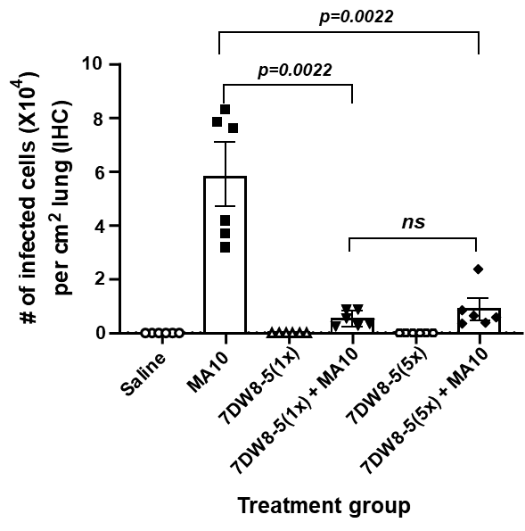

Extended Data Fig. 1. Average number of infected spots measured between each treatment group using immunostaining with SARS-CoV-2 NP antibody. The number of infected spots were counted in defined image sections of 0.8 mm² using Image J by setting the threshold at 0 and 145 at 16-bit.

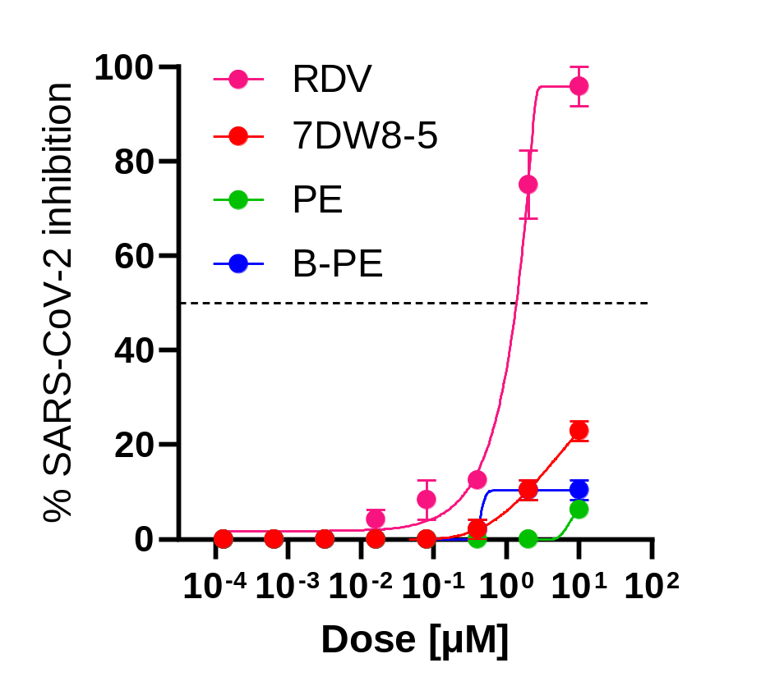
Extended Data Fig. 2. Lack of antiviral effect of 7DW8-5 on SARS-CoV-2 (USA/WA1) in VeroE6 cells as scored by reduction in cytopathic effect in vitro. Remdesivir (RDV) served as a positive control for the assay. Compounds 1,2-dioleoyl-sn-glycero-3-phosphoethanolamine-N-(hexanoylamine) (PE) and 1,2-dioleoyl-sn-glycero-3-phosphoethanolamine-N-(biotinyl) (B-PE) were included as lipid antigens known to bind to human CD1d.
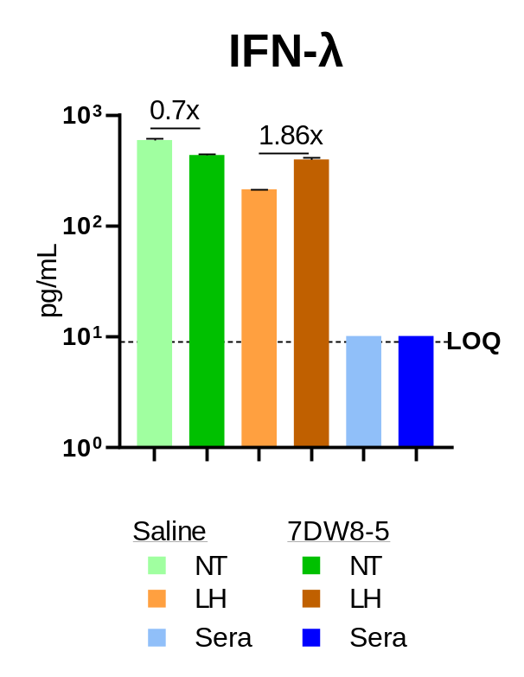
Extended Data Fig. 3. Minimal induction of IFN-λ by 7DW8-5. BALB/c mice (N=5) were given 2 µg of 7DW8-5 intranasally. Twenty-four hours later, supernatants of nasal turbinates (NT) and lung homogenates (LH) were harvested from 7DW8-5-treated and saline-treated mice. Sera were also collected. The level of IFN-λ was then analyzed by Mouse IL-28B/(IFN lambda 3) ELISA and the concentrations plotted (pg/mL). The fold increase with 7DW8-5 treatment is shown at the top of the graph.
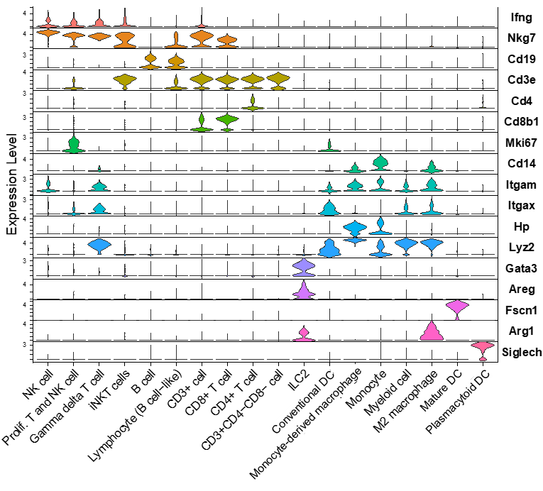
Extended Data Fig. 4. Single-cell analysis of mononuclear cells derived from the lungs of mice treated with 7DW8-5 or saline. (a) Experimental design and workflow. (b) Gating strategy used to sort live CD45⁺ cells. (c) Profiling of marker genes across 18 distinct populations immune cells from lung homogenates of 7DW8-5-treated mice.
a
c
b
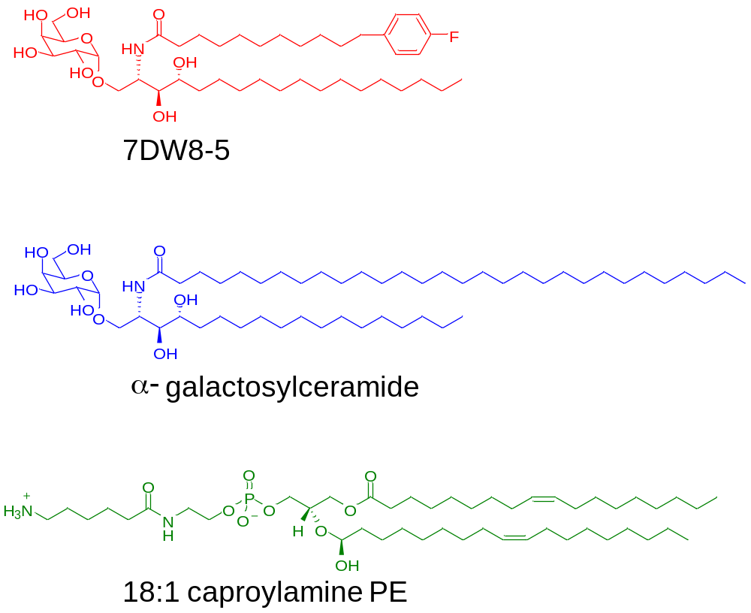
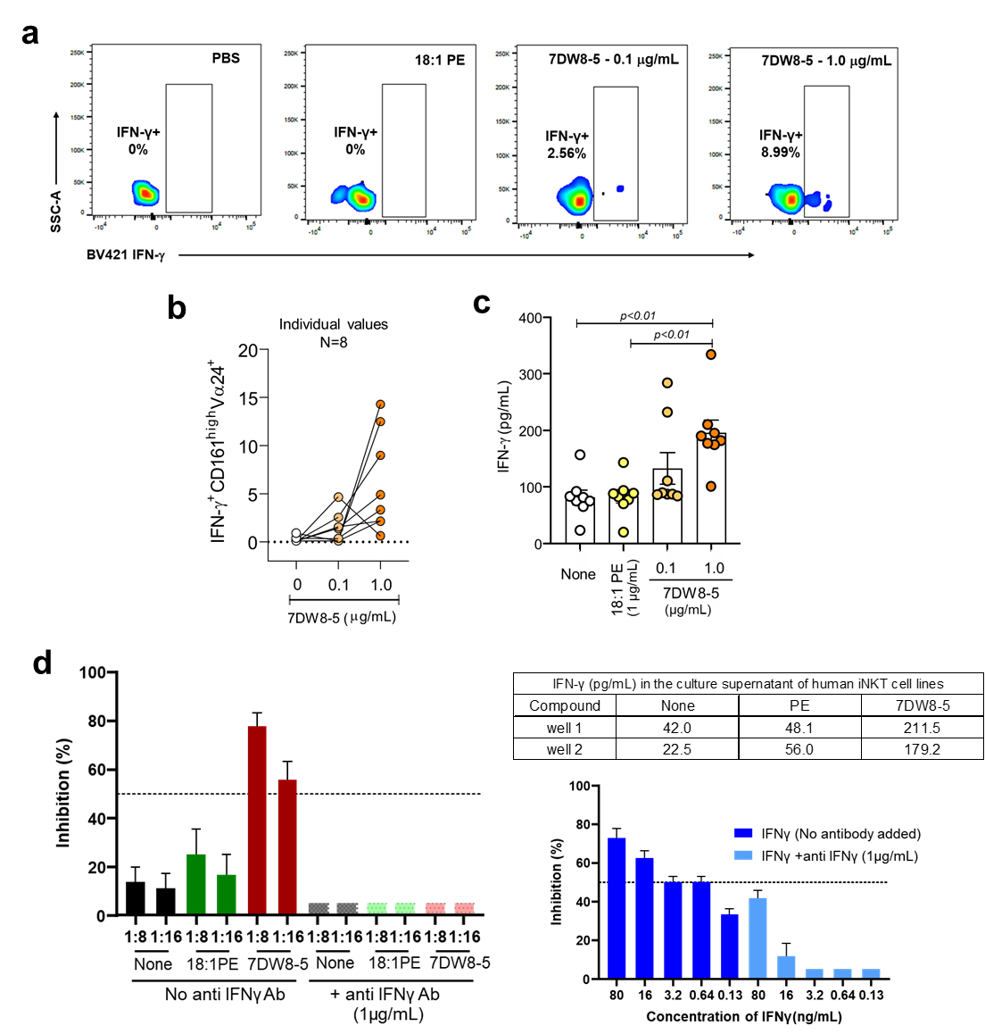
Extended Data Fig. 5. Chemical structures of glycolipids used in the study: 7DW8-5 and its parental compound, $α$-galactosylceramide, along with an inactive control 18:1 caproylamine phosphatidylethanolamine (PE).

Extended Data Fig. 6. Activation of human iNKT cells by 7DW8-5 in vitro and inhibition of SARS-CoV-2 infection of Huh7 cells by supernatant of 7DW8-5-activated human iNKT cells. (a) A flow cytometric analysis shows that 7DW8-5 activates human CD161^{high}TCRVα24⁺ NKT cells to secrete IFN-γ in vitro. (b) 7DW8-5 activates human CD161^{high}TCRVα24⁺ NKT cells from 8 individuals in a dose dependent fashion. (c) Dose dependent IFN-γ secretion by 7DW8-5-activated human PBMCs from 8 individuals. (d) Human iNKT cell lines from 3 different donors were cocultured with Hela cells transfected with human CD1d in the presence of 7DW8-5 or 18:1 PE or saline for 24h and the supernatants were collected and pooled. Amount of IFN-γ in the supernatants was determined by ELISA (inserted Table). Supernatants were then serially diluted (2-fold) and incubated on a monolayer of Huh7 cells overnight. A serial 5-fold dilution of recombinant IFN-γ was used as positive control. In addition, supernatants were mixed with anti-human IFN-γ antibody (1µg/mL). Following this incubation, the cells were infected with ic-SARS-CoV-2-mNeon isolate and incubated further for 24h. Cells were examined under fluorescent microscope to enumerate GFP+ cells and percent inhibition was calculated as the difference in fluorescence in the test wells compared to wells receiving no treatment (virus only) and plotted using GraphPad Prism v9.3

