Supplemental Data:
Supplemental Figure 1. Distribution of LOS (days) in hospitalized MG patients with exacerbation
Supplemental Figure 2. LOS (days) in intubated patients treated with plasmapheresis and in non-intubated patients treated with plasmapheresis
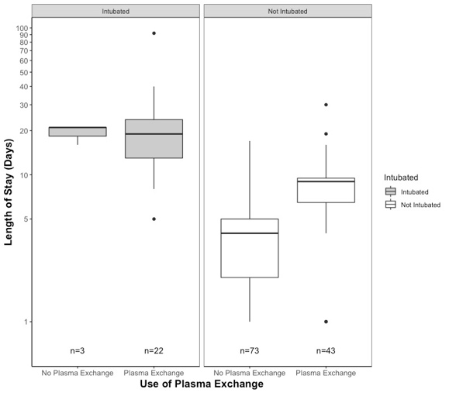
N=141. Circles represent outliers. Bold line represents median. Top and bottom of box represent the 75th and 25th quartile, respectively.
Supplemental Table 1. Multi-Variable Incidence Relative Ratio (IRR) for Length of Stay
Parameter | IRR ( 95% CI) | p Value
Age at diagnosis | 1.01 (1.00-1.01) | .10
Sex (Male) | 1.26 (1.02-1.55) | .028*
Thymectomy (Yes) | 0.67 (0.50-0.91) | .01*
Antibody Status (Positive) | 1.19 (0.93-1.52) | .16
Unknown Antibody Status | 1.60 (0.99-2.59) | .05
MGFA Status at Diagnosis
MGFA Class I | 1.00 | --
MGFA Class II | 0.86 (0.63-1.16) | .31
MGFA Class III | 1.07 (0.78-1.48) | .67
MGFA Class IV | 0.65 (0.44-0.95) | .027
MGFA Class V | 1.18 (0.80-1.74) | .40
Unknown MGFA Status | 0.94 (0.67-1.33) | .73
Cause of Exacerbation
Unknown | 1.00 | --
Diagnostic | 1.41 (0.96-2.06) | .08
Medication-Related | 1.09 (0.81-1.47) | .56
Non-Compliance | 1.55 (1.12-2.25) | .007
Procedural | 1.16 (0.72-1.86) | .55
VNPI | 1.17 (0.85-1.61) | .32
VPI | 1.04 (0.74-1.45) | .84
Other | 1.29 (0.90-1.85) | .16
Hospital Stay Location
General | 1.00 | --
ICU | 0.71 (0.48-1.06) | .09
Intermediate Care | 1.15 (0.87-1.50) | .32
Use of Ventilation
Intubated | 2.10 (1.60-2.74) | < .001*
Non-Invasive Ventilation | 1.03 (0.84-1.26) | .79
Medications Used to Treat Exacerbation
IVIG | 0.95 (0.76-1.20) | .66
Plasmapheresis | 2.13 (1.67-2.71) | < .001*

Adjusted for Multiple Comparison (n=141). *p<0.05. †p<.00625 per Bonferroni correction (see statistical methods)

Supplemental Table 2. Percentage of exacerbations per MGFA class at diagnosis.

MGFA Class at Diagnosis | Number (%)  (n=141)
MGFA Class I | 17%
MGFA Class II | 30%
MGFA Class III | 20%
MGFA Class IV | 11%
MGFA Class V | 6%

Supplemental Table 3. Percentage of hospitalizations admitted to the general floor, intermediate care (step-down from ICU unit), and ICU.

Hospital Stay Location | Number (%)  (n=141)
General | 81.8%
Intermediate Care | 13.5%
ICU | 5%

