Supplementary Tables & Figures

ST 1: Descriptive statistics of the compound flood characteristics
Statistic | Annual Maximum 24-hr Rainfall (mm) | Maximum Storm Surge (m) (Time interval = ±1days) | Maximum River Discharge (m3/sec) (Time interval = ±1 days)
Nbr. of observations | 46 | 46 | 46
Nbr. of missing values | 0 | 0 | 0
Sum of weights | 46 | 46 | 46
Minimum | 33.00 | -0.19 | 760.00
Maximum | 146.00 | 0.65 | 5440.00
Freq. of minimum | 1 | 1 | 1
Freq. of maximum | 1 | 1 | 1
Range | 113.00 | 0.85 | 4680.00
1st Quartile | 63.42 | 0.06 | 1085.00
Median | 79.50 | 0.23 | 1615.00
3rd Quartile | 93.35 | 0.35 | 2162.50
Mean | 80.67 | 0.22 | 1864.39
Variance (n) | 576.21 | 0.03 | 1242480.41
Standard deviation (n) | 24.00 | 0.18 | 1114.66
Variation coefficient (n) | 0.29 | 0.83 | 0.59
Variation coefficient (n-1) | 0.30 | 0.84 | 0.60
Skewness (Pearson) | 0.76 | 0.01 | 1.77
Skewness (Fisher) | 0.79 | 0.01 | 1.83
Kurtosis (Pearson) | 0.66 | -0.31 | 2.98
Kurtosis (Fisher) | 0.89 | -0.20 | 3.47
Standard error of the mean | 3.57 | 0.02 | 166.16
Lower bound on mean (95%) | 73.46 | 0.17 | 1529.71
Upper bound on mean (95%) | 87.88 | 0.28 | 2199.06
Standard error of the variance | 124.17 | 0.00 | 267758.71
Lower bound on variance (95%) | 405.22 | 0.02 | 873780.15
Upper bound on variance (95%) | 934.42 | 0.05 | 2014869.63
Standard error(Skewness (Fisher)) | 0.35 | 0.35 | 0.35
Standard error(Kurtosis (Fisher)) | 0.68 | 0.68 | 0.68
Mean absolute deviation | 18.44 | 0.15 | 802.84
Median absolute deviation | 15.05 | 0.12 | 550.00

ST 2: Test for serial correlation (or autocorrelation) within individual time series of the flood characteristics using the Ljung-Box test (using Q-statistics)
Hydrologic Variables | Statistics | Lag 20 | Lag 10 | Lag 5
Annual Maximum 24-hr Rainfall (mm) | X-squared (Q-statistics) | 13.917 | 5.439 | 2.681
Annual Maximum 24-hr Rainfall (mm) | p-value | 0.834 | 0.860 | 0.748
Maximum Storm Surge (m) (Time interval = ±1days) | X-squared (Q-statistics) | 25.836 | 14.499 | 10.403
Maximum Storm Surge (m) (Time interval = ±1days) | p-value | 0.171 | 0.151 | 0.064
\  Maximum River Discharge(m3/sec) (Time interval = ±1days) | X-squared (Q-statistics) | 16.899 | 6.780 | 2.341
\  Maximum River Discharge(m3/sec) (Time interval = ±1days) | p-value | 0.659 | 0.746 | 0.800
 | Critical value | 31.410 | 18.307 | 11.070
Null Hypothesis is $H_{0}$ |  | Accept (5% (or 0.05) level of significance or 95% (0.95) Confidence interval) | Accept (5% (or 0.05) level of significance or 95% (or 0.95) Confidence interval) | Accept (5% (or 0.05)) level of significance or 95% (or 0.95) Confidence interval)
Existence of serial correlation |  | No | No | No
Hypothesis Testing
$H_{0}$: The data are independently distributed and exhibited no autocorrelation/or serial correlation
$H_{a}$ = Alternate hypothesis = The data are not independently distributed and exhibited serial correlation

ST 3: Test for monotonic time trend behaviour within flood series using nonparametric Mann-Kendall (M-K) test
Hydrologic Variables | Calculated Z value | Critical Z value (Significance level$α=0.05 or 5\%$) | Null Hypothesis $H_{0}$ | Existence of Trend
Annual Maximum 24-hr Rainfall(mm) | z = 0.321 (p-value = 0.747) | $$±1.96$$ | Accept | No
Maximum Storm Surge (m) (Time interval = ±1days)* | z = 2.850 (p-value=0.004) | $$±1.96$$ | Reject | Yes
Maximum River Discharge(m3/sec) (Time interval = ±1days) | z= -0.454 (p-value=0.649) | $$±1.96$$ | Accept | No
Note: Rejection of Null hypothesis $H_{0}$, clearly reveals the existence of monotonic time trend behavior within time series of Maximum Storm Surge (m) (Time interval = ±1days) (indicated by bold letter with asterisk) observations (indicated by bold letter). Pre-whitening procedure can eliminate monotonic time-trend behavior within storm surges observation.

ST 4: Comparing the performance of the best-fitted nonparametric KDE and parametric distribution functions in defining univariate flood marginals
Flood characteristics | Best-fitted (Nonparametric/or parametric) KDE | Univariate functions | MSE (Mean square error) | RMSE (Root mean square error) | Akaike Information criterion (AIC) | Bayesian Information criterion (BIC) | Hannan-Quinn Information criterion (HQC)
Annual Maximum 24-hr Rainfall (mm) | Nonparametric KDE | Normal* | 0.0008 | 0.0288 | -324.27 | -322.44 | -323.58
Annual Maximum 24-hr Rainfall (mm) | Parametric function | GEV (Generalized extreme value) | 0.0009 | 0.0312 | -312.97 | -307.48 | -310.91
Maximum Storm surge (m) (Time interval = ±1days) | Nonparametric KDE | Normal* | 0.0007 | 0.0282 | -326.13 | -324.30 | -325.45
Maximum Storm surge (m) (Time interval = ±1days) | Parametric function | Normal | 0.0011 | 0.0345 | -307.60 | -305.77 | -306.91
Maximum River discharge (m3/sec) (Time interval = ±1days) | Nonparametric KDE | Normal* | 0.0008 | 0.0299 | -320.80 | -318.97 | -320.12
Maximum River discharge (m3/sec) (Time interval = ±1days) | Parametric function | GEV (Generalized extreme value) | 0.0012 | 0.0357 | -300.55 | -295.07 | -298.50
Note: The performance of nonparametric Normal kernel density (indicated by bold letter with asterisk) outperforms the parametric density approach in approximating the univariate marginal distribution of each flood characteristic (i.e., Minimum value of error indices statistics (i.e., MSE and RMSE) and information criterion statistics (i.e., AIC, BIC and HQC)

List of Figures

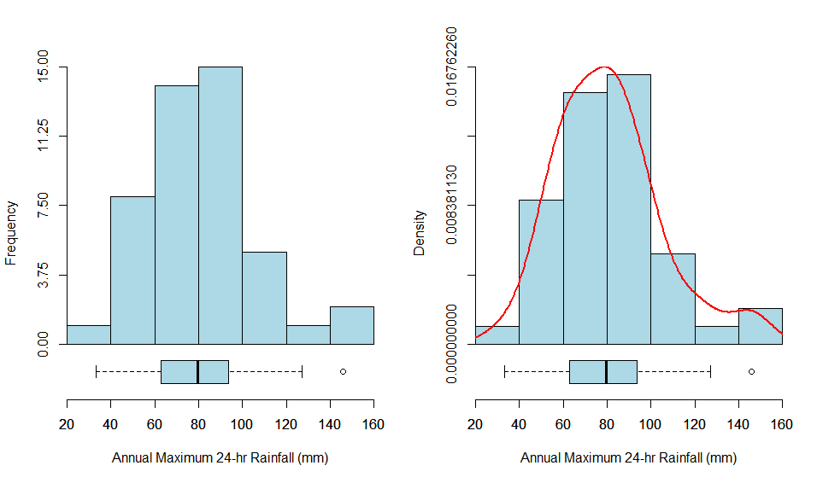
(a)

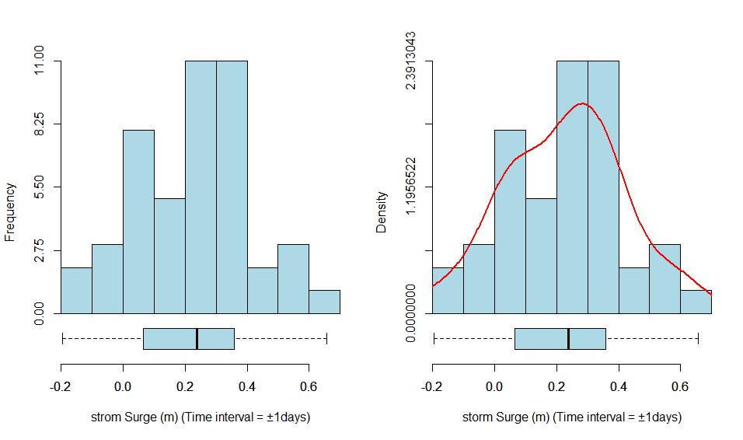
(b)
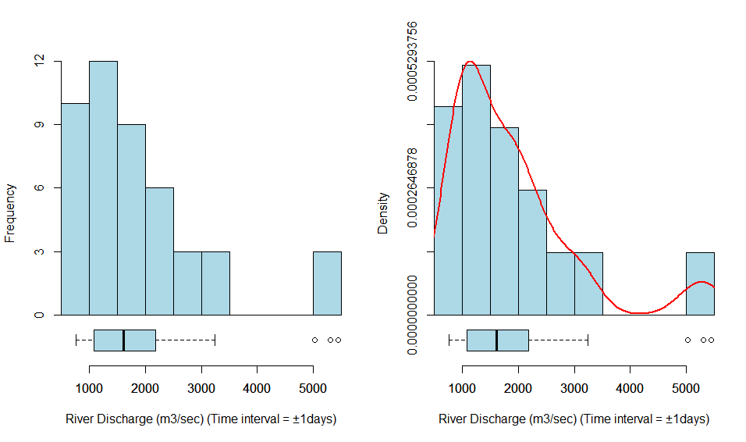
(c)
SF 1: Histogram distribution plot (both in frequency and density) (a) Annual Maximum 24-hr Rainfall (mm) (b) Maximum Storm surges (m) (Time interval = $±1 days$) (c) Maximum River discharge (m3/sec) (Time interval = $±1 days$)
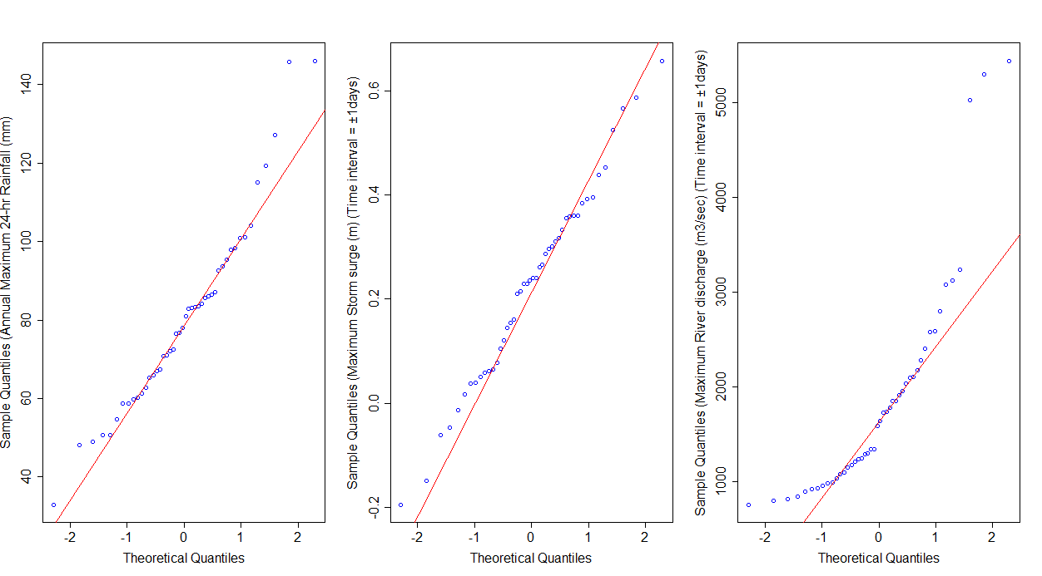
SF 2: Normal quantile-quantile (Q-Q) plot of targeted flood characteristics
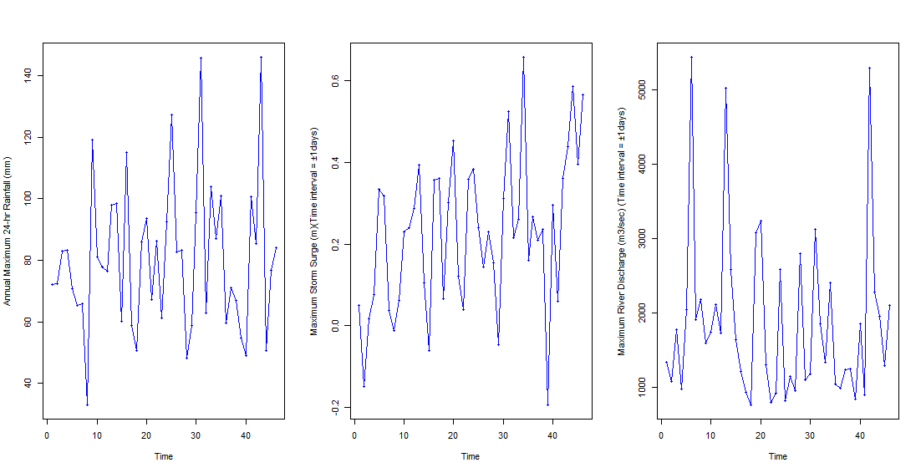
SF 3: Visualizing time-series behavior of the annual maximum 24-hr rainfall observations and their underlying maximum storm surge and maximum river discharge observations within a Time interval $±1 day$ from the date of the highest annual rainfall events

(a)
(b)
(c)
SF 4: Comparison of cumulative distribution functions (CDFs) plot of the fitted univariate kernel functions to (a) Annual maximum 24-hr Rainfall (b) Maximum Storm surges (Time interval = ±1 days) (c) Maximum River discharge (Time interval = ±1days)
(a)
(b)
(c)
SF 5: Comparison of probability-probability (P-P) plots of the fitted univariate kernel density functions to (a) Rainfall (b) Storm surge (c) River discharge series
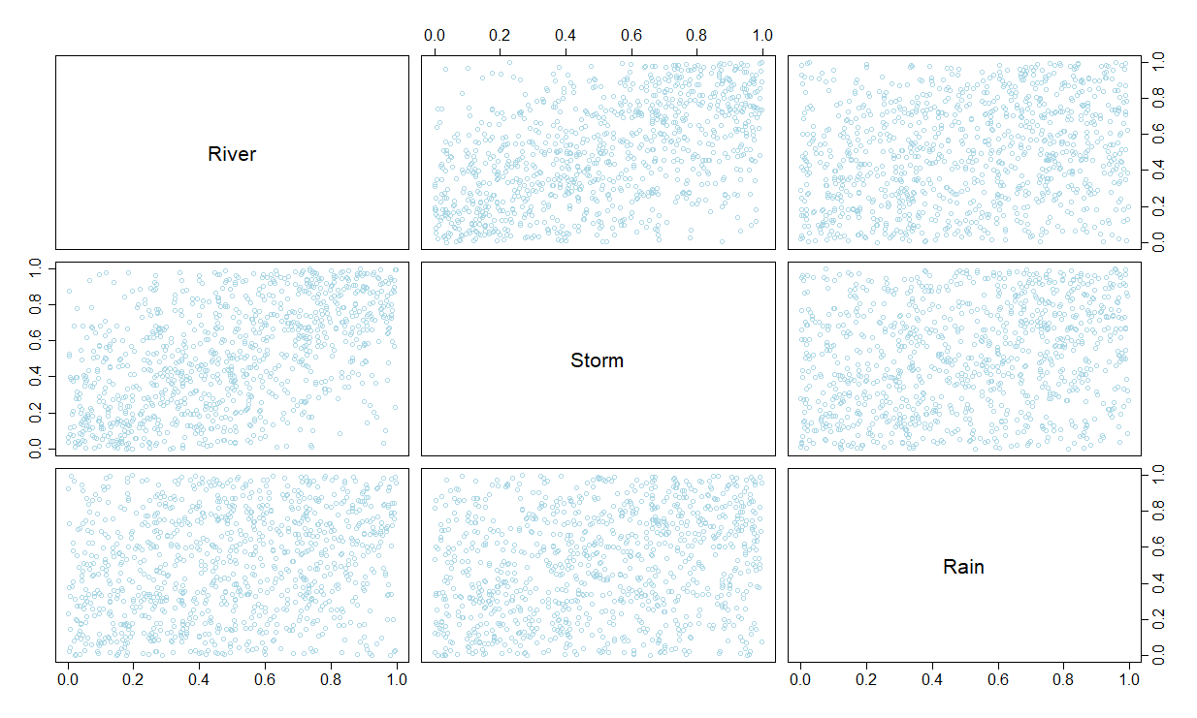
(a)
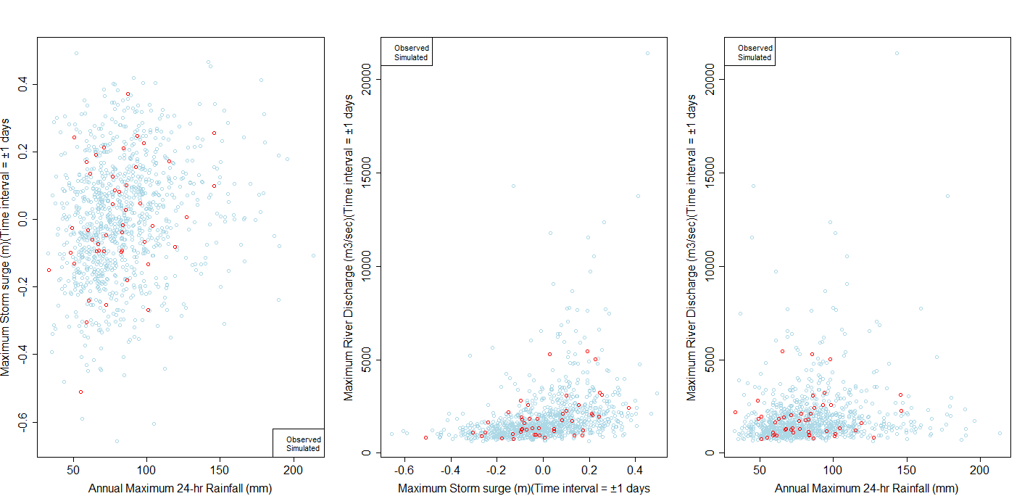

SF 6: (a) Scatterplot drawn from the random samples (size N=1000) generated from the best-fitted 3D nested Frank copulas with nonparametric marginals (under semiparametric settings) (b) Overlapped scatterplot between historical observation and theoretical samples generated from fitted asymmetric 3D FNA copula

