SUPPLEMENTAL MATERIALS

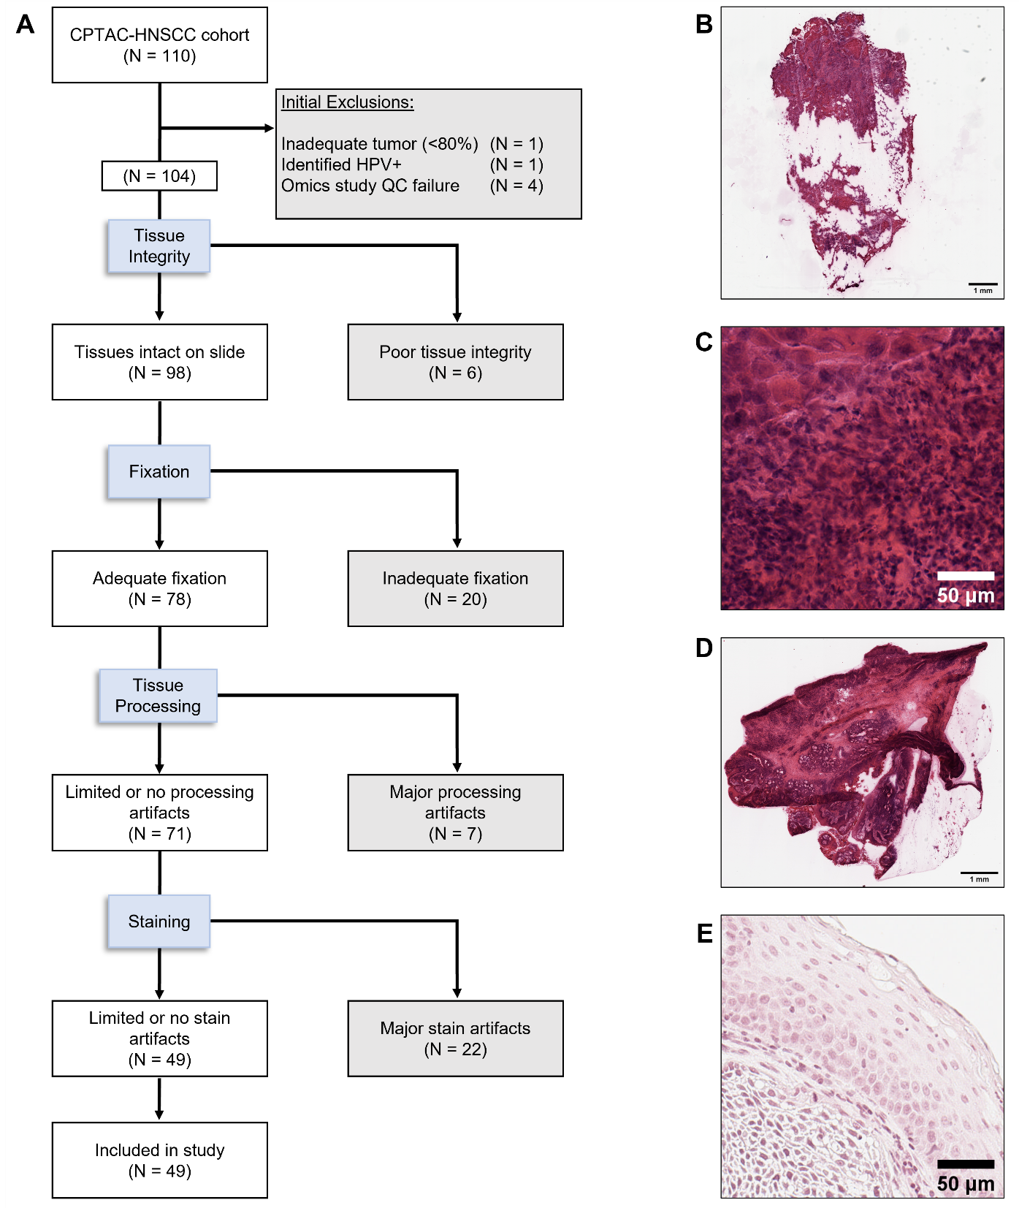
Supplemental Figure 1. Exclusion criteria for pathology slides. Shown is a flowchart (A) which describes the number of patients excluded from analysis based on tissue slide conditions. Examples of conditions which would exclude tissues from study are provided, including: (B) inadequate tissue integrity; (C) inadequate tissue fixation; (D) major processing artifacts; and (E) major stain artifacts or inconsistencies.

Supplemental Table 1. Number of evaluable slides available for each patient on study.
# Slides | N (%)
All | 49
1 | 27 (55.1%)
2 | 14 (28.6%)
3 | 3 (6.1%)
4 | 5 (10.2%)

Supplemental Table 2. Average intra-patient coefficients of variation for each cytometric feature for patients with multiple tumor slides (N=22).
Category | Feature | Coefficient of Variation
Topology | Detection Count | 0.109
Topology | Mean Diameter Ratio | 0.022
Topology | Variance in Diameter Ratio | 0.046
Topology | Mean Nuclear Area | 0.086
Topology | Variance in Nuclear Area | 0.040
Topology | Mean Nuclear Circularity | 0.012
Topology | Variance in Nuclear Circularity | 0.054
Topology | Average Nuclear Maximum Diameter | 0.040
Topology | Variance in Nuclear Maximum Diameter | 0.041
Topology | Average Nuclear Minimum Diameter | 0.041
Topology | Variance in Nuclear Minimum Diameter | 0.039
Topology | Mean Nuclear Solidity | 0.003
Topology | Variance in Nuclear Solidity | 0.065
Stain | Average Nuclear Maximum Hematoxylin Value | 0.081
Stain | Variance in Nuclear Maximum Hematoxylin Value | 0.059
Stain | Mean Nuclear Hematoxylin Value | 0.099
Stain | Variance in Nuclear Hematoxylin Value | 0.069
Stain | Average Nuclear Minimum Hematoxylin Value | 0.152
Stain | Variance in Nuclear Minimum Hematoxylin Value | 0.073
Stain | Nuclear Hematoxylin Value Range | 0.047
Delaunay | Mean Delaunay Maximum Distance | 0.073
Delaunay | Variance in Delaunay Maximum Distance | 0.031
Delaunay | Mean Delaunay Distance | 0.065
Delaunay | Variance in Mean Delaunay Distance | 0.033
Delaunay | Mean Delaunay Minimum Distance | 0.051
Delaunay | Variance in Delaunay Minimum Distance | 0.047
Delaunay | Mean Delaunay Ratio | 0.026
Delaunay | Variance in Delaunay Ratio | 0.033
Delaunay | Mean Delaunay Triangle Area | 0.132
Delaunay | Variance in Mean Delaunay Triangle Area | 0.034
Delaunay | Mean Number of Neighbors | 0.003
Delaunay | Variance in Number of Neighbors | 0.030
Haralick | Mean Nuclear Hematoxylin Angular Second Moment | 0.054
Haralick | Variance in Nuclear Hematoxylin Angular Second Moment | 0.054
Haralick | Mean Nuclear Hematoxylin Contrast | 0.171
Haralick | Variance in Nuclear Hematoxylin Contrast | 0.063
Haralick | Mean Nuclear Hematoxylin Correlation | 0.075
Haralick | Mean Nuclear Hematoxylin Entropy | 0.018
Haralick | Variance in Nuclear Hematoxylin Entropy | 0.049
Haralick | Mean Nuclear Hematoxylin Sum of Squares | 0.166
Haralick | Variance in Nuclear Hematoxylin Sum of Squares | 0.057

Supplemental Table 3. Kruskal-Wallis tests for association between each cytometric feature and Tumor Stage (N = 49).
Category | Cytometric Feature | Unadjusted  p-value | Benjamini-Hochberg  Adjusted  p-value | Bonferroni  adjusted p-value
Topology | Detection Count | 0.142 | 0.364 | 1
Topology | Mean Diameter Ratio | 0.841 | 0.884 | 1
Topology | Variance in Diameter Ratio | 0.448 | 0.576 | 1
Topology | Mean Nuclear Area | 0.152 | 0.367 | 1
Topology | Variance in Nuclear Area | 0.255 | 0.454 | 1
Topology | Mean Nuclear Circularity | 0.999 | 0.999 | 1
Topology | Variance in Nuclear Circularity | 0.688 | 0.762 | 1
Topology | Average Nuclear Maximum Diameter | 0.067 | 0.362 | 1
Topology | Variance in Nuclear Maximum Diameter | 0.252 | 0.454 | 1
Topology | Average Nuclear Minimum Diameter | 0.255 | 0.454 | 1
Topology | Variance in Nuclear Minimum Diameter | 0.410 | 0.576 | 1
Topology | Mean Nuclear Solidity | 0.206 | 0.422 | 1
Topology | Variance in Nuclear Solidity | 0.083 | 0.362 | 1
Stain | Average Nuclear Maximum Hematoxylin Value | 0.492 | 0.611 | 1
Stain | Variance in Nuclear Maximum Hematoxylin Value | 0.449 | 0.576 | 1
Stain | Mean Nuclear Hematoxylin Value | 0.554 | 0.668 | 1
Stain | Variance in Nuclear Hematoxylin Value | 0.349 | 0.511 | 1
Stain | Average Nuclear Minimum Hematoxylin Value | 0.810 | 0.874 | 1
Stain | Mean Nuclear Hematoxylin Value Range | 0.272 | 0.465 | 1
Stain | Variance in Nuclear Hematoxylin Value Range | 0.346 | 0.511 | 1
Delaunay | Mean Delaunay Maximum Distance | 0.107 | 0.362 | 1
Delaunay | Variance in Delaunay Maximum Distance | 0.132 | 0.362 | 1
Delaunay | Mean Delaunay Distance | 0.115 | 0.362 | 1
Delaunay | Variance in Mean Delaunay Distance | 0.077 | 0.362 | 1
Delaunay | Mean Delaunay Minimum Distance | 0.099 | 0.362 | 1
Delaunay | Variance in Delaunay Minimum Distance | 0.080 | 0.362 | 1
Delaunay | Mean Delaunay Ratio | 0.596 | 0.699 | 1
Delaunay | Variance in Delaunay Ratio | 0.059 | 0.362 | 1
Delaunay | Mean Delaunay Triangle Area | 0.127 | 0.362 | 1
Delaunay | Variance in Mean Delaunay Triangle Area | 0.115 | 0.362 | 1
Delaunay | Mean Number of Neighbors | 0.054 | 0.362 | 1
Delaunay | Variance in Number of Neighbors | 0.108 | 0.362 | 1
Haralick | Mean Nuclear Hematoxylin Angular Second Moment | 0.656 | 0.747 | 1
Haralick | Variance in Nuclear Hematoxylin Angular Second Moment | 0.072 | 0.362 | 1
Haralick | Mean Nuclear Hematoxylin Contrast | 0.108 | 0.362 | 1
Haralick | Variance in Nuclear Hematoxylin Contrast | 0.343 | 0.511 | 1
Haralick | Mean Nuclear Hematoxylin Correlation | 0.444 | 0.576 | 1
Haralick | Mean Nuclear Hematoxylin Entropy | 0.918 | 0.941 | 1
Haralick | Variance in Nuclear Hematoxylin Entropy | 0.186 | 0.401 | 1
Haralick | Mean Nuclear Hematoxylin Sum of Squares | 0.161 | 0.367 | 1
Haralick | Variance in Nuclear Hematoxylin Sum of Squares | 0.304 | 0.499 | 1

Supplemental Table 4. Kruskal-Wallis tests for association between each cytometric feature and Tumor Subsite (N = 49).
Category | Cytometric Feature | Unadjusted p-value | Benjamini-Hochberg  adjusted p-value | Bonferroni  adjusted p-value
Topology | Detection Count | 0.979 | 0.981 | 1
Topology | Mean Diameter Ratio | 0.062 | 0.520 | 1
Topology | Variance in Diameter Ratio | 0.051 | 0.520 | 1
Topology | Mean Nuclear Area | 0.432 | 0.799 | 1
Topology | Variance in Nuclear Area | 0.264 | 0.748 | 1
Topology | Mean Nuclear Circularity | 0.016 | 0.520 | 0.652
Topology | Variance in Nuclear Circularity | 0.068 | 0.520 | 1
Topology | Average Nuclear Maximum Diameter | 0.310 | 0.748 | 1
Topology | Variance in Nuclear Maximum Diameter | 0.631 | 0.891 | 1
Topology | Average Nuclear Minimum Diameter | 0.219 | 0.748 | 1
Topology | Variance in Nuclear Minimum Diameter | 0.229 | 0.748 | 1
Topology | Mean Nuclear Solidity | 0.027 | 0.520 | 1
Topology | Variance in Nuclear Solidity | 0.535 | 0.830 | 1
Stain | Average Nuclear Maximum Hematoxylin Value | 0.140 | 0.717 | 1
Stain | Variance in Nuclear Maximum Hematoxylin Value | 0.547 | 0.830 | 1
Stain | Mean Nuclear Hematoxylin Value | 0.089 | 0.520 | 1
Stain | Variance in Nuclear Hematoxylin Value | 0.432 | 0.799 | 1
Stain | Average Nuclear Minimum Hematoxylin Value | 0.077 | 0.520 | 1
Stain | Mean Nuclear Hematoxylin Value Range | 0.467 | 0.799 | 1
Stain | Variance in Nuclear Hematoxylin Value Range | 0.493 | 0.808 | 1
Delaunay | Mean Delaunay Maximum Distance | 0.943 | 0.981 | 1
Delaunay | Variance in Delaunay Maximum Distance | 0.790 | 0.981 | 1
Delaunay | Mean Delaunay Distance | 0.961 | 0.981 | 1
Delaunay | Variance in Mean Delaunay Distance | 0.687 | 0.938 | 1
Delaunay | Mean Delaunay Minimum Distance | 0.981 | 0.981 | 1
Delaunay | Variance in Delaunay Minimum Distance | 0.747 | 0.957 | 1
Delaunay | Mean Delaunay Ratio | 0.308 | 0.748 | 1
Delaunay | Variance in Delaunay Ratio | 0.968 | 0.981 | 1
Delaunay | Mean Delaunay Triangle Area | 0.903 | 0.981 | 1
Delaunay | Variance in Mean Delaunay Triangle Area | 0.412 | 0.799 | 1
Delaunay | Mean Number of Neighbors | 0.747 | 0.957 | 1
Delaunay | Variance in Number of Neighbors | 0.904 | 0.981 | 1
Haralick | Mean Nuclear Hematoxylin Angular Second Moment | 0.249 | 0.748 | 1
Haralick | Variance in Nuclear Hematoxylin Angular Second Moment | 0.619 | 0.891 | 1
Haralick | Mean Nuclear Hematoxylin Contrast | 0.372 | 0.799 | 1
Haralick | Variance in Nuclear Hematoxylin Contrast | 0.452 | 0.799 | 1
Haralick | Mean Nuclear Hematoxylin Correlation | 0.267 | 0.748 | 1
Haralick | Mean Nuclear Hematoxylin Entropy | 0.268 | 0.748 | 1
Haralick | Variance in Nuclear Hematoxylin Entropy | 0.831 | 0.981 | 1
Haralick | Mean Nuclear Hematoxylin Sum of Squares | 0.302 | 0.748 | 1
Haralick | Variance in Nuclear Hematoxylin Sum of Squares | 0.451 | 0.799 | 1

Supplemental Table 5. Adjusted Odds Ratios (AOR) from the multinomial logistic regression for integrated genomic subtype (N=45) including the seven cytometric features selected via LASSO.
 | AOR*
 | CIN/Basal | Immune/Basal
(Intercept) | 2.52 | 2.16
Mean Delaunay Ratio | 5.45 | 0.35
Variance in Nuclear Area | 9.13 | 9.40
Mean Nuclear Hematoxylin Value | 4.04 | 3.70
Mean Nuclear Maximum Diameter | 8.57 | 1.19
Variance in Nuclear Maximum Diameter | 1.39 | 4.62
Mean Nuclear Minimum Diameter | 0.10 | 0.22
Mean Nuclear Solidity | 1.18 | 0.71
* Adjusted for all other features selected via LASSO

